Arabiyat : Jurnal Pendidikan Bahasa Arab dan Kebahasaaraban
Vol. 11 No. 2, December 2024, …-..
P-ISSN: 2356-153X; E-ISSN: 2442-9473
doi: http://dx.doi.org/10.15408/a.v11i2....

Design of Qirâ`ah Skill Learning Media Based on
The Book Creator Application

Very Aulia Rahman¹, Sutiah², Umi Machmudah³, Faisal Mahmoud Adam⁴
¹ ² ³ Universitas Islam Negeri Maulana Malik Ibrahim Malang, Indonesia
⁴ University of The Holy Quran and Islamic Science, Sudan
Corresponding E-mail: veryrahmanbaru@gmail.com

Abstract
The Book Creator application has become one of the most relevant and modern learning media for teaching mahârah qirâ`ah. This study aims to develop a Book Creator-based learning medium and evaluate its effectiveness in nahârah qirâ`ah instruction. This research follows a Research and Development (RnD) approach using the ADDIE design model, developed by Reiser and Mollenda. Through the ADDIE stages—Analysis, Design, Development, Implementation, and Evaluation—this study explores students' learning needs, the implementation of the product, and the evaluation of the Book Creator-based learning tool. The evaluation of mahârah qirâ`ah learning through this application is based on several assessment indicators, including word meaning acquisition, coherence between sentences, general comprehension with appropriate grammatical accuracy (qawâ’id), and understanding of the text’s message. A key indicator of effective learning is students’ ability to analyze reading texts and articulate their understanding in their own words. Moreover, Book Creator serves as a tool that enhances students’ enthusiasm for learning Arabic.

Keywords: Book Creator, Mahârah Qirâ`ah, Learning Media.

Introduction
Mahârah al-qirâ`ah (Reading Skills) is a crucial aspect of learning Arabic. This aligns with Ahmad's statement that reading skills is the highest level of language proficiency (mahârah qirâ`ah). Without mastering reading skills, individuals will face difficulties in acquiring other language skills (Al-Fauzan, n.d.). Reading skills hold significant priority in all learning activities at schools (M.R Fadlullah, 1998). It is no secret that reading serves as a pathway for learners to gain knowledge and a tool for achieving success in academic life. Through reading, scientific problems being faced can be resolved. Thus, it is reasonable to consider reading as a vital process across various subjects.
The conventional qirâ`ah learning process, which still relies on lecture methods, manual reading, and the use of textbooks, is sometimes insufficient to capture students' attention and enhance their comprehension to the fullest. In some cases, these methods tend to be monotonous and lack interactivity, decreasing students' motivation to learn. In fact, effective qirâ`ah learning not only requires a theoretical understanding of linguistic rules but also regular practice supported by engaging and easily comprehensible media (Sanjaya, 2006).
One unique statement from a student to the researcher illustrates a common perception: "Arabic is like bitter melon, especially with its texts that seem like prayers, making it confusing and discouraging to even glance at." This sentiment highlights the challenge for language instructors to transform this "bitter melon" into something appealing and enticing for students to explore and enjoy. Motivated by this, the researcher aims to integrate Arabic learning, specifically mahârah qirâ`ah, with technology favored by today's generation. This approach seeks to create an effective and enjoyable learning experience.
Book Creator is one application that can be a solution to foster a love for reading. It is a platform designed to create interactive digital books rich in multimedia content. These e-modules include elements like text, embedded images, links, files, videos, and evaluations (P. A. Sanjaya, 2022).
Another advantage of using the Book Creator application is its ability to provide media that can be accessed anytime and anywhere, allowing students to learn independently outside of class hours. As a result, qirâ`ah learning is not limited by time and place, and students can study at a pace that matches their individual abilities (Silalahi et al., 2023).
Features such as animations, audio, video, and other interactive elements can be integrated into digital books, enhancing visual appeal and providing students a more interactive learning experience. Therefore, Book Creator can boost students' enthusiasm for learning and create a meaningful and enjoyable educational experience. This is achieved through carefully designed displays and materials tailored to the students' cognitive development stages and learning preference (Hasanah & Rodi’ah, 2021).
The utilization of Book Creator as a learning medium has been previously implemented by Eriana Farkhanah in the context of digital literacy, aimed at increasing interest and academic performance. The results of her study showed that Book Creator played a role in improving learning achievements related to creative products and entrepreneurship while contributing to better student understanding (Farkhanah, 2023).
Another study by (Muliarta, 2024) highlights the use of Book Creator to help students expand their vocabula and learn pronunciation and grammar. This media is effective because it integrates images, audio, and text, enhancing students' comprehension and motivation in language learning. Furthermore, research conducted by (Kusumawati, 2022) indicates that the use of E-Book Creator media can improve students' ability to write inspirational stories. This media is regarded as effective in assisting students in developing ideas and creativity in writing.
Based on this background, this article will discuss how the design of mahârah qirâ`ah learning media using the Book Creator application can be implemented to support more interactive and engaging learning while also enhancing students' understanding of the Arabic language.

Method
The research type employed is developmental research or Research and Development (R&D). Developmental research is a method used to produce a specific product and test its feasibility (Sudaryono et al., 2013). The product resulting from this research is a learning medium for mahârah qirâ`ah (Reading Skills) using the Book Creator application.
To develop this learning medium, the researcher applied the ADDIE development modelntroduced by Reiser and Mollenda (Sutarti & Irawan, 2017). The ADDIE model consists of the following stages: (1) Analysis Stage: In this stage, the researcher conducted a needs analysis for students and a material analysis involving interviews with Arabic language teachers. (2) Design Stage: This stage involved the design of the product, including the design of the media and the instructional materials. (3) Development Stage: This stage comprises three key steps: Realizing the product design into an actual product, validating the product with subject matter experts and media experts, and revising the product based on the validation feedback. (4) Implementation Stage: This involves field-testing the product. (5) Evaluation Stage: The researcher employed formative evaluation to improve the product during its development.
This research was conducted at Raden Mas Said State Islamic University of Surakarta, specifically in the Islamic Education Department for the Arabic Language course.

Result and Discussion
Mahârah Qirâ`ah in Arabic Language Learning
Linguistically, " mahârah " relateso precision, skill, and proficiency in something (Manzur, 1996). Meanwhile, reading skills (mahârah qirâ`ah) refer to the ability to recognize and understand the content of what is written (written symbols) by pronouncing or internalizing it in the mind (Acep, 2011).
Effendy also mentions that reading proficiency consists of two aspects or meanings. First, the transformation of written symbols into sounds. Second, capturing the meaning of the entire context symbolized through these written symbols and sounds (Fuad, 2016).
Based on the definitions above, the core of reading proficiency lies in the second aspect. This does not mean that proficiency in the first aspect is not important, as it forms the foundation for the proficiency in the second aspect. Both aspects are, however, objectives to be achieved in language instruction.
Therefore, in mahârah qirâ`ah learning, an approach that develops both aspects in a balanced manner is required. Reading proficiency is not merely about pronouncing texts but also understanding sentence structures, linguistic contexts, andeanings (Abdul Majid, 2019).
Mahârah qirâ`ah learning in Arabic can be conducted through two main methods: qirâ`ah jahriyyah (reading aloud) and qirâ`ah shamtiah (silent reading). Qirâ`ah jahriyyah helps students master phonetics, intonation, and reading fluency, while qirâ`ah shamtiah focuses more on text comprehension (Ahmad Fuad Effendi, 2020). Both methods need to be applied proportionally so that students not only become proficient in pronouncing Arabic words but also gain a deeper understanding of their meanings.
With the advancement of technology, Arabic reading instruction has evolved with the support of digital media, one of which is Book Creator. Book Creator allows teachers and students to create interactive digital books containing text, images, and audio, enriching the reading experience. With these features, students read written texts and consistently usehe correct pronunciation of Arabic words, helping them better understand the texts (Sespen, 2024).
Additionally, the use of Book Creator in mahârah qirâ`ah learning also contributes to increasing students’ motivation to learn. Digital-based learning is more engaging than conventional methods, allowingtudents to interact directly with the material (Taufik et al., 2023). This aligns with research findings that technology integrationn language learning enhances reading comprehension and overall language proficiency (Rohani & Anas, 2022).
Thus, combining traditional teaching methods with technology such as Book Creator can be an innovative solution for improving Arabic reading skills. Teachers can employ various strategies that accommodate students’ learning styles, making learning more effective and enjoyable.
Types of Qirâ`ah `ah Based on the Reader's Purpose
- Speed Reading
The primary goal of speed reading is to encourage students to read faster than they usually do (Mustofa & Hamid, 2016). In speed reading, students are not required to understand every detail, only the main points. However, it is important to note that not every reading material is suitable for speed reading (Mujib & Rahmawati, 2012).
Experts believe that speed reading improves time efficiency and increases the amount of information the reader can absorb. This is possible because the reader no longer has the habit of reading word by word; instead, they can move their eyes in certain patterns, enabling them to quickly capture the message from the text efficiently in terms of time.
- Reading to Form Generalizations
This type of reading is like reading laws or new books. It is intended to enrich knowledge that individuals should read in the modern era, thus enhancing intellectual productivity. This type of reading differs from reading in specific situations or locations. This type of reading aims to quickly gather data and information, along with a broad understanding that encompasses the information.
In the context of Arabic language learning, reading for generalization falls under qirâ`ah istikhsyâfiyyah, which refers to exploratory reading aimed at gaining a general understanding of a topic without having to analyze every detail of the text in depth (Al-Nahlawi, 2015). This method helps readers absorb broader information while maintaining a global comprehension of the content.
This type of reading instruction is essential for students who want to enhance their literacy skills in Arabic. By engaging with more complex texts—such as scientific articles, news reports, or official documents—students are trained to grasp implicit meanings, connect new information with prior knowledge, and draw conclusions from the text (Ahmad Fuad Effendi, 2020).
With technological advancements, the use of digital media such as Book Creator can support reading for generalization. Through this platform, students can access various types of texts in a more interactive digital format, such as e-books with annotation features, keyword searches, and audio-visual integration that enrich the reading experience. As a result, students can more easily identify key information in texts and accelerate their understanding of the concepts being studied.
- Reading for Comprehension
This type of reading aims to delve deeply into the text. It is done slowly and carefully. The goal is to understand the issues both globally and in detail. It also aims to consider knowledge that shares similarities or differences and other related aspects.
Reading for comprehension, known in Arabic as qirâ`ah fahmiyyah, is a reading skill requiring a high concentration levelnd deep information processing (Ibrahim, 1968). In this type of reading, the reader recognizes words and sentences and strives to understand implicit meanings, relationships between ideas, and the author's intent in structuring the text.
In Arabic language learning, reading for comprehension plays a crucial role in developing mahârah qirâ`ah, particularly in understanding academic, literary, and religious texts. This process involves several stages, such as identifying key words, understanding sentence structures, connecting new information with prior knowledge, and analyzing the text's overall meaning (Rahman, 2017).
- Reading to Gather Knowledge
Reading is a fundamental skill for acquiring information and expanding knowledge. One form of reading aimed at gathering knowledge is research reading (qirâ`ah bahthiyyah), in which the reader refers to various sources to gain a deeper understanding of a particular topic.
In research reading, several key steps must be followed. First, identifying relevant sources involves selecting readings that align with the topic being studied, such as scholarly journals, reference books, and academic articles. Second, recording key information includes noting down main ideas, the author’s arguments, and important quotations for further analysis. Third, comparing theories and ideas helps identify similarities and differences between various sources, leading to a more comprehensive understanding of the subject matter.

- Critical Analytical Reading
Critical and analytical reading are essential skills for deeply understanding and evaluating a text. Critical reading requires readers to passively accept information and uestion, as well as analyzend assess the content based on logical reasoning and valid evidence (Elder & Paul, 2020). Meanwhile, analytical reading focuses on breaking down the structure of a text, identifying the author’s thought patterns, and understanding the relationships between different ideas within a passage (Ennis, 1962).
In practice, critical and analytical reading involve several key steps. First, the author’s purpose must be identified which means understanding the reasons and background behind why the text was written (Fisher, 2004). Second, arguments are evaluatedy examining the strength of the evidence provided and questioning whether the arguments presented are objective or contain certain biases (Brookfield, 2013). Third, comparing with other sources, to determine how an idea is supported or challenged by other theories or research (Lipman, 2003).

Book Creator Application
Book Creator is a software that can be used to create interactive digital learning modules. It allows the combination of text, images, audio, video, and other interactive elements to create engaging and dynamic books (Hidayat et al., 2020). Besides making books more attractive, the process of creating them is also relatively easy. Book Creator has several advantages, including ease of distribution to students. Since it only requires the smartphone that students already have, the use of Book Creator can be distributed simply by sending a link, making it very practical and accessible anywhere (Puspitasari & Walujo, 2020).
This feature makes it easy for students to continue developing their reading skills anywhere. They can study independently or with their peers, which can boost their motivation to learn. It is essential for educators to continuously utilize technological advancements in education to make the delivery of learning materials easier and more enjoyable.
Furthermore, the use of Book Creator in learning also supports the principle of self-directed learning, allowing students to manage their own study time and pace according to their abilities and needs (Knowles, 1975). With its interactive features, students are not only reading but can also add notes, highlight key points, and independently organize summaries of their understanding.
Another advantage of Book Creator is its ability to enhance digital literacy skills. As technology continues to evolve, digital literacy has become an essential skill in modern education. By using Book Creator, students engage with academic texts andecome more accustomed to utilizing digital tools in their learning process (Puspitasari & Walujo, 2020).
Moreover, research indicates that the integration of digital media in education, including Book Creator, can increase students' learning motivation and active participation in understanding the material (Bujuri et al., 2023). They are more eager to explore the content when it is presented in an engaging format that combines text with visual and audio elements (Yusuf & Munawir, 2024).
In conclusion, the implementation of Book Creator in education provides numerous benefits, particularly in improving reading skills, motivating students, and supporting a more flexible and interactive learning process. Therefore, educators are encouraged to continue leveraging technological advancements to create a learning environment that is more effective, innovative, and enjoyable.

Product Development of Learning Media Using the Book Creator Application
The Book Creator media product was developed using the ADDIE development model (Analyze, Design, Development, Implementation, Evaluation). The results from the research stages are as follows:
- Analyze Stage
a. Analysis of Student Needs
To identify students' common problems and needs, the researcher interviewed several students and Arabic language lecturers. From the interview results, it was found that the curriculum at UIN Raden Mas Said Surakarta is an Outcome-Based Curriculum (OBC) referring to KKNI (KBO/OBC-KKNI) and the Kampus Merdeka initiative as set forth by the Rector's Decree Number 391 of 2020 on the Curriculum Development Guidelines at UIN Surakarta.
The media frequently used by lecturers as teaching aids include laptops, projectors, PowerPoint, whiteboards, and speakers. However, the challenges faced during mahârah qirâ`ah learning include students' lack of interest in reading Arabic texts because they contain few images and are mostly text-heavy. They also struggle with understanding the meaning and expressing the content of the readings.
b. Analysis of Material Needs
Based on interviews with Arabic language lecturers, it was found that the mahârah qirâ`ah learning often uses the book Al-Arabiyah Baina Yadaik, where sometimes the reading content does not align well with the students' socio-cultural context. The long reading materials, often without images, make it difficult for students to understand the content. They tend to get bored and hope the lesson ends soon.

- Design Stage
a. Media Design
In this stage, the researcher prepares the materials needed for creating the Book Creator media. The design process includes creating a cover design, instructions for use, character development, story display design, and exercises for questions.
b. Material Design
The researcher selects reading themes in the Book Creator media that align with students' daily activities. The researcher also tries to integrate the university's core values, such as religiosity, modernity, civility, and professionalism.

- Development Stage
In this stage, the researcher takes three important steps: the development of the Book Creator media product, validation, and product revision. Below is an explanation of these three steps:
- Development of Learning Media Using the Book Creator Application
Anyone can access the Book Creator application for free. There are options to log in as a teacher or as a student. To create learning media, the teacher login option is selected.
Various menus are available, such as adding images, sound, video links, emoticons, and more. Free users have some limitations, such as premium backgrounds, symbols, and additional accessories.
Once finished, the product can be saved and shared with the general audience through a shareable barcode. The result from Book Creator can be accessed via Android, iPhone, etc. However, creating the product requires a computer or laptop.

- Product Validation
Before the product is tested in the field, it is first validated by subject matter and media experts. This ensures that the developed product is suitable for use and aligns with the intended learning objectives. Below, the researcher presents the product validation indicators:
- Expert Material Validation

Table 1. Expert Material Validation Indicators
No | Indicator
1 | The material is aligned with the learning objectives
2 | The presented material is clear
3 | The presented story is engaging
4 | The material is aligned with Qirâ`ah learning
5 | The sentences used are easy to understand
6 | The level of language difficulty is suitable for students' abilities
7 | The sentence structure is correct according to the rules
The expert material validator's assessment shows how the quality of the content and the language use in qirâ`ah skill learning are evaluated.
- Media Expert Validation
In addition to requiring validation from content experts, educational media products are also validated by media experts. Below are the indicators for media expert validation:

Table 2. Media Expert Validation Indicators
No | Indicator
1 | The cover design is appealing
2 | Images or illustrations are presented clearly
3 | Text is easy to read
4 | Balance between the proportion of images and text
5 | The learning media is easy to use
6 | The media is aligned with technological advancements
7 | The media suits the characteristics of the students
The media validator's assessment shows how engaging the product is in encouraging students to enjoy reading, especially in qirâ`ah skill learning.
- Product Revision
The researcher improved the product based on suggestions and comments from content and media experts obtained through the assessment questionnaires. Before the product was implemented, both the content and media aspects were revised. This was done to ensure that the developed media is of good quality and functionality and suitable for use in the field.
In this case, the researcher did not conduct content expert and media expert validation due to time constraints and a limited number of respondents. The researcher only requested feedback from a few Arabic language professors after briefly showing them the media created with Book Creator.
The feedback received focused on the cover design and title. The displayed title should be something that can spark students' interest in reading, rather than just a broad and boring theme.

- Implementation Stage
In this stage, the researcher conducts a field trial of the product in the Department of Islamic Education (PAI), Faculty of Tarbiyah and Education Sciences, UIN Raden Mas Said Surakarta. After the learning session with the Book Creator media, the researcher will request comments and suggestions from both students and lecturers to assess the strengths and weaknesses of the product in teaching qirâ`ah skills.

- Evaluation Stage
The type of evaluation used by the researcher is formative evaluation. This evaluation is carried out to assess the developed product, improve the product, and determine the quality of the digital comic product based on the results of validation from content experts, media experts, and field trials.

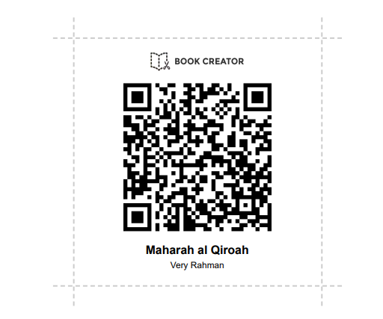
Product Design

"Please scan here."
Creation of Learning Media for Qirâ`ah Skills Using Book Creator
Materials for Creating Learning Media
Before creating learning media using Book Creator, several materials are needed to facilitate the creation process. These materials include:
- Prepare the Learning Content: The first step is to prepare the material that will be used in the learning media, whether in the form of text, audio, images, or videos. Although Book Creator offers the option to search for images and videos online, preparing these materials in advance helps speed up the module's creation process.
- Use of PDF Files: You can also directly insert PDF files in Book Creator. If you already have a module in the form of a book, you can simply import the file.
- Determine the design and layout in Book Creator. An engaging design helps students better understand the content. Using a combination of colors, easy-to-read fonts, and well-proportioned visual elements enhances the appeal of the module (Mayer, 2002).
- during the creation phase, users can add interactive elements such as quizzes, navigation buttons, and external links to additional learning resources. These elements encourage students to be more active in learning and increase their engagement with the material.
- before publishing the module, a trial phase is necessary to ensure that all elements function properly. This process includes checking content accuracy, text readability, and interactive media performance. Once finalized, the module can be shared with students via a link or in an offline-accessible format.
Book Creator is chosen because it is a user-friendly tool that supports various media formats, simplifies distribution, enables collaboration, and meets the needs of modern education. These features make it a strong choice for creating interactive learning modules.
One of the key advantages of Book Creator as a learning media tool is its flexibility in accommodating different learning styles. Visual learners benefit from images and videos, while auditory learners can utilize voice recordings and audio features. Additionally, students who prefer text-based learning still have access to well-structured reading materials.
Thus, the use of Book Creator in education not only facilitates teachers in structuring their materials but also provides a richer and more interactive learning experience for students. Therefore, integrating this tool into modern education is highly recommended to enhance both the effectiveness and quality of learning.
Steps for Creating Learning Media
After preparing the materials for creating the qirâ`ah learning media using Book Creator, the next step is to implement them on the Book Creator website. The steps are as follows:
- Search for Book Creator: Type "bookcreator.com" in the Google search bar. It will display a page similar to the one below.
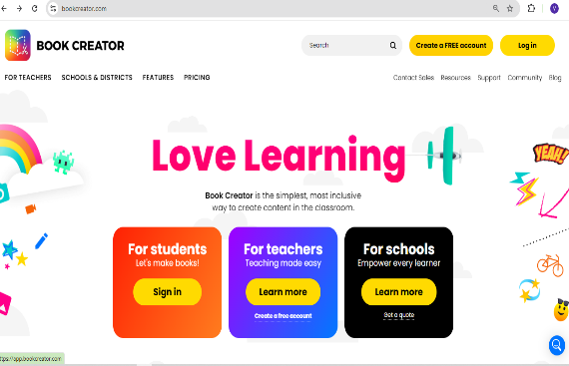

- Sign Up or Sign In: Once the page appears, click on the "Sign Up" or "Sign In" button in the top-right corner.
- Select "As a Teacher": Choose the option to enter as a teacher in order to create learning media. If you log in as a student, you can only read content posted by the teacher.

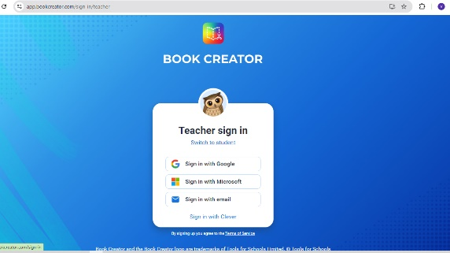

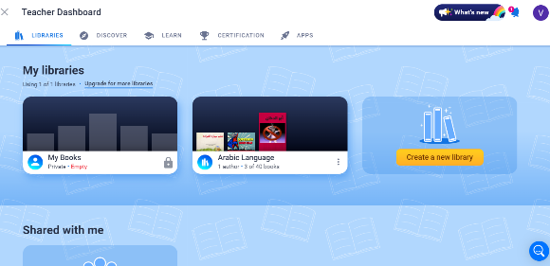
- Teacher Dashboard: The teacher dashboard will appear. Select the "My Books" menu.

- Create a New Book: Click on the "New Book" menu in the top-right corner. This will display the book layout along with template options, as shown in the image below.
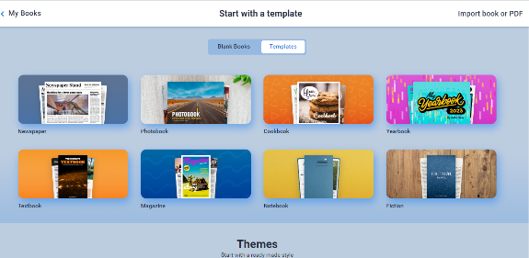
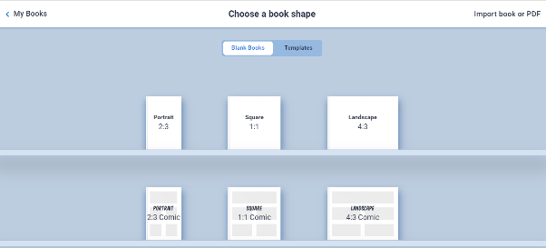

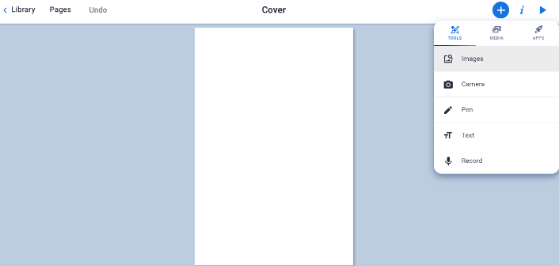
- Creating the Cover: After selecting the book layout/template, the next step is to create the cover. You can add a background image from your laptop's gallery. To import an image, go to the "Tools" menu.

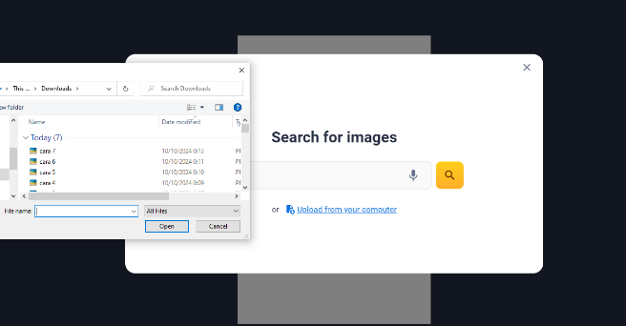
- Importing Images: You can import images from the internet. If you want to use images stored on your laptop, select the "Upload from your computer" menu.

- Adding Text: The next step is to add text once the cover is created. This option is also available in the "Tools" menu. Teachers can freely use their creativity by combining text and images to enhance the cover design.
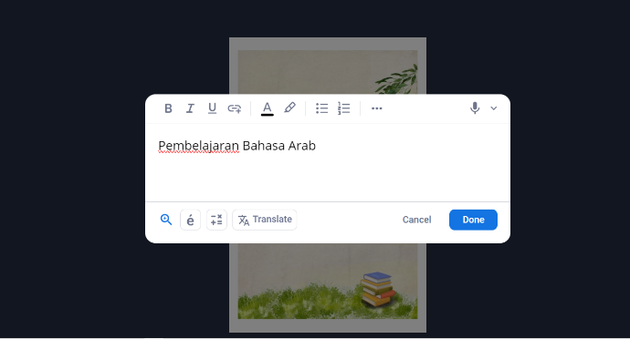

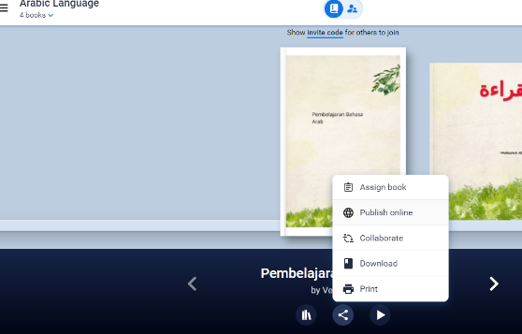
- Publishing the Media: Once the learning media is complete, it can be shared online by selecting the "Publish Online" menu, as shown in the image below.

- The final step is to share the link or QR code so that the public can access the learning media via laptops, computers, or Android devices.

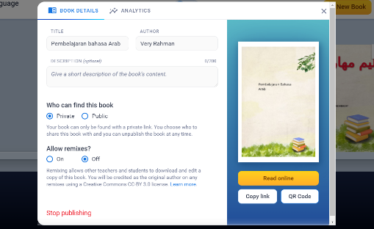

Evaluation of Qirâ`ah Skills Learning Using Book Creator Media
Based on the level of language learners, reading skill assessments can be classified into three stages according to the development of the learners as follows:
- For Beginner Learners (Mubtadi'): Recognizing language symbols or characters, reading the Hijaiyah letters and vocabulary, determining the meaning of words in the context of a sentence, true-false tests, recognizing or matching words and sentences.
- For Intermediate Learners (Mutawassith): Finding the main idea, supporting ideas, and key words, summarizing the content of a short reading, completing and correctly rearranging available sentences according to rules and sequence.
- For Advanced Learners (Mutaqaddim): Interpreting the content of a reading, making summaries, retelling longer reading materials, critiquing the content, connecting ideas within the text, reading fluently, identifying facts stated in the text, summarizing the main content of the reading, and translating the content of the reading (Munip, 2017).
Based on the reading skill learning objectives mentioned above, the techniques and assessment instruments for reading skills (mahârah al-qirâ`ah) are outlined in the table as follows:

No | Mahârah al-Qirâ'ah Objectives | Assessment Instrument
1 | Students are able to extract global meaning (information) directly from the text they read and understand how meaning changes due to structural alterations (tarkîb). | Students are asked to read a simple text with full diacritics silently (qirâ`ah shâmitah), then answer general questions about the text.
2 | Learners understand the meaning of the sentences used in the paragraph and their interrelated meanings. | Learners are asked to read an Arabic text without diacritics silently (qirâ`ah shâmitah), then state the meaning of the main sentences in the text.
3 | Students are able to read with a general understanding of the text without being hindered by issues with grammar (qawâ’id). | Students are asked to translate the text into Indonesian.
4 | Students are able to understand Arabic text without needing a dictionary or a collection of translated vocabulary. | Students are asked to summarize the text's content and identify the paragraph's main idea and supporting details.
Evaluation of qirâ`ah skills learning with book creator media emphasizes the mastery of students' understanding of the text. Through discovering the meaning of words, students analyze the structure of the language, and ultimately, they can express the content of the reading in their own linguistic style.
The researcher focuses on the most important aspect is how students practice independently and continuously. With the help of the Book Creator media, it is hoped that students will develop a passion for learning and consistently hone their Arabic language skills, particularly in qirâ`ah skills.
Moreover, the evaluation process in mahârah qirâ`ah learning using Book Creator also includes aspects such as reading fluency, accuracy in understanding text meaning, and critical thinking skills related to the reading material. Students are not only required to understand the text literally but are also challenged to interpret implicit meanings, identify main ideas and supporting details, and compose summaries based on their comprehension.
In the evaluation process, educators can utilize various Book Creator features, such as digital annotations, voice recordings, and interactive quizzes, to assess students' reading proficiency. The digital annotation feature allows students to highlight difficult words, take notes on their understanding, and ask questions about the text they read. Meanwhile, the voice recording feature enables students to practice reading with proper intonation and pronunciation, which instructors can later review for constructive feedback.
Another advantage of Book Creator-based evaluation is its ability to provide instant feedback, helping students identify and correct their mistakes independently. With the digital revision feature, students can continuously refine their understanding over time, allowing their reading skills to develop progressively.
In conclusion, the evaluation of mahârah qirâ`ah learning through Book Creator does not only focus on text comprehension but also encourages students to practice independently, think critically, and continuously enhance their reading skills. By maximizing this technology, Arabic language learning can become more engaging, effective, and aligned with the demands of the modern era.

Conclusion
Book Creator is an application that can be used to create interactive digital learning modules. It allows the integration of text, images, audio, video, and other interactive elements to create engaging and dynamic books. By using Book Creator, qirâ`ah skills learning can be realized in alignment with the experiences and psychology of today's students.
The evaluation of qirâ`ah skills learning with Book Creator media emphasizes the level of fahm al-maqrû’ (understanding of the reading). This indicates students' ability to analyze the reading text and rephrase the content based on their understanding. Equally important, Book Creator serves as a tool to capture students' enthusiasm for learning Arabic, particularly in qirâ`ah skills learning.
Additionally, in the evaluation of mahârah 1irâ`ah using Book Creator, aspects such as fluency, accuracy, and deep comprehension are key focal points. Students are not only expected to understand the explicit content of the text but also to identify implicit meanings, linguistic structures, and the social and cultural context embedded within the reading material.

REFERENCES
Abdul Majid. (2019). Strategi Pembelajaran Bahasa Arab. PT Raja Grafindo Persada.
Acep, H. (2011). Metodologi Pembelajaran Bahasa Arab. Bandung: Remaja Rosdakarya.
Ahmad Fuad Effendi. (2020). Pembelajaran Bahasa Arab: Teori dan Metode. Bandung: Remaja Rosdakarya.
Al-Fauzan, A. bin I. (n.d.). Idhâât Limu’allimî al-Lughah al-’Arabiyyah li Ghairin Nâthiqîn Bihâ. Riyadh: Arabic for All.
Al-Nahlawi. (2015). al-Tarbiyat al-Islâmiyah wa Falsafatuhâ. Dâr al-Fikr.
Brookfield, S. (2013). Teaching for Critical Thinking. International Journal of Adult Vocational Education and Technology (IJAVET), 4(1).
Bujuri, D. A., Sari, M., Handayani, T., & Saputra, A. D. (2023). Penggunaan Media Sosial dalam Pembelajaran: Analisis Dampak Penggunaan Media Tiktok terhadap Motivasi Belajar Siswa di Sekolah Dasar. Jurnal Ilmiah Pendidikan Dasar, 10(2).
Elder, L., & Paul, R. (2020). Critical Thinking: Tools for Taking Charge of your Learning and your Life. Rowman & Littlefield.
Ennis, R. H. (1962). A Concept of Critical Thinking. Harvard educational review.
Farkhanah, E. (2023). Pemanfaatan “Book Creator” dalam Pembelajaran Literasi Digital untuk Meningkatkan Minat dan Hasil Belajar Mata Pelajaran “Produk Kreatif dan Kewirausahaan.” Jurnal Cahaya Mandalika ISSN 2721-4796 (Online), 4(2).
Fisher, A. (2004). The Logic of Real Arguments. Cambridge University Press.
Fuad, A. (2016). Metodologi Pengajaran Bahasa Arab. Malang: Misykat.
Hasanah, I., & Rodi’ah, S. (2021). Strategi Pembelajaran Pendidikan Jasmani Berbantu media Book Creator Digital dalam Meningkatkan Kemampuan Motorik Kasar Siswa pada Tingkat Sekolah Dasar. Continuous Education: Journal of Science and Research, 2(2).
Hidayat, M. T., Junaidi, T., & Yakob, M. (2020). Pengembangan Model Pembelajaran Blended Learning dalam Meningkatkan Pemahaman Siswa terhadap Tradisi Lisan Aceh. Mimbar Ilmu, 25(3).
Ibrahim. (1968). Qirâ’ah wa Fahm al-Nushûsh. Dâr al-Ma’ârif.
Knowles, M. S. (1975). Self-directed learning: A guide for learners and teachers.
Kusumawati, N. A. (2022). Penggunaan Media E-Book Creator untuk Meningkatkan Kemampuan Menulis Cerita Inspiratif Peserta Didik Kelas IX F SMP Negeri 1 Dayeuhkolot Kabupaten Bandung Semester Genap Tahun Pelajaran 2021-2022. Continuous Education: Journal of Science and Research, 3(3).
Lipman, M. (2003). Thinking in Education. Cambridge University Press.
Manzur, I. (1996). Lisân al-Arab, Beirut: Dâr al-Shadr, t. th.
Mayer, R. E. (2002). Multimedia learning. In Psychology of learning and motivation, 41. Elsevier.
Muhammad Rajab Fadlullah. (1998). Itti’jâhat Tarbawiyah Mu’âshirah fi Tadrîs al-Lughah al’Arabiyah. Kairo: ‘Âlam Kutub.
Mujib, F., & Rahmawati, N. (2012). Permainan Edukatif Pendukung Pembelajaran Bahasa Arab. Jogjakarta: PT Gramedia Pustaka Utama.
Muliarta, I. K. D. (2024). Book Creator Sebagai Media dalam Pembelajaran Bahasa Kedua.
Munip, A. (2017). Penilaian Pembelajaran Bahasa Arab. Yogyakarta: FITK UIN Sunan Kalijaga.
Mustofa, B., & Hamid, M. A. (2016). Metode dan Strategi Pembelajaran Bahasa Arab. UIN-Maliki Press.
Puspitasari, V., & Walujo, D. A. (2020). Pengembangan Perangkat Pembelajaran dengan Model Diferensiasi Menggunakan Book Creator untuk Pembelajaran BIPA di Kelas yang Memiliki Kemampuan Beragam. Jurnal Education and Development, 8(4).
Rahman, A. A. (2017). Keterampilan Membaca dan Teknik Pengembangannya dalam Pembelajaran Bahasa Arab. Diwan: Jurnal Bahasa dan Sastra Arab, 3(2).
Rohani, A., & Anas, N. (2022). Pengembangan Media Komik dengan Menggunakan Aplikasi Comic Page Creator untuk Meningkatkan Kemampuan Membaca Siswa Kelas 2 Sekolah Dasar. Jurnal Cakrawala Pendas, 8(4).
Sanjaya, D. H. W. (2006). Strategi Pembelajaran Berorentasi Standar Proses Pendidikan.
Sanjaya, P. A. (2022). Pengembangan Pembelajaran Sejarah Berdiferensiasi Menggunakan e-Module Berbasis Book Creator. Prodiksema, 1(1).
Sespen, A. P. (2024). Inovasi Media Pembelajaran Menggunakan Book Creator di SDN Percobaan Padang. Didaktik: Jurnal Ilmiah PGSD STKIP Subang, 10(4).
Silalahi, J., Butarbutar, I., Sirait, R., & Gultom, T. Y. (2023). Pengembangan Pembelajaran Virtual dengan Aplikasi Book Creator pada Mata Kuliah Tafsir Perjanjian Lama. Jurnal Shanan, 7(2).
Sudaryono, Rahayu, W., & Margono, G. (2013). Pengembangan Instrumen Penelitian Pendidikan. Graha Ilmu.
Sutarti, T., & Irawan, E. (2017). Kiat Sukses Meraih Hibah Penelitian Pengembangan. Deepublish.
Tahir Ahmad Al-Zawi, Tartîb al-Qâmus al-Muhîth, Juz’I, Riyadh: Dâr al-‘Âlam al-Kutub.

Taufik, T., Rifki, A., Ilmiyah, D. F., Aghnia, C. D., Yani, A., & Murwanti, M. (2023). Pengembangan Media Pembelajaran Mahârah Qirâ’ah dengan Menggunakan Book Creator. Al Mi’yar: Jurnal Ilmiah Pembelajaran Bahasa Arab Dan Kebahasaaraban, 6(2).
Yusuf, M., & Munawir, A. (2024). Pengembangan Media Pembelajaran Interaktif Berbasis Permainan Edukasi Word Wall pada Materi Pecahan untuk Siswa Sekolah Dasar. An-Nahdlah: Jurnal Pendidikan Islam, 4(2).

