Suplemen material
Nimonol from Chisocheton macrophyllus (Meliaceae) Seeds and Their Cytotoxic Activity against
P-388 Leukaemia cells
Nurlelasari^{1*}, Desi Harneti¹, P.H., Rani Maharani¹, Darwati¹, Tri Mayanti¹, Kindi Farabi¹, Muhammad Hanafi², and Unang Supratman¹

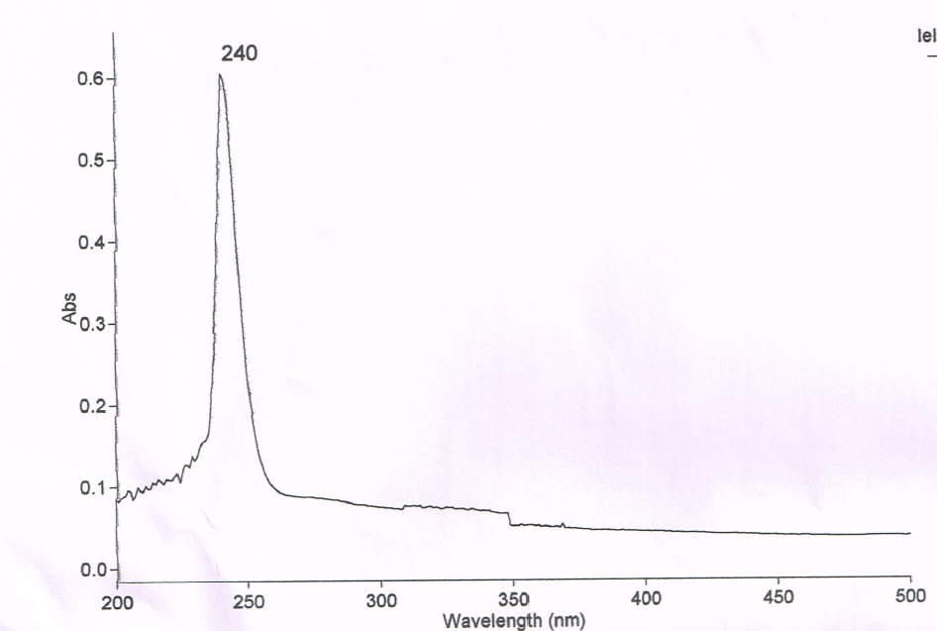
Figure 1. Ultraviolet spectrum of Nimonol (Methanol)

OH
CH-alifatik
C=O
C=O ester
C=C
C-O
Figure 2. Nimonol Infrared Spectrum (KBr)
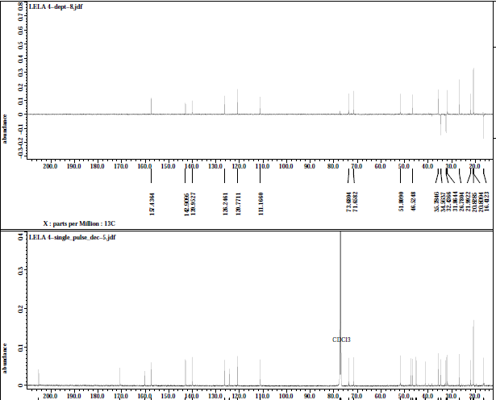
C-Sp³
CH-Sp³
C-O
C=C Sp²
Cq Sp²
Cq Sp²
Cq Sp³
Figure 3. Spectrum of DEPT 135º nimonol (CDCl₃, 125 MHz)
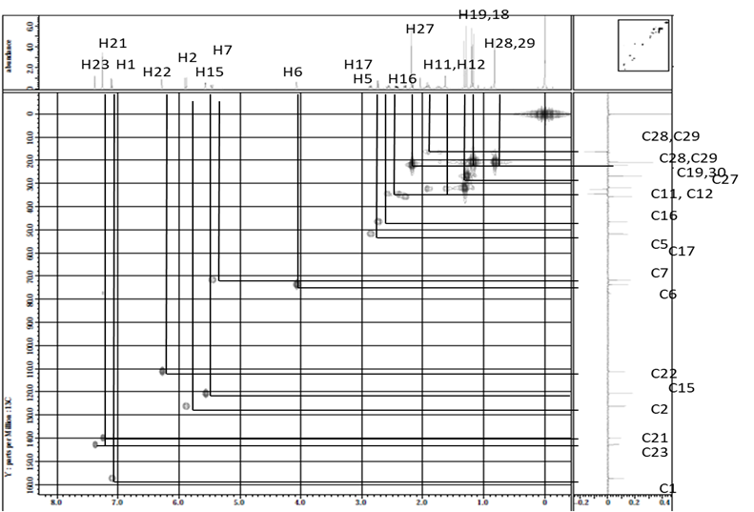
Figure 4. The HMQC spectrum of selected nimonol
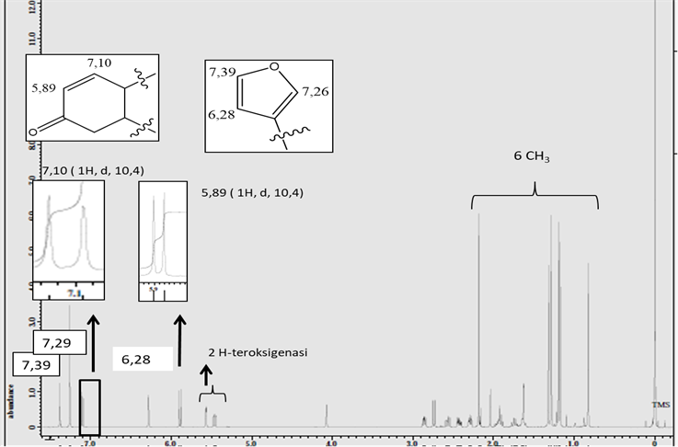
Figure 5. Nimonol ¹H-NMR spectrum (CDCl₃, 500 MHz)

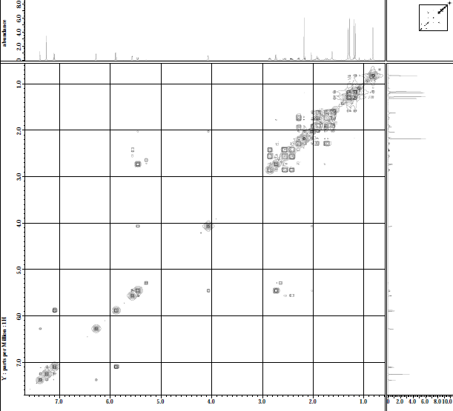
H23
H22
H1
H2
H7
H16
H6
H15
Figure 6. COSY ¹H-¹H spectrum selected nimonol

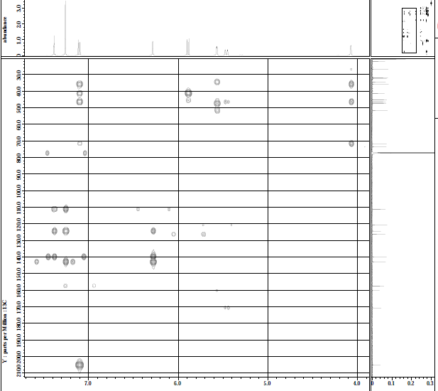
H6
H-2
H-15
H-7
H-1
H-21
H-23
C-7
C-5
C-9
C-4
H-22
C-20
C-23
C-21
C-1’
C-2’

Figure 7. Spectrum of selected nimonol HMBC

