
JURNAL TEKNIK INFORMATIKA
Homepage : http://journal.uinjkt.ac.id/index.php/ti

EXPERT SYSTEM: NAÏVE BAYES OPTIMIZATION FOR FELDER SILVERMAN LEARNING STYLE MODEL IDENTIFICATION

Slamet Risnanto¹, Hanatyati Nur Asmi², Othman Bin Mohd³

^{1,2}Program Studi Teknik Informatika, Fakultas Teknik
³Faculty of Information and Communication Technology,
^{1,2}Universitas Sangga Buana
³Universiti Teknikal Malaysia, Malaka 76100, Malaysia
^{1,2}Jl. PHH. Mustofa No 68 Bandung, Indonesia 40124
³Hang Tuah Jaya, 76100 Durian Tunggal, Melaka, Malaysia
E-mail: ¹slamet.risnanto@usbypkp.ac.id, ²hnatyani10@gmail.com, ³mothman@utem.edu.my

 | ABSTRACT  Higher education faces major challenges in providing quality education, One important issue is the differences in students learning styles, which requires educators to pay attention to individual learning preferences. The manual learning style identification method is considered less effective in terms of time and data accuracy. This study aims to develop a student learning style identification system using the Felder-Silverman model and the Naïve Bayes method, This system is designed to assist lecturers in adjusting learning strategies according to student learning preferences, thus increasing the effectiveness of the learning process. The Naïve Bayes method was applied by analyzing student datasets and determining the accuracy of learning style identification. The validation results showed significant identification accuracy: 85% for the active-reflective dimension, 96% for the sensitive-intuitive dimension, 98% for the verbal-visual dimension, and 91% for the sequential-global dimension. These findings indicate that the Naïve Bayes method is effective in providing appropriate learning recommendations based on student learning styles. By utilizing this system, universities can improve the personalization of learning, support a more efficient learning process according to student needs and preferences, and make a significant contribution to the development of more adaptive and responsive learning strategies.  Keywords: Learning Style, Naïve Bayes method, felder Silverman
  Article:  Accepted: xxx xx, 20xx  Revised: xxx xx, 20xx  Issued: xxx xx, 20xx  *Correspondence Address:  Slamet.risnanto@usbypkp.ac.id | ABSTRACT  Abstract is a synopsis of the work containing the problems studied, the purpose of research, information and methods used to solve problems, and conclusions. Articles must be submitted in print-ready format and are limited to a minimum of ten (10) pages and a maximum of twelve (12) pages. Abstract is a synopsis of the work that contains the issues studied, the research purpose, the information and methods used to solve the problem, and the research conclusion. Abstracts are limited to 200 words and should not contain references, mathematic equations, figures, and tables. The font size for abstracts, keywords, and body of article is 11pt. Keywords are no more than six (6) words, but the minimum is three (3) words.  Keywords: Web, Asset Management, CodeIgniter, Bootstrap

- INTRODUCTION

Higher education faces challenges in providing quality education and meeting the needs of each student. One important component that is often overlooked is the heterogeneity in how students learn, also known as "learning styles" [1] . Conceptually, learning styles are defined as the way individuals sort, process, and absorb data. Identifying students' learning styles not only impacts teaching strategies for lecturers but also in curriculum development. This has an impact on students having better self-awareness about how to process information, which can improve motivation and learning outcomes.
The effectiveness of the learning process is highly dependent on the learning methods and media used by educators and the tendency of students' learning styles using a questionnaire method that is answered by several people and then collected again and processed to find out that someone has a tendency for visual, auditory, or kinaesthetic learning styles. However, this method is done manually, so it is less effective in terms of time and data accuracy [2]. There are many learning style models that can be used to identify learning styles, one of which is the Felder-Silverman Learning Model (FSLM), used as a measure of learning styles in many studies on eLearning personalization. For example, to meet different learning needs with different learning styles through the use of adaptive hypermedia and recommendation systems in the Felder-Silverman model [3].
Current technological advances can create machines that have human-like abilities. Artificial intelligence, also known as artificial intelligence, began to be developed by humans who have knowledge. Artificial intelligence scientists study how machines can function and have human-like abilities. This includes imitating the way the human brain works, imitating neural networks, imitating the ability to move and recognise objects, and even developing in directions related to psychology and health. One part of artificial intelligence is the expert system [4].
Expert systems can mimic human judgment and provide integrated solutions to complex problems, providing a new and inventive method for identifying the Felder-Silverman Learning Style Model. This approach is further driven by machine learning technology, which requires large data sets to automatically predict and model student learning styles, often with very high levels of accuracy and speed . This combination of expert systems and machine learning technology allows for fast and precise identification of the Felder-Silverman Learning Style Model. Identification of the Felder-Silverman Learning Style Model in students shows how important it is to understand student learning styles in the evolving information technology environment. This is a hope to utilize advances in expert systems and machine learning algorithms to improve the quality of learning and support more efficient learning. The aims of this study is to build a system that can identify learning style models (Felder-Silverman Learning Style Model) in students in higher education and implement the Naïve Bayes expert system method in the builded expert system.

  - Related Works

Bayes' Theorem is a probability and statistical technique developed by the British scientist Reverend Thomas Bayes (1701-1761), which aims to predict the future based on data from the past. In classification, Bayes' theorem is used for the problem of the amount of training data that must be met, where n is the number of attributes with Boolean types. This method must be followed to achieve the minimum missing value. Naive Bayes can be described as a simple probabilistic classifier that helps in calculating the number of sets by combining the combination and frequency of the number of datasets obtained [5].
Learning style is a natural component that differentiates students from one another during the learning process. Not all students process or absorb information in the same way. A study of 230 students showed many differences in their learning styles: 27% use a visual style, 16% use an auditory style, 14% use a reading/writing style, and 43% use a kinaesthetic style. To improve the effectiveness of learning, educators must pay more attention to individual learning preferences due to differences [6].
From the perspective of educational institutions, understanding and identifying students' learning styles is very important because educational success is not only measured by the knowledge delivered by the teacher but also by how students utilize knowledge, comparing styles and levels of performance, and emphasizing the importance of matching teaching methods to students' learning styles for better academic outcomes. This study also validated the consistency and reliability of learning style assessments in various educational contexts. By accepting different learning styles, educators can create an inclusive learning environment where every student feels valued and supported throughout their academic journey. Knowing learning styles can help educators design more flexible curricula and provide learning approaches that are accessible to all students without sacrificing the quality of learning [7].
Based on research conducted to detect learning styles using log files on questionnaires combined with the FSLSM method by capturing student learning styles based on Indonesian time zones, it has an accuracy rate of 99% on the Naïve Bayes algorithm. The study shows that the Naïve Bayes method is feasible to classify learning styles in four different dimensions. Other research to detect learning styles of high school students in the Virtual Based Learning environment with the Decision Tree and Naïve Bayes algorithms shows very good performance in predicting high school students' learning styles. And the Naïve Bayes algorithm has an accuracy rate of 98%, slightly more accurate than Decision Tree with an accuracy rate of 96% [8].

- METHODOLOGY

II.1 Preliminary research

The stages of this research begin with preliminary research, by conducting observations of students and several psychological service places by conducting direct interviews to identify students' psychological problems. At this stage, problems are identified, and it is the identification of problems that becomes the basis for determining the formulation of the problem and the objectives of this research. The next stage is a literature study to enrich literacy by searching for articles relevant to psychology and information technology from journals, proceedings, and reputable articles. At this stage, experts are also determined to accompany this research as sources or to validate the results of this research.

II.2 System Development

The system development stage begins with an analysis of the ongoing system by identifying the stages of psychologists to analyze student learning styles, then implementing the Felder-Silverman method into the naïve Bayes expert system method to strengthen the analysis. Furthermore, a system design consisting of conceptual design using UML, database design for data storage and access needs, user interface design, and system design using the Visual Studio Code tool and the Python programming language. Finally, system testing is carried out on the development side using blackbox testing to ensure the system runs well.

II.3 Validation

The first validation stage is conducted by expert validation by comparing the results of the psychologist's analysis with the system analysis, then the second validation stage is carried out by the user, namely students are provided with a questionnaire to carry out user validation by analyzing using the system, determining the number of respondents and processing the results of the questionnaire based on statistical theory and quantitative research so as to produce valid measurements.
The Figure 1 below is an illustration of the research phase, which is a picture of this research process.

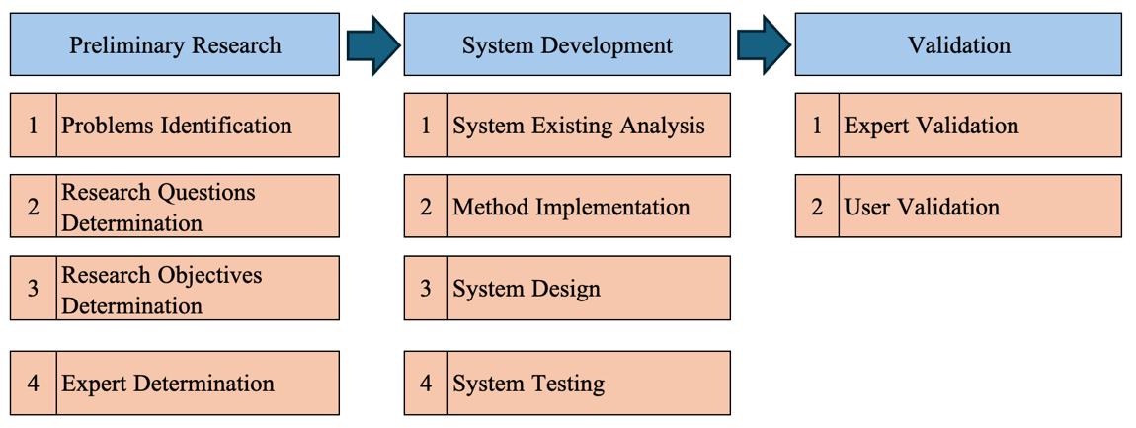

Figure 1. Research Phase

- RESULTS AND DISCUSSION

III.1. Naïve Bayes Method Implementation

The learning style model used is the Felder-Silverman style model which will be applied with the Naïve Bayes method approach to identify students' learning styles. The Felder-Silverman learning style model involves main dimensions such as active-reflective, sensitive-intuitive, visual-verbal, and sequential-global, each of which has two opposite poles. The data used to implement the model is a dataset of student respondents who have answered the online learning style questionnaire using Google Form. This questionnaire was created by Felder [9] and has been adapted into Indonesian by Dhini Cahyaningrum [10] which contains 44 questions, each of which has a learning style category according to the dimensions previously explained. The answers to each question are represented in binary form, namely 0 and 1 to identify preferences in each learning style dimension. Furthermore, the dataset is trained by dividing the data into training data and test data, calculating the prior probability for each Felder-Silverman class, and calculating the likelihood probability for each dimension in each class. The learning style prediction process is done by calculating the probability for each class and selecting the class with the highest probability as the final prediction. The basic formula for this implementation as follows.
- Calculating the prior probability, is the probability of each class without considering the features.

P(Class) =

$\frac{Number of occurrences of the class ​}{Total Occurrences}$ (1)

- Calculating Likelihood Probability, is the probability that a feature has a certain value, given a certain class.

P(Feature∣Class)=

$\frac{Number of occurrences of a feature in the class​}{Total Events in the class}$ (2)

- Calculating Posterior Probability, is the probability of each class given a particular feature. The posterior probability for an example with respondents' answers q1=1 and q2=0 is calculated as:

P(Class∣Feature) = P(Class) × P(Feature1​∣Class) × P(Feature2​∣Class) (3)

The Calculation using the dimensions of perceptual learning styles (sensitive and intuitive learning styles), dimensions of processing learning styles (active and reflective learning styles), dimensions of input learning styles (visual and verbal learning styles), and dimensions of understanding learning styles (global and sequential learning styles) in the application of Naïve Bayes using a dataset that has 234 respondents. Table 1 below is the number of respondents from each learning style class.
Table 1. Number of Respondents
P(Class) | Number of Respondent
Sensitive | 127
Intuitive | 107
Active | 117
Reflective | 117
Visual | 111
Verbal | 123
Sequential | 124
Global | 110

With the data that has been determined, the prior probability, likelihood probability, and posterior probability can be calculated. Table 2 The following is the result of the calculation of the prior probability.
Table 2. Probabilitas Prior Values
P(Class) | Probabilitas Prior Value
Sensitive | 0,54
Intuitive | 0,46
Aktive | 0,50
Reflective | 0,50
Visual | 0,47
Verbal | 0,53
Sequential | 0,53
Global | 0,47

In table 3 below are the values of the likelihood probability of each learning style.

Table 3 Likelihood Probability Values

P(Feature∣Class) | Value
P(q2=1∣Sensitive) | 0,51
P(q2=0∣Intuitive) | 0,49
P(q6=1∣Sensitive) | 0,70
P(q6=0∣Intuitive) | 0,30
P(q10=1∣Sensitive) | 0,50
P(q10=0∣Intuitive) | 0,50
P(q14=1∣Sensitive) | 0,46
P(q14=0∣Intuitive) | 0,54
P(q18=1∣Sensitive) | 0,70
P(q18=0∣Intuitive) | 0,30
P(q22=1∣Sensitive) | 0,61
P(q22=0∣Intuitive) | 0,39
P(q26=1∣Sensitive) | 0,27
P(q26=0∣Intuitive) | 0,73
P(q30=1∣Sensitive) | 0,48
P(q30=0∣Intuitive) | 0,52
P(q34=1∣Sensitive) | 0,64
P(q34=0∣Intuitive) | 0,36
P(q38=1∣Sensitive) | 0,69
P(q38=0∣Intuitive) | 0,31
P(q42=1∣Sensitive) | 0,45
P(q42=0∣Intuitive) | 0,55
P(q1=0|Active) | 0,76
P(q1=1|Reflective) | 0,24
P(q5=0|Active) | 0,29
P(q5=1|Reflektif) | 0,71
P(q9=0|Active) | 0,20
P(q9=1|Reflective) | 0,80
P(q13=0|Active) | 0,64
P(q13=1|Reflective) | 0,36
P(q17=0|Active) | 0,41
P(q17=1|Reflective) | 0,59
P(q21=0|Active) | 0,46
P(q21=1|Reflective) | 0,54
P(q25=0|Active) | 0,52
P(q25=1|Reflective) | 0,48
P(q29=0|Active) | 0,52
P(q29=1|Reflective) | 0,48
P(q33=0|Active) | 0,50
P(q33=1|Reflective) | 0,50
P(q37=0|Active) | 0,84
P(q37=1|Reflective) | 1,16
P(q41=0|Active) | 1,18
P(q41=1|Reflective) | 0,82
P(q3=0|Verbal) | 0,31
P(q3=1|Visual) | 0,69
P(q7=0|Verbal) | 0,54
P(q7=1|Visual) | 0,46
P(q11=0|Verbal) | 0,62
P(q11=1|Visual) | 0,38
P(q15=0|Verbal) | 0,45
P(q15=1|Visual) | 0,55
P(q19=0|Verbal) | 0,74
P(q19=1|Visual) | 0,26
P(q23=0|Verbal) | 0,60
P(q23=1|Visual) | 0,40
P(q27=0|Verbal) | 0,56
P(q27=1|Visual) | 0,44
P(q31=0|Verbal) | 0,38
P(q31=1|Visual) | 0,62
P(q35=0|Verbal) | 0,38
P(q35=1|Visual) | 0,62
P(q39=0|Verbal) | 0,56
P(q39=1|Visual) | 0,44
P(q43=0|Verbal) | 0,48
P(q43=1|Visual) | 0,52
P(q4=0|Sequential) | 0,25
P(q4=1|Global) | 0,75
P(q8=0| Sequential) | 0,65
P(q8=1|Global) | 0,35
P(q12=0| Sequential) | 0,32
P(q12=1|Global) | 0,68
P(q16=0| Sequential) | 0,77
P(q16=1|Global) | 0,23
P(q20=0| Sequential) | 0,63
P(q20=1|Global) | 0,37
P(q24=0| Sequential) | 0,30
P(q24=1|Global) | 0,70
P(q28=0| Sequential) | 0,29
P(q28=1|Global) | 0,71
P(q32=0| Sequential) | 0,81
P(q32=1|Global) | 0,19
P(q36=0| Sequential) | 0,47
P(q36=1|Global) | 0,53
P(q40=0| Sequential) | 0,46
P(q40=1|Global) | 0,54
P(q44=0| Sequential) | 0,52
P(q44=1|Global) | 0,48

The next process is calculating the posterior probability. In the following Table 4 the results of the posterior probability calculation are presented.
Tabel 4.Probabilitas Posterior values
P(Class∣Feature) | Value
P(Sensitive∣q2=0) | 0,28
P(Intuitive∣q2=1) | 0,22
P(Sensitive ∣q6=0) | 0,38
P(Intuitive ∣q6=1) | 0,14
P(Sensitive ∣q10=0) | 0,27
P(Intuitive ∣q10=1) | 0,23
P(Sensitive ∣q14=0) | 0,25
P(Intuitive ∣q14=1) | 0,25
P(Sensitive ∣q18=0) | 0,38
P(Intuitive ∣q18=1) | 0,14
P(Sensitive ∣q22=0) | 0,33
P(Intuitive ∣q22=1) | 0,18
P(Sensitive ∣q26=0) | 0,15
P(Intuitive ∣q26=1) | 0,33
P(Sensitive ∣q30=0) | 0,26
P(Intuitive ∣q30=1) | 0,24
P(Sensitive ∣q34=0) | 0,35
P(Intuitive ∣q34=1) | 0,16
P(Sensitive ∣q38=0) | 0,38
P(Intuitive ∣q38=1) | 0,14
P(Sensitive ∣q42=0) | 0,24
P(Intuitive ∣q42=1) | 0,25
P(Active∣q1=0) | 0,38
P(Reflective∣q1=1) | 0,12
P(Active∣q5=0) | 0,14
P(Reflective∣q5=1) | 0,36
P(Active∣q9=0) | 0,10
P(Reflective∣q9=1) | 0,40
P(Active∣q13=0) | 0,64
P(Reflective∣q13=1) | 0,36
P(Active∣q17=0) | 0,21
P(Reflective∣q17=1) | 0,29
P(Active∣q21=0) | 0,23
P(Reflective∣q21=1) | 0,27
P(Active∣q25=0) | 0,26
P(Reflective∣q25=1) | 0,24
P(Active∣q29=0) | 0,26
P(Reflective∣q29=1) | 0,24
P(Active∣q33=0) | 0,25
P(Reflective∣q33=1) | 0,25
P(Active∣q37=0) | 0,42
P(Reflective∣q37=1) | 0,58
P(Active∣q41=0) | 0,59
P(Reflective∣q41=1) | 0,41
P(Verbal∣q3=0) | 0,17
P(Visual∣q3=1) | 0,32
P(Verbal∣q7=0) | 0,29
P(Visual∣q7=1) | 0,21
P(Verbal∣q11=0) | 0,33
P(Visual∣q11=1) | 0,18
P(Verbal∣q15=0) | 0,24
P(Visual∣q15=1) | 0,26
P(Verbal∣q19=0) | 0,39
P(Visual∣q19=1) | 0,12
P(Verbal∣q23=0) | 0,32
P(Visual∣q23=1) | 0,19
P(Verbal∣q27=0) | 0,30
P(Visual∣q27=1) | 0,20
P(Verbal∣q31=0) | 0,20
P(Visual∣q31=1) | 0,29
P(Verbal∣q35=0) | 0,20
P(Visual∣q35=1) | 0,29
P(Verbal∣q39=0) | 0,30
P(Visual∣q39=1) | 0,21
P(Verbal∣q43=0) | 0,26
P(Visual∣q43=1) | 0,24
P(Sequential∣q4=0) | 0,13
P(Global∣q4=1) | 0,35
P(Sequential∣q8=0) | 0,34
P(Global∣q8=1) | 0,17
P(Sequential∣q12=0) | 0,17
P(Global∣q12=1) | 0,32
P(Sequential∣q16=0) | 0,41
P(Global∣q16=1) | 0,11
P(Sequential∣q20=0) | 0,33
P(Global∣q20=1) | 0,17
P(Sequential∣q24=0) | 0,16
P(Global∣q24=1) | 0,33
P(Sequential∣q28=0) | 0,15
P(Global∣q28=1) | 0,33
P(Sequential∣q32=0) | 0,43
P(Global∣q32=1) | 0,09
P(Sequential∣q36=0) | 0,25
P(Global∣q36=1) | 0,25
P(Sequential∣q40=0) | 0,24
P(Global∣q40=1) | 0,25
P(Sequential∣q44=0) | 0,28
P(Global∣q44=1) | 0,22

Model performance evaluation conducted by calculating the accuracy level of the Naïve Bayes model on each dimension of learning style. The first step is to separate the dataset into a training set and a testing set; in this study, it was conducted 80% training data and 20% testing data. The accuracy level uses the following formula:

Acuracy =
$\frac{Number of correct predictions}{Total predictions}$ x 100% (4)
The accuracy level of each dimension uses 20% of 234 respondents, namely 47 respondents, to be the test data. In table 5 below are the results of the accuracy level of each dimension of learning style.
Table 5. Accuracy Level
Learning Style Dimensions | Accuracy Level
Learning Style Perception | 96%
Learning Style Processing | 85%
Learning Style Input | 98%
Learning Style Understanding | 91%

Based on the calculation process conducted manually using the Naïve Bayes method on each dimension of learning style, the results obtained for the perception learning style dimension have an accuracy level of 96%, the processing learning style dimension have an accuracy level of 85%, the input learning style dimension have an accuracy level of 98%, and the understanding learning style dimension have an accuracy level of 91%.

III.2. Interface Design

Interface design is known as an important part of software development and focusses on how the appearance and user interaction with the system can be made more effective and efficient. Interface design aims to create a display that is easy to understand and easy to use so that users can use the system easily and comfortably and can also improve the user experience when using the system. In the learning style assessment start menu, students will be shown a form to fill in their name and student ID before starting to answer learning style questions, in the Figure 2, The following is a main interface.


Figure 2. Main interface
After students fill out the name and student ID form, the system will display a questionnaire about learning habits based on the Felder-Silverman learning style model. Figure 3 below interface of the learning style questionnaire.

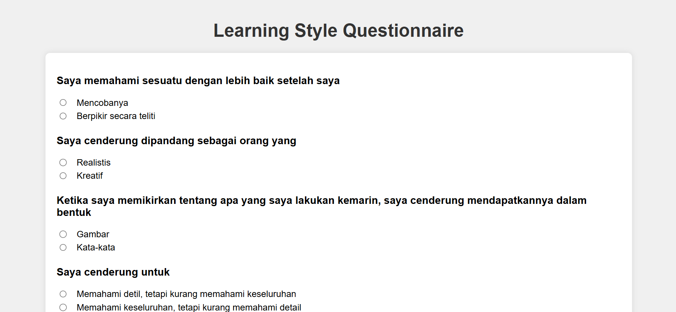
Figure 3 Learning Style Questionaire
The assessment result interface is a page after the student has answered the questions. On the display, it contains the student's name and student ID number, identification of the learning style, and suggestions for learning based on the learning style, Figure 4 shows the interface of the identification results.

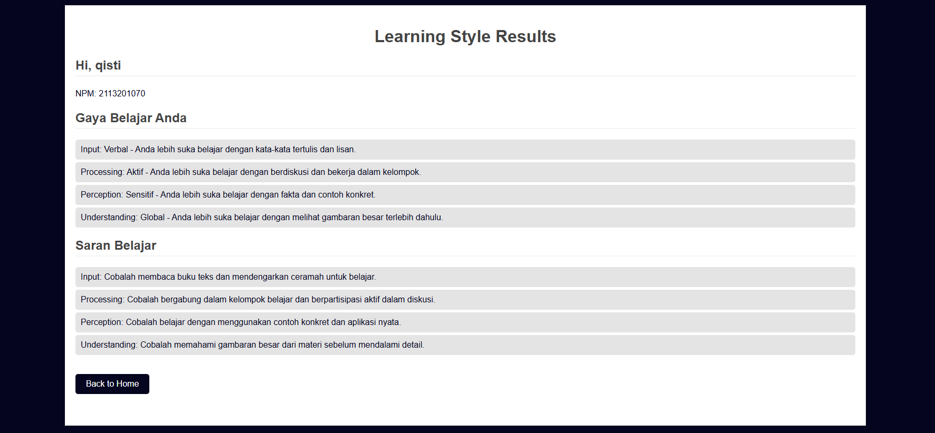
Figure 4. Identification result

III.3. Discussion

In the process of preliminary research, the underlying problems of this research were found. Observations and interviews with students and in various psychological service locations revealed several major problems, such as the challenges of higher education in providing quality education, differences in the way students process materials, the ineffectiveness of manual questionnaire methods, and the need for an application to identify Felder-Silverman learning styles. Based on the identification of these problems, the mapping of the problem formulation and research objectives showed a significant relationship between the three aspects supporting the development of an effective system for identifying student learning styles, providing a strong basis for continuing research, and implementing a system that can better meet the needs of higher education.
Analysis of the existing system was conducted to begin the system development phase. In this analysis, an understanding of how psychologists currently analyze students' learning styles is obtained. The process includes identifying the steps and methods used by psychologists to gain a deeper understanding of students' learning preferences. The results of this analysis are an important basis for designing a more effective and appropriate system for analyzing students' learning styles.
Implementation of the Felder-Silverman learning style model into the Naïve Bayes expert system method. The Felder-Silverman model includes active-reflective, sensitive-intuitive, visual-verbal, and sequential-global dimensions, with the resulting level of accuracy indicating that the system can identify students' learning styles. Next is the system design, which involves several important elements. The conceptual design process is carried out using the Unified Modeling Language (UML), which makes it easy to create diagrams to document the structure of the system. The user interface design is also designed to ensure ease of use of the system by considering the principles of good interface design. All of these designs are implemented using Visual Studio Code as the development tool and Python as the main programming language to ensure smooth integration between the various components of the system.
The user validation process is conducted by the questionnaire method, with a list of statements designed according to references from quantitative research. This validation aims to evaluate aspects of usability and user satisfaction with the application. This process involves the use of questionnaires that are designed to obtain feedback from users regarding various aspects of the application, such as ease of use, clarity of information, and interface design. The structure of the questionnaire used to collect data from 20 respondents has results that have been analysed by calculating the percentage value of user satisfaction with the application, which shows the effectiveness of the system in meeting user needs and expectations. Based on the calculations, an average percentage value of 85.6% was obtained, which shows that the application functions well in identifying students' learning styles.
Expert validation is conducted by experts to verify the results of the analysis carried out with the system created. Two experts in their fields have been determined as sources and validators of this study who are experts in the field of psychology, and the experts have the competence to be sources and validators in this study. With relevant backgrounds and expertise, the two experts have provided appropriate and in-depth validation of the system developed and ensured the suitability and quality of the results of the analysis carried out. The user validation process uses a questionnaire method with a list of statements designed according to references from quantitative research. This validation aims to evaluate aspects of usability and user satisfaction with the application. This process involves the use of questionnaires that are designed to obtain feedback from users regarding various aspects of the application, such as ease of use, clarity of information, and interface design. The questionnaire structure used to collect data from 20 respondents has results that have been analysed by calculating the percentage value of user satisfaction with the application, which shows the effectiveness of the system in meeting user needs and expectations. Based on the calculation, an average percentage value of 85.6% was obtained, which indicates that the application functions well in identifying student learning styles.

- CONCLUSION

This study successfully built a system that is able to identify students' learning style models based on the Felder-Silverman Learning Style Model. This system can recognize students' learning preferences individually, thus allowing for adjustments to teaching methods to improve learning effectiveness. The developed system implements the Naive Bayes expert system method well. This method has proven to be effective in identifying students' learning styles, showing an identification accuracy of 85% in the active-reflective learning style dimension, 96% in the sensitive-intuitive learning style dimension, 98% in the verbal-visual learning style dimension, and 91% in the sequential-global learning style dimension. Based on this level of accuracy, the use of Naive Bayes allows the system to provide accurate and reliable results. The validation carried out showed that the system built has good performance and can be implemented in higher education. System testing and evaluation showed a percentage of user satisfaction with an average value of 85.6%. Based on this percentage value, this system is suitable for use in adjusting teaching strategies to students' learning styles.
To improve the results and application of research on the learning style identification system (Felder-Silverman Model) using the Naïve Bayes method, some suggestions for further research, Integrate and compare more machine learning algorithms to provide additional insights into the most effective methods for learning style classification, Add other variables that may affect learning styles, such as educational background, technology usage preferences, and learning environments, to provide a more comprehensive picture of individual learning needs. Test and validate the system in various educational institutions with diverse cultural and geographical backgrounds to ensure the generalizability and effectiveness of the system on a wider scale.

BIBLIOGRAPHY

[1] M. Syarif And W. Nugraha, “Metode Incremental Dalam Membangun Aplikasi Identifikasi Gaya Belajar Untuk Meningkatkan Hasil Belajar Siswa,” 2019.
[2] S. Surorejo And A. Habibie, “Sistem Pakar Menentukan Gaya Belajar Anak Dengan Metode Rule Based Reasoning Dan Fordward Chaining Pada Sd Negeri 02 Mereng Kabupaten Pemalang,” 2021.
[3] Lasmedi, “Naïve Bayes For Detecting Student’s Learning Style Using Felder-Silverman Index,” 2021.
[4] M. M. And M. A. A. S. N. Alzahrani, “Automatic Prediction Of Learning Styles In Learning Management Systems: A Literature Review,” 2020, Accessed: Apr. 27, 2024.
[5] T. Rismawan, “Implementasi Metode Naïve Bayes Dan Certainty Factor Dalam Diagnosis Hama Dan Penyakit Tanaman Anggrek Bulan Berbasis Android,” Jurnal Sistem Dan Teknologi Informasi (Justin), Vol. 10, No. 1, P. 180, Jan. 2022, Doi: 10.26418/Justin.V10i1.51983.
[6] Nasharuddin, Wahyuddin, M. Amin Said, H. Yansa, M. Janna, And A. Reski Amelia, “Gaya Belajar Mahasiswa Farmasi Dalam Pembelajaran Fisika Berdasarkan Indeks Learning Style Felder Silverman,” Jpf (Jurnal Pendidikan Fisika) Universitas Islam Negeri Alauddin Makassar, Vol. 11, No. 1, Pp. 132–142, Mar. 2023, Doi: 10.24252/Jpf.V11i1.36183.
[7] J. Maya, J. F. Luesia, And J. Pérez-Padilla, “The Relationship Between Learning Styles And Academic Performance: Consistency Among Multiple Assessment Methods In Psychology And Education Students,” Sustainability (Switzerland), Vol. 13, No. 6, Mar. 2021, Doi: 10.3390/Su13063341.
[8] A. Kisnu Darmawan And M. Makruf, “Klik: Kajian Ilmiah Informatika Dan Komputer Deteksi Gaya Belajar Siswa Sma Pada Virtual Based Learning Environment(Vble) Dengan Decision Tree C4.5 Dan Naive Bayes,” Media Online, Vol. 3, No. 5, Pp. 532–544, 2023,
[9] R. M. Felder, “Index Of Learning Styles Questionnaire,” 1999.
[10] Dhini Cahyaningrum, “Pengaruh Gaya Belajar Model Felder-Silverman Terhadap Prestasi Belajar Pada Siswa Kelas V Mi Al-Huda Karangnongko,” 2019.

