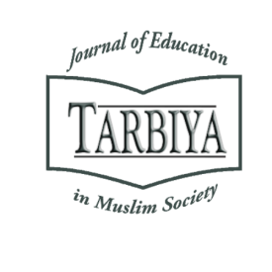
TARBIYA: Journal of Education in Muslim Society, x (x), xxxx, x-x
DOI:

Website: http://journal.uinjkt.ac.id/index.php/tarbiya

p-ISSN: xxxx-xxxx, e-ISSN: xxxx-xxxx

COMMUNITY-BASED EDUCATION: THE #LESSWASTE HABIT FORMATION BY THE YUKNGAJI CLUB AS AN ENVIRONMENTAL CONSERVATION EFFORT
Meshal Saleh A. Alanazi¹, Muhammad Asgar Muzakki², JM Muslimin³,
Syahrul Ramadhan Hidayat⁴*, Nabila Bin Yusof⁵, Ghulam Musthafa Nukhba⁶

¹²³⁴Graduate School of Syarif Hidayatullah State Islamic University Jakarta, Indonesia
⁵Universiti Sains Islam, Malaysia
⁶Kabul University, Afghanistan
E-mail: *ramadhanhidayat30@gmail.com,
No. Tlp/WA: 0823 8184 8386
Received: xxx; Revised: xxx; Accepted: xxx

Abstract
This study investigates the YukNgaji community’s #LessWaste initiative through Islamic ecotheology and modern educational strategies. Combining community-based education theory, internalization principles, virtual ethnography, and the Living Qur’an-Hadith approach, it analyzes how Islamic environmental teachings are integrated via social media, public campaigns, and real-world practices. Findings highlight that activities like waste donation (sedekah sampah), personal tumbler (tumbler minum kajian) use during study sessions, and decluttering show strong member adherence, becoming ingrained lifestyle habits. The research also reveals that the campaign extends beyond ecological goals, functioning as an adaptive post-HTI educational strategy. By leveraging contemporary issues, exponents employ #LessWaste to expand outreach and sustain influence through context-responsive methods, positioning it as both an eco-theological movement and a tool for flexible community engagement. This dual approach underscores the intersection of religious ethics, environmental action, and strategic education in modern Islamic communities.

Keywords: YukNgaji club, less waste, Islamic ecotheology, education, hybrid activism
Abstrak
Penelitian ini mengkaji inisiatif #LessWaste komunitas YukNgaji melalui lensa ekoteologi Islam dan strategi pendidikan kontemporer. Dengan menggabungkan teori pendidikan berbasis komunitas, prinsip internalisasi, etnografi virtual, dan pendekatan Living Qur’an-Hadits, studi ini menganalisis integrasi ajaran Islam tentang tanggung jawab lingkungan melalui media sosial, kampanye publik, serta praktik nyata. Temuan menunjukkan bahwa aktivitas seperti sedekah sampah, penggunaan tumbler minum kajian, dan decluttering memiliki tingkat kepatuhan anggota yang tinggi, serta telah menjadi kebiasaan gaya hidup yang mengakar. Hasil penelitian juga mengungkap bahwa kampanye ini tidak hanya bertujuan ekologis, tetapi juga berfungsi sebagai strategi pendidikan adaptif pasca-pembubaran HTI, di mana para eksponennya memanfaatkan isu-isu kontemporer. Melalui #LessWaste, mereka memperluas jangkauan edukasi dan mempertahankan pengaruh komunitas dengan metode yang kontekstual. Pendekatan ganda ini menegaskan pertemuan antara etika religius, aksi lingkungan, dan pendidikan strategis dalam komunitas Islam modern, menempatkan gerakan ini sebagai sarana perluasan keterlibatan komunitas yang fleksibel sekaligus manifestasi ekoteologi berbasis nilai-nilai keislaman

Kata Kunci: Komunitas YukNgaji, less waste, ekoteologi Islam, pendidikan, aktivisme hibrid
How to Cite : xxx
Permalink/DOI: xxx
Introduction
Following the dissolution of Hizbut Tahrir Indonesia (HTI), its affiliated club established YukNgaji community, where they advocate Islamic teachings in more substantive approach through community-based education on natural conservation.
David Wallace-Wells, in The Uninhabitable Earth, notes that ecological disasters that once occurred over decades or centuries are now happening more frequently and intensely (Wallace-Wells, 2019). Phenomena such as major floods, extreme heat waves, wildfires, and rapid glacier melt illustrate that environmental changes are unfolding at an unprecedented pace. The interval between one disaster and the next is shrinking, creating a new reality in which the impacts of the environmental crisis are more tangible and urgently need to be addressed.
Research indicates that during the COVID-19 pandemic, when human activities drastically decreased, the environment experienced significant improvement. For example, in China, lockdowns and reduced industrial activity led to a 25% drop in carbon emissions and up to a 50% reduction in nitrogen oxide emissions. Scientists estimate that this reduction in emissions saved approximately 77,000 lives in the first two months of the pandemic (Zhang et al., 2020). This phenomenon demonstrates that nature would remain evergreen without human interference, but not the other way around. Therefore, all forms of excessive exploitation of nature can only lead to two scenarios: 1) nature reacts with its defense mechanisms, potentially endangering humans, or 2) environmental degradation becomes so severe that it threatens the survival of both humanity and the ecosystem itself (Fatimah & ., 2020; Judijanto & Adiwjaya, 2024). There is no third option where humans can thrive while nature deteriorates, as human existence is intrinsically dependent on the balance and health of natural ecosystems.
The environmental crisis is not merely a scientific issue but also a moral and spiritual matter that demands deep reflection. Seyyed Hossein Nasr argues that the triumph of humanism, which absolutizes human power over the Earth, has led to massive and colossal exploitation of nature in the name of human rights (Nasr, 1990). In the tradition of Islamic thought, the relationship between humans and nature is not only understood within an ecological framework but also within a broader theological dimension. This perspective has fostered the development of eco-theological studies, which reflectively link environmental issues with the concept of servitude to God. Muslim scholars have extensively explored this idea, emphasizing that preserving the balance of ecosystems is not merely a social responsibility but also a religious obligation deeply rooted in Islamic sacred texts (Manik, 2023; Sholihin, 2025; Ubab, 2022).
The enthusiasm of Muslim scholars regarding environmental issues extends beyond theoretical discussions and reinterpretations of Qur'anic verses and Hadiths. It is also reflected in tangible actions that promote ecological awareness and concrete contributions to environmental conservation. This effort is evident in various Muslim communities that promote community-based education. It integrates Islamic values with ecological movements.
The concept is rooted in the philosophy of John Dewey, a progressive philosopher and educator who emphasized the significance of experiential learning. In his seminal work Democracy and Education, Dewey argued that education should be practical and directly relevant to real-life contexts, enabling students to comprehend their societal roles. He posited that schools should not function as isolated institutions but rather integrate into the broader community, where students engage in direct interactions and address real social problems. Dewey further asserted that education must adopt a democratic framework, empowering learners to participate in decision-making processes and cultivate critical thinking skills. Through this approach, Competency-Based Education extends beyond academic mastery to foster character development, social skills, and an awareness of individual responsibilities within communities. Dewey's ideas laid the foundation for participatory educational methodologies that prioritize community engagement in learning processes (Dewey, 2024).
Similar to Rabindranath Tagore, an Indian philosopher, poet, and educator, who developed a community-based educational concept emphasizing freedom, creativity, and the intrinsic connection between humanity and nature. In his approach, implemented at Visva-Bharati – the institution he founded in 1921 – Tagore rejected the rigid colonial education system centered on rote memorization. He Advocated for an organic, interactive educational framework rooted in the daily life of communities (Mukherjee & Koshal, 2020).
Tagore argued that schools should not operate as isolated institutions but rather serve as community hubs fostering lifelong learning through arts, cultural practices, and environmental exploration. He emphasized cultivating harmony between humans and nature, teaching students to derive knowledge from direct experiential engagement rather that relying solely on textbooks. Thus, the Community-Based Education model advanced by Tagore not only nurtured intellectual development but also instilled profound social and spiritual consciousness, aligning with progressive educational philosophies that prioritize equilibrium between individual autonomy and societal responsibility (Choudhary et al., 2024).
One examples of such a movement is the preacher community CariUstadz.id, which collaborates with Greenpeace—a global environmental organization focused on environmental protection and sustainability—to educate preachers so that the pulpit is not only a space for religious counsel but also a medium for promoting "green da'wah" (Choironi & Ferdiansyah, 2023). A similar initiative is undertaken by Laskar Hijau, a community actively involved in conserving Mount Lemongan in Lumajang, restoring the region's ecological balance through reforestation and environmental education (Thobroni et al., 2024). Meanwhile, Masjid Jogokariyan in Yogyakarta has revolutionized mosque management standards with a more sustainable concept, building synergy between the mosque, the community, and the surrounding environment (Achmad, 2024).
Among young people, eco-theological awareness is increasingly growing through study communities such as YukNgaji, which promote the #LessWaste movement as part of an Islamic lifestyle. With a relevant and social media-based approach, this community encourages the younger generation to be more mindful of the impact of excessive consumption and the importance of sustainability practices in daily life. These various movements demonstrate that Islamic values regarding environmental care are not only embedded in academic discourse but also translated into tangible practices with broad impact.
This writing focuses on the #LessWaste ecological movement initiated by the YukNgaji community, employing the John Dewey’s approach, Rabindranath Tagore’s model of public education as well as Thomas Lickona’s view on the internalisation of values in the context of community based education as its analytical theory and framework. This research adopts a descriptive-qualitative method with a phenomenological lens. Primary data is collected through observations and interviews, involving two types of informants: central administrators and community members of YukNgaji. Meanwhile, secondary data is gathered from previous research reports and various literature related to the research theme accessed through libraries and the internet. The uniqueness of YukNgaji lies in its hybrid activism model that balances digital space and real-world action. Their movement goes beyond mere clicktivism—such as raising awareness through social media campaigns—and is also realized through direct actions in mosques within the community's reach.
In addition, YukNgaji has the potential to continuously amplify "green sermons" sustainably. This is supported by their weekly study system, which is attended by a relatively stable and loyal congregation (Abzar Duraesa & Ahyar, 2021). Before the #LessWaste campaign emerged in early 2020, the community had already built a foundation of collective awareness through studies on monotheism, brotherhood, and other Islamic issues. The structured study patterns and strong bonds among community members are factors that enable ecological ideas within YukNgaji to develop consistently and sustainably.
A literature review reveals that studies on the Living Qur'an-Hadith approach in eco-theological issues have been widely conducted by previous scholars. To mention a few recent ones: Faisol Nasar and Moh. Barmawi conducted a study on living Qur'an, highlighting ecological verses that contribute to raising awareness in flood-prone areas (Madi & Barmawi, 2022). Nur Tata, Fatimah, and Umi Aflaha examined the implementation of the eco-theological paradigm at An-Nur Islamic Boarding School in Yogyakarta, with findings including the establishment of an independent waste management unit (UPT ASRI) and a ban on bringing plastic waste into the boarding school environment (Tata et al., 2024). Zainun Lutfiah conducted a similar study on a hadith narrated by Muslim, which was promoted by the Fadlun Minalloh Islamic Boarding School as part of environmental preservation efforts (Lutfiah, 2022). These studies generally focus on how Islamic values in the Qur'an and hadith are practiced in environmental movements, both individually and collectively, and how Islamic teachings encourage ecological awareness within various Muslim communities.
A case study from Millburn, New Jersey, demonstrates that community-based programs can address environmental education challenges during the COVID-19 pandemic by leveraging informal networks and local organizations to enhance environmental awareness (Iyengar & Shin, 2022). By actively engaging communities in environmental education and initiatives, this approach not only enhances ecological literacy but also strengthens social cohesion and collective responsibility toward environmental sustainability.
Moreover, community-based initiatives involving university students and local residents in community-based learning have demonstrated effectiveness in enhancing environmental awareness and fostering behavioral changes that support healthy lifestyles and harmony with nature (Oe et al., 2022). Thus, community-based education, particularly when integrating religious values, plays a pivotal role in cultivating environmental consciousness and promoting eco-friendly behaviors within Muslim communities.
As for studies specifically discussing the YukNgaji community, most focus on their da'wah model and strategy (Aula & Abas, 2020; Mutiarani et al., 2024; Suciati et al., 2019). Meanwhile, Duraesa and Ahyar propose a thesis that the community's typology is populist and identity-based. YukNgaji particularly appeals to young people who are newly acquainted with Islam (hijrah) and are searching for a stronger religious identity. Their da'wah model, which adapts to digital trends and popular culture, is a key factor in attracting and retaining their congregation (Abzar Duraesa & Ahyar, 2021).
Based on such literature review, this research identifies a gap in previous studies, particularly concerning the eco-theological campaign promoted by YukNgaji. There has been limited research specifically exploring the verses and hadiths that serve as their references in the #LessWaste campaign, as well as how interpretations of these texts are translated into real practices through community-based education. Therefore, this study seeks to explore how the YukNgaji community interprets and embodies Islamic teachings in fostering ecological awareness among its members.
Method
This study employs a qualitative approach utilizing community-based education theory and its internalisation theory of Dewey (Harfitt & Chow, 2020), Tagore and Lickona with the combination of virtual ethnography to analyze the #Less Waste campaign within the YukNgaji community. While community-based education looks critically at social participation and involvement, virtual ethnography examines social phenomena in digital environments, enable an in-depth analysis of interaction pattern, identity construction, and participatory dynamics within online communities. These methods were selected due to YukNgaji’s integration of digital activism with real-world actions to disseminate Islamic eco-theological messages, transcending mere online communication and mobilization. Through these approaches, the research investigates how Islamic eco-theological values are communicated, internalized, and practiced by community-based education via social media and offline activities.
As outlined by (Boellstorff et al., 2012), virtual etnography involves participatory observation in digital spaces, interviews with community members, and analysis of textual and multimedia content produced within online ecosystems. For this study, observation focused on YukNgaji’s official Instagram, including comment interaction, the dissemination of the #LessWaste campaign, and digital community response. Additionally, discussions within YukNgaji’s online groups–primary platform for organizing offline activities and reinforcing campaign values–were analyzed.
The methodology also incorporates the concept of hybrid activism, which bridges online and offline social mobilization (Ng & Carley, 2022). YukNgaji’s #LessWaste campaign exemplifies how social media serves not only as a messaging platform but also as a tool for organizing tangible initiatives, such as waste charity programs, environmental-themed studies, and mosque-based waste reduction efforts. By leveraging interactive social media features, the community has cultivated sustained active participation and fostered strong emotional among members.
Futhermore, virtual ethnography facilitates an understanding of how Islamic environmental teachings are contextualized digitally and how the concept of khalifah fil ardh (stewardship of the earth) underpins this eco-theological campaign. By analyzing YukNgaji’s communication patterns and social media content, the study identifies da’wah strategies employed to instill environmental consciousness among young Muslim. Narrative analysis of campaign materials, such as the Guardians of the Earth comic series and digital porters, highlights how Islamic eco-theological representations are constructed in accessible and engaging formats for target audiences.
Aligned with virtual ethnography principles, this research emphasizes active engagement within the digital community to gain a comprehensive understanding of YukNgaji members’ experiences and perceptions of the #LessWaste campaign. Beyond observation and media analysis. This approach offers broader insights into how modern Muslim communities adopt and implement eco-theological principles in the digital age.
Results and Discussion
- Islamic Ecotheology Discourse
Ecology is generally defined as the science that studies the reciprocal relationship between living beings and their environment. Over time, ecological approaches have often been structural and tend to be anthropocentric, positioning humans as the center and primary purpose of nature's existence. This perspective leads to the assumption that nature is merely created to serve human needs, ultimately paving the way for environmental exploitation and destruction without considering ecological balance. In response to this paradigm, the discourse of ecotheology emerged, aiming to view nature more fairly—not only as an object for human use but also as an entity with rights to be protected and preserved. Ecotheology emphasizes that humans have a moral and spiritual responsibility to care for nature as part of their devotion to God (Sholihin, 2025).
According to Fazlur Rahman, the awareness that nature is God's creation given to humans not merely as a resource but also as a place to live, a means of worship, and a field of good deeds in preparation for the afterlife, is part of piety (Firas et al., 2024). In the perspective of Islamic ecotheology, preserving nature is not only an ecological responsibility but also a form of spiritual obedience. Humans are expected not only to utilize nature but also to care for it as a trust from God, in line with the principle of khalifah fil ardh (stewardship of the earth) inherent in humanity.
The narrative of ecotheology in Islam generally refers to verses that emphasize human responsibility towards nature. The verse about humans as khalifah on earth (QS. Al-Baqarah: 30) is often cited to affirm the role of humans as responsible managers of the ecosystem. Additionally, the prohibition against damaging nature (QS. Al-A’raf: 56) and the warning that corruption on land and sea is due to human actions (QS. Ar-Rum: 41) provide strong theological foundations for building ecological awareness. The Qur'an also emphasizes the principle of balance by commanding not to be excessive in utilizing natural resources (QS. Al-An’am: 141). This verse lays the foundation for the concept of sustainability and wise resource management to avoid disrupting the balance that Allah has established in the universe (Andi Eki Dwi Wahyuni et al., 2024; Said et al., 2023).
Among the collections of hadiths often used as references in eco-theological campaigns are those emphasizing cleanliness, sustainability, and environmental care. One frequently quoted hadith is “Purity is part of faith”, a narration from Muslim that emphasizes cleanliness—both physical and environmental—as a fundamental aspect of Islamic teachings (Annaisaburi, 2006). Additionally, Prophet Muhammad (peace be upon him) reminded not to waste water, even when performing ablution by a flowing river, reflecting the principle of resource conservation (Majah, 2020). Another relevant hadith encourages planting trees as part of sadaqah jariyah (ongoing charity). The Prophet (pbuh) said: "Whenever a Muslim plants a tree or sows seeds, and a human, animal, or bird eats from it, it is regarded as a charity for him" (Khalik & Ansari, 2021). This hadith not only highlights the ecological benefits of greening but also links it to sustainable spiritual values. Conversely, Islam also prohibits destructive actions towards nature, such as the hadith forbidding the arbitrary cutting of trees, particularly in the context of war (Hanbal, 2001). These hadiths serve as the foundation for various eco-theological campaigns that advocate for a balance between the utilization and preservation of the environment from an Islamic perspective (Kholis & Aulassyahied, 2022).
In providing an eco-theological reinterpretation of these texts, Muslim scholars do not adhere to a uniform approach. Some apply the ma‘ānī al-ḥadīṡ approach, focusing on the meaning of hadiths within their historical and linguistic contexts (Akmaluddin, 2017). Others adopt fiqh al-maqāṣid, examining the texts through the lens of the objectives of Islamic law (maqāṣid syarī‘ah), positioning environmental issues within Islam’s primary mission to preserve the public good (maslahah) (Rahman & Mutakin, 2023). There are also those who employ Fazlur Rahman's double-movement approach, tracing the historical context of hadiths and then expanding them into universal principles applicable in modern contexts (Firas et al., 2024). Meanwhile, the interconnective approach typical of UIN Sunan Kalijaga attempts to bridge theological, sociological, and scientific perspectives in understanding religious texts related to ecology (Kholis & Aulassyahied, 2022).
Despite the diverse methods used, all of these approaches share a common goal: to cultivate environmental awareness within the framework of Islamic spirituality. When traced systematically, this awareness begins with tawḥīd (monotheism), the belief that both humans and nature are creations of God that submit to His laws. From this tawḥīd-based consciousness emerges an understanding of the khilāfah (stewardship) duty, wherein humans are entrusted as caretakers and guardians of the earth. This stewardship necessitates the principles of amānah (trustworthiness) and ‘adālah (justice), requiring humans not to exploit natural resources arbitrarily (Interview with Muhammad Islamil, November 17, 2024). Ultimately, all of this leads to the principle of mīzān (balance), which is the awareness that every human action towards the environment will be held accountable, even the most trivial forms of exploitation.
Thus, Islamic eco-theology not only offers a moral perspective on environmental issues but also provides a strong theological foundation for tangible actions in maintaining ecological balance. These principles become particularly relevant when applied within community-based social movements, integrating environmental awareness into everyday religious practices. One such community embodying this spirit is YukNgaji, a da'wah movement that combines online collectivism and offline activism to cultivate an Islamic lifestyle among urban youth (Interview with Irfan Arham, 15 December, 2024). To understand how eco-theological campaigns are implemented within this community, it is essential first to explore their background, vision, and da'wah strategies.
- YukNgaji Community: Community-based education in the era of digitalization
According to Andre Moewashi's 2023 research, the YukNgaji community is considered a strategic initiative by exponents of Hizbut Tahrir Indonesia (HTI) following the organization's official dissolution by the Indonesian government through Government Regulation in Lieu of Law (Perppu) No. 2 of 2017. This thesis remains debatable, as in interviews with Nindie Hanjarsari (central board of YukNgaji) and Annisa Mujadilah (member), it was explained that the community had been established before HTI was officially disbanded, specifically in 2015. Founded by popular HTI figures Felix Siauw and Hussain Assadi, the community harnessed the hijrah trend among urban youth as a vehicle for dakwah. Its focus is to promote an Islamic lifestyle appealingly through social media and offline events, without explicitly mentioning the caliphate agenda. This approach successfully attracted many young people who resonated with the message of personal and spiritual transformation it offered (Haq, 2023).
The roots of the YukNgaji community cannot be separated from HTI, both in methodology and ideology. Although this community conceals its HTI identity explicitly, the clandestine dakwah strategy it adopts, such as halaqah (study circles) and individual mentoring, is a hallmark of the HTI movement. YukNgaji also continues HTI’s strategic goal by recruiting new members through a softer approach, emphasizing the strengthening of Islamic personality that gradually directs participants to support the idea of a caliphate. This underlines that YukNgaji is a form of HTI's adaptation to navigate government restrictions while maintaining its ideological aspirations (Aswar, 2022).
In addition to its halaqah-based informal education strategy and individual mentoring, YukNgaji's approach is also heavily influenced by the nuances of popular Islam or Islamic popular culture. They blend Islamic values with popular culture, making them more accessible and relevant to urban youth (community-based education). Instead of using traditional public education methods that seem formal and exclusive, this community builds a more relaxed, inclusive, and youth-friendly public image, closely connected to everyday life.
One of the standout aspects of YukNgaji's community is its clicktivism, a form of digital activism that relies on visual appeal and social media engagement. Their digital posters for study session schedules are designed with vibrant, pop-out graphics and eye-catching titles, creating the impression that attending a study session is not just a religious activity but also part of a trending lifestyle (Interview with Nur Aini, January 21, 2025). The study sessions no longer feel like rigid religious forums but resemble exciting community events worth attending. Beyond visuals, their digital community-based education strategy is highly adaptive to trends. Their video content goes beyond the traditional format of a preacher delivering a monologue in front of the camera. Instead, they connect current issues with movies, music, memes, or viral events that are trending. Through this approach, they successfully "ride the wave," ensuring their content remains fresh and evergreen, consistently relevant to the latest viral phenomena (Abzar Duraesa & Ahyar, 2021).
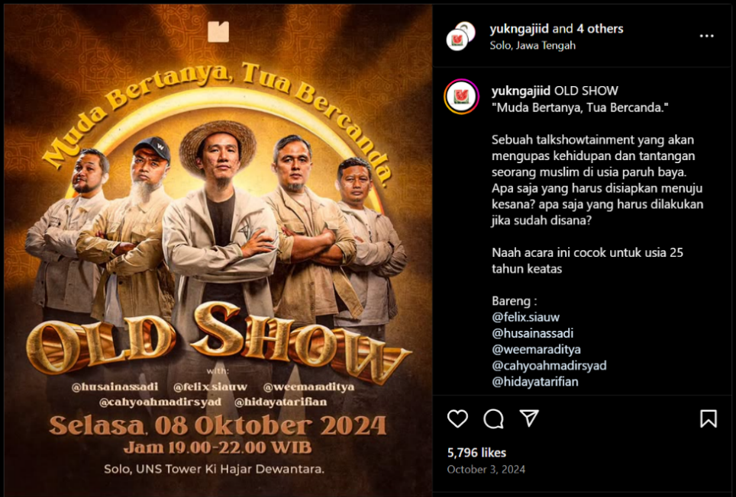

Figure 1.0. Digital poster by YukNgaji promoting a religious study session
(Source: Instagram @yukngajiid, 2024)
With such high-quality content production that appeals to young audiences, it's no wonder that the clicktivism they foster has grown rapidly. Their number of followers on social media who actively engage through likes, subscriptions, and shares is massive compared to other da'wah movements targeting youth. Thanks to this creative clicktivism strategy, various hashtags they promote—one of which is the ecological issue with #lesswaste—easily penetrate social media traffic and often even make it to the trending topics. Their content is designed to have high shareability, leveraging digital platform algorithms to reach a broader audience (Interview with Annisa Mujadilah, February 9, 2025). This demonstrates that their popular Islam strategy not only captures attention but also drives high engagement in the digital realm. As of this writing, YukNgaji's Instagram followers have reached 840,000, with YouTube subscribers at 565,000.
After successfully capturing attention and building a strong digital base, the YukNgaji community does not stop at mere clicktivism. Their activism also extends to the offline realm through various initiatives that bring online ideas into real-world actions. Some of their offline activism includes fundraising for disaster victims as a form of social responsibility, participating in protests against the Israel-Palestine humanitarian conflict, and organizing hijrah classes and mentoring programs for young people who want to deepen their understanding of Islam more intensively (Interview with Amir Salim, December 19, 2024).
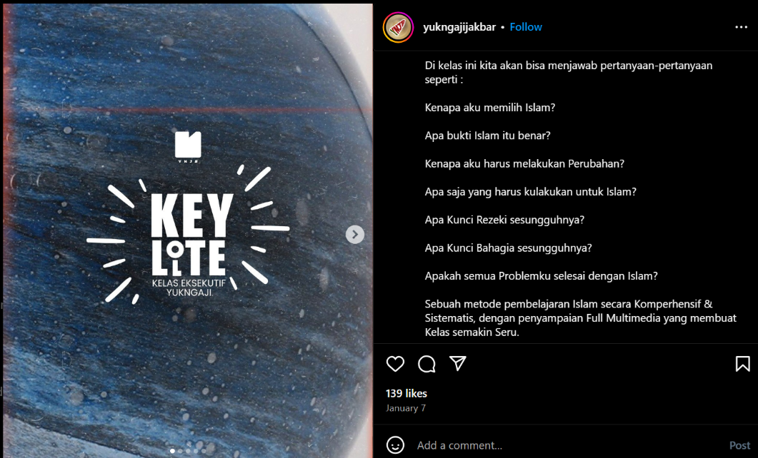

Figure 1.1. YukNgaji Offline Mentoring Program (Source: Instagram @yukngajijakbar, 2024)
Moreover, one of the significant campaigns highlighted in this journal is the green movement #lesswaste, which promotes environmental awareness within the framework of Islamic values. Mass mobilization in these initiatives is notably effective because the YukNgaji community has branches in various regions, each managed by local youth (Rohman et al., 2023; Salagi, 2023; Sopian, 2020). With this decentralized model, each area can adapt strategies and activities according to its local character, allowing the movement not only to achieve broad reach but also to become more grounded and easily accepted by surrounding communities.
With its combination of digital strategy and real-world action, the YukNgaji community can be categorized as a form of hybrid activism—a movement that is not only active on social media through clicktivism but also demonstrates strong mobilization power in the real world. They leverage digital algorithms to build a solid online community while simultaneously driving concrete social, educational, and environmental actions. This model enables their da'wah to go beyond mere virtual virality, creating tangible impacts in society and establishing YukNgaji as an example of contemporary da'wah that is both adaptive and relevant.
- The #LessWaste Campaign by the YukNgaji Community-based education.
Based on an interview with one of YukNgaji's administrators, the slogan "Less Waste, More Life," which means "fewer waste, more life," was popularized by the community from late 2019 to early 2020. This campaign stemmed from YukNgaji’s desire to demonstrate that Islamic movements are not solely focused on religious aspects but also have tangible social impacts. The informant added that, at the time, environmental issues were gaining significant attention among activists, with many figures and environmental movements starting to rise (Interview with Irfan Arham, 15 December, 2024). YukNgaji leveraged this momentum according to their "riding the wave" strategy, consistently aligning their messages with current issues to ensure broader acceptance of their da'wah (Islamic outreach).
The movement draws from Islamic teachings that promote balance and responsibility towards the earth as a trust from God. Through various studies and community activities, YukNgaji encouraged its members to reduce single-use plastics, utilize recycled items, and adopt a more eco-friendly lifestyle (Interview with Amir Salim, February 25, 2025) . The slogan was eventually shortened to the hashtag #LessWaste, which became the movement’s main identity across digital platforms and offline activities. This hashtag was also immortalized in YukNgaji’s official merchandise as a means to strengthen branding and expand the reach of their campaign.


Figure 1.3. Drinking tumbler with the YukNgaji logo and the LessWaste slogan
(Source: Instagram @yukngajiid, 2020)
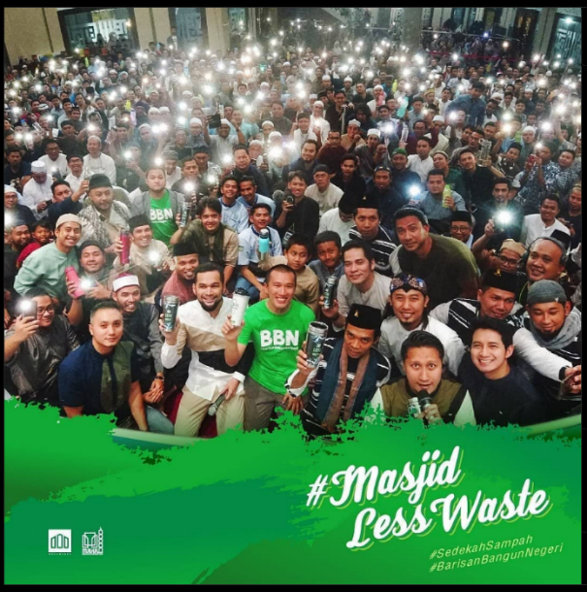
In promoting the #LessWaste movement, YukNgaji maintained its pop-out and relatable preaching style for young audiences. The campaign was presented in various content formats, such as digital posters, short videos, webinars, and offline activities that were massively promoted through social media. The uniqueness of this strategy was further strengthened by collaborations with popular preachers like Hanan Attaki, Oemar Mita, Abdul Somad, and Felix Siauw. The presence of these four figures not only expanded the campaign's reach but also reinforced its message, considering each has a dedicated and loyal follower base (Interview with Amir Salim, February 25, 2025). They became symbols of the #LessWaste movement, which then evolved into the broader #BarisanBangunNegeri campaign, indicating that the environmental spirit promoted by the initiative extended beyond ecological issues to social activities, such as social donations, distribution of basic necessities, and fundraising and charity for marginalized Muslim communities.

Figure 1.4. The #LessWaste Campaign Supported by Public Figures Outside the YukNgaji Community (Source: Instagram @yukngajiid, 2020)
The effectiveness of this campaign is evident from its tangible impact on the ground. Collaboration with several mosques led to the "Less Waste Mosque" initiative, where participating mosques function as waste banks. Through this concept, the surrounding community can donate recyclable household waste, such as plastic bottles and cardboard. Instead of passively waiting for mosques to show interest, the YukNgaji community also actively offers to conduct cleaning activities at the mosques, fostering closer interaction with the local community.
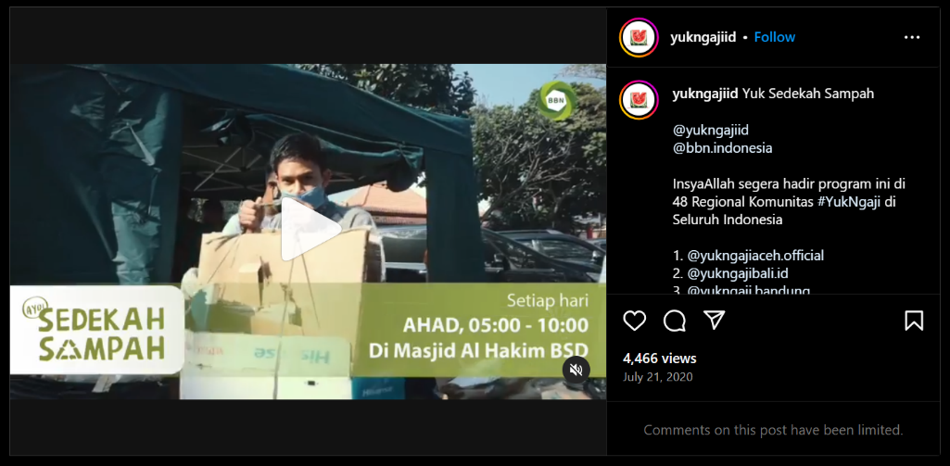

Figure 1.5. Video content explaining the technical process of donating waste at mosques collaborating with YukNgaji (Source: Instagram @yukngajiid, 2020)

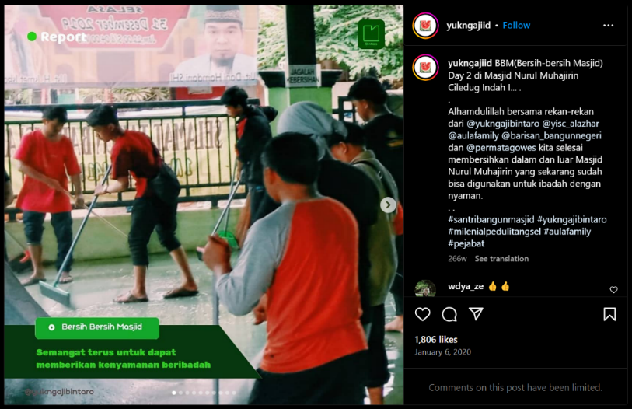

Figure 1.6. YukNgaji Bintaro community during a mosque cleaning activity
In addition to on-the-ground actions, documenting activities with proper equipment serves as a distinct strategy to capture the attention of digital audiences. High-quality photos and videos shared on social media effectively boost engagement, transforming the campaign from merely a social movement into a phenomenon that gains wide attention on digital platforms. Consequently, this strategy is effective in reaching audiences, promoting behavioral change among urban Muslims, and establishing YukNgaji's image as a community that concretely integrates Islamic values with environmental awareness.
- Scriptural Principles Supporting the #LessWaste Campaign by YukNgaji
To summarize this point, the researcher used two primary sources as references. First, interviews with three informants, namely two central administrators of YukNgaji who understand the ins and outs of the #LessWaste campaign and a YukNgaji member from West Jakarta who participated in various community activities. Second, observations of various posts on the official @yukngajiid page, which serves as the main portal for highlighting campaign activities in various regional branches. Additionally, the researcher also found an educational comic titled Guardians of the Earth (Pelindung Bumi) volumes 1 and 2, published in 2021 by Al-Fatih Press, YukNgaji's internal publisher. According to the official statement on Al-Fatih Press's page, this comic tells the spirit of #LessWaste in the effort to save the earth, written by Felix Siauw and illustrated by YukNgaji's internal artist team with the Instagram account @myodauz. After accessing both volumes, the researcher found that the narrative in this comic aligns with the eco-theological theme promoted by YukNgaji, complete with quotes from verses and hadiths that support their environmental campaign messages.
What is interesting to note is the absence of direct quotes from verses or hadiths in the content of Instagram @yukngajiid. Most of the video and photo uploads focus more on the content hook that highlights the essence of activities, social impact, and activity documentation, without explicitly including religious texts. Likewise, in the captions, the researcher found that the narratives used tend to be factual, describing real actions without directly including religious references. It is possible that these narratives are interpretations or understandings of certain verses and hadiths but are packaged in a more practical and easily understood form. Additionally, some captions only contain invitations or mentions from YukNgaji's central management to regional branches to participate in the same program, showing a more dynamic communication pattern compared to a normative or textual approach.
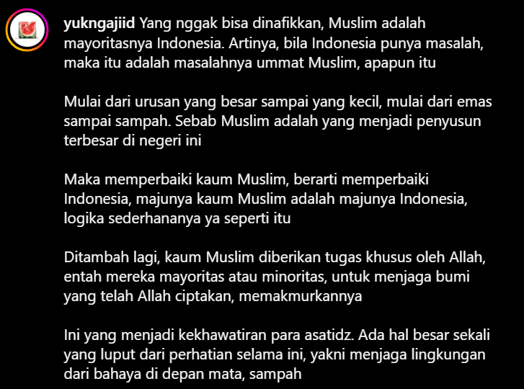

Figure 1.7. One of the content captions on Instagram @yukngajiid
(Source: Instagram @yukngajiid, 2020)
This narrative demonstrates that although there are no explicit quotations of Quranic verses or hadiths, Islamic values remain the primary foundation of the conveyed message. The main focus of this post is to build a collective awareness among Muslims about their role in protecting the environment, in line with the concept of Islam as a religion of rahmatan lil ‘alamin (mercy to all worlds). Indirectly, this content can be associated with Islamic teachings on human responsibility as khalifah (steward) on earth (QS. Al-Baqarah: 30) and the command to avoid corruption on earth (QS. Al-A’raf: 56). Thus, YukNgaji's approach to delivering Islamic moral messages prioritizes social narratives and participatory calls to action, which can be categorized as a form of Living Qur'an in an ecological context.
The researcher then confirmed the interpretation of these verses with three informants from the YukNgaji community, consisting of two administrators and one member. All three agreed that the concept of humans as stewards on earth is indeed one of the fundamental principles in the #LessWaste campaign they run. One of the administrators, emphasized that the human role as a khalifah not only means managing the earth but also includes the dimension of servitude to God and service to the environment as fellow creations of God (interview with Nindie Hanjarsari, January 12, 2025). This perspective shows that YukNgaji’s environmental movement is not only pragmatic but also has a strong theological foundation in Islamic teachings.
The researcher concludes that the absence of direct quotations of sacred texts in YukNgaji's social media content is due to two main factors related to communication strategy and audience characteristics. First, YukNgaji prioritizes practicality in presenting messages through concise and easily understood content. This approach is based on considerations of communication effectiveness on social media, where studies show that user attention spans are becoming shorter. Therefore, a direct and practical delivery is considered more effective in capturing the audience's attention and ensuring the message is well received.
In addition, this strategy also aims to reach a broader segment, especially young people who do not yet have a strong attachment to Islamic studies. One of the informants in this study, explained that the approach without explicit Quranic verses and hadith quotations is actually an attraction for YukNgaji's target audience (Interview with Annisa Mujadilah, February 9, 2025). She stated, "What makes YukNgaji's posts interesting is precisely because there are no verses or hadiths. The target audience is people or young individuals who are not yet engaged in Islamic studies. If there were religious references from the start, it would feel too segmented. Later, when they attend the events, that's when the verses and hadiths are presented by the ustadz or speakers."
Thus, the absence of sacred text quotations does not imply a disregard for religious evidence but is rather part of a more inclusive and gradual communication strategy in delivering the message of community-based education.
Secondly, the verse about humanity's role as stewards (khalifah) on earth is already a familiar concept to YukNgaji's target audience, particularly those who have previously participated in halaqah or Islamic study circles. This familiarity is linked to YukNgaji's methodological roots, which have a historical connection to the dakwah (preaching) of Hizbut Tahrir Indonesia (HTI). In HTI's preaching tradition, the concept of khilafah (caliphate) is understood as a transnational Muslim leadership and forms a foundational teaching in their halaqah sessions (Hayati, 2017). This perspective aligns with the thought of Taqiyuddin an-Nabhani, the founder of Hizb at-Tahrir globally, who emphasized the urgency of establishing a khilafah as the ideal Islamic governance system (Juhari & Malikah, 2021; Setia, 2021).
Therefore, YukNgaji’s decision not to always quote sacred texts directly in the #LessWaste campaign reflects a communication strategy that considers both message effectiveness and the audience’s background understanding. Rather than focusing on explicit religious evidence, they adopt a more practical and applicable approach to encourage active participation in the environmental conservation movement. However, this does not negate the emphasis and direct citation of green campaign religious texts in more clandestine settings, such as halaqah. In these more closed and exclusive study sessions, eco-theological concepts are often elaborated with direct references to Quranic verses and hadith that affirm human responsibility as stewards of the earth.
This is reflected in the responses of the informants, who affirmed that theological understanding of environmental conservation is an integral part of halaqah discussions. They revealed that in these forums, Quranic and hadith evidence is not only presented textually but also contextualized into everyday life, especially in practicing a low-waste lifestyle (#LessWaste). Thus, while YukNgaji’s social media strategy focuses on practical and applicative approaches, within the scope of halaqah, sacred text-based arguments remain a fundamental basis for fostering faith-based environmental awareness.
In addition to halaqah, eco-theological narratives are also present in other media produced by YukNgaji, such as the comic Guardians of the Earth. According to information obtained from Annisa Mujadilah, this comic is one of the educational tools promoting the #LessWaste spirit. Unlike Instagram posts or YouTube videos that are freely accessible, this comic is not a standard issue handbook within the YukNgaji community. However, this does not diminish its relevance to the environmental conservation values being promoted.
Guardians of the Earth depicts the journey of Felix Siauw and his family on a road trip. Throughout the journey, they encounter various phenomena that serve as starting points for discussing Islamic values (Siauw & Myodauz, 2021). The comic not only highlights eco-theological aspects, such as the importance of proper waste disposal, reducing plastic use, and water conservation, but also covers other aspects of Islamic life, such as worship practices, halal food laws, and issues surrounding Baitul Maqdis. The delivery of these values tends to follow a hierarchical structure, where Felix Siauw, as the father, plays an authoritative role in advising his children. Through this narrative approach, Guardians of the Earth serves as a medium that internalizes Islamic teachings gradually and contextually, including in terms of environmental awareness.
The eco-theological message in this comic is also reinforced by direct references to sacred texts. One of the verses quoted is QS. Al-An'am [6]:165:
"And it is He who has made you successors upon the earth and has raised some of you above others in degrees [of rank], to test you through what He has given you..."
This explicit use of religious texts underscores the theological foundation of YukNgaji’s environmental campaign, offering a more direct approach compared to their social media content, where the delivery is often more subtle and adapted to the general public.
Additionally, the comic also cites QS. Ar-Rum [30]:41:
"Corruption has appeared throughout the land and sea by [reason of] what the hands of people have earned so He may let them taste part of [the consequence of] what they have done that perhaps they will return [to righteousness]."
This verse is often associated with the impact of excessive exploitation of nature, leading to environmental crises such as pollution and climate change. By including this verse, Guardians of the Earth aims to instill an understanding that environmental damage is not merely a natural phenomenon but also a consequence of irresponsible human actions.
In addition to Qur’anic verses, the comic also features a hadith of the Prophet Muhammad that emphasizes the importance of human contribution to environmental preservation: "If a Muslim plants a tree or sows seeds, and a bird, person, or animal eats from it, it is regarded as a charitable gift (sadaqah) for him."
This hadith provides a moral incentive for Muslims to engage in reforestation and nature conservation. By planting a tree, one not only helps maintain environmental balance but also earns ongoing rewards (pahala jariyah).
- Living Qur'an-Hadith: Actualization of Eco-Theological Values by the YukNgaji Community
Based on interviews with informants, there are three main practices in the #LessWaste campaign by the YukNgaji community that have high retention and are still ongoing among regular attendees of the study sessions. These practices not only become habits but also reflect the actualization of Islamic teachings in everyday life regarding environmental awareness.
- Trash Charity (Sedekah Sampah)
The trash charity program is one of the long-standing initiatives still running at Al-Hakim Mosque in BSD, which previously collaborated with YukNgaji in 2020 to transform the mosque into a more eco-friendly place of worship. Currently, the program is independently managed by the Mosque Prosperity Council (DKM) with a flexible trash collection schedule to accommodate the local community (Interview with Nindie Hanjasari, January 12, 2025). This practice not only educates congregants on waste sorting and reduction but also internalizes the concept of charity in a broader sense—not merely through material or financial contributions but also by contributing to environmental cleanliness and sustainability.
- Study Session Water Tumbler
During a visit to the YukNgaji Headquarters in Bogor, the researcher observed that every attendee brought their own water tumbler to the study sessions. At the venue, a water dispenser was provided, allowing participants to refill their drinks without needing single-use plastic bottles. This culture of bringing a tumbler has persisted due to several factors, including easy access to drinking water and the availability of official YukNgaji merchandise in the form of community-branded tumblers. By owning a YukNgaji-branded tumbler, attendees not only feel more connected to the community but also incorporate this habit into their personal identity.


Figure 1.8. Refilling water bottles at a YukNgaji study session with personal tumblers (Source: Instagram @yukngajiid, 2020)

- Decluttering: Organizing and Letting Go of Unnecessary Items
One of the community members introduced the concept of decluttering within the context of the #LessWaste movement at YukNgaji. This concept involves organizing and removing items that are no longer needed at home, either by selling pre-loved goods that are still in good condition or by donating them to those in need (Interview with Muhammad Islamil, November 17, 2024). Annisa Mujadilah added that this practice is rooted in the Islamic principle of hisab (accountability), which emphasizes that the more possessions a person has, the longer and more burdensome their reckoning will be in the afterlife. Thus, decluttering is not merely seen as an act of minimalism or material management but also as a form of spiritual reflection on one's responsibility towards their belongings.
These three practices demonstrate that YukNgaji’s #LessWaste initiative is not merely a temporary trend but has become an integral part of the daily lives of its congregation as an expression of an Islamic lifestyle. By blending eco-theological values with tangible practices, this community shows that Islamic teachings on balance and responsibility towards nature can be implemented in simple yet sustainable ways.
- Beyond Green Campaign: Long-Term Strategy in the YukNgaji Movement
Although the #LessWaste campaign initiated by the YukNgaji community appears to be an independent eco-theological movement focused on environmental issues, there are indications that this initiative is part of a larger long-term strategy. This strategy seems to be aimed at maintaining and expanding the influence of Hizbut Tahrir Indonesia (HTI) ideology through non-conventional approaches. Instead of directly promoting the caliphate narrative, the community utilizes popular themes among young people, such as environmental issues, to build an inclusive image that aligns with current trends.
The decision to highlight environmental campaigns as part of YukNgaji’s programs is not merely a response to the rising ecological discourse but also reflects the movement’s adaptation to the socio-political landscape following HTI’s disbandment. Given the increasingly limited formal preaching space for HTI, the #LessWaste movement serves as a safe and effective medium to maintain public presence without appearing overly HTI-centric. Thus, this campaign is not just an invitation to adopt an eco-friendly lifestyle but also part of a broader masterplan to sustain the existence and influence of the caliphate ideology in a more flexible and publicly accepted format.
At this point, it is crucial to examine whether the fragmentation of the caliphate spirit within the YukNgaji community remains persistent or is still ongoing. The seemingly neutral and socially-based campaign could be a way to implicitly convey the message that “we are not always talking about the caliphate.” However, behind the environmental narrative, there remains a thread connecting the community’s activities with the idea that the fundamental solution to various issues—including environmental concerns—is the establishment of ideal Islamic leadership. This principle aligns with HTI’s doctrine that systemic change can only occur if leadership changes on a larger scale, specifically through the caliphate.
Moreover, YukNgaji’s preference for always being viral and aligning with social media trends indicates a strategic communication pattern. It is not merely about gaining popularity but also about ensuring their da'wah (preaching) message reaches a broader audience. This is where the riding the wave approach plays a crucial role. By adopting popular issues, YukNgaji not only aims to attract young audiences but also subtly guides them toward a bigger vision of Islamic leadership. As highlighted by some informants, the #LessWaste activities are not just about ecology but also about who delivers the message and how it is positioned within a larger, more strategic narrative.
Conclusion
This study shows that the #LessWaste eco-theological campaign by the YukNgaji community is not merely an environmental movement but also part of a broader and more strategic agenda. Through a hybrid activism approach, YukNgaji successfully combines clicktivism on social media with real-world actions, making this community-based education movement not only viral but also sustainable in daily practices. Several initiatives with high retention among the community members, such as trash charity (sedekah sampah), bringing personal tumblers to study sessions (tumbler minum kajian), and decluttering, demonstrate that the eco-theological values they promote have been well internalized within the community.
However, this study also indicates that YukNgaji's eco-theological campaign did not purely emerge from environmental awareness but is part of a larger master plan to maintain the community's existence and ideological influence. Consistent with Andre Moewashi's (2023) thesis, following the disbandment of HTI by the government, its exponents have adopted a more adaptive and non-conventional approach to promoting the caliphate narrative. By leveraging viral and popular issues, such as the environmental movement, YukNgaji appears to build a more progressive and relevant Islamic image for the younger generation.
The comic Guardians of the Earth is a concrete example of how this community-based education is not merely a neutral ecological movement but also carries a particular ideological narrative. Although focusing on ecological values, the comic subtly introduces messages about the glory of Islam during the Ottoman era and calls for the liberation of Baitul Maqdis. This indicates that behind the #LessWaste campaign lies a broader narrative of Islam as a comprehensive (kaffah) system, encompassing political and civilizational aspects.
While this ideological bias is evident in YukNgaji's campaign, it should not necessarily be viewed negatively. Every social and religious movement naturally carries a vision and mission aligned with the community’s foundational beliefs. In YukNgaji's case, the influence of HTI’s background is still apparent in their community-based education narrative, but through a more careful and flexible communication strategy. This adaptation demonstrates the community's ability to respond to the current socio-political context while maintaining its ideological vision in a more subtle and concealed format. However, as far as it remains open to public at large and it maintains as a forum of dialogue, interactive and inclusive community-based learning, it will have larger support. When it tends to be more ideological, for sure it will perish. It is just like the cases of many Islamic communities in Indonesia.
Therefore, YukNgaji’s #LessWaste community-based education is not merely an expression of Islamic-based ecological awareness but also serves as a space to sustain a broader Islamic discourse—including the caliphate vision—in a more adaptive and socially integrated manner with contemporary issues. It may be potentially and gradually tends to be more inclusive, adaptive and accommodative to ‘civil Islam’.
References
Abzar Duraesa, M., & Ahyar, M. (2021). Islamic Popul[Ar]Ism: Religious Popularism and Activism in the Yukngaji Community. Qudus International Journal of Islamic Studies, 9(2), 503–534. https://doi.org/10.21043/qijis.v9i2.7795
Achmad, A. F. U. (2024). Optimalisasi Manajemen Masjid dalam Meningkatkatan Sinergitas Lingkungan dan Masyarakat [UIN Sunan Gunung Djati Bandung]. https://digilib.uinsgd.ac.id/id/eprint/90615
Aini, N. Member of YukNgaji Club, January 21, 2025.
Akmaluddin, M. (2017). Pesan Profetik Lingkungan dalam Hadis. Jurnal Penelitian, 14(2), 149–170. https://doi.org/10.28918/jupe.v14i2.970
an naisaburi, Q. (2006). Muslim bin al-Ḥajjāj, Ṣaḥīḥ Muslim (Hadits no.). Dar Thayyiba.
Andi Eki Dwi Wahyuni, Mardan, & Muhammad Yusuf. (2024). Kesadaran Ekologis; Pelestarian Lingkungan Dalam Al-Qur’an. Al-Mutsla: Jurnal Ilmu-Ilmu Keislaman Dan Kemasyarakatan, 6(1), 125–139. https://doi.org/10.46870/jstain.v6i1.963
Arham, I., Member of YukNgaji Club, Personal Interview, December 15, 2024.
Aswar, H. (2022). Hizb Ut-Tahrir ’ s Adaptation Strategies against the State Repression in Indonesia : A Social Movement Perspective. SUVANNABHUMI, 14(2), 233–249. https://doi.org/10.22801/svn.2022.14.2.233
Aula, L. G., & Abas, Z. (2020). Da’wah Method by Preachers in the “Yuk Ngaji” Community Solo. Academic Journal of Da’wa and Communication, 1(2), 463–478. https://doi.org/10.22515/ajdc.v1i2.2729
Boellstorff, T., Nardi, B., Pearce, C., & Taylor, T. L. (2012). Ethnography and Virtual Worlds: A Handbook of Method. Princeton University Press.
Choironi, M. A. N., & Ferdiansyah, H. (2023). Khotbah Hijau. Islami Digital Indonesia.
Choudhary, R. K. S., Gopalakhrisnan, G., Khushalani, B., Ghadge, A. K., & Mani, M. (2024). UNIVERSITIES HANDBOOK – 35 th EDITION ( 2024 ) (Vol. 62, Issue 26). Association of Indian Universities.
Dewey, J. (2024). Democracy and Education (N. Tampio (ed.)). Columbia University Press.
Fatimah, A. S., & . S. (2020). Dampak Eksploitasi Minyak Dan Gas Bumi Pada Degradasi Biota Perairan Dan Penurunan Kualitas Air Permukaan. Jurnal Offshore: Oil, Production Facilities and Renewable Energy, 4(1), 17–27. https://doi.org/10.30588/jo.v4i1.732
Firas, M. F., Andriansyah, W. A., & Saifullah. (2024). Deep Ecology : Telaah Atas Pandangan Ekologi Fazlur Rahman dengan lingkungan sekitarnya . 1 Menurut ajaran Islam , Allah SWT telah menciptakan segala Pemahaman tentang keterjalinan hubungan antara manusia dengan lingkungannya melalui pendekatan struktural. Journal of Humanities Issue, 2(2), 105–115.
Hanbal, A. bin. (2001). Musnad Ahmad Bin Hanbal (No. Hadis). Ar-Risalah.
Hanjasari, N. Manager of YukNgaji Club, Personal Interview, January 12, 2025.
Haq, A. M. I. (2023). Hizbut Tahrir Indonesia’s (HTI) Efforts The Idea Of Caliphate and Recruit Members after Being Banned by the Government. Islam Transformatif : Journal of Islamic Studies, 2(2), 97–111.
Harfitt, G., & Chow, J. M. L. (2020). Employing Community-Based Experiential Learning in Teacher Education. Springer. https://doi.org/2366-7672
Hayati, N. (2017). Konsep Khilafah Islamiyyah Hizbut Tahrir Indonesia. Epismete, 12(1), 170–202.
Islamil, M., Member of YukNgaji Club, Personal Interview, November 17, 2024.
Iyengar, R., & Shin, H. (2022). Community-Based Programs to Tackle Environmental Education and COVID-19: A Case Study from Millburn, New Jersey. Prospects, 51(4), 643–653. https://doi.org/10.1007/s11125-020-09467-0
Judijanto, L., & Adiwjaya, S. (2024). Dampak Eksplorasi Sumber Daya Alam Terhadap Keberlanjutan Ekosistem Hutan Tropis di Kalimantan. Jurnal Geosains West Science, 2(3), 103–111. https://doi.org/10.58812/jgws.v2i03.1676
Juhari, I. B., & Malikah, R. (2021). Kontroversi Penafsiran Sistem Politik Khilafah HTI. Al-Manar Jurnal Kajian Alquran Dan Hadis, 7(1), 41–52. 10.35719/amn.v7i1.4
Khalik, S., & Ansari, M. (2021). Silsilah al-Żahāb dalam Ṣaḥīḥ al-Bukhārī. Ihyaussunna, 1(2), 91–103.
Kholis, N., & Aulassyahied, Q. (2022). Understanding Ecological Hadiths With Interconnective Approaches in Responding to Ecological Problems. IJISH (International Journal of Islamic Studies and Humanities), 5(1), 25–41. https://doi.org/10.26555/ijish.v5i1.5853
Lutfiah, Z. (2022). Budaya Peduli Lingkungan di Pondok (Studi Living Hadis di Pondok Pesantren Fadlun Minalloh, Wonokromo). UIN Sunan Kalijaga Yogyakarta.
Madi, F. N. bin, & Barmawi, M. (2022). Ayat-Ayat Spiritual Ekologi (Eco-Spirituality) dan Kontribusianya Pada Lingkungan Rawan Bencana Banjir (Studi Living Al-Qur’an). Islamika Inside …, 8(2), 233–251. http://islamikainside.iain-jember.ac.id/index.php/islamikainside/article/view/203
Majah, M. bin Y. I. (2020). Sunan Ibnu Majah (No. Hadis). Dar Ihya At-Turots.
Manik, W. (2023). Reinterpretasi Ayat-Ayat Ekologi dalam Al-Qur’an: Perumusan Rencana Aksi Berbasis Konservasi Lingkungan, Masyarakat Cerdas Berkehidupan. Al-Fatih: Jurnal Pendidikan Dan Keislaman, VI(2), 165–185.
Mujadilah, A. Manager of YukNgaji Club, Personal Interview, February 9, 2025.
Mukherjee, M., & Koshal, N. (2020). “Other Ways of Knowing and Doing”: Globalizing Social Science Knowledge in Higher Education. International Education Journal, 19(1), 1–57.
Mutiarani, A., Mufidah, G., & Yusuf, M. (2024). Dakwah Strategy of YukNgaji Community Towards Hallyu Fans through Korean Nuanced Content. Alhadharah: Jurnal Ilmu Dakwah, 23(1), 89–107. https://doi.org/10.18592/alhadharah.v23i1.12614
Nasr, S. H. (1990). Islam and The Environmental Crisis. Islamic Quarterly: London, 34(4).
Ng, L. H. X., & Carley, K. M. (2022). A Combined Synchronization Index for Grassroots Activism on Social Media.
Oe, H., Yamaoka, Y., & Ochiai, H. (2022). A Qualitative Assessment of Community Learning Initiatives for Environmental Awareness and Behaviour Change: Applying UNESCO Education for Sustainable Development(ESD) Framework. International Journal of Environmental Research and Public Health, 19(6). https://doi.org/10.3390/ijerph19063528
Rohman, A. N., Nurdin, A., Eken, M., & Bax, W. B. (2023). Da’wah Approach to The Strawberry Generation: A Study on Yuk Ngaji TV Channel. Islamic Communication Journal, 8(2), 303–228. https://doi.org/10.21580/icj.2023.8.2.16331
Said, M., Yunus, M., Rahman, A., Asiah, S., Tahir, M. T., Paizin, K., & Wulandari, S. (2023). PENYULUHAN KONSERVASI LINGKUNGAN BERBASIS AL QUR’AN(Living Qur’an dan Penguatan Nilai-Nilai Qur’ani Pada Masyarakat Sembalun Bumbung Terhadap Ayat-Ayat Ekologi dan Konservasi). Empowerment: Jurnal Pengabdian Kepada Masyarakat, 3(1), 30–38. https://doi.org/10.51700/empowerment.v3i1.438
Salagi, R. R. (2023). Efektivitas Komunitas Yuk Ngaji Sebagai Media Dakwah Di Bandar Lampung [UIN Raden Intan Lampung]. http://repository.radenintan.ac.id/id/eprint/23252%0Ahttp://repository.radenintan.ac.id/23252/1/COVER BAB 1 BAB 2 DAPUS.pdf
Salim, A. Senior of Yuk Ngaji, Senior Educator of YukNgaji Club, Personal Interview, January 19, 2025.
Salim, A. Senior of Yuk Ngaji, Senior Educator of YukNgaji Club, Personal Interview, Februay 25, 2025.
Setia, P. (2021). Membumikan Khilafah di Indonesia: Strategi Mobilisasi Opini Publik oleh Hizbut Tahrir Indonesia (HTI) di Media Sosial. Journal of Society and Development, 1, 33–45. http://journal.medpro.my.id/index.php/jsd
Sholihin, A. S. (2025). Menelisik Urgensitas Fikih Ekologi terhadap Pelestarian Lingkungan Hidup. Iqtishaduna: Jurnal Ilmiah Mahasiswa Jurusan Hukum Ekonomi Syariah, 6(3), 637–646. https://doi.org/10.24252/iqtishaduna.vi.54558
Siauw, F., & Myodauz. (2021). Guardians of The Earth (1st ed.). Al-Fatih Press.
Sopian, D. A. (2020). Strategi Dakwah Dalam Menerapkan Nilai Ajaran Islam Di Komunitas “Yuk Ngaji” Wilayah Bandung. JURNAL SYNTAX IMPERATIF : Jurnal Ilmu Sosial Dan Pendidikan, 1(1), 1. https://doi.org/10.36418/syntax-imperatif.v1i1.3
Suciati, I., Purwasito, A., & Rahmanto, A. (2019). Involvement “Yuk Ngaji Solo” Community to Building Youth Morality. Proceedings of the 3rd International Conference on Indonesian Social & Political Enquiries (ICISPE 2018), 366(Icispe), 14–20.
Tata, N., Fatmawati, F., & Aflaha, U. (2024). Respon Agama terhadap Krisis Lingkungan: Studi Implementasi Paradigma Eco-Theology di Pondok Pesantren An-Nur Yogyakarta. Al-i’jaz: Jurnal Studi Al-Qur’an, Falsafah Dan Keislaman, 6(2), 111–134. https://doi.org/10.53563/ai.v6i2.211
Thobroni, A. Y., Syamsudin, S., & Rizqiyah, A. (2024). Peran Ajaran Agama di Kalangan Komunitas Laskar Hijau dalam Melaksanakan Konservasi Hutan Gunung Lemongan Lumajang: Kajian Living Qur’an. KACA: Karunia Cahaya Allah, 14(2), 215–237.
Ubab, A. J. (2022). Penerapan Tafsir Ekologis Dalam Usaha Merawat Lingkungan Pesantren. The International Journal of Pegon : Islam Nusantara Civilization, 8(02), 93–106. https://doi.org/10.51925/inc.v8i02.69
Waheeda binti H. Abdul Rahman, & Mutakin, A. (2023). Fiqh Ekologi; Upaya Merawat Lingkungan Hidup Berbasis Konsep Maqashid Syariah. Syariah: Journal of Fiqh Studies, 1(2), 107–126. https://doi.org/10.61570/syariah.v1i2.31
Wallace-Wells, D. (2019). The Uninhabitable Earth: Life After Warming. Crown Publishing Group. https://doi.org/2018051268
Zhang, R., Zhang, Y., Lin, H., Feng, X., Fu, T. M., & Wang, Y. (2020). NOx emission reduction and recovery during COVID-19 in East China. Atmosphere, 11(4), 1–15. https://doi.org/10.3390/ATMOS11040433

