**TENNIS AS SOCIAL MOBILITY IN ACHIEVING AMERICAN DREAM IN *KING RICHARD* (2021) FILM**

Haekal Ramadhan

UIN Syarif Hidayatullah Jakarta

haekalramadhan98@gmail.com

Akhmad Zakky

UIN Syarif Hidayatullah Jakarta

akhmad.zakky@uinjkt.ac.id

08121810317

**ABSTRACT**

This study aims to investigate the influence of tennis on the social mobility of an African-American family which ultimately shapes their pursuit of the American Dream. In addressing the above issues, this qualitative research utilized elements of *mise-en-scène* in film and Pitirim Alexandrovich Sorokin's social mobility theory to comprehensively explore the various things that make Richard's family use tennis as an instrument to achieve their American dream. This study shows that the beginning of Richard's journey as a black man determined to guide his two daughters, Venus and Serena, to become world tennis champions was to challenge the deep-rooted racial challenges within American society. In addition, motivation, education and achievement were significant factors that influenced Richard's family's social mobility to become vertical. In this case, although Richard's family did not come from a high social status family, tennis became the path that led them to achieve their American Dream. Thus, this research stated that tennis broke boundaries and cemented the Richard family's legacy as a living embodiment of the American Dream. It stands as a testament to the boundless possibilities that determination and resilience through tennis can offer, even when confronted with significant racial challenges and social disparities.

**Keywords**: *African* *American*, *American Dream*, *King Richard, Social Mobility, Tennis.*

**INTRODUCTION**

A considerable number of individuals residing in America share a common aspiration of achieving success, often defined as earning more money, amassing wealth, and elevating their social status. This pursuit is often referred to as the American Dream, a path to success that has become synonymous with the nation's ethos. DeVitis and Rich (1996) argued that "the American dream itself is a set of values that guide Americans in their daily lives. It is rooted in the idea that every individual possesses the freedom and the right to pursue happiness and is built upon a foundation of principles like individual rights, freedom, democracy, and equality" (p.10). The American Dream encourages every person in America to pursue their success.

Furthermore, Yuhan (2022) defined the American Dream as "that dream of a land in which life should be better and richer and fuller for everyone, with opportunity for each according to ability or achievement" (p.38). He emphasized the egalitarian aspect of the dream and its capacity to advance society as a whole. However, the way pursuit of success itself can happen in two answers: those who work hard gain success and are privileged with fame, power, money, and property, and the other ways those who fail are guilty of either insufficient effort or character deficiencies (DeVitis and Rich, 1996, p.12). In this regard, the pursuers of the American Dream must develop their skills to reach their dream because it would be a callous way to get through.

In the American Dream context, sports have consistently served as a rich tapestry of socio-cultural practices, intricately interwoven with various facets of society. It is recognized as both a social institution and a cultural expression; sports derive much of their symbolic significance from the concept of the nation. Over two centuries, sports have evolved, gradually extending beyond national boundaries in material and symbolic dimensions (Rowe, 2017, p.524). However, the impact of sports on culture is multifaceted and it reflects and influences cultural values, acting as a dynamic mirror of societal norms. Sports offer arenas for social interaction, fostering a sense of identity and belonging among individuals and groups. A profound connection appears as people align themselves with specific sports teams or athletes, creating communities centered around shared interests.

However, sports play a pivotal role in shaping individual and collective identities. Beyond personal pride, sports participation provides valuable socialization and interaction opportunities. Sports events become shared experiences where people converge, establishing connections and relationships based on their passion for a particular sport. It is deeply embedded in the fabric of society, contributing to well-being, fostering connections, and addressing social issues. As a dynamic force, sports continually shape and reflect the cultural landscape, illustrating their profound impact on individuals and communities.

Tennis is a widely popular sport enjoyed by people from all corners of the world. While the sport does not have inherent cultural ties, it has both been influenced by and has influenced various cultures in diverse ways. Furthermore, tennis has actively promoted inclusivity and diversity within the sport. It is an interesting case study regarding racial equality, especially in elite tennis circles in countries like France and the United States, where there have historically been relatively few non-white players (Maxwell, 2017). US has had a lot of the best players, among them are Venus Williams, and her sister Serena Williams, who are successful in the world of tennis. Interestingly, Venus Williams and Serena Williams are the first black African-American tennis players to win a grand. William’s sister is one of the Greatest of All Time in American Women's tennis history, winning the tournament 122 times in total (Tennis Companion, 2022).

The depiction of the Williams family's efforts to enter the world of professional tennis and dominate world tennis tournaments is clearly depicted in *King* *Richard*, which was released in 2021. However, *King Richard* showed an initiative to increase participation among underrepresented communities and support players from diverse backgrounds, contributing to a more inclusive and multicultural environment within the tennis community. Its commitment to diversity resonates with the values of many cultures, further enhancing tennis's cultural significance. Notably, US has become a significant producer of professional tennis players in this evolving landscape.

Moreover, tennis enjoyed growing popularity and became a favored sport among the bourgeoisie in the 16th century. It created the perception that tennis players belonged to the upper class. Tennis was one of the few sports that acted as a pathway for America's highest social echelons; it represented more than just mastering groundstrokes and winning trophies (Zhai, 2018, p.70). Hence, in pursuing the American Dream, tennis became a measure of success. It is important to note that tennis was predominantly associated with white-collar professionals, including lawyers, doctors, and business executives, during that era.

Indeed, there is no doubt that the existence of Richard’s daughters is quite interesting to study, especially about how their dream as a successful tennis player with various obstacles was successfully passed and dreams come true. It has been said that they succeeded in being the answer to the challenges of black people. Parents encouraged their children to be upwardly mobile, and tennis was part of that, even with its frightening costs, as manners and values were an integral and particularly significant element of this community (Zhai, 2018, p.70). On the other hand, Richard's hard work in living his life was not always done for fame. The writers see that there is indeed a significant difference here from how white people play the majority of tennis. Richard has been thinking otherwise that his daughters can also be tennis stars, and he is living his American Dream. Besides that, Richard's progression towards higher life prospects in social life gives an intriguing pattern that should be investigated further. Indeed, a society is a complex social structure made up of people who share common physical regions, interact with one another, and adhere to a set of shared norms, values, and cultural beliefs. The greater framework within which individuals live, engage, and create relationships with one another is referred to as society.

**THEORY AND METHOD**

This study uses qualitative method with descriptive analysis by using dialogues and pictures as the data in order to investigate the breadth, depth, and complexities of human experiences, emotions, behaviors, and interactions (Creswell, 2007; Emzir, 2012). In order to analyze this film, the writers use Social Mobility theory by Pitirim Alexandrovich Sorokin. This theory can be used as an approach to see any transition of an individual or social object or value, anything that has been created or modified by human activity from one position to another social position (Grusky, 2019, p.7). Sorokin states that social mobility is "any transition of an individual or social object or value—anything that has been created or modified by human activity—from one social position to another" (1959, p.10). In this sense, Sorokin defines social mobility as a shift from one social position to another, both at the individual level and at a certain level of social status, whose value is produced or influenced by human actions through individual interactions with various groups. Sorokin (1959) argues that social mobility encompasses a sequence of shifts in lifestyle, employment prospects, income, and distinct social standing. It operates as a mechanism that incentivizes individuals, primarily under the influence of various societal factors, motivating them to seek new roles that promise an improved standard of living.

In this context, social mobility signifies movement within the social structure, characterized by patterns that impact individuals within a social group. Thus, when examining an individual's quest for a particular social status, it is essential to take into account the various factors that influence social mobility. Hence, the social mobility can be achieved, at least, by considering motivation (Jeon, 2020), education (Duncan & Blau, 1992), migration (Madrah, 2023), industrialization and modernization (Lipset, 2018), and Achievement (Huang, 2021). These factors become a kind of prerequisite that must be met when individuals are struggling to achieve a better position socially. Moreover, Sorokin (1959) categorized levels of mobility into two types; horizontal and vertical. In addition, Anwar (2023) adds two other types of mobility; intragenerational social mobility and intergenerational social mobility. Moreover, the concept of social mobility encompasses the pathways that individuals use to achieve or move between different social statuses. It is important to note that the methods individuals use to make changes in their social class vary widely.

Since the corpus is film, the writers also use *mise en scene* to analyze various elements that utilize in the film scene. Barsam and Monahan (2016) stated mise en scène plays an important role in conveying a message to the audience through its elements such as design set, acting and blocking, shooting angle, costume design, lighting. Hereafter, it is not only important for conveying the message of the film maker's intention, but it also sets the tone and creates a certain atmosphere that affects the audience’s emotional response to the film.

**RESULTS AND DISCUSSIONS**

**Navigating Race in a Divers America**

Tennis, with its fast-paced rallies and exhilarating moments, not only captivates audiences on the court, but also leaves an indelible mark on the canvas of cinematic history. As Barsam and Monahan assert “society and culture influence the films, and vice versa, the films serve as primary sources for studying society” (2016, p.409). In this sense, the sporting form of tennis reflects not only its rich tradition, but also the evolving sociocultural landscape that frames it. From riveting sports dramas to moving stories of personal triumph, the sport of tennis has provided fertile ground for filmmakers to craft narratives that inspire, entertain and provoke thought.

Richard Williams was born in Shreveport, Louisiana, in 1942, at a time when segregation and racial prejudice were deeply rooted in American society. The early years of his journey into the world of tennis were characterized by challenges and hardships. As Richard's line in the film says, "*Where I grew up, in Louisiana, Seedy Grove. Tennis was not a game people played. We were too busy running from the Klan. But here it is. When I'm interested in a thing, I learn it* “(Green and Smith, 2019, 00:01:04). In this context, "*Klan*" refers to an extremist organization called the *Ku Klux Klan* (KKK) that has a long history of promoting white supremacy, racism, and discrimination in the United States. The *Klan* is known for its violent tactics, including acts of terrorism, murder, and intimidation, with the goal of opposing civil rights for African Americans and other minority groups.

Furthermore, tennis has historically been a sport dominated by elites and white people. According to Robert Lake's work, "*Routledge Handbook of Tennis: History, Culture, Politics*" (2019), tennis originated in the 16th century in Britain. By the 18th century, it became known as lawn tennis, primarily among the British aristocracy. It was a sport exclusive to the upper and upper-middle classes. Tennis found its way to the United States in the 19th century. The social framework of earlier lawn tennis events, particularly garden parties, was swiftly replicated in elite, members-only clubs with the same aim: to provide a setting that allowed geographical distance from the masses and interaction solely with individuals of equal social standing (Lake, 2019).

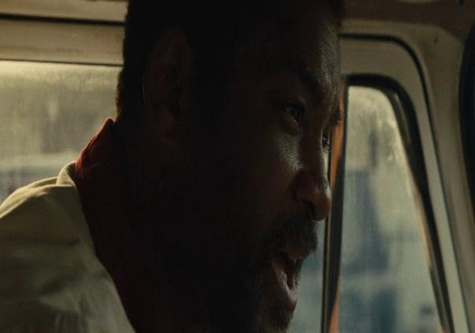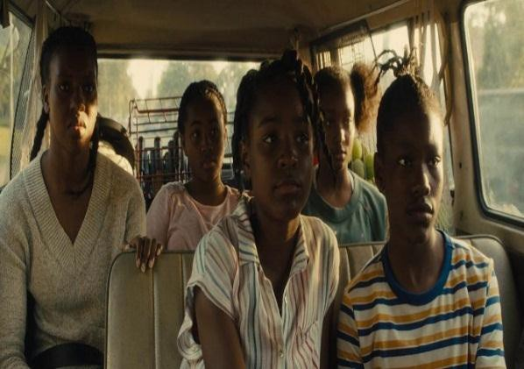

Picture.1 (00:01:04) Picture.2 (00:01:06)

|  |  |
| --- | --- |
| **RICHARD:** | *“When I was your age, I used to have to fight every day. If it wasn't the Ku Klux Klan or police or the white boys from the next town. This world ain’t never had no respect for Richard Williams, but they gonna respect y’all. They gonna respect y’all”* (Green and  Smith, 2021). |

In this Regard, the quoted scene and dialogue above is a statement of tennis racial issues, where the character Richard Williams is speaking to all his daughters in a car, especially for Venus and Serena Williams as the tennis athlete. Picture 1, the close-up angle and lighting that focuses on Richard's face aims to show the expression of courage that is channeled by him to his daughters. Picture 2, by using a wide angle, the film tries to portray that all of Richard's daughters in the car are serious and listening well to their father's words. These two scenes capture the essence of Richard Williams’ commitment to his daughters’ success and his unwavering belief in their potential to overcome systemic racial barriers in the world of tennis. "*They gonna respect y'all*" twice in the dialogue hints at the emphasis on the sacrifice and determination of a father who wants his daughters to achieve their dreams and be recognized by the rest of society.

Moreover, racial issues against black tennis athletes are also shown when Venus and Serena get a sports sponsorship offer from an agent named Laird. He came to Richard as the guardian of his two children to discuss the cooperation between the sponsor and the athletes. However, Laird's attitude as a white man implicitly shows his superiority attitude towards Richard by considering himself more "incredible". As the scene follows:

Picture.3 (01:04:30 – 01:04:40)

|  |  |
| --- | --- |
| **RICHARD:** | “*Why is it so incredible what we did?”* |
| **LAIRD:** | “*I’m sorry, -- I certainly did not mean any offense, Mr. Williams. I’m very sorry. I just meant with your background –* “. |
| **RICHARD:** | “*My background? Of course what you mean is our race. (Laird*  *is silent) That’s ok. We get it. Little black girl in an all-white sport, that’s why we picked tennis.”* (Green and Smith, 2021). |

The quoted scene from picture 3 above explains that Laird demeans Richard based on his race. The close-up camera capture focusing on Laird's character shows the director's intention to show the conflict he wants to convey in the film. The camera's focus shows Laird's sitting position pressed against the side of the chair, where Richard is focused on listening and not leaning on his chair. Richard's position, captured with his back to the camera angle, gives the impression that the audience is present with Richard at the meeting. In other words, the director wanted to give an authentic experience as someone who experienced racial prejudice through the point of view of Richard's character.

On the other hand, Richard’s characterization is portrayed as resilient and determined in the face of racial prejudice. Through Richard’s action, depicted by his focused listening and avoidance of leaning on the chair, suggests a sense of composure and dignity despite the disrespectful treatment (Boggs and Petrie, 2008, p.64). The phrase, "*Little black girl in an all-white sport, that's why we picked tennis*", is a powerful statement that captures Richard's criticism of Laird's racial bias. Richard asserts his presence in the tennis world, emphasizing his active participation and commitment, even as a minority. Thus, the scenes and dialogue above showcase Richard's unwavering determination to challenge racial prejudices and secure a place for himself and his family in the sport.

Similarly, as Djata points out, numerous comprehensive articles have examined the racist and sexist comments directed at Serena Williams following her victories, highlighting that these derogatory remarks often originate from individuals who exploit the anonymity provided by social media (2019, p. 392). On a different note, another glaring example of racism within tennis is the notion of "natural talent," frequently attributed to black athletes such as Gibson, the Australian Aboriginal Evonne Goolagong Cawley, Yannick Noah (of Cameroonian and French heritage), the American James Blake (whose heritage includes a black father and a white mother), and the Williams sisters (Djata, 2019, p. 394). In this sense, it is interwoven with the notion of "race logic" implying that if black individuals are perceived as physically superior to white individuals, then an implicit assumption exists that black individuals are intellectually inferior to their white counterparts.

Although overt racial discrimination in tennis tournaments has diminished in the professional landscape, these acts of racism continue in more subtle forms, such as the exclusion of black players from junior travel teams, the disproportionate focus by the media on white players, racial slurs directed at black players by fans at tournaments where such comments are often not heard, and incidents where security guards demand identification from black players while allowing their white counterparts to pass without the same scrutiny (Djata, 2019, p. 397).

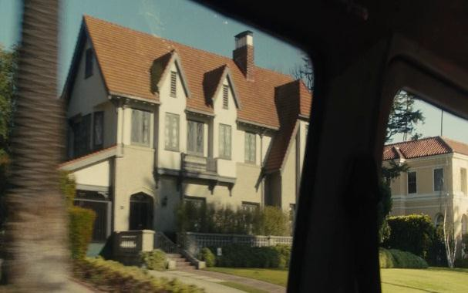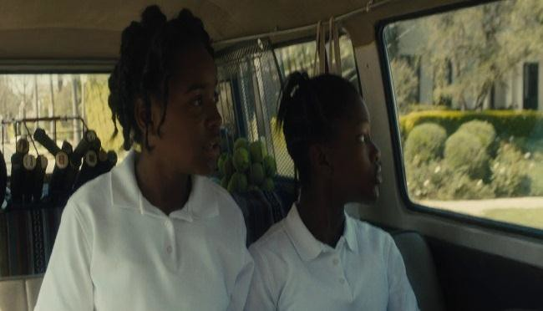Furthermore, *King Richard*’s film provides the exploration of how tennis can serve social mobility. Richard's strategic pattern in his plan emphasizes that tennis can provide social mobility to his family. "If you fail to plan, you plan to fail" (Green and Smith, 2021, 01:00:01) is a motto that Richard passed on to his daughters. The word "plan" in this quote implies a dream that Richard's family hopes for. In other words, Green infiltrates the idea of the American Dream through Richard's character who is very ambitious about his tennis plan. As the film emphasizes in the following scene:

Picture.4 (00:26:00-00:26:30) Picture.5 (00:26:30-00:27:00)

|  |  |  |
| --- | --- | --- |
| **RICHARD** | : | *“You all like these houses?”* |
| **SERENA** | : | *“Yes!”* |
| **VENUS** | : | *“That one looks like the White House“* |
| **RICHARD** | : | *“Which one is your favorite?”* |
| **VENUS** | : | *“I like that one”* |
| **SERENA** | : | *“If that was my house, I would put a pool in the front and a slide on the roof”* |
| **RICHARD**  **VENUS AND SERENA** | :  : | *“Well that’s the one then. That’s the one. You’re gonna have any of these houses that you want. Beverly Hills. Hollywood Hills. Any of these hills, ‘cause you got*  *a plan and you gon’ stick to it. When I was a little boy, my mom used to say: Son, the most strongest, most powerful, the most dangerous creature on this whole earth is a woman who know how to think. Ain’t nothing she can’t do. Y’all know how to think?”*  *“Yes, Daddy!”* (Green and Smith, 2021) |

Based on the scene and dialogue above, Green emphasized the significance of Richard's "plan," suggesting it as a crucial factor in shaping her two daughters into world tennis champions. Picture 1 captures a moment where Venus and Serena, seated in the center of the frame, observe something intriguing from their car before their tennis practice with Richard. This composition serves to engage the audience's curiosity, prompting them to anticipate the unfolding of the next scene. In contrast, the Picture 2 unfolds with the sisters noticing an expansive house from inside the car. Venus, using the term "White House" to describe it, subtly conveys an image of opulence and exclusivity, drawing parallels to the prestigious American presidential residence. This choice of words adds a layer of sophistication to the visual narrative, hinting at the grandeur and elite status associated with the building.

On the other hand, when Venus and Serena express their feelings, such as "I like that one", or speculate about the house being theirs with comments, such as "If only it was my house," this reveals their aspiration to own a grand residence. These remarks hint at a longing for social status, underlining that Richard's family does not come from an elite background. The depiction of this scene also shows the characterization of Venus and Serena as dreamers, aspiring to own a beautiful house and raise the status of their family (Boggs and Petrie, 2008, p.65). Therefore, in response to his daughters' musings, Richard assures them they can achieve whatever they want by "sticking to" the plan and developing a deep understanding of how women "think". In other words, Richard believed that tennis could be a means of social mobility for his family, emphasizing to his daughters that success in the sport could open doors to higher social standing.

Therefore, tracing the historical evolution of tennis as a global sport, particularly regarding black American athletes in *King Richard*’s Film, prompts us to question the reality of living in a multi-ethnic American society. Even in an era marked by heightened political correctness, discussions on racism have been rekindled by certain commentators, analysts, and fellow players. Their perspectives often reflect the enduring influence of historical racism woven into the social fabric of the United States. In addition, Richard’s plan symbolizes his dream and serves as a reminder that despite progress, the battle against racial discrimination and prejudice is far from over. Thus, Richard used tennis as a vehicle for his family’s social mobility to achieve the American Dream and underscored the ongoing need for a more inclusive and equitable society, especially in tennis.

**Unlocking the American Dream: How Tennis Offers Social Mobility**

The American Dream, a concept deeply ingrained in the nation's spirit, represents the belief that hard work, determination, and talent can elevate individuals and their families to a better life. This idea was celebrated by millions of people worldwide who had endured hardships such as famine and severe drought. Hundreds of immigrants from various corners of the globe flocked to America with a singular goal in mind: the American Dream. Roshadi emphasizes “*American Dream promised to thousands of people who sought liberty and equality in their pursuit of a better life*” (2012, p.26). It represented a glimmer of hope, offering the prospect of achieving financial success and a higher social standing that had been unattainable in their home countries. Similarly, throughout history, sports have served as a pivotal arena where this dream materializes, and among them, tennis stands out with its unique blend of elegance and intensity for social mobility.

Moreover, Social mobility signifies movement within the social structure, marked by patterns that influence individuals within a particular social group. Indeed, through tennis, *King Richard’s* film narrates the factors that influenced the Richard family's journey towards a certain social status, which includes motivation, education, and achievements that resulted in their vertical mobility. Hence, this chapter aims to unveil the profound link between tennis and the American Dream, delving into how this sport has provided individuals the opportunity to climb the social ladder. Its discussion will be divided into four aspects: *Motivation: The Ambition To Become A Tennis Champion*, *Education: The Significance of Education and Etiquette*, *Achievements: Form Cohen to Rick Maci* - *From Junior to Pro Tournament*, *and Vertical Mobility: The Glory and Respect of Richard’s Family*.

**Motivation: The Ambition to Become a Tennis Champion**

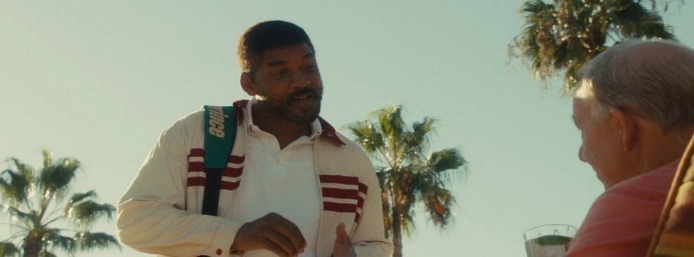Motivation is one of the social mobility factors that influenced Richard to achieve his ambition of making Venus and Serena world tennis champions. He has a strong determination and belief in his daughters' potential. This can be seen in how he has created 78 plans for the future of Venus-Serena's career and socialized his plans to various great coaches to facilitate their needs. As film narrates:

Picture.6 (00:01:39 – 00:01:43)

|  |  |
| --- | --- |
| **RICHARD:** | “*I wrote me a 78-page plan for their whole career before they was even born. It was 1977 and I had watched this tennis match, and I seen them give this girl - Virginia Ruzici -- 40 thousand dollars for four days work, and since I knew I’d only made*  *$52,000 all year, I knew I was in the wrong business. Went home that night, told the wife we need to make two more kids. So that night I wrote up the plan. One for Venus. One for Serena. Covered their tennis. Educations. Foreign languages. Everything. And now that plan says it’s time for us to come see you so you can help turn them into champions*” (Green and Smith,  2021). |

In this sense, the scene quoted above summarizes the beginning of the Williams sisters' journey and the incredible commitment and ambition of their father, Richard. The plans Richard made in 1977 laid the foundation for the success Venus and Serena Williams would achieve in professional tennis. It also Richard’s characterization as a father who is ambitious towards good values for his family (Boggs and Petrie, 2008, p.64). As in picture 4, Richard's camera shot positioned in the center hints at the story's focal point for the audience. In addition, Will Smith's expression as the actor portraying Richard in the scene conveys a confident and alluring expression with the help of his hand gestures promoting his plans.

Moreover, Richard's ambition to transform Venus and Serena into world-class tennis champions is evident in his parenting style. He imparts the practice of crafting a nightly plan to all his daughters. This underscores Richard's approach as a father, centered on instilling discipline, nurturing focus, and unwavering dedication to help his children, including Venus and Serena Williams, realize their dreams. As the film narrates:

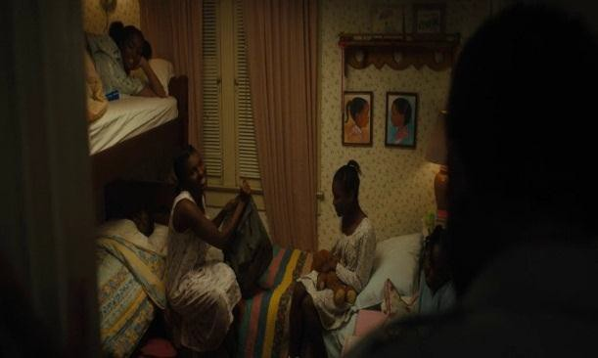

Picture.7 (00:16:00) Picture.8 (00:16:03)

|  |  |  |
| --- | --- | --- |
| **RICHARD** | **:** | *“You all wrote in your journals? Made your plans for tomorrow?”* |
| **ALL THE GIRLS** | **:** | *“Yes, Daddy”* |
| **RICHARD** | **:** | *“Cause you gotta have a plan. Every day. Else what?“* |
| **ALL THE GIRLS** | **:** | *“You fail to plan. You plan to fail”* |
| **RICHARD** | **:** | *“That’s right. And we not failing, are we?“* |
| **ALL THE GIRLS** | **:** | *“No, Daddy”* |
| **RICHARD** | **:** | *“All the way to the top”*(Green and Smith, 2021). |

In this essence, the two scenes above show Richard's routine of greeting and reminding his children of his daily plans before bed. The film's setting, in a reasonably small room used by the five children, also shows that Richard's family is not upper-class but middle-class in general. In other words, this also conveys that Richard wants his children to have dreams and ambitions so they can have a better life than him. In addition, the use of beige color and subtle lighting seeks to cultivate a warm and cozy atmosphere for the audience, providing a glimpse into the harmonious world of the Richard family. Thus, the vital force that drives Richard to have motivation is to improve his social status, where the trajectory of his family's life and circumstances are directed toward a better and more prosperous direction by sticking to their plan.

**Education: The Significance of Education and Etiquette**

Education is one of the social mobility factors that influenced Richard's family in achieving their American Dreams. Education provides a force that transcends social boundaries and gives individuals the opportunity to improve their lives, broaden their horizons and climb the socioeconomic ladder. Al Shuaibi asserts that education shapes human personality, fosters critical thinking, cultivates interpersonal skills, and equips individuals to navigate life's challenges. It bestows upon people a distinctive standing within their own society and wherever they may reside (2014, p.1). Indeed, in his dream to make Serena and Venus world tennis champions, Richard sees education as the foundational pillar that can equip his daughters with the knowledge, skills, and weapons needed to navigate the complexity of the world's challenges. As in the film when Richard is confronted by his co-coach's question why education is important beside joining tournament for Venus and Serena:

|  |  |  |
| --- | --- | --- |
| **RICHARD** | : | *“And that’s why we not rushing. With no education, as good as they are, they won’t keep their money. They’ll be broke by 18 and have 50 more years to live like a fool. We not doing*  *that*.” (Green and Smith, 2021). |

According to the quotation above, Richard wants his daughters to get a proper education in order to rush into their careers as tennis athletes. He emphasized that even talented individuals in sports may need help managing their resources effectively. His statement that "*they'll be broke by 18 and have 50 more years to live like a fool. We're not doing that*" implies the long-term consequences of not prioritizing education. In addition, the wide-angle shown in explaining this scene by showing the position of the children behind Richard and his colleagues implies a message to be able to pay more attention to the priority needs of each child. Thus, education is about academic knowledge and equipping individuals with the skills and wisdom to make informed and responsible decisions in various aspects of their lives.

Furthermore, Venus and Serena grew up in Compton, California, where many of the neighbors were white; Richard was once accused by a neighbor named Mrs Strickland that he raised his children to be athletes too hard and forgot their obligation to study. Consequently, when Richard, Venus, and Serena returned home after their training, they were surprised to find a social worker waiting in their house and trying to investigate Mrs.Strickland's report:

|  |  |  |
| --- | --- | --- |
| **SOCIAL WORKER** | : | “*A little wet for practice, don’t you think? Don’t they have school work to do*?” |
| **RICHARD** | : | “*You wanna check on the kids? Let’s check on the kids. We got future doctors and lawyers, plus a couple tennis stars in this house. Now, I understand you got to do your job, even if some crazy-ass neighbor do call talking foolishness, and I don’t even mind you saying we hard on these kids, you know why? ‘cause we are. That’s our job. To keep them off these street. You wanna arrest us for that, fine. But what you not gon’ never do is come knock on this door to say you blew our daughters’ damn brains out ‘cause they been hanging with hoodlums and doing drugs and things. That’s what you not never gon’ say in this house.*” (Green and Smith,  2021) |

The dialogue above explains Richard's dedication to providing a nurturing and structured environment for their children, especially their daughter, who pursues tennis and academic achievements. He acknowledges that they are indeed hard on their children. This admission is not a sign of cruelty but rather an acknowledgement that their role is to protect their children from the dangers of “*the streets*” and guide them towards a better future (Green and Smith, 2020). In addition, this scene also implies the problem of white racial stereotypes towards blacks, who are considered undisciplined and criminal (Nadjowski, 2023, p.4).

However, through Richard's firm, courageous, and dramatic response (Boggs and Petrie, 2008, p.66), he also shows his resistance to the accusations against his family. It can be seen from Richard's characterization of standing tall in front of his children, which is a symbol of protection for his family. Thus, Richard provides a strict structure to his children by trying to balance between the tennis routine and his daughter's academic needs.

Moreover, Richard believes that there are manners involved in education. This can be seen when he admonishes all his children to always be humble and not arrogant in every situation and circumstances. As the film emphasizes:

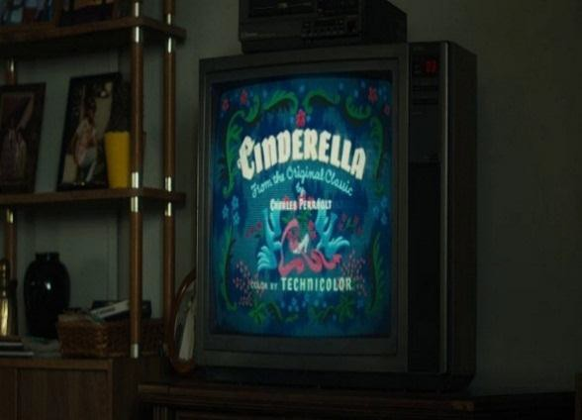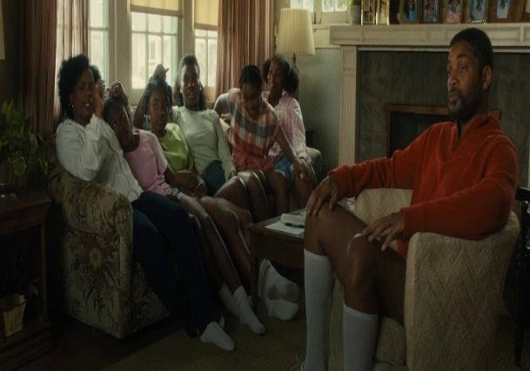

Picture.9 (00:49:00-00:49:01) Picture.10 (00:49:01-00:49:02)

According to the scene and dialogue above, Richard expresses the importance of “*humble*” as a part of education through the character of Cinderella (picture 9), which shows the quality of a civilized and educated person (Boggs and Petrie, 2008, p.64). Meanwhile, the setting in picture 10, with the family gathered in the living room and sitting close to each other, suggests a strong emotional bond within Richard's family. Richard is portrayed as calm and focused, conveying his desire to encourage his daughters to pay attention and learn from Cinderella's behavior. In addition, the sentence "*No matter how they people treated her, she stayed calm. She kept her heart clean. She was humble*" underscores the idea that being humble and kind is an integral part of the outcomes of education, leading to the cultivation of positive values and improved quality of life. Thus, Richard's actions reflect his belief that education can be derived from sources like films. He conveys that films offer more than entertainment; they carry valuable life lessons that can be internalized and applied to human's lives. In this case, he uses the character of Cinderella to teach his daughters the importance of humility and good-heartedness as essential aspects of their education and personal growth.

**Achievement: Form Cohen to Mecci, from Junior to Professional**

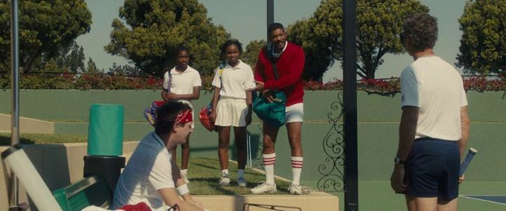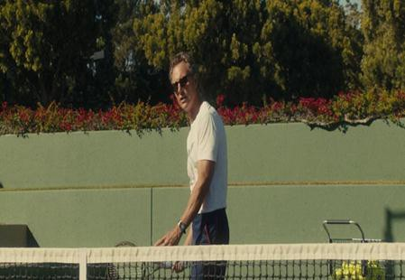The process of social mobility relies heavily on individual achievements. It serves as significant milestones that propel individuals through different social strata. Indeed, an Individual achievement has a huge impact on a person's social status as Huang argued “It affects how they are seen and recognized in their social environment” (2021, p.64). In this sense, these achievements serve as the stepping stones in one's journey towards social mobility and they shape not only how individuals are perceived by others but also how they perceive themselves. In this context, *King Richard*'s film narrates achievement as a journey to pursue their American dream. It begins when the scene shows Richard trying to find a coach for Venus and Serena:

Picture.11 (00:29:00-00:29:03) Picture.12 (00:29:03-00:29:05)

Based on the scene above, Richard meets Paul Cohen, a professional tennis coach from the same area. In picture 11, Richard's optimistic characterization reflects determination and hope as he discusses his daughter's budding tennis career with the coach. He believes that the right coach will be instrumental in realizing their potential and taking them to a higher level in professional tennis. Cohen's promising performance in picture 12 gives the audience an impression of professionalism when they see him. In addition, since the offer Richard made to Cohen to coach was free, Cohen decided that he could only coach one athlete, Venus. From here, Venus finally participated in the Junior tournament and won the gold trophy, followed by Serena, who trained independently with her mother by getting the silver trophy (Green and Smith, 2021, 01:23:10).

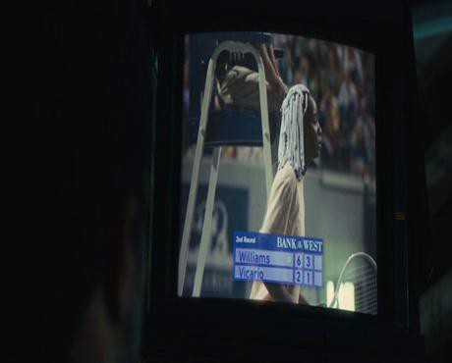In addition, the transition from junior player to professional athlete was greatly influenced by the critical role played by Rick Macci. Macci's coaching expertise and dedication to improving the William brothers proved instrumental in elevating their performance to the professional level. His guidance honed their skills and paved the way for opportunities that would eventually reshape their social status.

Picture. 13 (01:23:40-01:24:00). Picture. 14 (02:01:00-02:04:00).

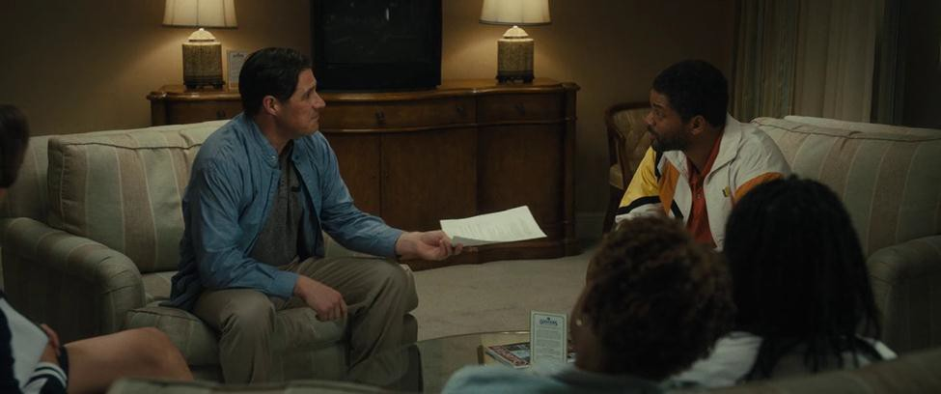

Picture. 15 (01:49:00-01:50:00).

Based on the picture above, picture.13 shows a scene of Rick giving directions to Venus and Serena during practice. He is known as a coach who has tremendous experience in molding junior athletes into pros, as Richard affirms by calling him, "*nothing is impossible for Rick Macci!*" (Green and Smith, 2021, 01:23:40). Indeed, Rick's coaching is characterized by hard training, unwavering discipline, and a focus on technique (Boggs and Petrie, 2008, p.64). It is evidenced in the results that allowed Serena to debut at the professional level, as shown in picture 14. In addition, Venus' achievement of debuting in the professional battle brought another award to Richard's family, namely the presence of sponsorship from Nike. He seeks to make a contract cooperation between the brand and Venus as an athlete worth 3 million dollars.

According to the description of the pictures above, Individual achievements can go beyond personal recognition. They can challenge and reshape societal norms and expectations. When individuals from marginalized or underrepresented backgrounds are honored, it sends a powerful message that success knows no boundaries and that social mobility is achievable for all, as Venus and Serena Williams, an African-American woman who reached the pinnacle of tennis (which is the sport that known as dominated by white people), have broken racial and gender barriers in the world of tennis sport. Thus, their success has been instrumental in changing the landscape of women's tennis and advocating for equality and diversity in the world of sports.

**Vertical Mobility: The Glory and Respect of Richard’s Family**

The journey of Richard Williams and his family is a story that explains the struggle through various social strata and the pursuit of a better life. Although Richard has experienced various social prejudices, and financial limitations to guide his daughter, he remains steadfast and does not give up. with the power of ambition, instilling the importance of education, and hard work to get various achievements provide a way for him to pursue the American Dream that he hopes for. In this sense, the various factors that influence the social mobility of Richard's family put their social status higher or referred to as Vertical Mobility. This vertical mobility journey can be traced in more detail in the description below:



Picture.16 (00:59:00-00:59:01) Picture.17 (01:42:37-01:43:00)

In this regard, picture 16 shows the state of Richard's family home while still living in Compton, California. The wide angle in showing the scene aims to explain all aspects of the property used by Richard's family. The house is not large but still suitable for living, the front yard is not too large, and a car that Richard often uses to travel and take his son to tennis practice shows the social status of Richard's family as a well-off family. However, picture 17 shows a scene that provides information about Richard's past. The shot focusing on Richard's face and his crying expression provides an emotional atmosphere. It draws the audience's empathy, especially when Richard tells the story of his childhood, as quoted below:

**RICHARD** : *When I was a little boy, I grew up in Shreveport. One day my father took me to town. He gave me this money to pay this white man for something. Back in them days, black folks wasn’t allowed to touch white peoples. So I went to give the man this money and I accidentally touched his hand and he start beating on me. He knocked me down. His friends come over, they all start stomping on me, beating on me. And I look up and see my father in the crowd, and he took off running. Left me there with these grown men beating on me. (as Venus listens) Now, I haven’t been no great daddy. But I’ve never done nothing but try and protect you. This next step you ‘bout to take, it would be hard for anybody. But for you, you not just gon’ be representing you. You gon’ be representing every little black girl on earth. And you gonna be the first one going through that gate, and I just never wanted you to look up and see your* daddy running away.” (Green and Smith, 2021)

In this regard, Richard’s Narrative is a poignant reminder of the racial injustice and prejudice that he experienced in his life. His painful experience drives his unwavering determination to protect his daughter. When Richard states that he never wants Venus to witness her father “running away”, it shows the depth of his commitment to Venus' journey and his unwavering support, even in the face of challenges such as racism and violence. Thus, Richard's dialogue above aligns his role as a father with the broader fight for equality and emphasizes the importance of not allowing racial prejudice to continue (Boggs and Petrie, 2008, p.63).

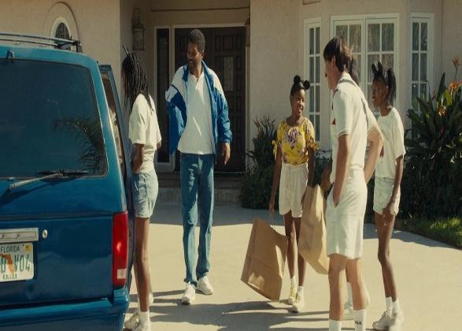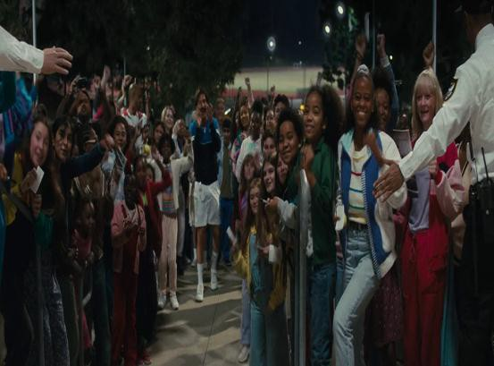

Picture.18 (01:33:00-01:33:10) Picture.19 (02:15:03-02:16:00)

Therefore, Richard's persistence in achieving equality and a better life can be achieved through tennis, especially his two daughters, who finally get respect. Various sponsors, such as Nike, Reebok, Puma, Fila, also approached the two to work together by proposing a fantastic price exceeding 10 million dollars (Green and Smith, 2021, (02:16:00). Hence, as in the picture.18, the depiction of Richard's family finally getting a big house shows visual evidence of their success in the tennis world. In other words, the object of the house that fills the frame of the scene serves as tangible evidence of their achievement of the fulfillment of their aspirations and symbolizes the realization of their American Dream through tennis. Meanwhile, Picture.19 showed that Richard not only succeeded in achieving his American Dream, but he gained the glory and respect of everyone, especially the African-American community, who were inspired by his determination, courage, and dedication to tennis.

**CONCLUSION**

The *King Richard* film is able to present a picture of an Afro-American family who uses tennis as an instrument to achieve the American Dream, a concept that for many people in the US is a part of motivation in life. By using social mobility theory, the results of the analysis obtained are that motivation, education, achievement and vertical mobility factors have a significant influence on Richard in making his family, through his two daughters, live a better life. The ambition to make his children tennis champions is the strongest motivation. Richard's strength in encouraging his two daughters to train is an illustration of how education should be carried out for an athlete. For achievements, Richard directed his two daughters to get the best coach to become world champions. Finally, his daughter's success in becoming world champion made Richard and his family gain respect from society, and this means that he and his family succeeded in doing vertical mobility. Thus, these aspects provide an understanding of the role of tennis in King Richard's film where it acts as a conduit for social mobility and the pursuit of the American Dream.

**REFERENCES**

Anwar, C. (2023). Social mobility in modern society. *OSF Preprints*. https://doi.org/10.31219/osf.io/38edn

Al-Shuaibi, A. (2014). The importance of education. *Salalah College of Technology*.

Ashabi, N. N. (2019). Representation of Immigrant Reaching American Dream In Planes Film (2013). *Doctoral Dissertation, Universitas Airlangga*.

Blau, P. M. (1992). Mobility and status attainment [Review of *The American Occupational Structure*, by P. Blau & O. D. Duncan]. *Contemporary Sociology*, *21*(5), 596–598. https://doi.org/10.2307/2075538

Barsam, R., & Monahan, D. (2016). *Looking at films: An introduction to film* (5th ed.). W.W. Norton & Company.

Boggs, J. M., & Petrie, D. W. (2008). *The Art of Watching Films*. McGraw Hill.

Churchwell, S. (2018). Behold, America: the entangled History of "America First" and "the American Dream". *Basic Books*.

Crim, J. 75+ Famous American Tennis Players & Stats. *Tennis Companion*. https://tenniscompanion.org/american-tennis-players/

Cullen, J. (2003). *The American dream: A short history of an idea that shaped a nation*. Oxford University Press.

DeVitis, J. L., & Rich, J. M. (1996). *The success ethic, education, and the American dream*. SUNY Press.

Dewi, F. M., & Chandraningrum, P. D. (2023). Struggle Of Richard Williams To Educate And Training His Two Daughters To Become World Tennis Athletes In King Richard Film (2021): An Individual Psychological Approach. *Doctoral dissertation, Universitas Muhammadiyah Surakarta*.

Djata, S. (2019). *Racial politics in the history of American tennis*. Routledge Handbook of Tennis: History, Culture and Politics, 392-401. https://doi.org/10.4324/9781315533575

Emzir, M. (2014). *Penelitian Kualitatif: Analisis Data*. PT Raja Grafindo Persada.

Firmansyah, Ikhsan. (2023). *Representation of Father's Role in King Richard Film*. Sekolah Tinggi Ilmu Komunikasi Jakarta.

Gordon, J. B., & Kuehner, K. (1999). Fiction: the elements of the short story. *National Textbook Company*.

Grusky, D. (2019). Social stratification, class, race, and gender in sociological perspective. *Routledge*.

Hall, E. A. (2014). Arthur Ashe: Tennis and justice in the civil rights era. *JHU Press*. https://doi.org/10.1353/book.33738

Huang, H., & Paralkar, V. K. (2021). Better Scores, Better Jobs, an Untested Assumption: Social Mobility and Achievement in Mathematics and Science in the United States. *Journal of Research in Education, 30(3), 61-96*.

Jeon, B. C. (2020). *Personal social mobility beliefs and motivation for goals* [Doctoral dissertation, Memorial University of Newfoundland]. Memorial University Research Repository. https://doi.org/10.48336/1ha2-k712

Jones, E. A. (2018) *Characterization Methodology, Modeling, and Converter Design for 600 V Enhancement-Mode GaN FETs* [PhD diss., University of Tennessee]. Trace Tennessee Research and Creative Exchange. https://trace.tennessee.edu/utk_graddiss/4932

Lake, R. J. (Ed.). (2019). *Routledge handbook of tennis: History, culture and politics*. Routledge. https://doi.org/10.4324/9781315533575

Lipset, S. (2018). *Social mobility in industrial society*. Routledge. https://doi.org/10.4324/9781351306362

Madrah, M. Y., & Permtasari, R. (2023, March). The Dynamic of Social Mobility Through Migration and Higher Education: A Study on Indonesian Migrant Workers-Students. *In International Conference on Academia-Based Tourism Revival 2022 (ABTR 2022), Atlantis Press,148-159.* https://doi.org/10.2991/978-2-38476-028-2_14

Maxwell, R. (2017). Racial equality in France and the United States: media coverage of professional tennis players. *Ethnic and Racial Studies, 40(4), 656-674.* https://doi.org/10.1080/01419870.2016.1181271

Najdowski, C. J. (2023). How the “Black criminal” stereotype shapes Black people’s psychological experience of policing: Evidence of stereotype threat and remaining questions. *American Psychologist, 78(5), 695–713*. https://doi.org/10.1037/amp0001159

Roberts, S. (2022). Naomi Osaka, Racial Hybridity, and Black Femininity in Tennis. InPerceptions of East Asian and Asian North American Athletics(pp. 319-342). *Cham: Springer International Publishing*.

Roshadi, I. (2012). American Dream as an Ideology for American Immigrant Workers in Upton Sinclair’s The Jungle. *Allusion Volume 01 Number 01*.

Rowe, D. (2017). Sports journalism and the FIFA scandal: Personalization, co-optation, and investigation. *Communication & Sport, 5(5), 515-533*. https://doi.org/10.1177/2167479516642206

Smith, W., & Green, R. Marcus. (2021). King Richard. *Westbrook Studios*.

Smith, S. E. (2016). Defining the American Dream. *Google Docs. Web, 1*.

Sorokin, P. (1959). *Social and Cultural Mobility*. New York: The Free Press.

Yuhan, H. (2022). The Disillusion of American Dream, A Review of Movie Nomadland. *Art and Performance Letters, Vol. 3: 37-40*. http://dx.doi.org/10.23977/artpl.2022.030408.

Zhai, Y. (2022). Tennis and Socioeconomic Class: The Change in Perception of the Sport. *Advances in Applied Sociology, 12(4), 69-74*. https://dx.doi.org/10.23977/artpl.2022.030408