AUTHOR’S STATEMENT

The undersigned below,
Name | : | Henny Helmi
Origin of affiliation | : | Universitas Bangka Belitung
Office address | : | Kampus Terpadu UBB Balunijuk, Desa Merawang, Bangka district, Bangka Belitung Islands Province, Indonesia, postal code: 33172,
Office phone number | : | (0717) 4260024
Home address | : | Perumahan Graha Puri Cluster Damar Blok C5 No.11 Kelurahan Selindung, Kecamatan Gabek, Provinsi Kep. Bangka Belitung
Mobile number | : | 081918997733
E-mail | : | Hennyhelmi24@gmail.com
As the corresponding author in the manuscript entitled:
Isolation And Characterization of Bacteriocin-Producing Lactic Acid Bacteria From Giant Prawn (Macrobrachium rosenbergii)
With the author’s order:
- Della Meysari
- Henny Helmi
- Rahmad Lingga

Stated that the manuscript that I submitted to Al-Kauniyah: Jurnal Biologi is:
- Does not contain elements of plagiarism, according to applicable regulations
- Not being submitted to other journals
- Not being processed to be published in any form of publications
- All authors have agreed to the author’s order and agreed to the final form of the manuscript
- Willing to bear the risk of the accuracy of the data and will not hold the editor responsible for the data errors provided.

Thus, I make this statement in truth, and I am willing to accept all actions taken by the Editorial Board of Al-Kauniyah: Jurnal Biologi, if in the future it is proven that one or more of my statements are incorrect.

Bangka, 19 Maret 2024

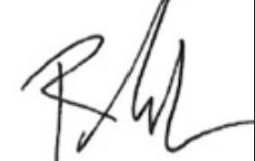
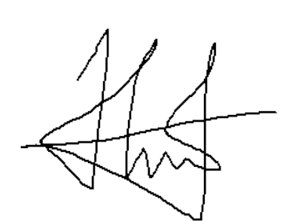
Signature Signature Signature
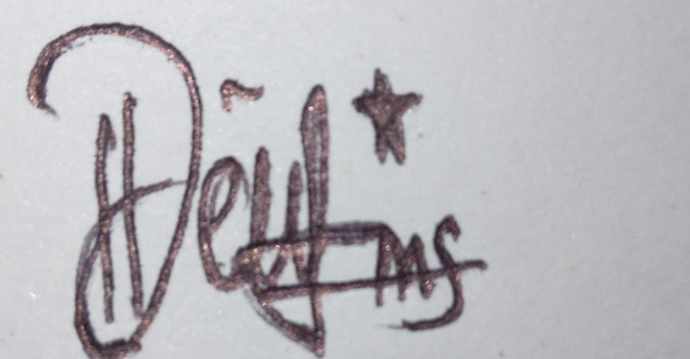

(Della Meysari) (Henny Helmi) (Rahmad Lingga)

