AUTHOR’S STATEMENT

The undersigned below,
Name | : | Marwan Setiawan
Origin of affiliation | : | Research Center for Ecology and Ethnobiology, National Research and Innovation Agency (BRIN)
Office address | : | Jl. Raya Jakarta-Bogor Km 46, Cibinong 16911, Jawa Barat, Indonesia
Office phone number | : | +62 8111 933 3601
Home address | : | JL. Paledang No. 24F.1 Bojong Neros, Bogor Tengah, Kota Bogor
Mobile number | : | +62 856 143 8718
E-mail | : | marw002@brin.go.id, marwan.cm@gmail.com
As the corresponding author in the manuscript entitled: Diversity of Plant as Traditional Culinary Food Wrappers on the Bogor’s Society, West Java, Indonesia
With the author’s order:
- Muhamad Nikmatullah
- Mulyati Rahayu
- Titi Kalima
- Marwan Setiawan
- Ida Farida H.)

Stated that the manuscript that I submitted to Al-Kauniyah: Jurnal Biologi is:
- Does not contain elements of plagiarism, according to applicable regulations
- Not being submitted to other journals
- Not being processed to be published in any form of publications
- All authors have agreed to the author’s order and agreed to the final form of the manuscript
- Willing to bear the risk of the accuracy of the data and will not hold the editor responsible for the data errors provided.

Thus, I make this statement in truth, and I am willing to accept all actions taken by the Editorial Board of Al-Kauniyah: Jurnal Biologi, if in the future it is proven that one or more of my statements are incorrect.

Bogor, 03 August 2023

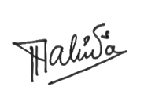

Signature Signature Signature Signature Signature
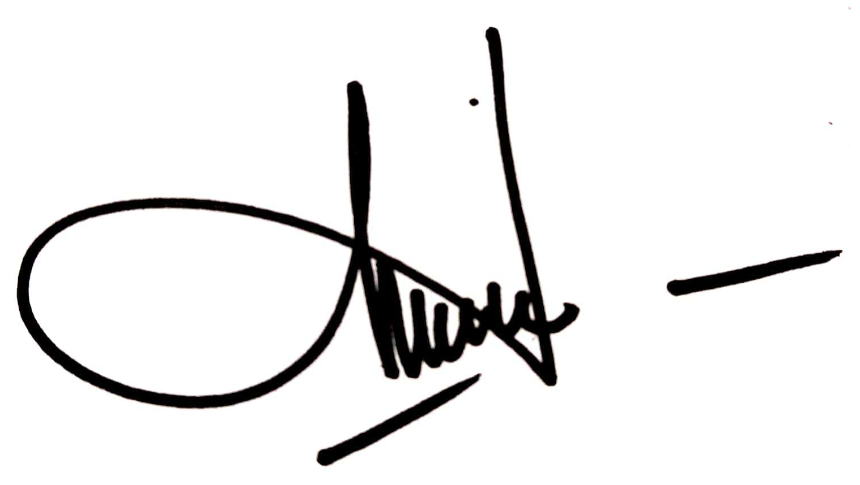


(Muhamad Nikmatullah) (Mulyati Rahayu) (Titi Kalima) (Marwan Setiawan) (Ida Farida H.)

