AUTHOR’S STATEMENT

The undersigned below,
Name | : | Abdul Rahman Singkam, Ph. D
Origin of affiliation | : | Program Studi Pendidikan Biologi, Fakultas Keguruan dan Ilmu Pendidikan, Universitas Bengkulu
Office address | : | Jl W.R. Supratman Kandang Limun, Bengkulu, 38371 A,
Office phone number | : | (0736) 28116
Home address | : | Perumnas Medan Baru No 33 RT. 14 RW.3 Kandang Limun
Mobile number | : | 085273118795
E-mail | : | arsingkam@unib.ac.id
As the corresponding author in the manuscript entitled:
KERAGAMAN MAKROINVERTEBRATA SUNGAI KAMPAI BENGKULU (THE DIVERSITY OF MACROINVERTEBRATES IN KAMPAI RIVER, BENGKULU)
With the author’s order:
- Abdul Rahman Singkam
- Moh Aziz Pathori
- Irwandi Ansori
- Talib Chitheer
Stated that the manuscript that I submitted to Al-Kauniyah: Jurnal Biologi is:
- Does not contain elements of plagiarism, according to applicable regulations
- Not being submitted to other journals
- Not being processed to be published in any form of publications
- All authors have agreed to the author’s order and agreed to the final form of the manuscript
- Willing to bear the risk of the accuracy of the data and will not hold the editor responsible for the data errors provided.

Thus, I make this statement in truth, and I am willing to accept all actions taken by the Editorial Board of Al-Kauniyah: Jurnal Biologi, if in the future it is proven that one or more of my statements are incorrect.

Bengkulu, 31 Agustus 2022
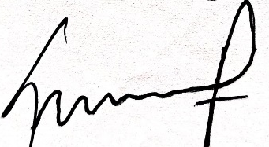
Abdul Rahman Singkam, Ph. D

