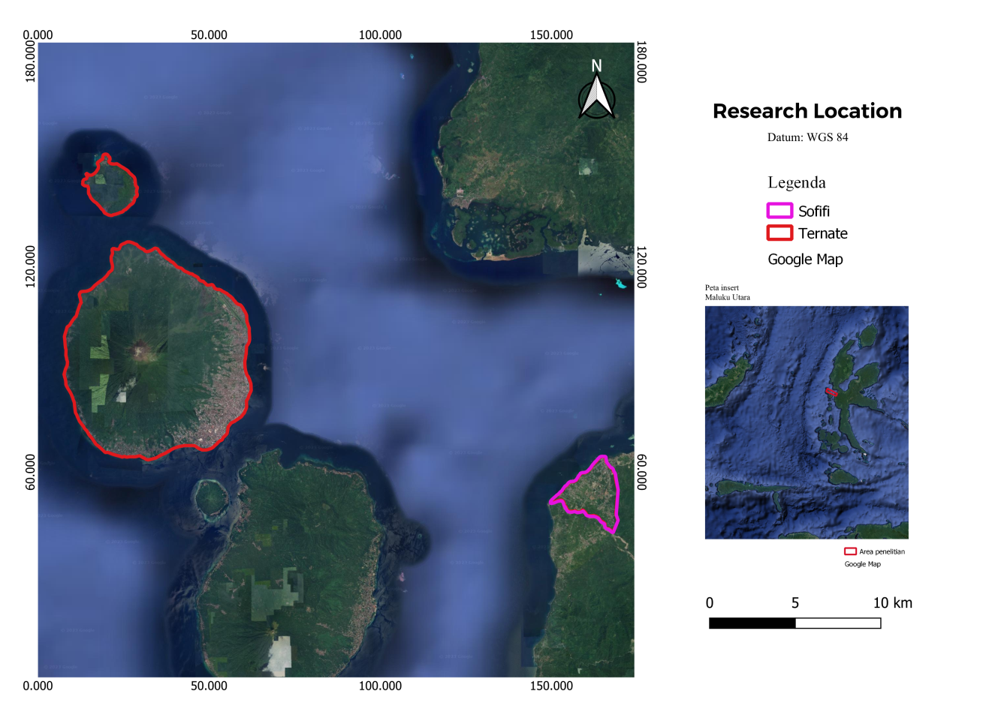
Figure 1. Map of community interview locations in North Maluku

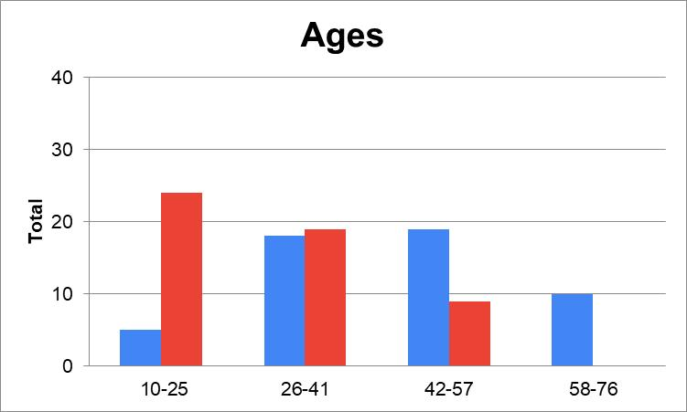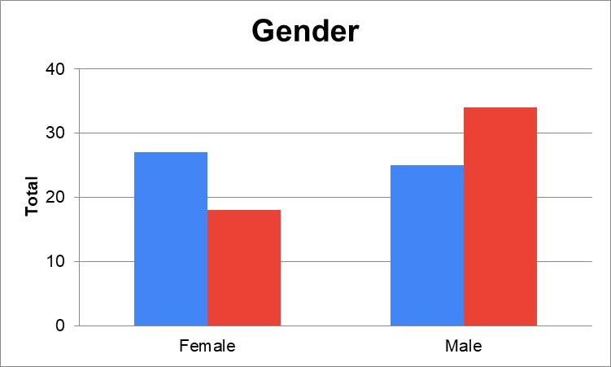
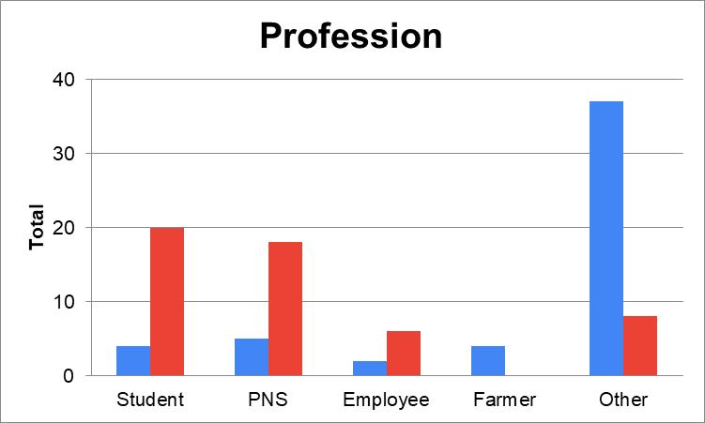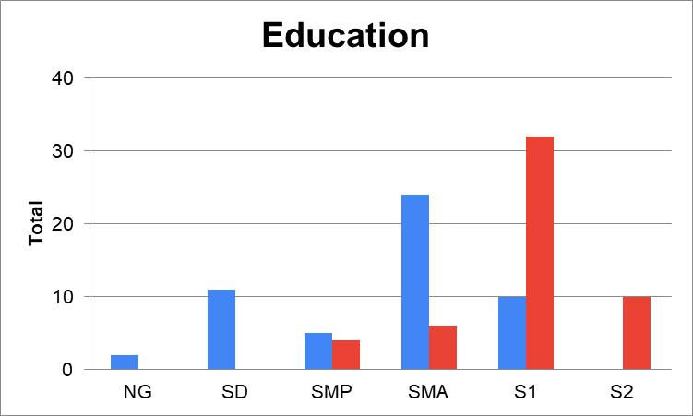
Figure 2. Diagram Respondent Profile (Black: owner and Grey: non-owner; NG: Not Graduated)

Table 1. Coefficient of determination
Model | Owner |  |  |  | Non-owner
Model | A | G | P | E | A | G | P | E
R² | 0.128 | 0.097 | 0.258 | 0.161 | 0.158 | 0.008 | 0.073 | 0.036
(A: Ages, G: Gender, P: Profession, E: Education)

Table 2. The simultaneous F test
Model ANOVA | Owner |  |  |  | Non-owner
Model ANOVA | A | G | P | E | A | G | P | E
Regression | 0.084 | 0.177 | 0.002 | 0.036 | 0.040 | 0.942 | 0.620 | 0.302
(A: Ages, G: Gender, P: Profession, E: Education)

Table 3. The t test
Model | Owner |  |  |  | Non-owner
Model | P |  | E |  | A
Model | Unstandardized Coefficients B | Sig. | Unstandardized Coefficients B | Sig. | Unstandardized Coefficients B | Sig.
Constant | 1.352 | 0.301 | 4.019 | 0.001 | 60.456 | 0.000
K | -0.304 | 0.106 | 0.326 | 0.050 | -4.552 | 0.092
At | 0.701 | 0.005 | -0.478 | 0.026 | -3.973 | 0.012
Pra | 0.506 | 0.212 | -0.015 | 0.967 | 1.242 | 0.638
(A: Ages, G: Gender, P: Profession, E: Education; K: Knowledge, At: Attitude, Pra: Practice)

Table 4. Canonical correlation significance test results
Multivariate tests of significance | Owner | Non-owner
Pillais | 0.002 | 0.000
Hotellings | 0.002 | 0.000
Wilks | 0.002 | 0.000
Roys | - | -
Note: F statistic are exact.

Table 5. Results of Eigenvalue and canonical functions
Root No. | Owner |  |  | Non-owner
Root No. | Eigenvalue | Cum. Pct. | Canon Cor. | Eigenvalue | Cum. Pct. | Canon Cor
1 | 0,67818 | 90,21867 | 0,63570 | 0,32249 | 78,54871 | 0,49381
2 | 0,07095 | 99,65725 | 0,25739 | 0,06575 | 94,56359 | 0,24838
3 | 0,00258 | 100,00000 | 0,05069 | 0,02232 | 100,00000 | 0,14776

Table 6. Canonical correlation for variable modifiers
Dimension |  | Owner |  | Non-owner
 |  | Canonical weight | Conanical loading | Canonical weight | Conanical loading
Independent or KAP | Knowledge | -0.53994 | -0.41020 | 0.33100 | 0.33100
Independent or KAP | Attitude | 0.81840 | 0.83381 | 0.90586 | 0.90586
Independent or KAP | Practice | 0.21088 | 0.45584 | 0.15801 | 0.15801
Dependent or Respondent profile | Ages | 0.13136 | 0.54461 | -1.07415 | -0.77926
Dependent or Respondent profile | Gender | 0.15193 | 0.43730 | -0.17620 | -0.04322
Dependent or Respondent profile | Profession | 0.66008 | 0.78462 | -0.08018 | -0.33922
Dependent or Respondent profile | Education | -0.56201 | -0.61229 | 0.66282 | 0.19333

