AUTHOR’S STATEMENT

The undersigned below,
Name | : | Moh. Mirza Nuryady
Origin of affiliation | : | Universitas Muhammadiyah Malang
Office address | : | Jl. Raya Tlogomas No. 246 Malang, Jawa Timur
Office phone number | : | (0341) 464318
Home address | : | Jl. Bulu Tangkis Perum Akhtara blok B-06, Tasikmadu, Lowokwaru, Kota Malang
Mobile number | : | 085731090163
E-mail | : | mirzanuryady@umm.ac.id
As the corresponding author in the manuscript entitled:
DESAIN PRIMER SPESIFIK Aedes Aegypti BERDASARKAN PENYANDI COX-I (Cytochrome Oxidase Subunit I) DNA MITOKONDRIA
With the author’s order:
- Siti Nur Aldina
- Sri Wahyuni
- Tutut Indria Permana
- Zakiyatul Khoiriyah
- Moh. Mirza Nuryady

Stated that the manuscript that I submitted to Al-Kauniyah: Jurnal Biologi is:
- Does not contain elements of plagiarism, according to applicable regulations
- Not being submitted to other journals
- Not being processed to be published in any form of publications
- All authors have agreed to the author’s order and agreed to the final form of the manuscript
- Willing to bear the risk of the accuracy of the data and will not hold the editor responsible for the data errors provided.

Thus, I make this statement in truth, and I am willing to accept all actions taken by the Editorial Board of Al-Kauniyah: Jurnal Biologi, if in the future it is proven that one or more of my statements are incorrect.

Malang, 15 January 2023
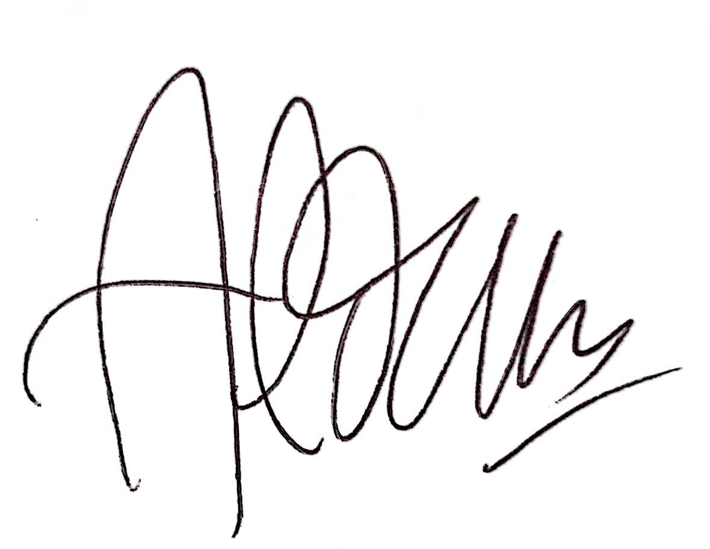  (Siti Nur Aldina) | 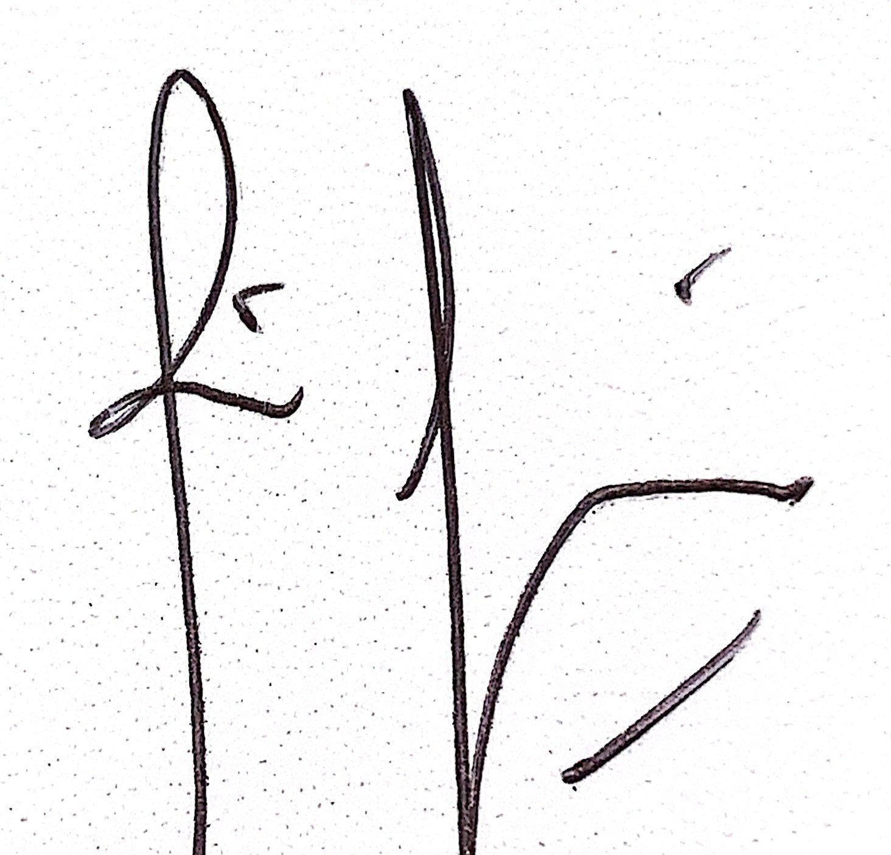  (Sri Wahyuni) | 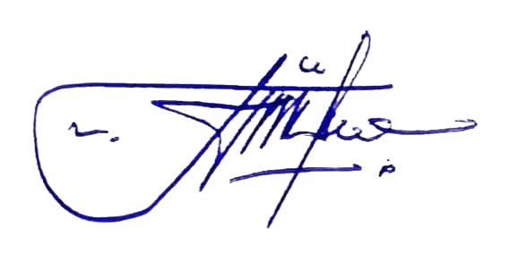  (Tutut Indria Permana)

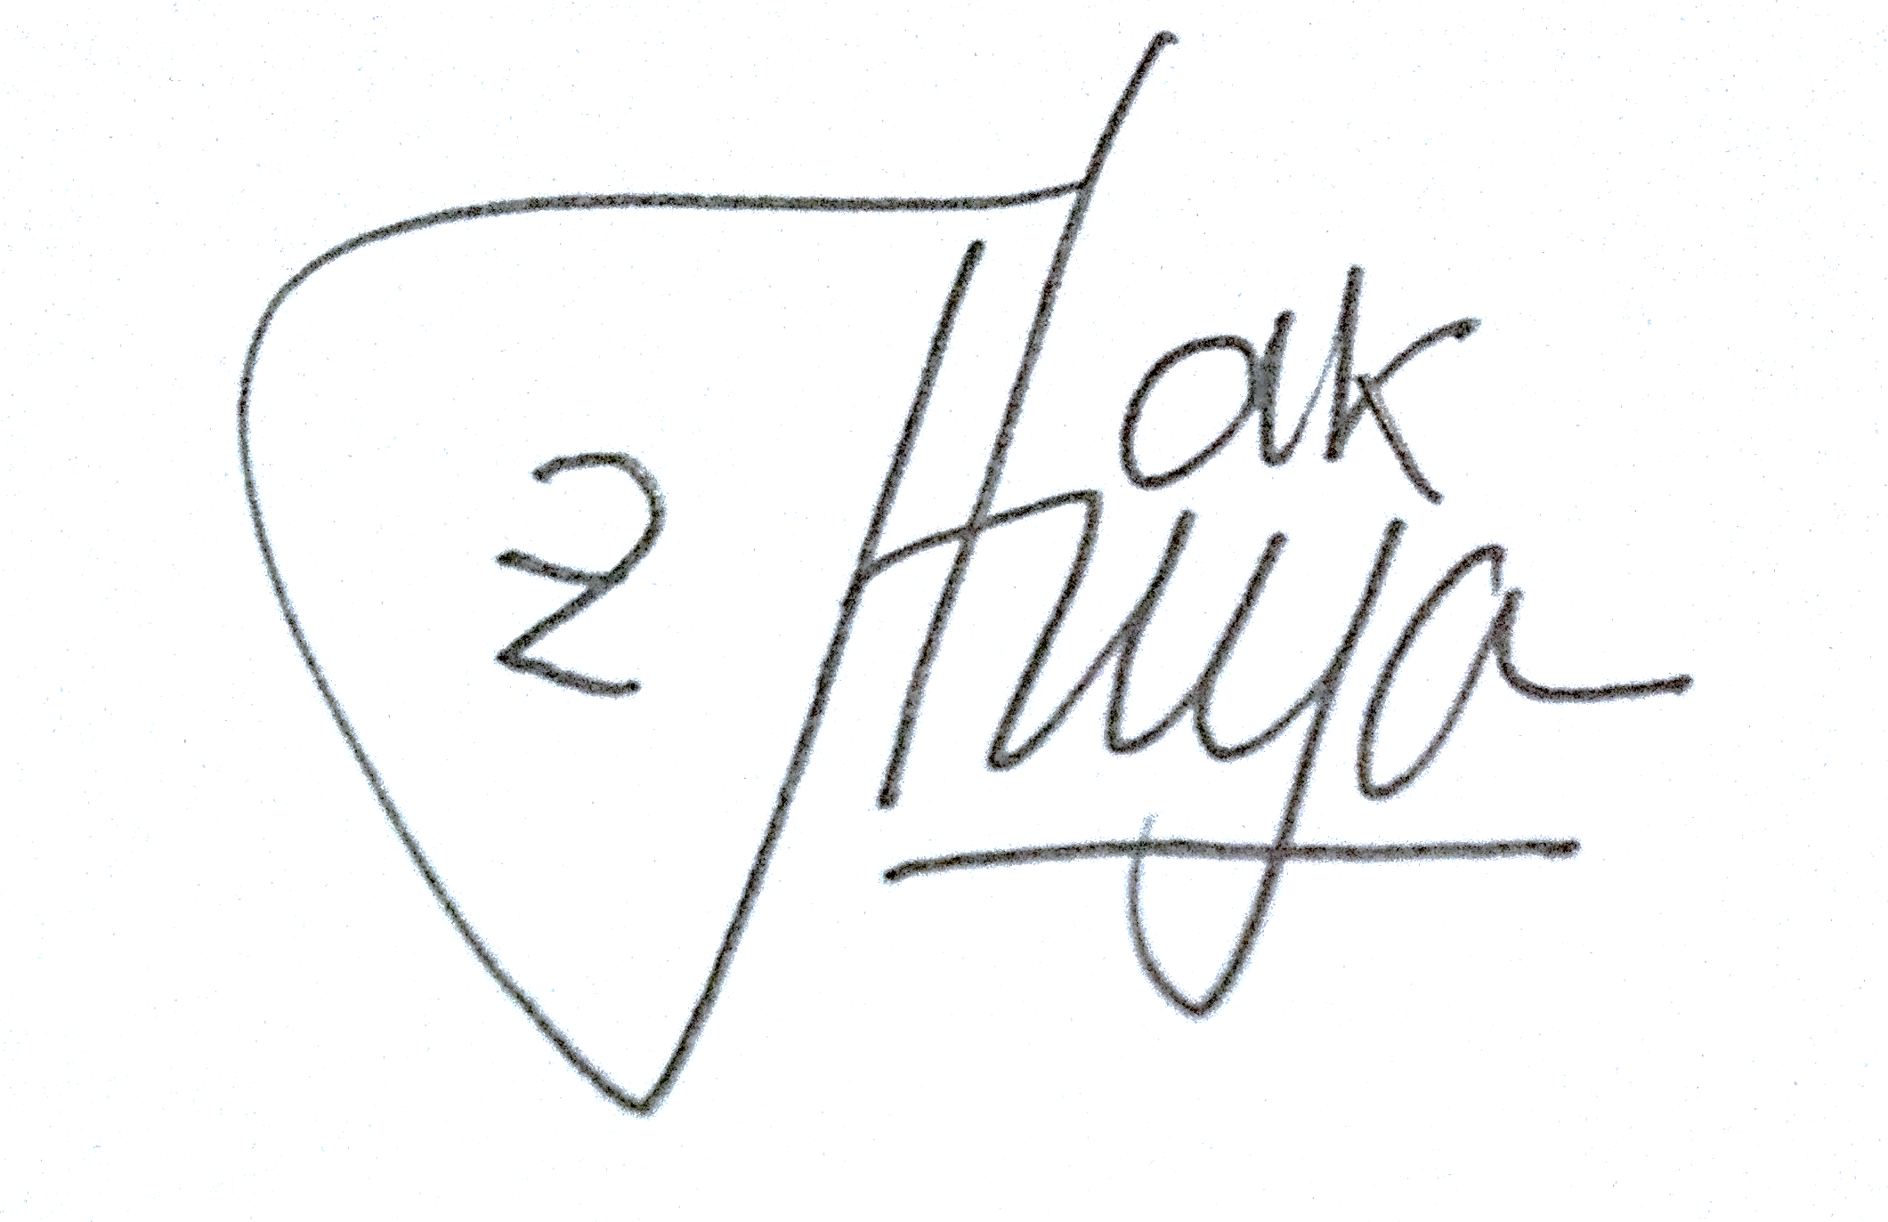  (Zakiyatul Khoiriyah) | 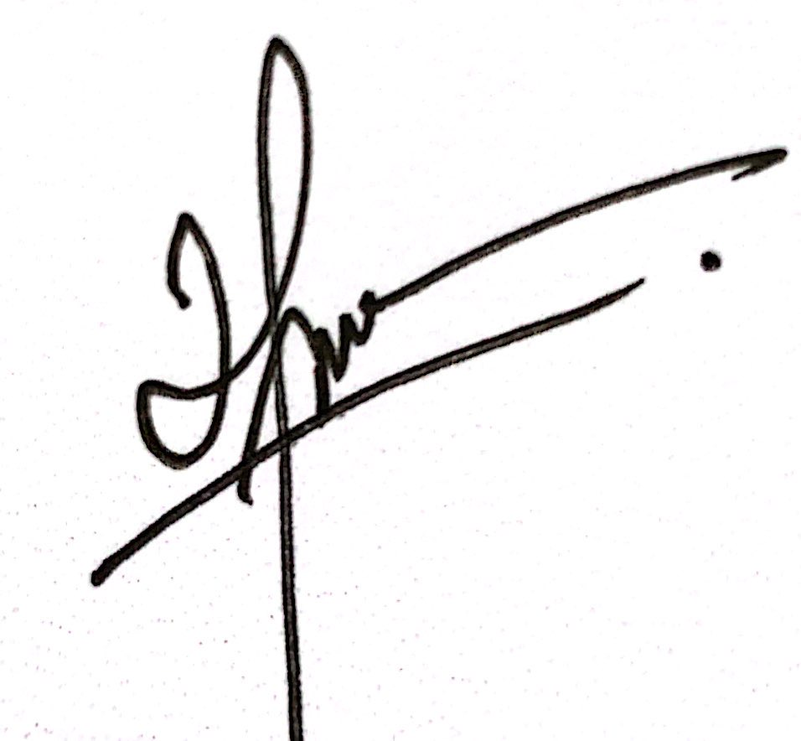  (Moh. Mirza Nuryady)

