Table 1. Guillard f/2 medium composition for diatom 1 L
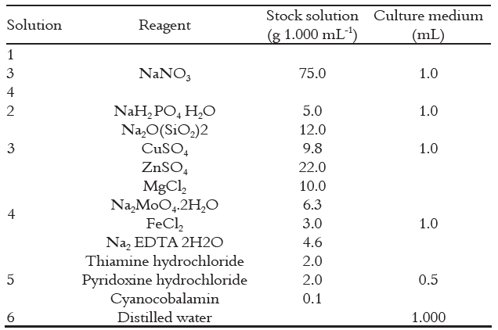
Table 2. Treatment of variations in silica concentration in Navicula sp medium.

No | Treatment | Repetition | Silica Concentration
1 | PK | 1 | 0 mL/L
1 | PK | 2 | 0 mL/L
1 | PK | 3 | 0 mL/L
2 | P1 | 1 | 1 mL/L
2 | P1 | 2 | 1 mL/L
2 | P1 | 3 | 1 mL/L
3 | P2 | 1 | 1.5 mL/L
3 | P2 | 2 | 1.5 mL/L
3 | P2 | 3 | 1.5 mL/L
4 | P3 | 1 | 2 mL/L
4 | P3 | 2 | 2 mL/L
4 | P3 | 3 | 2 mL/L
PK=Control treatment
P1=Treatment 1
P2=Treatment 2
P3=Treatment 3

(a)

(b)
Figure 1. Optical Density (OD) (a) and Specific Growth Rate (b) of Navicula sp. in one culture period. Different letters in Figure. 1b indicated significant differences between treatments and were calculated through one-way ANOVA followed by Duncan Multiple Range Test (DMRT) (p<0.05)

(a)

(b)

(c)
Figure 2. Navicula sp. biomass in 12 days (a), biomass productivity (b), and doubling time (c). The same letter (a) indicated insignificant differences among groups and was calculated through one-way ANOVA followed by Duncan Multiple Range Test (DMRT) (p>0.05).

(a)

(b)
Figure 3. Lipid content (a) and lipid productivity (b) of Navicula sp. during a culture period of 20 days. The same letter (a) indicated insignificant differences among groups and was calculated through one-way ANOVA followed by Duncan Multiple Range Test (DMRT) (p>0.05).

(a)

(b)
Figure 4. Carbohydrate content of Navicula sp. (a) and carbohydrate productivity (b). Different letters indicated significant differences between treatments and were calculated through by one-way ANOVA followed by Duncan Multiple Range Test (DMRT) (p<0.05).

Figure 5. Protein productivity of Navicula sp. during the culture period. Letter (a) indicated insignificant differences among groups and were calculated through one-way ANOVA followed by Duncan Multiple Range Test (DMRT) (p>0.05).

