AUTHOR’S STATEMENT

The undersigned below,
Name | : | Nina Ratna Djuita
Origin of affiliation | : | Institut Pertanian Bogor
Office address | : | Departemen Biologi, FMIPA, IPB, Jln Agatis Kampus Dramaga, Bogor
Office phone number | : | (0251) 8622833
Home address | : | Taman Dramaga Permai 2, Jl Asparagus Blok A4 no 6, Ciampea, Bogor
Mobile number | : | 087873645343
E-mail | : | ninadj@apps.ipb.ac.id
As the corresponding author in the manuscript entitled:
KERAGAMAN SERBUK SARI PADA TUMBUHAN LEGUM DI KAMPUS IPB, DRAMAGA, BOGOR

With the author’s order:
- Tiarana Brilyanita
- Nunik Sri Ariyanti
- Nina Ratna Djuita

Stated that the manuscript that I submitted to Al-Kauniyah: Jurnal Biologi is:
- Does not contain elements of plagiarism, according to applicable regulations
- Not being submitted to other journals
- Not being processed to be published in any form of publications
- All authors have agreed to the author’s order and agreed to the final form of the manuscript
- Willing to bear the risk of the accuracy of the data and will not hold the editor responsible for the data errors provided.

Thus, I make this statement in truth, and I am willing to accept all actions taken by the Editorial Board of Al-Kauniyah: Jurnal Biologi, if in the future it is proven that one or more of my statements are incorrect.

Bogor, 22 Desember 2022


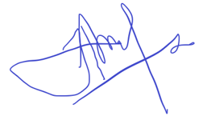
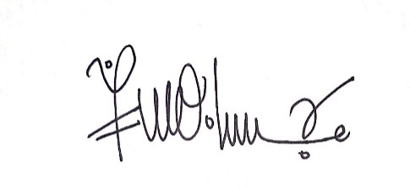

- (Tiarana Brilyanita ) (2). (Nunik Sri Ariyanti) (3). Nina Ratna Djuita

