EFA first pilot test
Descriptive frekuensi
Descriptive Statistics
 |  | Sex |  | Residence |  | Tribe |  | University |  | Faculty |  | Semester
Valid |  | 61 |  | 61 |  | 61 |  | 61 |  | 61 |  | 61
Missing |  | 0 |  | 0 |  | 0 |  | 0 |  | 0 |  | 0
Mean |  |  |  |  |  |  |  |  |  |  |  | 5.08
Std. Deviation |  |  |  |  |  |  |  |  |  |  |  | 2.41
Minimum |  |  |  |  |  |  |  |  |  |  |  | 2.00
Maximum |  |  |  |  |  |  |  |  |  |  |  | 8.00
Note. Not all values are available for Nominal Text variables

Frequency Tables
Frequencies for Sex
Sex |  | Frequency |  | Percent |  | Valid Percent |  | Cumulative Percent
men |  | 16 |  | 26.23 |  | 26.23 |  | 26.23
women |  | 45 |  | 73.77 |  | 73.77 |  | 100.00
Missing |  | 0 |  | 0.00
Total |  | 61 |  | 100.00

Frequencies for Residence
Residence |  | Frequency |  | Percent |  | Valid Percent |  | Cumulative Percent
Bersama orang tua |  | 51 |  | 83.61 |  | 83.61 |  | 83.61
Kost |  | 9 |  | 14.75 |  | 14.75 |  | 98.36
Rumah sendiri |  | 1 |  | 1.64 |  | 1.64 |  | 100.00
Missing |  | 0 |  | 0.00
Total |  | 61 |  | 100.00

Frequencies for Tribe
Tribe |  | Frequency |  | Percent |  | Valid Percent |  | Cumulative Percent
Aceh |  | 2 |  | 3.28 |  | 3.28 |  | 3.28
Banjar |  | 2 |  | 3.28 |  | 3.28 |  | 6.56
Banten |  | 1 |  | 1.64 |  | 1.64 |  | 8.20
Batak |  | 3 |  | 4.92 |  | 4.92 |  | 13.11
Gayo |  | 1 |  | 1.64 |  | 1.64 |  | 14.75
Jawa |  | 23 |  | 37.70 |  | 37.70 |  | 52.46
Karo |  | 1 |  | 1.64 |  | 1.64 |  | 54.10
Mandailing |  | 6 |  | 9.84 |  | 9.84 |  | 63.93
Melayu |  | 5 |  | 8.20 |  | 8.20 |  | 72.13
Minang |  | 8 |  | 13.11 |  | 13.11 |  | 85.25
Piliang |  | 1 |  | 1.64 |  | 1.64 |  | 86.89
Sunda |  | 1 |  | 1.64 |  | 1.64 |  | 88.52
batak |  | 2 |  | 3.28 |  | 3.28 |  | 91.80
jawa |  | 1 |  | 1.64 |  | 1.64 |  | 93.44
karo |  | 1 |  | 1.64 |  | 1.64 |  | 95.08
mandailing |  | 1 |  | 1.64 |  | 1.64 |  | 96.72
melayu |  | 2 |  | 3.28 |  | 3.28 |  | 100.00
Missing |  | 0 |  | 0.00
Total |  | 61 |  | 100.00

Frequencies for University
University |  | Frequency |  | Percent |  | Valid Percent |  | Cumulative Percent
University Brawijaya |  | 1 |  | 1.64 |  | 1.64 |  | 1.64
University Harapan Medan |  | 1 |  | 1.64 |  | 1.64 |  | 3.28
University Islam Negeri Sumatera Utara |  | 9 |  | 14.75 |  | 14.75 |  | 18.03
University Islam Sumatera Utara |  | 1 |  | 1.64 |  | 1.64 |  | 19.67
University Medan Area |  | 43 |  | 70.49 |  | 70.49 |  | 90.16
University Muhammadiyah Sumatera Utara |  | 3 |  | 4.92 |  | 4.92 |  | 95.08
University Negeri Medan |  | 2 |  | 3.28 |  | 3.28 |  | 98.36
university sari mutiara indonesia |  | 1 |  | 1.64 |  | 1.64 |  | 100.00
Missing |  | 0 |  | 0.00
Total |  | 61 |  | 100.00

Frequencies for Faculty
Faculty |  | Frequency |  | Percent |  | Valid Percent |  | Cumulative Percent
Dakwah dan Komunikasi |  | 1 |  | 1.64 |  | 1.64 |  | 1.64
Hukum |  | 3 |  | 4.92 |  | 4.92 |  | 6.56
Ilmu Tarbiyah dan Keguruan |  | 4 |  | 6.56 |  | 6.56 |  | 13.11
Ilmu tarbiyah dan keguruan |  | 1 |  | 1.64 |  | 1.64 |  | 14.75
Psikologi |  | 37 |  | 60.66 |  | 60.66 |  | 75.41
Sains dan teknologi |  | 2 |  | 3.28 |  | 3.28 |  | 78.69
Teknik |  | 4 |  | 6.56 |  | 6.56 |  | 85.25
Agama Islam |  | 2 |  | 3.28 |  | 3.28 |  | 88.52
Bahasa dan Komunikasi |  | 1 |  | 1.64 |  | 1.64 |  | 90.16
Ilmu Pendidikan |  | 1 |  | 1.64 |  | 1.64 |  | 91.80
Ilmu Sosial |  | 1 |  | 1.64 |  | 1.64 |  | 93.44
Keguruan dan Ilmu Pendidikan |  | 1 |  | 1.64 |  | 1.64 |  | 95.08
ekonomi dan bisnis |  | 1 |  | 1.64 |  | 1.64 |  | 96.72
Pertanian |  | 1 |  | 1.64 |  | 1.64 |  | 98.36
farmasi dan ilmu kesehatan |  | 1 |  | 1.64 |  | 1.64 |  | 100.00
Missing |  | 0 |  | 0.00
Total |  | 61 |  | 100.00

Frequencies for Semester
Semester |  | Frequency |  | Percent |  | Valid Percent |  | Cumulative Percent
2 |  | 20 |  | 32.79 |  | 32.79 |  | 32.79
4 |  | 4 |  | 6.56 |  | 6.56 |  | 39.34
6 |  | 21 |  | 34.43 |  | 34.43 |  | 73.77
8 |  | 16 |  | 26.23 |  | 26.23 |  | 100.00
Missing |  | 0 |  | 0.00
Total |  | 61 |  | 100.00

Descriptive sex
Descriptive Statistics
 |  | total
 |  | men |  | women
Valid |  | 16 |  | 45
Missing |  | 0 |  | 0
Mean |  | 102.00 |  | 100.44
Std. Deviation |  | 12.43 |  | 9.03
Minimum |  | 87.00 |  | 82.00
Maximum |  | 132.00 |  | 122.00

Exploratory Factor Analysis first pilot test

Kaiser-Meyer-Olkin test
 |  | MSA
Overall MSA |  | 0.46
b1 |  | 0.50
b2 |  | 0.42
b3 |  | 0.51
b4 |  | 0.41
b5 |  | 0.40
b6 |  | 0.42
b7 |  | 0.60
b8 |  | 0.27
b9 |  | 0.31
b10 |  | 0.28
b11 |  | 0.37
b12 |  | 0.52
b13 |  | 0.49
b14 |  | 0.58
b15 |  | 0.43
b16 |  | 0.58
b17 |  | 0.21
b18 |  | 0.69
b19 |  | 0.30
b20 |  | 0.32
b21 |  | 0.64
b22 |  | 0.41
b23 |  | 0.44
b24 |  | 0.41
b25 |  | 0.38
b26 |  | 0.54
b27 |  | 0.53
b28 |  | 0.68
b29 |  | 0.60
b30 |  | 0.28
b31 |  | 0.69
b32 |  | 0.49

Bartlett's test
Χ² |  | df |  | p
823.38 |  | 496.00 |  | < .001

Chi-squared Test
 |  | Value |  | df |  | p
Model |  | 563.81 |  | 433 |  | < .001

Factor Loadings
 |  | Factor 1 |  | Factor 2 |  | Uniqueness
b1 |  |  |  |  |  | 0.94
b2 |  |  |  |  |  | 0.97
b3 |  | 0.48 |  |  |  | 0.77
b4 |  |  |  |  |  | 0.93
b5 |  |  |  |  |  | 0.91
b6 |  |  |  |  |  | 0.94
b7 |  | 0.60 |  |  |  | 0.64
b8 |  |  |  |  |  | 0.84
b9 |  |  |  |  |  | 0.95
b10 |  |  |  |  |  | 0.93
b11 |  |  |  |  |  | 0.91
b12 |  |  |  |  |  | 0.93
b13 |  |  |  |  |  | 0.82
b14 |  |  |  |  |  | 0.80
b15 |  | 0.43 |  |  |  | 0.81
b16 |  | 0.55 |  |  |  | 0.68
b17 |  |  |  |  |  | 0.99
b18 |  |  |  | 0.83 |  | 0.28
b19 |  |  |  |  |  | 0.95
b20 |  |  |  |  |  | 0.96
b21 |  |  |  | 0.86 |  | 0.22
b22 |  |  |  | 0.57 |  | 0.65
b23 |  |  |  |  |  | 0.99
b24 |  | 0.46 |  |  |  | 0.78
b25 |  |  |  | 0.44 |  | 0.76
b26 |  |  |  | 0.52 |  | 0.69
b27 |  | 0.58 |  |  |  | 0.64
b28 |  | 0.64 |  |  |  | 0.57
b29 |  | -0.40 |  | 0.43 |  | 0.65
b30 |  |  |  |  |  | 0.91
b31 |  | 0.42 |  | -0.43 |  | 0.64
b32 |  | 0.41 |  |  |  | 0.82
Note. Applied rotation method is varimax.

Factor Characteristics
 |  | SumSq. Loadings |  | Proportion var. |  | Cumulative
Factor 1 |  | 3.49 |  | 0.11 |  | 0.11
Factor 2 |  | 3.25 |  | 0.10 |  | 0.21

Factor Correlations
 |  | Factor 1 |  | Factor 2
Factor 1 |  | 1.00 |  | -0.06
Factor 2 |  | -0.06 |  | 1.00

Path Diagram
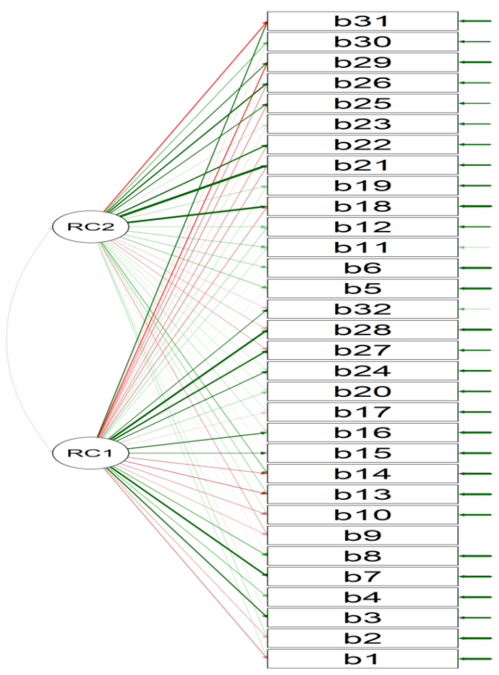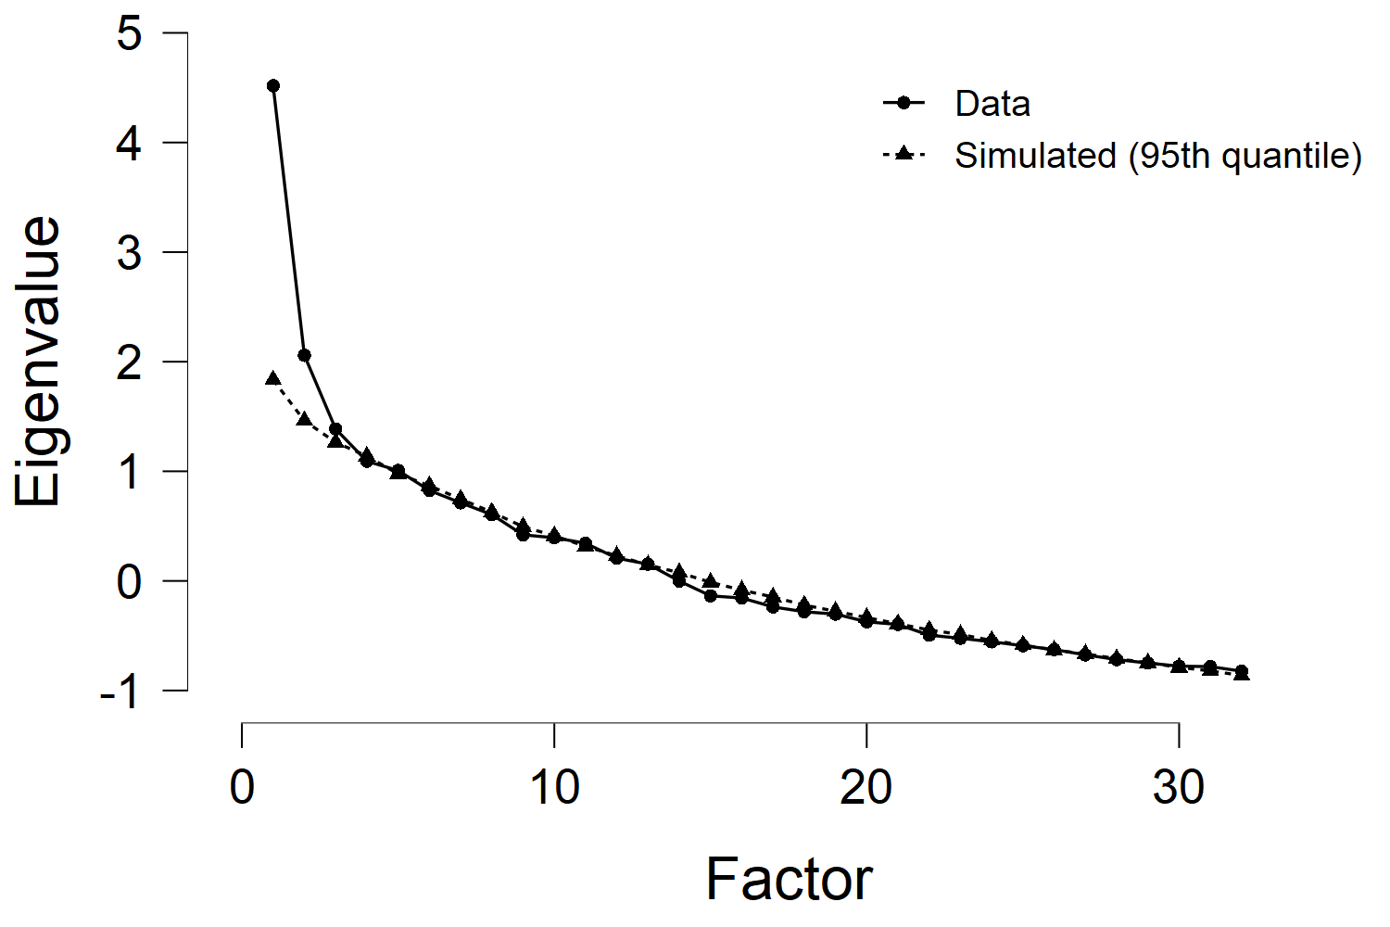

EFA second pilot test

Descriptive total
Descriptive Statistics
 |  | Sex |  | Gender |  | Order in the family |  | Parenting style |  | Personality |  | Skill tendency |  | Tribe |  | University |  | Semester
Valid |  | 183 |  | 183 |  | 183 |  | 183 |  | 183 |  | 183 |  | 183 |  | 183 |  | 183
Missing |  | 0 |  | 0 |  | 0 |  | 0 |  | 0 |  | 0 |  | 0 |  | 0 |  | 0
Mean |  |  |  |  |  |  |  |  |  |  |  |  |  |  |  |  |  | 3.58
Std. Deviation |  |  |  |  |  |  |  |  |  |  |  |  |  |  |  |  |  | 2.29
Minimum |  |  |  |  |  |  |  |  |  |  |  |  |  |  |  |  |  | 1.00
Maximum |  |  |  |  |  |  |  |  |  |  |  |  |  |  |  |  |  | 8.00
Note. Not all values are available for Nominal Text variables

Frequency Tables
Frequencies for Sex
Sex |  | Frequency |  | Percent |  | Valid Percent |  | Cumulative Percent
Men |  | 22 |  | 12.02 |  | 12.02 |  | 12.02
Women |  | 161 |  | 87.98 |  | 87.98 |  | 100.00
Missing |  | 0 |  | 0.00
Total |  | 183 |  | 100.00

Frequencies for Gender
Gender |  | Frequency |  | Percent |  | Valid Percent |  | Cumulative Percent
Androgini (Memiliki peran seimbang antara maskulin dan feminim) |  | 103 |  | 56.28 |  | 56.28 |  | 56.28
Feminim (Lembut, sabar, penyayang, dst) |  | 54 |  | 29.51 |  | 29.51 |  | 85.79
Maskulin (berani, mandiri, tegas, kuat, ambisius, agresif, dst) |  | 26 |  | 14.21 |  | 14.21 |  | 100.00
Missing |  | 0 |  | 0.00
Total |  | 183 |  | 100.00

Frequencies for Order in the family
Order in the family |  | Frequency |  | Percent |  | Valid Percent |  | Cumulative Percent
Pertama |  | 65 |  | 35.52 |  | 35.52 |  | 35.52
Tengah |  | 67 |  | 36.61 |  | 36.61 |  | 72.13
Terakhir |  | 51 |  | 27.87 |  | 27.87 |  | 100.00
Missing |  | 0 |  | 0.00
Total |  | 183 |  | 100.00

Frequencies for Parenting style
Parenting style |  | Frequency |  | Percent |  | Valid Percent |  | Cumulative Percent
Demokratis (Anak diberikan batasan dan konsekuensi yang konsisten, orang tua tetap memberikan pujian, dukungan emosional, dan ha |  | 135 |  | 73.77 |  | 73.77 |  | 73.77
Neglectful (orang tua tidak terlibat penuh dengan anak, tidak mengetahui aktifitas anak dan tidak mau tau, merasa anak dapat ber |  | 8 |  | 4.37 |  | 4.37 |  | 78.14
Otoriter (kaku, tegas, menerapkan hukuman jika tidak sesuai aturan. Orang tua cenderung selalu benar dalam mengemukakan pendapat |  | 27 |  | 14.75 |  | 14.75 |  | 92.90
Permisif (orang tua selalu mendorong anaknya untuk berbuat bebas, semaunya, mewujudkan apa yang anak mau, dan tidak memberikan b |  | 13 |  | 7.10 |  | 7.10 |  | 100.00
Missing |  | 0 |  | 0.00
Total |  | 183 |  | 100.00

Frequencies for Personality
Personality |  | Frequency |  | Percent |  | Valid Percent |  | Cumulative Percent
Ambivert (memiliki pribadi introvert dan ekstrovert) |  | 81 |  | 44.26 |  | 44.26 |  | 44.26
Ekstrovert (terbuka, senang bicara, banyak teman, fleksibel, dst) |  | 51 |  | 27.87 |  | 27.87 |  | 72.13
Introvert (tertutup, senang sendiri, banyak diam, sadar akan diri sendiri, teman sedikit, dst) |  | 51 |  | 27.87 |  | 27.87 |  | 100.00
Missing |  | 0 |  | 0.00
Total |  | 183 |  | 100.00

Frequencies for Skill tendency
Skill tendency |  | Frequency |  | Percent |  | Valid Percent |  | Cumulative Percent
Akademisi (pernah atau sedang membuat buku, cerpen, puisi, mengikuti kompetisi penelitian, pembuatan makalah, dst) |  | 35 |  | 19.13 |  | 19.13 |  | 19.13
Pengusaha/ entrepreneur (Sedang atau pernah jualan di kampus atau diluar, ingin membuka toko offline maupun online, dst) ) |  | 39 |  | 21.31 |  | 21.31 |  | 40.44
Politisi (Sedang atau pernah mengikuti kompetisi debat mahasiswa, mengikuti banyak organisasi, menjabat dalam organisasi) |  | 6 |  | 3.28 |  | 3.28 |  | 43.72
Praktisi (Setelah selesai kuliah ingin bekerja, mencari karir di perusahaan, berpakian seragam dan rapi, mengejar jabatan di per |  | 103 |  | 56.28 |  | 56.28 |  | 100.00
Missing |  | 0 |  | 0.00
Total |  | 183 |  | 100.00

Frequencies for Tribe
Tribe |  | Frequency |  | Percent |  | Valid Percent |  | Cumulative Percent
1. Tribe Kubu - Sumatra (Jambi) |  | 1 |  | 0.55 |  | 0.55 |  | 0.55
15. Tribe Batak - Sumatra |  | 16 |  | 8.74 |  | 8.74 |  | 9.29
16. Tribe Batak Angkola - Sumatra |  | 3 |  | 1.64 |  | 1.64 |  | 10.93
17. Tribe Batak Karo - Sumatra |  | 4 |  | 2.19 |  | 2.19 |  | 13.11
18. Tribe Batak Mandailing - Sumatra |  | 37 |  | 20.22 |  | 20.22 |  | 33.33
20. Tribe Batak Simalungun - Sumatra |  | 4 |  | 2.19 |  | 2.19 |  | 35.52
21. Tribe Batak Toba - Sumatra |  | 5 |  | 2.73 |  | 2.73 |  | 38.25
23. Tribe Minangkabau - Sumatra |  | 15 |  | 8.20 |  | 8.20 |  | 46.45
24. Tribe Melayu - Sumatra |  | 23 |  | 12.57 |  | 12.57 |  | 59.02
3. Tribe Gayo - Sumatra |  | 1 |  | 0.55 |  | 0.55 |  | 59.56
35. Tribe Sunda - Pulau Jawa |  | 1 |  | 0.55 |  | 0.55 |  | 60.11
36. Tribe Jawa - Pulau Jawa |  | 64 |  | 34.97 |  | 34.97 |  | 95.08
4. Tribe Aceh - Sumatra |  | 4 |  | 2.19 |  | 2.19 |  | 97.27
45. Tribe Banjar - Kalimantan |  | 3 |  | 1.64 |  | 1.64 |  | 98.91
5. Tribe Alas - Sumatra |  | 1 |  | 0.55 |  | 0.55 |  | 99.45
Tribe Bugis - Sulawesi |  | 1 |  | 0.55 |  | 0.55 |  | 100.00
Missing |  | 0 |  | 0.00
Total |  | 183 |  | 100.00

Frequencies for University
University |  | Frequency |  | Percent |  | Valid Percent |  | Cumulative Percent
Unimed |  | 1 |  | 0.55 |  | 0.55 |  | 0.55
University Islam Negeri Sultan Syarif Kasim Riau |  | 1 |  | 0.55 |  | 0.55 |  | 1.09
University Islam Negeri Sumatera Utara |  | 167 |  | 91.26 |  | 91.26 |  | 92.35
University Medan Area |  | 7 |  | 3.83 |  | 3.83 |  | 96.17
University Muhammadiyah Sumatera Utara |  | 4 |  | 2.19 |  | 2.19 |  | 98.36
University Negeri Malang |  | 1 |  | 0.55 |  | 0.55 |  | 98.91
University Sumatera Utara |  | 2 |  | 1.09 |  | 1.09 |  | 100.00
Missing |  | 0 |  | 0.00
Total |  | 183 |  | 100.00

Frequencies for Semester
Semester |  | Frequency |  | Percent |  | Valid Percent |  | Cumulative Percent
1 |  | 1 |  | 0.55 |  | 0.55 |  | 0.55
2 |  | 116 |  | 63.39 |  | 63.39 |  | 63.93
4 |  | 12 |  | 6.56 |  | 6.56 |  | 70.49
6 |  | 29 |  | 15.85 |  | 15.85 |  | 86.34
8 |  | 25 |  | 13.66 |  | 13.66 |  | 100.00
Missing |  | 0 |  | 0.00
Total |  | 183 |  | 100.00

Exploratory Factor Analysis pilot test
Kaiser-Meyer-Olkin test
 |  | MSA
Overall MSA |  | 0.84
b1 |  | 0.77
b2 |  | 0.84
b3 |  | 0.85
b4 |  | 0.88
b5 |  | 0.87
b6 |  | 0.86
b7 |  | 0.84
b8 |  | 0.85
b9 |  | 0.83
b10 |  | 0.89
b11 |  | 0.76
b12 |  | 0.82
b13 |  | 0.89
b14 |  | 0.74
b15 |  | 0.80
b16 |  | 0.76
b17 |  | 0.77
b18 |  | 0.79
b19 |  | 0.76
b20 |  | 0.83
b21 |  | 0.84
b22 |  | 0.90
b23 |  | 0.88
b24 |  | 0.87

Bartlett's test
Χ² |  | df |  | p
1472.45 |  | 276.00 |  | < .001

Chi-squared Test
 |  | Value |  | df |  | p
Model |  | 398.86 |  | 207 |  | < .001

Factor Loadings
 |  | Factor 1 |  | Factor 2 |  | Factor 3 |  | Uniqueness
b1 |  |  |  |  |  | 0.52 |  | 0.73
b2 |  |  |  |  |  | 0.57 |  | 0.63
b3 |  |  |  |  |  | 0.56 |  | 0.56
b4 |  |  |  |  |  |  |  | 0.78
b5 |  |  |  |  |  | 0.76 |  | 0.32
b6 |  |  |  |  |  | 0.58 |  | 0.51
b7 |  | 0.53 |  |  |  |  |  | 0.64
b8 |  |  |  |  |  |  |  | 0.84
b9 |  | 0.75 |  |  |  |  |  | 0.41
b10 |  | 0.54 |  |  |  |  |  | 0.65
b11 |  |  |  |  |  |  |  | 0.73
b12 |  |  |  | 0.65 |  |  |  | 0.55
b13 |  | 0.46 |  |  |  |  |  | 0.66
b14 |  | 0.43 |  |  |  |  |  | 0.80
b15 |  |  |  | 0.53 |  |  |  | 0.71
b16 |  |  |  |  |  |  |  | 0.84
b17 |  |  |  | 0.48 |  |  |  | 0.71
b18 |  |  |  |  |  |  |  | 0.74
b19 |  |  |  |  |  |  |  | 0.83
b20 |  |  |  | 0.43 |  |  |  | 0.76
b21 |  |  |  | 0.71 |  |  |  | 0.38
b22 |  |  |  | 0.45 |  |  |  | 0.57
b23 |  | 0.55 |  |  |  |  |  | 0.63
b24 |  |  |  |  |  |  |  | 0.66
Note. Applied rotation method is varimax.

Factor Characteristics
 |  | SumSq. Loadings |  | Proportion var. |  | Cumulative
Factor 1 |  | 2.90 |  | 0.12 |  | 0.12
Factor 2 |  | 2.75 |  | 0.11 |  | 0.24
Factor 3 |  | 2.72 |  | 0.11 |  | 0.35

Factor Correlations
 |  | Factor 1 |  | Factor 2 |  | Factor 3
Factor 1 |  | 1.00 |  | 0.10 |  | 0.11
Factor 2 |  | 0.10 |  | 1.00 |  | 0.11
Factor 3 |  | 0.11 |  | 0.11 |  | 1.00

Scree plot
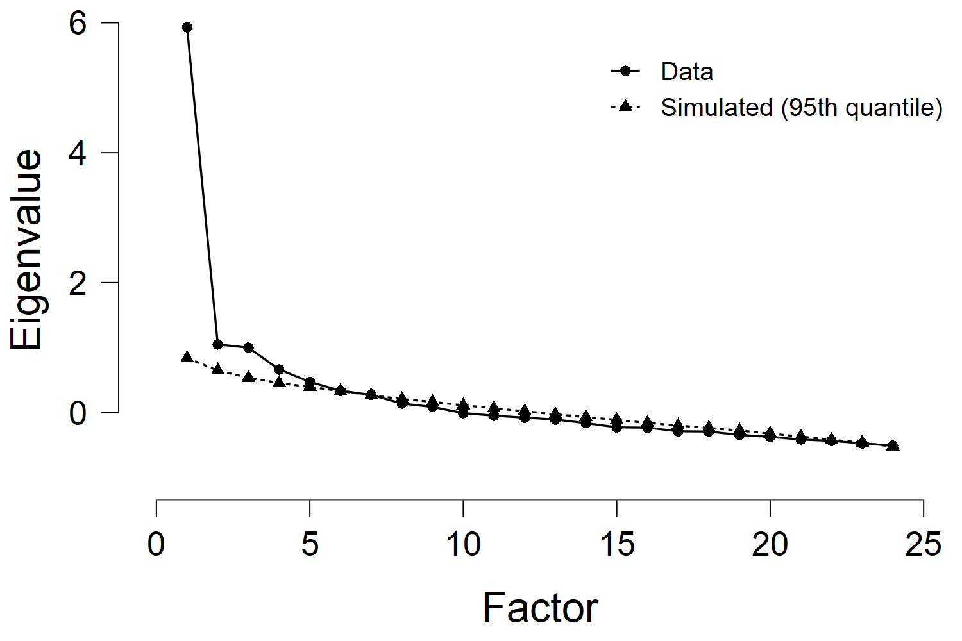

Descriptive total 3 skala dari sex
Descriptive Statistics
 |  | jihad academic |  |  | academic resilience |  |  |  | school burnout inventory
 |  | P |  | W | P |  | W |  | P |  |  | W
Valid |  | 70 |  | 113 |  | 70 |  | 113 |  | 70 |  |  | 113
Missing |  | 0 |  | 0 |  | 0 |  | 0 |  | 0 |  |  | 0
Mean |  | 68.60 |  | 68.59 |  | 62.56 |  | 61.96 |  | 24.23 |  |  | 24.97
Median |  | 70.00 |  | 69.00 |  | 62.00 |  | 61.00 |  | 23.50 |  |  | 25.00
Mode | ᵃ | 80.00 |  | 68.00 |  | 57.00 |  | 56.00 |  | 23.00 |  |  | 22.00
Std. Deviation |  | 10.61 |  | 7.06 |  | 9.39 |  | 7.86 |  | 9.36 |  |  | 7.82
Minimum |  | 16.00 |  | 38.00 |  | 40.00 |  | 45.00 |  | 9.00 |  |  | 12.00
Maximum |  | 80.00 |  | 80.00 |  | 85.00 |  | 85.00 |  | 45.00 |  |  | 45.00
Sum |  | 4802.00 |  | 7751.00 |  | 4379.00 |  | 7001.00 |  | 1696.00 |  |  | 2822.00
ᵃ More than one mode exists, only the first is reported

Descriptive total 3 skala dari gender
Descriptive Statistics
 |  | jihad academic |  |  |  |  |  |  |  | academic resilience |  |  |  |  |  |  |  | school burnout inventory
 |  | A |  | F |  | M |  | T |  | A |  | F |  | M |  | T |  | A |  | F |  | M |  | T
Valid |  | 93 |  | 37 |  | 46 |  | 7 |  | 93 |  | 37 |  | 46 |  | 7 |  | 93 |  | 37 |  | 46 |  | 7
Missing |  | 0 |  | 0 |  | 0 |  | 0 |  | 0 |  | 0 |  | 0 |  | 0 |  | 0 |  | 0 |  | 0 |  | 0
Mean |  | 68.47 |  | 67.95 |  | 69.43 |  | 68.14 |  | 62.58 |  | 60.24 |  | 63.17 |  | 60.71 |  | 26.30 |  | 22.03 |  | 22.59 |  | 31.14
Median |  | 68.00 |  | 69.00 |  | 72.00 |  | 67.00 |  | 61.00 |  | 59.00 |  | 62.50 |  | 57.00 |  | 27.00 |  | 21.00 |  | 22.50 |  | 32.00
Mode | ᵃ | 68.00 |  | 61.00 |  | 76.00 |  | 60.00 |  | 56.00 |  | 56.00 |  | 62.00 |  | 53.00 |  | 29.00 |  | 17.00 |  | 23.00 |  | 16.00
Std. Deviation |  | 7.25 |  | 7.58 |  | 11.65 |  | 6.91 |  | 8.43 |  | 7.67 |  | 9.16 |  | 7.80 |  | 8.09 |  | 7.46 |  | 8.75 |  | 8.67
Minimum |  | 38.00 |  | 51.00 |  | 16.00 |  | 60.00 |  | 44.00 |  | 46.00 |  | 40.00 |  | 53.00 |  | 9.00 |  | 9.00 |  | 9.00 |  | 16.00
Maximum |  | 80.00 |  | 80.00 |  | 80.00 |  | 80.00 |  | 85.00 |  | 85.00 |  | 85.00 |  | 72.00 |  | 45.00 |  | 45.00 |  | 45.00 |  | 45.00
Sum |  | 6368.00 |  | 2514.00 |  | 3194.00 |  | 477.00 |  | 5820.00 |  | 2229.00 |  | 2906.00 |  | 425.00 |  | 2446.00 |  | 815.00 |  | 1039.00 |  | 218.00
ᵃ More than one mode exists, only the first is reported
A= Androgini; F=Feminim;M=Maskulin;T=Tidak tergolong

SECTION VALIDITY AND RELIABILITY

Validity dan Reliability item jihad academic
Frequentist Scale Reliability Statistics
Estimate |  |  |  |  | McDonald's |  | Cronbach's |  | Average interitem correlation
Point estimate |  |  |  |  | 0.88 |  | 0.88 |  | 0.34
95% CI lower bound |  |  |  |  | 0.85 |  |  |  | 0.85
95% CI upper bound |  |  |  |  | 0.91 |  |  |  | 0.91
Frequentist Individual Item Reliability Statistics
 |  | If item dropped
Item |  | McDonald's |  | Cronbach's |  | Item-rest correlation
p1 |  | 0.87 |  | 0.87 |  | 0.60
p2 |  | 0.88 |  | 0.88 |  | 0.38
p3 |  | 0.88 |  | 0.88 |  | 0.48
p4 |  | 0.88 |  | 0.88 |  | 0.49
p5 |  | 0.89 |  | 0.89 |  | 0.32
p6 |  | 0.87 |  | 0.88 |  | 0.52
k1 |  | 0.87 |  | 0.87 |  | 0.62
k2 |  | 0.88 |  | 0.88 |  | 0.43
k3 |  | 0.87 |  | 0.88 |  | 0.50
k4 |  | 0.87 |  | 0.87 |  | 0.64
k5 |  | 0.87 |  | 0.87 |  | 0.65
k6 |  | 0.87 |  | 0.87 |  | 0.63
e1 |  | 0.87 |  | 0.87 |  | 0.63
e2 |  | 0.87 |  | 0.87 |  | 0.68
e3 |  | 0.87 |  | 0.87 |  | 0.58
e4 |  | 0.87 |  | 0.87 |  | 0.60

Validity dan Reliability item resiliensi academic
Frequentist Scale Reliability Statistics
Estimate |  |  | McDonald's |  | Cronbach's |  | Average interitem correlation
Point estimate |  |  | 0.82 |  | 0.87 |  | 0.30
95% CI lower bound |  |  | 0.84 |  |  |  | 0.78
95% CI upper bound |  |  | 0.89 |  |  |  | 0.86
Frequentist Individual Item Reliability Statistics
 |  | If item dropped
Item |  | McDonald's |  | Cronbach's |  | Item-rest correlation
per1 |  | 0.81 |  | 0.86 |  | 0.43
per2 |  | 0.81 |  | 0.86 |  | 0.46
per3 |  | 0.79 |  | 0.86 |  | 0.56
per4 |  | 0.81 |  | 0.87 |  | 0.25
per5 |  | 0.80 |  | 0.86 |  | 0.58
per6 |  | 0.80 |  | 0.86 |  | 0.58
ref1 |  | 0.80 |  | 0.86 |  | 0.49
ref2 |  | 0.80 |  | 0.86 |  | 0.58
ref3 |  | 0.81 |  | 0.86 |  | 0.38
ref4 |  | 0.80 |  | 0.86 |  | 0.54
ref5 |  | 0.80 |  | 0.86 |  | 0.43
ne1 |  | 0.82 |  | 0.86 |  | 0.42
ne2 |  | 0.82 |  | 0.86 |  | 0.51
ne3 |  | 0.82 |  | 0.86 |  | 0.52
ne4 |  | 0.82 |  | 0.86 |  | 0.59
ne5 |  | 0.81 |  | 0.85 |  | 0.61
ne6 |  | 0.81 |  | 0.85 |  | 0.61
Note. The following items were reverse scaled: ne1, ne2, ne3, ne4, ne5, ne6.

Validity dan Reliability item school burnout inventory
Frequentist Scale Reliability Statistics
Estimate |  |  |  |  | McDonald's |  | Cronbach's |  | Average interitem correlation
Point estimate |  |  |  |  | 0.89 |  | 0.90 |  | 0.49
95% CI lower bound |  |  |  |  | 0.87 |  |  |  | 0.87
95% CI upper bound |  |  |  |  | 0.92 |  |  |  | 0.92
Frequentist Individual Item Reliability Statistics
 |  | If item dropped
Item |  | McDonald's |  | Cronbach's |  | Item-rest correlation
ke1 |  | 0.88 |  | 0.89 |  | 0.64
ke2 |  | 0.88 |  | 0.88 |  | 0.67
ke3 |  | 0.89 |  | 0.89 |  | 0.62
ke4 |  | 0.89 |  | 0.89 |  | 0.52
ke5 |  | 0.88 |  | 0.88 |  | 0.69
si1 |  | 0.88 |  | 0.87 |  | 0.77
si2 |  | 0.88 |  | 0.88 |  | 0.76
si3 |  | 0.89 |  | 0.89 |  | 0.59
si4 |  | 0.88 |  | 0.88 |  | 0.67

Section CFA

Deskriptif scale

Descriptive Statistics
 |  | jihad academic |  | academic resilience |  | school burnout inventory
Valid |  | 183 |  | 183 |  | 183
Missing |  | 0 |  | 0 |  | 0
Mean |  | 68.60 |  | 62.19 |  | 24.69
Median |  | 69.00 |  | 61.00 |  | 24.00
Mode |  | 68.00 |  | 61.00 |  | 23.00
Std. Deviation |  | 8.56 |  | 8.46 |  | 8.43
Skewness |  | -1.89 |  | 0.55 |  | 0.37
Std. Error of Skewness |  | 0.18 |  | 0.18 |  | 0.18
Kurtosis |  | 8.14 |  | 1.08 |  | -0.06
Std. Error of Kurtosis |  | 0.36 |  | 0.36 |  | 0.36
Shapiro-Wilk |  | 0.87 |  | 0.96 |  | 0.98
P-value of Shapiro-Wilk |  | < .001 |  | < .001 |  | 3.69e -3
Minimum |  | 16.00 |  | 40.00 |  | 9.00
Maximum |  | 80.00 |  | 85.00 |  | 45.00
Sum |  | 12553.00 |  | 11380.00 |  | 4518.00

Descriptive Statistics
 |  | p1 |  | p2 |  | p3 |  | p4 |  | p5 |  | p6 |  | k1 |  | k2 |  | k3 |  | k4 |  | k5 |  | k6 |  | e1 |  | e2 |  | e3 |  | e4 |  | ne4 |  | total ja
Valid |  | 183 |  | 183 |  | 183 |  | 183 |  | 183 |  | 183 |  | 183 |  | 183 |  | 183 |  | 183 |  | 183 |  | 183 |  | 183 |  | 183 |  | 183 |  | 183 |  | 183 |  | 183
Missing |  | 0 |  | 0 |  | 0 |  | 0 |  | 0 |  | 0 |  | 0 |  | 0 |  | 0 |  | 0 |  | 0 |  | 0 |  | 0 |  | 0 |  | 0 |  | 0 |  | 0 |  | 0
Mean |  | 3.90 |  | 3.72 |  | 3.98 |  | 4.25 |  | 4.33 |  | 3.81 |  | 4.54 |  | 4.61 |  | 4.14 |  | 4.66 |  | 4.60 |  | 4.19 |  | 4.41 |  | 4.51 |  | 4.43 |  | 4.54 |  | 2.55 |  | 68.60
Median |  | 4.00 |  | 4.00 |  | 4.00 |  | 5.00 |  | 5.00 |  | 4.00 |  | 5.00 |  | 5.00 |  | 4.00 |  | 5.00 |  | 5.00 |  | 4.00 |  | 5.00 |  | 5.00 |  | 5.00 |  | 5.00 |  | 2.00 |  | 69.00
Mode |  | 5.00 |  | 3.00 |  | 5.00 |  | 5.00 |  | 5.00 |  | 3.00 |  | 5.00 |  | 5.00 |  | 5.00 |  | 5.00 |  | 5.00 |  | 5.00 |  | 5.00 |  | 5.00 |  | 5.00 |  | 5.00 |  | 1.00 |  | 68.00
Std. Deviation |  | 0.96 |  | 1.10 |  | 1.05 |  | 0.95 |  | 1.15 |  | 0.86 |  | 0.78 |  | 0.84 |  | 0.93 |  | 0.69 |  | 0.72 |  | 0.91 |  | 0.82 |  | 0.73 |  | 0.82 |  | 0.77 |  | 1.34 |  | 8.56
Minimum |  | 1.00 |  | 1.00 |  | 1.00 |  | 1.00 |  | 1.00 |  | 1.00 |  | 1.00 |  | 1.00 |  | 1.00 |  | 1.00 |  | 1.00 |  | 1.00 |  | 1.00 |  | 1.00 |  | 1.00 |  | 1.00 |  | 1.00 |  | 16.00
Maximum |  | 5.00 |  | 5.00 |  | 5.00 |  | 5.00 |  | 5.00 |  | 5.00 |  | 5.00 |  | 5.00 |  | 5.00 |  | 5.00 |  | 5.00 |  | 5.00 |  | 5.00 |  | 5.00 |  | 5.00 |  | 5.00 |  | 5.00 |  | 80.00
Sum |  | 713.00 |  | 681.00 |  | 728.00 |  | 777.00 |  | 793.00 |  | 698.00 |  | 830.00 |  | 844.00 |  | 758.00 |  | 852.00 |  | 841.00 |  | 766.00 |  | 807.00 |  | 825.00 |  | 810.00 |  | 830.00 |  | 467.00 |  | 12553.00

Descriptive Statistics
 |  | Sex |  | University |  | Faculty
Valid |  | 183 |  | 183 |  | 183
Missing |  | 0 |  | 0 |  | 0
Mean
Std. Deviation
Minimum
Maximum
Note. Not all values are available for Nominal Text variables

Frequency Tables
Frequencies for Sex
Sex |  | Frequency |  | Percent |  | Valid Percent |  | Cumulative Percent
Men |  | 70 |  | 38.25 |  | 38.25 |  | 38.25
Women |  | 113 |  | 61.75 |  | 61.75 |  | 100.00
Missing |  | 0 |  | 0.00
Total |  | 183 |  | 100.00

Frequencies for University
University |  | Frequency |  | Percent |  | Valid Percent |  | Cumulative Percent
STAI ACEH TAMIANG |  | 17 |  | 9.29 |  | 9.29 |  | 9.29
STAI-JM TG. PURA |  | 1 |  | 0.55 |  | 0.55 |  | 9.84
UIN Ar-Raniry |  | 1 |  | 0.55 |  | 0.55 |  | 10.38
UINSU |  | 2 |  | 1.09 |  | 1.09 |  | 11.48
UISU |  | 4 |  | 2.19 |  | 2.19 |  | 13.66
UMA |  | 157 |  | 85.79 |  | 85.79 |  | 99.45
UNIMED |  | 1 |  | 0.55 |  | 0.55 |  | 100.00
Missing |  | 0 |  | 0.00
Total |  | 183 |  | 100.00

Frequencies for Faculty
Faculty |  | Frequency |  | Percent |  | Valid Percent |  | Cumulative Percent
EKONOMI |  | 5 |  | 2.73 |  | 2.73 |  | 2.73
ILMU TARBIYAH DAN KEGURUAN |  | 2 |  | 1.09 |  | 1.09 |  | 3.83
MATEMATIKA DAN ILMU PENGETAHUAN ALAM |  | 1 |  | 0.55 |  | 0.55 |  | 4.37
PERTANIAN |  | 1 |  | 0.55 |  | 0.55 |  | 4.92
PSIKOLOGI |  | 169 |  | 92.35 |  | 92.35 |  | 97.27
PSIKOLOGI ISLAM |  | 5 |  | 2.73 |  | 2.73 |  | 100.00
Missing |  | 0 |  | 0.00
Total |  | 183 |  | 100.00

CFA jihad academic

Model fit
Chi-square test
Model |  | Χ² |  | df |  | p
Baseline model |  | 1122.07 |  | 120
Factor model |  | 161.46 |  | 101 |  | < .001

Additional fit measures
Fit indices
Index |  | Value
Comparative Fit Index (CFI) |  | 0.94
Tucker-Lewis Index (TLI) |  | 0.93
Bentler-Bonett Non-normed Fit Index (NNFI) |  | 0.93
Bentler-Bonett Normed Fit Index (NFI) |  | 0.86
Parsimony Normed Fit Index (PNFI) |  | 0.72
Bollen's Relative Fit Index (RFI) |  | 0.83
Bollen's Incremental Fit Index (IFI) |  | 0.94
Relative Noncentrality Index (RNI) |  | 0.94

Information criteria
 |  | Value
Log-likelihood |  | -3263.06
Number of free parameters |  | 35.00
Akaike (AIC) |  | 6596.11
Bayesian (BIC) |  | 6708.44
Sample-size adjusted Bayesian (SSABIC) |  | 6597.59

Other fit measures
Metric |  | Value
Root mean square error of approximation (RMSEA) |  | 0.06
RMSEA 90% CI lower bound |  | 0.04
RMSEA 90% CI upper bound |  | 0.07
RMSEA p-value |  | 0.23
Standardized root mean square residual (SRMR) |  | 0.05
Hoelter's critical N (α = .05) |  | 143.19
Hoelter's critical N (α = .01) |  | 156.24
Goodness of fit index (GFI) |  | 0.91
McDonald fit index (MFI) |  | 0.85
Expected cross validation index (ECVI) |  | 1.26

R-Squared
 |  | R²
p1 |  | 0.48
p2 |  | 0.22
p3 |  | 0.28
p4 |  | 0.27
p5 |  | 0.13
p6 |  | 0.34
k1 |  | 0.44
k2 |  | 0.26
k3 |  | 0.29
k4 |  | 0.52
k5 |  | 0.54
k6 |  | 0.43
e1 |  | 0.52
e2 |  | 0.68
e3 |  | 0.53
e4 |  | 0.50

Parameter estimates
Factor loadings
 |  |  |  |  |  |  |  |  |  |  |  |  |  | 95% Confidence Interval
Factor |  | Indicator |  | Symbol |  | Estimate |  | Std. Error |  | z-value |  | p |  | Lower |  | Upper |  | Std. Est. (all)
Prove |  | p1 |  | λ11 |  | 0.67 |  | 0.07 |  | 9.67 |  | < .001 |  | 0.53 |  | 0.80 |  | 0.69
 |  | p2 |  | λ12 |  | 0.51 |  | 0.08 |  | 6.01 |  | < .001 |  | 0.34 |  | 0.68 |  | 0.46
 |  | p3 |  | λ13 |  | 0.56 |  | 0.08 |  | 7.00 |  | < .001 |  | 0.40 |  | 0.71 |  | 0.53
 |  | p4 |  | λ14 |  | 0.50 |  | 0.07 |  | 6.90 |  | < .001 |  | 0.36 |  | 0.64 |  | 0.52
 |  | p5 |  | λ15 |  | 0.42 |  | 0.09 |  | 4.59 |  | < .001 |  | 0.24 |  | 0.60 |  | 0.36
 |  | p6 |  | λ16 |  | 0.50 |  | 0.06 |  | 7.78 |  | < .001 |  | 0.37 |  | 0.62 |  | 0.58
Kindness |  | k1 |  | λ21 |  | 0.51 |  | 0.05 |  | 9.60 |  | < .001 |  | 0.41 |  | 0.62 |  | 0.66
 |  | k2 |  | λ22 |  | 0.43 |  | 0.06 |  | 6.93 |  | < .001 |  | 0.31 |  | 0.55 |  | 0.51
 |  | k3 |  | λ23 |  | 0.50 |  | 0.07 |  | 7.43 |  | < .001 |  | 0.37 |  | 0.63 |  | 0.54
 |  | k4 |  | λ24 |  | 0.50 |  | 0.05 |  | 10.77 |  | < .001 |  | 0.41 |  | 0.59 |  | 0.72
 |  | k5 |  | λ25 |  | 0.53 |  | 0.05 |  | 11.04 |  | < .001 |  | 0.43 |  | 0.62 |  | 0.74
 |  | k6 |  | λ26 |  | 0.60 |  | 0.06 |  | 9.49 |  | < .001 |  | 0.47 |  | 0.72 |  | 0.66
Endurance |  | e1 |  | λ31 |  | 0.59 |  | 0.06 |  | 10.65 |  | < .001 |  | 0.48 |  | 0.69 |  | 0.72
 |  | e2 |  | λ32 |  | 0.60 |  | 0.05 |  | 12.96 |  | < .001 |  | 0.51 |  | 0.69 |  | 0.83
 |  | e3 |  | λ33 |  | 0.60 |  | 0.05 |  | 10.90 |  | < .001 |  | 0.49 |  | 0.71 |  | 0.73
 |  | e4 |  | λ34 |  | 0.54 |  | 0.05 |  | 10.47 |  | < .001 |  | 0.44 |  | 0.64 |  | 0.71

Factor variances
 |  |  |  |  |  |  |  |  |  | 95% Confidence Interval
Factor |  | Estimate |  | Std. Error |  | z-value |  | p |  | Lower |  | Upper |  | Std. Est. (all)
Prove |  | 1.00 |  | 0.00 |  |  |  |  |  | 1.00 |  | 1.00 |  | 1.00
Kindness |  | 1.00 |  | 0.00 |  |  |  |  |  | 1.00 |  | 1.00 |  | 1.00
Endurance |  | 1.00 |  | 0.00 |  |  |  |  |  | 1.00 |  | 1.00 |  | 1.00

Factor Covariances
 |  |  |  |  |  |  |  |  |  |  |  |  |  | 95% Confidence Interval
 |  |  |  |  |  | Estimate |  | Std. Error |  | z-value |  | p |  | Lower |  | Upper |  | Std. Est. (all)
Prove |  | ↔ |  | Kindness |  | 0.87 |  | 0.05 |  | 19.26 |  | < .001 |  | 0.79 |  | 0.96 |  | 0.87
Prove |  | ↔ |  | Endurance |  | 0.74 |  | 0.06 |  | 13.12 |  | < .001 |  | 0.63 |  | 0.86 |  | 0.74
Kindness |  | ↔ |  | Endurance |  | 0.87 |  | 0.04 |  | 24.34 |  | < .001 |  | 0.80 |  | 0.94 |  | 0.87

Residual variances
 |  |  |  |  |  |  |  |  |  | 95% Confidence Interval
Indicator |  | Estimate |  | Std. Error |  | z-value |  | p |  | Lower |  | Upper |  | Std. Est. (all)
p1 |  | 0.48 |  | 0.06 |  | 7.46 |  | < .001 |  | 0.35 |  | 0.61 |  | 0.52
p2 |  | 0.95 |  | 0.11 |  | 8.97 |  | < .001 |  | 0.74 |  | 1.15 |  | 0.78
p3 |  | 0.79 |  | 0.09 |  | 8.71 |  | < .001 |  | 0.61 |  | 0.97 |  | 0.72
p4 |  | 0.66 |  | 0.08 |  | 8.74 |  | < .001 |  | 0.51 |  | 0.81 |  | 0.73
p5 |  | 1.15 |  | 0.12 |  | 9.24 |  | < .001 |  | 0.91 |  | 1.40 |  | 0.87
p6 |  | 0.49 |  | 0.06 |  | 8.45 |  | < .001 |  | 0.37 |  | 0.60 |  | 0.66
k1 |  | 0.34 |  | 0.04 |  | 8.57 |  | < .001 |  | 0.26 |  | 0.41 |  | 0.56
k2 |  | 0.53 |  | 0.06 |  | 9.13 |  | < .001 |  | 0.41 |  | 0.64 |  | 0.74
k3 |  | 0.61 |  | 0.07 |  | 9.05 |  | < .001 |  | 0.48 |  | 0.74 |  | 0.71
k4 |  | 0.23 |  | 0.03 |  | 8.16 |  | < .001 |  | 0.17 |  | 0.28 |  | 0.48
k5 |  | 0.24 |  | 0.03 |  | 8.04 |  | < .001 |  | 0.18 |  | 0.29 |  | 0.46
k6 |  | 0.47 |  | 0.05 |  | 8.60 |  | < .001 |  | 0.36 |  | 0.58 |  | 0.57
e1 |  | 0.32 |  | 0.04 |  | 8.11 |  | < .001 |  | 0.25 |  | 0.40 |  | 0.48
e2 |  | 0.17 |  | 0.03 |  | 6.60 |  | < .001 |  | 0.12 |  | 0.22 |  | 0.32
e3 |  | 0.31 |  | 0.04 |  | 8.00 |  | < .001 |  | 0.24 |  | 0.39 |  | 0.47
e4 |  | 0.29 |  | 0.04 |  | 8.18 |  | < .001 |  | 0.22 |  | 0.36 |  | 0.50

Implied covariance matrix
p1 |  | p2 |  | p3 |  | p4 |  | p5 |  | p6 |  | k1 |  | k2 |  | k3 |  | k4 |  | k5 |  | k6 |  | e1 |  | e2 |  | e3 |  | e4
0.92
0.34 |  | 1.21
0.37 |  | 0.28 |  | 1.10
0.33 |  | 0.25 |  | 0.28 |  | 0.91
0.28 |  | 0.21 |  | 0.23 |  | 0.21 |  | 1.33
0.33 |  | 0.25 |  | 0.28 |  | 0.25 |  | 0.21 |  | 0.73
0.30 |  | 0.23 |  | 0.25 |  | 0.22 |  | 0.19 |  | 0.22 |  | 0.60
0.25 |  | 0.19 |  | 0.21 |  | 0.19 |  | 0.16 |  | 0.18 |  | 0.22 |  | 0.71
0.29 |  | 0.22 |  | 0.24 |  | 0.22 |  | 0.18 |  | 0.22 |  | 0.25 |  | 0.21 |  | 0.85
0.29 |  | 0.22 |  | 0.24 |  | 0.22 |  | 0.18 |  | 0.22 |  | 0.26 |  | 0.21 |  | 0.25 |  | 0.48
0.31 |  | 0.23 |  | 0.26 |  | 0.23 |  | 0.19 |  | 0.23 |  | 0.27 |  | 0.22 |  | 0.26 |  | 0.26 |  | 0.51
0.35 |  | 0.27 |  | 0.29 |  | 0.26 |  | 0.22 |  | 0.26 |  | 0.31 |  | 0.25 |  | 0.30 |  | 0.30 |  | 0.31 |  | 0.83
0.29 |  | 0.22 |  | 0.24 |  | 0.22 |  | 0.18 |  | 0.22 |  | 0.26 |  | 0.22 |  | 0.25 |  | 0.26 |  | 0.27 |  | 0.31 |  | 0.67
0.30 |  | 0.23 |  | 0.25 |  | 0.22 |  | 0.19 |  | 0.22 |  | 0.27 |  | 0.22 |  | 0.26 |  | 0.26 |  | 0.28 |  | 0.31 |  | 0.35 |  | 0.53
0.30 |  | 0.23 |  | 0.25 |  | 0.22 |  | 0.19 |  | 0.22 |  | 0.27 |  | 0.22 |  | 0.26 |  | 0.26 |  | 0.28 |  | 0.31 |  | 0.35 |  | 0.36 |  | 0.67
0.27 |  | 0.21 |  | 0.23 |  | 0.20 |  | 0.17 |  | 0.20 |  | 0.24 |  | 0.20 |  | 0.24 |  | 0.24 |  | 0.25 |  | 0.28 |  | 0.32 |  | 0.33 |  | 0.32 |  | 0.59

Residual covariance matrix
p1 |  | p2 |  | p3 |  | p4 |  | p5 |  | p6 |  | k1 |  | k2 |  | k3 |  | k4 |  | k5 |  | k6 |  | e1 |  | e2 |  | e3 |  | e4
< .001
0.05 |  | < .001
3.98e -3 |  | < .001 |  | < .001
< .001 |  | < .001 |  | 0.02 |  | < .001
< .001 |  | 0.09 |  | 0.04 |  | 0.18 |  | < .001
0.02 |  | 0.02 |  | < .001 |  | < .001 |  | < .001 |  | < .001
< .001 |  | < .001 |  | 0.05 |  | < .001 |  | 6.34e -3 |  | 0.04 |  | < .001
< .001 |  | < .001 |  | < .001 |  | 0.01 |  | < .001 |  | < .001 |  | < .001 |  | < .001
< .001 |  | < .001 |  | 0.01 |  | 0.09 |  | 0.06 |  | 0.07 |  | < .001 |  | < .001 |  | < .001
< .001 |  | < .001 |  | < .001 |  | < .001 |  | < .001 |  | 9.77e -3 |  | 5.68e -3 |  | 0.07 |  | 8.84e -3 |  | < .001
0.01 |  | 7.75e -3 |  | < .001 |  | 1.02e -3 |  | < .001 |  | < .001 |  | < .001 |  | 6.66e -3 |  | < .001 |  | 7.84e -3 |  | < .001
0.05 |  | 0.10 |  | 0.09 |  | 0.05 |  | 0.05 |  | 0.08 |  | 4.66e -3 |  | < .001 |  | 0.01 |  | < .001 |  | 0.03 |  | < .001
0.05 |  | 6.42e -3 |  | < .001 |  | 0.06 |  | < .001 |  | 0.03 |  | 0.04 |  | < .001 |  | < .001 |  | 0.03 |  | 0.03 |  | 0.01 |  | < .001
< .001 |  | < .001 |  | 0.03 |  | < .001 |  | 0.03 |  | < .001 |  | < .001 |  | 0.03 |  | 0.02 |  | 5.18e -3 |  | 0.02 |  | < .001 |  | 0.01 |  | < .001
0.03 |  | < .001 |  | < .001 |  | < .001 |  | < .001 |  | 0.03 |  | < .001 |  | < .001 |  | 0.03 |  | < .001 |  | 6.27e -3 |  | < .001 |  | < .001 |  | 2.04e -3 |  | < .001
< .001 |  | < .001 |  | 0.09 |  | 0.02 |  | < .001 |  | 0.05 |  | 0.05 |  | 0.02 |  | < .001 |  | < .001 |  | < .001 |  | < .001 |  | < .001 |  | < .001 |  | 0.06 |  | < .001

Modification Indices
Cross-loadings
 |  |  |  |  |  | Mod. Ind. |  | EPC
Prove |  | → |  | k6 |  | 14.51 |  | 0.77
Endurance |  | → |  | k6 |  | 8.15 |  | -0.51
Prove |  | → |  | k2 |  | 5.79 |  | -0.48
Kindness |  | → |  | e1 |  | 5.14 |  | 0.36
Prove |  | → |  | e1 |  | 4.53 |  | 0.23

Residual covariances
 |  |  |  |  |  | Mod. Ind. |  | EPC
e3 |  | ↔ |  | e4 |  | 10.94 |  | 0.09
k2 |  | ↔ |  | k4 |  | 10.78 |  | 0.09
p4 |  | ↔ |  | p5 |  | 8.96 |  | 0.21
k6 |  | ↔ |  | e3 |  | 7.14 |  | -0.09
p3 |  | ↔ |  | e4 |  | 5.74 |  | 0.09
e1 |  | ↔ |  | e4 |  | 4.97 |  | -0.06
k1 |  | ↔ |  | e4 |  | 4.90 |  | 0.06
p6 |  | ↔ |  | k5 |  | 4.73 |  | -0.06
p6 |  | ↔ |  | k2 |  | 4.66 |  | -0.09
p2 |  | ↔ |  | k3 |  | 4.06 |  | -0.12
p2 |  | ↔ |  | k6 |  | 3.94 |  | 0.11

Plots

Model plot
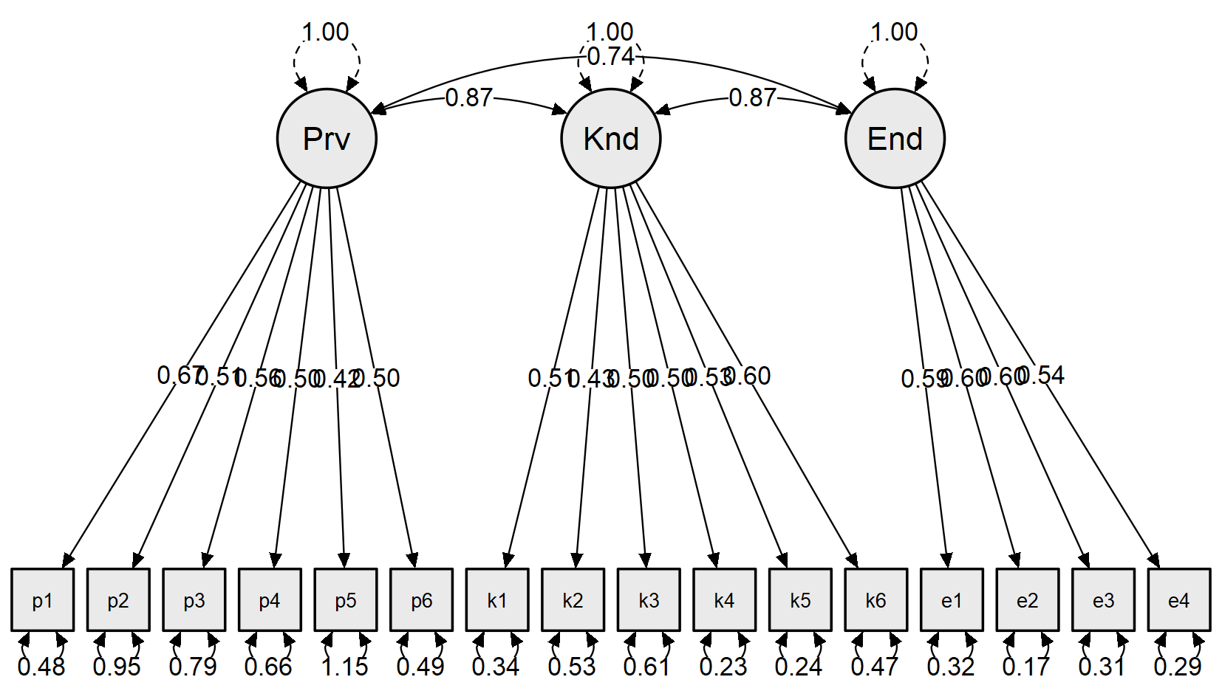

CFA academic resilience

Model fit
Chi-square test
Model |  | Χ² |  | df |  | p
Baseline model |  | 1809.37 |  | 136
Factor model |  | 227.88 |  | 116 |  | < .001

Additional fit measures
Fit indices
Index |  | Value
Comparative Fit Index (CFI) |  | 0.93
Tucker-Lewis Index (TLI) |  | 0.92
Bentler-Bonett Non-normed Fit Index (NNFI) |  | 0.92
Bentler-Bonett Normed Fit Index (NFI) |  | 0.87
Parsimony Normed Fit Index (PNFI) |  | 0.75
Bollen's Relative Fit Index (RFI) |  | 0.85
Bollen's Incremental Fit Index (IFI) |  | 0.93
Relative Noncentrality Index (RNI) |  | 0.93

Information criteria
 |  | Value
Log-likelihood |  | -3533.73
Number of free parameters |  | 37.00
Akaike (AIC) |  | 7141.47
Bayesian (BIC) |  | 7260.22
Sample-size adjusted Bayesian (SSABIC) |  | 7143.03

Other fit measures
Metric |  | Value
Root mean square error of approximation (RMSEA) |  | 0.07
RMSEA 90% CI lower bound |  | 0.06
RMSEA 90% CI upper bound |  | 0.09
RMSEA p-value |  | 5.06e -3
Standardized root mean square residual (SRMR) |  | 0.06
Hoelter's critical N (α = .05) |  | 115.14
Hoelter's critical N (α = .01) |  | 124.94
Goodness of fit index (GFI) |  | 0.88
McDonald fit index (MFI) |  | 0.74
Expected cross validation index (ECVI) |  | 1.65

R-Squared
 |  | R²
per1 |  | 0.43
per2 |  | 0.52
per3 |  | 0.47
per4 |  | 0.24
per5 |  | 0.61
per6 |  | 0.62
ref1 |  | 0.49
ref2 |  | 0.64
ref3 |  | 0.41
ref4 |  | 0.47
ref5 |  | 0.33
ne1 |  | 0.41
ne2 |  | 0.55
ne3 |  | 0.72
ne4 |  | 0.78
ne5 |  | 0.64
ne6 |  | 0.74

Parameter estimates
Factor loadings
 |  |  |  |  |  |  |  |  |  |  |  |  |  | 95% Confidence Interval
Factor |  | Indicator |  | Symbol |  | Estimate |  | Std. Error |  | z-value |  | p |  | Lower |  | Upper |  | Std. Est. (all)
Perserverance |  | per1 |  | λ11 |  | 0.52 |  | 0.05 |  | 9.59 |  | < .001 |  | 0.42 |  | 0.63 |  | 0.66
 |  | per2 |  | λ12 |  | 0.59 |  | 0.05 |  | 10.94 |  | < .001 |  | 0.48 |  | 0.69 |  | 0.72
 |  | per3 |  | λ13 |  | 0.60 |  | 0.06 |  | 10.18 |  | < .001 |  | 0.49 |  | 0.72 |  | 0.69
 |  | per4 |  | λ14 |  | 0.50 |  | 0.07 |  | 6.73 |  | < .001 |  | 0.35 |  | 0.65 |  | 0.49
 |  | per5 |  | λ15 |  | 0.52 |  | 0.04 |  | 12.27 |  | < .001 |  | 0.44 |  | 0.61 |  | 0.78
 |  | per6 |  | λ16 |  | 0.63 |  | 0.05 |  | 12.35 |  | < .001 |  | 0.53 |  | 0.73 |  | 0.79
Reflecting and Adaptive Help-seeking |  | ref1 |  | λ21 |  | 0.63 |  | 0.06 |  | 10.38 |  | < .001 |  | 0.51 |  | 0.75 |  | 0.70
 |  | ref2 |  | λ22 |  | 0.63 |  | 0.05 |  | 12.55 |  | < .001 |  | 0.53 |  | 0.73 |  | 0.80
 |  | ref3 |  | λ23 |  | 0.59 |  | 0.06 |  | 9.23 |  | < .001 |  | 0.46 |  | 0.71 |  | 0.64
 |  | ref4 |  | λ24 |  | 0.47 |  | 0.05 |  | 10.09 |  | < .001 |  | 0.37 |  | 0.56 |  | 0.68
 |  | ref5 |  | λ25 |  | 0.56 |  | 0.07 |  | 8.18 |  | < .001 |  | 0.43 |  | 0.69 |  | 0.58
Negative Affect and Emotional Response |  | ne1 |  | λ31 |  | 0.77 |  | 0.08 |  | 9.40 |  | < .001 |  | 0.61 |  | 0.93 |  | 0.64
 |  | ne2 |  | λ32 |  | 0.97 |  | 0.08 |  | 11.51 |  | < .001 |  | 0.80 |  | 1.13 |  | 0.74
 |  | ne3 |  | λ33 |  | 1.16 |  | 0.08 |  | 13.99 |  | < .001 |  | 0.99 |  | 1.32 |  | 0.85
 |  | ne4 |  | λ34 |  | 1.18 |  | 0.08 |  | 14.89 |  | < .001 |  | 1.02 |  | 1.33 |  | 0.88
 |  | ne5 |  | λ35 |  | 1.02 |  | 0.08 |  | 12.83 |  | < .001 |  | 0.86 |  | 1.17 |  | 0.80
 |  | ne6 |  | λ36 |  | 1.09 |  | 0.08 |  | 14.37 |  | < .001 |  | 0.94 |  | 1.24 |  | 0.86

Factor variances
 |  |  |  |  |  |  |  |  |  | 95% Confidence Interval
Factor |  | Estimate |  | Std. Error |  | z-value |  | p |  | Lower |  | Upper |  | Std. Est. (all)
Perserverance |  | 1.00 |  | 0.00 |  |  |  |  |  | 1.00 |  | 1.00 |  | 1.00
Reflecting and Adaptive Help-seeking |  | 1.00 |  | 0.00 |  |  |  |  |  | 1.00 |  | 1.00 |  | 1.00
Negative Affect and Emotional Response |  | 1.00 |  | 0.00 |  |  |  |  |  | 1.00 |  | 1.00 |  | 1.00

Factor Covariances
 |  |  |  |  |  |  |  |  |  |  |  |  |  | 95% Confidence Interval
 |  |  |  |  |  | Estimate |  | Std. Error |  | z-value |  | p |  | Lower |  | Upper |  | Std. Est. (all)
Perserverance |  | ↔ |  | Reflecting and Adaptive Help-seeking |  | 0.96 |  | 0.02 |  | 39.90 |  | < .001 |  | 0.92 |  | 1.01 |  | 0.96
Perserverance |  | ↔ |  | Negative Affect and Emotional Response |  | -0.19 |  | 0.08 |  | -2.37 |  | 0.02 |  | -0.35 |  | -0.03 |  | -0.19
Reflecting and Adaptive Help-seeking |  | ↔ |  | Negative Affect and Emotional Response |  | -0.20 |  | 0.08 |  | -2.50 |  | 0.01 |  | -0.36 |  | -0.04 |  | -0.20

Residual variances
 |  |  |  |  |  |  |  |  |  | 95% Confidence Interval
Indicator |  | Estimate |  | Std. Error |  | z-value |  | p |  | Lower |  | Upper |  | Std. Est. (all)
per1 |  | 0.36 |  | 0.04 |  | 8.81 |  | < .001 |  | 0.28 |  | 0.44 |  | 0.57
per2 |  | 0.32 |  | 0.04 |  | 8.45 |  | < .001 |  | 0.24 |  | 0.39 |  | 0.48
per3 |  | 0.41 |  | 0.05 |  | 8.67 |  | < .001 |  | 0.31 |  | 0.50 |  | 0.53
per4 |  | 0.80 |  | 0.09 |  | 9.25 |  | < .001 |  | 0.63 |  | 0.97 |  | 0.76
per5 |  | 0.17 |  | 0.02 |  | 7.93 |  | < .001 |  | 0.13 |  | 0.21 |  | 0.39
per6 |  | 0.24 |  | 0.03 |  | 7.89 |  | < .001 |  | 0.18 |  | 0.30 |  | 0.38
ref1 |  | 0.41 |  | 0.05 |  | 8.50 |  | < .001 |  | 0.32 |  | 0.51 |  | 0.51
ref2 |  | 0.22 |  | 0.03 |  | 7.47 |  | < .001 |  | 0.17 |  | 0.28 |  | 0.36
ref3 |  | 0.50 |  | 0.06 |  | 8.80 |  | < .001 |  | 0.39 |  | 0.61 |  | 0.59
ref4 |  | 0.25 |  | 0.03 |  | 8.58 |  | < .001 |  | 0.19 |  | 0.30 |  | 0.53
ref5 |  | 0.62 |  | 0.07 |  | 9.01 |  | < .001 |  | 0.49 |  | 0.76 |  | 0.67
ne1 |  | 0.86 |  | 0.10 |  | 9.04 |  | < .001 |  | 0.67 |  | 1.05 |  | 0.59
ne2 |  | 0.76 |  | 0.09 |  | 8.62 |  | < .001 |  | 0.58 |  | 0.93 |  | 0.45
ne3 |  | 0.52 |  | 0.07 |  | 7.58 |  | < .001 |  | 0.39 |  | 0.66 |  | 0.28
ne4 |  | 0.40 |  | 0.06 |  | 6.86 |  | < .001 |  | 0.28 |  | 0.51 |  | 0.22
ne5 |  | 0.58 |  | 0.07 |  | 8.18 |  | < .001 |  | 0.44 |  | 0.71 |  | 0.36
ne6 |  | 0.41 |  | 0.06 |  | 7.31 |  | < .001 |  | 0.30 |  | 0.52 |  | 0.26

Implied covariance matrix
per1 |  | per2 |  | per3 |  | per4 |  | per5 |  | per6 |  | ref1 |  | ref2 |  | ref3 |  | ref4 |  | ref5 |  | ne1 |  | ne2 |  | ne3 |  | ne4 |  | ne5 |  | ne6
0.64
0.31 |  | 0.66
0.31 |  | 0.35 |  | 0.77
0.26 |  | 0.29 |  | 0.30 |  | 1.05
0.27 |  | 0.31 |  | 0.31 |  | 0.26 |  | 0.45
0.33 |  | 0.37 |  | 0.38 |  | 0.31 |  | 0.33 |  | 0.64
0.32 |  | 0.36 |  | 0.36 |  | 0.30 |  | 0.32 |  | 0.38 |  | 0.81
0.32 |  | 0.36 |  | 0.37 |  | 0.30 |  | 0.32 |  | 0.38 |  | 0.40 |  | 0.62
0.30 |  | 0.33 |  | 0.34 |  | 0.28 |  | 0.30 |  | 0.36 |  | 0.37 |  | 0.37 |  | 0.85
0.23 |  | 0.26 |  | 0.27 |  | 0.22 |  | 0.23 |  | 0.28 |  | 0.29 |  | 0.29 |  | 0.27 |  | 0.46
0.28 |  | 0.32 |  | 0.32 |  | 0.27 |  | 0.28 |  | 0.34 |  | 0.35 |  | 0.35 |  | 0.33 |  | 0.26 |  | 0.94
-0.08 |  | -0.09 |  | -0.09 |  | -0.07 |  | -0.08 |  | -0.09 |  | -0.10 |  | -0.10 |  | -0.09 |  | -0.07 |  | -0.09 |  | 1.45
-0.10 |  | -0.11 |  | -0.11 |  | -0.09 |  | -0.10 |  | -0.12 |  | -0.12 |  | -0.12 |  | -0.12 |  | -0.09 |  | -0.11 |  | 0.75 |  | 1.70
-0.11 |  | -0.13 |  | -0.13 |  | -0.11 |  | -0.11 |  | -0.14 |  | -0.15 |  | -0.15 |  | -0.14 |  | -0.11 |  | -0.13 |  | 0.89 |  | 1.12 |  | 1.86
-0.12 |  | -0.13 |  | -0.13 |  | -0.11 |  | -0.12 |  | -0.14 |  | -0.15 |  | -0.15 |  | -0.14 |  | -0.11 |  | -0.13 |  | 0.91 |  | 1.14 |  | 1.36 |  | 1.79
-0.10 |  | -0.11 |  | -0.12 |  | -0.10 |  | -0.10 |  | -0.12 |  | -0.13 |  | -0.13 |  | -0.12 |  | -0.10 |  | -0.12 |  | 0.79 |  | 0.99 |  | 1.18 |  | 1.20 |  | 1.61
-0.11 |  | -0.12 |  | -0.12 |  | -0.10 |  | -0.11 |  | -0.13 |  | -0.14 |  | -0.14 |  | -0.13 |  | -0.10 |  | -0.12 |  | 0.84 |  | 1.06 |  | 1.26 |  | 1.29 |  | 1.11 |  | 1.60

Residual covariance matrix
per1 |  | per2 |  | per3 |  | per4 |  | per5 |  | per6 |  | ref1 |  | ref2 |  | ref3 |  | ref4 |  | ref5 |  | ne1 |  | ne2 |  | ne3 |  | ne4 |  | ne5 |  | ne6
< .001
0.14 |  | < .001
< .001 |  | < .001 |  | < .001
< .001 |  | 0.01 |  | 0.07 |  | < .001
< .001 |  | < .001 |  | < .001 |  | < .001 |  | < .001
< .001 |  | < .001 |  | < .001 |  | 0.04 |  | 7.29e -3 |  | < .001
< .001 |  | < .001 |  | 0.02 |  | 0.09 |  | 0.02 |  | < .001 |  | < .001
< .001 |  | 5.50e -3 |  | 0.02 |  | < .001 |  | 8.76e -3 |  | 8.04e -3 |  | < .001 |  | < .001
< .001 |  | < .001 |  | 0.03 |  | < .001 |  | 0.01 |  | 9.73e -3 |  | < .001 |  | < .001 |  | < .001
7.46e -3 |  | < .001 |  | 0.01 |  | < .001 |  | 0.02 |  | < .001 |  | < .001 |  | < .001 |  | < .001 |  | < .001
< .001 |  | < .001 |  | < .001 |  | < .001 |  | < .001 |  | 0.02 |  | < .001 |  | 3.50e -3 |  | 0.07 |  | 0.03 |  | < .001
0.07 |  | 0.14 |  | < .001 |  | 0.14 |  | 0.02 |  | 0.01 |  | 0.06 |  | 0.08 |  | 0.11 |  | < .001 |  | < .001 |  | < .001
0.07 |  | 0.07 |  | 0.04 |  | 0.18 |  | < .001 |  | < .001 |  | 0.06 |  | < .001 |  | 0.08 |  | < .001 |  | < .001 |  | 0.10 |  | < .001
0.12 |  | 0.14 |  | < .001 |  | 0.23 |  | 4.42e -3 |  | 0.02 |  | 0.05 |  | 2.78e -3 |  | 0.19 |  | 0.03 |  | < .001 |  | < .001 |  | < .001 |  | < .001
0.04 |  | 0.07 |  | < .001 |  | 0.13 |  | < .001 |  | < .001 |  | < .001 |  | 0.03 |  | 0.12 |  | < .001 |  | < .001 |  | 0.03 |  | < .001 |  | 0.12 |  | < .001
0.01 |  | < .001 |  | < .001 |  | 0.11 |  | < .001 |  | < .001 |  | < .001 |  | < .001 |  | 0.02 |  | < .001 |  | < .001 |  | < .001 |  | 0.10 |  | < .001 |  | < .001 |  | < .001
< .001 |  | 0.04 |  | < .001 |  | 0.11 |  | < .001 |  | < .001 |  | < .001 |  | < .001 |  | 0.13 |  | < .001 |  | 0.02 |  | < .001 |  | < .001 |  | < .001 |  | < .001 |  | 0.11 |  | < .001

Modification Indices
Cross-loadings
 |  |  |  |  |  | Mod. Ind. |  | EPC
Reflecting and Adaptive Help-seeking |  | → |  | per2 |  | 6.93 |  | -1.19
Reflecting and Adaptive Help-seeking |  | → |  | per5 |  | 4.82 |  | 0.81
Negative Affect and Emotional Response |  | → |  | ref3 |  | 4.62 |  | 0.13
Perserverance |  | → |  | ne5 |  | 4.43 |  | -0.14
Negative Affect and Emotional Response |  | → |  | per4 |  | 4.32 |  | 0.15
Reflecting and Adaptive Help-seeking |  | → |  | ne5 |  | 4.25 |  | -0.14

Residual covariances
 |  |  |  |  |  | Mod. Ind. |  | EPC
per1 |  | ↔ |  | per2 |  | 38.42 |  | 0.18
ne3 |  | ↔ |  | ne4 |  | 29.76 |  | 0.29
ne5 |  | ↔ |  | ne6 |  | 17.44 |  | 0.20
ne4 |  | ↔ |  | ne5 |  | 10.07 |  | -0.16
per4 |  | ↔ |  | ref5 |  | 9.19 |  | -0.17
per3 |  | ↔ |  | ne2 |  | 8.58 |  | 0.13
ne3 |  | ↔ |  | ne5 |  | 8.26 |  | -0.15
ref5 |  | ↔ |  | ne1 |  | 7.17 |  | -0.15
per1 |  | ↔ |  | ne6 |  | 7.13 |  | -0.09
per2 |  | ↔ |  | ref4 |  | 7.10 |  | -0.06
ne2 |  | ↔ |  | ne5 |  | 5.97 |  | 0.14
per1 |  | ↔ |  | per6 |  | 5.89 |  | -0.06
per4 |  | ↔ |  | ref1 |  | 5.16 |  | 0.10
ref4 |  | ↔ |  | ne3 |  | 4.92 |  | 0.07
ref4 |  | ↔ |  | ne2 |  | 4.52 |  | -0.07
ne2 |  | ↔ |  | ne4 |  | 4.06 |  | -0.11
ref5 |  | ↔ |  | ne5 |  | 3.98 |  | 0.10

Plots

Model plot
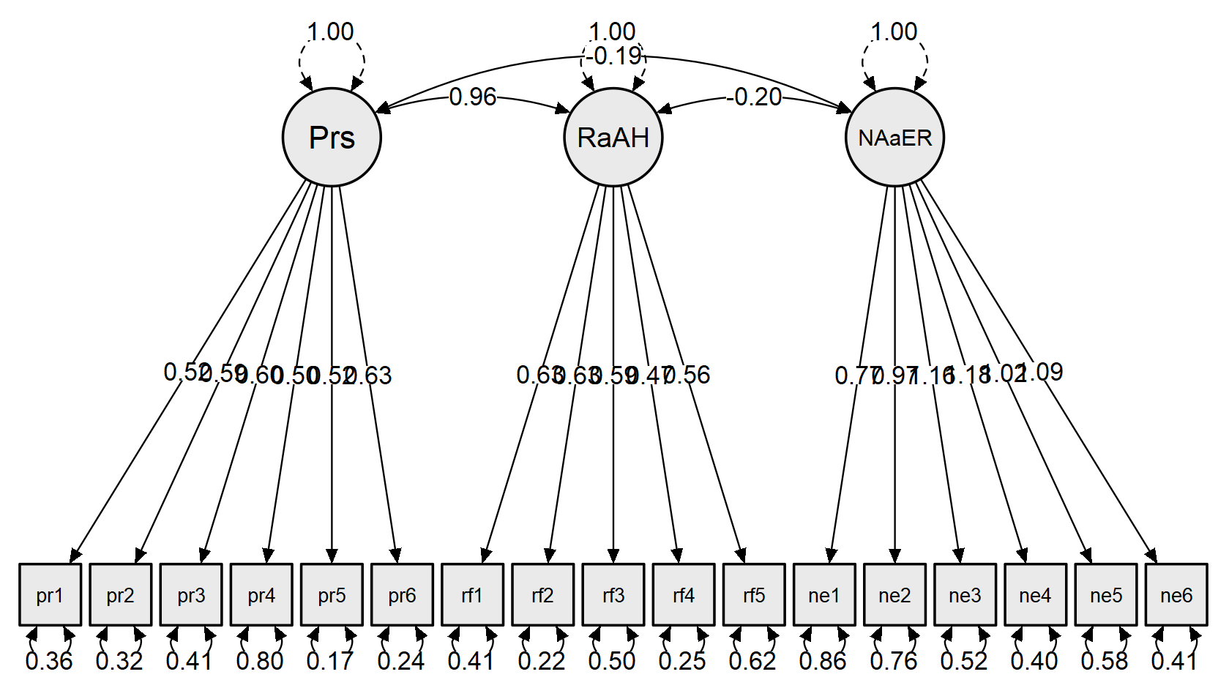

CFA school burnout inventory

Model fit
Chi-square test
Model |  | Χ² |  | df |  | p
Baseline model |  | 912.66 |  | 36
Factor model |  | 83.38 |  | 26 |  | < .001

Additional fit measures
Fit indices
Index |  | Value
Comparative Fit Index (CFI) |  | 0.93
Tucker-Lewis Index (TLI) |  | 0.91
Bentler-Bonett Non-normed Fit Index (NNFI) |  | 0.91
Bentler-Bonett Normed Fit Index (NFI) |  | 0.91
Parsimony Normed Fit Index (PNFI) |  | 0.66
Bollen's Relative Fit Index (RFI) |  | 0.87
Bollen's Incremental Fit Index (IFI) |  | 0.94
Relative Noncentrality Index (RNI) |  | 0.93

Information criteria
 |  | Value
Log-likelihood |  | -2304.64
Number of free parameters |  | 19.00
Akaike (AIC) |  | 4647.28
Bayesian (BIC) |  | 4708.26
Sample-size adjusted Bayesian (SSABIC) |  | 4648.09

Other fit measures
Metric |  | Value
Root mean square error of approximation (RMSEA) |  | 0.11
RMSEA 90% CI lower bound |  | 0.08
RMSEA 90% CI upper bound |  | 0.14
RMSEA p-value |  | 1.75e -4
Standardized root mean square residual (SRMR) |  | 0.06
Hoelter's critical N (α = .05) |  | 86.34
Hoelter's critical N (α = .01) |  | 101.17
Goodness of fit index (GFI) |  | 0.91
McDonald fit index (MFI) |  | 0.85
Expected cross validation index (ECVI) |  | 0.66

R-Squared
 |  | R²
ke1 |  | 0.56
ke2 |  | 0.57
ke3 |  | 0.52
ke4 |  | 0.34
ke5 |  | 0.53
si1 |  | 0.77
si2 |  | 0.82
si3 |  | 0.45
si4 |  | 0.57

Parameter estimates
Factor loadings
 |  |  |  |  |  |  |  |  |  |  |  |  |  | 95% Confidence Interval
Factor |  | Indicator |  | Symbol |  | Estimate |  | Std. Error |  | z-value |  | p |  | Lower |  | Upper |  | Std. Est. (all)
Emotional exhaustion |  | ke1 |  | λ11 |  | 0.88 |  | 0.08 |  | 11.15 |  | < .001 |  | 0.72 |  | 1.03 |  | 0.75
 |  | ke2 |  | λ12 |  | 0.91 |  | 0.08 |  | 11.30 |  | < .001 |  | 0.75 |  | 1.07 |  | 0.75
 |  | ke3 |  | λ13 |  | 1.03 |  | 0.10 |  | 10.67 |  | < .001 |  | 0.84 |  | 1.22 |  | 0.72
 |  | ke4 |  | λ14 |  | 0.71 |  | 0.09 |  | 8.13 |  | < .001 |  | 0.54 |  | 0.88 |  | 0.58
 |  | ke5 |  | λ15 |  | 0.95 |  | 0.09 |  | 10.75 |  | < .001 |  | 0.78 |  | 1.12 |  | 0.73
Cynicism |  | si1 |  | λ21 |  | 1.11 |  | 0.08 |  | 14.55 |  | < .001 |  | 0.96 |  | 1.26 |  | 0.87
 |  | si2 |  | λ22 |  | 1.14 |  | 0.07 |  | 15.30 |  | < .001 |  | 1.00 |  | 1.29 |  | 0.90
 |  | si3 |  | λ23 |  | 0.86 |  | 0.09 |  | 9.94 |  | < .001 |  | 0.69 |  | 1.03 |  | 0.67
 |  | si4 |  | λ24 |  | 0.92 |  | 0.08 |  | 11.65 |  | < .001 |  | 0.77 |  | 1.08 |  | 0.75

Factor variances
 |  |  |  |  |  |  |  |  |  | 95% Confidence Interval
Factor |  | Estimate |  | Std. Error |  | z-value |  | p |  | Lower |  | Upper |  | Std. Est. (all)
Emotional exhaustion |  | 1.00 |  | 0.00 |  |  |  |  |  | 1.00 |  | 1.00 |  | 1.00
Cynicism |  | 1.00 |  | 0.00 |  |  |  |  |  | 1.00 |  | 1.00 |  | 1.00

Factor Covariances
 |  |  |  |  |  |  |  |  |  |  |  |  |  | 95% Confidence Interval
 |  |  |  |  |  | Estimate |  | Std. Error |  | z-value |  | p |  | Lower |  | Upper |  | Std. Est. (all)
Emotional exhaustion |  | ↔ |  | Cynicism |  | 0.78 |  | 0.04 |  | 18.88 |  | < .001 |  | 0.70 |  | 0.86 |  | 0.78

Residual variances
 |  |  |  |  |  |  |  |  |  | 95% Confidence Interval
Indicator |  | Estimate |  | Std. Error |  | z-value |  | p |  | Lower |  | Upper |  | Std. Est. (all)
ke1 |  | 0.61 |  | 0.08 |  | 7.68 |  | < .001 |  | 0.46 |  | 0.77 |  | 0.44
ke2 |  | 0.63 |  | 0.08 |  | 7.59 |  | < .001 |  | 0.47 |  | 0.79 |  | 0.43
ke3 |  | 0.97 |  | 0.12 |  | 7.93 |  | < .001 |  | 0.73 |  | 1.21 |  | 0.48
ke4 |  | 0.97 |  | 0.11 |  | 8.80 |  | < .001 |  | 0.76 |  | 1.19 |  | 0.66
ke5 |  | 0.81 |  | 0.10 |  | 7.89 |  | < .001 |  | 0.61 |  | 1.01 |  | 0.47
si1 |  | 0.38 |  | 0.06 |  | 6.38 |  | < .001 |  | 0.26 |  | 0.49 |  | 0.23
si2 |  | 0.30 |  | 0.06 |  | 5.39 |  | < .001 |  | 0.19 |  | 0.40 |  | 0.18
si3 |  | 0.90 |  | 0.10 |  | 8.83 |  | < .001 |  | 0.70 |  | 1.11 |  | 0.55
si4 |  | 0.65 |  | 0.08 |  | 8.36 |  | < .001 |  | 0.49 |  | 0.80 |  | 0.43

Implied covariance matrix
ke1 |  | ke2 |  | ke3 |  | ke4 |  | ke5 |  | si1 |  | si2 |  | si3 |  | si4
1.38
0.80 |  | 1.46
0.90 |  | 0.93 |  | 2.02
0.62 |  | 0.65 |  | 0.73 |  | 1.48
0.83 |  | 0.86 |  | 0.98 |  | 0.67 |  | 1.71
0.76 |  | 0.78 |  | 0.89 |  | 0.61 |  | 0.82 |  | 1.61
0.78 |  | 0.81 |  | 0.91 |  | 0.63 |  | 0.84 |  | 1.27 |  | 1.60
0.59 |  | 0.61 |  | 0.69 |  | 0.47 |  | 0.64 |  | 0.95 |  | 0.98 |  | 1.64
0.63 |  | 0.65 |  | 0.74 |  | 0.51 |  | 0.68 |  | 1.02 |  | 1.05 |  | 0.79 |  | 1.50

Residual covariance matrix
ke1 |  | ke2 |  | ke3 |  | ke4 |  | ke5 |  | si1 |  | si2 |  | si3 |  | si4
< .001
0.07 |  | < .001
0.08 |  | < .001 |  | < .001
< .001 |  | < .001 |  | 0.30 |  | < .001
< .001 |  | < .001 |  | < .001 |  | < .001 |  | < .001
< .001 |  | 0.12 |  | < .001 |  | 0.05 |  | 0.22 |  | < .001
< .001 |  | 0.06 |  | < .001 |  | < .001 |  | 0.11 |  | 0.02 |  | < .001
< .001 |  | 0.02 |  | < .001 |  | < .001 |  | 0.12 |  | < .001 |  | < .001 |  | < .001
< .001 |  | < .001 |  | < .001 |  | 0.04 |  | 0.13 |  | < .001 |  | 0.02 |  | 0.15 |  | < .001

Modification Indices
Cross-loadings
 |  |  |  |  |  | Mod. Ind. |  | EPC
Cynicism |  | → |  | ke5 |  | 15.82 |  | 0.63
Cynicism |  | → |  | ke3 |  | 11.70 |  | -0.59
Emotional exhaustion |  | → |  | si1 |  | 4.56 |  | 0.27

Residual covariances
 |  |  |  |  |  | Mod. Ind. |  | EPC
ke3 |  | ↔ |  | ke4 |  | 24.66 |  | 0.42
si3 |  | ↔ |  | si4 |  | 9.47 |  | 0.20
si1 |  | ↔ |  | si4 |  | 8.05 |  | -0.16
ke2 |  | ↔ |  | si4 |  | 4.90 |  | -0.12
ke1 |  | ↔ |  | ke2 |  | 4.69 |  | 0.14
ke1 |  | ↔ |  | ke4 |  | 4.06 |  | -0.14

Plots

Model plot
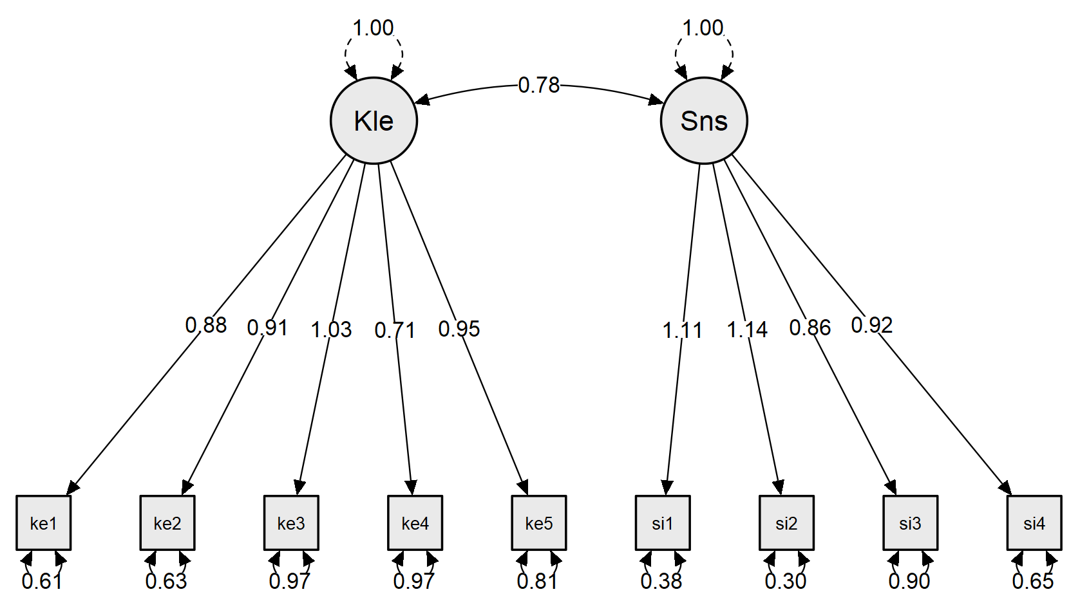

Correlation three scale
Correlation Table
Variable |  |  |  | jihad academic |  | academic resilience |  | school burnout inventory
jihad academic |  | Pearson's r |  | —
 |  | p-value |  | —
 |  | Spearman's rho |  | —
 |  | p-value |  | —
academic resilience |  | Pearson's r |  | 0.41 | *** | —
 |  | p-value |  | < .001 |  | —
 |  | Spearman's rho |  | 0.35 | *** | —
 |  | p-value |  | < .001 |  | —
school burnout inventory |  | Pearson's r |  | -0.11 |  | 0.29 | *** | —
 |  | p-value |  | 0.12 |  | < .001 |  | —
 |  | Spearman's rho |  | -0.21 | ** | 0.24 | ** | —
 |  | p-value |  | 4.38e -3 |  | 1.07e -3 |  | —
* p < .05, ** p < .01, *** p < .001

Assumption checks
Shapiro-Wilk Test for Multivariate Normality
Shapiro-Wilk |  | p
0.87 |  | < .001

