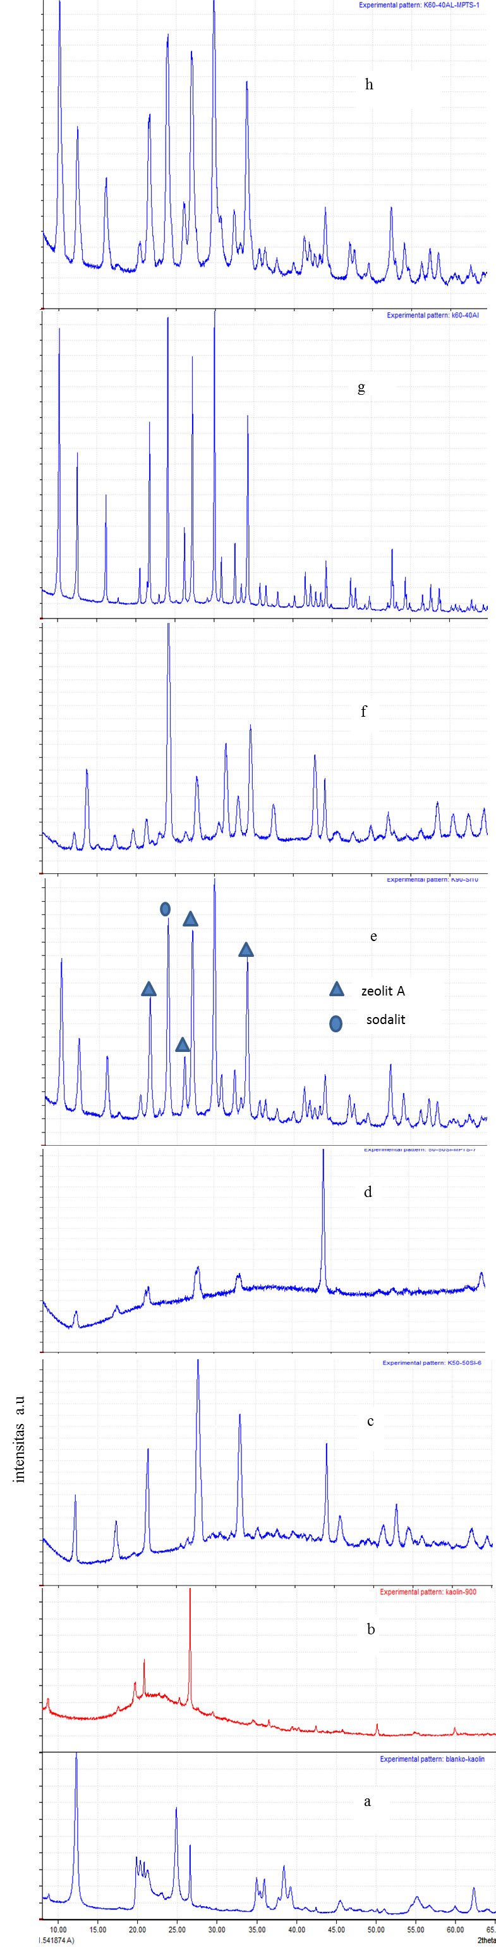
Gambar 1. Hasil XRD (a=kaolin),(b=metakaolin),(c= AX2 zeolite),(d=modified AX2 zeolite),(e= AX4 zeolite),(f= modified AX4 zeolite),(g= AZ zeolite), (h= modified AZ3 zeolite).

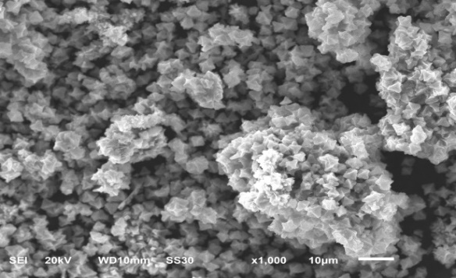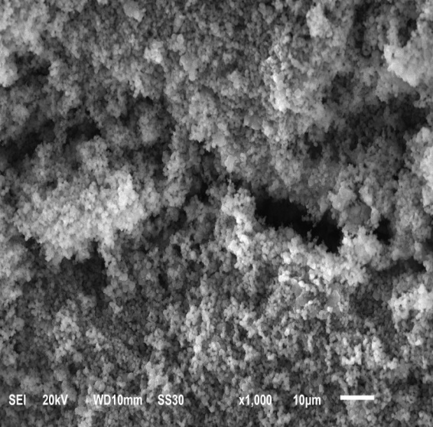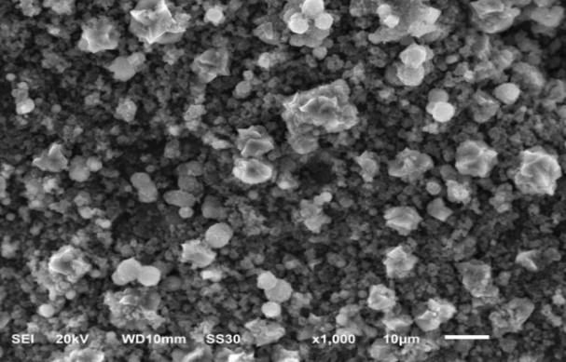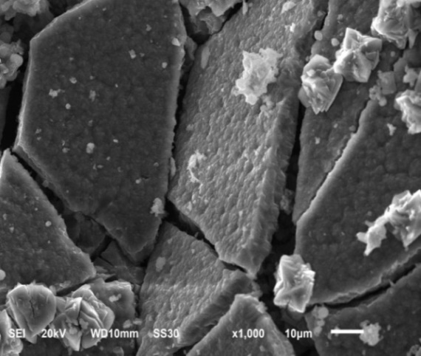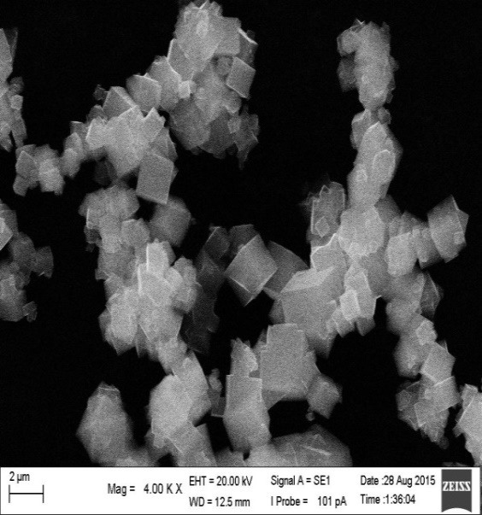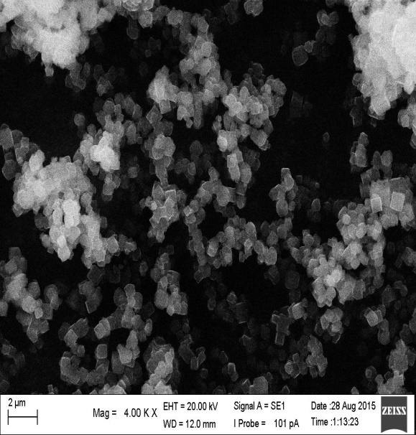
f
e
d
c
b
a
Gambar 2. Hasil SEM (a= AX2 zeolite), (b = modified AX2 zeolite ), (c= AX4 zeolite), (d= modified AX4 zeolite), (e= AZ3zeolite), (f= modified AZ3 zeolite )

Tabel 1 perbandingan volume dalam sintesis zeolit
Sampel | Volume (ml)
 | Kaolin | Na₂SiO₃ (Merck)
Sampel AX1 | 40 | 60
Sampel AX2 | 50 | 50
Sampel AX3 | 60 | 40
Sampel AX4 | 90 | 10

Tabel 2 Perbandingan volume sintesis zeolit AZ
Sampel | Volume (ml)
 | Kaolin | Na-Aluminat
Sampel AZ1 | 40 | 60
Sampel AZ2 | 50 | 50
Sampel AZ3 | 60 | 40

Tabel 3. Kapasitas adsorpsi Cu(II) and Biru Metilena
Sample | Adsorption capacity for methylene blue  (mg/g) | Adsorption capacity for Cu (II)  (mg/g) | Adsorption Isotherm type
Zeolit Y | 18,44 | 1,53 | Langmuir  (R²=0,9755)
Zeolite Y modified by MPTS | 17,31 | 1,40 | Langmuir  (R²=0,9929)
Mixture Zeolit A and sodalite | 27,68 | 1,59 | Langmuir  (R²=0,9872)
sodalite modified by MPTS | 28,82 | 1,62 | Langmuir  (R²=0,9596)
Zeolit A | 17,81 | 1,44 | Langmuir  (R²=0,9530)
Zeolite A by MPTS | 30,114 | 1,63 | Langmuir  (R²=0,9969)

