S1. Curcuminoid content of C. xanthorriza samples were determined by HPLC
C. xanthorriza Sample | Cocentration (% w/w)
C. xanthorriza Sample | Bisdemethoxycurcumin | Demethoxycurcumin | Curcumin | Curcuminoid
A1 | 0.04 | 0.45 | 0.94 | 1.47 ± 0.04
A2 | 0.04 | 0.47 | 0.99 | 1.47 ± 0.04
B1 | 0.02 | 0.22 | 0.88 | 1.09 ± 0.03
B2 | 0.02 | 0.21 | 0.84 | 1.09 ± 0.03

S2. Examples of pellet sample for BaSO₄ blank (A), Sudan III (B) and C. xanthorriza (C)

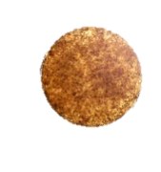
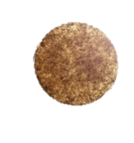
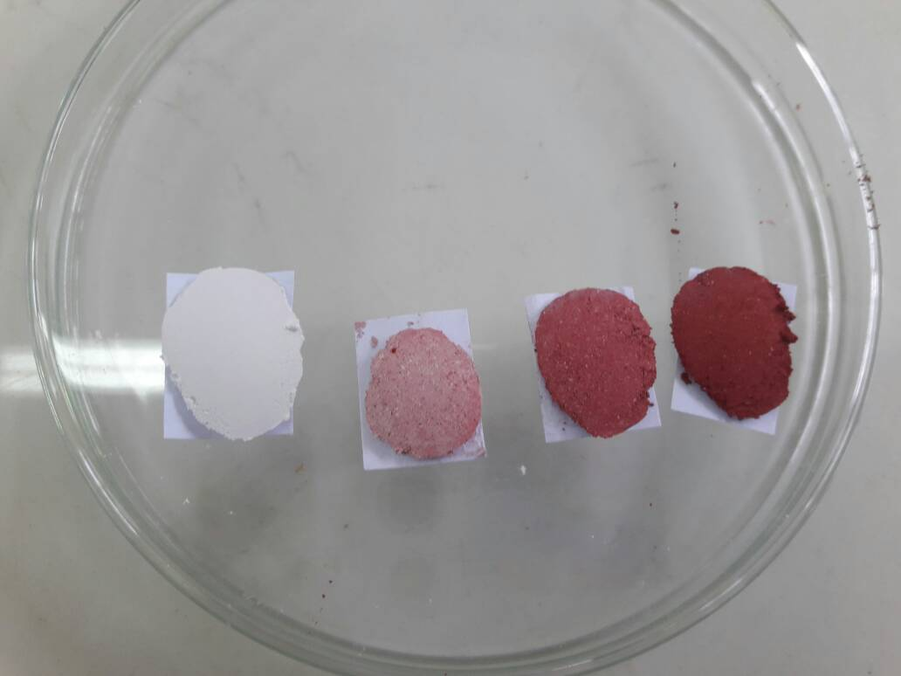

- (B) (C)

S3. Schematic of reflectance spectrophotometer performance test samples and comparison test results with commercial spectrophotometers.
Mixture | Mixture of Sudan III Standard dan BaSO₄ |  |  | Spectrophotometer Reflectance |  |  |  | Spectrophotometer UV Vis (Shinadzu UV-1800)
Mixture | massa Sudan III (g) | massa BaSO₄ (g) | Calculated Concentration (%) | Repilcate Sample | Concentration (%b/b) | Average Concentration (%b/b) | Massa Sudan III in 10g Mixture (g) | Replicate Measurement | Absorbance | Concentration (μg/mL)* | Average Concentration (μg/mL) | Average Concentration in 10 g Mixture solution Larutan (μg/mL) | Massa Sudan III in 10g Mixture (g)
1 | 0.0011 | 9.9995 | 0.0110 | Pellet 1.1 | 0.0112 | 0.0121 | 0.0012 | Replicate 1.1 | 0.835 | 12.9 | 12.9 | 128.7 | 0.0013
 |  |  |  | Pellet 1.2 | 0.0121 |  |  | Replicate 1.2 | 0.835 | 12.9
 |  |  |  | Pellet 1.3 | 0.0124 |  |  | Replicate 1.3 | 0.836 | 12.9
 |  |  |  | Pellet 1.4 | 0.0124 |  |  | Replicate 1.4 | 0.835 | 12.9
 |  |  |  | Pellet 1.5 | 0.0123 |  |  | Replicate 1.5 | 0.835 | 12.9
2 | 0.0010 | 9.9996 | 0.0100 | Pellet 2.1 | 0.0099 | 0.0098 | 0.0010 | Replicate 2.1 | 0.665 | 10.5 | 10.5 | 105.4 | 0.0011
 |  |  |  | Pellet 2.2 | 0.0098 |  |  | Replicate 2.2 | 0.664 | 10.5
 |  |  |  | Pellet 2.3 | 0.0097 |  |  | Replicate 2.3 | 0.665 | 10.5
 |  |  |  | Pellet 2.4 | 0.0098 |  |  | Replicate 2.4 | 0.665 | 10.5
 |  |  |  | Pellet 2.5 | 0.0099 |  |  | Replicate 2.5 | 0.665 | 10.5
3 | 0.0010 | 9.9996 | 0.0100 | Pellet 3.1 | 0.0098 | 0.0099 | 0.0010 | Replicate 3.1 | 0.668 | 10.6 | 10.6 | 105.9 | 0.0011
 |  |  |  | Pellet 3.2 | 0.0099 |  |  | Replicate 3.2 | 0.668 | 10.6
 |  |  |  | Pellet 3.3 | 0.0099 |  |  | Replicate 3.3 | 0.668 | 10.6
 |  |  |  | Pellet 3.4 | 0.0099 |  |  | Replicate 3.4 | 0.668 | 10.6
 |  |  |  | Pellet 3.5 | 0.0098 |  |  | Replicate 3.5 | 0.668 | 10.6
* Calculated using calibration curve y = 0.0731x - 0.1058 (R²= 0.9999)

