Compound 1 and 2 from Stem Bark of Aglaia angustifolia (Miq.) Miq (Meliaceae).
Table of contents | Page
Figure 1.1. ¹H-NMR Spectrum of 1 (600 MHz in CDCl₃). | 2
Figure 1.2. ¹³C-NMR Spectrum of 1 (150 MHz in CDCl₃). | 3
Figure 1.3. DEPT-135° Spectrum of 1 (in CDCl₃). | 4
Figure 1.4. HSQC Spectrum of 1. | 5
Figure 1.5. HMBC Spectrum of 1. | 6
Figure 1.6. ¹H-¹H COSY Spectrum of 1 | 7
Figure 1.7. IR Spectrum of 1 | 8
Figure 1.8. HR-TOF-MS Spectrum of 1 | 9
Figure 2.1. ¹H-NMR Spectrum of 2 (600 MHz in CDCl₃). | 10
Figure 2.2. ¹³C-NMR Spectrum of 2 (150 MHz in CDCl₃). | 11
Figure 2.3. DEPT-135° Spectrum of 2 (in CDCl₃). | 12
Figure 2.4. HSQC Spectrum of 2. | 13
Figure 2.5. HMBC Spectrum of 2. | 14
Figure 2.6. ¹H-¹H COSY Spectrum of 2. | 15
Figure 2.7. IR of Spectrum of 2. | 16
Figure 2.8. HR-TOF-MS Spectrum of 2. | 17
 | 18

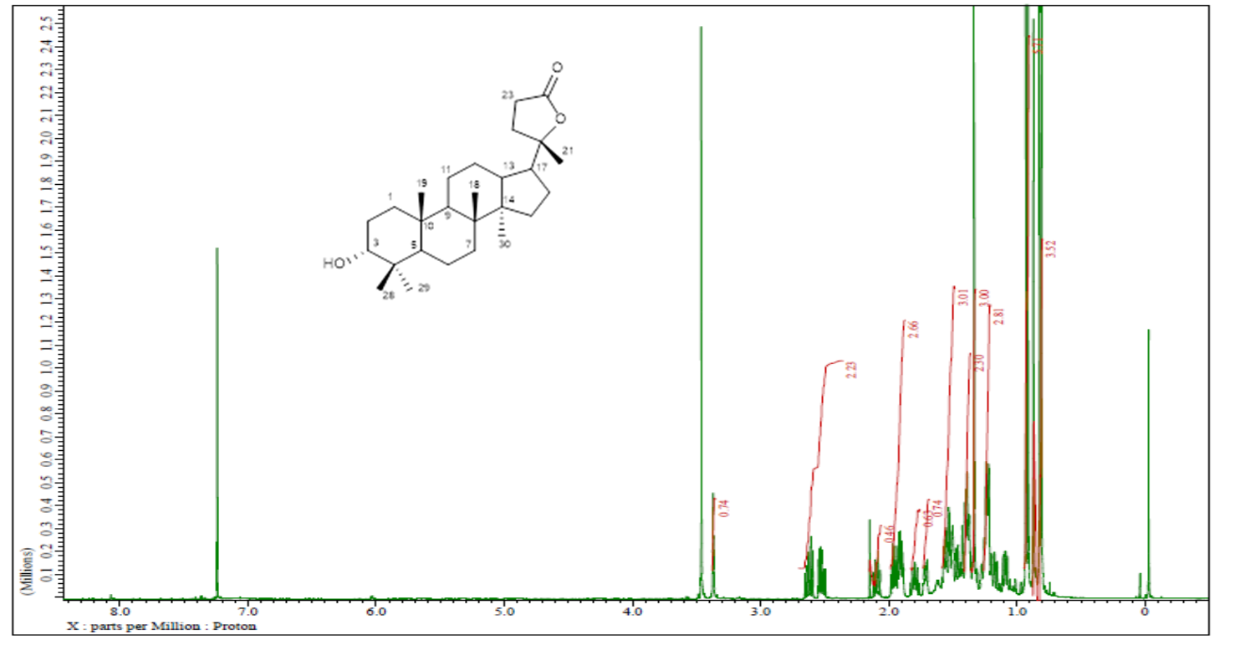

Figure 1.1. ¹H-NMR Spectrum of 1 (600 MHz in CDCl₃).

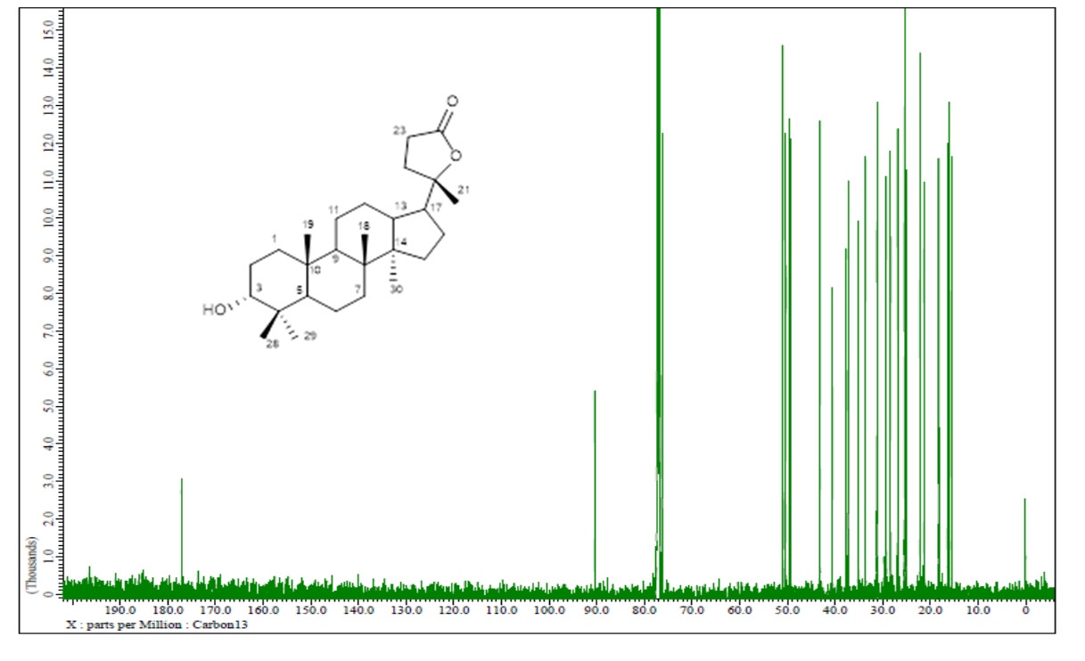

Figure 1.2. ¹³C-NMR Spectrum of 1 (150 MHz in CDCl₃).

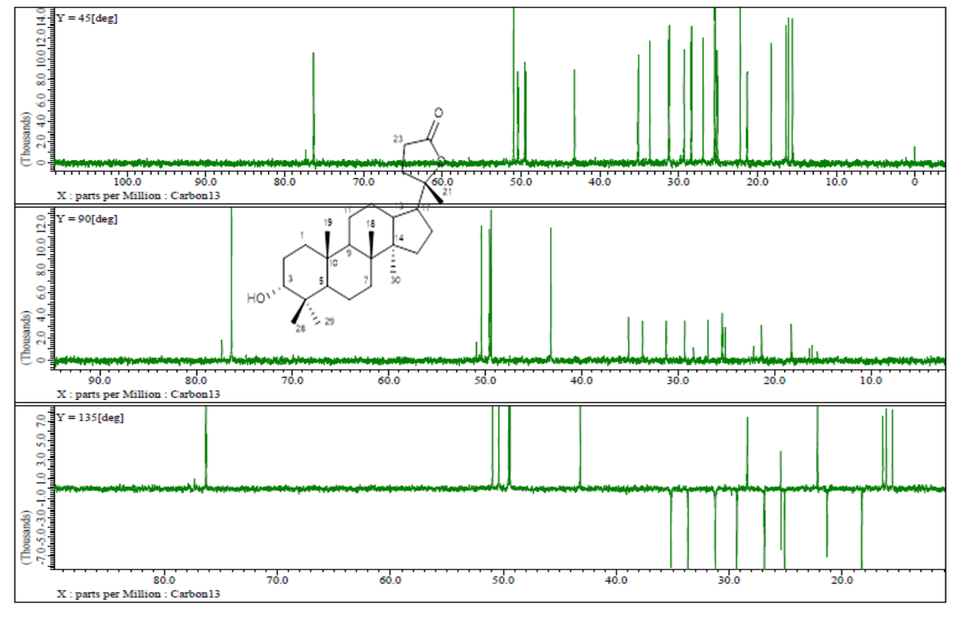
Figure 1.3. DEPT-135° Spectrum of 1 (in CDCl₃).

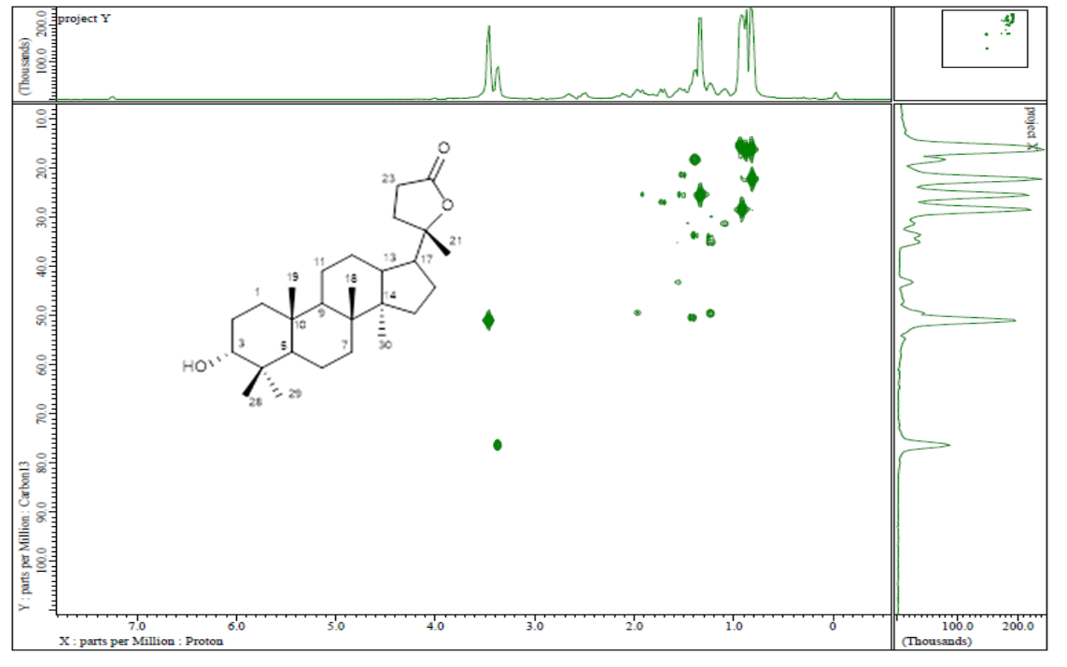

Figure 1.4. HSQC Spectrum of 1 (in CDCl₃).

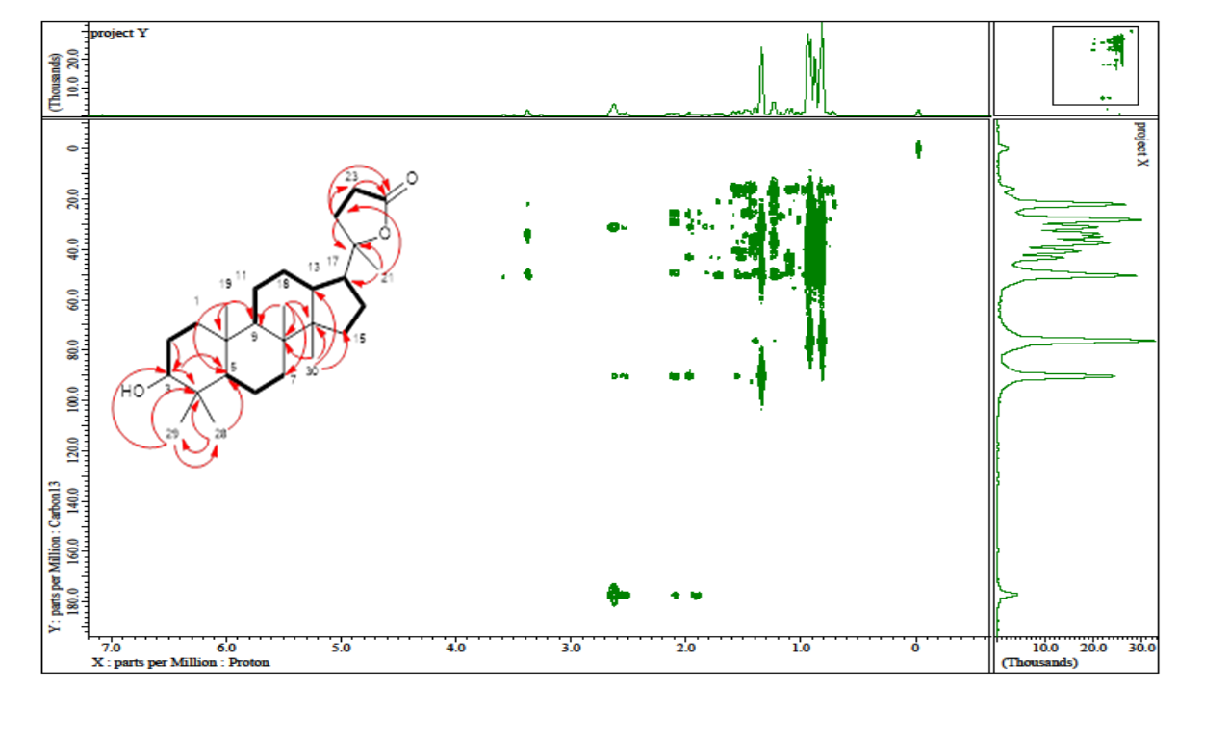
Figure 1.5. HMBC Spectrum of 1 (in CDCl₃).

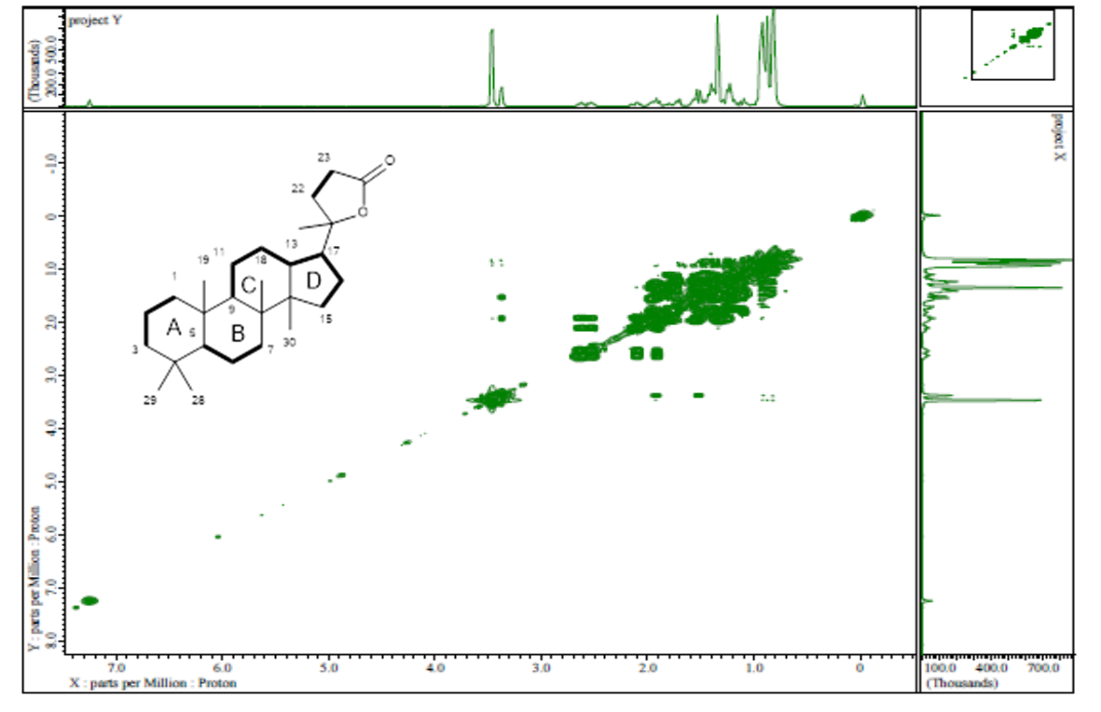

Figure 1.6. ¹H-¹H COSY Spectrum of 1

Figure 1.7. IR Spectrum of 1

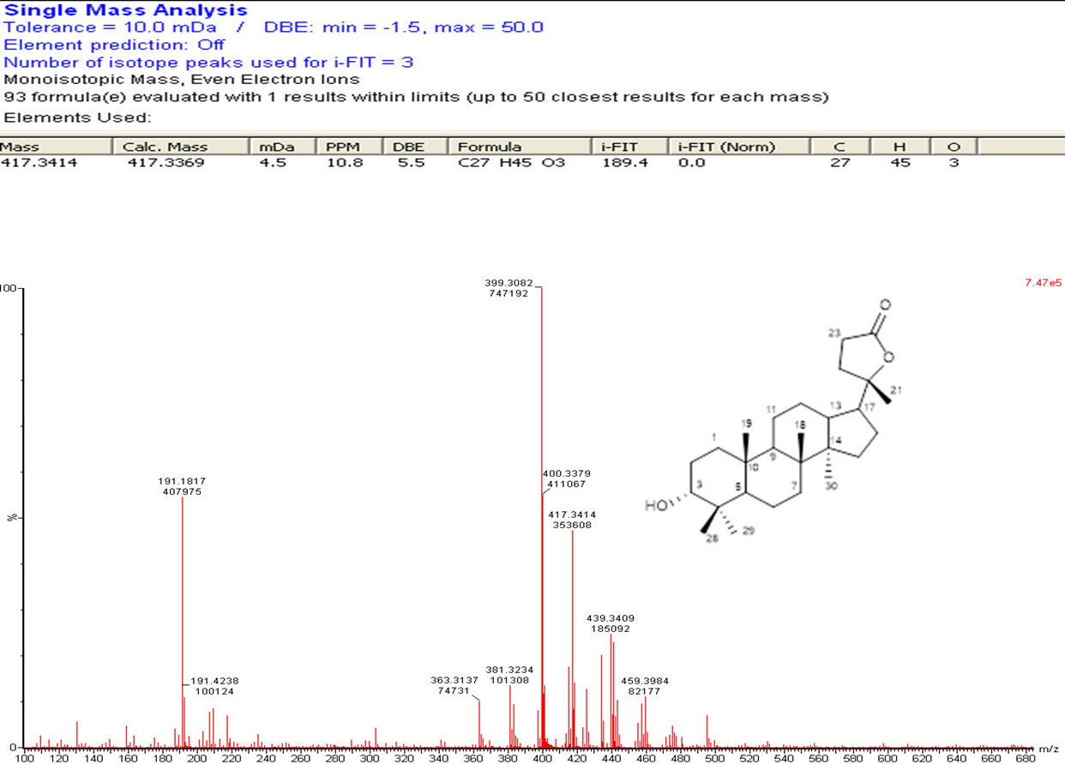

Figure 1.8. HR-TOF-MS Spectrum of 1

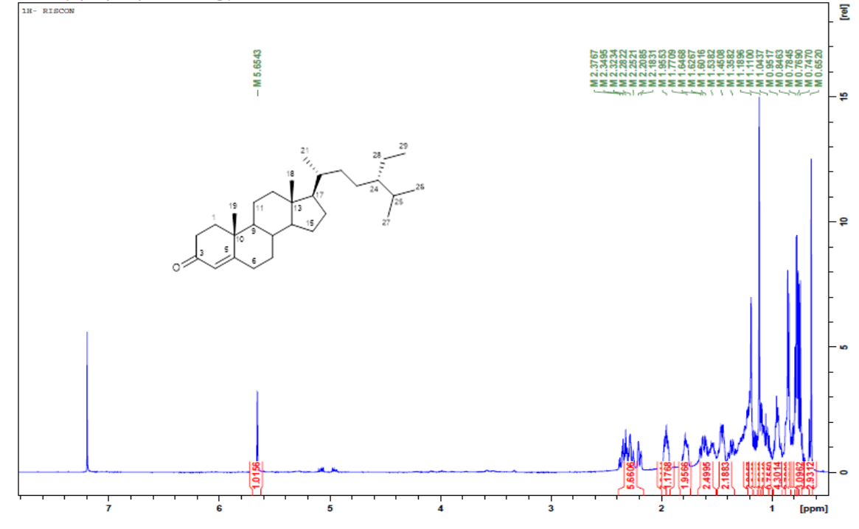

Figure 2.1. ¹H-NMR Spectrum of 2 (600 MHz in CDCl₃).

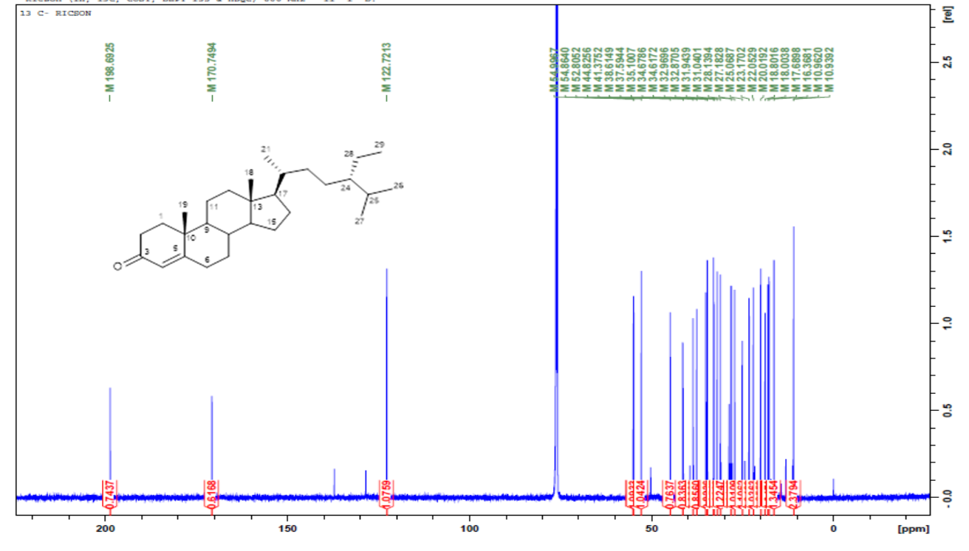

Figure 2.2. ¹³ C-NMR Spectrum of 2 (600 MHz in CDCl₃).

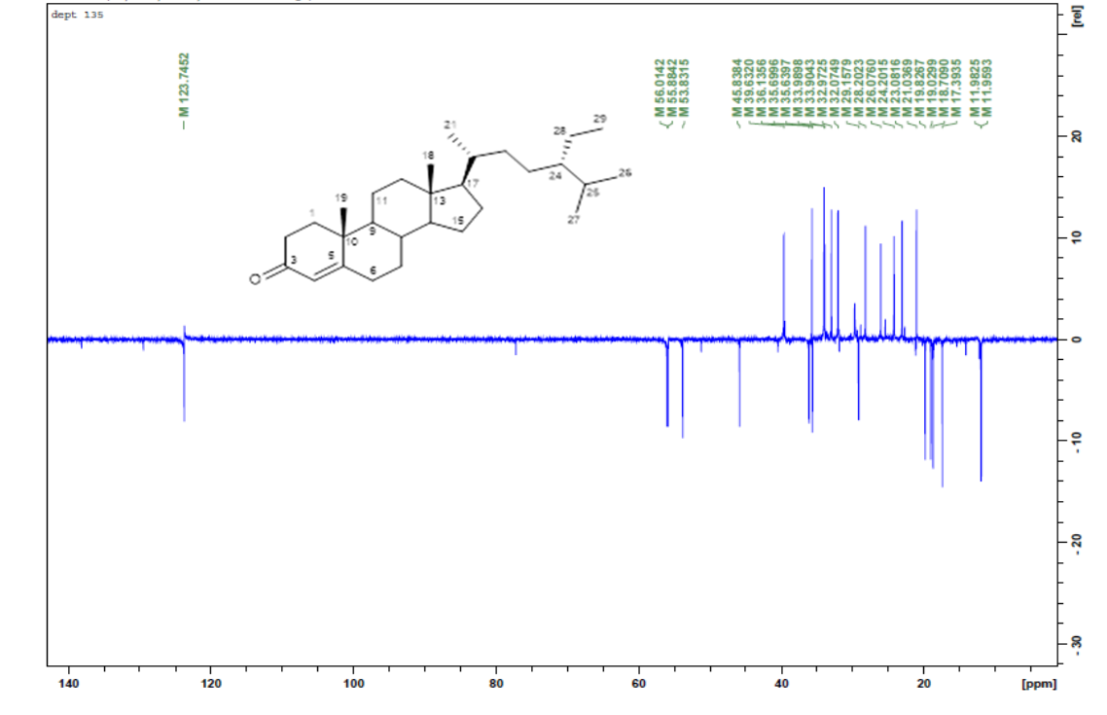

Figure 2.3. DEPT-135° Spectrum of 2 (in CDCl₃).

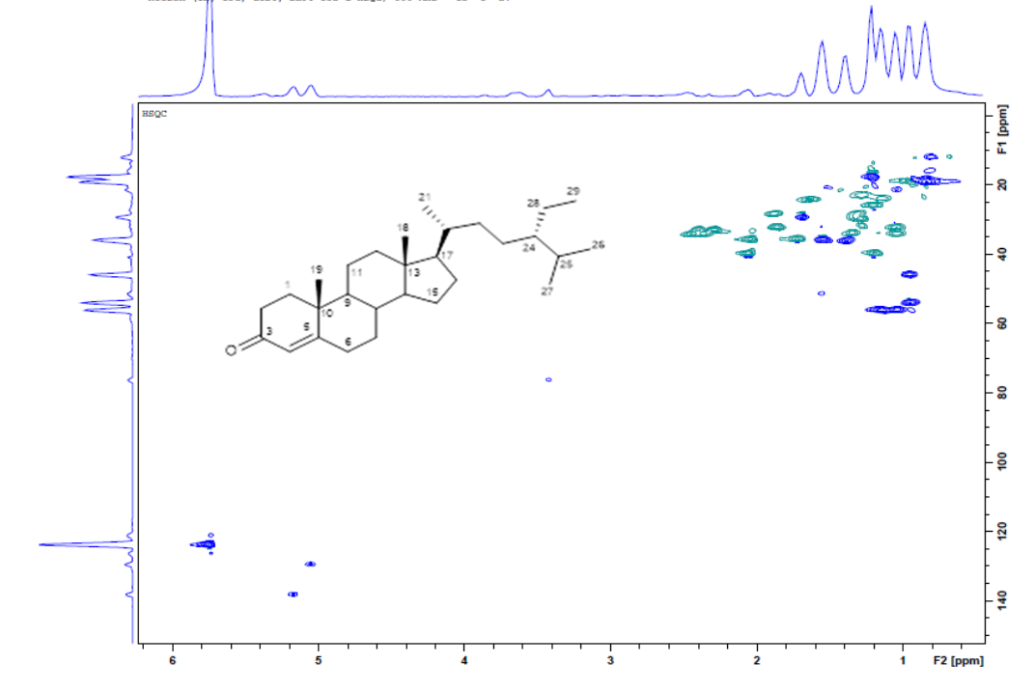

Figure 2.4. HSQC Spectrum of 2..

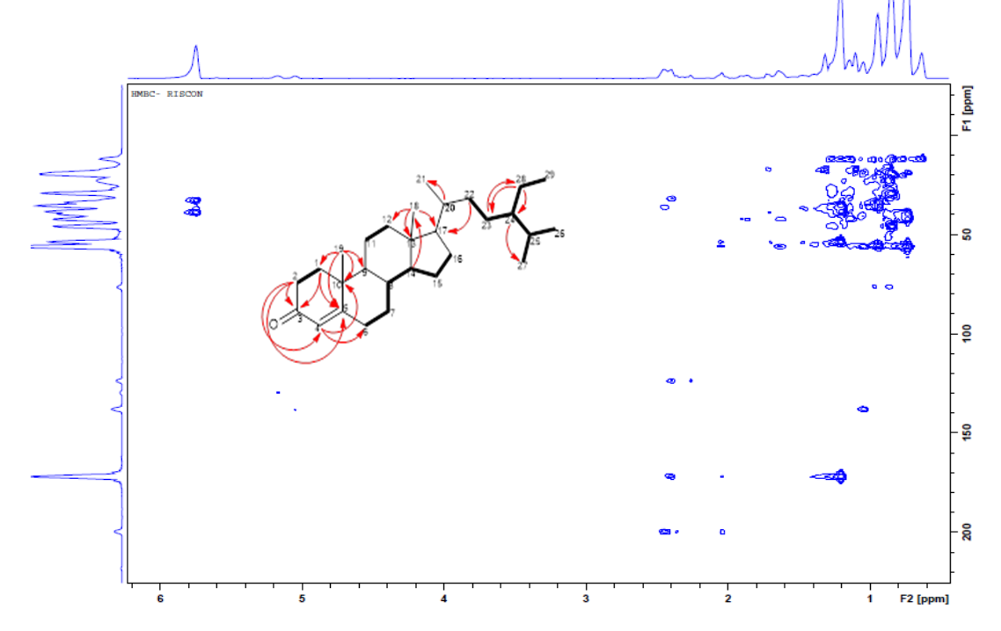

Figure 2.5. . HMBC Spectrum of 2

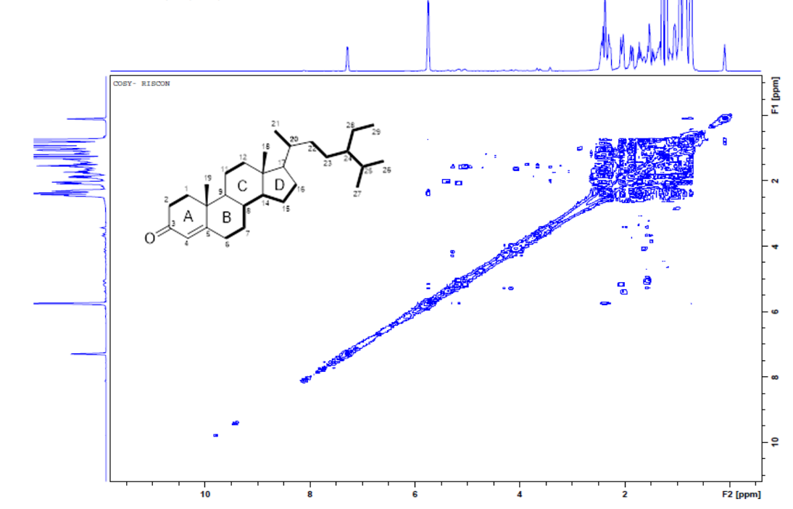
Figure 2.6. ¹H-¹H COSY Spectrum of 2. .

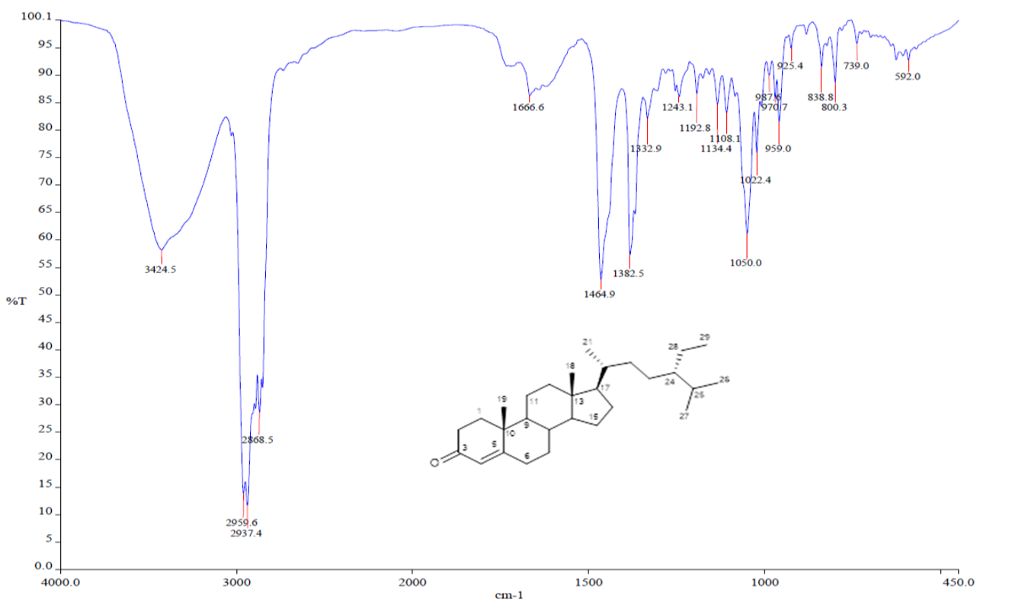

Figure 2.7. IR Spectrum of 2... .

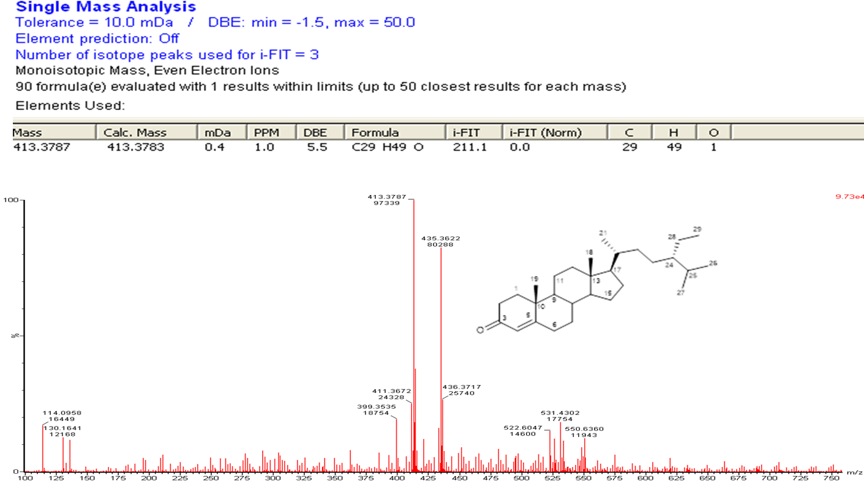

Figure 2.8. HR-TOF-MS Spectrum of 2.

