Supporting Information
Garciniaxanthone E and 12b-Hydroxy-des-D-garcigerrin A from The Tree Bark Garcinia dulcis and their Inhibitory Properties against Receptor Tyrosine Kinases
Fera Kurniadewi^{1*}, Amadita Shafa Aqilah¹ , Irma Ratna Kartika¹, Muktiningsih Nurjayadi¹, Elvira Hermawati², Ade Danova²
¹ Chemistry Study Program, Universitas Negeri Jakarta, Jakarta, 13220, Indonesia
²Organic Chemistry Division, Institut Teknologi Bandung, Bandung, 40116, Indonesia
Email: fera@unj.ac.id
Phone: +62 81380118565
fera@unj.ac.id*, amadita.shafa01@gmail.com, irmaratna@unj.ac.id, muktiningsih@unj.ac.id elvira.hermawati@itb.ac.id, adedanova@itb.ac.id

S1: Uv-Vis Spectrum of Compound 1 (garciniaxanthone E) 2
S2: MS Spectrum of Compound 1 (garciniaxanthone E) 2
S3: IR Spectrum of Compound 1 (garciniaxanthone E) 3
S4: ¹H-NMR (500 MHz, (CD₃)₂CO) Spectrum of Compound 1 (garciniaxanthone E) 3
S5: Expansion of the ¹H-NMR Spectrum of Compound 1 (garciniaxanthone E) (from 1.5 to 6.5 ppm) 4
S6: ¹³C-NMR (500 MHz, (CD₃)₂CO) Spectrum of Compound 1 (garciniaxanthone E) 4
S8: HMBC (500 MHz, (CD3)2CO) Spectrum of Compound 1 (garciniaxanthone E) 5
S7: HSQC (500 MHz, (CD₃)₂CO) Spectrum of Compound 1 (garciniaxanthone E) 5
S9: Uv-Vis Spectrum of Compound 2 (12b-Hydroxy-des-D-garcigerrin A) 6
S10: MS Spectrum of Compound 2 (12b-Hydroxy-des-D-garcigerrin A) 6
S11: IR Spectrum of Compound 2 (12b-Hydroxy-des-D-garcigerrin A) 7
S12: ¹H-NMR (500 MHz, (CD₃)₂CO) Spectrum of Compound 2 (12b-Hydroxy-des-D-garcigerrin A) 7
S13: Expansion of the ¹H-NMR Spectrum of Compound 2 (12b-Hydroxy-des-D-garcigerrin A) (from 4.8 to 8.0 ppm) 8
S14: ¹³C-NMR (500 MHz, (CD₃)₂CO) Spectrum of Compound 2 (12b-Hydroxy-des-D-garcigerrin A) 8
S15: HSQC (500 MHz, (CD₃)₂CO) Spectrum of Compound 2 (12b-Hydroxy-des-D-garcigerrin A) 9
S16: HMBC (500 MHz, (CD₃)₂CO) Spectrum of Compound 2 (12b-Hydroxy-des-D-garcigerrin A) 9

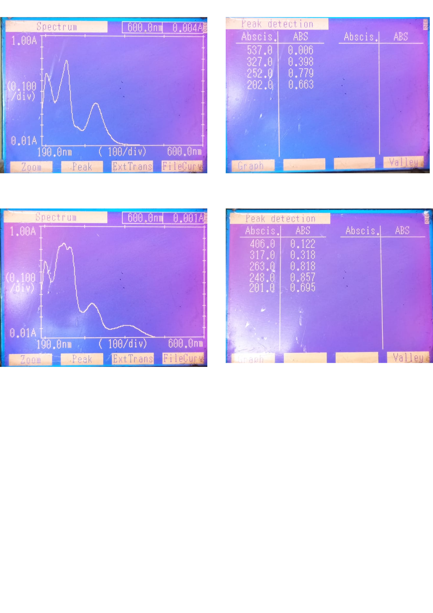
S1: Uv-Vis Spectrum of Compound 1 (garciniaxanthone E)

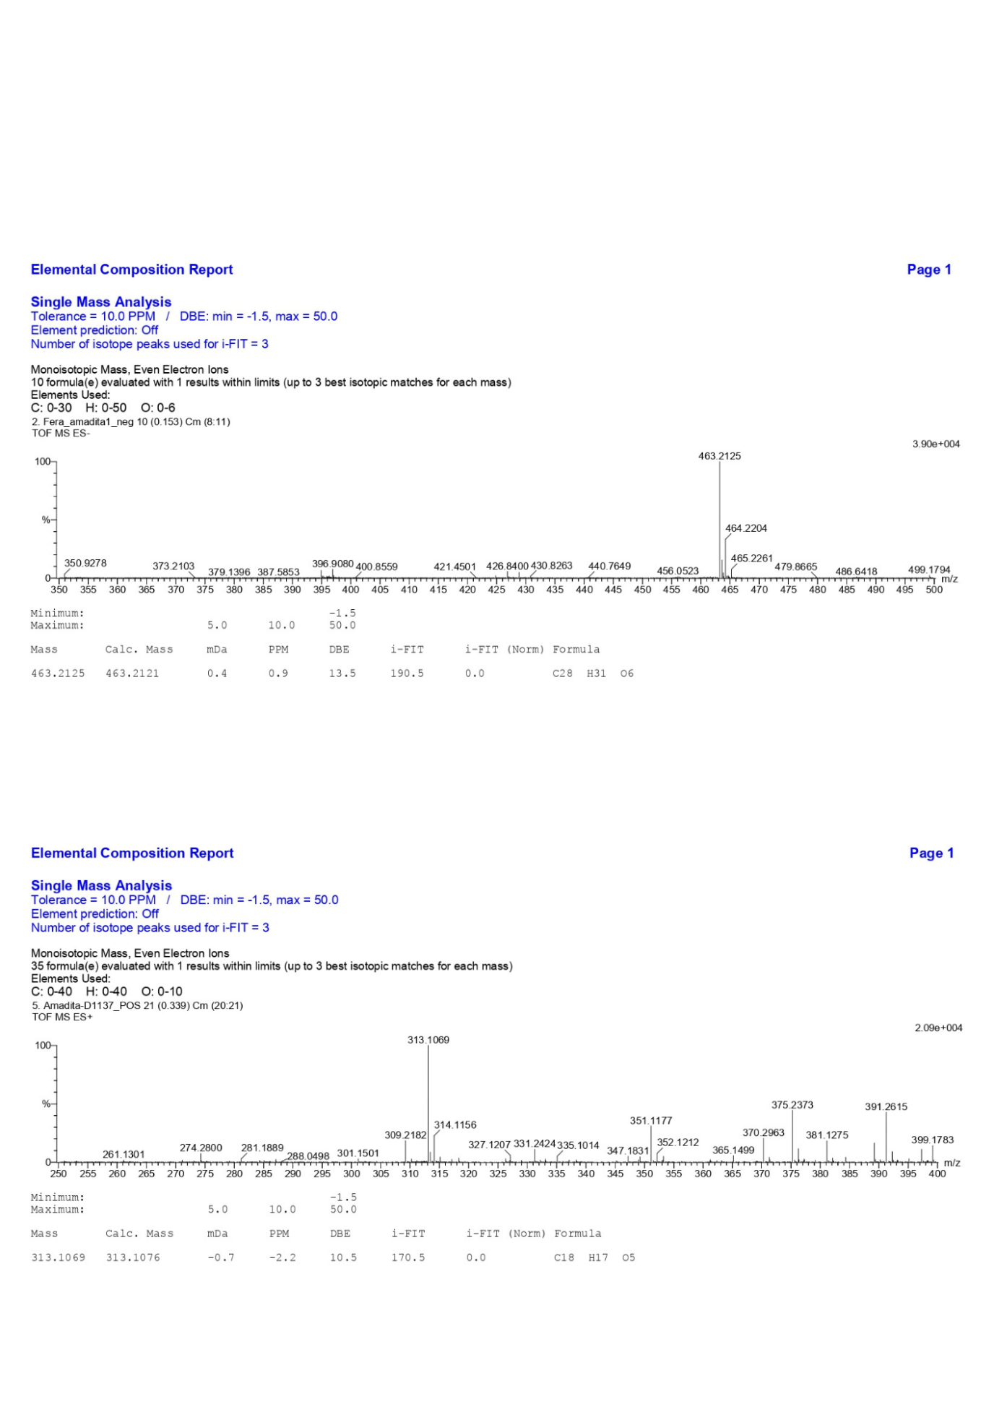
S2: MS Spectrum of Compound 1 (garciniaxanthone E)

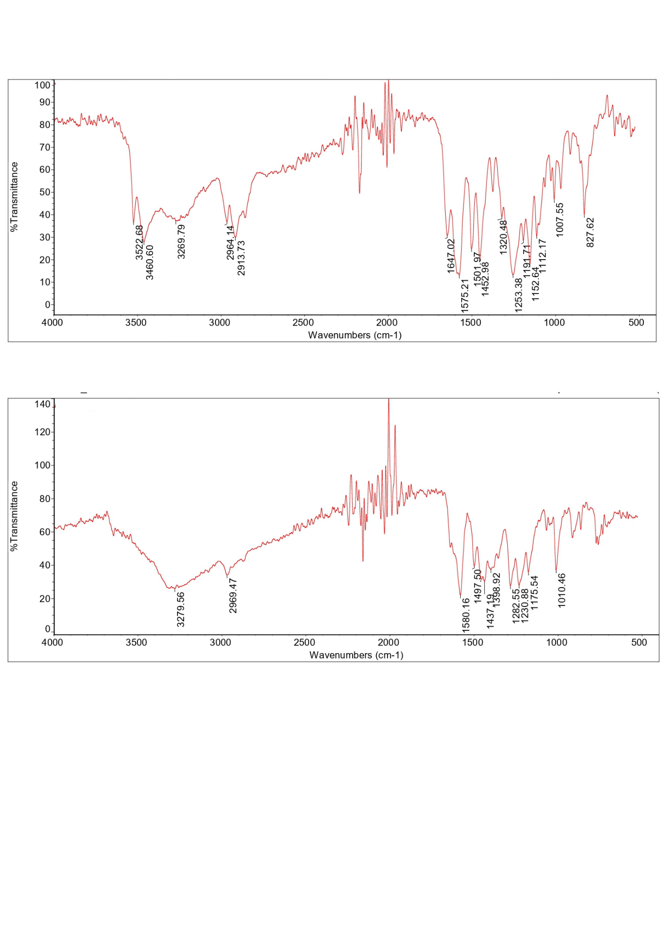
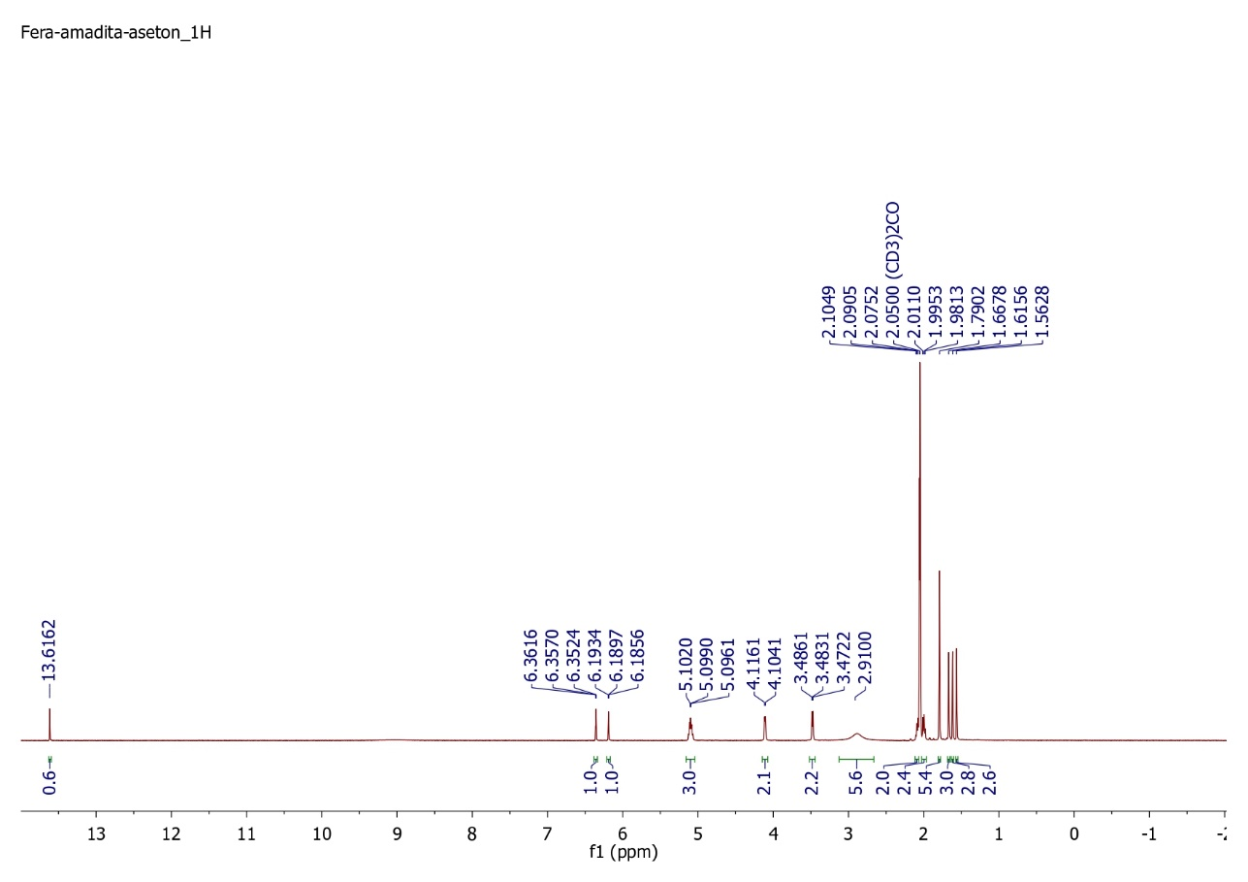
S3: IR Spectrum of Compound 1 (garciniaxanthone E)
S4: ¹H-NMR (500 MHz, (CD₃)₂CO) Spectrum of Compound 1 (garciniaxanthone E)
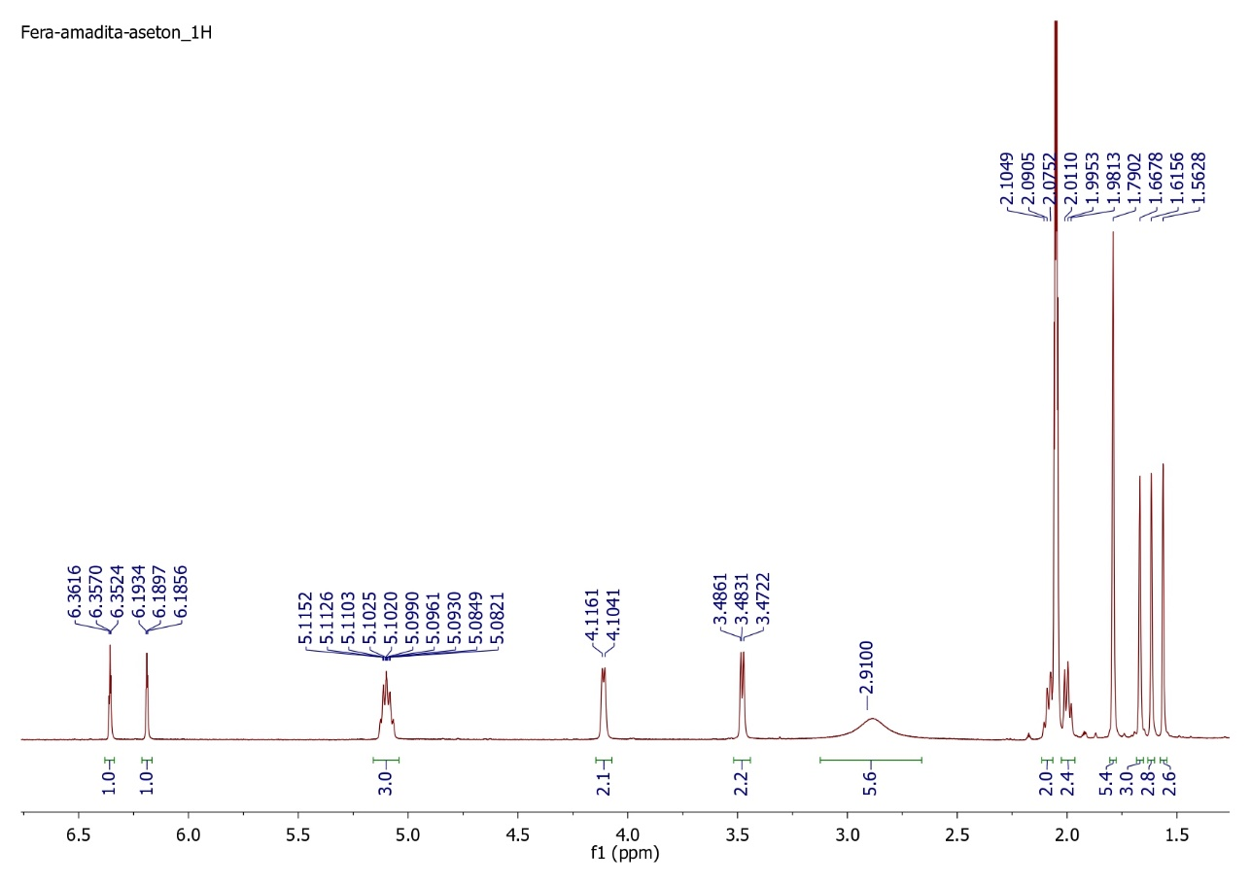
S5: Expansion of the ¹H-NMR Spectrum of Compound 1 (garciniaxanthone E) (from 1.5 to 6.5 ppm)
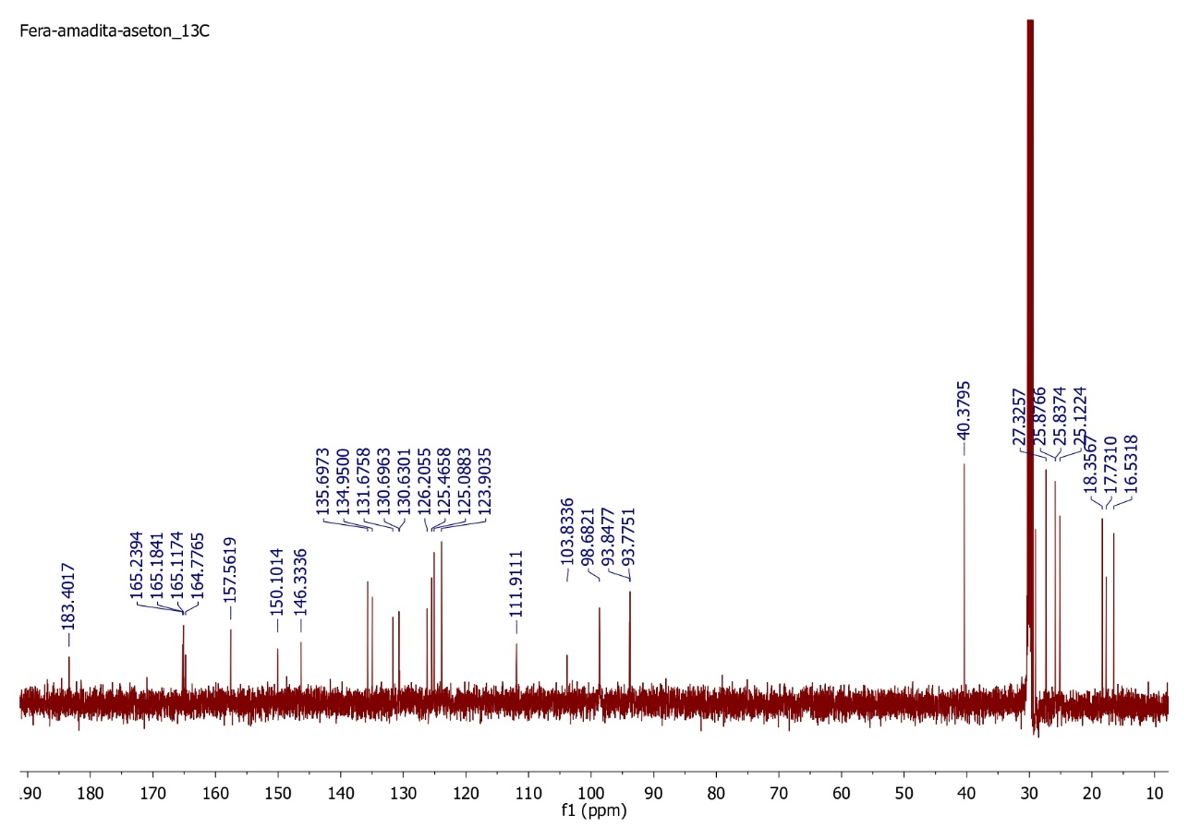
S6: ¹³C-NMR (500 MHz, (CD₃)₂CO) Spectrum of Compound 1 (garciniaxanthone E)
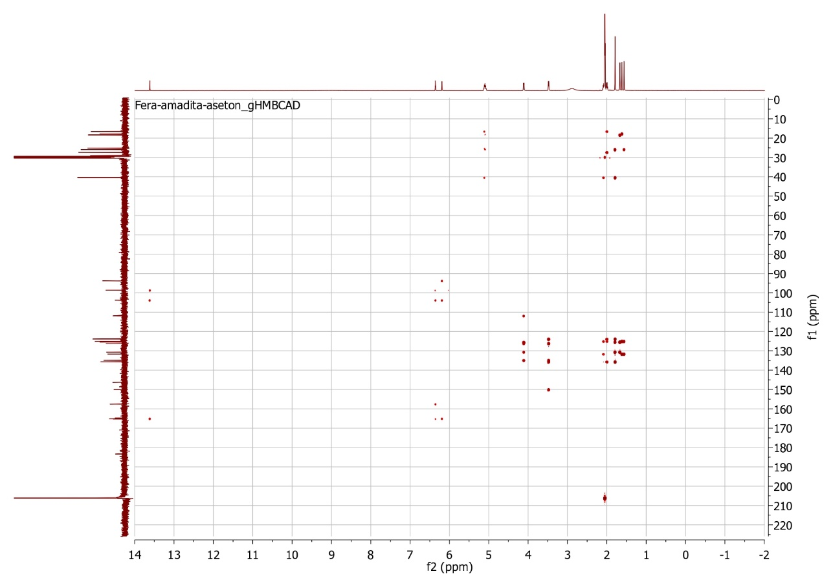
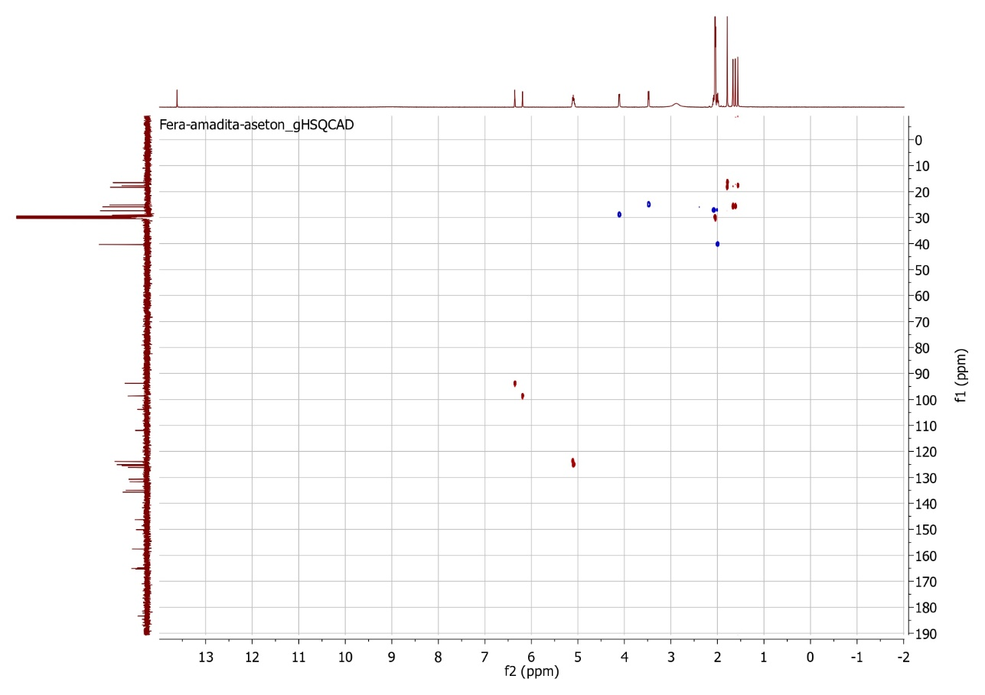
S8: HMBC (500 MHz, (CD3)2CO) Spectrum of Compound 1 (garciniaxanthone E)
S7: HSQC (500 MHz, (CD₃)₂CO) Spectrum of Compound 1 (garciniaxanthone E)
S9: Uv-Vis Spectrum of Compound 2 (12b-Hydroxy-des-D-garcigerrin A)

S10: MS Spectrum of Compound 2 (12b-Hydroxy-des-D-garcigerrin A)

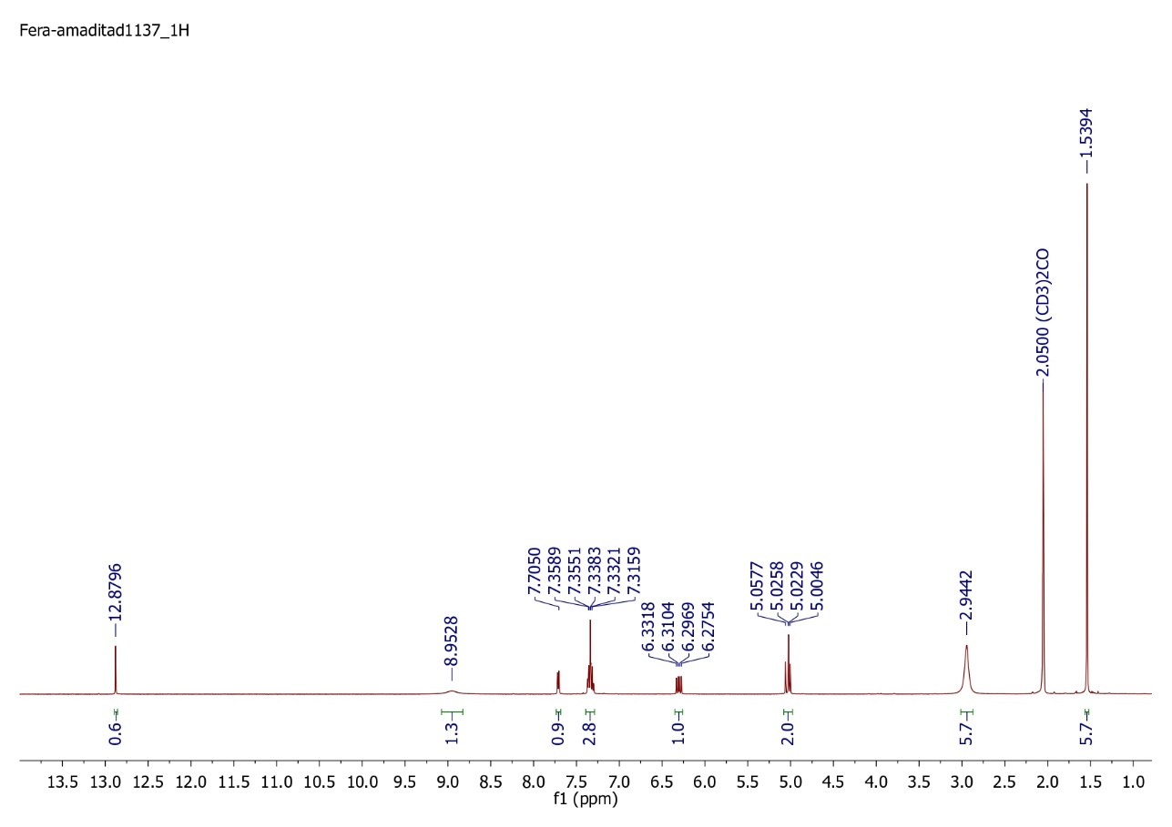
S11: IR Spectrum of Compound 2 (12b-Hydroxy-des-D-garcigerrin A)
S12: ¹H-NMR (500 MHz, (CD₃)₂CO) Spectrum of Compound 2 (12b-Hydroxy-des-D-garcigerrin A)
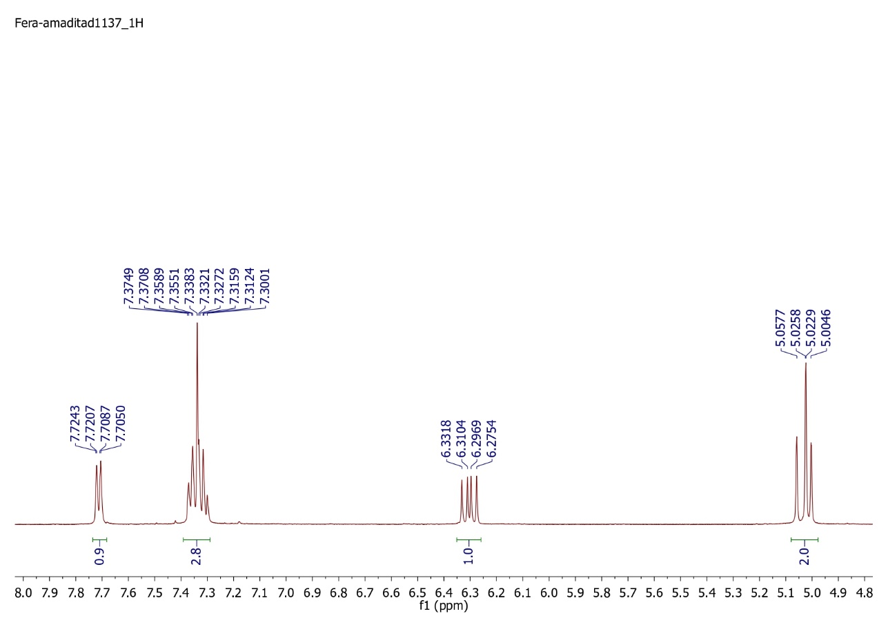
S13: Expansion of the ¹H-NMR Spectrum of Compound 2 (12b-Hydroxy-des-D-garcigerrin A) (from 4.8 to 8.0 ppm)

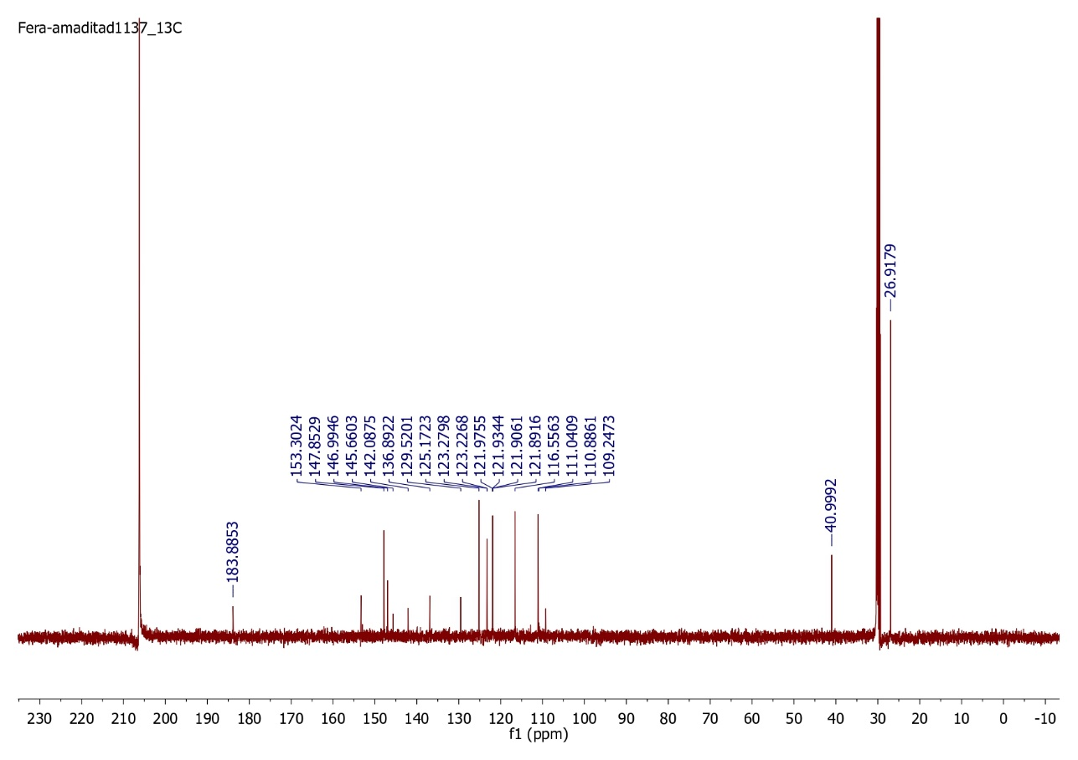
S14: ¹³C-NMR (500 MHz, (CD₃)₂CO) Spectrum of Compound 2 (12b-Hydroxy-des-D-garcigerrin A)
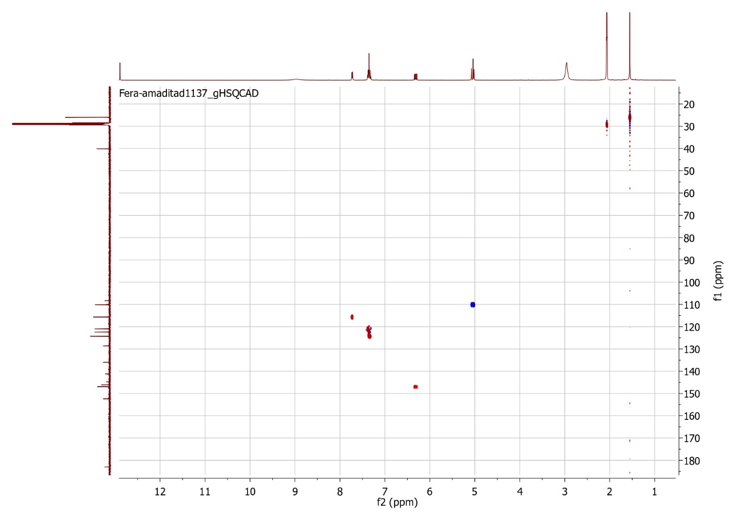
S15: HSQC (500 MHz, (CD₃)₂CO) Spectrum of Compound 2 (12b-Hydroxy-des-D-garcigerrin A)
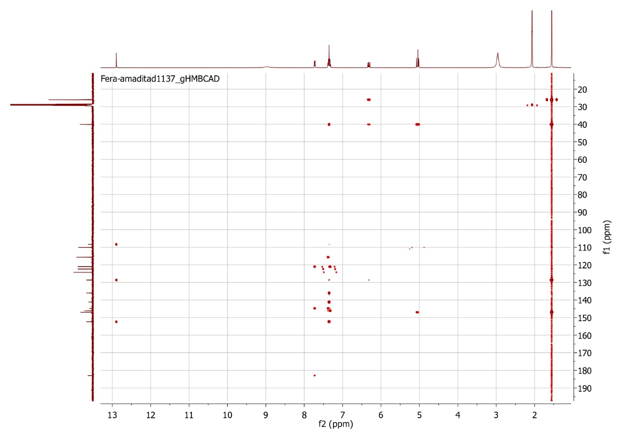
S16: HMBC (500 MHz, (CD₃)₂CO) Spectrum of Compound 2 (12b-Hydroxy-des-D-garcigerrin A)

