**Sesquiterpenoids from the stem bark of *Aglaia pachyphylla* Miq (Meliaceae) and cytotoxic activity against MCF-7 Cancer Cell Line**  
  
**Wahyu Safriansyah1, Fajar Fauzi Abdullah1, Endang Juliansyah1, Kindi Farabi1,2, Harizon3, Hadi Kuncoro4, Nurlelasari1, Rani Maharani1,2, Mohamad Nurul Azmi Mohamad Taib**5**, Unang Supratman1,2 and Desi Harneti1\***   
  
1Department of Chemistry, Faculty of Mathematics and Natural Science, Universitas Padjadjaran,

Jatinangor 45363, Sumedang, Indonesia  
2Central Laboratory, Universitas Padjadjaran, Jatinangor 45363, Sumedang, Indonesia

3Faculty of Teacher Training and Education, Universitas Jambi, Mendalo Indah, Jambi 36361, Indonesia

4Faculty of Pharmacy, Mulawarwan University, Samarinda, 75119,

Kalimantan Timur, Indonesia

5School of Chemical Sciences, Universiti Sains Malaysia, 11800 Penang, Malaysia

Email: *desi.harneti@unpad.ac.id*

**TABLE OF CONTENTS**

**Figure S1.** MS Spectra of Compound **1** 13

**Figure S2.** IR Spectra of Compound **1** 14

**Figure S3.** 1H-NMR Spectra of **1** (500 MHz in CDCl3) 15

**Figure S4.** DEPT-135° and 13C-NMR Spectrum of **1** (125 MHz in CDCl3) 16

**Figure S5.** MS Spectra of Compound **2** 17

**Figure S6.** IR Spectra of Compound **2** 18

**Figure S7.** 1H-NMR Spectra of **2** (500 MHz in CDCl3) 19

**Figure S8.** DEPT-135° and 13C-NMR Spectrum of **2** (125 MHz in CDCl3) 20

**Figure S9.** MS Spectra of Compound **3** 21

**Figure S10.** IR Spectra of Compound **3** 22

**Figure S11.** 1H-NMR Spectra of **3** (500 MHz in CDCl3) 23

**Figure S12.** DEPT-135° and 13C-NMR Spectrum of **3** (125 MHz in CDCl3) 24

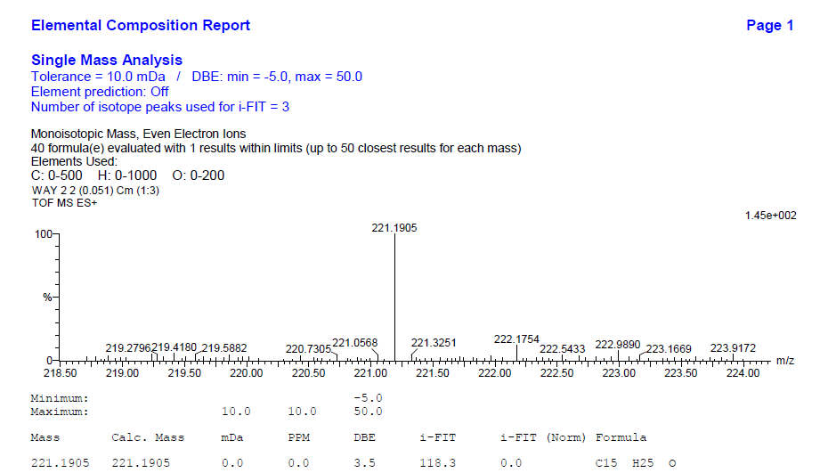**Figure S1.** MS Spectra of Compound **1**

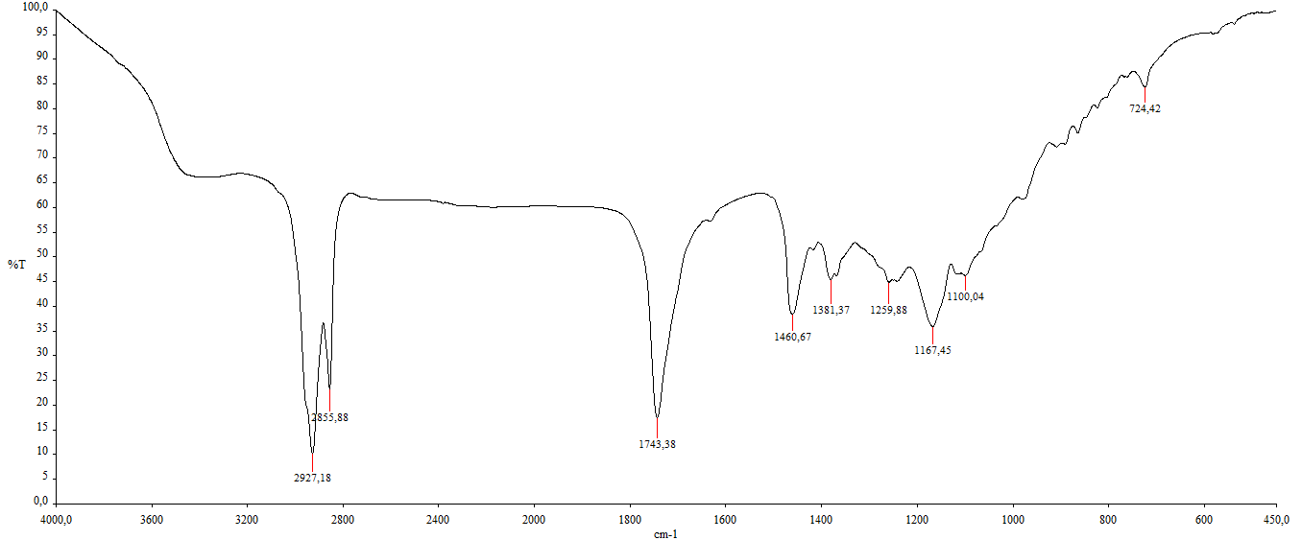**Figure S2.** IR Spectra of Compound **1**

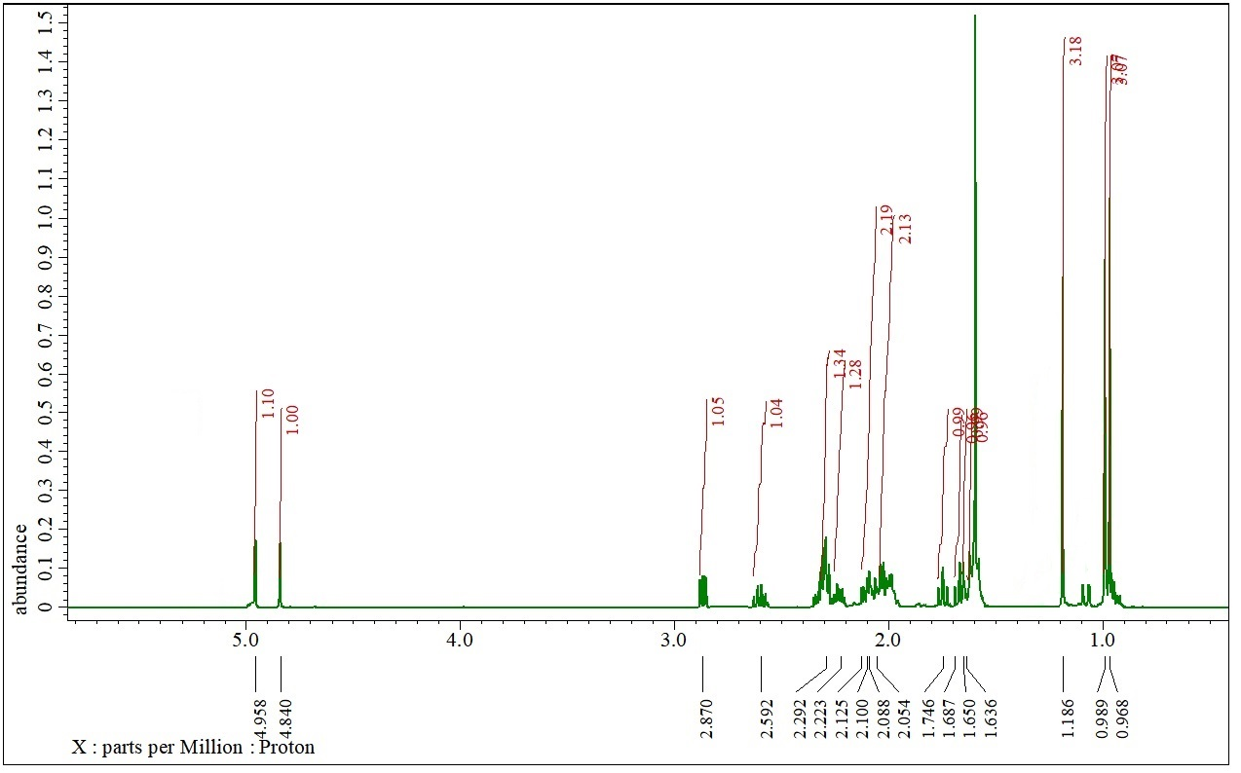**Figure S3.** 1H-NMR Spectra of (**1**) (500 MHz in CDCl3)

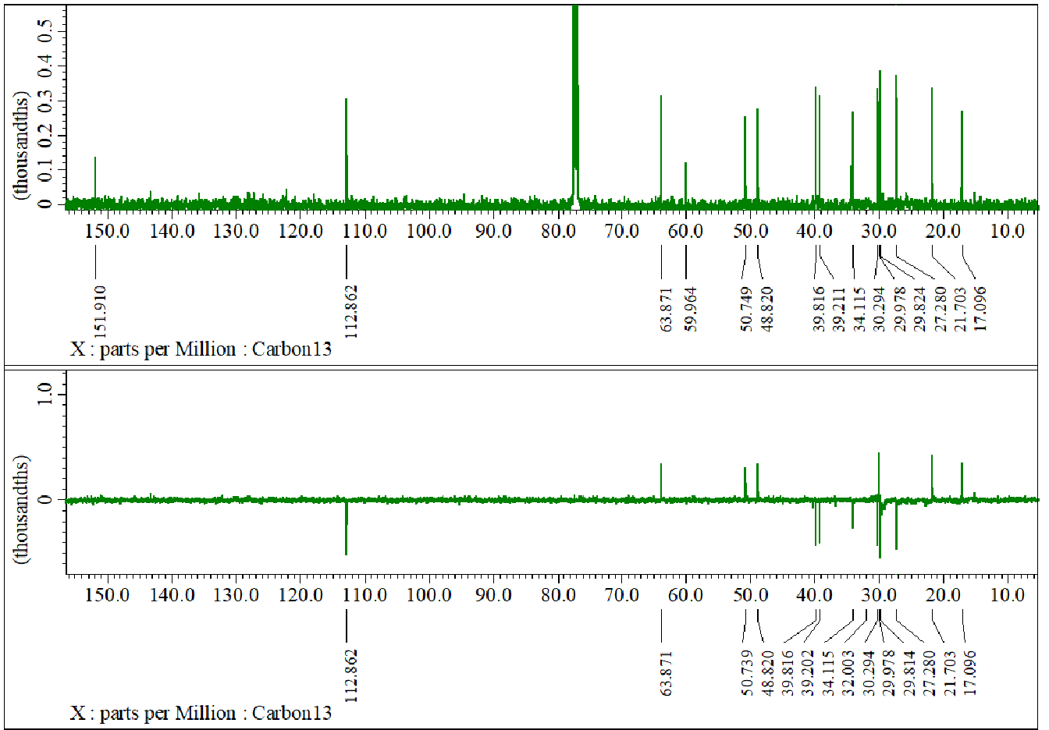

**Figure S4.** DEPT-135° and 13C-NMR Spectrum of (**1**) (125 MHz in CDCl3)

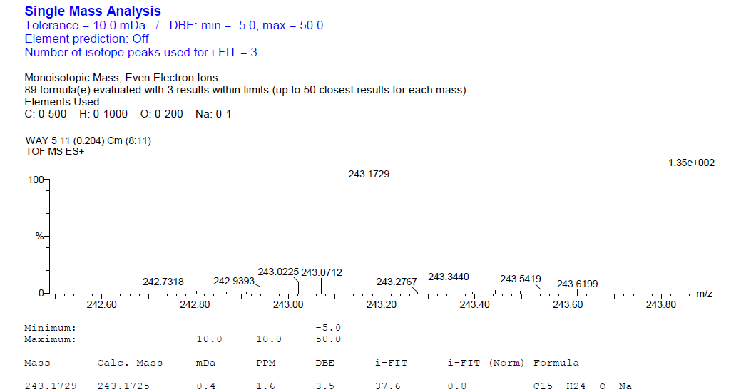

**Figure S5.** MS Spectra of Compound **2**

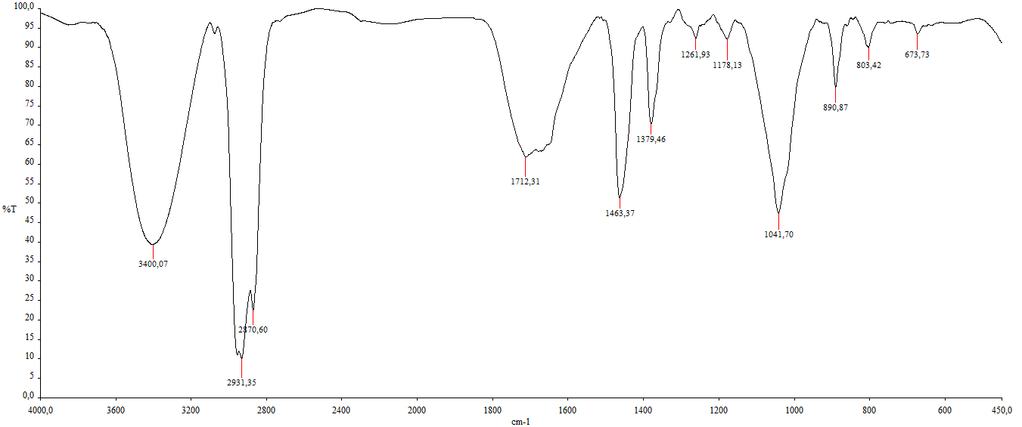**Figure S6.** IR Spectra of Compound **2**

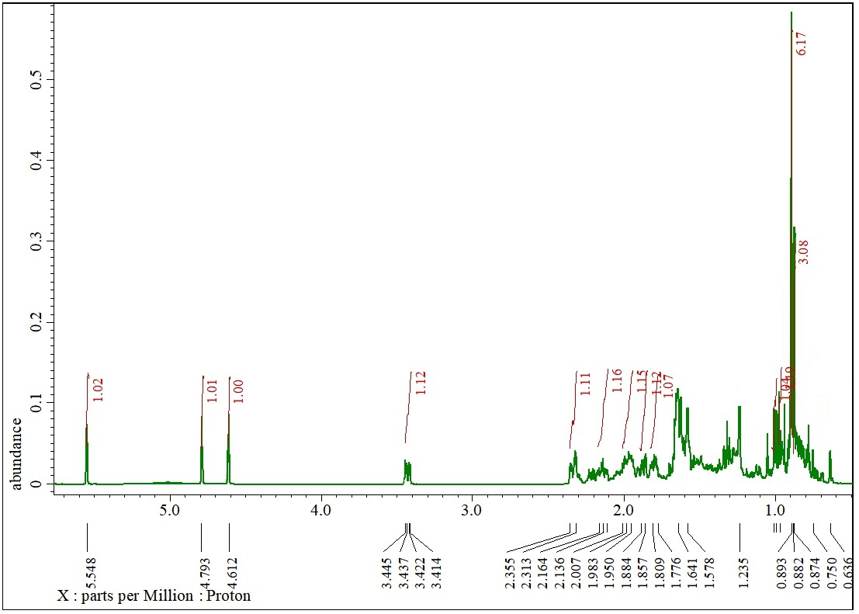**Figure S7.** 1H-NMR Spectra of (**2**) (500 MHz in CDCl3)

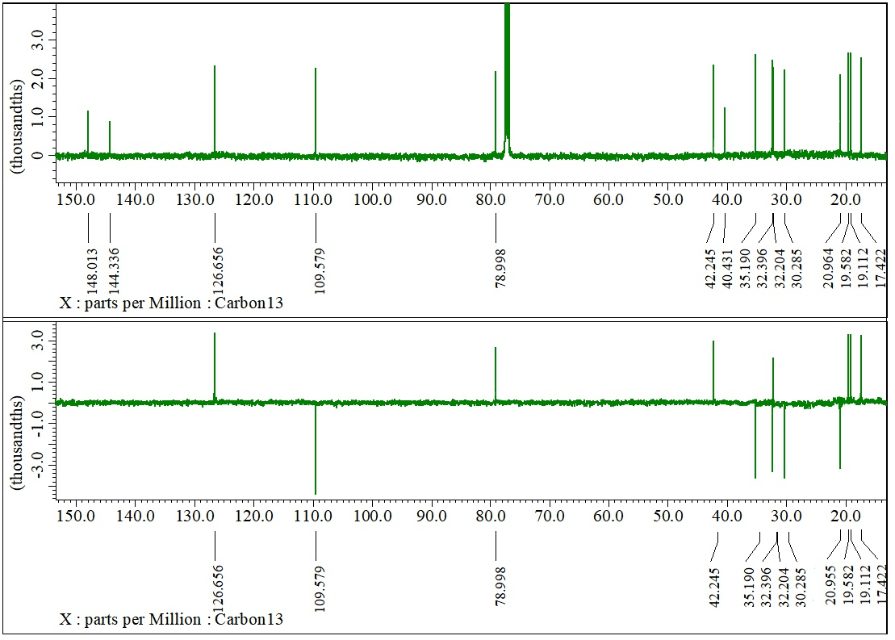**Figure S8.** DEPT-135° and 13C-NMR Spectrum of (**2**) (125 MHz in CDCl3)

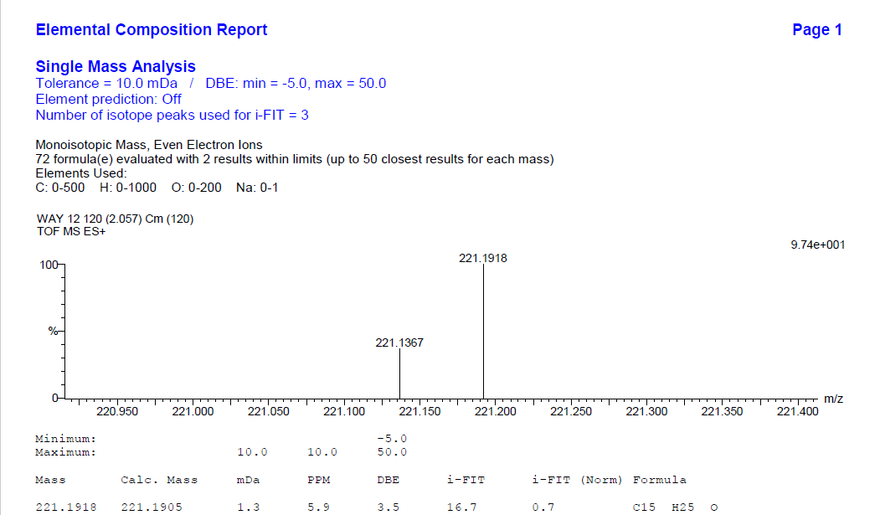**Figure S9.** MS Spectra of Compound **3**

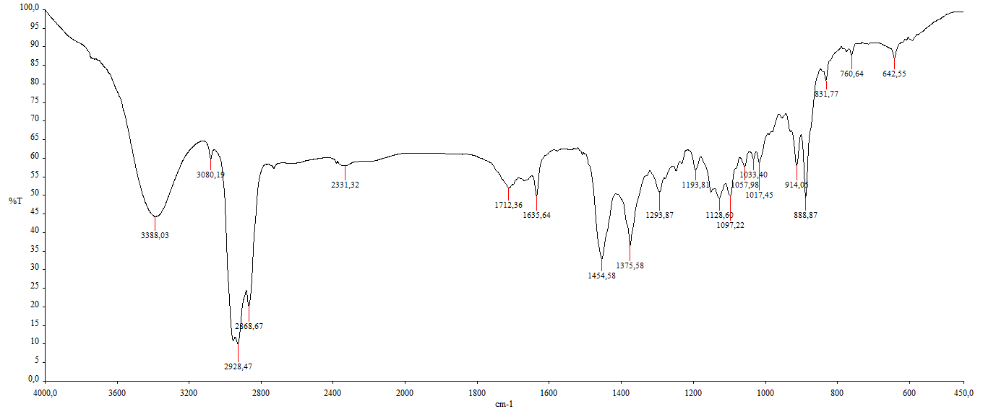**Figure S10.** IR Spectra of Compound **3**

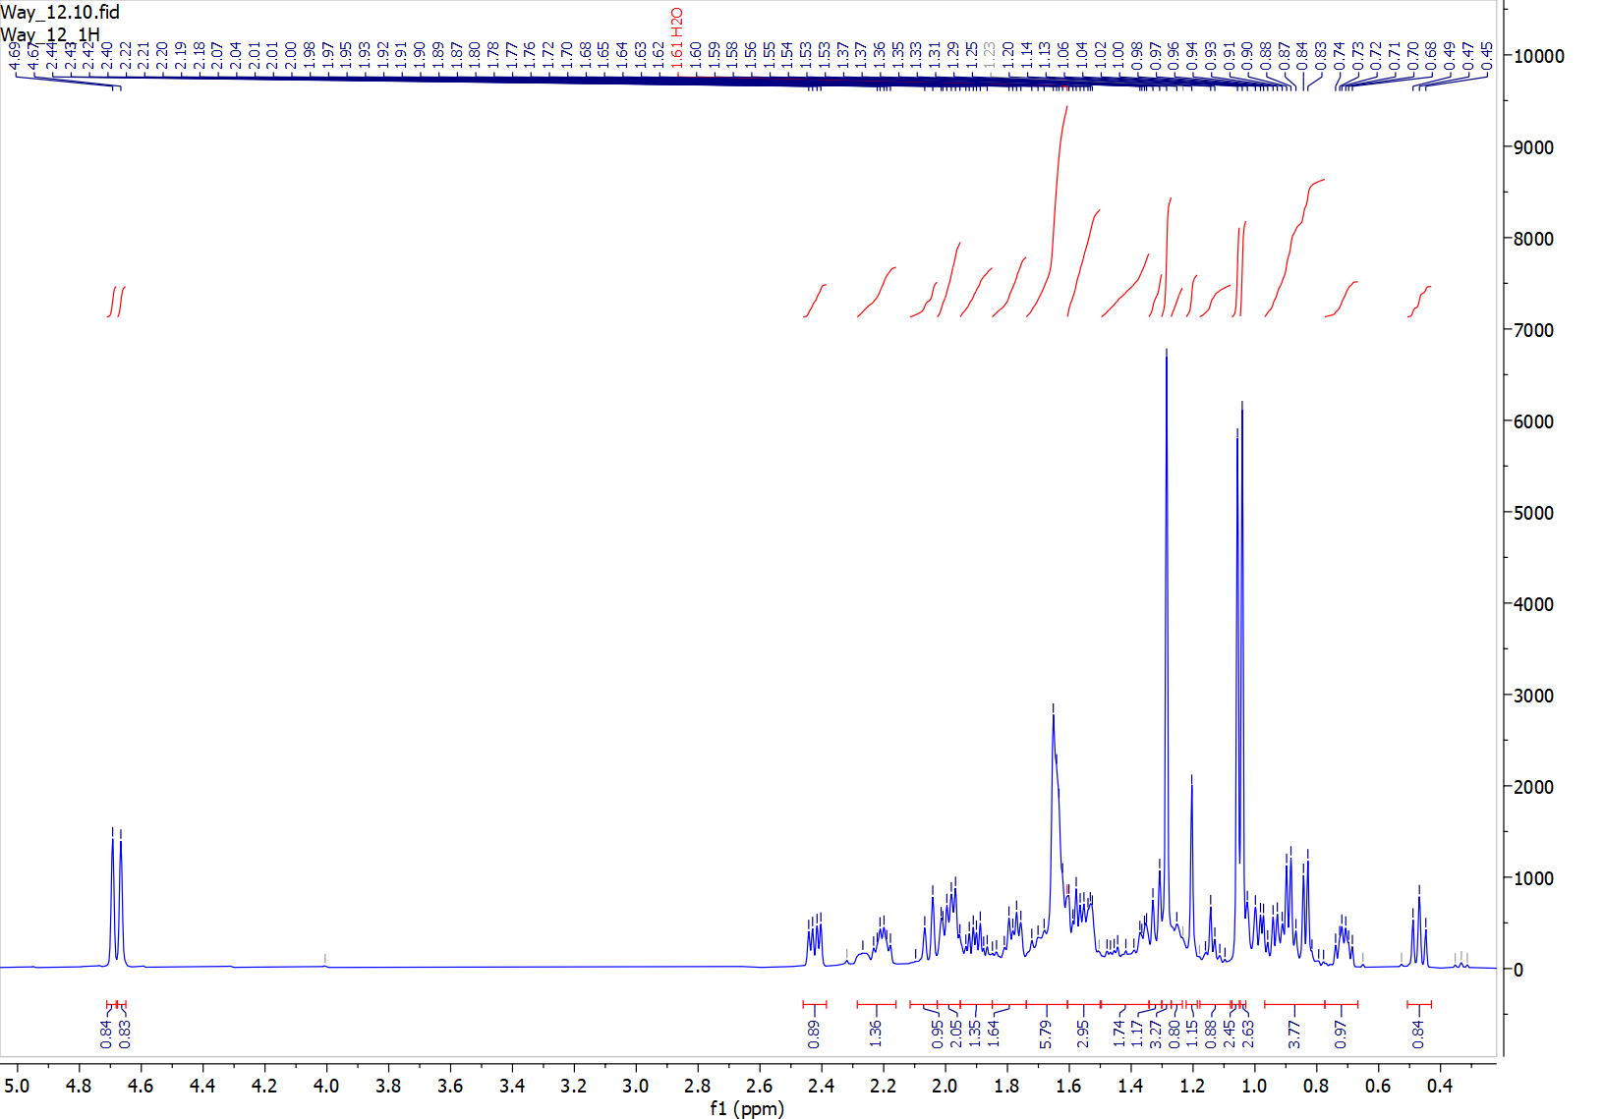**Figure S11.** 1H-NMR Spectra of (**3**) (500 MHz in CDCl3)

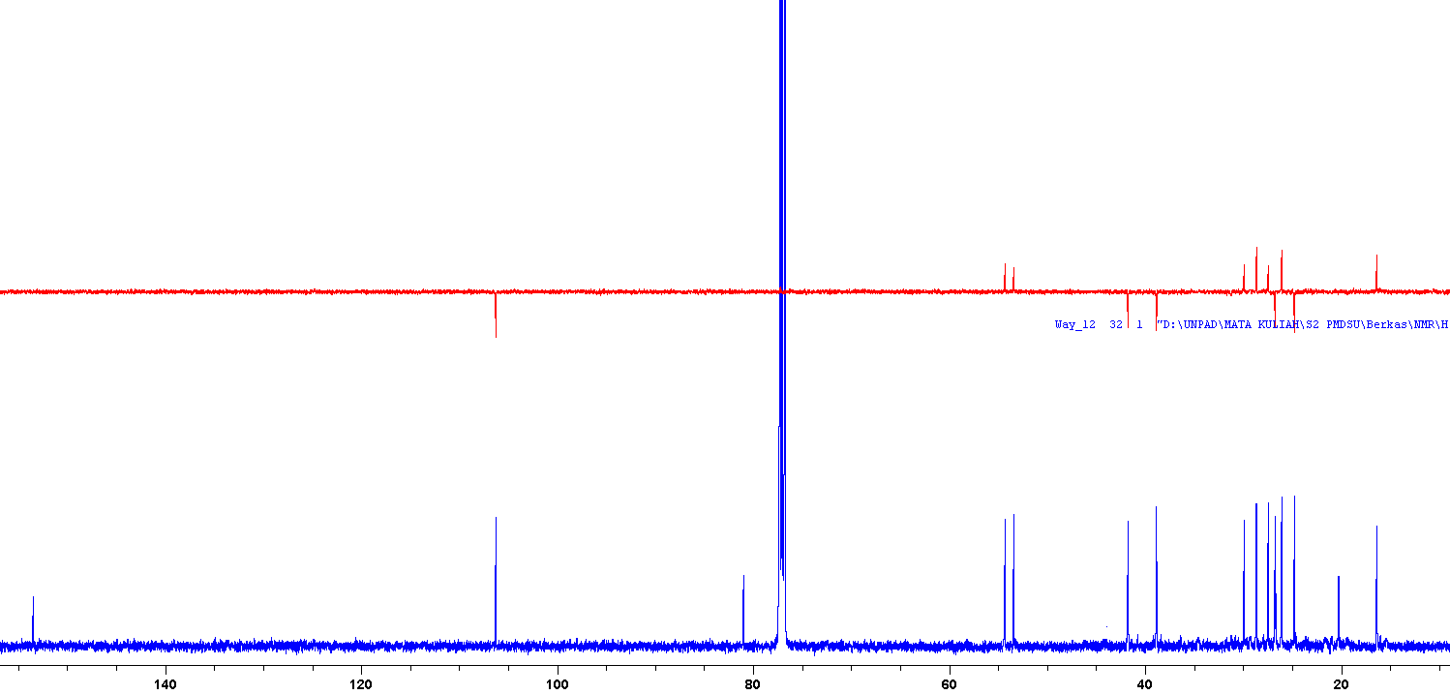**Figure S12.** DEPT-135° and 13C-NMR Spectrum of (**3**) (125 MHz in CDCl3)