Suplemen material

**Nimonol from Chisocheton macrophyllus (Meliaceae) Seeds and Their Cytotoxic Activity against**

**P-388 Leukaemia cells**

**Nurlelasari1*, Desi Harneti1, P.H., Rani Maharani1, Darwati1, Tri Mayanti1, Kindi Farabi1, Muhammad Hanafi2, and Unang Supratman1**

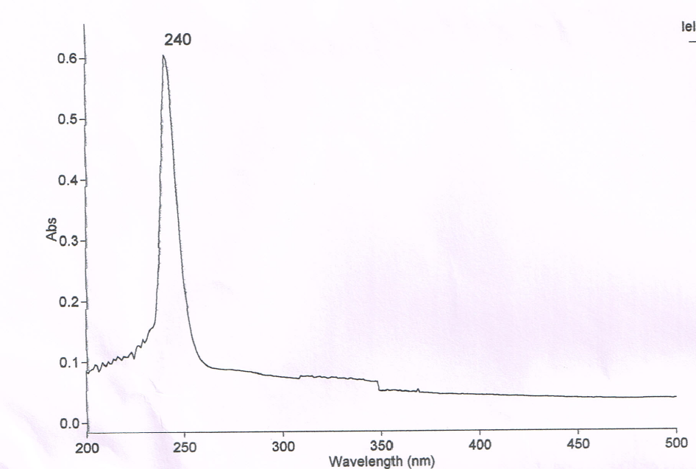

Figure 1. Ultraviolet spectrum of Nimonol (Methanol)



OH

CH-alifatik

C=O

C=O ester

C=C

C-O

Figure 2. Nimonol Infrared Spectrum (KBr)

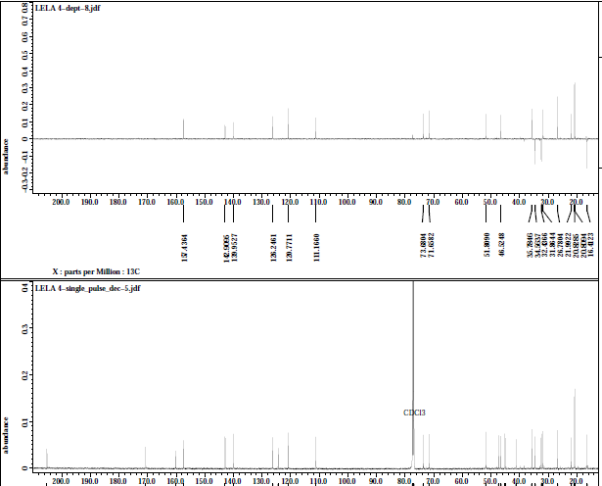

C-Sp3

CH-Sp3

C-O

C=C Sp2

Cq Sp2

Cq Sp2

Cq Sp3

Figure 3. Spectrum of DEPT 135o nimonol (CDCl3, 125 MHz)

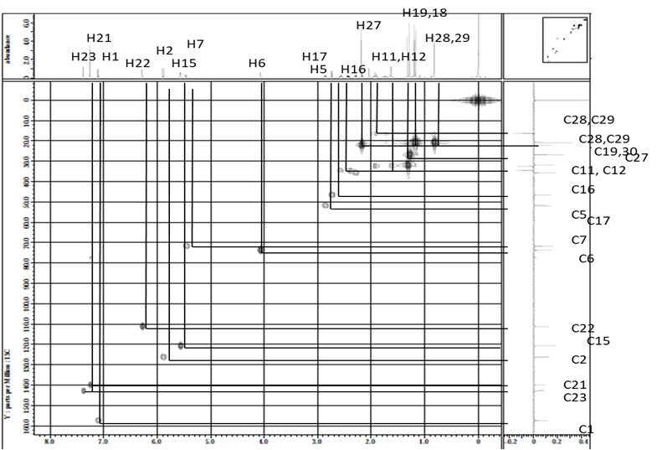

Figure 4. The HMQC spectrum of selected nimonol

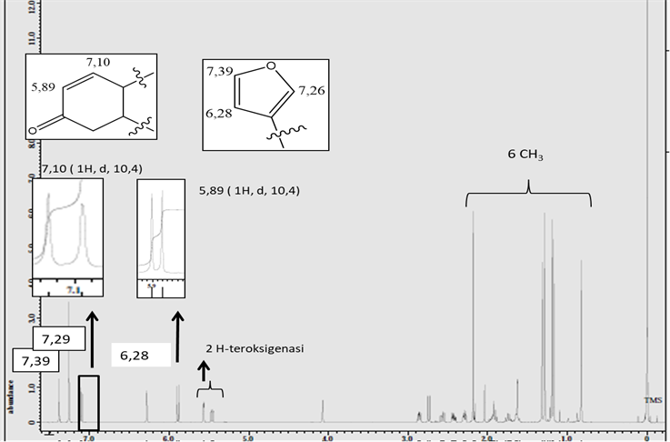

Figure 5. Nimonol 1H-NMR spectrum (CDCl3, 500 MHz)

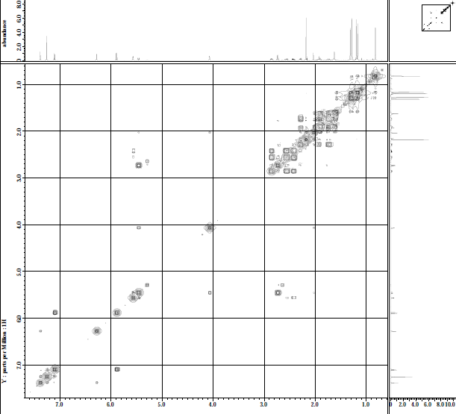

H23

H22

H1

H2

H7

H16

H6

H15



Figure 6. COSY 1H-1H spectrum selected nimonol

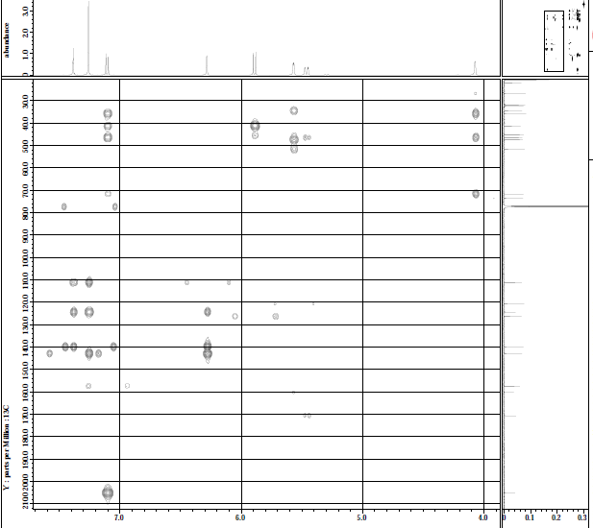

H6

H-2

H-15

H-7

H-1

H-21

H-23

C-7

C-5

C-9

C-4

H-22

C-20

C-23

C-21

C-1’

C-2’

Figure 7. Spectrum of selected nimonol HMBC