Suplemen material

**Nimonol, Limonoid Compound From Seeds *Chisocheton macrophyllus* (Meliaceae)**

**Nurlelasari1\*, Desi Harneti1, P.H., Rani Maharani1, Darwati1, Tri Mayanti1, Kindi Farabi1, Muhammad Hanafi2, and Unang Supratman1**

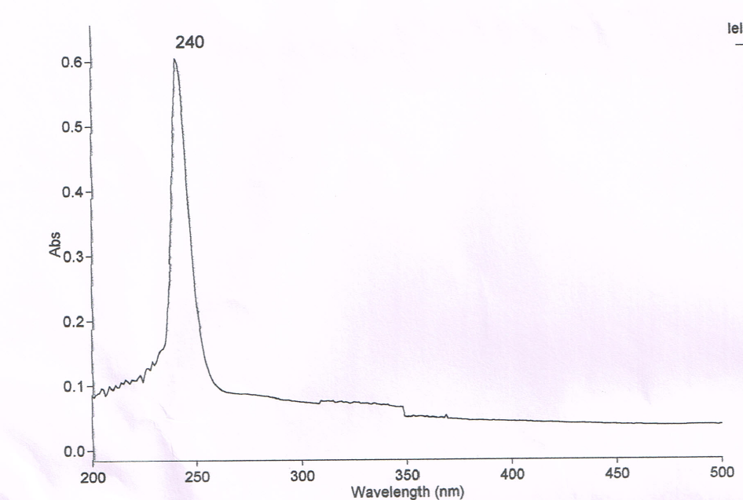

Gambar 1. Spektrum ultraviolet Nimonol (Metanol)



OH

CH-alifatik

C=O

C=O ester

C=C

C-O

Gambar 2. Spektrum Infra merah nimonol (KBr)

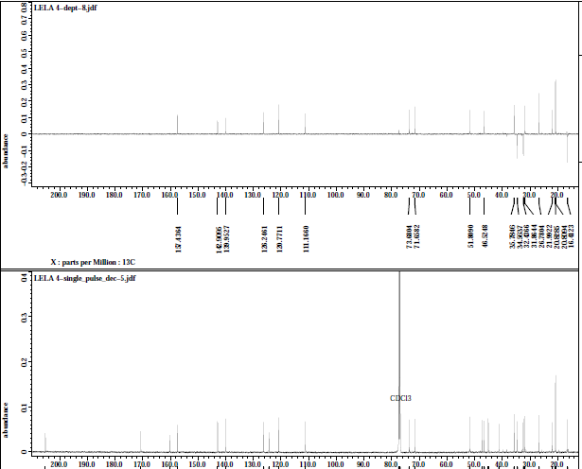

C-Sp3

CH-Sp3

C-O

C=C Sp2

Cq Sp2

Cq Sp2

Cq Sp3

Gambar 3. Spektrum DEPT 135o nimonol (CDCl3, 125 MHz)

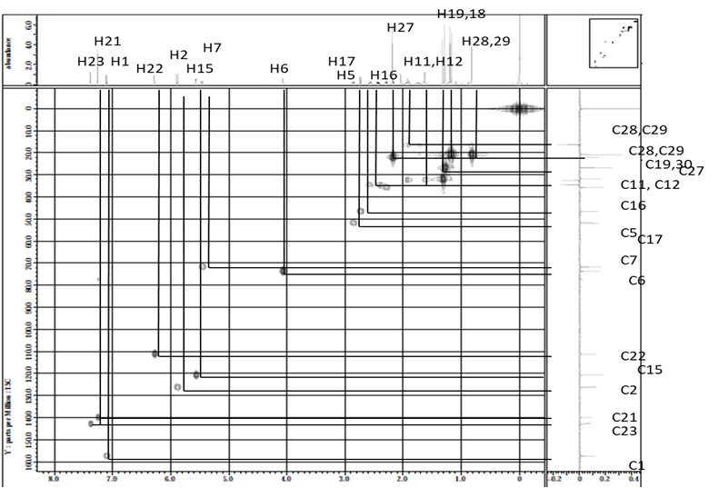

Gambar 4. Spektrum HMQC terpilih nimonol

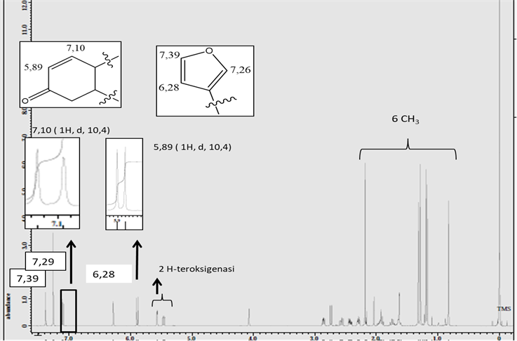

Gambar 5. Spektrum 1H-NMR nimonol (CDCl3, 500 MHz)

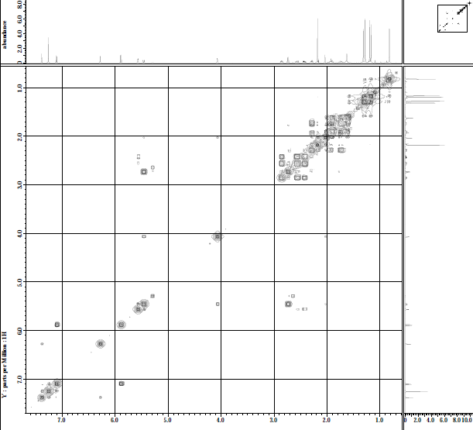

H23

H22

H1

H2

H7

H16

H6

H15



Gambar 6. Spektrum 1H-1H COSY terpilih nimonol

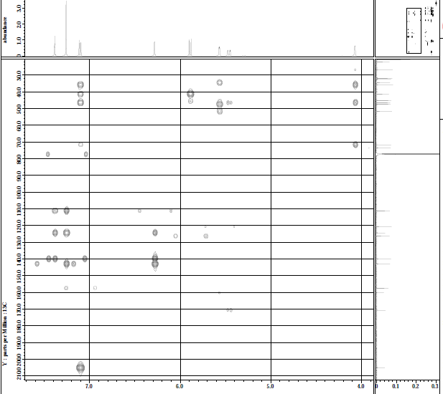

H6

H-2

H-15

H-7

H-1

H-21

H-23

C-7

C-5

C-9

C-4

H-22

C-20

C-23

C-21

C-1’

C-2’

Gambar 7. Spektrum HMBC terpilih nimonol