Supplementary

Table S1. The 1-(3-nitrobenzoiloksimetil)-5-fluorourasil derivatives structure
No. | IUPAC Name | 2D structure | 3D structure
 | 1-(3-nitrobenzoiloksimetil)-5-fluorourasil  (NB5FU) |  | 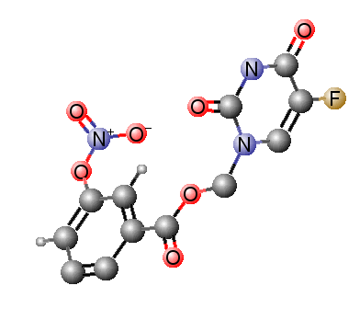
1 | (E)-(5-fluoro-2,4-dioxo-3,4-dihydropyrimidin-1(2H)-yl)methyl 3-nitro-4-(phenyldiazenyl)benzoate  (NB5FU1) |  | 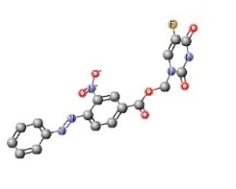
2 | (E)-(5-fluoro-2,4-dioxo-3,4-dihydropyrimidin-1(2H)-yl)methyl 3-nitro-4-(phenyldiazenyl)benzoate  (NB5FU2) |  | 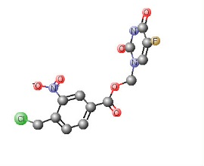
3 | (5-fluoro-2,4-dioxo-3,4-dihydropyrimidin-1(2H)-yl)methyl 4-(dimethylamino)-3-nitrobenzoate (NB5FU3) |  | 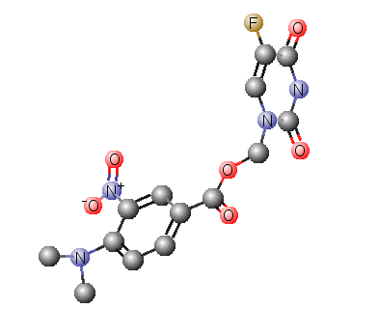
4 | (5-fluoro-2,4-dioxo-3,4-dihydropyrimidin-1(2H)-yl)methyl 2-(chloromethyl)-5-nitrobenzoate (NB5FU4) |  | 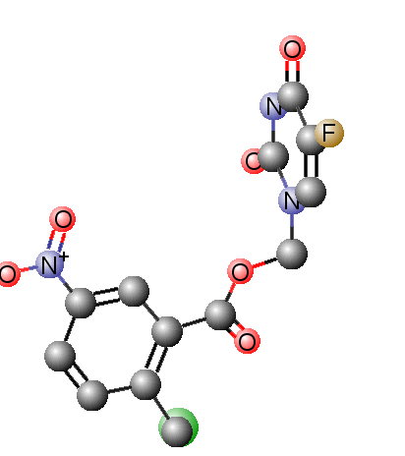
5 | (5-fluoro-2,4-dioxo-3,4-dihydropyrimidin-1(2H)-yl)methyl 3-nitro-5-(trifluoromethyl)benzoate  (NB5FU5) |  | 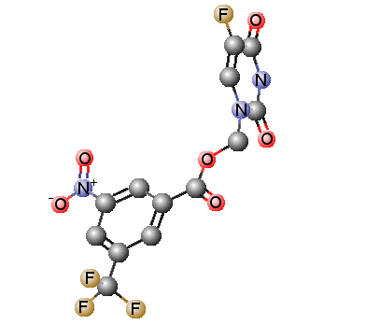
6 | (5-fluoro-2,4-dioxo-3,4-dihydropyrimidin-1(2H)-yl)methyl 3-acetoxy-5-nitrobenzoate (NB5FU6) |  | 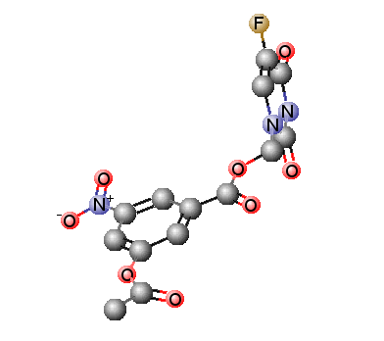
7 | (5-fluoro-2,4-dioxo-3,4-dihydropyrimidin-1(2H)-yl)methyl 4-(methylthio)-3-nitrobenzoate (NB5FU7) |  | 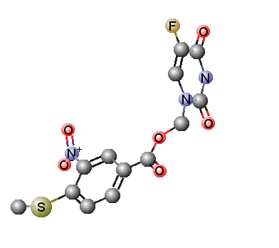
8 | (5-fluoro-2,4-dioxo-3,4-dihydropyrimidin-1(2H)-yl)methyl 3-nitro-2-(trifluoromethyl)benzoate  (NB5FU8) |  | 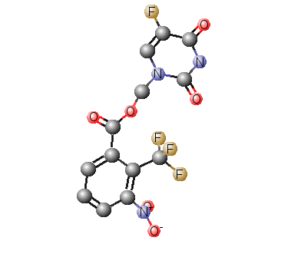
9 | (5-fluoro-2,4-dioxo-3,4-dihydropyrimidin-1(2H)-yl)methyl 3-nitro-5-(trifluoromethoxy)benzoate  (NB5FU9) |  | 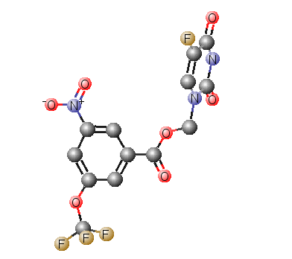
10 | (5-fluoro-2,4-dioxo-3,4-dihydropyrimidin-1(2H)-yl)methyl 3-nitro-4-(trifluoromethylthio)benzoate  (NB5FU10) |  | 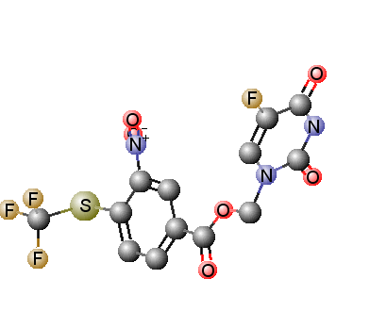
11 | (5-fluoro-2,4-dioxo-3,4-dihydropyrimidin-1(2H)-yl)methyl 3-nitro-4-(trifluoromethoxy)benzoate  (NB5FU11) |  | 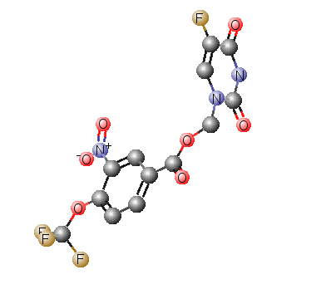
12 | (5-fluoro-2,4-dioxo-3,4-dihydropyrimidin-1(2H)-yl)methyl 4-(chlorosulfonyl)-3-nitrobenzoate (NB5FU12) |  | 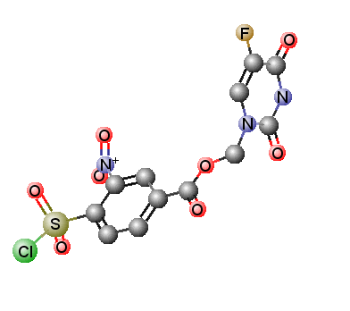
13 | (5-fluoro-2,4-dioxo-3,4-dihydropyrimidin-1(2H)-yl)methyl 4-(difluoromethylthio)-3-nitrobenzoate (NB5FU13) |  | 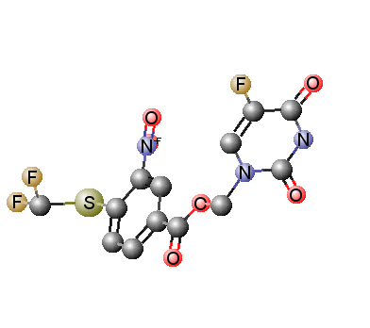
14 | (5-fluoro-2,4-dioxo-3,4-dihydropyrimidin-1(2H)-yl)methyl 4-(difluoromethoxy)-3-nitrobenzoate (NB5FU14) |  | 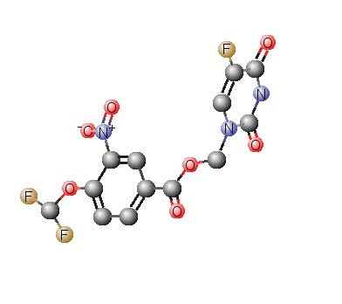
15 | (5-fluoro-2,4-dioxo-3,4-dihydropyrimidin-1(2H)-yl)methyl 3-nitro-2,6-bis(trifluoromethyl)benzoate  (NB5FU15) |  | 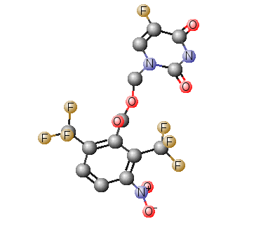
16 | (5-fluoro-2,4-dioxo-3,4-dihydropyrimidin-1(2H)-yl)methyl 2-fluoro-3-nitro-5-(trifluoromethyl)benzoate  (NB5FU16) |  | 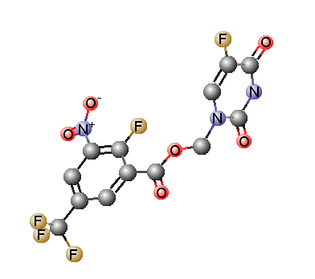
17 | (5-fluoro-2,4-dioxo-3,4-dihydropyrimidin-1(2H)-yl)methyl 3-nitro-2,5-bis(trifluoromethyl)benzoate  (NB5FU17) |  | 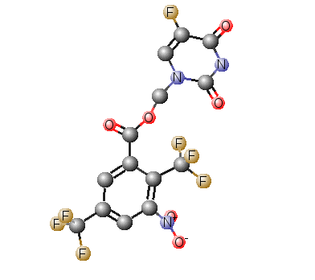
18 | (5-fluoro-2,4-dioxo-3,4-dihydropyrimidin-1(2H)-yl)methyl 4-fluoro-3-nitro-2-(trifluoromethyl)benzoate  (NB5FU18) |  | 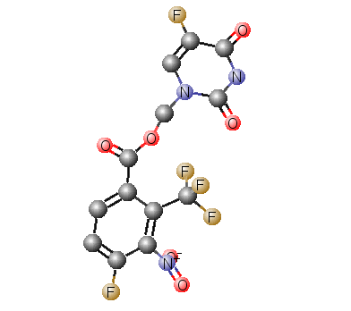
19 | (5-fluoro-2,4-dioxo-3,4-dihydropyrimidin-1(2H)-yl)methyl 2-fluoro-3-nitro-4-(trifluoromethyl)benzoate  (NB5FU19) |  | 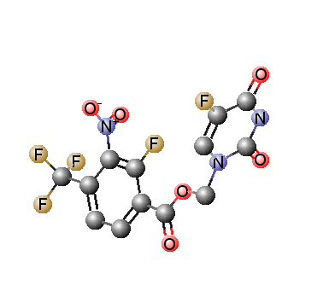
20 | (5-fluoro-2,4-dioxo-3,4-dihydropyrimidin-1(2H)-yl)methyl 3-fluoro-5-nitro-4-(trifluoromethyl)benzoate  (NB5FU20) |  | 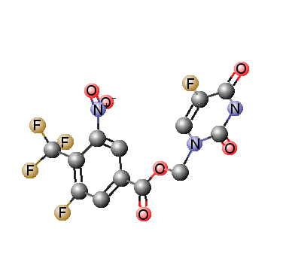
21 | (5-fluoro-2,4-dioxo-3,4-dihydropyrimidin-1(2H)-yl)methyl 3-fluoro-5-nitro-2-(trifluoromethyl)benzoate  (NB5FU21) |  | 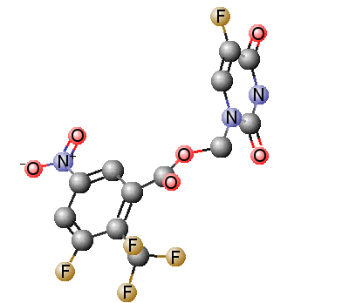
22 | (5-fluoro-2,4-dioxo-3,4-dihydropyrimidin-1(2H)-yl)methyl 5-fluoro-3-nitro-2-(trifluoromethyl)benzoate  (NB5FU22) |  | 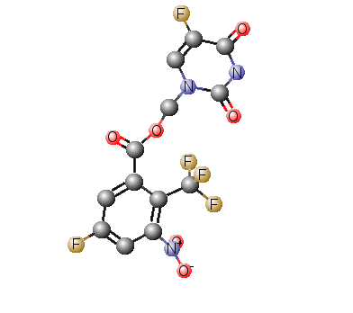
23 | (5-fluoro-2,4-dioxo-3,4-dihydropyrimidin-1(2H)-yl)methyl 5-nitro-2,4-bis(trifluoromethyl)benzoate  (NB5FU23) |  | 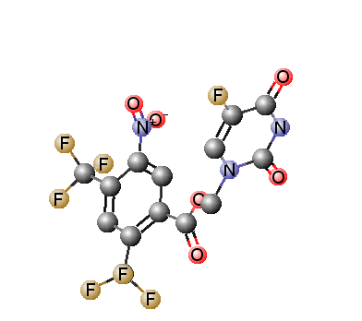
24 | (5-fluoro-2,4-dioxo-3,4-dihydropyrimidin-1(2H)-yl)methyl 3-nitro-2,6-bis(trifluoromethyl)benzoate  (NB5FU24)
25 | (5-fluoro-2,4-dioxo-3,4-dihydropyrimidin-1(2H)-yl)methyl 2-chloro-3-nitro-4-(trifluoromethyl)benzoate  (NB5FU25) |  | 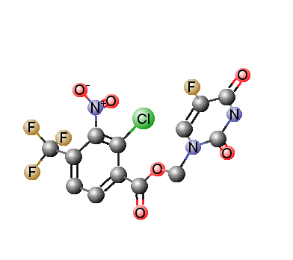
26 | (5-fluoro-2,4-dioxo-3,4-dihydropyrimidin-1(2H)-yl)methyl 2,5-dichloro-4-methoxy-3-nitrobenzoat (NB5FU26) |  | 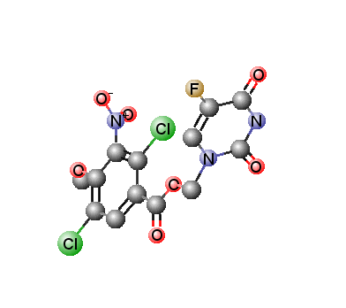
27 | (5-fluoro-2,4-dioxo-3,4-dihydropyrimidin-1(2H)-yl)methyl 3-chloro-2-fluoro-5-nitro-6-(trifluoromethyl)benzoate  (NB5FU27) |  | 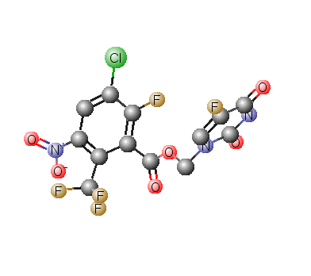
28 | (5-fluoro-2,4-dioxo-3,4-dihydropyrimidin-1(2H)-yl)methyl 3-chloro-2-fluoro-5-nitro-4-(trifluoromethyl)benzoate  (NB5FU28) |  | 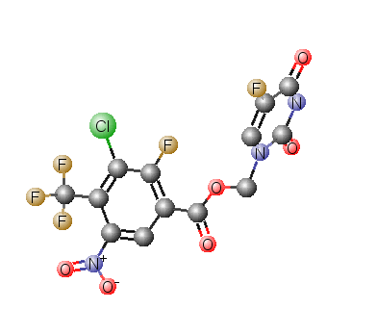
29 | (5-fluoro-2,4-dioxo-3,4-dihydropyrimidin-1(2H)-yl)methyl 2-fluoro-3-nitro-4-(trifluoromethyl)benzoate  (NB5FU29) |  | 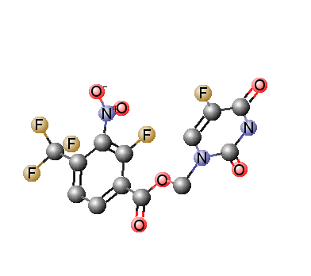
30 | (5-fluoro-2,4-dioxo-3,4-dihydropyrimidin-1(2H)-yl)methyl 5-chloro-3-nitro-2-(trifluoromethyl)benzoate  (NB5FU30) |  | 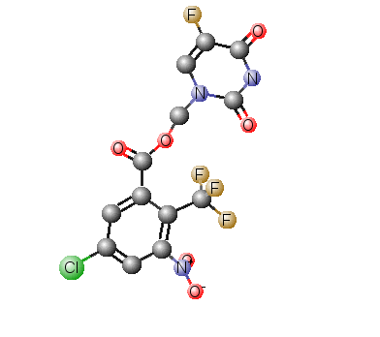
31 | (5-fluoro-2,4-dioxo-3,4-dihydropyrimidin-1(2H)-yl)methyl 3-nitro-4-(1,2,3-thiadiazol-4-yl)benzoate (NB5FU31) |  | 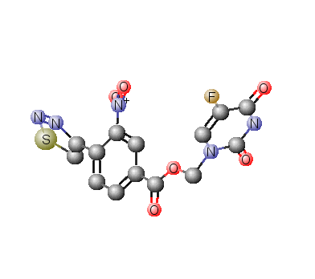
32 | (5-fluoro-2,4-dioxo-3,4-dihydropyrimidin-1(2H)-yl)methyl 4-methyl-3-nitro-5-(trifluoromethyl)benzoate  (NB5FU32) |  | 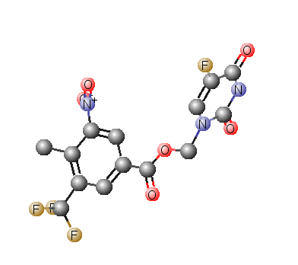
33 | (5-fluoro-2,4-dioxo-3,4-dihydropyrimidin-1(2H)-yl)methyl 3-nitro-4-(1H-pyrazol-1-yl)benzoate  (NB5FU33) |  | 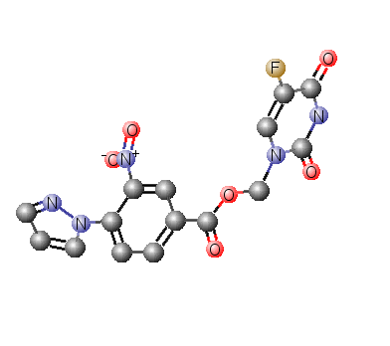
34 | (5-fluoro-2,4-dioxo-3,4-dihydropyrimidin-1(2H)-yl)methyl 4-(bromomethyl)-3-nitrobenzoate (NB5FU34) |  | 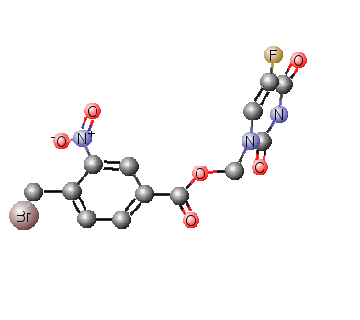
35 | (5-fluoro-2,4-dioxo-3,4-dihydropyrimidin-1(2H)-yl)methyl 2,3,4,6-tetrafluoro-5-nitrobenzoate (NB5FU35) |  | 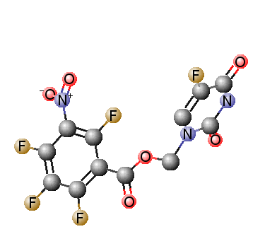
36 | (NB5FU36) |  | 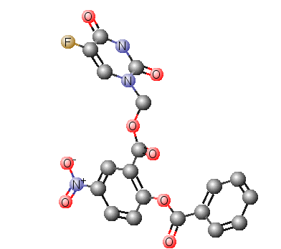
37 | (5-fluoro-2,4-dioxo-3,4-dihydropyrimidin-1(2H)-yl)methyl 4-ethyl-3-nitrobenzoate (NB5FU37) |  | 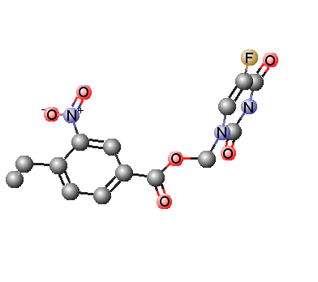
38 | (5-fluoro-2,4-dioxo-3,4-dihydropyrimidin-1(2H)-yl)methyl 2-cyano-3-nitrobenzoate (NB5FU38) |  | 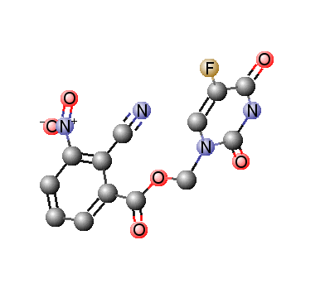
39 | (5-fluoro-2,4-dioxo-3,4-dihydropyrimidin-1(2H)-yl)methyl 3-cyano-5-nitrobenzoate (NB5FU39) |  | 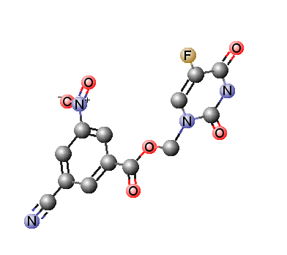
40 | (5-fluoro-2,4-dioxo-3,4-dihydropyrimidin-1(2H)-yl)methyl 4-cyano-3-nitrobenzoate (NB5FU40) |  | 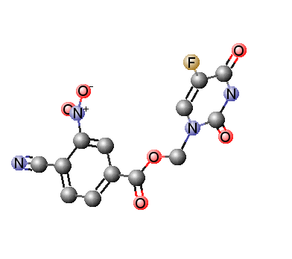
41 | (5-fluoro-2,4-dioxo-3,4-dihydropyrimidin-1(2H)-yl)methyl 3-nitro-4-propylbenzoate (NB5FU41) |  | 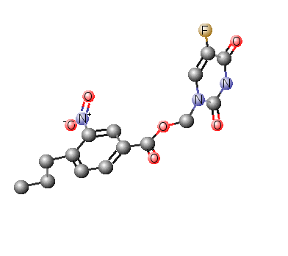
42 | (5-fluoro-2,4-dioxo-3,4-dihydropyrimidin-1(2H)-yl)methyl 4-iodo-3-nitrobenzoate (NB5FU42) |  | 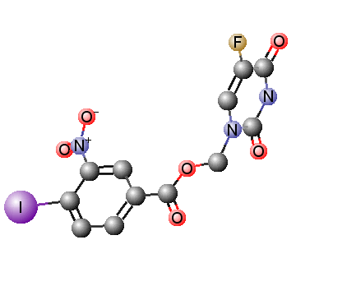
43 | (5-fluoro-2,4-dioxo-3,4-dihydropyrimidin-1(2H)-yl)methyl 4-butyl-3-nitrobenzoate (NB5FU43) |  | 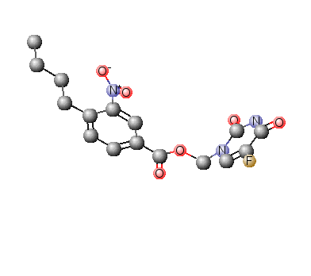
44 | (5-fluoro-2,4-dioxo-3,4-dihydropyrimidin-1(2H)-yl)methyl 4-heptyl-3-nitrobenzoate (NB5FU44) |  | 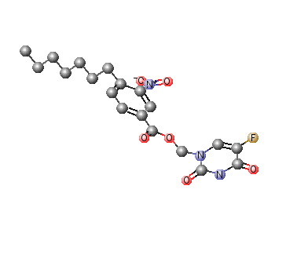
45 | (5-fluoro-2,4-dioxo-3,4-dihydropyrimidin-1(2H)-yl)methyl 4-hexyl-3-nitrobenzoate (NB5FU45) |  | 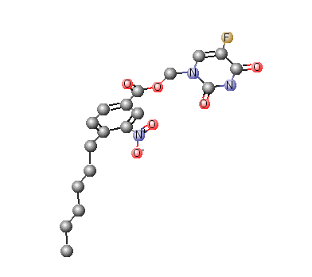
46 | (5-fluoro-2,4-dioxo-3,4-dihydropyrimidin-1(2H)-yl)methyl 3-nitro-4-octylbenzoate (NB5FU46) |  | 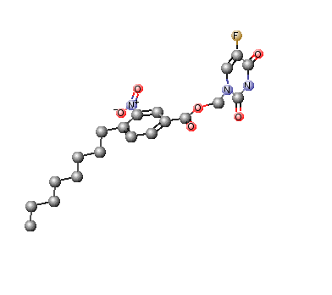
47 | (5-fluoro-2,4-dioxo-3,4-dihydropyrimidin-1(2H)-yl)methyl 4-decyl-3-nitrobenzoate (NB5FU47) |  | 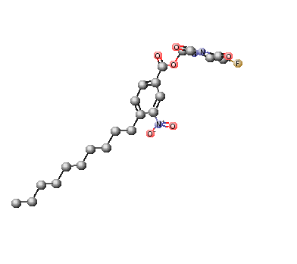
48 | (5-fluoro-2,4-dioxo-3,4-dihydropyrimidin-1(2H)-yl)methyl 4-butoxy-3-nitrobenzoate (NB5FU48) |  | 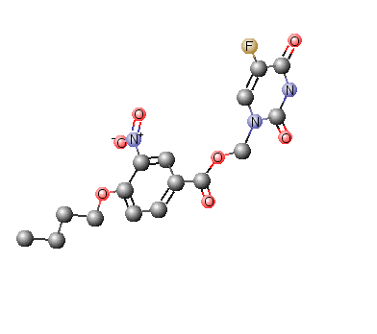
49 | (5-fluoro-2,4-dioxo-3,4-dihydropyrimidin-1(2H)-yl)methyl 2,4-dimethyl-3-nitrobenzoate (NB5FU49) |  | 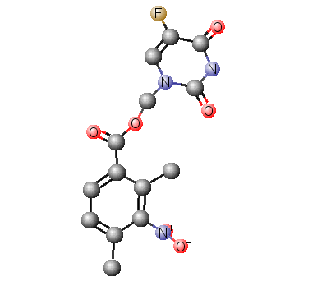
50 | (5-fluoro-2,4-dioxo-3,4-dihydropyrimidin-1(2H)-yl)methyl 2,4-difluoro-3-nitrobenzoate (NB5FU50) |  | 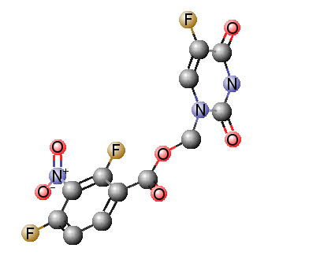
51 | (5-fluoro-2,4-dioxo-3,4-dihydropyrimidin-1(2H)-yl)methyl 3,4-difluoro-5-nitrobenzoate (NB5FU51) |  | 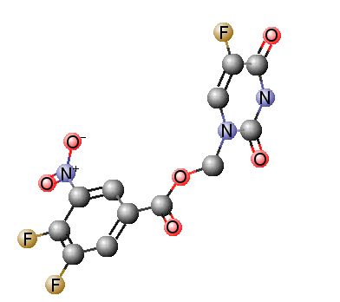
52 | (5-fluoro-2,4-dioxo-3,4-dihydropyrimidin-1(2H)-yl)methyl 2,4,6-trimethyl-3-nitrobenzoate (NB5FU52) |  | 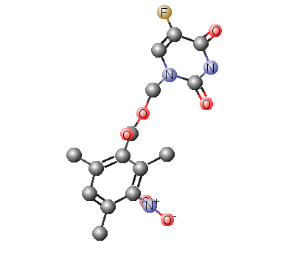
53 | (5-fluoro-2,4-dioxo-3,4-dihydropyrimidin-1(2H)-yl)methyl 2,4,5-trifluoro-3-nitrobenzoate (NB5FU53) |  | 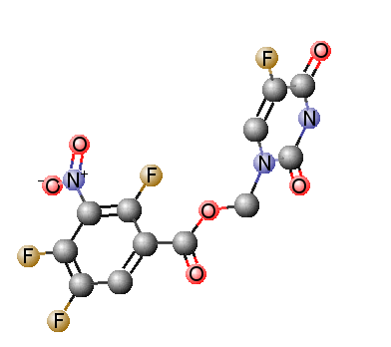
54 | (5-fluoro-2,4-dioxo-3,4-dihydropyrimidin-1(2H)-yl)methyl 4-chloro-3,5-dinitrobenzoate (NB5FU54) |  | 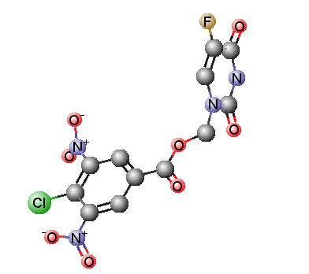
55 | (5-fluoro-2,4-dioxo-3,4-dihydropyrimidin-1(2H)-yl)methyl 2,3,4-trifluoro-5-nitrobenzoate (NB5FU55) |  | 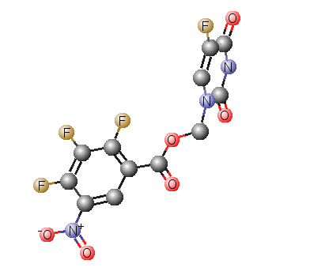
56 | (5-fluoro-2,4-dioxo-3,4-dihydropyrimidin-1(2H)-yl)methyl 2-chloro-3,4-dinitrobenzoate (NB5FU56) |  | 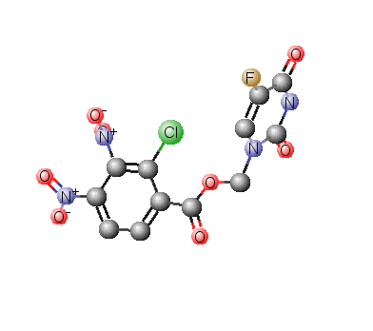
57 | (5-fluoro-2,4-dioxo-3,4-dihydropyrimidin-1(2H)-yl)methyl 2,4,6-trichloro-3-nitrobenzoate (NB5FU57) |  | 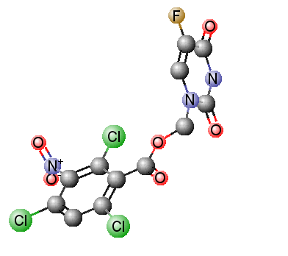
58 | (5-fluoro-2,4-dioxo-3,4-dihydropyrimidin-1(2H)-yl)methyl 2,3,4-trimethoxy-5-nitrobenzoate (NB5FU58) |  | 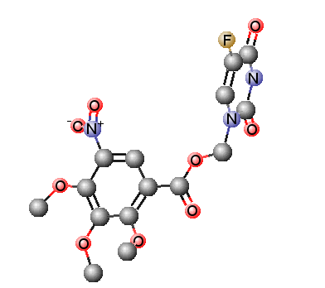
59 | (5-fluoro-2,4-dioxo-3,4-dihydropyrimidin-1(2H)-yl)methyl 3,4-dimethoxy-5-nitrobenzoate (NB5FU59) |  | 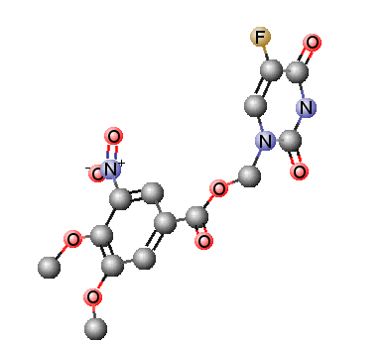
60 | (5-fluoro-2,4-dioxo-3,4-dihydropyrimidin-1(2H)-yl)methyl 2,3,4-trinitrobenzoate (NB5FU60) |  | 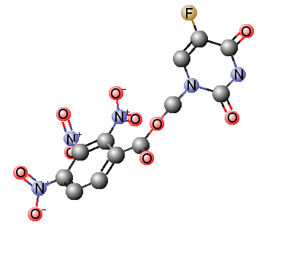
61 | (5-fluoro-2,4-dioxo-3,4-dihydropyrimidin-1(2H)-yl)methyl 2,4-dimethoxy-3-nitrobenzoate (NB5FU61) |  | 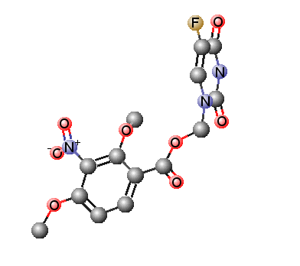
62 | (5-fluoro-2,4-dioxo-3,4-dihydropyrimidin-1(2H)-yl)methyl 4-methyl-3,5-dinitrobenzoate (NB5FU62) |  | 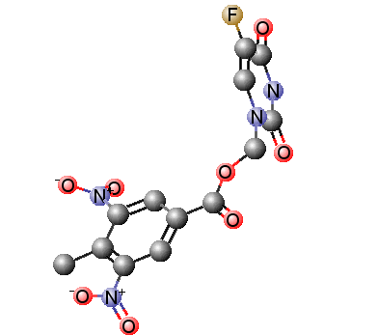
63 | (5-fluoro-2,4-dioxo-3,4-dihydropyrimidin-1(2H)-yl)methyl 2-chloro-4-fluoro-3-nitrobenzoate (NB5FU63) |  | 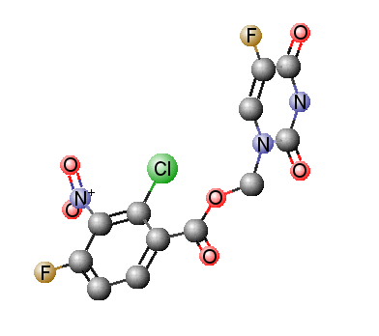
64 | (5-fluoro-2,4-dioxo-3,4-dihydropyrimidin-1(2H)-yl)methyl 4-fluoro-3-methyl-5-nitrobenzoate (NB5FU64) |  | 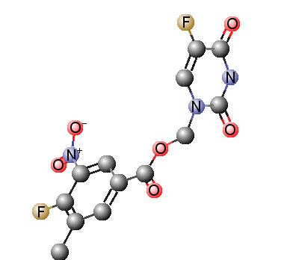
65 | (5-fluoro-2,4-dioxo-3,4-dihydropyrimidin-1(2H)-yl)methyl 2,3-difluoro-5-nitrobenzoate (NB5FU65) |  | 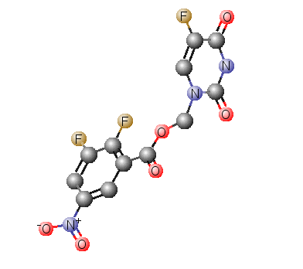
66 | (5-fluoro-2,4-dioxo-3,4-dihydropyrimidin-1(2H)-yl)methyl 2,4-difluoro-5-nitrobenzoate (NB5FU66) |  | 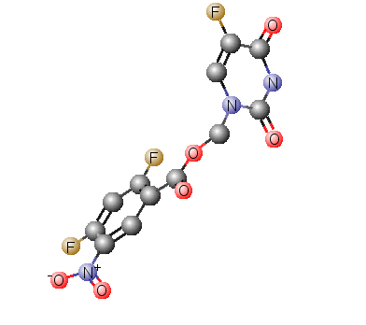
67 | (5-fluoro-2,4-dioxo-3,4-dihydropyrimidin-1(2H)-yl)methyl 2,6-difluoro-4-methoxy-3-nitrobenzoate (NB5FU67) |  | 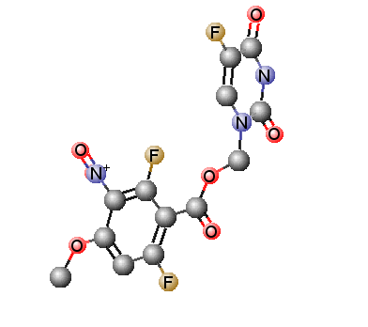
68 | (5-fluoro-2,4-dioxo-3,4-dihydropyrimidin-1(2H)-yl)methyl 2,5-dichloro-4-methoxy-3-nitrobenzoate (NB5FU68) |  | 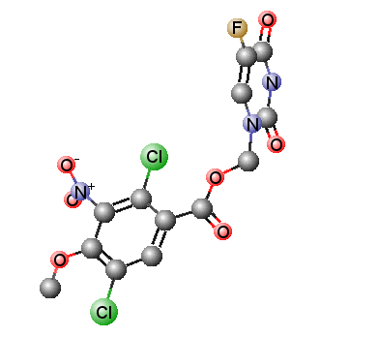
69 | (5-fluoro-2,4-dioxo-3,4-dihydropyrimidin-1(2H)-yl)methyl 4-chloro-2,5-difluoro-3-nitrobenzoate (NB5FU69) |  | 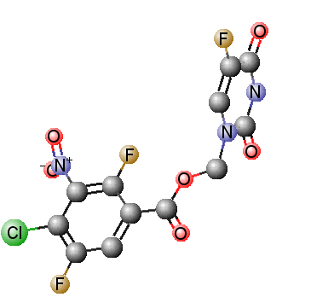
70 | (5-fluoro-2,4-dioxo-3,4-dihydropyrimidin-1(2H)-yl)methyl 3-chloro-4-fluoro-5-nitrobenzoate (NB5FU70) |  | 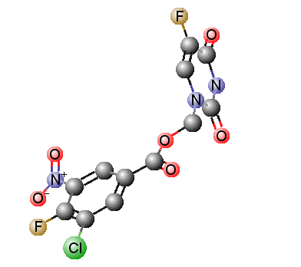
71 | (5-fluoro-2,4-dioxo-3,4-dihydropyrimidin-1(2H)-yl)methyl 3-fluoro-4-methoxy-5-nitrobenzoate (NB5FU71) |  | 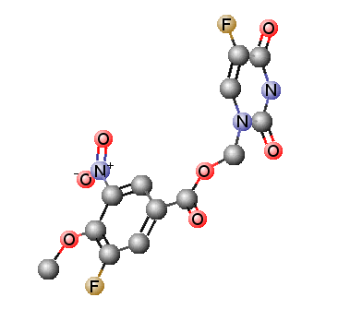
72 | (5-fluoro-2,4-dioxo-3,4-dihydropyrimidin-1(2H)-yl)methyl 3-fluoro-4-methyl-5-nitrobenzoate (NB5FU72) |  | 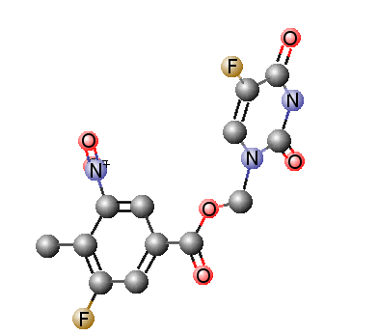
73 | (5-fluoro-2,4-dioxo-3,4-dihydropyrimidin-1(2H)-yl)methyl 4-bromo-2-fluoro-3-nitrobenzoate (NB5FU73) |  | 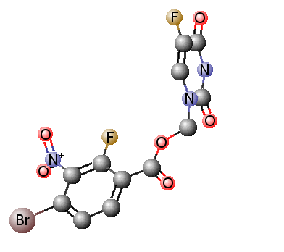
74 | (5-fluoro-2,4-dioxo-3,4-dihydropyrimidin-1(2H)-yl)methyl 4-bromo-3-methyl-5-nitrobenzoate (NB5FU74) |  | 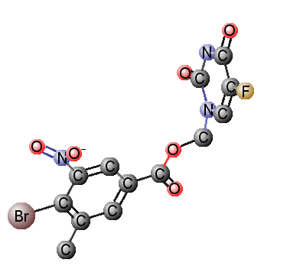
75 | (5-fluoro-2,4-dioxo-3,4-dihydropyrimidin-1(2H)-yl)methyl 4-chloro-2,5-difluoro-3-nitrobenzoate (NB5FU75) |  | 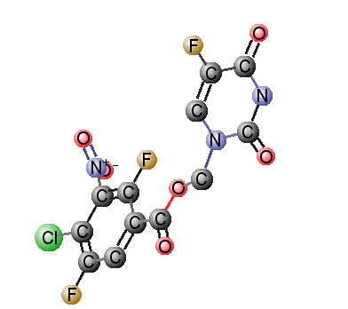
76 | (5-fluoro-2,4-dioxo-3,4-dihydropyrimidin-1(2H)-yl)methyl 4-fluoro-3-nitro-5-(trifluoromethyl)benzoate (NB5FU76) |  | 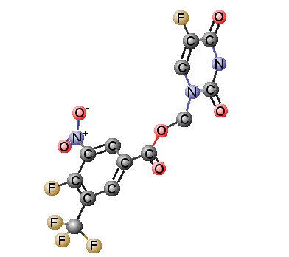
77 | (5-fluoro-2,4-dioxo-3,4-dihydropyrimidin-1(2H)-yl)methyl 4-(fluorosulfonyl)-3-nitrobenzoate (NB5FU77) |  | 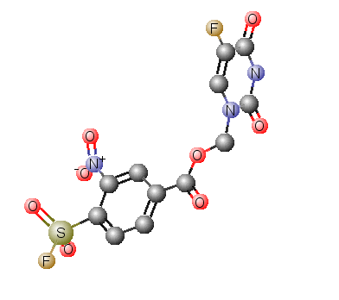
78 | (5-fluoro-2,4-dioxo-3,4-dihydropyrimidin-1(2H)-yl)methyl 3-nitro-4-(thiophen-2-yl)benzoate (NB5FU78) |  | 