
JURNAL TEKNIK INFORMATIKA
Homepage: http://journal.uinjkt.ac.id/index.php/ti

MOBILE APPLICATION DEVELOPMENT ANALYSIS
FOR CAFE RESERVATIONS AND DELIVERY ORDER

Anggy Trisnadoli¹, Rika Perdana Sari², Iqbal Setiawan³

^{1,2,3}Information Technology Department,
Politeknik Caltex Riau
^{1.2,3}Jl. Umbansari No. 1 Rumbai, Pekanbaru, Riau, Indoensia
E-mail: ¹anggy@pcr.ac.id, ²rika@pcr.ac.id, ³iqbalsetiawan@alumni.pcr.ac.id

 | ABSTRACT  Owning a cafe is one of a business that is currently trending in Indonesia, especially in Pekanbaru. Technology development today makes the competition between cafe owners increasingly tight. As a result, several problems arise when cafe managers want to advance their cafe in the field of digital business that is more efficient, fast, and sophisticated to reach more customers. One of the problems is that customers want to make delivery orders online easily and quickly. Several online food services have solved this problem, but the increasingly expensive delivery costs have made many customers reluctant to use them.  On the other hand, another problem arises when a cafe customer wants to make a reservation to dine in. The limited space available and the difficulty of cafe employees organizing tables harm customer satisfaction to want to come to the cafe. So, to solve some of these problems, a mobile application was developed to help customers make ordering food and drinks easier to deliver and place reservations online. The development of this mobile application is based on Android. Based on the survey results in the case study Jeber Cafe Pekanbaru, where Android mobile device users dominate the customers. After the software development is complete, an evaluation is carried out using UAT and a survey which results in a statement that the developed Mobile Application can be used properly and is beneficial for all stakeholders.  Keywords: Cafe, Online Delivery Order, Online Reservations, Mobile Application
  Article:
  Accepted: xxx xx, 20xx
  Revised: xxx xx, 20xx
  Issued: xxx xx, 20xx
  *Correspondence Address:
  Anggy Trisnadoli
  (anggy@pcr.ac.id)

- INTRODUCTION

The cafe business is a fast-growing business, also promising at this time. The number of cafes in Pekanbaru makes the competition more competitive. Technology development today makes the competition between cafe owners increasingly tight for digital food services to reach customers and provide them with high-quality services [1]. As a result, several problems arise when cafe managers want to advance their cafe in the field of digital business that is more efficient, fast, and sophisticated to reach more customers. One of the problems is that customers want to make delivery orders online easily and quickly. The use of technology in the delivery order feature is believed to be a fast, efficient, and up-to-date business marketing channel. The delivery order itself is offered in two ways. The first way is a call center by telephone. With this feature, customers can order food or drinks at the cafe without coming and only need to wait for the food and drinks to be delivered to the customer's destination address.

In addition to using the call center facility by telephone as a delivery order, the second method that cafes use is the delivery service provided by online food order services. This method is effective because it can increase the income of the cafe. However, there is a weak point that is obtained when using the services of a third party, such as the cafe manager must pay for the third-party service as a condition to be able to enter the service. In addition, the cafe must carry out a profit-sharing system with third-party services in revenue sharing [2]. Meanwhile, from the customer's point of view, the increasingly expensive delivery costs have resulted in several customers needing more time to be willing to use it.

With a high amount of enthusiasm, the cafe manager came up with the idea to start a service in the form of a reservation. This service is intended for people who want to eat and drink or do other activities directly at the cafe without fear of running out of space. Usually, customers only need to call the cafe's phone number. Then the cafe will write it down again on a piece of paper. However, by still using this conventional system, there are several weaknesses: the high risk of duplication using paper media. In addition, systems that still use paper are very prone to data loss, so it will not be accessible if they want to reaccess the data [3].

On the other hand, another problem arises when a cafe customer wants to make a reservation to dine in. The limited space available and the difficulty of cafe employees organizing tables make negatively affect customer satisfaction want to come to the cafe. Also, the cafe does not cover shipping costs to customers. However, the cafe will increase its price slightly higher than its price by a range of IDR 1.000 to IDR 3.000, which serves to stabilize revenue. Customers can also make a place reservation online while ordering food and drinks, then provide a down payment of 50% according to the amount ordered, which will be given directly to the cafe. However, the reservation will be forfeited if the customer comes within a maximum time limit of 30 minutes.

The cafe owner needs a specific system to solve some of these problems for his business process. The main problem is the system that can accommodate current needs so that his customers can place orders more easily, quickly, and well organized and reduce delivery costs.

Food delivery services can now be easily accessed via mobile phones, along with the technological development of mobile phones today. Food delivery services via mobile phones are called Mobile Food Ordering Apps (MFOAs) [4]. The Food delivery application market is overgrowing with smartphones, and their development is convenience-oriented for people's lifestyles [5-6]. Belanche, et al. [7] said that the customers’ behavioral intentions toward food delivery services are influenced by their attitudes and subjective norms. Then, companies should attach importance to the design of valuable, user-friendly mobile apps; this will increase their customers' perceptions about the worth of these technology-based services.

With the increase in mobile device users in Pekanbaru, the location of this research case study, the system development is directed to the development of mobile-based applications. The mobile application was developed that can help customers make it easier to order food and drinks for delivery and place reservations online. The development of this mobile application is based on Android. Based on the survey results in the case study Jeber Cafe Pekanbaru, where Android mobile device users dominate the customers.

Meanwhile, with the development of this mobile application, it is hoped that this application can be an innovation that will later become an added value for the cafe itself for business. The expected added value is increased income, streamlining the business processes of each cafe's buying and selling system by utilizing the delivery order and place reservation features.

- PREVIOUS RESEARCH

Reservation comes from the verb reserve, which means to order and provide a place. In this case, the notion of the reservation is a transaction involving the provision of places and special services for other facilities for passengers who will travel using aircraft services. Terminologically, the word café comes from the French—coffee, which means coffee [8].

In Indonesia, the word café then simplified back to cafe [9]. The literal meaning refers to (drink) coffee, better known as a place to enjoy coffee with various other non-alcoholic drinks such as soft drinks and snacks in Indonesia. "Café is an establishment providing food and refreshment for consumption and the premises to general public" [10]. A café in two terms: a place where people can buy drinks and simple meals; also a place where we can buy drinks and snacks, and a "small shop (the store that sells sweets, food, newspaper, and others) usually stay open later than other shop or store"; where cafe refers more to a tavern or stalls that sells not only drinks and food but also newspapers, books and is open until late at night. Based on the above understanding, cafes have characteristics such as a comfortable place to enjoy various food and drinks and a comfortable atmosphere for gathering.

Several previous researchers have solved this by developing an android mobile application, especially for online culinary orders. The first research was conducted by Qadhafi et al. [11] by creating a delivery order application that can be run if the user has internet access and was built using a J2ME method. Also, Yuliana et al. [12] developed a delivery order application using the Composite Performance Index (CPI). This method will later assist users in determining appropriate food menu recommendations based on ratings, bestsellers, and the highest and lowest prices. Kapoor & Vij [13] also state that Online food delivery is expanding choice and convenience. It allows customers to order from various restaurants with a single tap on their smartphone. Delivering food services is rapidly changing as new online platforms race to capture the market's customers. Although, there are essential concerns about customer satisfaction and customers' intention to reuse mobile apps [1].

Song et al. l [14] said that delivery app usage factors influence customer satisfaction, reuse intention, and methods of improving the quality of delivery apps among smartphone users. Like satisfaction showed that usage factors positively influence satisfaction with delivery apps. Also, to increase customer satisfaction and reuse intention, delivery app companies should update new menus and prices quickly to provide more accurate information. Food delivery service providers with the most profound understanding of customer demands will be the ones to acquire solid growth. Service providers should focus more on advertising activities to persuade customers that food delivery apps take safety and hygiene precautions because of the effects of delivery food hygiene [15].

In general, developing mobile applications that do not have specific criteria is enough to develop using the Waterfall method. This waterfall model is a classic linear sequential model used in software development [16]. The waterfall is an evolutionary process to implement a computer-based information system or subsystem [17]. The waterfall model provides a sequential or sequential approach to four software lifelines starting from the analysis, coding, testing, and support stages used by a system analyst to develop an information system [18].

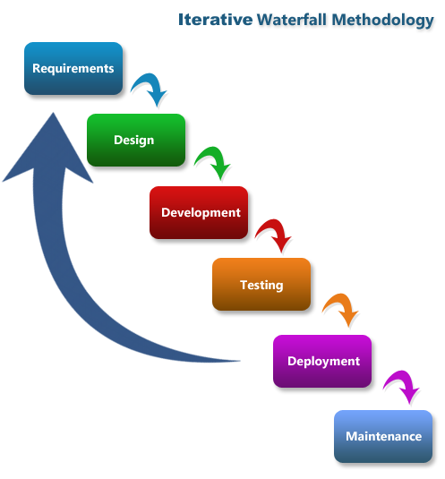

Figure 1. Waterfall Model Phase

Figure 2 shows that the Waterfall method is a sequential software development process. It happens with continuing to flow down through phases of planning, modeling, implementation, and testing. Also, there are several successive stages like requirements, design, coding, testing, and maintenance [19].

Based on some of this research, it is necessary to develop specific mobile applications to be used by cafe owners to reach more customers and increase satisfaction from these customers, especially today's customers who depend on smartphone technology. Moreover, of course, using the Waterfall model method as the media creation application software by systematic as the requirements, design Implementation, Verification, and Maintenance [20].

- METHODOLOGY

In order to solve the problems found with the best solution that will be offered, a framework is carried out with the methodology described in figure 2.

The development of this mobile application is carried out by utilizing the waterfall model according to the needs and the phases implemented in each development activity.
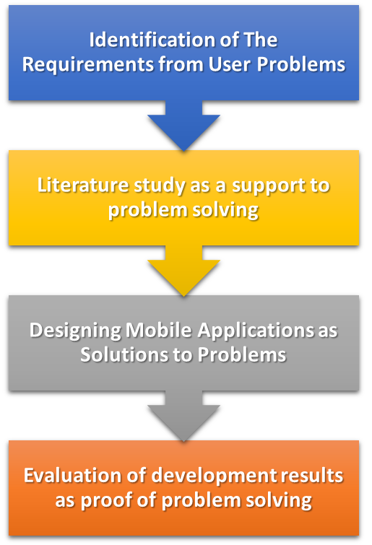
Figure 2. Research Methodology

The first step is identifying the problems in the user's business processes. So that software requirements can be formed, which can later be developed into a good design. For this step, we already agreed and decided that there is a cafe in Pekanbaru called Jeber Café for our case study. Furthermore, the researchers conducted interviews about the advantages and disadvantages of carrying out the food and beverage delivery process, making reservations, and conducting an analysis. At the end of the interview, the researcher collected several functional requirements, which would later be implemented into the system. Functional requirements are related to what the system can do. If a system knows its functional requirements, then the next thing is to do the modeling. The function of modeling is to make it easier for developers to determine the system's flow that will be made later. Then several literature reviews from other researchers were conducted to support the development process.

Furthermore, the design is carried out to develop a mobile application based on the expected functional features based on the previous stages that have been carried out so that various types of models can be formed as expected for this development phase.

After the designing stage, the next step is implementation. As previously explained, there needs to be a functional requirement to know what functions can be performed by this system. The primary function of this system is the delivery order feature, which helps customers place food and beverage orders online. When the customer has completed the order, the customer can send feedback. In addition the second feature is the place reservation feature, which can be used when a customer makes a reservation at the cafe. When making a reservation, customers can also order food and drinks simultaneously so that when they are at the place, customers no longer need to wait twice. If the cafe changes its status, there will be a real-time notification on the customer's smartphone. If the customer finds a profile error, then the customer can make profile edits.

Meanwhile, this system can manage menus by adding, editing, and viewing menus from the cafe's business side. Then, if the customer makes a delivery order and makes a reservation, the admin can also view the order and then edit the order status. The cafe can find out the location of the order when tapping on the order details, which uses Google Maps technology. When the number of seats is no longer available, on the main page, the cafe can check to update the status that, at that time, it is not possible to make an online reservation. Similarly, when a menu is unavailable, the cafe can check the menu to inform customers that the menu is not available.

When implementation is complete, the next step is the evaluation stage. This phase is carried out by conducting several tests, such as Functional Tests, User Acceptance Tests, and Surveys, to Jeber Cafe customers.

Functional testing is carried out by prioritizing all aspects of the mobile application's functionality to show that all existing features have been completed and succeeded by the user requirements agreed upon from the start. This test is carried out using the black box method, where these functions are reduced to a test list that is compiled to ensure success with several scenarios then. These results later indicate that if this phase is completed and the entire test list has been successful, the next testing phase can be carried out.

When all functions are running well, all functions can be validated by the Café owner. This test is a User Acceptance Test (UAT). This test is carried out in the checklist of items, along with suggestions and input from the café owner. With all the functions of the mobile application that has been developed are running well. The results of this test will later become a benchmark that cafe owners and customers can use to develop the mobile application successfully.

The final phase of the testing is to test the use of the mobile application for café customers. This test is carried out with the hope that the developer can receive customer feedback regarding the comfort, convenience, and satisfaction of users using the mobile application. This activity is carried out by allowing café customers to try using the application for some time, then providing survey questionnaires as a medium to get feedback from these customers. The data obtained from this activity will then be processed using the Likert scale method so that the processing results can later show that all mobile applications are ready to be used and disseminated by the café owner for use to a broader range of customers.

With the results of these tests, it is hoped that later, all development phases that have been carried out are appropriate and ensure that the mobile applications developed have been helpful for café owners and customers to support a better business.

- RESULTS AND DISCUSSION

Based on the user requirement identification results, the phase in the research methodology that is being carried out is to identify the problem with the primary user, the café owner. This activity is carried out by interviewing all stakeholders, the owner, and several employees directly involved in using the developed mobile application.

Several requirements were obtained based on the interviews and then processed and validated by all stakeholders to be used as user requirements in the development of mobile applications in this study. The following in table 1 is the result of the user requirements.

Table 1. User’s Requirements
No | User Requirement
1 | Customers can register to the system.
2 | Customer can login to the system
3 | Customer can edit their profiles
4 | Customers can see the menu of the system
5 | Customers can make online reservations
6 | Customers can make delivery orders
7 | Café staff can see the status of orders
8 | Customers can give feedback on their order
9 | Café owners can register new staff account
10 | Café owner can manage staff data
11 | Café owner can see the financial report
12 | Café staff can log in to the system
12 | Café staff can edit the order status for delivery orders
14 | Café staff can change the cafe's status when the order is complete.
15 | Café staff can edit the status for place reservations.

The development results from the user requirements are then implemented in a software design by the targets and the expectations of all related parties, namely developers and café owners.

It starts from the formation of user requirements to the design to the implementation, and then the coding applied to the mobile application prototype takes as much as 12-15 weeks. The developer communicated several times during the development phase to confirm the design so that it continues to run well according to what is expected by the user. So that the development process carried out can be on the right track and minimize the possibility of problems and errors that arise later in the future.

To the expectations of the development carried out, the implementation results are implemented in a mobile application prototype which is then prepared for testing.

Based on the author's implementation, a result can be given in the form of android-based delivery order and place reservation application. The display itself can be seen as shown below, which is a login page.

This page is the main page when the user has successfully installed the mobile application on their smartphone. Next, they can register to get an account and full access to this mobile application's features.

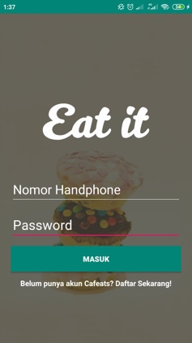
Figure 3. Sign In Page

Figure 3 is a sign-in page that will appear when a customer wants to enter the system. Sign-in will be successful if the customer already has an account. If not, customers will be advised to register by clicking the login button below.

If an admin has successfully signed in, they will be directed to the page shown in Figure 3. the dashboard page for admins. Here, the admin can manage the menu and edit the status of orders made by customers.

In addition to the menu, some other things must be filled in. Such as the food name, photos, and price. There is an edit feature if an error is encountered. A notification will appear when the customer changes the status of the order.

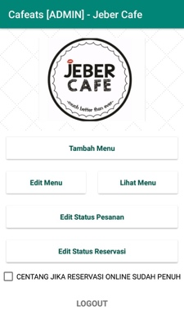
Figure 4. Dashboard Admin Page

Not much different from the admin. If a customer has registered for an account and then logs in and is successful, then the customer will be directed to the page shown in Figure 5.

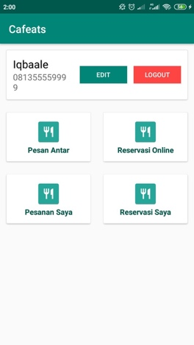
Figure 5. Dashboard Customer Page

Figure 5 is the dashboard page for the customer. On this page, customers can use the main features of this application, namely delivery orders or online reservations. In addition, customers can also see the status of orders.

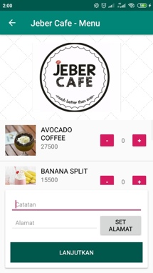
Figure 6. Menu Page

When a customer has selected a cafe, the customer will be directed to the next page, namely the menu page. Here are available menu details, as well as the desired amount. A note and the address set are the delivery destination underneath it.

In addition to the several views in the image above, various other pages still have implemented all the expected user requirements from the start. These pages then show that all the expected items have been appropriately implemented and all the expected features have been running as they should.

Thirty-five menu pages can be utilized by all stakeholder users of this mobile application, starting from café owners, managers, supervisors, cashiers, delivery staff, the financial team, and customers.

After the entire mobile application prototype has been developed, this mobile application is ready for evaluation to prove that the developed mobile application is following what is expected by all stakeholders from this development.

- ANALYSIS OF TESTING RESULTS FOR MOBILE APPLICATION DEVELOPMENT

As a result of the implementation of the design that has been developed in the form of a mobile application product prototype, the next thing to do is evaluate it in the form of various tests. These tests are carried out to prove the success and suitability of the results with what is expected. Then the test results are processed for analysis to provide concrete answers and information on existing needs.

Based on the application that has been built, then a test is carried out, namely Blackbox Testing. The way to do this test is to test the system's functional requirements, and the following conclusions can be drawn.

Table 2. Functional Requirements Test Status
No | Functional | Status
1 | The system can log in and register. | Success
2 | The system can register. | Success
3 | The system can help admins display the home page for admins and customers. | Success
4 | The system can help admins manage menus, such as adding and editing. | Success
5 | The system can help admins edit order status for delivery orders | Success
6 | The system can help admins edit order status for place reservations | Success
7 | The system can help the admin change the cafe's status when it is complete. | Success
8 | The system can help customers to make delivery orders. | Success
9 | The system can help customers to make online reservations. | Success
10 | The system can help customers see the status of orders. | Success
11 | The system can help customers edit profiles. | Success

Table 2 shows that the system's functional requirements are running well and can be used. Thus, all the features on the system have been implemented and work appropriately to help users make online reservations and delivery orders.

In addition, other evaluations have been carried out with User Acceptance Testing (UAT) to validate the requirements of the cafe owner as the primary user in the development of this mobile application so that it can then be forwarded for testing to customers. The results of this UAT test state that all the functionalities and features of the developed mobile application are acceptable and feasible for their business needs.

Furthermore, a survey was conducted on cafe customers as feedback on whether this mobile application can later help them place delivery orders and reservations online. Based on the survey results that have been carried out to about 50 respondents, the results show that this mobile application already has good value in terms of functionality and user satisfaction, so it can be used and distributed to the entire community.

With the development of this mobile application, researchers conclude some of its advantages and disadvantages, the advantage of this application is that customers are not charged additional fees such as shipping costs when making a delivery order. At the same time, this application has the advantage of new features, such as reservations, that make it easier to book a place for later. At the same time, the drawback of this application is the lack of options for payment methods other than those currently available, like Cash on Delivery (COD). In addition, when the order is in transit, the application cannot track the position of the order in real-time. The last thing is that the features of this application are still limited.

- CONCLUSION

From the tests and analyses, it can be concluded that this research already has a tremendous functional requirement and is ready to be used by the café owner and their customer. The system is declared valuable and feasible.

This result is demonstrated by the success of all the tests that have been carried out, starting from functional testing, user acceptance tests (UAT), and surveys to get feedback from café customers. In other words, the developed mobile application has shown good value in being immediately published and distributed to the public. With the implementation and utilization of the mobile application, of course, it is hoped that the café will obtain good results as a positive impact from the development of this research.

For future works, some suggestions can be made, like the number of features possessed by this application will increase, such as increasing the number of payment methods by a digital wallet. Expanding the payment method will likely make it easier for customers to make payments. In addition, this application is recommended to track orders in real-time so that customers can find out directly about the location of their orders.

REFERENCES

[1] Alalwan, Ali Abdallah. (2020). Mobile food ordering apps: An empirical study of the factors affecting customer e-satisfaction and continued intention to reuse. International Journal of Information Management (50).
[2] Riyanto, R. (2016). Rancang Bangun Sistem Informasi Pemesanan Makanan Berbasis Android Di Rumah Makan Nasi Bebek Ma’Isa.
[3] Intan, P. D., & Sinatra, R. Y. (2016). Rancang Bangun Aplikasi Delivery Order Berbasis Android Di Ageng Bakery Group Blitar. Sinteks: Jurnal Teknik, 5(1).
[4] Cahyani, Z., Nurcahyo, R., & Farizal (2020). Popularity Analysis of Mobile Food Ordering Apps in Indonesia. In 2020 IEEE 7th International Conference on Industrial Engineering and Applications, ICIEA 2020 (pp. 1000-1004). [9102024] (2020 IEEE 7th International Conference on Industrial Engineering and Applications, ICIEA 2020). Institute of Electrical and Electronics Engineers Inc.. https://doi.org/10.1109/ICIEA49774.2020.9102024
[5] Lee, Soyeun (Olivia); Han, Heesup. (2022). Food delivery application quality in customer brand loyalty formation: Identifying its antecedent and outcomes. International Journal of Hospitality Management.
[6] Cho, Meehee; Bonn, Mark A.; Li, Jun (Justin). (2019). Differences in perceptions about food delivery apps between single-person and multi-person households. International Journal of Hospitality Management
[7] Belanche, Daniel & Flavián, Marta & Pérez-Rueda, Alfredo. (2020). Mobile Apps Use and WOM in the Food Delivery Sector: The Role of Planned Behavior, Perceived Security and Customer Lifestyle Compatibility. Sustainability. 12. 4275. 10.3390/su12104275.
[8] Oldenburg, Ray. (1989). The Great Good Place: Cafes, Coffee Shops, Bookstores, Bars, Hair Salons, and Other Hangouts at The Heart of a Community. London: Da Capo Press
[9] Herlyana, Elly. (2012). Fenomena Coffee Shop Sebagai Gejala Gaya Hidup Baru Kaum Muda. Jurnal THAQAFIYYAT, Vol. 13, No. 1 Juni 2012
[10] Medlik, S. (1996). Dictionary of Travel, Tourism, and Hospitality. UK: Butterworth Heinemann
[11] Qadhafi, M, dkk. (2012). Rancang Bangun Aplikasi Pemesanan Makanan Online Pada Restoran Cepat Saji Berbasis Mobile Application (Studi Kasus Chicken Mania Cabang Rungkut). Jurnal Sistem Informasi &amp; Komputer Akuntansi, 1(2), 1–11.
[12] Yuliana, N., & Wiguna, W. (2016). Sistem Delivery Order Makanan Menggunakan Metode Composite Performance Index (CPI) Berbasis Android Pada Steak Hotel By Holycow Bandung. Ilmu Pengetahuan Dan Teknologi (SIMNASIPTEK), 122–128.
[13] Kapoor, Anuj Pal; Vij, Madhu. (2018). Technology at the dinner table: Ordering food online through mobile apps. Journal of Retailing and Consumer Services
[14] Song, Ye-Eun; Jeon, Sang-Hoon and Jeon, Min-Sun. (2017). The Effect of Mobile Food Delivery Application Usage Factors on Customer Satisfaction and Intention to Reuse. Culinary Science & Hospitality Research. 23(1):37-47. DOI: 10.20878/cshr.2017.23.1.005
[15] Tran, V.D. Using Mobile Food Delivery Applications during the COVID-19 Pandemic: Applying the Theory of Planned Behavior to Examine Continuance Behavior. (2021). Sustainability. 13, 12066. https://doi.org/10.3390/su132112066
[16] Swara, Ganda Yoga; Warman, Indra; Putra, Dede Wira Trise. (2022). Implementation of The Waterfall Model on Android-Based Travel Ticket Booking Applications. JISICOM (Journal of Information System, Informatics and Computing), [S.l.], v. 6, n. 1, p. 235-245. ISSN 2597-3673.
[17] Akbar, F., Setiaji, S., Ishak, R., Saputra, D., & Masruri, B. (2020). Rancang Bangun Sistem Informasi Karang Taruna Menggunakan Metode Waterfall. Jurnal Khatulistiwa Informatika, 8(1).
[18] I. Indriaturrahmi and F. Fitriani, “Rancang Bangun Sistem Pendukung Keputusan Potensi Promosi Calon Mahasiswa Baru Studi Kasus Universitas Pendidikan Mandalika,” MATRIK: Jurnal Manajemen, Teknik Informatika dan Rekayasa Komputer, pp. 397–406, 2021
[19] Tjahjanto; Arista, Artika, Ermatita. (2022). Application of the Waterfall Method in Information System for State-owned inventories Management Development. Sinkron : Jurnal dan Penelitian Teknik Informatika. 7(4). October 2022. DOI: https://doi.org/10.33395/sinkron.v7i4.11678
[20] Buchori, Achmad & Setyosari, Punaji & Dasna, Wayan & Ulfa, S.. (2017). Mobile augmented reality media design with waterfall model for learning geometry in college. International Journal of Applied Engineering Research. 12. 3773-3780.
[21] Manan, A., Wiley, V., & Lucas, T. (2019). Application Design for Food and Beverage Online Delivery System Based on Android Framework. JUITA: Jurnal Informatika, 7(2), 101-107. doi:http://dx.doi.org/10.30595/juita.v7i2.5645
[22] Exstrilia, G.; Andjarwirawan, J.; Dewi, L.P. (2017). Pembuatan Aplikasi Delivery Order Dengan Menggunakan HTML5 Berbasis Mobile. Jurnal INFRA, 5 (1)
[23] Mustaqbal, M. S., Firdaus, R. F., & Rahmadi, H. (2015). Pengujian Aplikasi Menggunakan Black Box Testing Boundary Value Analysis (Studi Kasus: Aplikasi Prediksi Kelulusan SNMPTN), I (3), 31–3

