System User Interface Design
SR is divided into thirteen modules according to its functionality. SR has four sections, which are, administration section, lecturer section, student section, and agent module section as illustrated in Figure 5.11.

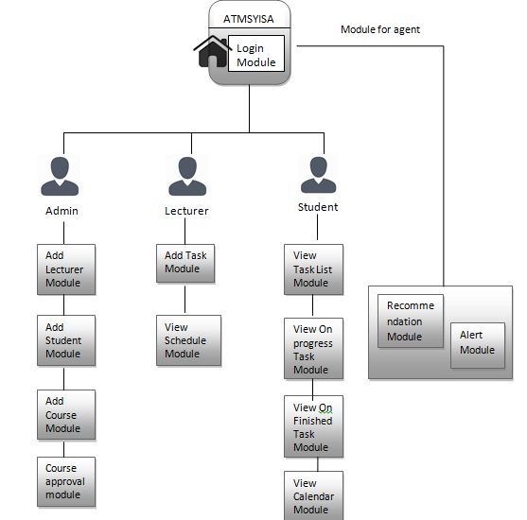
11: Module of

Figure 5.11: Module of Spectrum Recommender

System Implementation
This section discusses the programming languages and the development tools used to develop the SR, which includes, among other, the web server, database management system, and the operating system for the development of the SR.

Development Environment
The SR is developed in this research as a web based system, which runs on MySQL and Apache web servers. The SR system uses the MySQL database to store all data processes in the system, and allows multiple users to access the SR simultaneously and efficiently. SR enables users to store, search, sort, retrieve, and manipulate data remotely.
PHP is used as the language of the interface between the Apache and MySQL server. PHP is an open sourced scripting language, intended especially for developing dynamic web contents and is flexible.

Graphical User Interface
The implementation of each interface model for SR is based on the user requirement elicited discussed in chapter 4 and the system designed discussed earlier in this chapter.

Login Page
Before users can access the SR’s main interface, users need to login. The login module authenticates the accesses and the requests made by users as shown in Figure 5.12. Username and password keyed in by the user enable the SR to differentiate a lecturer, student or administrator. If a user forgot his or her password, the user can click on the ‘Forgot Password’link, which triggers the SR to send password reset confirmation and a link to enter the new password. Figure 5.13 shows the interface for the Username and Password Authentication Alert page.
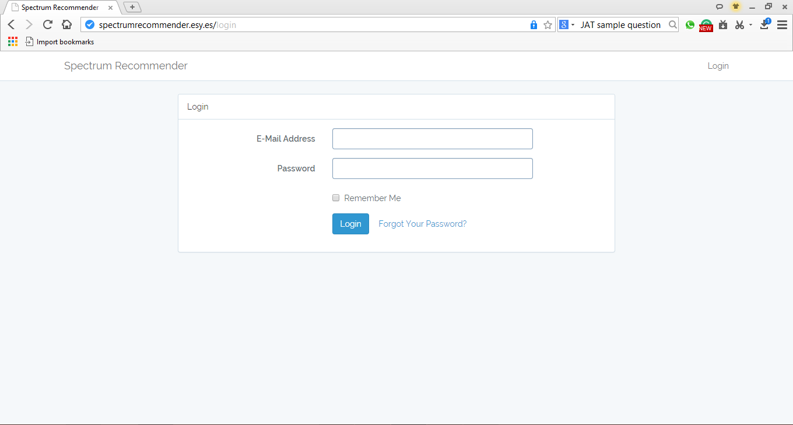

Figure 5.12: Login Page
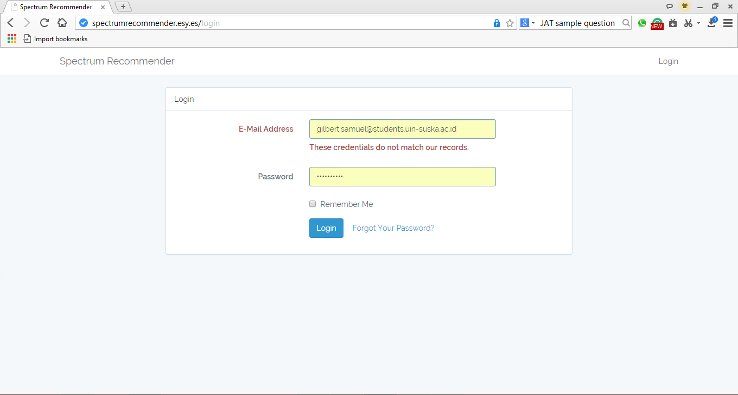
Figure 5.13: Username and Password Authentication Alert

Add New Student Interface
Once the Login process is completed by the administrator, the administrator can enter the SR main page. By choosing the student’s hyperlink and click the add student button, the administrator can add new student as user, the next page requires the administrator to add the student’s details. The administrator will fill-in the details such as full name, email, phone number, address, and account password as shown in Figure 5.14.
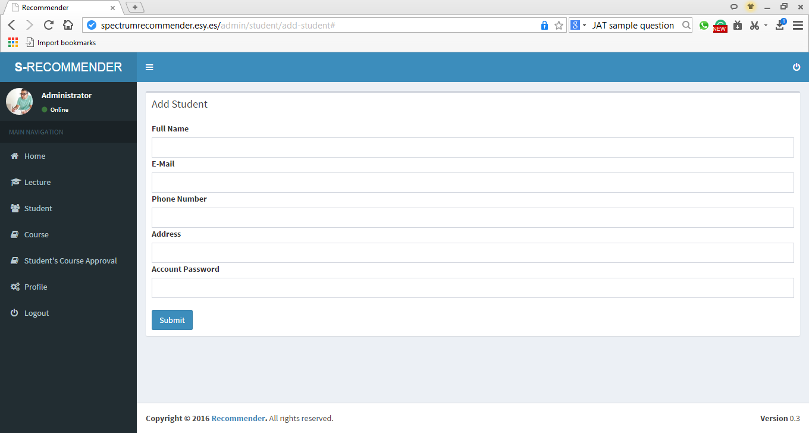
Figure 5.14: Add new student

Add Lecturer Interface
The administrator can also add a new lecturer, by choosing the Lecturer’s hyperlink and click Add lecturer. The next page requires the administrator to add the lecturer’s details. The administrator will fill-in the details such as full name, email, phone number, address, and account password as shown in Figure 5.15.
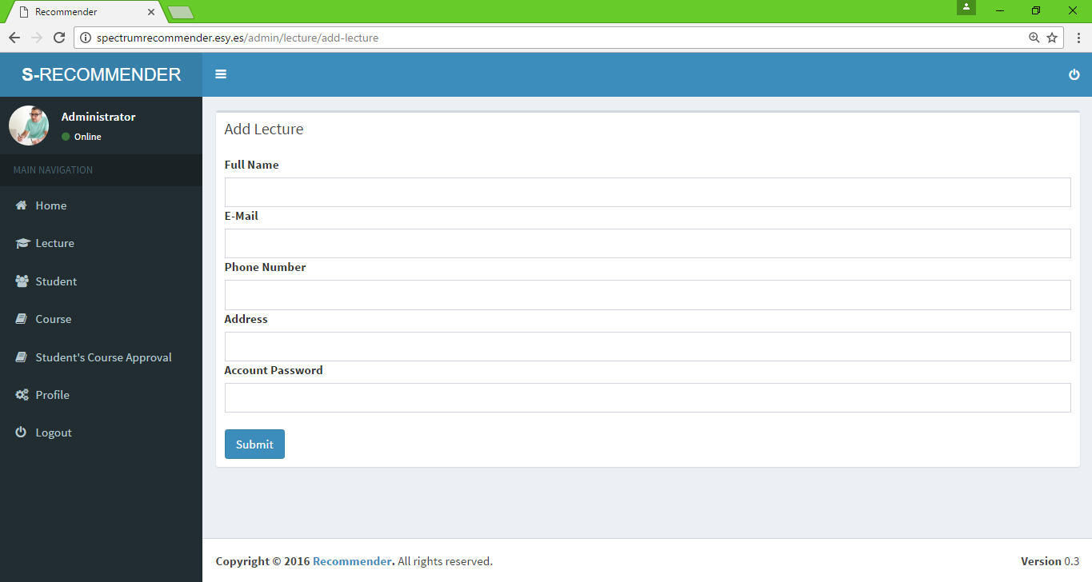
Figure 5.15: Add new lecturer

Add Course Interface
In SR, courses can be added by the administrator. The processes are similar to adding student and lecturer’s detail, but the information to be added is only the course name as shown in Figure 5.16.

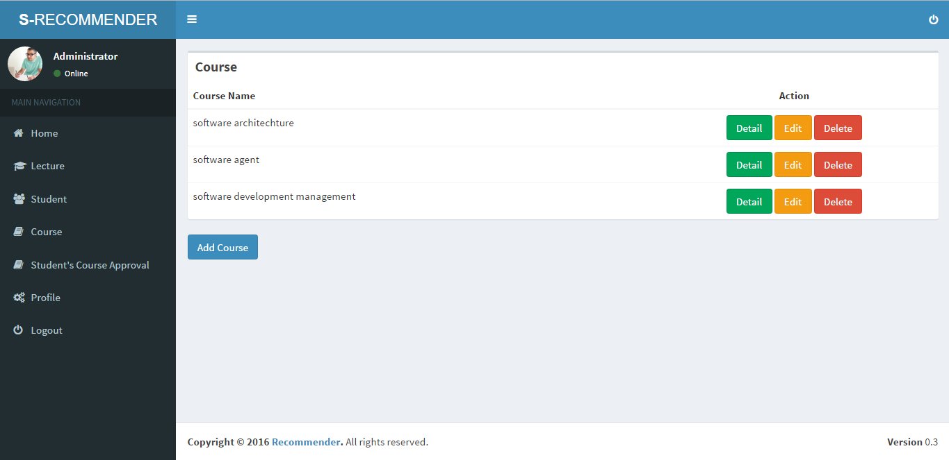
Figure 5.16: Add Course

Student’s Course Approval Interface
When a student has registers with SR, the students will be asked to join a classroom. Students cannot access information related to the course before the administrator can approve the class request. For this, the administrator needs to logon and click student’s class approval hyperlink as shown in figure 5.17.
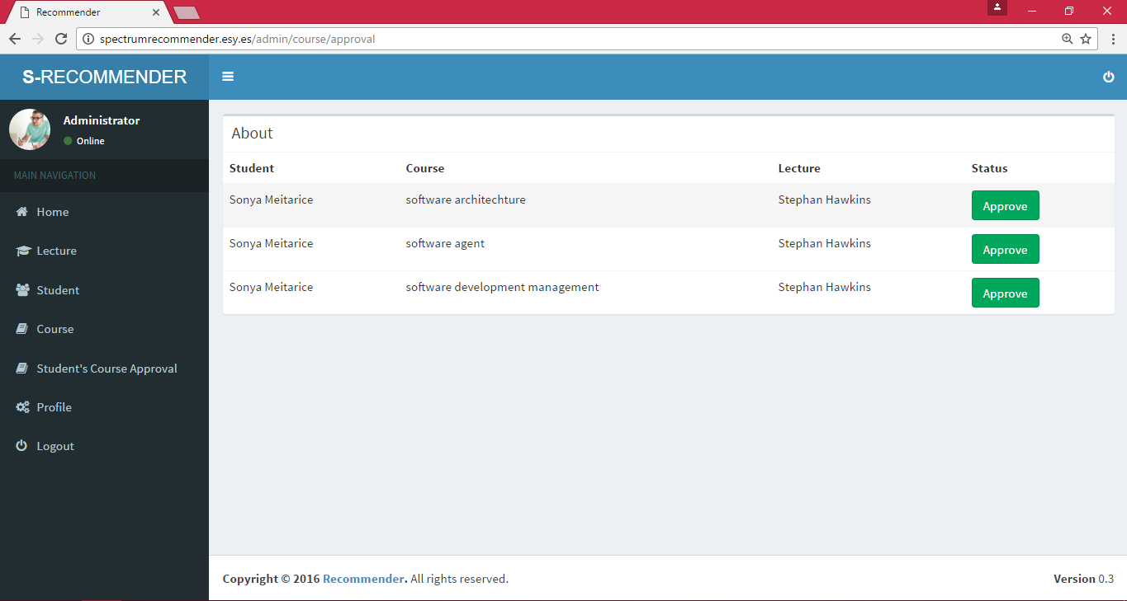
Figure 5.17: Student’s Course Approval

Add Task Interface
The second user who can access SR is the lecturer. When the lecturer logon to SR, he or she can add new task by clicking the add task button as shown in figure 5.18. Then figure 5.19 appear, and the lecturer fills up the task information such as, Task Name, Duedate, Task Type, Course Name, Venue, Percentage of Mark, Number of chapters, and comments.
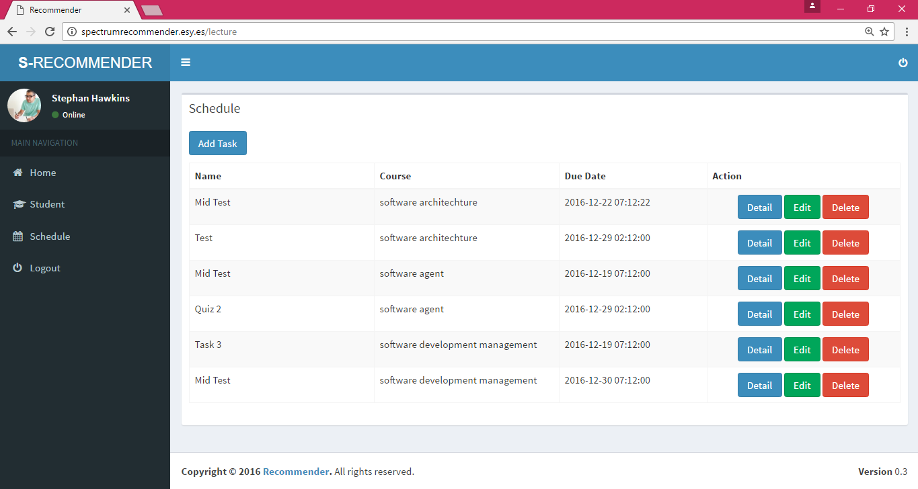
Figure 5.18: Lecturer’s home Page
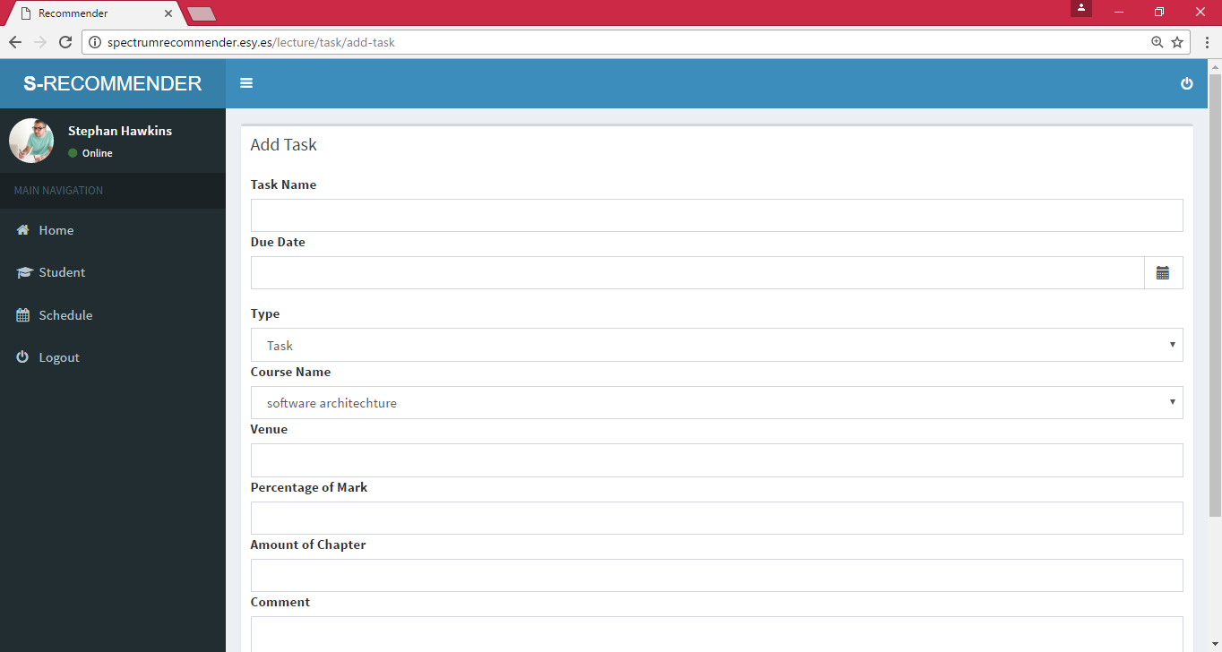
Figure 5.19: Add Task

View Student and Schedule in Calendar.
SR also allows lecturers to view student and schedule page. The lecturer can access to how many students have enrolled to a course and other information such as student’s name, email, and phone number as shown in Figure 5.20. On top of that, Lecturer can view their schedule by clicking the Schedule Hyperlink. The lecturer can view the schedule calendar by month, week, day, or list as shown in Figure 5.21.
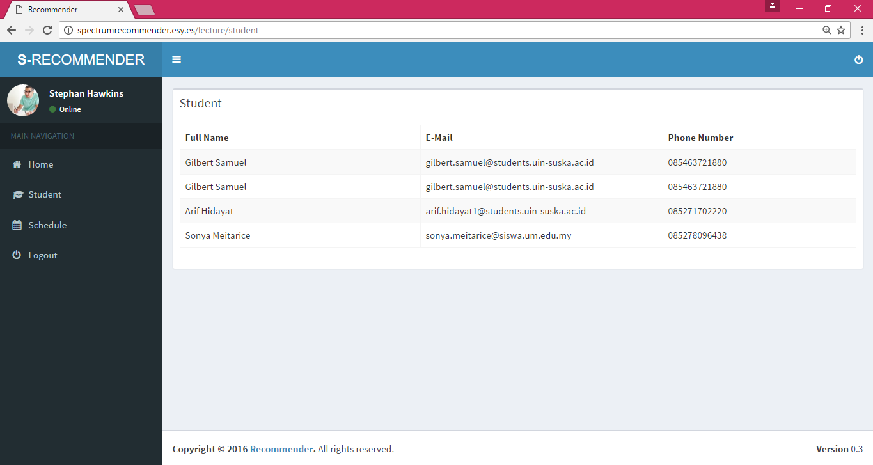
Figure 5.20: View Student

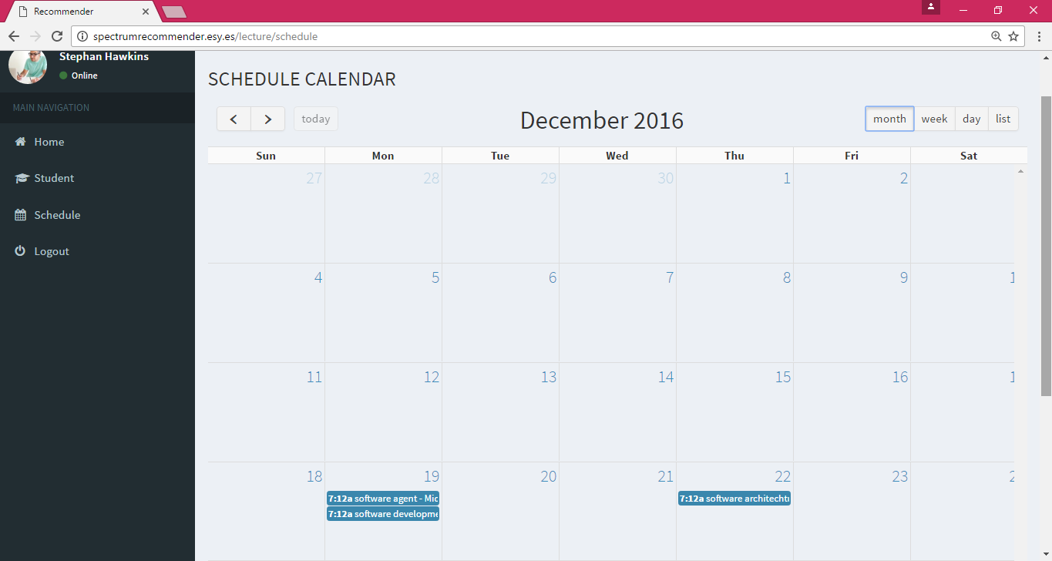
Figure 5.21: Schedule Calendar

Task Recommendation and Monitoring Interface

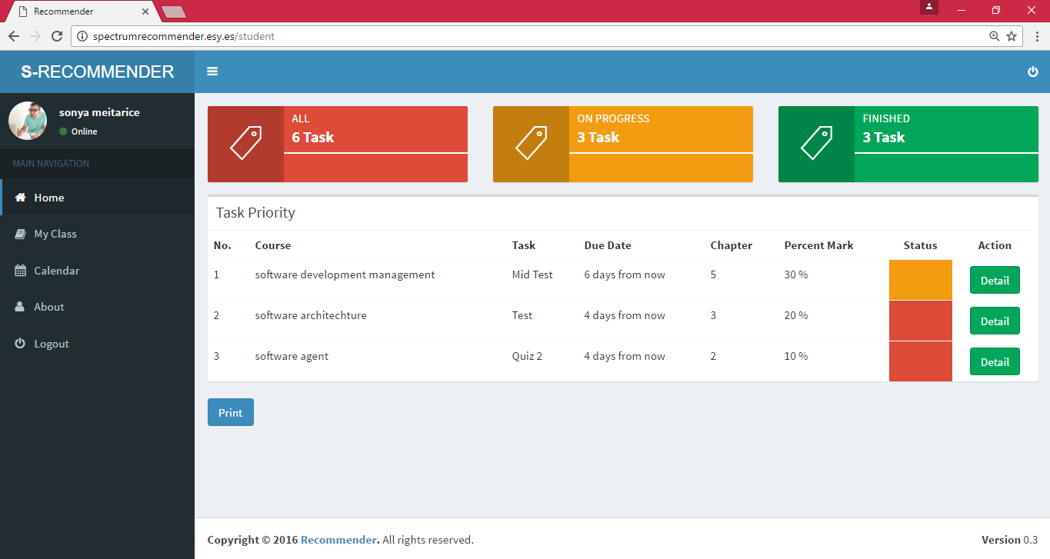
Figure 5.22: Task Monitoring and Recommendation

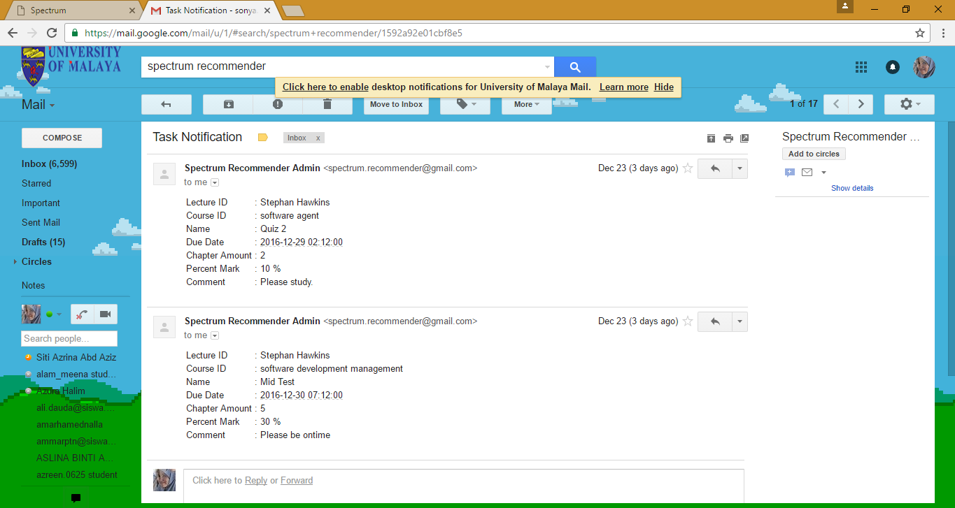
Figure 5.23: Task Alert for Spectrum Recommender.

My Class (Request of join Class by student) Interface
Another feature of the SR is “My Class” feature. After student successfully logon into the system, they need to choose the class that they want to join by clicking on my class hyperlink. A new page with the course information, such as, course name, lecturer’s name, email, phone number and action to join the class will be displayed, as shown in figure 5.24.
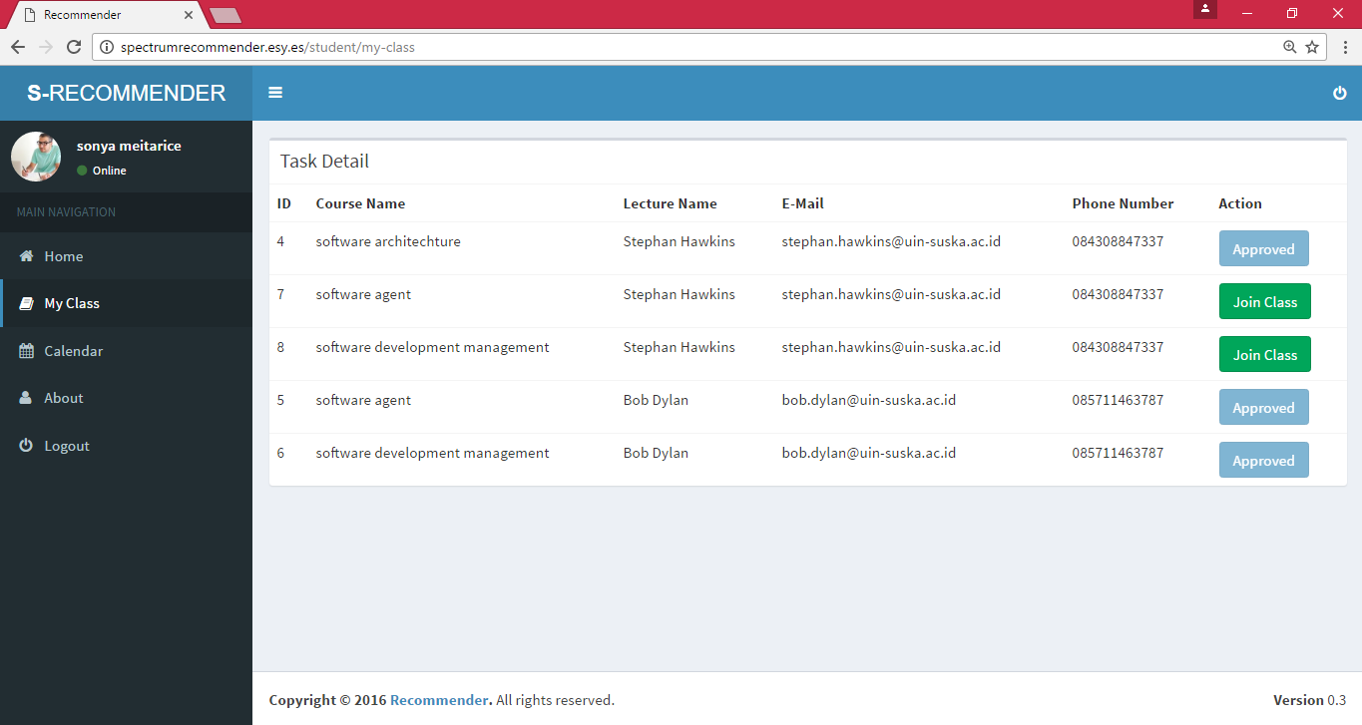
Figure 5.24: My Class Interface

Schedule Calendar Interface
All the tasks published by the lecturer can be viewed by the student in the calendar view. Students can access this feature by clicking on the Calendar hyperlink, and they can view the calendar as shown in Figure 5.25.
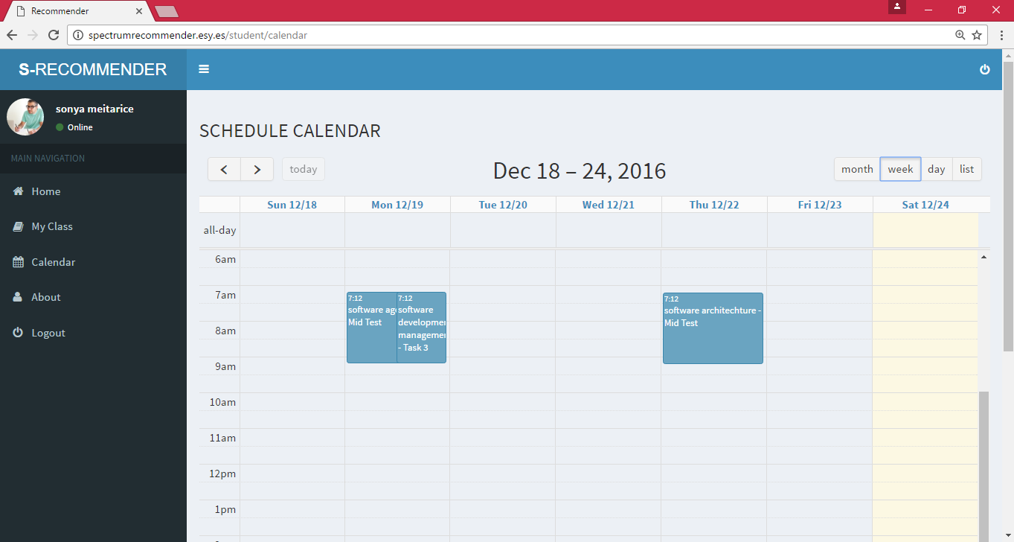
Figure 5.25: Schedule Calendar.

