********************* PROCESS for R Version 4.3.1 *********************

Written by Andrew F. Hayes, Ph.D. www.afhayes.com

Documentation available in Hayes (2022). www.guilford.com/p/hayes3

***********************************************************************

Model : 7

Y : M_WE

X : M_OLC

M : M_ER

W : M_AS

Covariates:

JK Usia MK

Sample size: 206

Custom seed: 654321

***********************************************************************

Outcome Variable: M_ER

Model Summary:

R R-sq MSE F df1 df2 p

0.6404 0.4101 0.1372 23.0566 6.0000 199.0000 0.0000

Model:

coeff se t p LLCI ULCI

constant 1.0078 0.3644 2.7658 0.0062 0.2893 1.7264

**M_OLC 0.4785 0.0656 7.2940 0.0000 0.3491 0.6078**

**M_AS 0.4087 0.1540 2.6533 0.0086 0.1049 0.7124**

Int_1 -0.0752 0.0313 -2.4002 0.0173 -0.1369 -0.0134

JK 0.0641 0.0561 1.1422 0.2548 -0.0465 0.1747

Usia -0.0055 0.0052 -1.0583 0.2912 -0.0159 0.0048

MK -0.0013 0.0058 -0.2240 0.8230 -0.0127 0.0101

Product terms key:

Int_1 : M_OLC x M_AS

Test(s) of highest order unconditional interaction(s):

R2-chng F df1 df2 p

X*W 0.0171 5.7608 1.0000 199.0000 0.0173

----------

Focal predictor: M_OLC (X)

Moderator: M_AS (W)

Conditional effects of the focal predictor at values of the moderator(s):

M_AS effect se t p LLCI ULCI

1.0000 0.4033 0.0410 9.8316 0.0000 0.3224 0.4842

1.1000 0.3958 0.0391 10.1232 0.0000 0.3187 0.4729

1.8880 0.3366 0.0316 10.6440 0.0000 0.2742 0.3989

Data for visualizing the conditional effect of the focal predictor:

M_OLC M_AS M_ER

4.1429 1.0000 2.9335

5.0000 1.0000 3.2792

6.0000 1.0000 3.6825

4.1429 1.1000 2.9432

5.0000 1.1000 3.2825

6.0000 1.1000 3.6783

4.1429 1.8880 3.0199

5.0000 1.8880 3.3084

6.0000 1.8880 3.6450

***********************************************************************

Outcome Variable: M_WE

Model Summary:

R R-sq MSE F df1 df2 p

0.7675 0.5891 0.3702 57.3431 5.0000 200.0000 0.0000

Model:

coeff se t p LLCI ULCI

constant -0.1362 0.3892 -0.3499 0.7268 -0.9037 0.6313

**M_OLC 0.5921 0.0605 9.7825 0.0000 0.4727 0.7114**

M_ER 0.4849 0.1143 4.2418 0.0000 0.2595 0.7104

JK 0.0042 0.0924 0.0456 0.9637 -0.1779 0.1864

Usia 0.0139 0.0086 1.6139 0.1081 -0.0031 0.0308

MK 0.0014 0.0095 0.1451 0.8847 -0.0174 0.0202

***********************************************************************

Bootstrapping progress:

|>>>>>>>>>>>>>>>>>>>>>>>>>>>>>>>>>>>>>>>>>>>>>>>>>>>>>>>>>>>>>>| 100%

**************** DIRECT AND INDIRECT EFFECTS OF X ON Y ****************

Direct effect of X on Y:

effect se t p LLCI ULCI

0.5921 0.0605 9.7825 0.0000 0.4727 0.7114

Conditional indirect effects of X on Y:

INDIRECT EFFECT:

M_OLC -> M_ER -> M_WE

M_AS Effect BootSE BootLLCI BootULCI

1.0000 0.1956 0.0520 0.0973 0.3079

1.1000 0.1919 0.0502 0.0962 0.2982

1.8880 0.1632 0.0406 0.0814 0.2431

Index of moderated mediation:

Index BootSE BootLLCI BootULCI

M_AS -0.0364 0.0279 -0.1114 -0.0020

******************** ANALYSIS NOTES AND ERRORS ************************

Level of confidence for all confidence intervals in output: 95

Number of bootstraps for percentile bootstrap confidence intervals: 5000

W values in conditional tables are the 16th, 50th, and 84th percentiles.

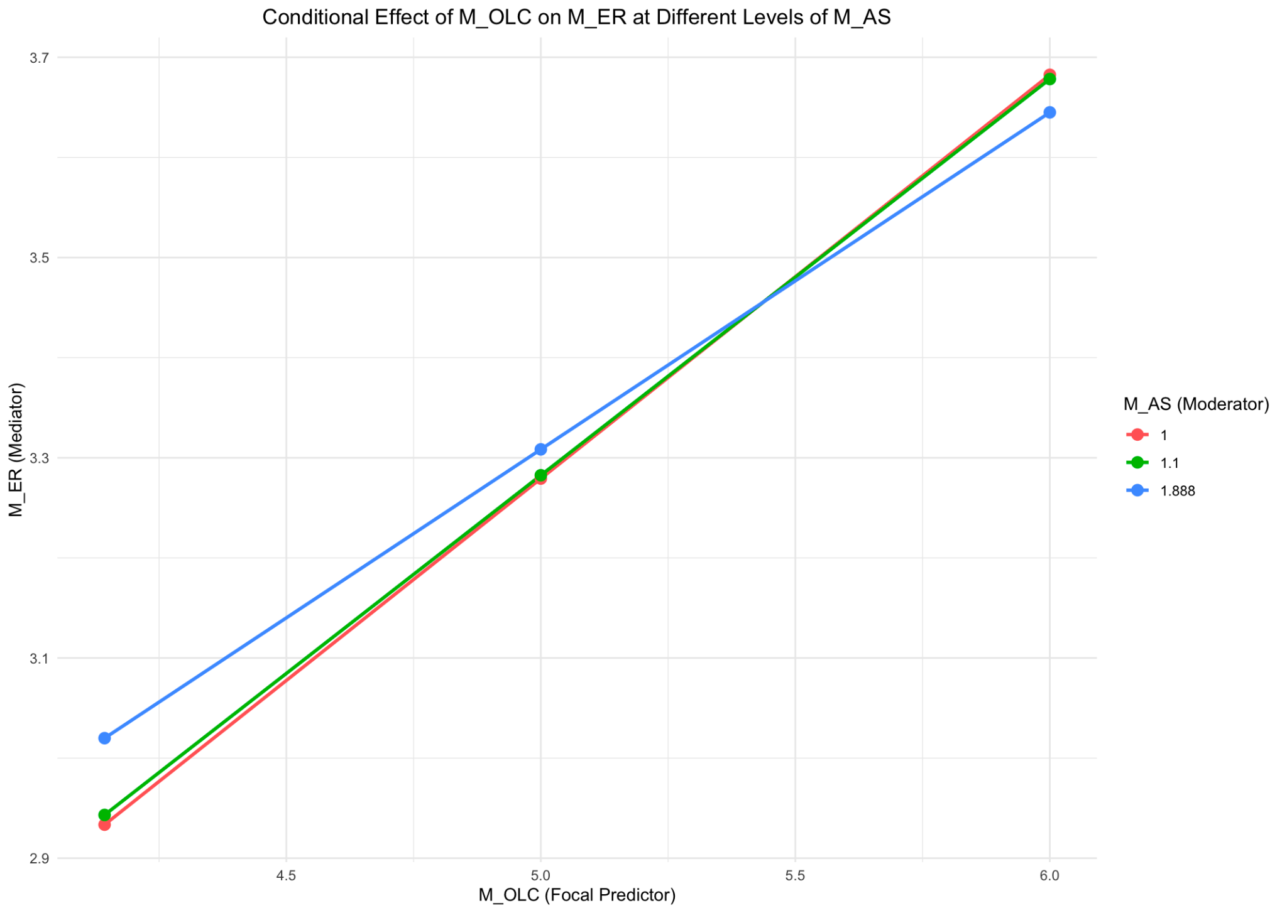

********************* PROCESS for R Version 4.3.1 *********************

Written by Andrew F. Hayes, Ph.D. www.afhayes.com

Documentation available in Hayes (2022). www.guilford.com/p/hayes3

***********************************************************************

Model : 4

Y : M_WE

X : M_OLC

M : M_ER

Covariates:

JK Usia MK

Sample size: 206

Custom seed: 654321

***********************************************************************

Outcome Variable: M_ER

Model Summary:

R R-sq MSE F df1 df2 p

0.6230 0.3882 0.1409 31.8813 4.0000 201.0000 0.0000

Model:

coeff se t p LLCI ULCI

constant 1.8350 0.2023 9.0723 0.0000 1.4362 2.2339

**M_OLC 0.3248 0.0295 11.0155 0.0000 0.2667 0.3829**

JK 0.0620 0.0568 1.0908 0.2767 -0.0501 0.1740

Usia -0.0053 0.0053 -1.0093 0.3140 -0.0158 0.0051

MK -0.0014 0.0059 -0.2407 0.8100 -0.0130 0.0102

***********************************************************************

Outcome Variable: M_WE

Model Summary:

R R-sq MSE F df1 df2 p

0.7675 0.5891 0.3702 57.3431 5.0000 200.0000 0.0000

Model:

coeff se t p LLCI ULCI

constant -0.1362 0.3892 -0.3499 0.7268 -0.9037 0.6313

**M_OLC 0.5921 0.0605 9.7825 0.0000 0.4727 0.7114**

**M_ER 0.4849 0.1143 4.2418 0.0000 0.2595 0.7104**

JK 0.0042 0.0924 0.0456 0.9637 -0.1779 0.1864

Usia 0.0139 0.0086 1.6139 0.1081 -0.0031 0.0308

MK 0.0014 0.0095 0.1451 0.8847 -0.0174 0.0202

***********************************************************************

Bootstrapping progress:

|>>>>>>>>>>>>>>>>>>>>>>>>>>>>>>>>>>>>>>>>>>>>>>>>>>>>>>>>>>>>>>| 100%

**************** DIRECT AND INDIRECT EFFECTS OF X ON Y ****************

Direct effect of X on Y:

effect se t p LLCI ULCI

**0.5921 0.0605 9.7825 0.0000 0.4727 0.7114**

Indirect effect(s) of X on Y:

Effect BootSE BootLLCI BootULCI

**M_ER 0.1575 0.0392 0.0816 0.2391**

******************** ANALYSIS NOTES AND ERRORS ************************

Level of confidence for all confidence intervals in output: 95

Number of bootstraps for percentile bootstrap confidence intervals: 5000

