LAMPIRAN 1. Rekap Tabulasi Jawaban Responden

LAMPIRAN 2. Hasil Uji Validitas
- Hasil Uji Validitas Variabel Peranan Rumah Pangan Kita dalam Stabilisasi Harga (Y)

- Hasil Uji Validitas Variabel Pengetahuan tentang RPK
- Hasil Validitas Variabel Sarana Prasarana Uji
LAMPIRAN 3. Hasil Uji Reliabilitas
- Hasil Uji Reliabilitas Variabel Peranan Rumah Pangan Kita dalam Stabilisasi Harga (Y)
Reliability Statistics
Cronbach's Alpha | N of Items
.795 | 22

- Hasil Uji Reliabilitas Variabel Pengetahuan Tentang RPK
Reliability Statistics
Cronbach's Alpha | N of Items
.639 | 9

- Hasil Uji Reliabilitas Variabel Sarana Prasarana
Reliability Statistics
Cronbach's Alpha | N of Items
.603 | 8

LAMPIRAN 4. Hasil Uji Regresi linier Berganda
- Uji t
- Faktor Internal
Coefficientsª
Model |  | Unstandardized Coefficients |  | Standardized Coefficients | t | Sig.
 |  | B | Std. Error | Beta | t | Sig.
1 | (Constant) | 15,211 | 5,185 |  | 2,934 | ,005
1 | Umur (X1) | ,491 | ,777 | ,053 | ,631 | ,530
1 | Tingkat Pendidikan (X2) | ,049 | ,526 | ,008 | ,094 | ,926
1 | Pengalaman (X3) | 1,463 | ,581 | ,213 | 2,520 | ,014
1 | Pendapatan (X4) | ,005 | ,536 | ,001 | ,010 | ,992
1 | Pengetahuan tentang RPK (X5) | 1,569 | ,193 | ,732 | 8,119 | ,000
a. Dependent Variable: Peranan RPK dalam Stabilisasi Harga

- Faktor Eksternal
Model |  | Unstandardized Coefficients |  | Standardized Coefficients | t | Sig.
 |  | B | Std. Error | Beta | t | Sig.
1 | (Constant) | 21,851 | 5,500 |  | 3,973 | ,000
1 | Modal (X1) | ,444 | ,172 | ,252 | 2,578 | ,012
1 | Lokasi (X2) | ,095 | ,153 | ,061 | ,619 | ,538
1 | Sarana Prasarana (X3) | 1,339 | ,221 | ,592 | 6,047 | ,000

- Uji F
- Faktor Internal
ANOVAª
Model |  | Sum of Squares | df | Mean Square | F | Sig.
1 | Regression | 1039,495 | 5 | 207,899 | 16,813 | ,000^{b}
1 | Residual | 754,296 | 61 | 12,366
1 | Total | 1793,791 | 66
a. Dependent Variable: Peranan RPK dalam Stabilisasi Harga
b. Predictors: (Constant), Pengetahuan tentang RPK (X5), Pengalaman (X3) , Umur (X1), Tingkat Pendidikan (X2), Pendapatan (X4)

- Faktor Eksternal
ANOVAª
Model |  | Sum of Squares | df | Mean Square | F | Sig.
1 | Regression | 725,546 | 3 | 241,849 | 14,263 | ,000^{b}
1 | Residual | 1068,245 | 63 | 16,956
1 | Total | 1793,791 | 66
a. Dependent Variable: Peranan RPK dalam Stabilisasi Harga (Y)
b. Predictors: (Constant), Sarana Prasarana (X8), Modal (X6), Lokasi (X7)

- Uji Koefisien Determinasi
- Faktor Internal
Model Summary^{b}
Model | R | R Square | Adjusted R Square | Std. Error of the Estimate
1 | ,761ª | ,579 | ,545 | 3,516
a. Predictors: (Constant), Pengetahuan tentang RPK (X5), Pengalaman (X3) , Umur (X1), Tingkat Pendidikan (X2), Pendapatan (X4)
b. Dependent Variable: Peranan RPK dalam Stabilisasi Harga

- Faktor Eksternal
Model Summary^{b}
Model | R | R Square | Adjusted R Square | Std. Error of the Estimate
1 | ,636ª | ,404 | ,376 | 4,118
a. Predictors: (Constant), Sarana Prasarana (X8), Modal (X6), Lokasi (X7)
b. Dependent Variable: Peranan RPK dalam Stabilisasi Harga (Y)

LAMPIRAN 5. Uji Asumsi Klasik
  - Uji Normalitas
- Faktor Internal
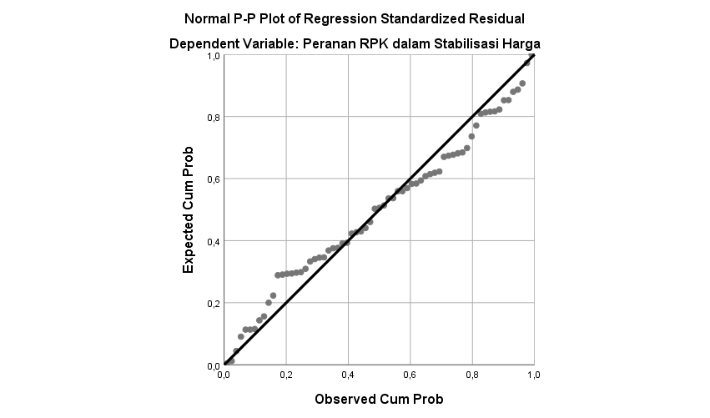
- Faktor Eksternal
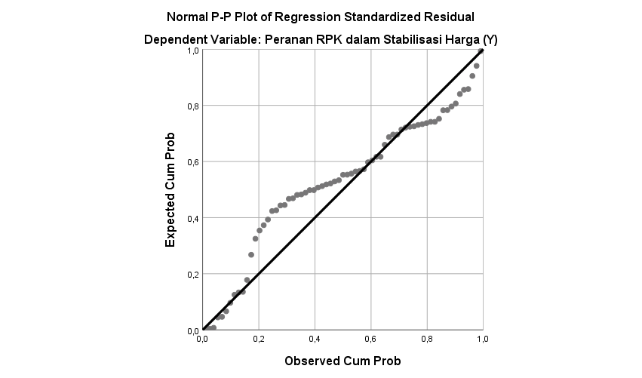

  - Uji Heterokedastisitas
- Faktor Internal
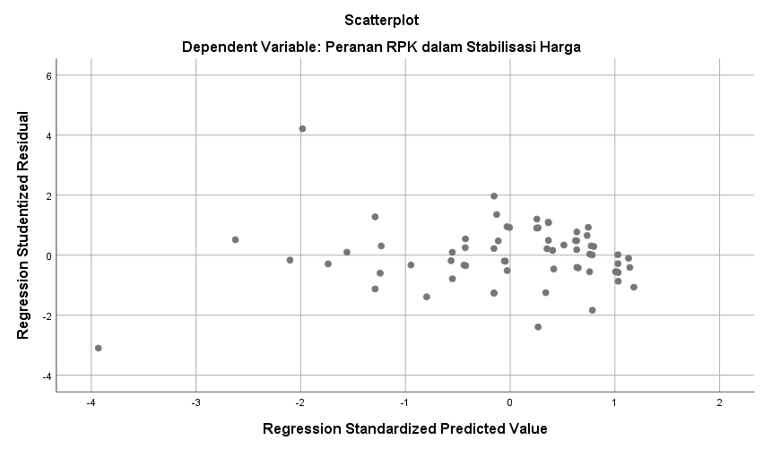
- Faktor Eksternal
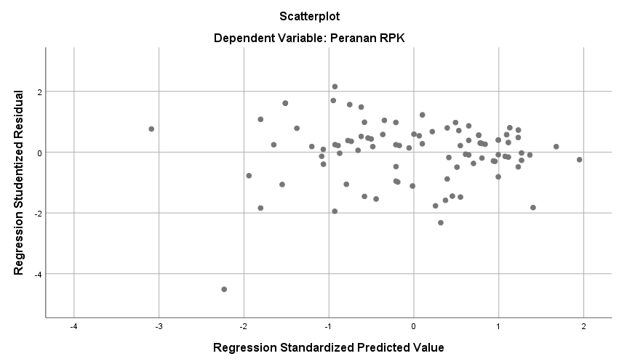

- Uji Multikolinearitas
- Faktor Internal
Coefficientsª
Model |  | Unstandardized Coefficients |  | Standardized Coefficients | t | Sig. | Collinearity Statistics
 |  | B | Std. Error | Beta | t | Sig. | Tolerance | VIF
1 | (Constant) | 15,211 | 5,185 |  | 2,934 | ,005
1 | Umur (X1) | ,491 | ,777 | ,053 | ,631 | ,530 | ,988 | 1,013
1 | Tingkat Pendidikan (X2) | ,049 | ,526 | ,008 | ,094 | ,926 | ,911 | 1,098
1 | Pengalaman (X3) | 1,463 | ,581 | ,213 | 2,520 | ,014 | ,961 | 1,041
1 | Pendapatan (X4) | ,005 | ,536 | ,001 | ,010 | ,992 | ,869 | 1,151
1 | Pengetahuan tentang RPK (X5) | 1,569 | ,193 | ,732 | 8,119 | ,000 | ,847 | 1,180
a. Dependent Variable: Peranan RPK dalam Stabilisasi Harga

- Faktor Eksternal
Coefficientsª
Model |  | Unstandardized Coefficients |  | Standardized Coefficients | t | Sig. | Collinearity Statistics
 |  | B | Std. Error | Beta | t | Sig. | Tolerance | VIF
1 | (Constant) | 21,851 | 5,500 |  | 3,973 | ,000
1 | Modal (X6) | ,444 | ,172 | ,252 | 2,578 | ,012 | ,990 | 1,010
1 | Lokasi (X7) | ,095 | ,153 | ,061 | ,619 | ,538 | ,979 | 1,021
1 | Sarana Prasarana (X8) | 1,339 | ,221 | ,592 | 6,047 | ,000 | ,988 | 1,012
a. Dependent Variable: Peranan RPK dalam Stabilisasi Harga (Y)

LAMPIRAN 6. Dokumentasi
  - Proses wawancara dengan responden
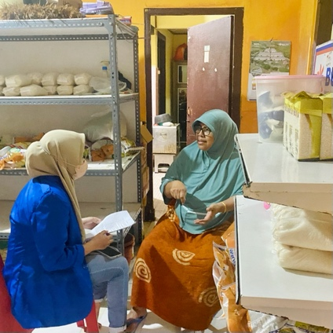
  - Operasi Pasar Murah oleh BULOG

  - Proses pengemasan produk RPK, outlet RPK dan Produk-produk RPK
