AUTHOR’S STATEMENT

The undersigned below,
Name | : | Drs. Khoiron Nazip, M. Si
Origin of affiliation | : | Universitas Sriwijaya
Office address | : | Jl. Raya-Palembang-Prabumulih, Indralaya Ogan Ilir, 30662, Sumatra Selatan
Office phone number | : | (0711) 580085
Home address | : | Griya Harapan A Blok 4 Nomor 27 RT 72 RW 28 Kelurahan Sako Kecamatan Sako Palembang
Mobile number | : | 08127855868
E-mail | : | khoiron_nazip@fkip.unsri.ac.id
As the corresponding author in the manuscript entitled:
Effect of Ethanol Extract of Wijaya Kusuma Leaves (Epiphyllum oxypetalum) as an Inhibitor of Salmonella thypi Bacteria.
With the author’s order:
- M. Tegar Suhitar Ahada
- Drs. Khoiron Nazip, M. Si.
- Nike Anggraini, S. Pd., M. Sc.

Stated that the manuscript that I submitted to Al-Kauniyah: Jurnal Biologi is:
- Does not contain elements of plagiarism, according to applicable regulations
- Not being submitted to other journals
- Not being processed to be published in any form of publications
- All authors have agreed to the author’s order and agreed to the final form of the manuscript
- Willing to bear the risk of the accuracy of the data and will not hold the editor responsible for the data errors provided.

Thus, I make this statement in truth, and I am willing to accept all actions taken by the Editorial Board of Al-Kauniyah: Jurnal Biologi, if in the future it is proven that one or more of my statements are incorrect.

Palembang, 27 Juli 2024


Signature Signature Signature
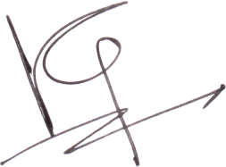
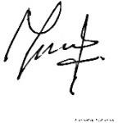

(M. Tegar Suhitar Ahada) (Drs. Khoiron Nazip, M. Si) (Nike Anggraini, S. Pd., M. Sc.)

