AUTHOR’S STATEMENT

The undersigned below,
Name | : | Dr. Sunarno, S.Si., M.Si.
Origin of affiliation | : | Universitas Diponegoro
Office address | : | Departemen Biologi, Jl. Prof. Soedarto, SH, Tembalang, Semarang, 50275
Office phone number | : | (024) 70799494
Home address | : | Jl. Mulawarman Barat II No. 3A, Tembalang, Semarang
Mobile number | : | 081392946145
E-mail | : | sunarno@lecturer.undip.ac.id
As the corresponding author in the manuscript entitled:
LEUKOCYTE PROFILE OF BROILER CHICKENS (Gallus domesticus) AFTER CONSUMPTION OF FEED WITH SPIRULINA (Spirulina sp.) FEED ADDITIVES AND LIQUID NANOCHITOSAN
With the author’s order:
- Sunarno
- Rida Arwanda Gunawan
- Muhammad Anwar Djaelani
- Kasiyati
Stated that the manuscript that I submitted to Al-Kauniyah: Jurnal Biologi is:
- Does not contain elements of plagiarism, according to applicable regulations
- Not being submitted to other journals
- Not being processed to be published in any form of publications
- All authors have agreed to the author’s order and agreed to the final form of the manuscript
- Willing to bear the risk of the accuracy of the data and will not hold the editor responsible for the data errors provided.

Thus, I make this statement in truth, and I am willing to accept all actions taken by the Editorial Board of Al-Kauniyah: Jurnal Biologi, if in the future it is proven that one or more of my statements are incorrect.

Semarang, 24 Juli 2024

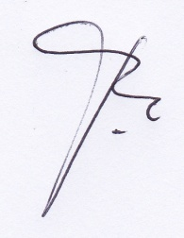 | 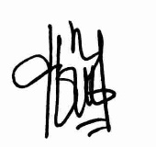 | 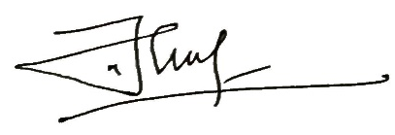 | 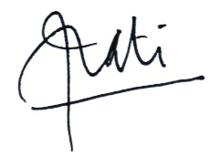
Dr. Sunarno, S.Si., M.Si. | Rida Arwanda Gunawan | Drs. Muhammad Anwar Djaelani, M.Kes. | Dr. Kasiyati, S.Si., M.Si.

