AUTHOR’S STATEMENT

The undersigned below,
Name | : | Mega Atria
Origin of affiliation | : | Departemen Biologi, FMIPA, Universitas Indonesia
Office address | : | Departemen Biologi, FMIPA, Universitas Indonesia, Kampus UI Depok, Depok 16424
Office phone number | : | 021-7270163
Home address | : | Jalan Haji Riman no 78, RT 4/RW 6, Limo, Depok 16515
Mobile number | : | 087784319672
E-mail | : | mega.atria@sci .ui.ac.id
As the corresponding author in the manuscript entitled:
Management of Pyrrosia Mirb. Fern Specimens in Herbarium Depokensis (UIDEP) Universitas Indonesia, Depok
With the author’s order:
- Mega Atria
- Ghifari Rahmandika
- Andi Salamah
- Saifudin
- Afiatry Putrika

Stated that the manuscript that I submitted to Al-Kauniyah: Jurnal Biologi is:
- Does not contain elements of plagiarism, according to applicable regulations
- Not being submitted to other journals
- Not being processed to be published in any form of publications
- All authors have agreed to the author’s order and agreed to the final form of the manuscript
- Willing to bear the risk of the accuracy of the data and will not hold the editor responsible for the data errors provided.

Thus, I make this statement in truth, and I am willing to accept all actions taken by the Editorial Board of Al-Kauniyah: Jurnal Biologi, if in the future it is proven that one or more of my statements are incorrect.

Depok, 19 Juli 2024
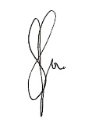
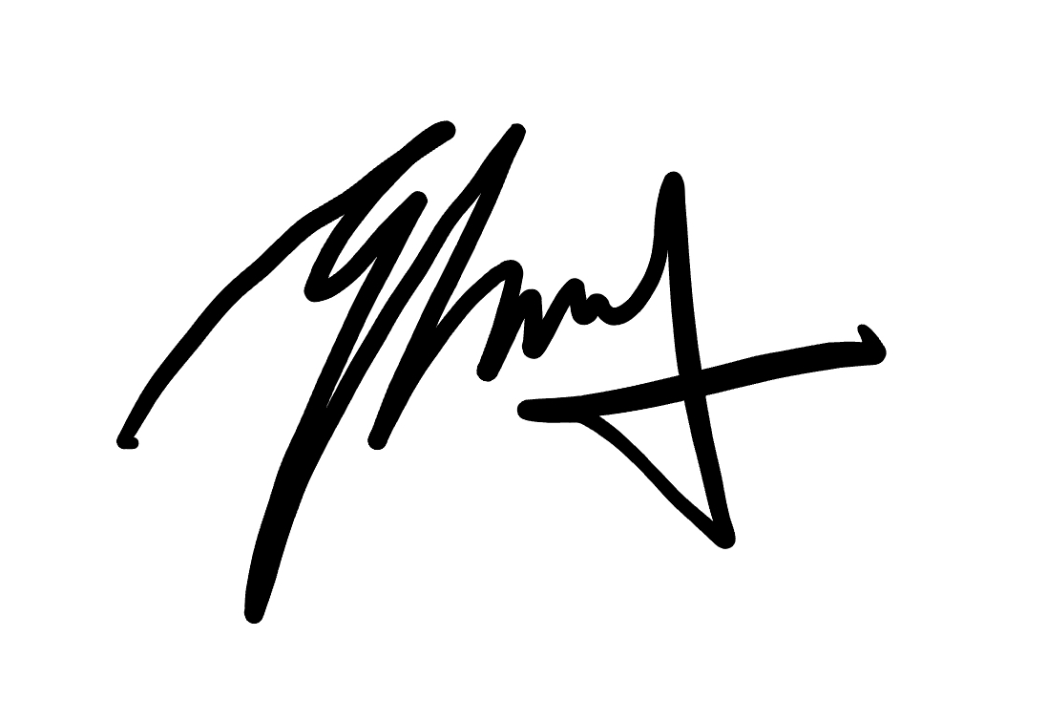
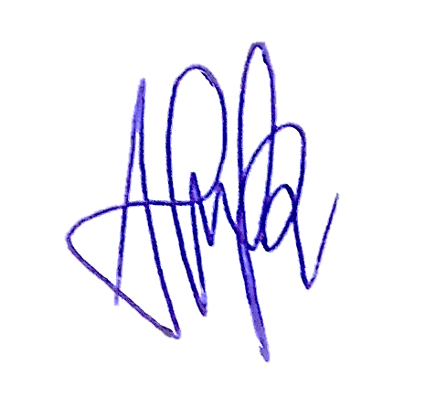
Signature Signature Signature Signature Signature

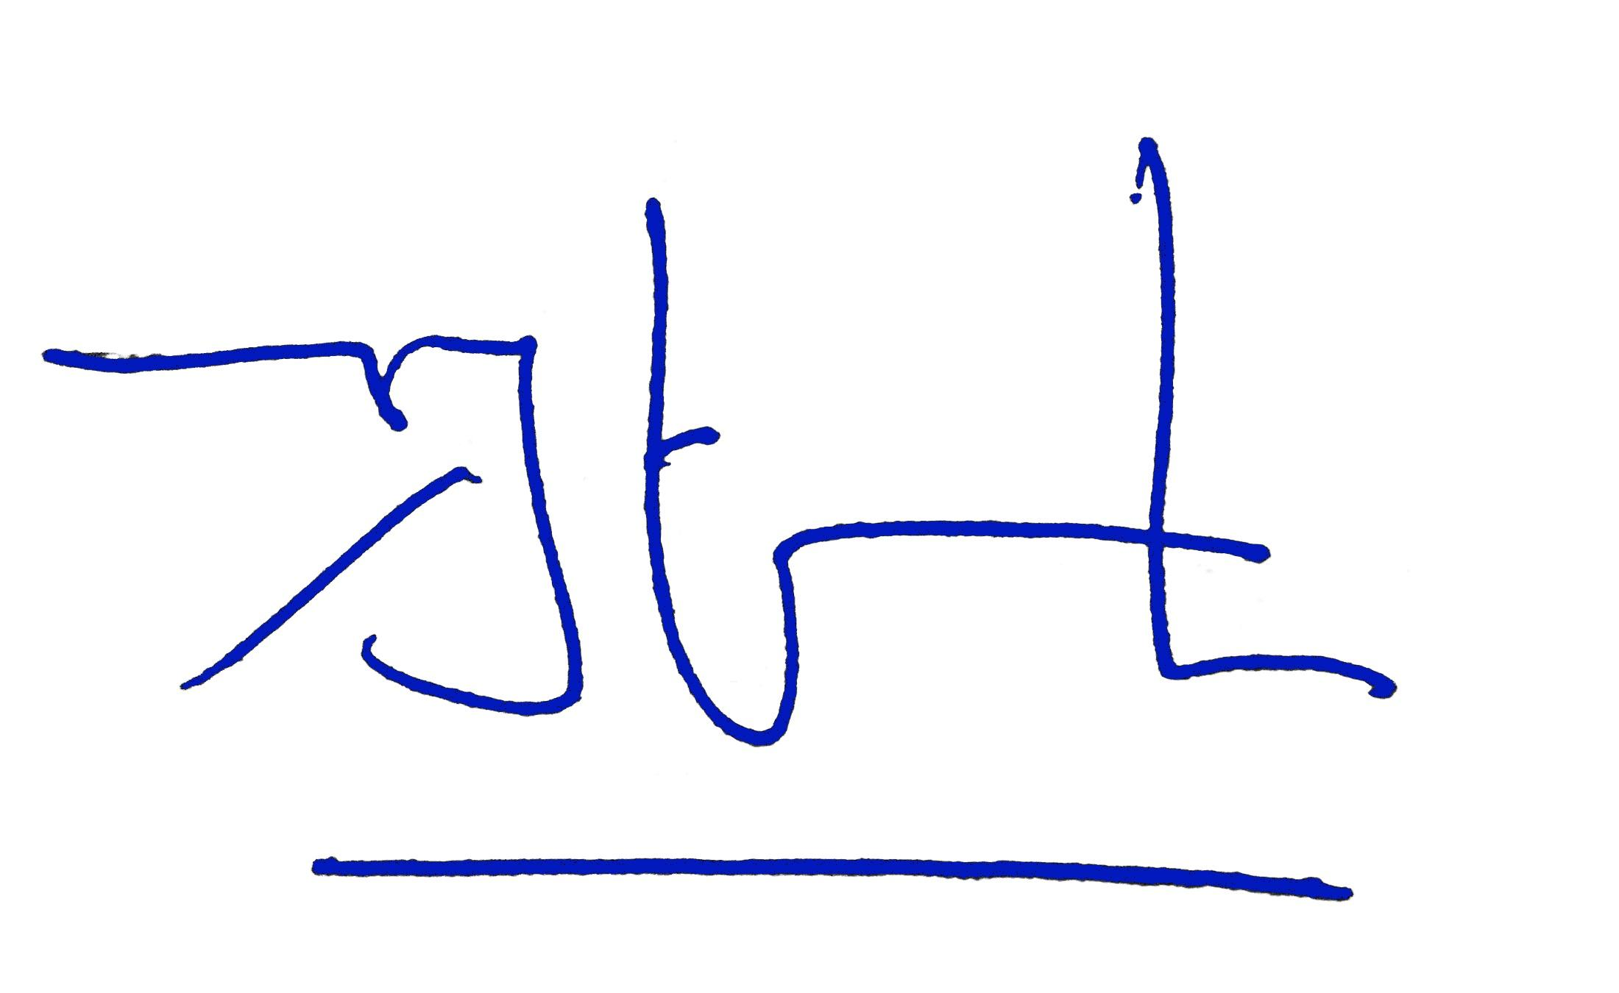

(Mega Atria) (Ghifari Rahmandika) (Andi Salamah) (Saifudin) (Afiatry Putrika)

