IDENTIFIKASI DAN ANALISIS FILOGENETIK KEPITING BIRU
(Portunus sp.) DI PERAIRAN UTARA JEPARA
MENGGUNAKAN BARCODING DNA

IDENTIFICATION AND PHYLOGENETIC ANALYSIS OF BLUE SWIMMING CRAB
(Portunus sp.) IN THE NORTHERN WATERS OF JEPARA USED DNA BARCODING

Risqi Lazuardhi, Aninditia Sabdaningsih*, Diah Ayuningrum, Suradi Wijaya Saputra,
Agus Hartoko and Haeruddin
Department of Aquatic Resources, Faculty of Fisheries and Marine Sciences, Diponegoro University
Jl. Prof. Jacub Rais, Tembalang, Semarang, Indonesia

*Corresponding author: aninditiasabdaningsih@live.undip.ac.id

Figures and Tables

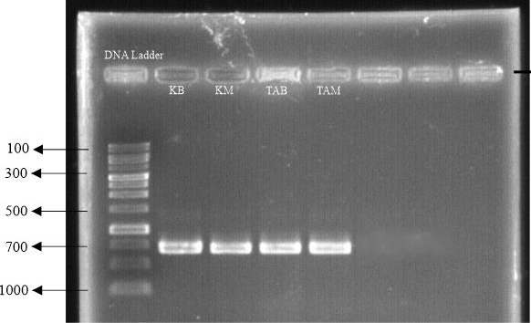

Figure 1. Results of COI Gene Amplification using DNA Barcode Universal Primer LCO 1490 and HCO 2198

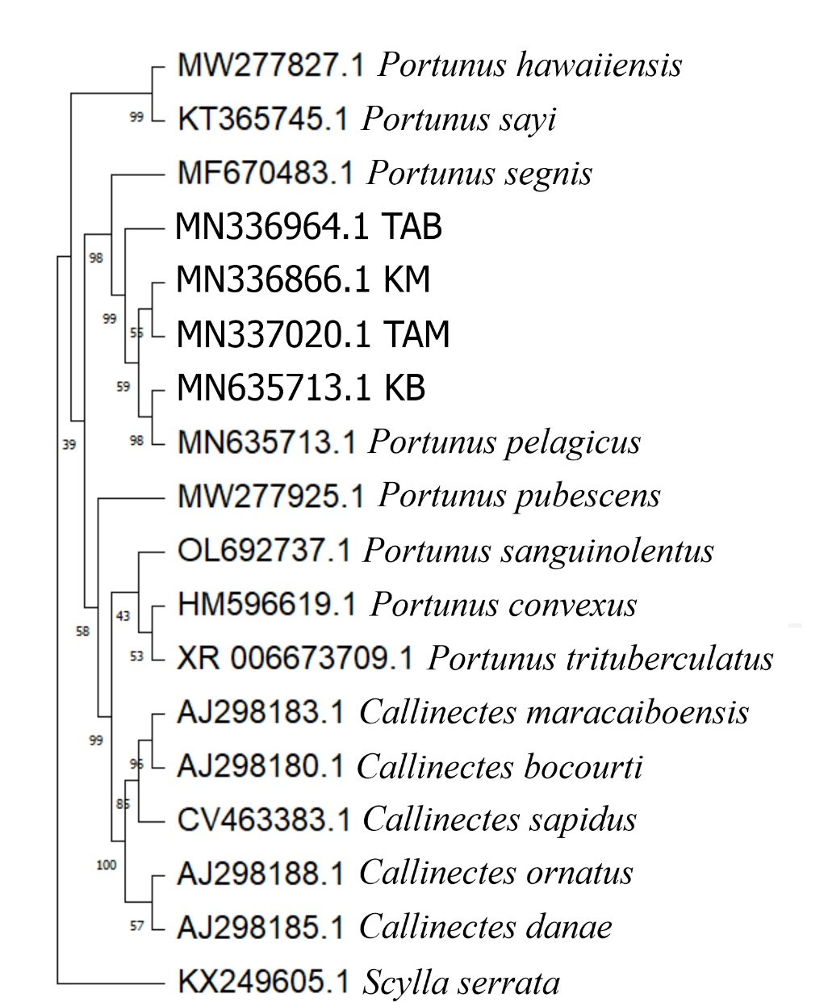
Figure 2. Phylogenetic Tree of Crabs Based on Genetic Distance from COI Gene DNA Sequences using Maximum Likelihood Method with 1000x Bootstrap Kimura-2-parameter Model.

Table 1. Results of forward and reverse sequences from crab samples
No. | Sample Code | Primer | Sequence Length (bp) | Number of N
1 | TAB | Forward | 679 | 0
 |  | Reverse | 686 | 0
2 | TAM | Forward | 680 | 1
 |  | Reverse | 697 | 0
3 | KB | Forward | 677 | 1
 |  | Reverse | 685 | 0
4 | KM | Forward | 682 | 0
 |  | Reverse | 686 | 0

Table 2. BLAST Results of Crab DNA Sequences with COI Primers
No. | Sample Code | Species Identification Result (BLAST) | Reference No. | Sequence Length (bp) | Identity Percentage
1 | TAB | Portunus pelagicus | MN336964.1 | 717 | 99.13%
2 | TAM | Portunus pelagicus | MN337020.1 | 643 | 97.02%
3 | KB | Portunus pelagicus | MN635713.1 | 715 | 99.14%
4 | KM | Portunus pelagicus | MN336866.1 | 715 | 99.42%

