AUTHOR’S STATEMENT

The undersigned below,
Name | : | Annisa Ramadani
Origin of affiliation | : | Universitas Nasional
Office address | : | Jl. Harsono RM 19, Ragunan, Kota Jakarta Selatan, Daerah Khusus Ibukota Jakarta 12520
Office phone number | : | -
Home address | : | Depok, Jawa Barat
Mobile number | : | 08568653353
E-mail | : | ramadani.annisa@gmail.com
As the corresponding author in the manuscript entitled:
Differences in Knowledge, Attitude, Practice of The Community Paroots in Ternate and Sofifi, North Maluku
With the author’s order:
- Tatang Mitra Setia,
- Fachruddin M. Mangunjaya,
- Benny A. Siregar,
- Fitriah Basalamah
Stated that the manuscript that I submitted to Al-Kauniyah: Jurnal Biologi is:
- Does not contain elements of plagiarism, according to applicable regulations
- Not being submitted to other journals
- Not being processed to be published in any form of publications
- All authors have agreed to the author’s order and agreed to the final form of the manuscript
- Willing to bear the risk of the accuracy of the data and will not hold the editor responsible for the data errors provided.

Thus, I make this statement in truth, and I am willing to accept all actions taken by the Editorial Board of Al-Kauniyah: Jurnal Biologi, if in the future it is proven that one or more of my statements are incorrect.

Depok, 27 Maret 2023

Signature Signature etc
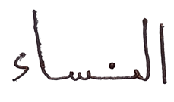
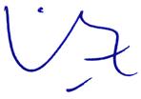

(Annisa Ramadani) (Tatang Mitra Setia)

