AUTHOR’S STATEMENT

The undersigned below,
Name | : | Alanindra Saputra, S.Pd., M.Sc.
Origin of affiliation | : | Biology Education Universitas Sebelas Maret
Office address | : | Kentingan, Jl. Ir Sutami No.36, Kec. Jebres, Kota Surakarta, Jawa Tengah 57126
Office phone number | : | 085643580677
Home address | : | Lemahireng, Kaligawe, Pedan, Klaten, jawa Tengah, Indonesia
Mobile number | : | -
E-mail | : | alanindra@staff. uns.ac.id
As the corresponding author in the manuscript entitled:
Phytoplankton Diversity as Bioindicator of Pollution in the Jenes River, Surakarta, Central Java

With the author’s order:
- Endah Pratiwi
- Dhiya’ Choirunnisa Azmi
- Riannisa Shafira
- Alanindra Saputra

Stated that the manuscript that I submitted to Al-Kauniyah: Jurnal Biologi is:
- Does not contain elements of plagiarism, according to applicable regulations
- Not being submitted to other journals
- Not being processed to be published in any form of publications
- All authors have agreed to the author’s order and agreed to the final form of the manuscript
- Willing to bear the risk of the accuracy of the data and will not hold the editor responsible for the data errors provided.

Thus, I make this statement in truth, and I am willing to accept all actions taken by the Editorial Board of Al-Kauniyah: Jurnal Biologi, if in the future it is proven that one or more of my statements are incorrect.

Surakarta, December 8th 2023

Signature Signature Signature Signature
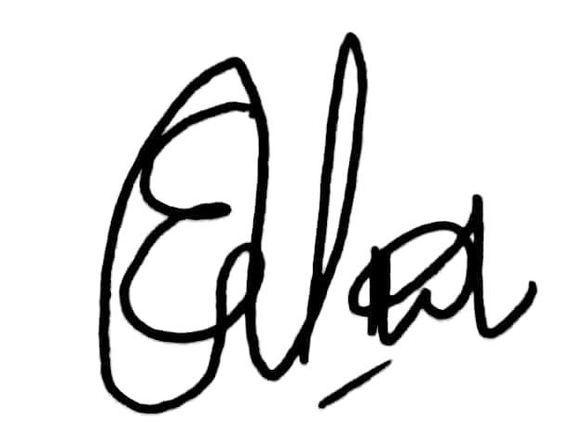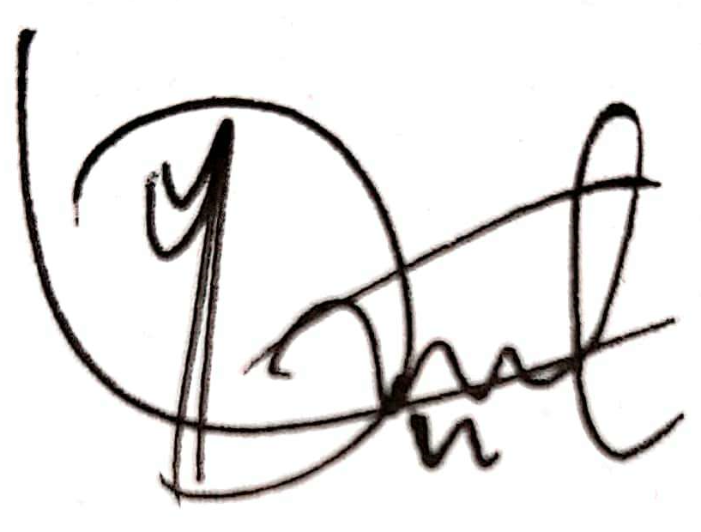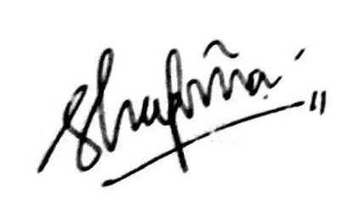
(Endah Pratiwi) (Dhiya’ Choirunnisa Azmi) (Riannisa Shafira) (Alanindra Saputra)

