DIVERSITY OF PLANT AS TRADITIONAL CULINARY FOOD WRAPPERS ON THE BOGOR’S SOCIETY, WEST JAVA, INDONESIA

Muhamad Nikmatullah^{1,}*, Mulyati Rahayu¹, Titi Kalima¹, Marwan Setiawan¹,
Ida Farida Hasanah¹

¹⁾Research Center for Ecology and Ethnobiology, National Research and Innovation Agency (BRIN) Jl. Raya Jakarta-Bogor Km 46, Cibinong 16911, Jawa Barat, Indonesia

*Corresponding author. Email address: muhamadnikmatullah@gmail.com

Abstract
Traditional culinary is a food that has a distinctive taste, usually consumed by a particular society. Generally, traditional culinary used the diversity of plants as wrapping it. The research method used the ethnobotany approach, through observation and direct interview to a key informant on the three traditional market’s Bogor city. The research was conducted to reveal the diversity of plants that are still used as traditional culinary wrapping in Bogor city. The result of data collection showed there were 23 kinds of traditional culinary. These traditional culinary are utilized 5 plant species as wrapping it. Most of these plant species are Banana leaf (Musa spp.) which is used as traditional culinary wrapping. The advantage of utilizing plants as traditional culinary wrapping, between for increase flavor and art. Utilization plants as food wrapping need to preserved, developed, and socialized to society common so that this local culture constantly long-lasting and it can decrease use resource non-natural that get bad impact on the environment and public health.

Keywords: Ethnobotany, leaf wrap, traditional culinary, Bogor, West Java.

INTRODUCTION
Plants constitute an important factor for life on the earth, besides the world's lungs, also act as in human life. Many plant species are utilized to source food, medicine, clothing, and board by humans to their life necessities every day (Haryanti et al., 2015). Ajiningrum (2011) show that most of the plant species were used as food sources by Dayak Lundayeh Uma’Lung society in the Malinau district.
Indonesia is famous for local food diversity, especially traditional culinary which utilizes plants as a primary source or as its wrapping. Generally, parts of plants that were used as food wrapping are leaves, however not a little using the other part of plants, for example, rind or bark. The natural material of culinary wrapping was used to retard expiration and protect from chemical and biological contamination.
Indonesia’s traditional culinary has high diversity, different each locality, and be identity every region. It can be found in the traditional market. Some traditional markets in Bogor city still founded a traditional culinary which used wrapping from plants. Species diversity of plants were used as culinary wrapping that needed to be explored to know their advantages, so it can attract the attention of society for using plants as a food wrapping again. It was conducted to reduce plastic consumption which gave negative impacts on public health (Novianti & Kartika, 2017).

MATERIALS AND METHODS
Study area
This ethnobotany research was conducted in the three of Bogor city’s traditional markets, namely Anyar / Kembang market, Sukasari market, and Surya Kencana market (Figure 1). Bogor city is located in West Java, Indonesia.
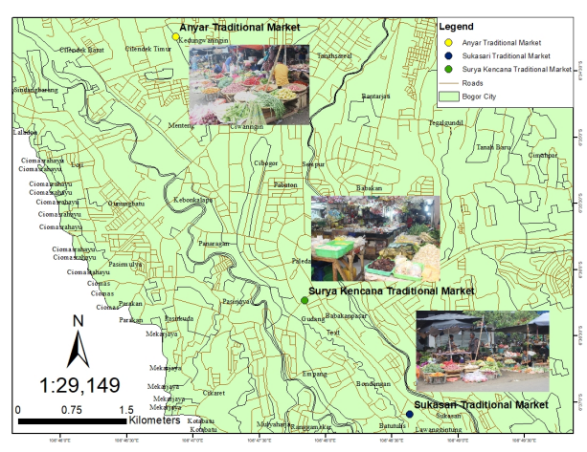
Note: The research location: Anyar / Kembang market, Sukasari market, and Surya Kencana market.
Figure 1. The study area of Diversity of Plant as Traditional Culinary Food Wrappers on the Bogor’s Society, West Java, Indonesia.

Ethnobotanical Data Collection
Data collection was conducted by interviewing some merchants of traditional culinary in the research area. Determination of research location based on consideration of market characteristics. The traditional markets on this research are located nearby Bogor’s Commuter Line (KRL) station and some tourism areas, among Bogor Botanical Garden, National Museum of Indonesia Natural History (Munasain), Museum of Zoology, Museum of Palace, Museum of Land and Agriculture, and Museum of Patriot. The interviewing was conducted with three key informants in each traditional market, namely the merchant of food wrapping plants, merchant of traditional culinary, and buyers. This research method was using a qualitative approach (Maleong, 2013), through interviews and direct observation. It had been done to find species and plant characteristics that are used as food wrapping and other traditional culinary. Data was collected that comprised of plants species, part of plants, the reason for using it, and other benefits.

Data Analysis
The interview data were analysed qualitatively. Tables were utilized to depict qualitative analysis.

RESULTS AND DISCUSSION
Currently, the utilization of plants is rarely found as food wrapping. It is caused by technological advances that produced the cheapest and easy products than food wrapping from plants. The type of food wrapping materials will increase the endurance of food storage and contamination rate (Rini & Akbarini, 2017). Diyah (2013) explained that food wrapping from plants is one of the methods to make the food look more attractive and increase the taste and flavor of food Sari et al. (2019) show stated that there were 7 plant species used in traditional food wrapping by Bangka Tengah district society. According to Maflahah (2012), leaves are often utilized as traditional food wrapping which are banana leaves, cornhusk, coconut leaves, water apple’s leaves, and teak’s leaves.
The result of this study showed 23 kinds of traditional culinary. These traditional culinary is using part of plants for wrapping in the Bogor city’s traditional market, among various side dishes, local cake, and the other snacks. There are five plant species used as traditional culinary wrapping. The most of plant’s parts are leaves (4 species) and rind (1 species). The result of the interview has been known that several benefits of plants part besides wrapping traditional culinary are enhancing flavor in food, food preservative, and improve the food appearance. Its benefit as preservatives is supported by Sucipta et al. (2017) show that leaves are safe to use, biodegradable than plastic usage. The following is attached to table 1 that showed about species diversity of plants used as traditional culinary wrapping in Bogor City’s traditional market.

Table 1. Diversity of plants species as traditional culinary wrapping on the Bogor’s Society in traditional market
Scientific /Family Name | Local Name | Part of Plant | Culinary Variety | Number of Culinary
Musa spp.  (Musaceae) | Cau/ Gedang | Leaves | Lemper, Nagasari, Bugis, Ketimus, Serabi Solo, Buras, Pepes, Tempe Mendoan, Lontong, Uli/ Gemblong, Lupis, and Jongkong | 14
Phrynium pubinerve Blume  (Marantaceae) | Patat | Leaves | Toge goreng, and Doclang | 2
Gigantochloa spp. (Poaceae) | Awi | Leaves | Bacang, Pesor, and Kue cang | 3
Cocos nucifera L. (Arecaceae) | Kalapa | Leaves | Ketupat and Lepet | 2
Zea mays L.  (Poaceae) | Jagung | Fruit Cobs “Klobot” | Wajik and Dodol | 2

The following is an explanation about the diversity of plants species that were used as traditional culinary wrapping in Bogor City’s traditional market:

Musa spp.
Banana is one of the plants which produce fruits every moment without a certain period time. It can be grown in the tropic climate area, such as Indonesia (Hartono & Janu, 2013). Banana trees are grown relatively easily and produced fruits faster than other plants. Based on price, banana fruit is relatively constant, that gave benefit for banana’s farmer (Hidayat, 2013). The most common part of plants that were used as traditional culinary wrapping is leaves. Banana leaves are a type of food packaging material that is safe to use because they contain natural ingredients and are generally in the form of leaves that are still green (Suparti & Safitri, 2020). The utilization of banana leaves as food wrapping was conducted in Indonesia’s ancestors years ago. Some food rarely was founded without banana leaves as wrapping. The results showed that many still culinary merchants in the Bogor city’s traditional market, which used banana leaves as wrapping. The reason for a merchant using banana leaves, besides cheaper also its leaves have a smooth surface and it is not rigid. It is giving easiness for a merchant to pack up and improve the food appearance on the culinary based on their desire that increased aesthetic value. Results of the interview known that banana leaves also enhancing flavor on the food which is wrapped. The flavor came from polyphenols contents which are given delicious flavor and antioxidants (Mastuti & Handayani, 2014). Traditional culinary is unique in the Bogor city which used banana leaves as wrappings, such as tempe mendoan, lemper, Nagasari, Bugis, Ketimus, Serabi Solo, Buras, Pepes, Lontong, Uli/ Gemblong, Lupis, and Jongkong (fig.2). In addition to using banana leaves that are green or fresh, there is also the use of dry leaves (klaras) as packaging for palm sugar and dodol, if used, besides being able to reduce agricultural waste, it also has some quite high nutritional content (Suparti & Safitri, 2020). Moreover, the banana leaves easier to find because it is one of the plant species which produced fruits commonly cultivated by local society.
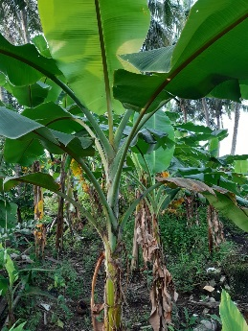
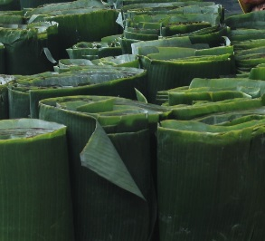
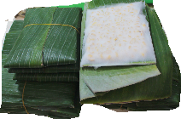
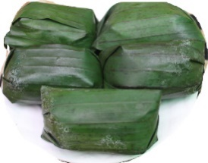
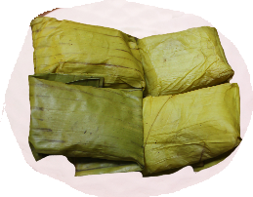
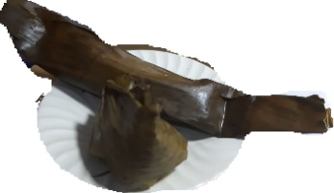
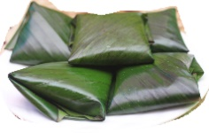
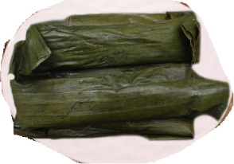
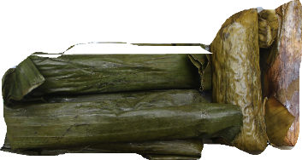

A
B
B
C
D
G
H
F
E
I

Figure 2. a. banana trees; b. banana leaves; c. tempe mendoan; d. lemper; e. buras; f. bugis; g. papais; h. pepes; i. lemet
Based on the results of observation and interview on the banana’s leaves merchant, known that the species of banana’s leaves which is used in food wrapping is Musa brachycarpa Backer (Batu Banana). It has a soft and smooth texture, also is not easily ripped. The size of Musa brachycarpa leaves is appreciable and it has shiny color. It was utilized to give flavor, beautiful color, and natural, so that increased appetite buyers. Besides, M. brachycarpa leaves (Batu banana), M. acuminate leaves (Kepok banana) are also used in traditional culinary wrapping, namely Getuk and Tiwul. Many studies have been conducted to test the activity of banana leaves. Although the banana family is of more interest for its nutrient than its medical properties, it has some value in traditional medicine. Herbalists use the leaves and the peel of the unripe fruit as antimicrobial agents (unpublished reports). Nahdya (2018) found that M. acuminate leaves also have benefits in the medical field, because they are known to have antimicrobial and antioxidant activity. Banana leaves also contain flavonoids, tannins and alkaloids which can stimulate the healing process of burns (Nahdya, 2018). Sahaa et al. (2013) found that M. sapietum leaf has antimicrobial and antioxidant activity. Then based on research (Asuquo & Udobi, 2016) the ethanol extract of M. paradisiaca leaves and the water fraction have been investigated to have antibacterial activity, it is indicated has a potential anti-diabeic property (Kappel et al., 2013), antioksidan (Rani, 2017). A study by Palupi (2019) and Handayani et al. (2021) show that M. balbisiana leaf extract contains the most active antioxidant, and the highest phenolic and flavonoid content, when compared to M.acuminata and M. paradisiaca. The bananna leaf is always a better option than other food wrappers, it is very healthy too. Merchant of Kepok’s banana leaves is not as much Batu’s banana leaves. The selling price of kepok’s banana leaves is cheaper than Batu’s banana leaves. The results of the interview showed that banana leaves in the traditional market of Bogor city have a price of one bunch of about five thousand rupiahs. Each bunch has taken 12 to 15 stems of banana leaves.

Phrynium pubinerve Blume
Patat (Phrynium pubinerve Blume), synonym P. capitatum Willd. (Ardiyani et al., 2010), included in the Marantaceae tribe. and the genus Phrynium (Wawo & Sukamto, 2011). Habitus of patat is an herb, Form of its leaves widened and oval, the shape of the leaves is wide and oval, tall is about 1,5-2,2 meter (Badar, 2006). These species are cultivated and their leaves are utilized for food wrapping in Indonesia (Heyne, 1987). Its leaves surface contains a cuticle and its content higher than banana leaves (Badar, 2006). Based on the results of phytochemical tests (Fathoni, 2021), patat leaf extract is known to contain alkaloids, steroids, triterpenoids, flavonoids, saponins, phenolic hydroquinone, and tannins. The content of compounds in patat leaves affects the effect of their use as food packaging materials.
The results of observation are known that traditional food in the Bogor city that utilizes leaves as its wrapping is merchant “tauge goreng” and “doclang”. Tauge goreng is one of the unique traditional culinary in Bogor City that is serving vegetarians. It has tasteful that is made in by sauteing with a little hot water, added sliced tofu, a rice-based food (ketupat), yellow noodles, and thick sauce. While doclang is a typical traditional Bogor food found in Indonesia that has the composition contained in doclang, are lontong or pesor in Sundanese, fried tofu, boiled eggs, and fried steamed potatoes and bean spices as an additional. According to the merchant of tauge goreng and doclang stated that texture of P. pubinerve leaves is not easily ripped and its leaf surface contains a cuticle. It was caused a food which contained water safer. The price of P. pubinerve leaves in Bogor city’s traditional market for 1 bunch consists of 8 leaves is two thousand rupiahs. Currently, the existence of P. pubinerve leaves it harder to find it on market, caused is not much local society who was cultivated it. It will be affected to continue on the price P. Pubinerve leaves that will be increased together with its scarcity.

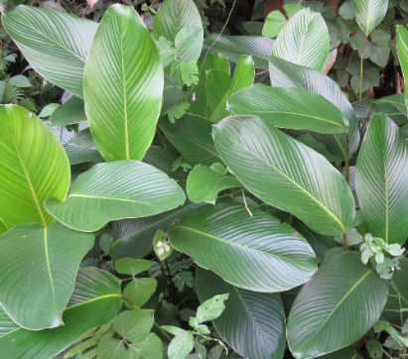
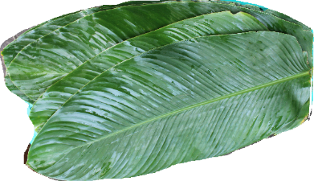
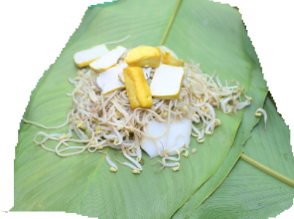
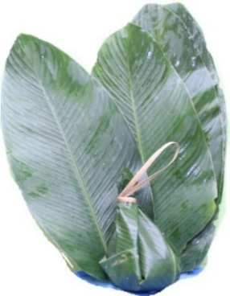
A
B
C
D

Figure 3. a. patat plants; b. patat leaves; c.Tauge goreng; d. tauge goreng wrapped up by patat leaves.

Gigantochloa spp.
The species diversity of bamboo in the world high enough, there are about 1439 species (Clark et al., 2012), while in Indonesia there are about 176 species (Widjaja, 2018). However, utilization of its leaves as food wrapping is not much known from its species. We are expected bamboo leaves of the genus “Gigantochloa” was utilized for food wrapping, caused its leaves size is large and lengthy. It has a long petiole, The flags on its bottom of the leaves surface are slight, smooth, its leaves color darker green than other species. Commonly bamboo leaves used to wrap bacang that is one of unique local food came from the mainland of China. This food is carried by China merchants to Indonesia. A producer bacang still maintained the inheritance of traditional culture through the utilization of bamboo leaves as traditional culinary wrapping. Research was conducted by Zhang et al. (2005), Mulyono et al. (2012), Wayan et al. (2014) known that bamboo leaves can be utilized as an antioxidant and antibacterial. Gigantochloa leaf extract has no antifungal activity against the growth of Candida albicans (Setyawan et al., 2018), and was detected positive for polifenol, triterpenoid, flavonoid, saponins, alkaloids and tannins (Sujarwanta & Zen, 2021). Moreover, the fiber and texture of bamboo leaves are rude, small, and not sticky. It can be a reason that bamboo leaves are utilized as traditional culinary wrapping, namely bacang and kue cang. Thus, bamboo leaves have a high potential to be added in the manufacture of food products.

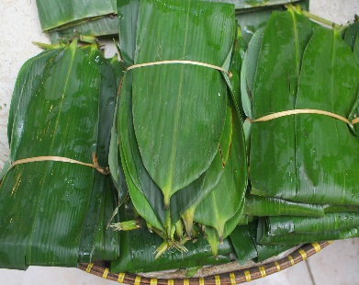
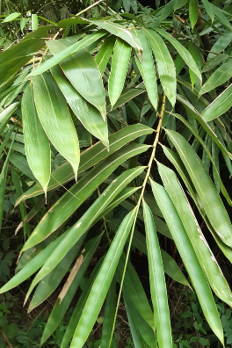
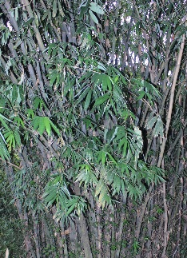
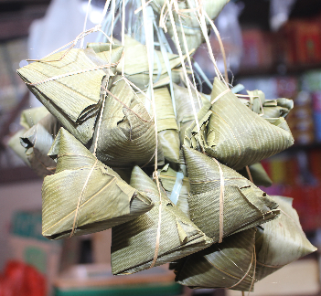
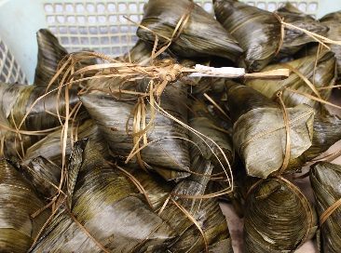
A
B
C
D
E

Figure 4. a. bamboo leaf be marketed; b. bamboo leaf; c. bamboo trees; d. kue cang; e. bacang

Cocos nucifera L.
Cocos nucifera L. is a native tropical plant and can almost grow in all areas of Indonesia (Putra et al., 2015). It is plant species that all parts of the plant can be utilized for food, drink, medicine, household appliances, energy, and board so that it is called multifunction plants (Setiyanto, 2018). Young leaves of C. nucifera still common were utilized as wrapping some traditional food in Bogor. It is such as lepet and ketupat, while old leaves were utilized as wrapping palm sugar. The result of the interview known that coconut leaf has an advantage given a flavor and durable expired time on the food which it's wrapping. A study by Hasanah (2019) shows that from both fresh and steamed coconut exhibit antimicrobial and has antioxidant activity.
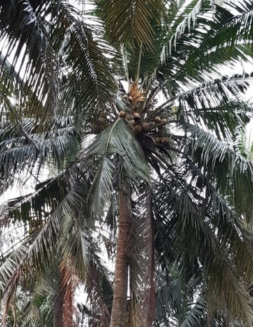
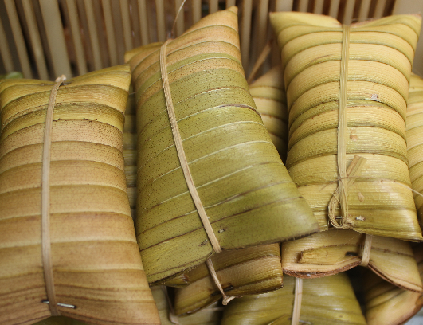
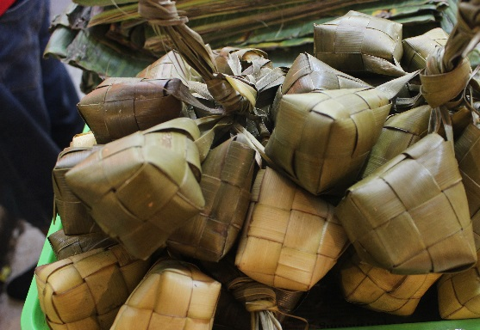
A
B
C

Figure 5. a. Coconut trees; b. lepet; d. Ketupat
Zea mays L.
Zea mays L. is a seasonal plant species that many were cultivated by society in Indonesia. This species has many high cultivars (Koopmans et al., 1996). Some areas in Indonesia, such as Madura, Nusa Tenggara Timur, and Sulawesi Selatan have dominated the dispersion of Z. mays and its seeds which be dried as substitute food rice (Amzeri, 2018). Stems and their leaves are utilized as animal feed. A rind of Z. mays (kelobot) is utilized as culinary traditional wrapping. The result of the chemical analysis showed that kelobot is a substance that has high water content and crude fiber (Pratiwi, 2014). Content of fiber is one of factor which supported utilization kelobot as food wrapping (Pratiwi, 2014). Based on the mechanic, kelobot is elastic material and solid material also has a lowly absorption (Pratiwi, 2014). It can be an extended expired time of the product (Pratiwi, 2014). Although its fibers are rude, however, it has the ability no easy to absorb water, so that is often utilized as wajik and dodol wrapping. Kelobot also was utilized as a given flavor. and the leaf wrapping only contained alkaloid compounds and antioxidant (Pangemanan et al., 2020).
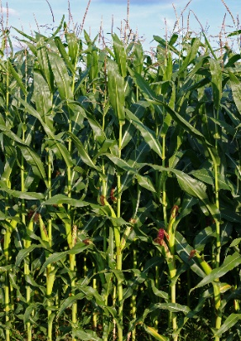
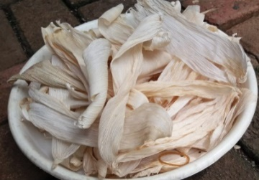
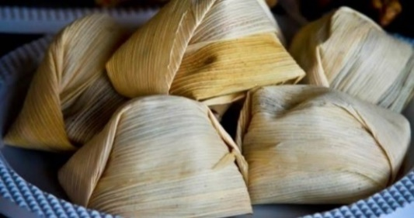
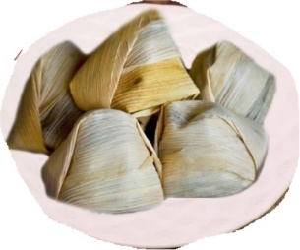
A
B
C
D

Figure 6. a. Corn trees; b. the rind of Zea mays (kelobot); c. wajik; d. dodol

Utilization of natural material as traditional culinary wrapping given a positive effect on around environment and consumers. It caused material that did not contain dangerous chemicals. it is easily founded, simple to be folded and given a delicious flavor to food. Utilization of leaves as traditional culinary wrapping can be conserved by the environment and nature, caused natural ingredients will be unraveled in the realm, so that environmentally friendly. Utilization of leaves as traditional culinary wrapping also can be an identity of culinary in certain areas. Therefore, the utilization of leaves as traditional culinary wrapping needs to be improved to reduce the volume of environmental pollution from the waste of non-organic. Moreover, it can be maintained local knowledge, so not easy to extinct. It is expected to conserve a diversity of plants that has economic value.

CONCLUSIONS
Utilization of plants as traditional culinary wrapping in Bogor still can be founded. 5 plant species are utilized as wrapping material. Banana leaves (Musa spp.) are the most of the plants part utilized for traditional culinary wrapping. Natural wrapping the most difficult found is patat leaves (Phrynium pubinerve Blume). It is utilized to give flavor, durable food expired time, antioxidant, antibacterial and increased aesthetic value. socialization about the utilization of vegetable waste as traditional culinary wrapping is required.

AUTHOR CONTRIBUTION
Muhamad Nikmatullah, Mulyati Rahayu, Titi Kalima, Marwan Setiawan, Ida Farida Hasanah are the main contributors from the beginning of research processes to publication writings for this article. The author read and approved the final manuscript.

ACKNOWLEDGMENTS
The author would like wants to thank Irawati from the Biology Department, Faculty of Mathematics and Natural Sciences, University of Udayana, Bali, Indonesia who helped to collect data.

CONFLICT OF INTEREST
The authors have no conflicts of interest to declare

REFERENCES

Ajiningrum, P.S., (2011). Valuasi Potensi Keanekaragaman Jenis Hasil Hutan Non Kayu (HHNK) Masyarakat Lokal Dayak Lundayeh dan Um’a Lung di Kabupaten Malinau, Kalimantan Timur. Universitas Indonesia.
Amzeri, A. (2018). Tinjauan Perkembangan Pertanian Jagung di Madura dan Alternatif Pengolahan Menjadi Biomaterial. Rekayasa, 1(11), pp.75-86. doi:10.21107/rekayasa.v11i1.4127
Ardiyani, M. et al., (2010). Marantaceae in Sulawesi. Reinwardtia, 13, pp.213-220. doi: 10.14203/reinwardtia.v13i2.2143
Asuquo, E.G. & Udobi, C.E. (2016). Antibacterial and toxicity studies of the ethanol extract of Musa paradisiaca leaf. Cogent Biology, 2, pp.1-10. doi:10.1080/23312025.2016.1219248
Badar, A.A. (2006). Karakterisasi Sifat Fisiko Kimia Dan mekanik Daun Patat Daun (phrynium capitatum) Sebagai Bahan Kemasan. IPB Repository. viewed 7 August 2022, from https://repository.ipb.ac.id/
Clark, L.G. et al., (2012). An Updated tribal and subtribal classification of the bamboos (Poaceae: Bambusoideae). Bamboo Science and Culture: The Journal of the American Bamboo Society, 24(1), pp.1–10. ISSN 0197– 3789
Diyah, I. (2013). Daun Pembungkus Makanan Paling Aman dan Ramah Lingkungan. Kompasiana, viewed 20 July 2022, from https://www.kompasiana.com/
Fathoni, A. (2021). Characterization of phytochemicals and chemical compounds of patat leaves (Phrynium capitatum) as wrapping materials for Pesor Doclang. EduChemia (Jurnal Kimia dan Pendidikan), 6, pp.13-25. doi:10.30870/educhemia.v6i1.9189
Gemilang, G.P, Hidayat, M.J. & Anam, C. (2015). Pemanfaatan Pelepah Kelapa Untuk Perlengkapan Makan. Seminar Nasional Sains dan Teknologi Terapan III, ISBN: 978-602-98569-1-0.
Handayani, R. et al., (2021). Comparison study of antioxidant activity from three banana leaves extract. J.Tekno. dan Industri Pangan, 32, pp.92-97. doi:10.6066/jtip.2021.32.92.
Hartono, A. & Janu, P.B.H. (2013). Pelatihan pemanfaatan limbah kulit pisang sebagai bahan dasar pembuatan kerupuk. Jurnal Inovasi dan Kewirausahaan, 3(2), pp.198-203. ISSN: 2089-3086.
Haryanti, E.S., Diba, F. & Wahdina (2015). Ethnobotany of useful plant society around the area model kph kapuas upstream (Case study Tamao Village, District Embaloh Hulu West Kalimantan). Jurnal Hutan Lestari, 3, pp.434-445. doi: 10.26418/jhl.v3i3.11370.
Hasanah, U. (2019). Perubahan Komponen Volatil, Aktivitas Antioksidan Dan Antimikrobia Daun Kelapa (Cocos nucifera L.) Muda Akibat Pengukusan. Universitas Gajah Mada.
Heyne, K. (1987). Tumbuhan berguna Indonesia Jilid I (translate). Jakarta: Badan Litbang Kehutanan, Yayasan Sarana Warna Jaya.
Hidayat, A.M. (2013). Morfologi Tanaman Pisang (Musa parasidica). AnakAgronomy, viewed 20 August 2022, from https://www.anakagronomy.com/
Kappel, V.D., et al. (2013). Beneficial effects of banana leaves (Musa x paradisiaca) on glucose homeostasis: Multiple sites of action. Revista Brasileira de Farmacognosia, 23, pp.706–715. doi:10.1590/S0102-695X2013005000062
Koopmans, A., H. ten Have. & Subandi. (1996). Zea Mays L, in: G.J.H., Grubben, And S. Partohardjono (Eds), Plant Resources of South East Asia No. 10. Cereals. In Leiden: Backhuys Publishers.
Maflahah, I. (2012). Desain kemasan makanan tradisional madura dalam rangka pengembangan IKM. Agrointek., 6, pp.118-122. doi:10.21107/agrointek.v6i2.1982.
Maleong, L.J. (2013). Metodologi penelitian kuantitatif. Bandung: PT Remaja Rosdakarya.
Mastuti, T.S. & Handayani, R. (2014). Senyawa kimia penyusun ekstrak ethyl asetat dari daun pisang batu dan ambon hasil distilasi air. Proceedings of the 5th Seminar Nasional Sains and Teknologi (SNST) Universitas Wahid Hasyim, 1(1). doi: 10.36499/psnst.v1i1.975
Mulyono, N. et al. (2012). The physical and chemistry properties of bambu petung (Dendrocalamus asper) leaf extract and its inhibiting activity against some patogennic escherichia coli. International Journal of Phamaceutical and Biological Archives, 4(3), pp.770-778. ISSN : 0976-3333
Nahdya, F. A. (2018). Standarisasi Parameter Spesifik Dan Non Spesifik Ekstrak Etanol Daun Pisang Kepok (Musa paradisiaca Linn). Universitas Wahid Hasyim Semarang. Retrieved from https://eprints.unwahas.ac.id/1533/
Novianti, A.I. & Kartika, L. (2017). Pengaruh green marketing kebijakan kantong plastik berbayar terhadap green behaviour masyarakat Kota Bogor. Jurnal Riset Manajemen dan Bisnis, 2, pp.81 – 94. ISSN: 2527 – 7502.
Palupi, V.I. (2019). Ekstraksi Epigallocatechin Gallate (Egcg) Daun Pisang Batu (Musa Balbisiana Colla) Dengan Teknik Kavitasi. Universitas Brawijaya.
Pangemanan, D.A., Suryanto, E. & Yamlean, P.V.Y. (2020). Skrinning Fitokimia, Uji Aktivitas Antioksidan dan tabir surya pada tanaman Jagung (Zea mays L.). Pharmacon. Universitas Sam Ratulangi.
Pratiwi, E. (2014). Klobot jagung sebagai kemasan alami wajik kelapa. Institut Pertanian Bogor.
Rani, K. (2017). Role of antioxidants in prevention of diseases. J.Appl.Biotechnol Bioeng., 4, pp.495-496. doi: 10.15406/jabb.2017.04.00091
Rini, F.Y. & Akbarini, D. (2017). Pemanfaatan daun sebagai pembungkus makanan tradisional oleh masyarakat Bangka (Studi kasus di Kecamatan Merawang). Ekotonia: Jurnal Penelitian Biologi Botani, Zoologi, dan Mikrobiologi, 2, pp.20-32. doi: 10.33019/ekotonia.v2i1.465
Sahaa, R.K. et al. (2013). Medicinal activities of the leaves of Musa sapientum var. sylvesteris in vitro. Asian Pac J Trop Biomed, 3, pp.476-482. doi: 10.1016/S2221-1691(13)60099-4.
Sari, Y., Afriyansyah, B. & Juairiah, L. (2019). Pemanfaatan daun sebagai bahan pembungkus makanan di Kabupaten Bangka Tengah. Ekotonia: Jurnal Penelitian Biologi, Botani, Zoologi dan Mikrobiologi, 4, pp.48–56. doi: 10.33019/ekotonia.v4i2.1686.
Setiyanto, E. (2018). Leksikalisasi Dan Fungsi Bagian-Bagian Pohon Kelapa: Pendekatan Etnolinguistik. Aksara, 30, pp.285-300. doi:10.29255/aksara.v30i2.300.285-300
Setyawan, A.A., Aditama, L.Y. & Yusransyah. (2018). Uji Aktivitas Antijamur Ekstrak Daun Bambu Tali (Gigantochloa apus (Schult.) Kurz.). Dalam: Setyawan, A.A & Rangkuti, S.N.). Jurnal Farmagazine, 5, pp.12-22. doi: 10.47653/farm.v5i2.100
Sucipta, I.N., Suriasih, K. & Kencana, P.K.D. (2017). Pengemasan Pangan Kajian Pengemasan yang Aman, Nyaman, Efektif dan Efisien, Udayana University Press.
Sujarwanta, A. & Zen, S. (2021). Identifikasi Senyawa Bioaktif Beberapa Jenis Daun Bambu Yang Berpotensi Sebagai Antimalaria. Jurnal Lentera Pendidikan Pusat Penelitian LPPM UM Metro, 1(7), pp.96-104. ISSN 2541-2922
Suparti, S. & Safitri, W.A. (2020). Media Alternatif Campuran Daun Pisang Kering dan Kulit Jagung untuk Meningkatkan Produktivitas Jamur Merang (Volvariella volvacea (Bull) Singer.) dalam Keranjang. Bioeksperimen: Jurnal Penelitian Biologi, 6, pp.69–73. doi: 10.23917/bioeksperimen.v6i1.10435
Wawo, A.H. & Sukamto, L.A. (2011). Kajian cara perbanyakan dan pertumbuhan garut (Maranta arundinaceae L.) pada kondisi ketersediaan cahaya yang berbeda. E-jurnal BPPT., 2(7), pp.127-136. ISSN: 2085.3866
Wayan, N. et al. (2014). Aktivitas antioksidan senyawa flavonoid ekstrak etanol biji terong belanda (Solanum betaceum, syn) dalam menghambat reaksi perok-sidasi lemak pada plasma darah tikus wistar. Cakra Kimia (Indonesian E-Journal of Applied Chemistry), 1(2), pp.7–16. doi: ISSN 2302-7274. \
Widjaja, E.A. (2018). The spectacular Indonesian bamboos. PT. Gudang Garam Tbk (In Press).
Zhang, Y. et al. (2005). Determination of flavone C-glucosides in antioxidant of bamboo leaves (AOB) fortified foods by reversed-phasehighperformance liquid chromatography with ultravioletdiode array detection. J Chromatogr A., 2(1065), pp.177-185. doi: 10.1016/j.chroma.2004.12.086.

