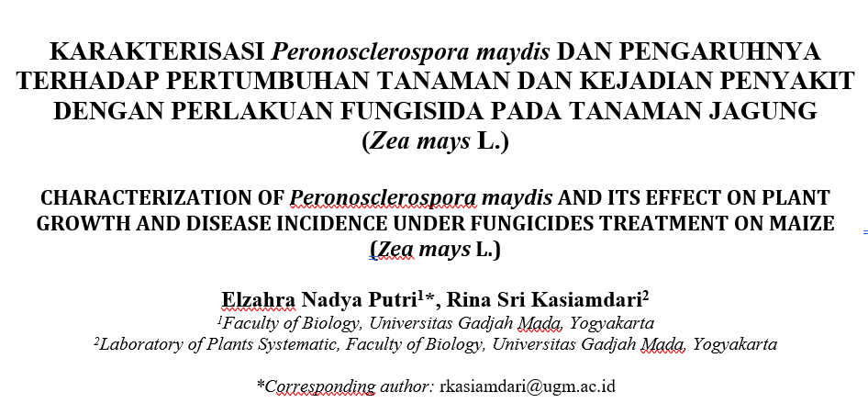

Table 1. Comparison of Morphological Character of Downy Mildew Fungi from Sleman Compared to Reference Species of Peronosclerospora

Morphological Character | Observation Result | Species of Peronosclerospora (Ristiyani et al., 2015)
Morphological Character | P. maydis | P. maydis | P. shorgi | P. philipinensis
Conidiophore size | 374.65 µm | 111-410 µm | 183-300 µm | 150-300 µm
Conidiophore branched | 3-4 branches | 3-4 branches | 2 branches | 3 branches
Conidia cell wall | Thin Wall | Thin Wall | Thick Wall | Thin Wall
Conidia size | 19.22 µm | 12-23 µm | 10-11 µm | 15-40 µm
Conidia shape | Spherical to Subspherical | Spherical to Subspherical | Oval | Oval

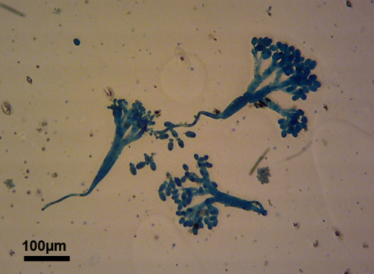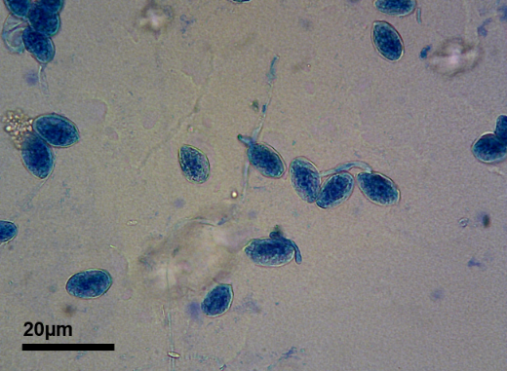
a b
Figure 1. Morphological character of Peronosclerospora maydis (a) Conidiophore (b) Conidia

Figure 2. Plant height of Zea mays inoculated with Peronosclerospora maydis and fungicide treatments from 0-35 DAP

Figure 3. Number of leaves of Zea mays inoculated with Peronosclerospora maydis and fungicide treatments from 0-35 DAP

Histogram followed by the same letter shows no significant difference at the level of 5% of the DMRT test

Figure 4. Plant fresh weight of Zea mays inoculated with Peronosclerospora maydis and fungicide treatments from 0-35 DAP

Histogram followed by the same letter shows no significant difference at the level of 5% of the DMRT test

Figure 4. Plant dry weight of Zea mays inoculated with Peronosclerospora maydis and fungicide treatments from 0-35 DAP

Tabel 2. Disease incidence and severity of Zea mays inoculated with Peronosclerospora maydis and fungicide treatments on 35 DAP

Treatment | Disease incidence (%) | Disease severity (%) | Reduction of Disease Severity (%)
PMD | 60.00±0.00 ab | 14.16±14.89 ab | 58.66 %
PMMe | 10.00 ±14.14 a | 2.50±5.59 a | 92.70%
PMP | 30.00 ± 14.14 a | 7.50±11.18 a | 78.10%
PMMz | 50.00±42.43 ab | 28.50±21.18 bc | 16.79%
PM | 100.00±0.00 b | 34.25±12.42 c | 0%
Values±SD in the same column followed by the same letter show no significant difference at the level of 5% of the DMRT test.

