Figure 1. Plant height (mean ±SE, n =8) in North Sulawesi local rice cultivars (Superwin, Ombong, Temo, and Burungan) under well-watered, partial submerged and water deficit treatments for 14 days

Figure 2. Leaf number (mean ±SE, n =8) in North Sulawesi local rice cultivars (Superwin, Ombong, Temo, and Burungan) under well-watered, partial submerged and water deficit treatments for 14 days

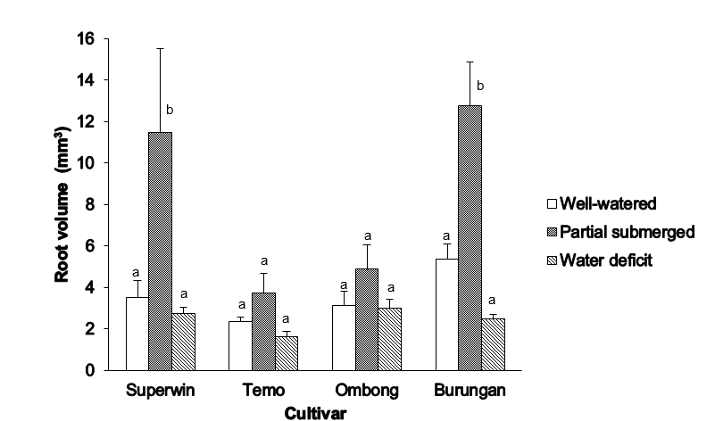
Figure 3. Root volume (mean ±SE, n =8) in North Sulawesi local rice cultivars (Superwin, Ombong, Temo, and Burungan) under well-watered, partial submerged and water deficit treatments for 14 days. Significant differences (P<0.05) by LSD were indicated by different letters

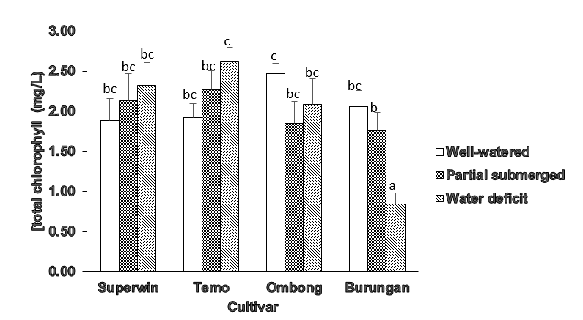
Figure 4. Concentration of leaf total chlorophyll (mean ±SE, n = 10) in North Sulawesi local rice cultivars (Superwin, Ombong, Temo, and Burungan) under well-watered, partial submerged and water deficit treatments for 14 days. Significant differences (P<0.05) by LSD were indicated by different letters

Table 1. Root length (mean ± SE; n=8) in North Sulawesi local rice cultivars (Superwin, Ombong, Temo, and Burungan) under well-watered, partial submerged and water deficit treatments for 14 days
 |  | Root length (cm)
Cultivar | Well-watered | Partial submerged | Water deficit | Mean
Superwin | 22.15 ± 2.75 | 19.73 ± 3.71 | 21.51 ± 0.67 | 21.10 ± 1.50 a
Temo | 26.70 ± 1.72 | 17.05 ± 3.65 | 22.46 ± 1.62 | 22.10 ± 1.60 a
Ombong | 24.46 ± 2.96 | 22.56 ± 3.52 | 20.66 ± 1.54 | 22.60 ± 1.60 a
Burungan | 29.68 ± 0.76 | 28.85 ± 1.67 | 21.45 ± 0.54 | 26.70 ± 0.10 b
Mean | 25.50 ± 0.60 b | 22.00 ± 1.70 a | 21.60 ± 1.20 a
Note: SE = standard error. Significant differences (P<0.05) by LSD (Least Significant Difference) were indicated by different letters in the same row (for the treatment) and in the same column (for the cultivar)

