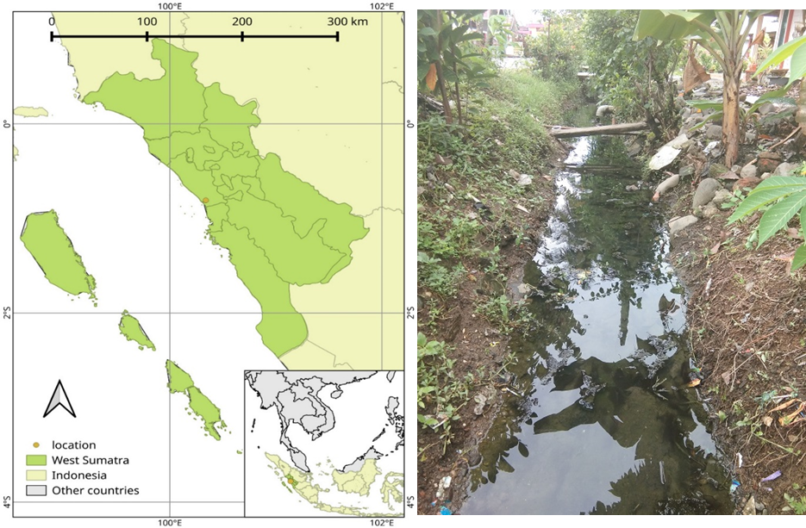
Figure 1. Survey location at a settlement complex in Sub-district Padang Utara, West Sumatra, Indonesia (0°55'36.318''S, 100°22'12.349''E) (left) and the ditch where the observation on Agriocnemis femina conducted (right).

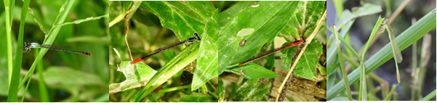

Figure 2. Individual category of A. femina: (from left to right) adult male, immature male, female, and teneral

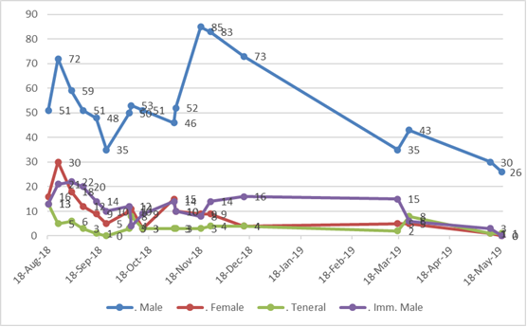
Figure 3. Fluctuation of each individual category of A. femina during survey period

