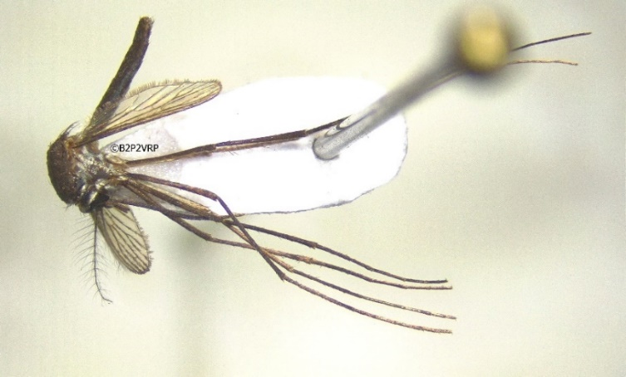

Gambar 1. Nyamuk Tripteroides affinis betina, hasil koleksi dari penelitian nasional Rikhus Vektora (foto oleh Mujiyono, B2P2VRP)
Tabel 1. Keanekaragaman spesies nyamuk dalam Genus Tripteroides di Indonesia.

No. | Subgenus | Spesies | Smt | Kln | Jawa | BNT | Slw | Mlk | Pap | Literatur
1 | Polylepidomyia | altivallis |  |  |  |  |  |  | ˅+e | Bonne-Wepster, 1948
2 | Polylepidomyia | argenteiventris |  |  |  |  |  |  | ˅ | Lee et al., 1989
3 | Polylepidomyia | digoelensis |  |  |  |  |  |  | ˅+e | Brug, 1934
4 | Polylepidomyia | microlepis |  |  |  |  |  |  | ˅+ | Assem & Bonne-Wepster, 1964
5 | Polylepidomyia | punctolateralis |  |  |  | ˅ |  |  |  | Whelan & Hapgood, 2000
6 | Rachionotomyia | affinis |  | r | r |  |  |  |  | B2P2VRP, 2015, 2016, 2017
7 | Rachionotomyia | aranoides | ˅ | ˅ | ˅ | ˅ |  |  |  | Thurman, 1959
8 | Rachionotomyia | nepenthisimilis |  | ˅ |  |  |  |  |  | Mattingly, 1981
9 | Rachionotomyia | tenax | ˅ | ˅ | ˅ |  |  |  |  | Mattingly, 1981
10 | Rachisoura | adentata |  |  |  |  |  |  | ˅+ | Lee et al., 1989
11 | Rachisoura | bisquamatus |  |  |  |  |  |  | ˅+ | Assem & Bonne-Wepster, 1964
12 | Rachisoura | brevirhynchus |  |  |  |  |  |  | ˅+ | Lee et al., 1989
13 | Rachisoura | concinnus |  |  |  |  |  |  | ˅+ | Lee et al., 1989
14 | Rachisoura | confusus |  |  |  |  |  |  | ˅ | Lee et al., 1989
15 | Rachisoura | cuttsi |  |  |  |  |  |  | ˅+ | Lee et al., 1989
16 | Rachisoura | exnebulis |  |  |  |  |  |  | ˅+ | Lee et al., 1989
17 | Rachisoura | felicitatis |  |  |  |  |  |  | ˅+ | Lee et al., 1989
18 | Rachisoura | filipes |  |  |  |  |  |  | ˅+ | Lee et al., 1989
19 | Rachisoura | flabelliger |  |  |  |  |  |  | ˅+ | Lee et al., 1989
20 | Rachisoura | fuliginosus |  |  |  |  |  |  | ˅+ | Lee et al., 1989
21 | Rachisoura | fuscipleura |  |  |  |  |  |  | ˅+ | Lee et al., 1989
22 | Rachisoura | kingi |  |  |  |  |  |  | ˅+ | Lee et al., 1989
23 | Rachisoura | latisquama |  |  |  |  |  |  | ˅+ | Lee et al., 1989
24 | Rachisoura | leei |  |  |  |  |  |  | ˅ | Lee et al., 1989
25 | Rachisoura | longipalpatus |  |  |  |  |  |  | ˅+ | Lee et al., 1989
26 | Rachisoura | obscurus |  |  |  |  |  |  | ˅+ | Lee et al., 1989
27 | Rachisoura | pallidus |  |  |  |  |  |  | ˅+ | Lee et al., 1989
28 | Rachisoura | pilosus |  |  |  |  |  |  | ˅+ | Lee et al., 1989
29 | Rachisoura | plumiger |  |  |  |  |  |  | ˅+ | Lee et al., 1989
30 | Rachisoura | simplex |  |  |  |  |  |  | ˅+ | Lee et al., 1989
31 | Rachisoura | subnudipennis |  |  |  |  |  |  | ˅+ | Lee et al., 1989
32 | Rachisoura | tityae |  |  |  |  |  |  | ˅+ | Lee et al., 1989
33 | Rachisoura | vanleeuweni |  |  |  |  |  |  | ˅+ | Lee et al., 1989
34 | Tripteroides | alboscutellatus |  |  |  |  |  |  | ˅+ | Lee et al., 1989
35 | Tripteroides | bimaculipes |  |  |  |  |  |  | ˅ | Lee et al., 1989
36 | Tripteroides | brevipalpis |  |  |  |  |  | ˅+ | ˅ | Lee et al., 1989
37 | Tripteroides | caeruleocephalus |  |  | ˅ |  |  |  |  | Thurman, 1959
38 | Tripteroides | elegans |  |  |  |  |  |  | ˅+ | Lee et al., 1989
39 | Tripteroides | indicus |  |  |  |  | ˅ |  |  | Thurman, 1959
40 | Tripteroides | littlechildi |  |  |  |  |  |  | ˅ | Maffi et al., 1979
41 | Tripteroides | nitidoventer |  |  |  |  | ˅ |  |  | Brug, 1939
42 | Tripteroides | plumosus | ˅ |  | ˅ | ˅ |  |  |  | Brug & Bonne-Wepster, 1947
43 | Tripteroides | powelli |  |  | ˅ |  |  |  | r | B2P2VRP, 2017b; Thurman, 1959
44 | Tripteroides | proximus | ˅ |  | ˅ |  |  |  |  | Brug, 1932
45 | Tripteroides | quasiornatus |  |  |  |  |  |  | ˅ | Lee et al., 1989
46 | Tripteroides | similis | ˅ |  | ˅ |  | r | r |  | B2P2VRP, 2015b, 2016b; Thurman, 1959
47 | Tripteroides | vicinus | ˅ | ˅ |  |  |  |  |  | Delfinado & Hodges, 1968
Keterangan: Smt: Sumatera, Kln: Kalimantan, BNT: Bali dan Nusa Tenggara, Slw: Sulawesi, Mlk: Maluku, Pap: Papua,
V: tersebar, +: asal tipe spesies, e: endemic, r: data dari laporan Rikhus Vektora Kemenkes RI (unpublished).

Tabel 2. Perubahan daftar spesies dalam Genus Tripteroides di Indonesia dibandingkan O’Connor & Sopa (1981)

No. | Spesies | Keterangan
1 | Tp. (Pol.) altivallis | Pindah subgenus dari Rachionotomyia ke Polylepidomyia
2 | Tp. (Pol.) argenteiventris | Pindah subgenus dari Rachionotomyia ke Polylepidomyia
3 | Tp. (Pol.) digoelensis | Pindah subgenus dari Rachionotomyia ke Polylepidomyia
4 | Tp. (Pol.) microlepis | Pindah subgenus dari Rachionotomyia ke Polylepidomyia
5 | Tp. (Pol.) punctolateralis | Pindah subgenus dari Rachionotomyia ke Polylepidomyia
6 | Tp. (Rah.) affinis | Catatan sebaran spesies baru di Indonesia (Kalimantan & Jawa)
7 | Tp. (Rah.) nepenthisimilis | Tercatat tersebar di Indonesia dalam Mattingly (1981)
8 | Tp. (Rah.) tenax | Tercatat tersebar di Indonesia dalam Mattingly (1981)
9 | Tp. (Rac.) obscurus | Pindah subgenus dari Rachionotomyia ke Rachisoura
10 | Tp. (Rac.) papua | Merupakan sinonim dari Tp. (Rac.) filipes (Lee et al., 1989)
11 | Tp. (Rac.) concinnus | Masuk dalam subgenus Rachisoura, sebelumnya “uncertain”
12 | Tp. (Rac.) subnudipennis | Masuk dalam subgenus Rachisoura, sebelumnya “uncertain”
13 | Tp. (Trp.) littlechildi | Tercatat tersebar di Indonesia dalam Maffi et al. (1979)
14 | Tp. (Trp.) powelli | Catatan sebaran spesies baru di Papua
15 | Tp. (Trp.) similis | Catatan sebaran spesies baru di Sulawesi dan Maluku

Tabel 3. Lokasi penemuan Tp. affinis dari penelitian Rikhus Vektora

No. | Tahun | Jumlah (ekor) | Desa | Kabupaten | Titik koordinat
1 | 2015 | 1 | Lambanggelun | Pekalongan | 7°7’26,6”LS – 109°32’56,94”BT
2 | 2016 | 3 | Sukamandi | Subang | 6°42’24,5”LS – 107°37’40,7”BT
3 | 2017 | 1 | Batu Makap Tumbang | Murung Raya | 0°31’10,6”LS - 114°7’24,1”BT

