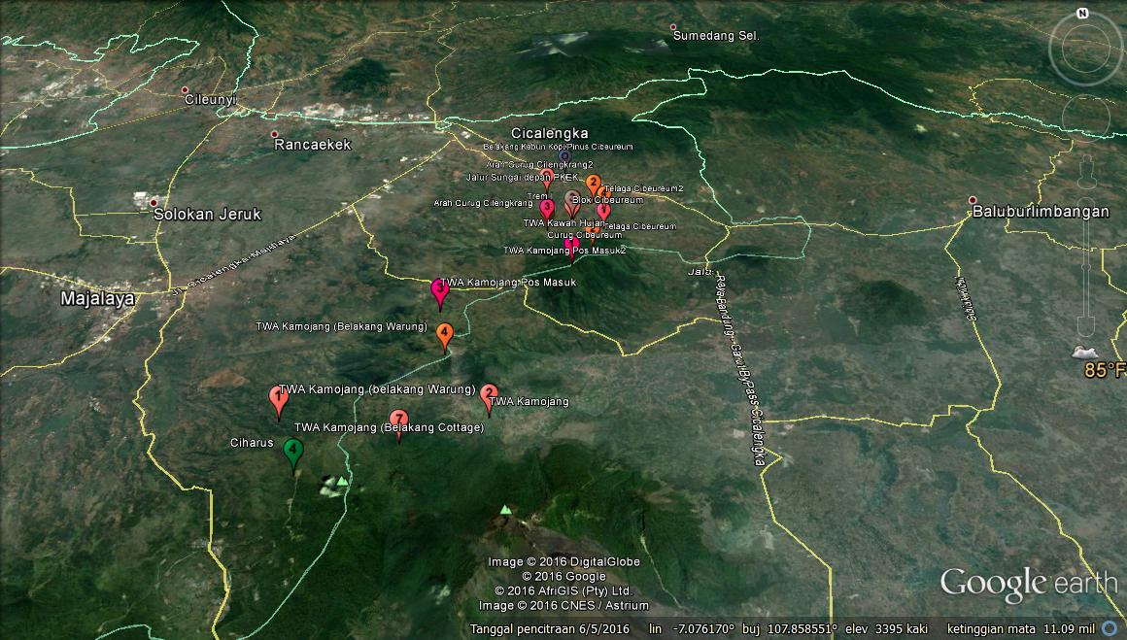
Figure 1. Distribution of Surili in Kamojang Area

Figure 2. Population Estimates of Surili

