**AUTHOR’S STATEMENT**

The undersigned below,

|  |  |  |
| --- | --- | --- |
| Name | : | Dr. Linda Oktavianingsih M.Si |
| Origin of affiliation | : | Department of Biology FMIPA Mulawarman University |
| Office address | : | Jl. Barong Tongkok No.04 Kampus Universitas Mulawarman, Gunung Kelua Samarinda, Kalimantan Timur 75123 |
| Office phone number | : | (0541) 749140, 749152, 749153, 749156 |
| Home address | : | Jl. Labu Merah 4 Blok B-208 Perumnas Bengkuring Samarinda |
| Mobile number | : | 0823 1255 5398 |
| E-mail | : | lindaoktavianingsih@fmipa.unmul.ac.id |

As the corresponding author in the manuscript entitled:

**KERAGAMAN KULTIVAR LOKAL UBI JALAR (*Ipomoea batatas* (L.) Lam) DI KABUPATEN KUTAI TIMUR-KALIMANTAN TIMUR, INDONESIA**

With the author’s order:

1. **Maysavitrie Citra Wijayanti Kristianto**
2. **Medi Hendra**
3. **Linda Oktavianingsih**

Stated that the manuscript that I submitted to Al-Kauniyah: Jurnal Biologi is:

1. Does not contain elements of plagiarism, according to applicable regulations
2. Not being submitted to other journals
3. Not being processed to be published in any form of publications
4. All authors have agreed to the author’s order and agreed to the final form of the manuscript
5. Willing to bear the risk of the accuracy of the data and will not hold the editor responsible for the data errors provided.

Thus, I make this statement in truth, and I am willing to accept all actions taken by the Editorial Board of Al-Kauniyah: Jurnal Biologi, if in the future it is proven that one or more of my statements are incorrect.

Samarinda, Januari 2023

Signature Signature Signature

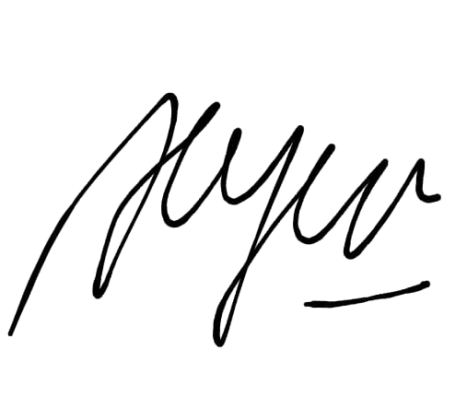  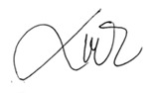

(Maysavitrie Citra W.K) (Dr. Medi Hendra M.Si) (Dr. Linda Oktavianingsih M.Si)