

Kalimātunā: Journal of Arabic Research
P-ISSN: 2829-0852 I E-ISSN: 2829-0097
Vol. x No. x, 2023, xx
http://journal.uinjkt.ac.id/index.php/kalimatuna
01 II doi: 10.15408//kjar.v1i1.xxxx.

HELLOTALK: A REVIEW OF INTERNET-BASED SOFTWARE IN SUPPORTING THE MASTERY OF MUFRADAT
Farha Fuada,¹ Salman Rizqan Karima,² Kisno Umbar ³
¹UIN Syarif Hidayatullah Jakarta, Tangerang Selatan
²UIN Syarif Hidayatullah Jakarta, Tangerang Selatan
³Sekolah Pascasarjana UIN Syarif Hidayatullah Jakarta, Tangerang
Correspondence E-mail: fuada,farha21@mhs.uinjkt.ac.id

Abstract:
One of the important elements of mastering Arabic is memorizing vocabulary. This is because vocabulary is related to the four language skills. The main impediment to learning Arabic motivation is a lack of vocabulary mastery. This study focuses on the description of the HelloTalk application in learning Arabic, especially in teaching vocabulary. This research covers the advantages and disadvantages of the HelloTalk application as a means of learning vocabulary. A qualitative approach and the application of triangulation are used to verify the data obtained. The data collection method used was observation and interviews to investigate the practice of teaching vocabulary in the HelloTalk application. The data analysis technique used in this research uses the Miles and Huberman model, which consists of the processes of data collection, data reduction, data display, and drawing conclusions. The involvement of multiple instruments and participants makes the HelloTalk application review more comprehensive. HelloTalk as a learning tool that is popular and effective in learning vocabulary must be further developed so that the potential for language learning is increased and made more useful.
Keywords: HelloTalk App, Vocabulary Learning, Arabic
Abstrak:
Elemen penting dalam menguasai bahasa arab salah satunya adalah dengan menghafalkan kosakata. Hal ini dikarenakan kosakata memiliki keterkaitan dengan empat keterampilan berbahasa. Kurangnya penguasaan kosakata menjadi masalah utama bagi moivasi seseorang dalam belajar bahasa arab. Penelitian ini fokus pada deskripsi aplikasi HelloTalk dalam pembelajaran bahasa arab khususnya dalam pengajaran kosakata. Peneltian ini mencakup kelebihan serta kekurangan aplikasi HelloTalk sebagai sarana pembelajaran kosakata. Pendekatan kualitatif dan penerapan triangulasi digunakan untuk memverifikasi data yang diperoleh. Metode pengumpulan data yng diterapkan berupa observasi dan wawancara guna menyelidiki praktik pengajaran kosakata pada aplikasi HelloTalk. Teknik analisis data penelitian ini menggunkan model Miles dan Huberman yang terdiri dari proses pengumpulan data, reduksi data, display data, dan penarikan kesimpulan. Keterlibatan instrument dan partisipan yang multiple menjadikan telaah aplikasi HelloTalk lebih komprehensif. HelloTalk sebagai alat pembelajaran yang popular dan efektif dalam pembelajaran kosakata harus lebih dikembangkan lagi, sehingga potensi pembelajaran bahasanya lebih meningkat dan bermanfaat.
Kata Kunci: Aplikasi HelloTalk, Pembelajaran Kosakata, Bahasa Arab

A. Introduction
One of the international languages that people from all corners of the world like to learn besides English is Arabic. By learning Arabic as a second language, it can make it easier for students of Arabic to interact with people from different Arab countries. Teaching a language means teaching someone to be proficient in that language to achieve the main goal of communication. The curriculum in Islamic-based schools has been modified with the introduction of Arabic from elementary to high school as one of the intermediary components in studying religion that has been recognized by the Ministry of Religion. Based on the curriculum of the Ministry of Religion of the Republic of Indonesia, it is expected that students who study Arabic can communicate fluently. Students who are proficient in vocabulary mastery will find it easier to express their thoughts compared to students who are too focused only on grammar. Mastery of vocabulary can improve and support students in skills such as al-Istima, al-Qiraah, Muhadasah, and al-Kitabah. As a result, we can conclude that the four stages listed above are the ideal components of learning Arabic.
Vocabulary mastery is one of the language competencies and has a role related to skills such as al-Istima and al-Qiraah. The core of the language component is what will adequately equip learners in terms of how they speak, listen, read, and write. Besides that, why is vocabulary the essence of learning a foreign language? Because it will allow students to express something in different word variations. This means that vocabulary is the main aspect of learning a foreign language, even if a little vocabulary mastery can build good communication. Mastery of vocabulary has a vital effect on our success in using a foreign language. Without a large vocabulary, the learner cannot use grammatical structures for comprehensive communication. However, as we know, there are still many students out there who have weaknesses in pronunciation and spelling and low motivation to learn languages, especially Arabic. Consistency in the pronunciation of words, the spelling of words, their length and complexity, their grammar, word meanings, connotations, and idioms are some of the factors that make some words more difficult to learn.
The implementation of the digital world as a container or means of teaching vocabulary can support students in becoming more enthusiastic about learning. HelloTalk is one of the most popular language learning apps, with over 10 million downloads. HelloTalk is an internet-based application for mobile phones that claims to be able to create experiences with foreign cultures, make language learning easy and interesting, and do intuitive exercises. In this application, users can connect with native speakers from all over the country. Users can interact with the interlocutor in a variety of ways, such as through written text, speech-to-text conversion, audio recordings, and live video recordings. The HelloTalk application is the no. 1 application in the world of language learning and cultural exchange, connecting users with native speakers of various languages (English, Arabic, Korean, Spanish, Mandarin Chinese, Japanese, and 100 others) for free.
Several previous studies have stated that technology has played a major role in the means of vocabulary acquisition. like a study that focuses more on the advantages of using the Memrise application as a personal learning medium. Another study, entitled "Application of Multimedia Technology in Vocabulary Learning for Engineering Students," tested the effectiveness of the implementation of computer-assisted instruction (CAI) in personal learning. In addition, this study also investigates whether CAI can improve vocabulary defects or not. Quantitative research on the theme of using technology in the field of education, especially in vocabulary development, has existed before and is not something that has just been studied.
Another study entitled "Effectiveness of Using Kahoot Games to Improve Students' Vocabulary Comprehension" has proven quantitatively that there is a difference in scores between students who are taught using Kahoot Games and students who are taught using ancient or conventional methods. Later in the same year, relevant research was also carried out with the theme "Studying Quizlet as a Media to Improve Seventh Grade Children's Vocabulary Mastery." The results show that students improve their skills during the teaching and learning process by using Quizlet. This is evidenced by the data obtained from this study. Relevant research listed previously proves that the implementation of technology is an alternative way to make students more interactive and engaged in vocabulary learning and teaching. In relation to this study, this study attempts to investigate the use of HelloTalk in teaching vocabulary to young learners. This is because HelloTalk is an easy-to-use application and has many features such as Helloword, English Time, Hello English, Amy, Translation, an English dictionary, notepad, and many more. More importantly, the use of the HelloTalk application in teaching vocabulary to young learners is still rare.
Based on the introduction above, this research is focused on analyzing the HelloTalk application from the aspect of its function to teach Arabic vocabulary and the benefits and obstacles of these practices. The findings from this study can be used as material for consideration in using this application to support teaching Arabic vocabulary.
B. Research Method
The research method used is the descriptive research method. Descriptive research is part of qualitative research. Qualitative research is defined as research in which the results of data processing are presented in the form of elaboration in the form of text that is described extensively and in greater detail so that the reader can understand the meaning of the research findings. In qualitative research, the main characteristics come from the background of events or the reality of events that exist in society.
The research data was collected through observation, interviews, and documentation. The data that has been obtained is then analyzed using the data analysis technique of the Miles and Huberman models. Triangulation is also used to validate the data that has been obtained. namely, by comparing the data from observations, interviews, and documentation.
C. Results and Discussions
Based on Richey's definitions, R.C., it can be concluded that good educational technology or learning technology is a discipline or field with the main objectives of learning: 1) to solve learning problems or facilitate learning; and 2) to improve skills; 3) Educational/learning technology uses a systems approach (a comprehensive approach, not a partial approach); 4) The area of educational technology can include analysis, design, development, utilization, management, implementation, and evaluation of both processes and learning resources; 5) What is meant by "technology" in educational technology is "technology" in its broadest sense, which includes both physical technology (hardtech) and soft technology (softtech); 6) Educational technology is an integrated complex process including people, procedures, ideas, facilities, and organizations to analyze problems and design, implement, assess, and manage problem solving in all aspects of learning.

With a rating of 4.3 on Google Play, HelloTalk is a popular language learning assistive app on the market, with teams based in Hong Kong and Shenzhen, China. Almost all languages in the world, including English, Japanese, Korean, Spanish, French, Chinese, Portuguese, German, Italian, Russian, Arabic, and many other languages, are covered by this app. Its main aim is to connect language learners directly with native speakers and the target culture to facilitate language learning. The app has many different options, but to access them without restrictions, the premium version must be downloaded due to the limitations of the free version. While the app isn't completely free, its user base is relatively large; according to the HelloTalk website, there are more than 7 million members currently using the app. It is very advantageous that this application is accessible to Android and iOS users. The first step to take after installing HelloTalk is to fill out their profile (see Figure 1). As soon as they are done with this task, they can start looking for language partners by making and receiving requests. HelloTalk users have access to an amazing global language exchange community. The app allows learners to find language partners, chat with them, send them voice messages, or call them. It should be noted that while there are websites that allow individuals to search for suitable conversation partners via platforms such as Skype, they are ineffective due to their small usage base compared to applications such as HelloTalk.

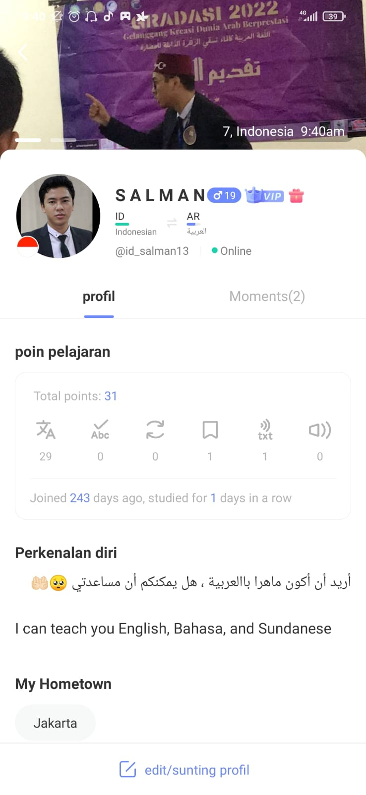

Gambar 1

HelloTalk offers many desirable features for language learners around the world. Among the features available are:
- Voicemail
- Chat with text
- Share camera photos
- HelloWord (learn vocabulary in the application; see Figures 2, 3, 4)
- Smiley (means to draw)
- Share your GPS location
- Free or paid courses
Dedicated language learning features: translation, transliteration, and native speech recognition help learners write, speak, and listen in their target language.

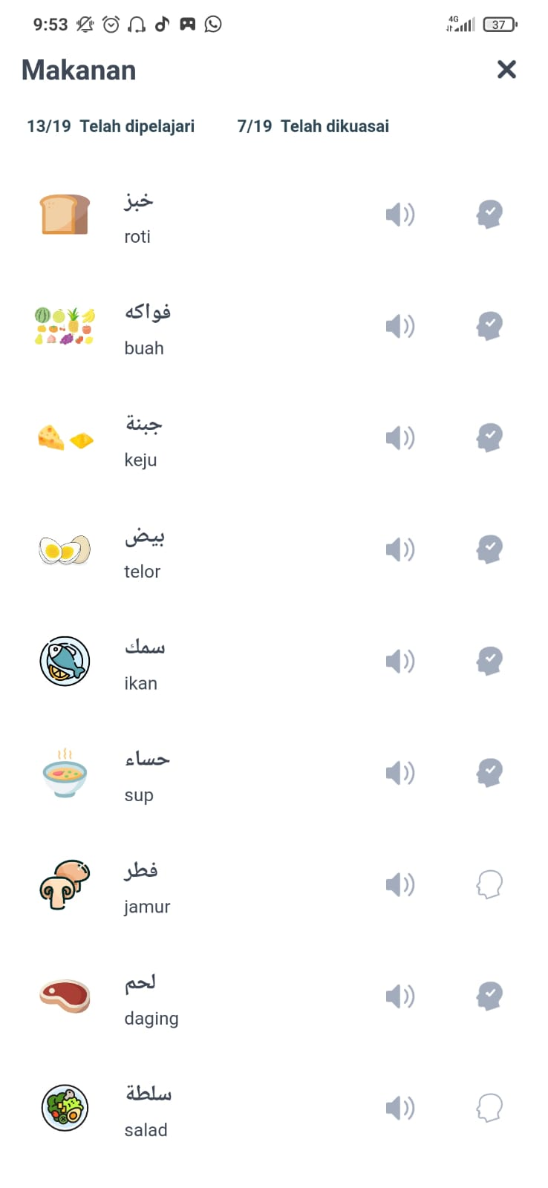
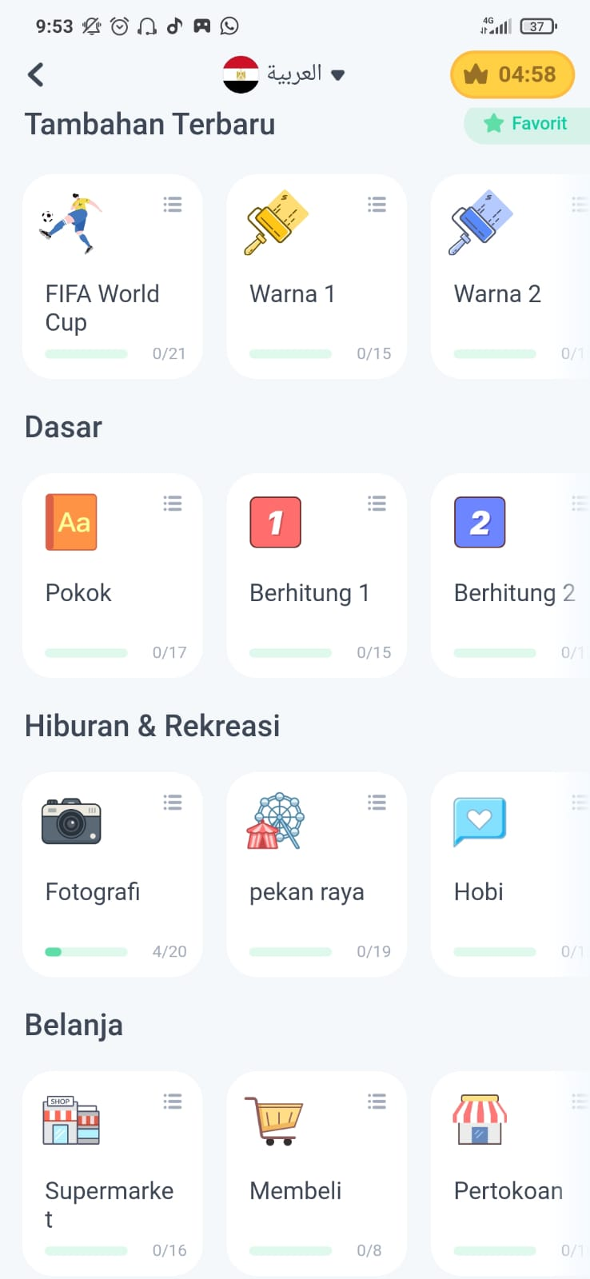
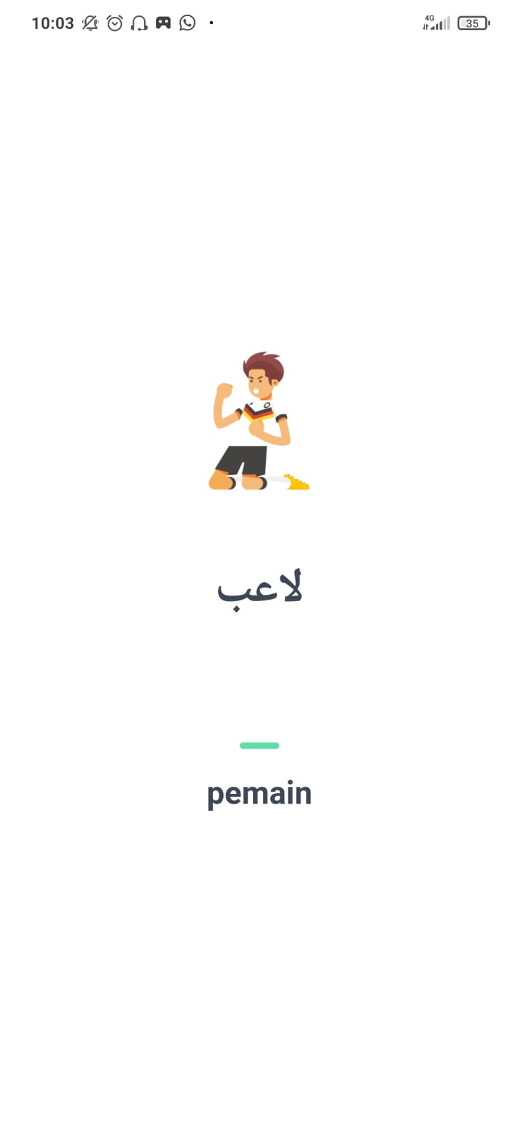

Gambar 2 Gambar 3 Gambar 4

All of these features function as language learning tools, especially vocabulary mastery and options that are suitable for users to establish good communication with other members of the language community. Several other features are also very interesting. For example, the voice recognition system built into the app is capable of converting speech into text. Furthermore, this application allows you to chat in multiple languages at the same time without changing the target language in the settings. Therefore, it will be very easy for Arabic learners to practice the vocabulary they have memorized directly with native speakers.
Another feature that is displayed from this application, as shown in Figures 2, 3, and 4, is a feature that displays vocabulary that has been memorized by the user. Users can tap on a text message and have a number of options appear. The options are to copy the text message, mark it as a favorite, add it to a personal notebook, revise it, read it or recite it aloud, translate it, and transliterate it.

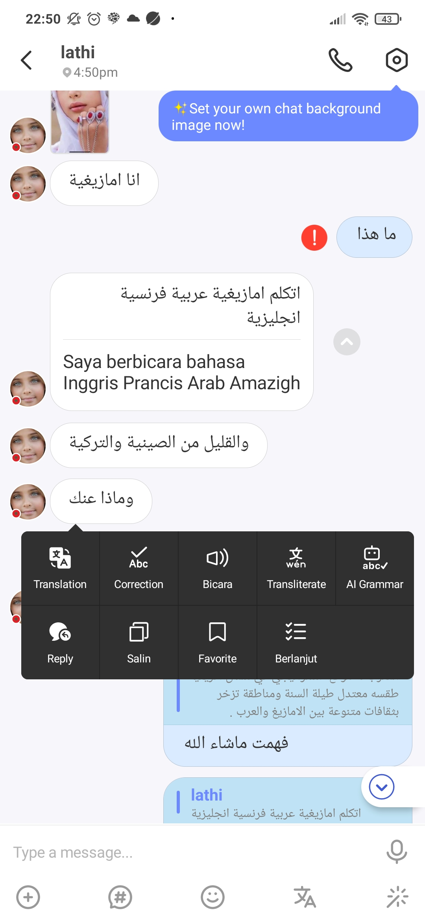

Gambar 5

The most challenging obstacle that must be overcome in learning a new language is actually starting a consistent conversation with the other person. Therefore there is another feature called "Moments" in the HelloTalk application, shown in Figure 6, which can really help students face this challenge. This option allows students to share multiple submissions and write comments on their own and others' posts. This helps them get a lot more exposure to the target language and creates a unique environment. This feature was first discovered in Suggestopedia and its peripheral learning principle introduced by Lozanov (1978) who believed that language learners could understand information easily by creating a good language environment rather than having to always teach at the blackboard.

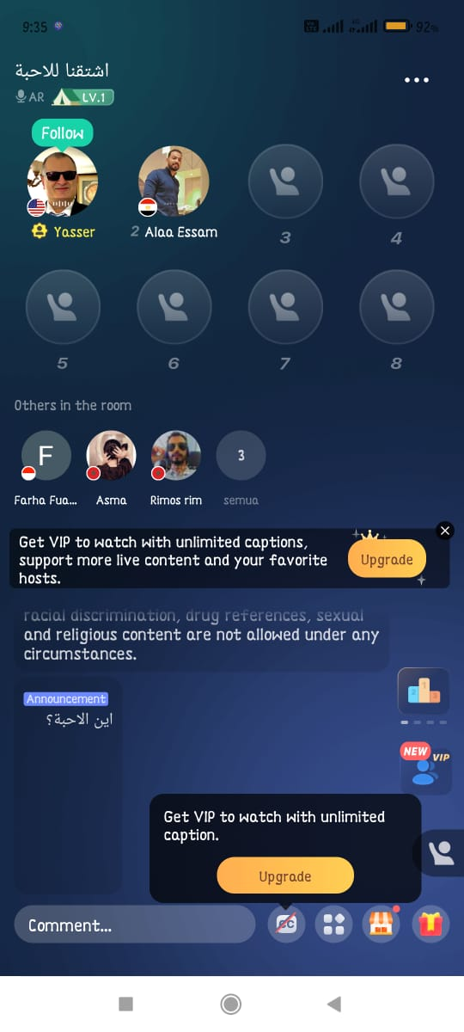
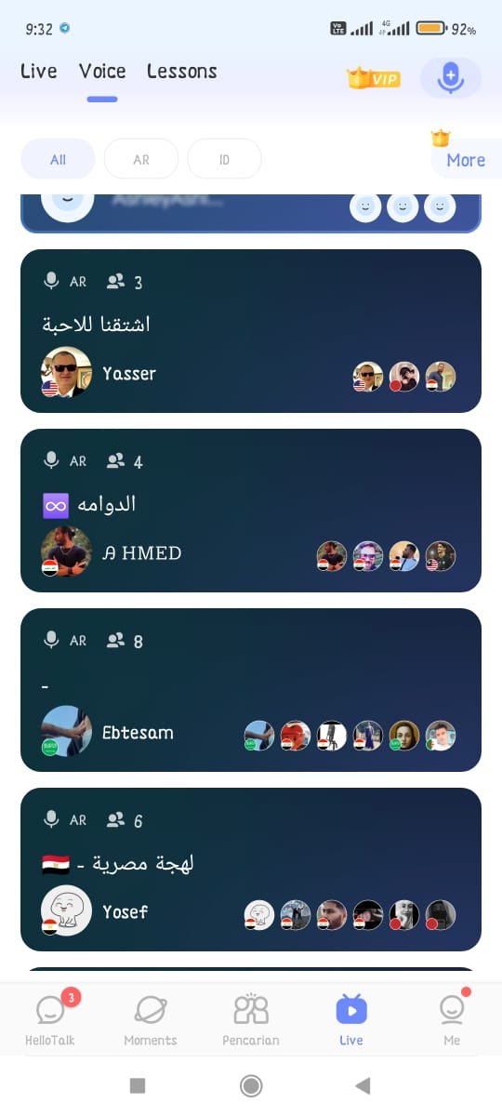
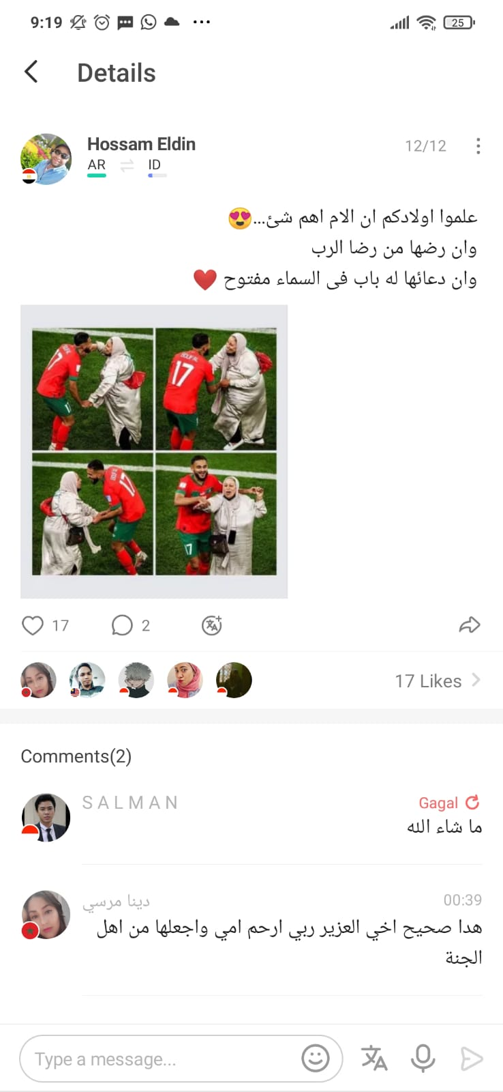

Gambar 6 Gambar 7 Gambar 8
As shown in Figure 9, in the settings section, there is a friend search engine. This app caters to students precisely and can customize searches based on what students want. In addition, students can even change the speed of computerized foreign language "Voice Notes" to make them easier to understand. For the convenience of users, chat settings, chat notifications, and backup settings are also available in this application. Many of the features offered are also used by various other language learning applications, such as Duolingo.
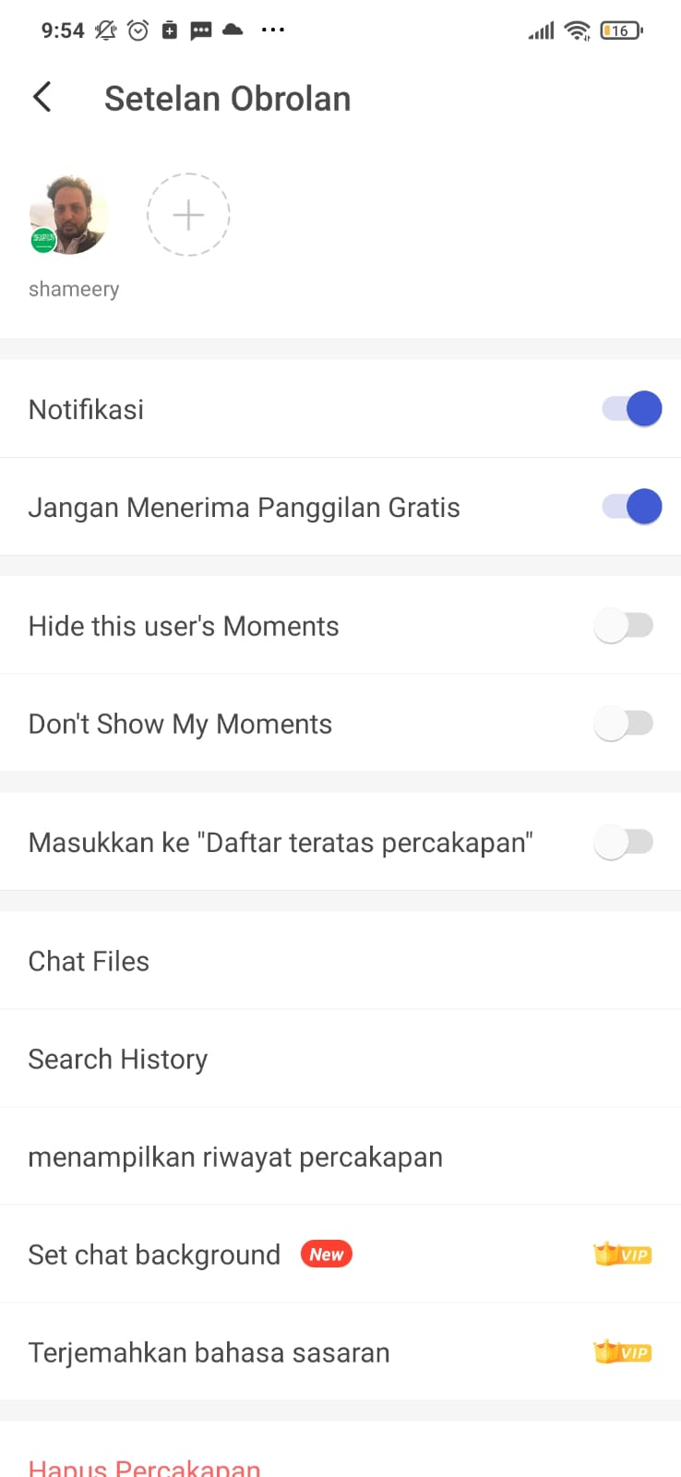
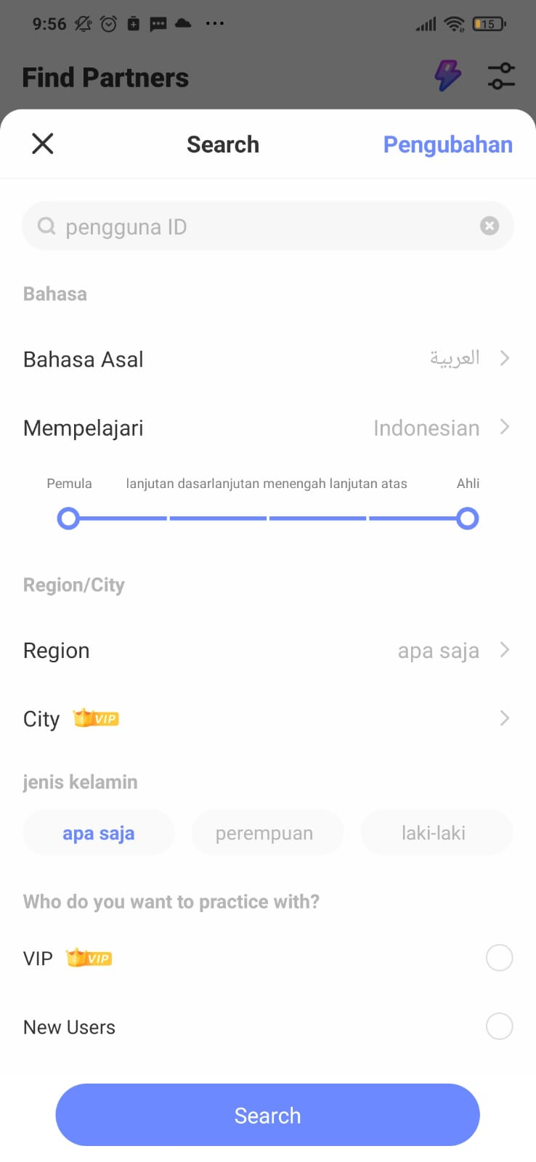

Advantages
To have a real-life connection, HelloTalk allows its users to make free phone calls for a better and friendlier language learning experience. Usually, learners take advantage of this feature to speak directly with native speakers, and through this feature, learners also become familiar with the relaxed and informal speech of the target language, which is an important skill in a second language. One of the most prominent features of this app is its automatic translation feature, which helps to keep the conversation going. In addition, for languages that use alphabets other than Latin, they are also Latinized. It is also useful, particularly for languages such as Arabic, Chinese, and Korean. Figures 9, 10, and 11 show these features. Again, it must be emphasized that all these features are fully available in the premium version of the application, and in this case, non-VIP users have limited access.


Gambar 11
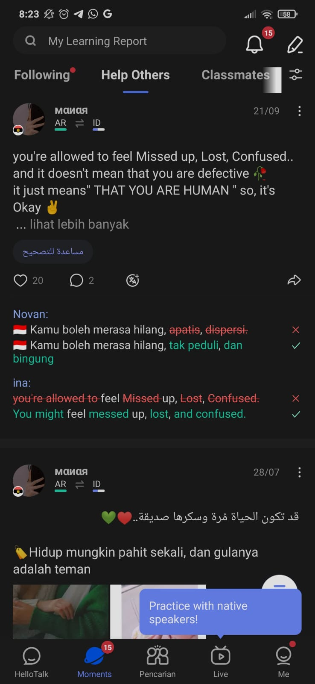
This app also displays the user's nationality flag as well as the user's local time and location beneath their profile picture. For convenience, this feature informs the user whether it is the right time to start chatting with their conversation partner or not. Of course, this app also allows users to hide privacy details and other details like their age or location in advanced privacy settings if they want to keep those details private. What's special about this app is its excellent "on-the-text" correction system. As illustrated in Figure 12, such a system enables students to be confident in writing properly and correctly while also receiving corrections as they learn.

Gambar 12
To ensure that fellow users can disproportionately learn the target language, the application provides a special "Language Exchange" feature that counts the number of characters or the amount of time spent (e.g., 500–1000 characters or 5 minutes) in one language. When the number of characters or time reaches the limit, the application recommends switching languages so that there will be no one-sided conversations that only benefit one party. Finally, HelloTalk is a secure application that respects individual privacy. The image below shows the various privacy and security features in this app.
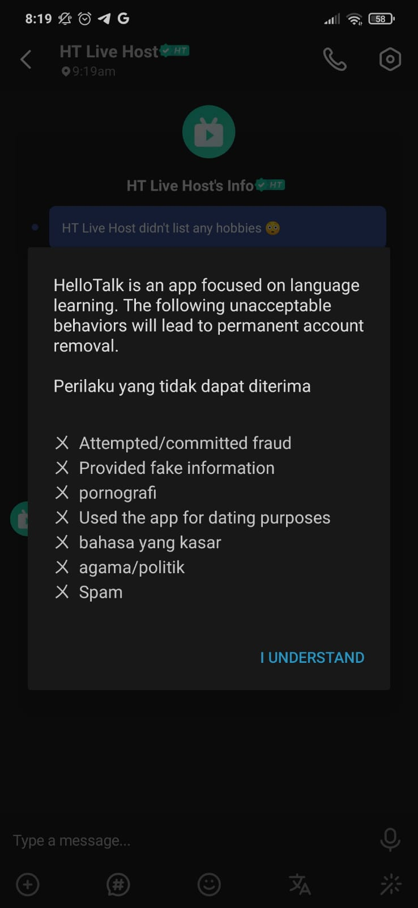
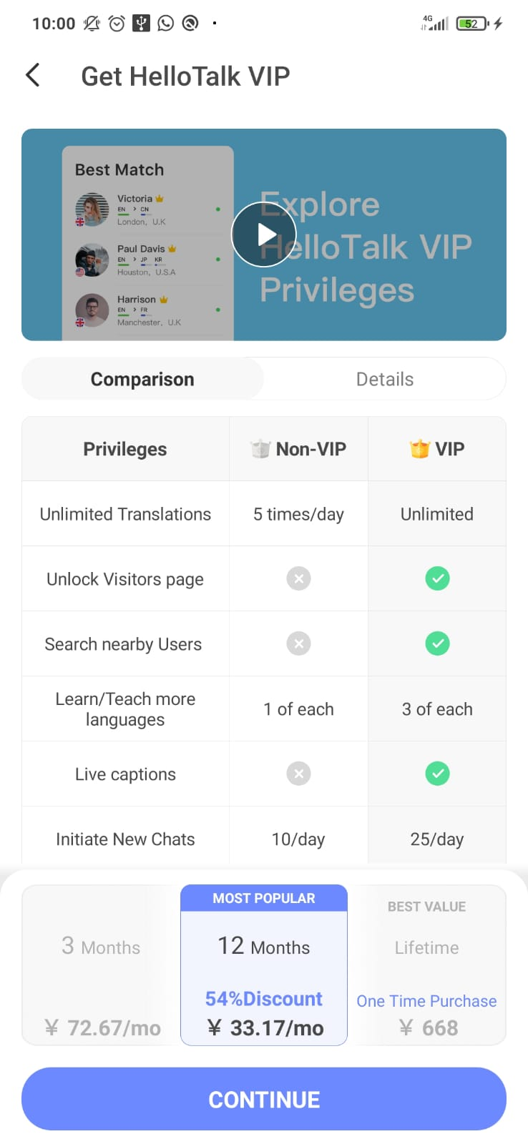

Weakness
The most vital weakness of this app that needs more attention is the lack of a motivational system to encourage learners to keep learning languages with this app, due to the fact that there are no reminders like words of encouragement or gifts from the HelloTalk team. Users, particularly those with a lack of intrinsic motivation, may not make the effort to participate regularly in chats in other languages. Similar to many similar mobile language learning apps, HelloTalk is not 100% free. To be able to access more indulgent features, users must first become VIP members. The VIP membership price (i.e., paid version) is quite high with several options, namely Rp. 120,000 per month or Rp. 48,000 per month with a discount up to Rp. 2,500,000 for all time, as shown in Figure 14. Apart from that, this can be considered very unfair for users to have to pay a high price to simply learn a language with an online application.
Then, there is no response given by Hellotalk to students regarding their progress status during chat, such as reminders of new vocabulary that has been learned (except in the HelloWord feature). In addition, there are basically no official courses when it comes to learning a new language, its resulting meaning, grammar, phonology, vocabulary, and so on. monitored only by native speakers and/or non-native speakers who are proficient in certain languages in the community. Actually, this can backfire on the user if it turns out that the teacher is not proficient. On the other hand, the knowledge they teach will be more specific than learning in ordinary formal courses. From what the author knows, these weaknesses not only reduce the level of motivation of the learner but also make the learner confused when determining the appropriate level of language rules. Therefore, the HelloTalk team of experts needed to eliminate this need.

HelloTalk user testimonials
Direct application to several students of the Arabic language education study program at UIN Syarif Hidayatullah Jakarta batch 21 based on the conclusions we obtained from data collection stated that students of various languages in this context, Arabic, were greatly assisted and served. In addition to the limited access for users other than VIPs owned by this application, the free features are also very helpful in using it as a fun learning medium.

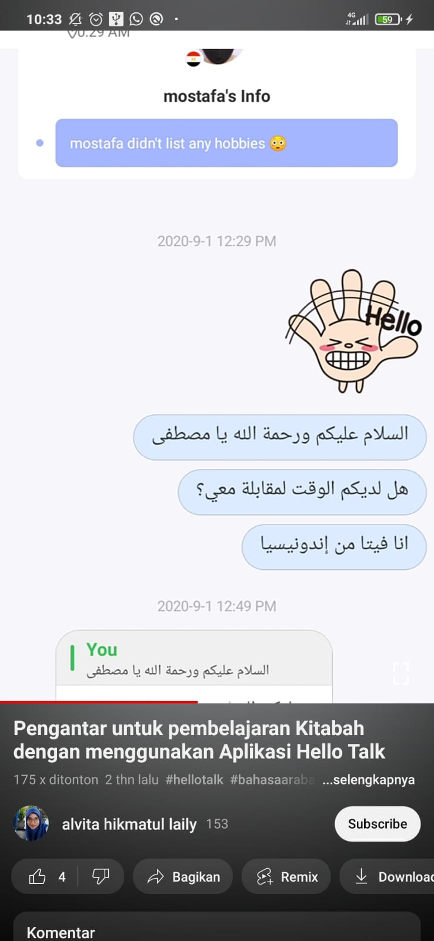
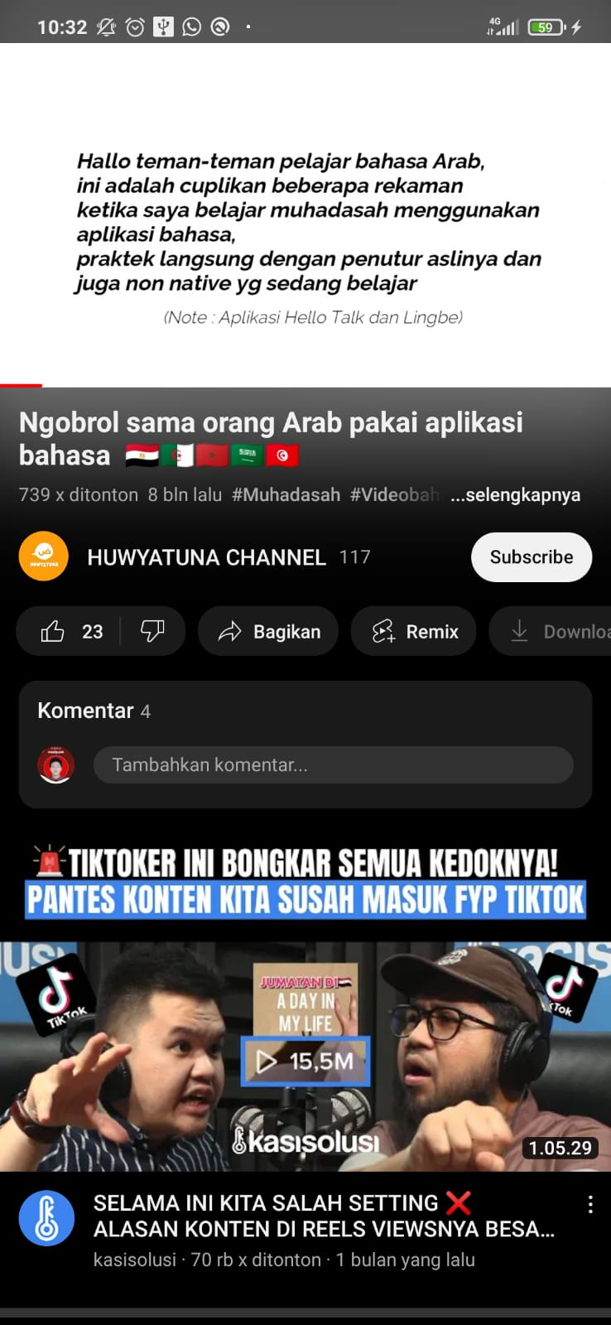
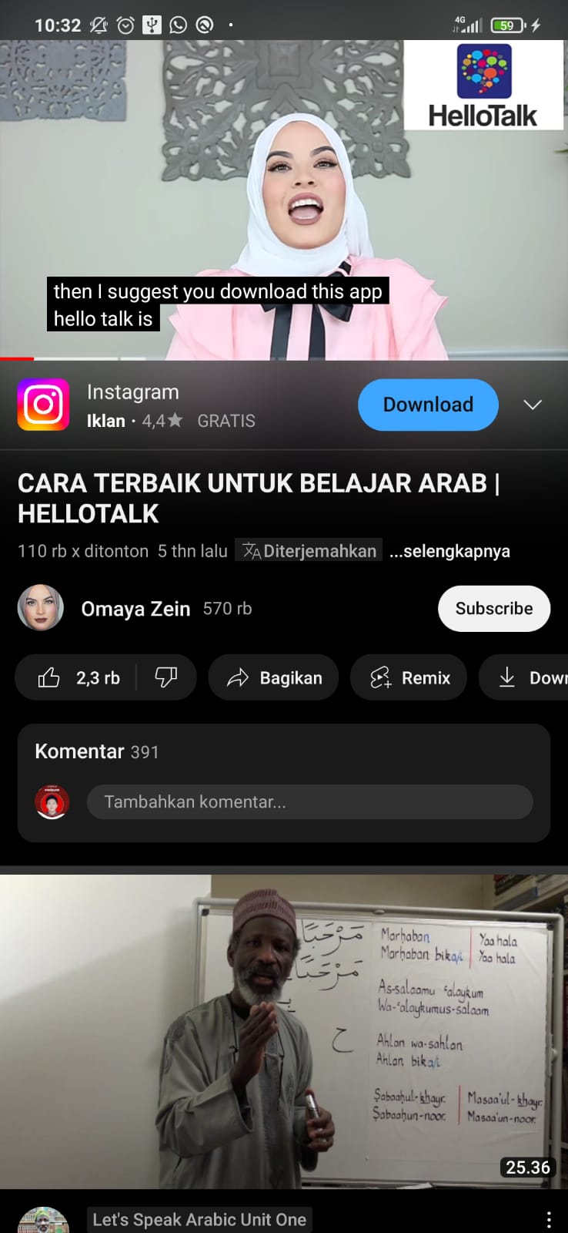

Gambar 15 Gambar 16 Gambar 17

The following is concrete evidence of the benefits of using the HelloTalk application in language learning that can be felt by language learners, especially Arabic. Some of the YouTubers above posted videos of the benefits they got from using the HelloTalk application. Apart from being a means to add mufradat, This application can also be used as a learning application, such as maharah al-Kitabah, maharah al-Qiraah, maharah al-Kalam, and maharah al-Istima. They can speak directly, correct mistakes in sentences, and hear how they speak with native Arabic speakers. Because of these advantages, it's not surprising that this application has been downloaded by more than ten million enthusiasts in various languages on the Play Store.

D. Conclusion
HelloTalk is a language learning tool that is quite effective, especially for the younger generation because it is easy to understand. In this application, there are various kinds of languages and a variety of features to create a pleasant atmosphere for learning vocabulary, or mufradat. This application also facilitates language learners with various types of facilities for fast, effective, and meaningful learning. This is an amazing task that has been done by the HelloTalk professional team. Some of the notable features of this app are text correction, automatic translation, and transliteration, which have established this app as an excellent one. Similar to other language learning applications, Hello Talk also suffers from a number of limitations. non-free VIP membership for more indulgent access, no reports and/or feedback on the learner's language progress, and no alerts or monitoring as a stimulus to users other than concerned native speakers, which this app seems to be lacking. In short, it's fair to say that HelloTalk is a popular and widely used language learning app that attracts attention but still needs a lot of development. The HelloTalk team was required to iron out minor issues with the app to maximize its language learning potential as much as possible.

References
A. Fuad Efendi. Metodologi Pengajaran Bahasa Arab. Malang: Misyakat, 2005.
Abdellatif Elsafy Elgazzar. “Developing E-Learning Environments for Field Practitioners and Developmental Researchers: A Third Revision of an ISD Model to Meet E-Learning and Distance Learning Innovations.” Open Journal of Social Sciences 2, no. 2 (January 9, 2014).
Acep Hermawan. Metodologi Pembelajaran Bahasa Arab,. Bandung: Remaja Rosdakarya, 2011.
Henry Guntur Tarigan. Metodologi Pengajaran Bahasa. Bandung: Angkasa, 1991.
Izah, N. “Upgrading Students ’ Vocabulary Through ‘ Memrise ’ App.” Proceeding of First Conference of English Language and Literature (CELL), 2019, 1–10. https://semnas.untidar.ac.id/wp-content/uploads/2019/07/Nurul-Izah_Upgrading-Students-Vocabulary-through-Memrise-App.pdfShi.
Jack C. Richards and Martha C. Pennington. “Teacher Identity in Language Teaching: Integrating Personal, Contextual, and Professional Factors.” Sage Journals 47, no. 1 (March 10, 2016). https://doi.org/10.1177/0033688216631219.
Jack C. Richards and Willy A. Renandya, eds. Methodology in Language Teaching. Cambridge University Press, 2002.
Jauhar Helmie and Nuraeni Susilawati. “ORAI APPLICATION TO PROMOTE AUTONOMOUS LEARNING TO ENGLISH LEARNER AT SENIOR HIGH SCHOOL.” Indonesia Journal of English Teaching 7, no. 2 (Desember 2018): 110–15. https://scholar.google.co.id/citations?view_op=view_citation&hl=id&user=LbXe2SkAAAAJ&citation_for_view=LbXe2SkAAAAJ:TQgYirikUcIC.
Ling Feng Shi and Wei Gang Jia. “Mode-Selectable High-Efficiency Low-Quiescent-Current Synchronous Buck DC–DC Converter.” Xidian University, Mei 2014. https://doi.org/10.1109.
Mofareh Alqahtani. “The Importance Of Vocabulary in Language Learning and How To Be Taught” 3 (September): 21–34. https://doi.org/10.52950.
Puspitasari, Nining. “Enhancing Student’s Vocabulary Mastery by Using Quizlet Media at the Seventh Grade of MTs Ma’Arif Al-Ishlah Bungkal Ponorogo.” IAIN PONOROGO, 2019. http://etheses.iainponorogo.ac.id/5905/1/SKRIPSI%20UP.pdf.
Putri, W. N. “Pengaruh Media Pembelajaran Terhadap Motivasi Belajar Bahasa Arab Siswa Madrasah Tsanawiyah.” LISANIA: Journal of Arabic Education and …, 2017. https://lisania.iainsalatiga.ac.id/index.php/lisania/article/view/1160.
Rivera, A. V. “HelloTalk.” Calio Journal, 34 (Agustus 2017): 384–92. https://journal.equinoxpub.com/Calico/article/view/7642.
Thornbury, Scott. How to Teach Vocabulary/ Thornbury. Oxfordshire: Pearson, 2002.
Ur, Penny. A Course in Language Teaching: Practice and Theory. Cambridge: Cambridge University Press, 1996. https://sacunslc.files.wordpress.com/2015/03/penny-ur-a-course-in-language-teaching-practice-of-theory-cambridge-teacher-training-and-development-1996.pdf.

Acep Hermawan, Metodologi Pembelajaran Bahasa Arab, (Bandung: Remaja Rosdakarya, 2011), 130–35.
A. Fuad Efendi, Metodologi Pengajaran Bahasa Arab (Malang: Misyakat, 2005).
Jack C. Richards and Willy A. Renandya, eds., Methodology in Language Teaching (Cambridge University Press, 2002).
Ur, Penny, A Course in Language Teaching: Practice and Theory (Cambridge: Cambridge University Press, 1996), https://sacunslc.files.wordpress.com/2015/03/penny-ur-a-course-in-language-teaching-practice-of-theory-cambridge-teacher-training-and-development-1996.pdf.
Mofareh Alqahtani, “The Importance Of Vocabulary in Language Learning and How To Be Taught” 3 (September): 21–34, https://doi.org/10.52950.
Thornbury, Scott, How to Teach Vocabulary/ Thornbury (Oxfordshire: Pearson, 2002).
Jauhar Helmie and Nuraeni Susilawati, “ORAI APPLICATION TO PROMOTE AUTONOMOUS LEARNING TO ENGLISH LEARNER AT SENIOR HIGH SCHOOL,” Indonesia Journal of English Teaching 7, no. 2 (Desember2018): 110–15
Rivera, A. V, “HelloTalk,” Calio Journal, 34 (Agustus 2017): 384–92, https://journal.equinoxpub.com/Calico/article/view/7642.
Izah, N., “Upgrading Students ’ Vocabulary Through ‘ Memrise ’ App,” Proceeding of First Conference of English Language and Literature (CELL), 2019, 1–10, https://semnas.untidar.ac.id/wp-content/uploads/2019/07/Nurul-Izah_Upgrading-Students-Vocabulary-through-Memrise-App.pdfShi.
Ling Feng Shi and Wei Gang Jia, “Mode-Selectable High-Efficiency Low-Quiescent-Current Synchronous Buck DC–DC Converter,” Xidian University, Mei 2014, https://doi.org/10.1109.
W. N. Putri, “Pengaruh Media Pembelajaran Terhadap Motivasi Belajar Bahasa Arab Siswa Madrasah Tsanawiyah,” LISANIA: Journal of Arabic Education and …, 2017, https://lisania.iainsalatiga.ac.id/index.php/lisania/article/view/1160.
Puspitasari, Nining, “Enhancing Student’s Vocabulary Mastery by Using Quizlet Media at the Seventh Grade of MTs Ma’Arif Al-Ishlah Bungkal Ponorogo” (Ponorogo, IAIN PONOROGO, 2019), http://etheses.iainponorogo.ac.id/5905/1/SKRIPSI%20UP.pdf.
Abdellatif Elsafy Elgazzar, “Developing E-Learning Environments for Field Practitioners and Developmental Researchers: A Third Revision of an ISD Model to Meet E-Learning and Distance Learning Innovations,” Open Journal of Social Sciences 2, no. 2 (January 9, 2014).
Jack C. Richards and Martha C. Pennington, “Teacher Identity in Language Teaching: Integrating Personal, Contextual, and Professional Factors,” Sage Journals 47, no. 1 (March 10, 2016).
Henry Guntur Tarigan, Metodologi Pengajaran Bahasa (Bandung: Angkasa, 1991), 90.

