AL-IQTISHAD

***Jurnal Ilmu Ekonomi Syariah (Journal of Islamic Economics)***

# P-ISSN: 2087-135X, E-ISSN: 2407- 8654

**Web:** <http://journal.uinjkt.ac.id/index.php/iqtishad>

# Email: [iqtishad@uinjkt.ac.id](mailto:iqtishad@uinjkt.ac.id)

**COPYRIGHT TRAN SFER AGREEMENT FORM**

Name of Principal Authors: Fitriana Rahman………………………………………………………………………

Address of Principal Authors: Nurul Ihsan Street, No 15, South Jakarta 12630……………………

…………………………………………………………….……………………………………………………..………………………

Tel/Fax: 089636869909…………….…………………………………………………………………………………………

E-mail: fitrianarahman99@gmail.com……...……………………………………………………………...……….. Author(s) Name: Fitriana Rahman, Laily Dwi Arsyianti……………………………….……………….………

Manuscript Title:

Islamic Financial Literacy And Its Influence On Investment Decisions Through Student

Financial Behavior …………..………………………………………………………………………………………………....

Date Received: ………………………………………………………………………………………………………………………

1. I/We submit to the ***Al-Iqtishad: Jurnal Ilmu Ekonomi Syariah (Journal of Islamic Economics)***. I/We certify that the work reported here has not been published before and contains no materials the publication of which would violate any copyright or other personal or proprietary right of any person or entity.
2. I/We hereby agree to transfer to ***Al-Iqtishad: Jurnal Ilmu Ekonomi Syariah (Journal of Islamic Economics)***/ Publisher for the copyright of the above - named manuscript.
3. I/We reserve the following: (1) All proprietary rights other than copyright such as patent rights. (2) The right to use all or part of this article in future works of our own such as in books and lectures. Print or Type Name and Title of Author.

Date: 06 August 2021

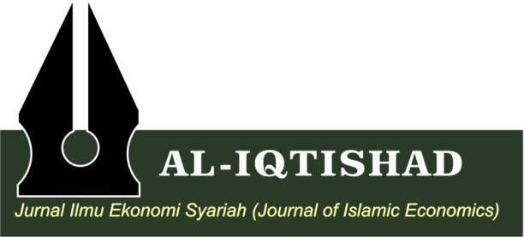Signature (original)



………………………………

(Fitriama Rahman)