Field Note 8B student English Class at Multi-age Class
Field Notes Field notes were used when observing the programme's implementation. Field notes are written observations recorded during or immediately following participant observations in the area and are considered critical to understanding phenomena encountered (Allen, 2017). They helped the researchers remember and record an observation's behaviours, activities, events, and other features (Schwandt, 2015).
RR: Researcher
ET: English Teacher
SS: Student
Field Note
Day and Date | : | Tuesday, 25th April 2023
Time | : | 10.30 – 12.00
Meeting / Cycle | : | 1 / 1
Topic | : | Pre-Test: How to describe a thing and a person.

Students were asked to do the pre-test about descriptive text on written and spoken text. First, the students were given the test handouts (written tests) and explained how to do them. A student said, "Gimana miss? [Pardon?]". The other student said, "Yang mana miss? [Which one?]". After explaining the instructions and preparing the pre-test, suddenly, a student said, "Miss ulangi [Can you repeat??]". Honestly, the RR almost got angry and frustrated. Still, the RR kept the emotion down since it was the first meeting. I remembered what the teacher said and tried to repeat the instruction slowly.

The RR had to repeat how to do it many times until students could use it with many questions. The RR and SSs discussed how to answer the written test activity on paper. Meanwhile, the RR called students one by one to come and sit at the bench near the RR.

The speaking test was done individually with the researcher. When the researcher asked a basic question related to the topic, they seemed nervous, produced speech fillers, kept silent and smiled. Some of them said, "Miss aku tidak bisa" [Miss, I cannot answer it] or "Bicara apa itu miss?" [What did you say, miss?]. The other students, whom a teacher did not call, might wait their turn by doing the written exercise given. Several students showed that their speaking was low proficiency and they were beginners in English speaking.

At the end of the class, the RR explained how to do the vocabulary exercise. The students agreed to do the instruction and committed to writing the vocabulary exercise. However, as the SS liked to listen to songs, the RR offered to listen. The SS agreed and requested a song used for the next meeting. Hopefully, it could boost the spirit of learning English.

Field Note
Day and Date | : | Tuesday, 2nd May 2023
Time | : | 10.30 – 12.00
Meeting / Cycle | : | 2 / 1
Topic | : | How to describe a thing
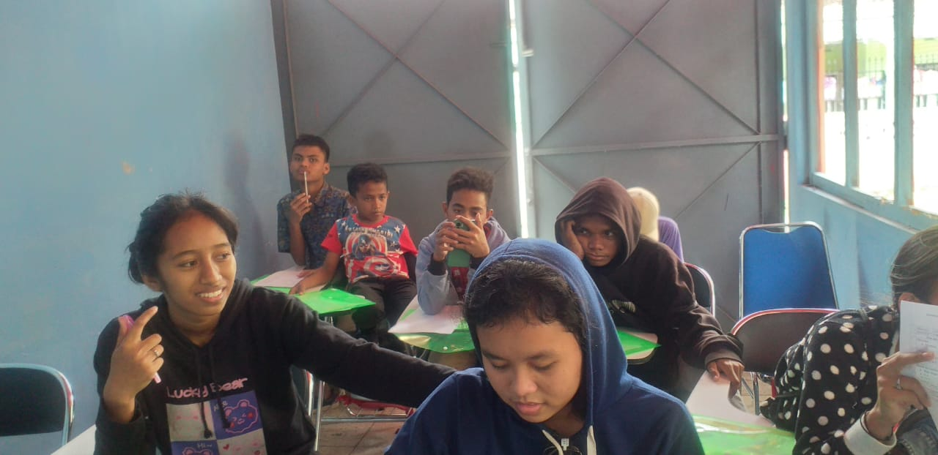

SS had already finished the daily written vocab before the English class began. The RR called the students' names to know who was present and who was absent.

The RR had already given a handout and explained how to describe a person in a spoken way. The RR tried to make the class alive by asking students to find a thing around them to describe. They were excited that they were able to find an item that was interesting to them.

First, the RR explained how to make a description text and gave an example by hiding a thing. All students took a turn hiding and guessing a thing. They were interested in this activity. They could follow the lesson (describe an item) because they did daily writing on the vocabulary exercise every day at home. Thus, they quickly followed the lesson. The handout was written like the colour is …, the shape is…, and it helps us to…….

Then, the RR asked the students to go out of class to find a thing to describe. Then, they went back to class 5 minutes later to write the details of the description. Still, with their partner, they did not do citing. They asked help from their peers to translate an Indonesian word into English and English into Indonesian. They also asked for help from their peer to build a simple English sentence.

Ten minutes passed, and the students came in front of the class to describe what they had written by reading it. Their peer could guess it. The students were excited to guess a thing described by their friends. They answered it in English and Bahasa Indonesia. Many students had the confidence to speak in front of the class. Even they still mispronounced the words. The activity went smoothly. Students were shouting to get their turn in guessing a thing.

Field Note
Day and Date | : | Friday, 5th May 2023
Time | : | 09.00 - 10.30
Meeting / Cycle | : | 3 / 1
Topic | : | Describing a thing
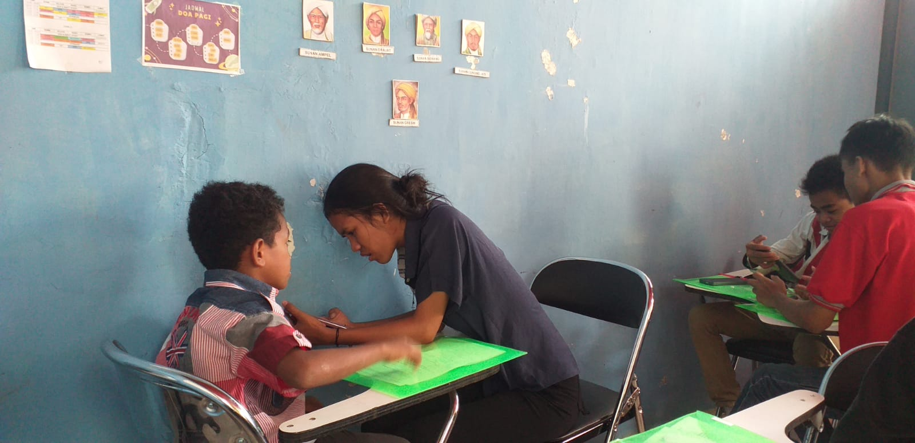

Meeting 3 began by listening to a song and filling in the black lyrics. The RR played a song the SS had requested since the first meeting. The activity took around 30 minutes, and SS listened 4 the song 4 times. The RR also checked their answer, but many of them almost got incorrect answers. Nevertheless, they loved listening to music; sometimes, I heard them humming it during class.

Meeting 3 described a person who referred to the lesson plan in Meeting 2. The RR started with middle-level material describing a person they already knew. I really asked them to refer to the handout Activity 4.

Although they had the handout and I kept giving them clues, they still did not grasp how to describe a person. I asked them to do peer tutoring, but I decided on the partner (RR decided on the partner). The instruction was about making it in Indonesian after that, translating it into English.

I still had much time to see their progress by watching their speaking performance describing someone. However, it took a long time to do peer teaching. They needed to adjust to a new friend and determine their abilities. The RR said, "You have to help your friend if your friend does not know how to write a describing text." the RR spoke slowly, repeated it two times, and mixed English with Bahasa Indonesia. The RR even used body language while speaking this sentence: "If you did not know, please ask for some help."

Finally, the SS had done the task given (Indonesian and English). Yet, they could not perform description text in front of the class due to limited time and the long Peer Tutoring process.

Field Note
Day and Date | : | Tuesday, 9th May 2023
Time | : | 10.30 – 12.00
Meeting / Cycle | : | 4 /1
Topic | : | Describing a thing
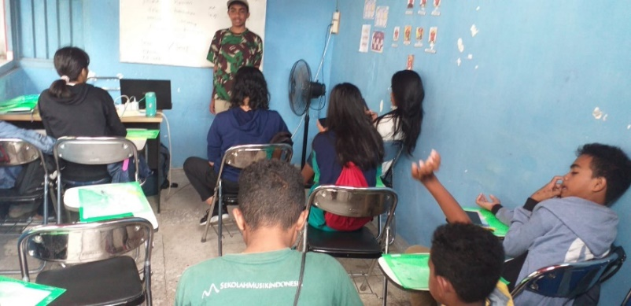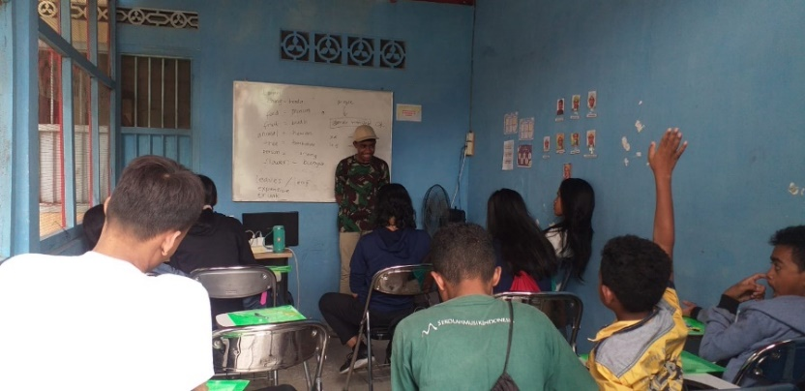

The RR began the class by teaching how to lead a prayer and write it on the whiteboard. The student Clara led the prayer by reading it.

The class began with listening and filling in the blank lyrics of a song that students had requested. The RR did that to boost the excitement of the SS toward English. In the last activity, the listening was done 4 times. Now, the SS only listened to the song 3 times.

After listening to a song, the RR began the class with students describing a thing. The RR did not try to move to the next topic because they wanted the SS to understand the material and practice their English speaking. After a short discussion with the English teacher, the RR made a new lesson plan before teaching how to describe a person. One SS came before the class, and the other SS would guess it (food, fruit, flower, tree, animal, or a thing).

The SS were so excited they described by asking the RR how to pronounce the word. Some SS even brought their phone to open Google Translate and click the sound English button. All students were finally able to answer and guess the thing. The SS, who previously were shy to speak, were not scared anymore and could deliver sentences confidently.

The RR tried to ask the students about this teaching method, and the SS said, "Miss, I like this game!" Another student, “Miss besok belajarnya seperti ini lagi ya”.

Field Note
Day and Date | : | Wednesday, 10th May 2023
Time | : | 12.30 – 14.00
Meeting / Cycle | : | 5 / 1
Topic | : | Describing a person
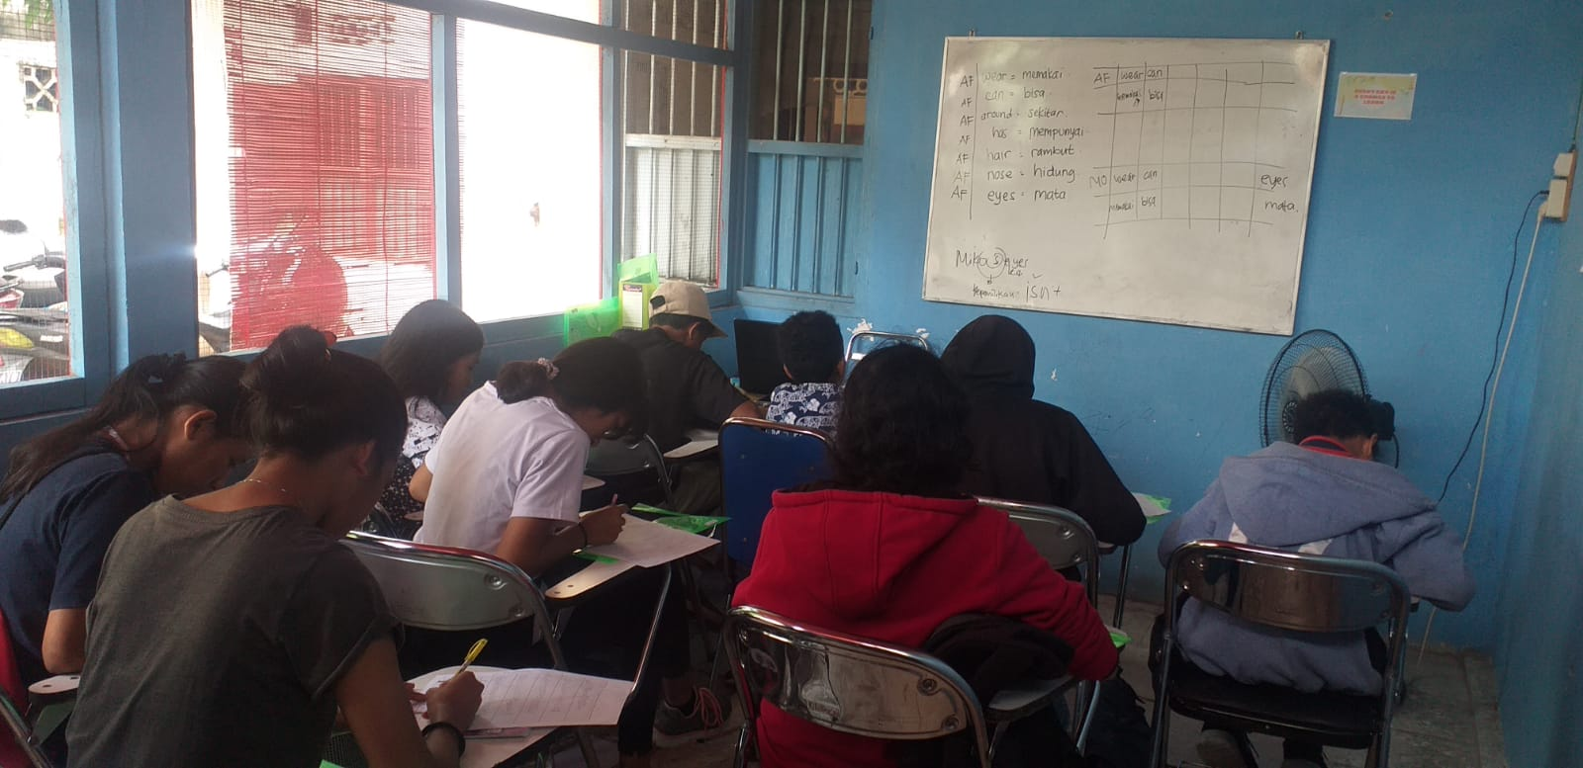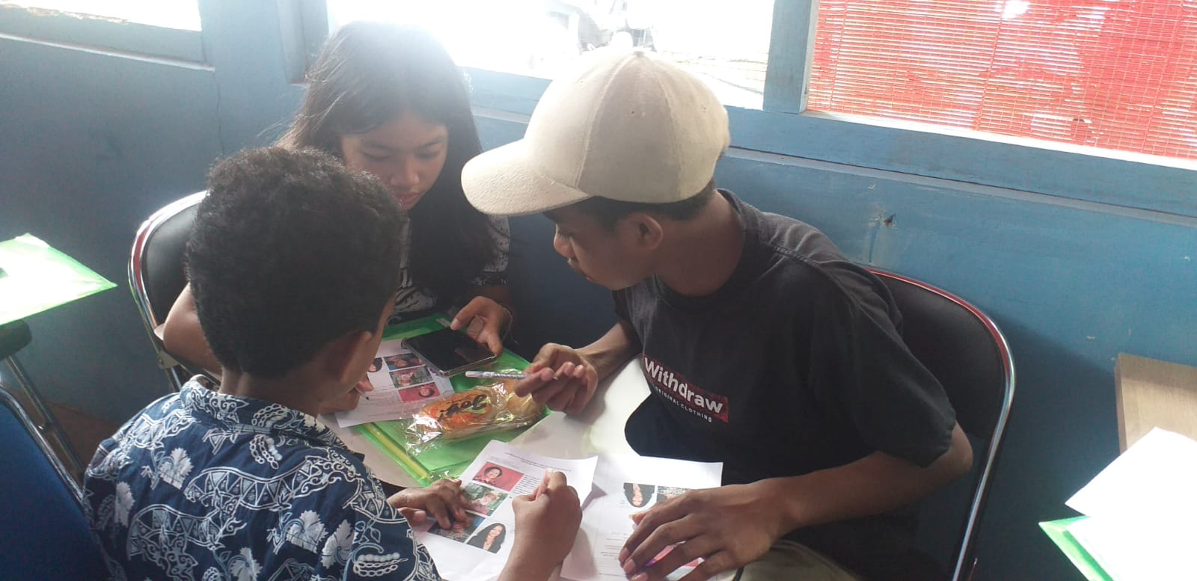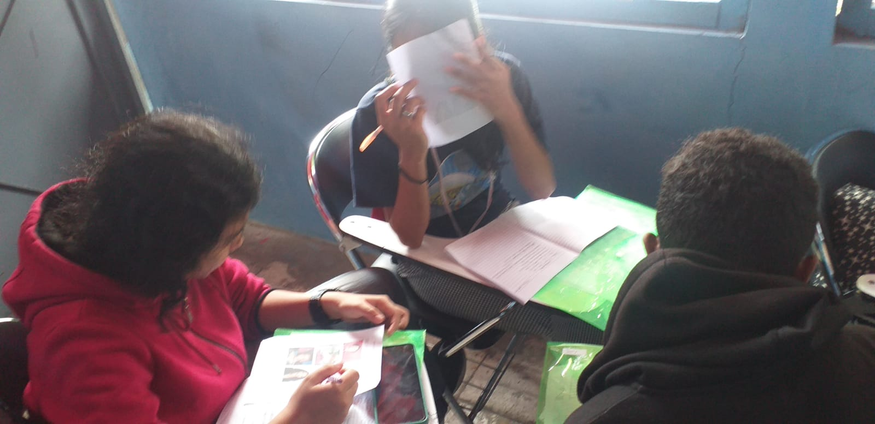

The RR began the class by asking a student (Sony) to lead a prayer in English. Then, the researcher gave some new vocabulary for SS to write for the next 6 days. While waiting for the SS, the researcher prepared the teaching material and lesson plan.

The RR showed the big picture and asked the SS to describe the person in Bahasa, Indonesia. Next, the RR and the SS translated them into English with a vocabulary list that the RR had already prepared and given.

The SS were excited to give opinions on the pictures. Some SS even asked another SS to mention one statement only. After understanding the basic knowledge of describing a person, the RR divided the SS into four groups consisting of three people to do peer tutoring. The RR had already understood the SS' abilities and differentiated them who would be student-tutors and tutees. The level of SS' ability was figured out from the pre-test and some previous meetings that had been held. Four students would be student-tutors, and the other would be tutees.

They did the exercise the RR gave with their group. The student-tutor helped them. After that, the RR asked one student in each group to come in front and present the answer. Each student judged the presentation of a particular group. Still, one student said, "Miss, all are right (benar) miss, karena semua group punya jawabannya sendiri-sendiri”.

The RR was happy because the SS had spoken her opinion by mixing English and Indonesian. The use of classroom language They also tried to speak English when they wanted to use the toilet or wash their hands, like "Miss, I want to go to the toilet, miss boleh?" or "Miss, can I drink?". The daily-written vocabulary also gave a significant improvement to SS. They still remembered and used the words in some written and spoken sentences.

Field Note
Day and Date | : | Thursday, 15th May 2023
Time | : | 10.30 – 12.00
Meeting / Cycle 2 | : | 6 / 1
Topic | : | Describing a person
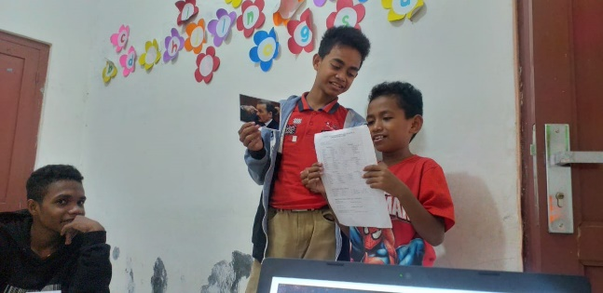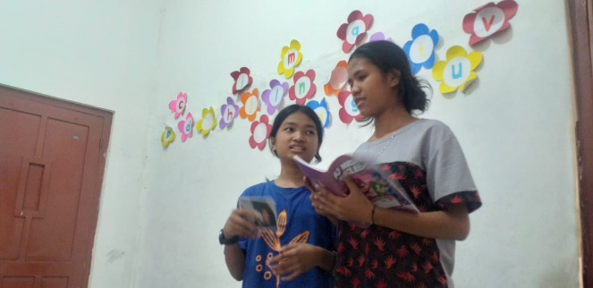
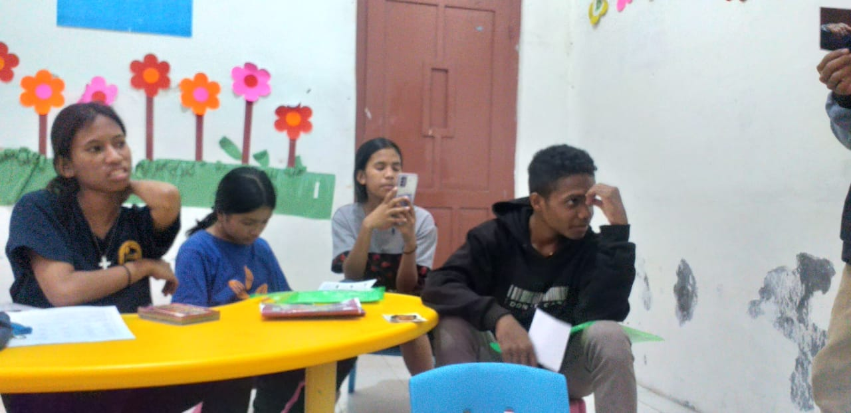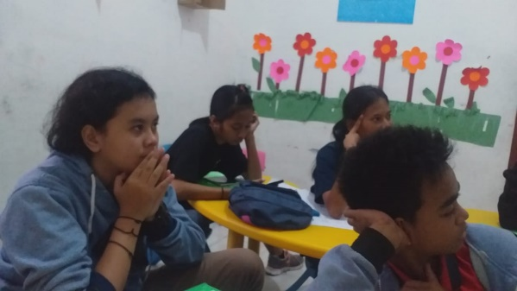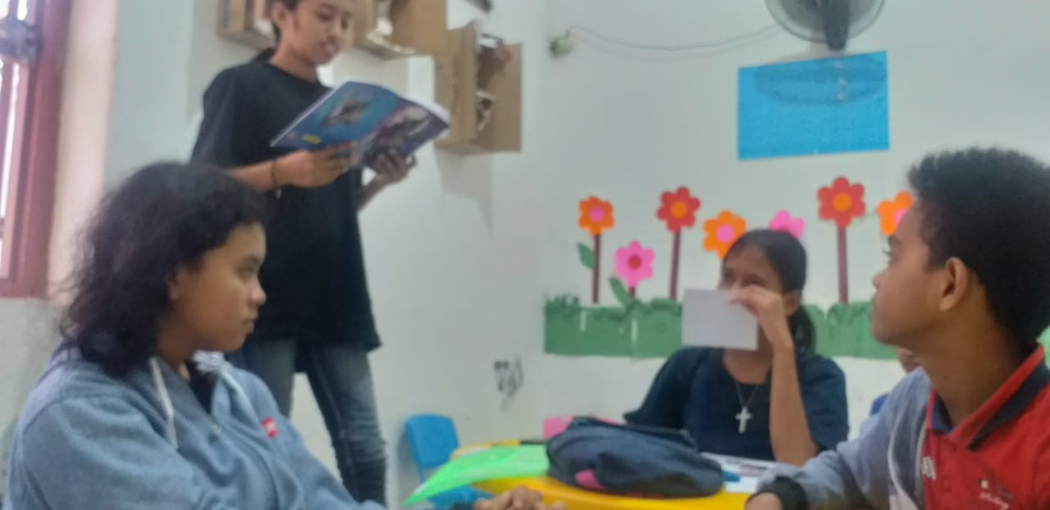

The class was supposed to be held on Friday, but as Friday is a public holiday, the class was moved to Wednesday. Several SS could not attend the class because they had another class.

The RR began the class by asking whether they did the homework, but two persons did it, and the RR rewarded each. It motivated another student to do the homework.

The two SS who did the homework discussed their answer with their classmates in front of the class. The RR asked the other students to listen and respond to the sentences they made, like "it was either correct or incorrect." All students participated in the activity and expressed their opinions. The class was alive.

Then, in the next activity, the RR gave several pictures of people they needed to describe using the vocabulary list provided by the RR and daily written vocabulary. Every student got a different classmate and worked in a group of three. The RR had divided the student-tutors and tutees. They studied and solved the problem together. While presenting the work, the student-tutor helped the tutee without being asked. There was not any student-tutor and tutee who worked individually in class. Therefore, the RR could concentrate on the content because the student-tutor already helped the RR task. One student in each group also presented the work in front of the class, scored, and judged by their friends.

As the last activity, the SS wrote the first open-ended reflective paper. It was about the activities that they have done in peer tutoring for some meetings. The SS was also confused. "Peer Tutoring itu kayak gimana miss?”. The RR explained that Peer Tutoring was the activity that all the SS had done by teaching and assisting their friend. Finally, they understood that the activity was called Peer Tutoring.

The class ended, and the SS requested the teacher to play a short video every Thursday.

Field Note
Day and Date | : | Friday, 19th May 2023
Time | : | 09.00 - 10.30
Meeting / Cycle | : | 7 / 1
Topic | : | Describe something and degree comparison.
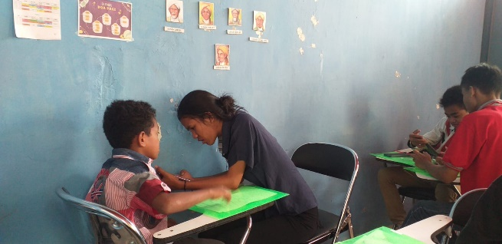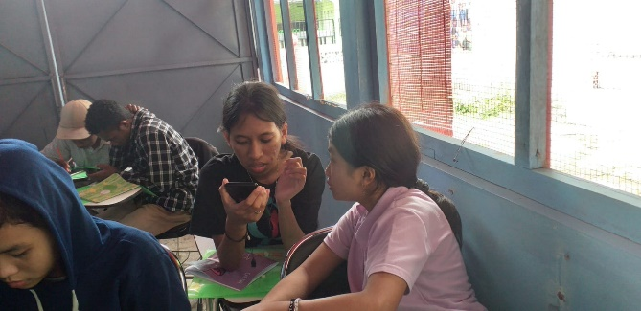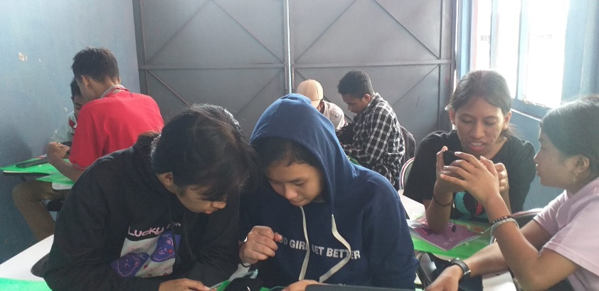

The RR explained today's material about comparing two or more things. The RR gave an example and explanation for about 10 minutes. Then, the RR asked students to work in pairs using peer tutoring. The rule was that all students could be student-tutors and tutees in return.
The RR gave an online worksheet that the SS should answer with their phone. The RR applied peer tutoring activities to each student so that they could help each other understand the material. Here, everybody can be a student-tutor and a tutee.
The RR gave an online worksheet that should be done only once. They may discuss each other within a group. A group got 5/15, meaning they only got five correct numbers out of 15 questions. The RR asked them to replay the online quiz again, and on the second try, they got 15/15. The peer tutoring activity helped the SS understand the material faster because the RR had students assist their friends.
The RR also spilled the tea about the post-test that would be done in the next meeting, which includes writing, listening, and speaking.

Field Note
Day and Date | : | Thursday, 22nd May 2023
Time | : | 10.30 – 12.00
Meeting / Cycle | : | 8 / 1
Topic | : | Post-Test about describing something and degree comparison.
The SS had been explained in a previous meeting that they would have a writing, listening, and speaking test. They had already understood the test system because the RR used the same test system as in the pre-test.

The SS did the writing test for about 5 minutes; then, the RR called students individually to do a speaking test with the RR. After all, students finished the writing and speaking tests during the time given. They joined a listening test in which the RR became the test examiner.

At the end of the class, one of the SS said that she experienced the listening test for the first time. She thought the listening test was fun and challenging: "Miss, tadi listening testnya seru loh miss, bener-bener aku harus konsentrasi". She also explained “Dulu aku sekolah tidak ada metode speaking yang bener-bener mengharuskan siswa untuk speaking secara langsung dan ini pertama kalinya juga saya mengikuti tes listening yang bener-bener kayak begini [In the past, I went to school but there was no speaking practice that really required students to immediately perform their speaking. It is my first experience to join a listening test]".

The Day of the Post-Test in Cycle 1 meant the researcher would interview the English teacher. The interview would evaluate English Language Teaching (speaking practice) in a multi-age class.

Field Note
Day and Date | : | Thursday, 6th June 2023
Time | : | 10.30 – 12.00
Meeting / Cycle | : | 9 / 2
Topic | : | Asking and Giving Information
The RR began the class by explaining the result of the previous speaking test in a glimpse. Encouragement and compliments were given to all the SS because the result of the post-test was better than the pre-test, and before they learned about Peer Tutoring and practiced speaking more in English class,
The class began with listening to a song and explaining a topic about asking and giving permission. The RR used examples with sentences that they regularly used in the class, like how to interrupt a teacher or friend politely, go to the restroom, wash hands, take a break for drinking, etc. The SS were excited to listen and even took notes on how to say those things in English. Therefore, they could use those phrases in real life.
The SS had used peer tutoring in Cycle 1; therefore, they were ready to do peer tutoring again in this cycle with different people. They used material in Appendix 10 to reference the vocabulary used in this topic. They did peer tutoring for each of them; they learned a lot, and sometimes, another group member asked another member to teach them how to pronounce a word. The RR also tried to walk around the group and heard a word like "Eh enggak gitu ngucapinnya deh, kan itu tanda tanya harusnya nadanya naik, may I attend Mia’s birthday? Kata day nya nadanya naik kan tanya". There was another student who told their friend “Kalau minta ijin pilih aja, may I, can I, could I terus lanjutin ngapain".
The first lesson plan in Cycle 2 was delivered well, and all activities could be done based on the time given. The activities used in meeting 9 were peer tutoring and making dialogue.

Field Note
Day and Date | : | Friday, 9th June 2023
Time | : | 09.00 - 10.30
Meeting / Cycle | : | 10 / 2
Topic | : | Asking and Giving Information: Permission
It is a time for students to perform in front of people about how to ask and give permission (Appendix 11). The students had done enough speaking practice; they would then show their speaking ability. They had done it before, so they were not afraid anymore. Some of them also memorized the text because they wanted a challenge. The RR scored a range for those who memorized and read the text in different scores.
This section was also special as the other pair of students from another group would assess the friends who were performing the dialogue. The RR had already explained the points at the beginning of meeting ten; therefore, the SS understood what speaking elements or points they should pay attention to. The RR also did the assessment individually to check the validity of the assessment. "Miss jadi guru itu kayak gini ya karena kita harus memperhatikan dan bertanggug jawab dengan nilai yang kita kasih ke orang tersebut” said by a multi-age student.
The students who performed the dialogue improved their abilities, such as not doubting anymore what they had uttered, speaking bravely and loudly, and memorizing the dialogue rather than reading it.
Peer Tutoring also had a good impact in that students were demanded to pay serious attention to the class and every individual's speaking performance.

Field Note
Day and Date | : | Thursday, 13th April 2023
Time | : | 10.30 – 12.00
Meeting / Cycle | : | 11 / 2
Topic | : | Asking and Giving Information: Someone's Ability and Willingness
The class began by listening to a song requested by students. The teacher had prepared a blank lyric, and students filled in the lyric by listening to a song. The students said they liked the music and figured out the title on YouTube.

The teacher explained a little bit about the previous material to recall their memories. Then, they gathered with a peer to do the exercise using peer tutoring from Activity 12. The writing and grammar lessons were given to the multi-age students to improve their cognitive abilities in speaking.

After the class, the researchers got a report from another teacher that students kept asking permission in English from another teacher, like: May I go to the toilet? Can I wash my hands? Could I move the fan? It was a great experience as students performed English speaking outside the English class.

Field Note
Day and Date | : | Friday, 16th June 2023
Time | : | 09.00 - 10.30
Meeting / Cycle 2 | : | 12 / 2
Topic | : | Asking and Giving Information: Someone's Ability and Willingness
The students remembered the last topic they learned: "how to ask permission, someone's ability to do something and willingness". In this part, the SS needed to do speaking practice with a greater community by asking them to have short conversations.

The RR provided a handout, and students should walk outside the classroom during the English class to find people whom they were willing to talk to. The conversation was simple: introduce themselves, ask someone's willingness to be interviewed shortly, write the response, and express gratitude for the time being.

Field Note
Day and Date | : | Friday, 20th May 2023
Time | : | 09.00 – 10.30
Meeting / Cycle | : | 13 / 2
Topic | : | Post-Test Cycle 2
The students would do a Post-Test in Cycle 2. However, the RR had already given hints about the Post-Test topic in meeting 12. Therefore, the SS could make and prepare the dialogue.

The speaking test was related to asking and giving permission, someone's ability, and willingness. Students just made a dialogue with some criteria explained. The RR encourages the students to make it as creative as possible. The peer assessment was also used in the Post-Test, but the RR also got her participation to assess the student's speaking ability.

