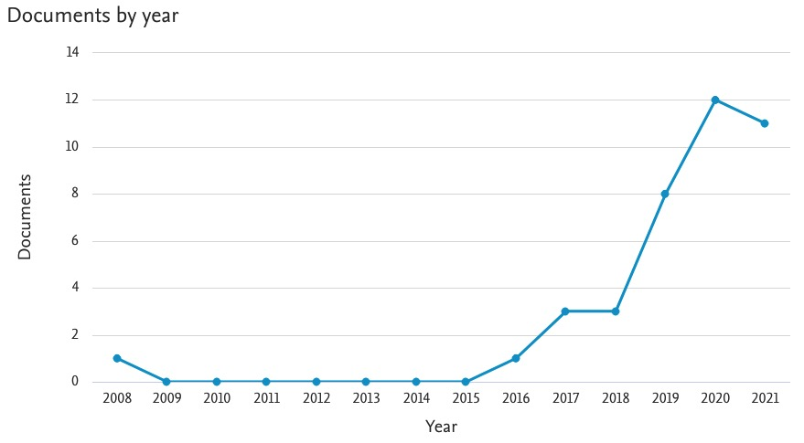
Figure 1. Development of Scopus indexed research publications for keywords “business model” and “circular economy” and “small and medium enterprise” or “SME” or “micro and small medium enterprise” or “MSME”
(Source: Scopus.com)
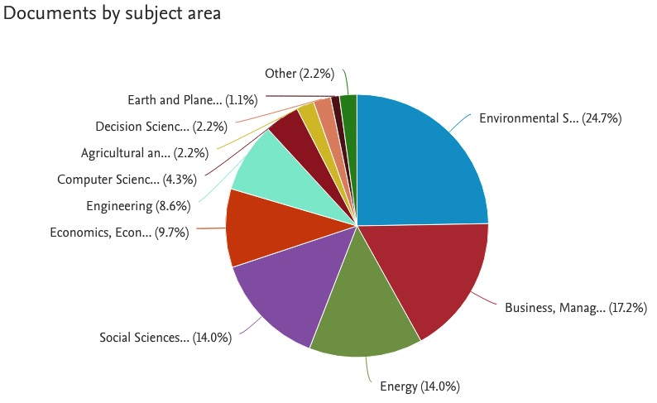
Figure 2. Scientific subjects of Scopus indexed research publications for keywords: “business model” and “circular economy” AND “small medium enterprise” OR “SME” OR “micro small medium enterprise” OR “MSME” (Source: Scopus.com)

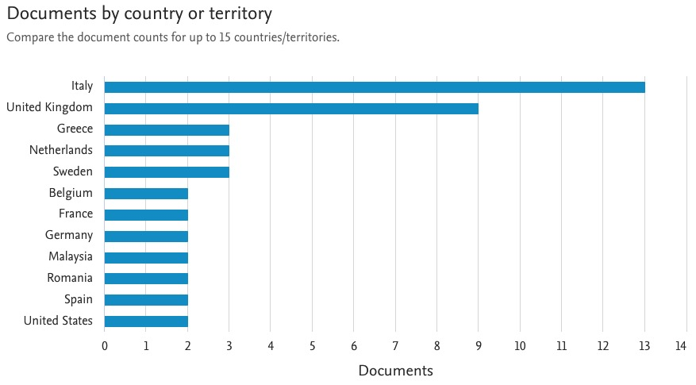
Figure 3. Top 15 countries of origin of authors of Scopus indexed research publications for keywords “business model” and “circular economy” and “small and medium enterprise” or “SME” or “micro and small medium enterprise” or “MSME”
(Source: Scopus.com)

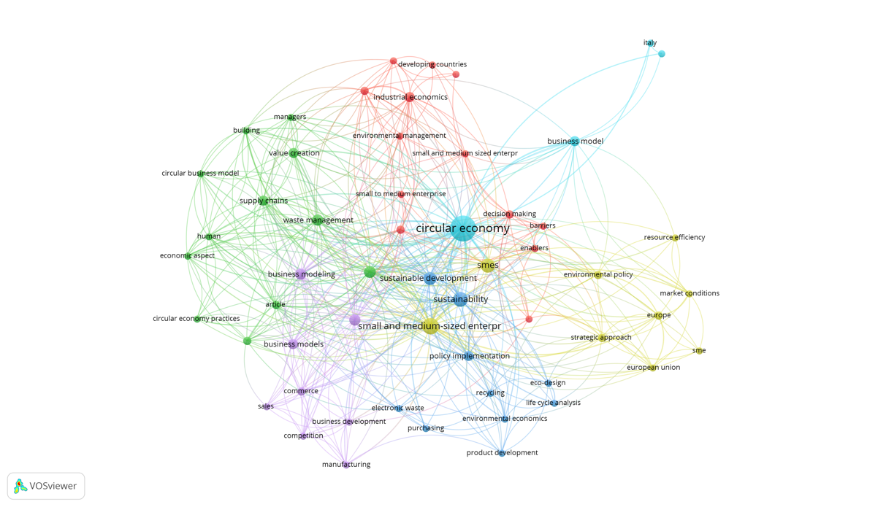

Figure 4. Results of data processing using VOSviewer for Scopus indexed research publications for keywords “business model” and “circular economy” and “small and medium enterprise” or “SME” or “micro and small medium enterprise” or “MSME”
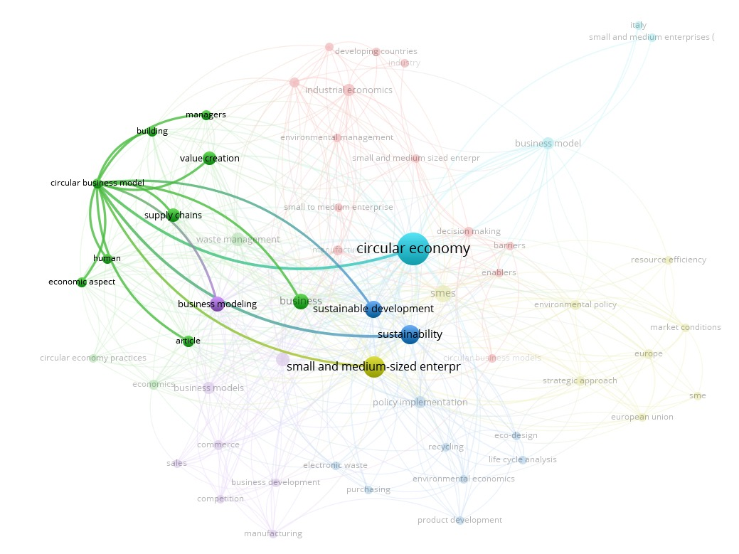
Figure 5a. Processing results of the VOSviewer circular business model (green cluster)
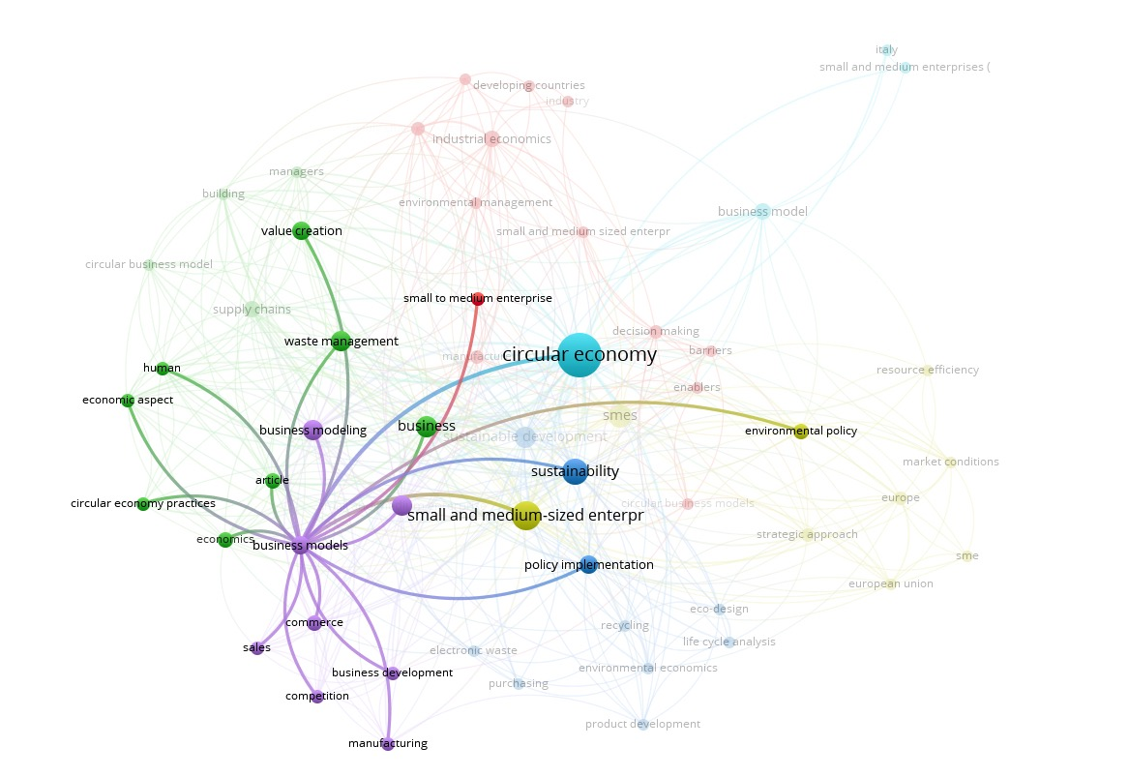
Figure 5b. Processing results of the VOSviewer circular business model (purple cluster)
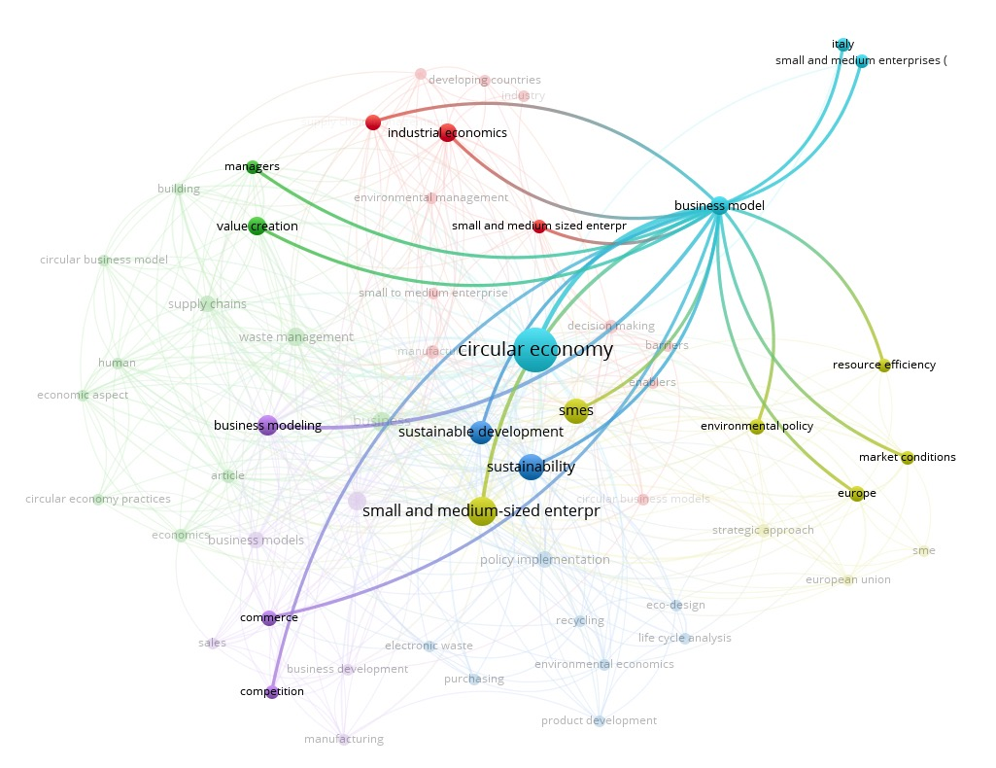
Figure 5c. Processing results of the VOSviewer circular business model (turquoise cluster)

