ETIKONOMI
Web: http://journal.uinjkt.ac.id/index.php/etikonomi
Email: etikonomi@uinjkt.ac.id

COPYRIGHT TRAN SFER AGREEMEN T FORM

Name of Principal Authors: Allah Ditta Nawaz

Address of Principal Authors: Ph.D. candidate at the Sukkur IBA University, Sukkur, Pakistan

Tel/Fax: +92 302 7326692
E-mail: allahditta.phdmgt16@iba-suk.edu.pk
Author(s) Name: Allah Ditta Nawaz, Suresh Kumar Oad Rajput

Manuscript Title: Impact of Policy Uncertainty on Stock Markets Correlation

Date Received: ………………………………………………………………………………………………………………………

1. I/We submit to the Etikonomi . I/We certify that the work reported here has not been published before and contains no materials the publication of which would violate any copyright or ot her personal or proprietary right of any person or entity.
2. I/We hereby agree to transfer to Etikonomi/ Publisher for the copyright of the above - named manuscript.
3. I/We reserve the following: (1) All proprietary rights other than copyright such as
patent rights. (2) The right to use all or part of this article in future works of our own such as in books and lectures. Print or Type Name and Title of Author.

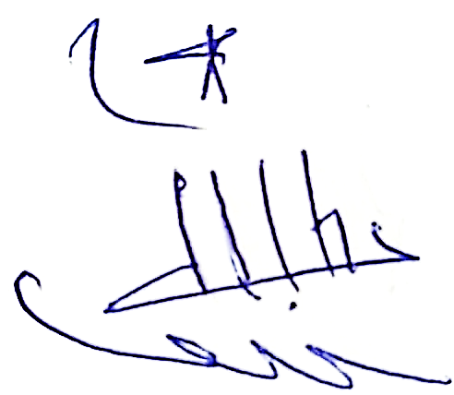

Date:………………………………
Signature (original)

………………………………
( When t here is more than one author, on ly one signat ure will suffice)

