The Impact of Financial Inclusion on Public Financial Services Education through Financial Technology in Sleman Regency, Indonesia

I Made Laut Mertha Jaya
Sekolah Tinggi Ilmu Ekonomi Bisnis dan Perbankan
Email: mad.jaya@yahoo.com; mad.74ya@gmail.com

Abstract
The purpose of this study is to know the impact of financial inclusion on public financial services education through financial technology. This research was conducted in Sleman Regency because the area was quite large in Yogyakarta, and was ranked third. This type of research is quantitative research. Data collection methods used are questionnaires and literature studies. Data analyses used in this study are the validity test, reliability test, descriptive statistical test, and SEM (Structural Equation Modeling) analysis test. The results of this study found that financial inclusion has been proven to have no significant impact on public financial services education. However, financial inclusion has proven to have a significant impact on financial technology in Sleman Regency in 2018. In addition, financial inclusion through financial technology has also proven to have a positive significant impact on public financial service education in Sleman Regency in 2018.

Keywords: Financial Inclusion, Financial Technology, and Public Financial Services Education

A. Introduction
Financial Inclusion after the economic crisis occurred in 2008 adversely affected the financial stability in Indonesia. When the financial stability of a country is unstable and does not perform efficiently, it can cause the fund allocation process to not work well. According to Bank Indonesia (2014), financial inclusion is all efforts made to remove all forms of obstacles that are reviewed based on price and non-price aspects to maximize the benefits and access to services of formal financial institutions for the community. The Inclusive Financial goals are:
- Achieve economic growth through equal distribution of income,
- Poverty alleviation and
- Financial system stability (Bank Indonesia, 2014).
Meanwhile, the general goal of financial inclusion is to spread the economic growth in several regions in one country. This policy is widely used in countries that have a low annual gross income level, and most of the populations still live in remote areas, they do not have legal identity document, and many people still live in urban suburbs, so they generally belong to “unbanked” society.
Unbanked Society is all citizens who do not have traditional bank accounts or access to banking services. This is because they have gained very low level of education, so they only work in the informal business sector, and live with minimum financial conditions. So, this condition also has an impact on the difficulties to fulfill their life needs. On the other hand, they also have difficulty in obtaining access to banking services because they are in the community which is classified as the “unbanked”. Generally they do not believe in the banking system. Another factor is the financial service infrastructure system that is still limited to reach them. The following figure describes the proportion of population with access to financial services in Asia.
Figure 1. Proportion of the Population with access to financial services in Asia.
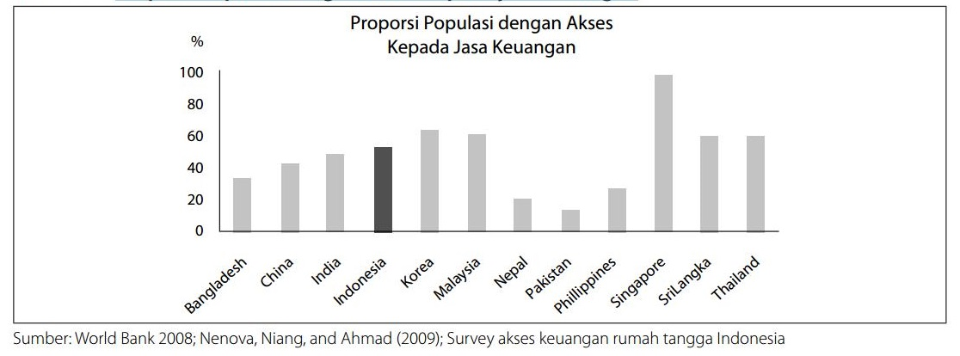

Source: World Bank, 2018.
Based on the results of a survey conducted by the World Bank (2010), it shows that Indonesian family who are having access to formal financial institutions is only 49% (percent). Similar things were also found by Bank Indonesia in the Family Balance Sheet Survey (2011) which shows that the percentage of family who save in formal financial institution and non financial institutions are only 48 % (percent). So, people who have no savings at all (unbanked) either at the bank or at Non-bank financial institutions are still relatively very high at 51-52% (percent). For those reasons, it is clear that the informal sector actually serves more customers than the banking sector. These results led to the ideas that the government should immediately set the inclusive financial strategies, and encourage economic activity among the society who have not enjoyed financial services yet to accelerate income equity and poverty alleviation in Indonesia.
An inclusive financial inclusion strategy is described in 6 pillars, namely; financial education, public financial facilities, a map of financial information, supporting policies/regulation, intermediation and distribution facilities, and consumer’s protection (Bank Indonesia, 2014). In building a sustainable inclusive financial program, Bank Indonesia, the ministries, and other related institutions should make a great team and coordination in order to make some development, priority determination and program implementation. In addition, monitoring activities and program evaluation are needed regularly. So, the improvement of access for the Unbanked people to get financial services can be maximally achieved.
The survey results of Mc Kinsey & Company (2015) concluded that since 2011 the adoption of digital-banking services has been increased rapidly throughout Asia. Customers switch to use computers, smart phones and tablets in their interactions with banks. So, the activity of visiting the branch office and talking via telephone lines to enjoy banking services began to decrease.
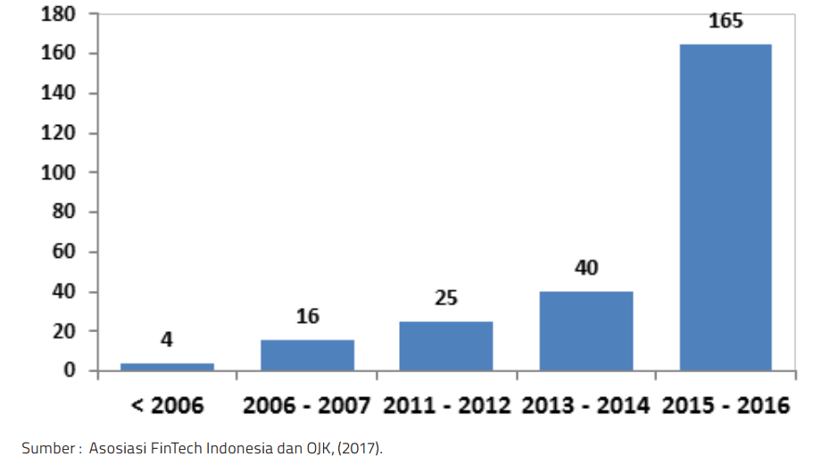
Figure 2. The Graph of FinTech Developments during 2006-2016 in Indonesia
Source: Association of Fintech Indonesia and the Financial Services Authority (OJK), 2017.
Based on the data in the graph above, it can be seen that before 2006, the number of FinTech participating companies were only 4 companies and increased to 16 companies in 2006-2007. Over the next four years there were 9 companies that carried out FinTech activities, and then the total number were 25 companies in 2011-2012. The number of FinTech companies in that year only grew around 177.78%, it was lower than the number in 2006-2007 which could grow up around 300%. In 2013-2014 the number of FinTech companies increased by 15 companies and the total became 40 companies, or it grew around 60%. A spectacular development took place in 2014-2016, where the number of FinTech companies increased by 125 companies and the total became 165 companies. It means that there was an increase in the number of FinTech companies by around 312.5% ​​if the number was compared to the previous year.
The consumers became more and more dependent to the technology make the development of FinTech faster. In addition, FinTech also supports various financial services in Indonesia. At present, it is estimated that there are more than 140 start-up companies and they are predicted to continue to grow. The increasing number of users makes the services offered by fintech were also increasingly varied, such as payments, financing/loans, investment in the capital market, and then the insurance is packaged more attractively with a touch of fintech.
In addition, the government also needs to carry out an education on the financial services to the community, including people who are classified as unbanked. It can be done by working with academics and activists as well as local government. The aim of financial services education is facilitating the public in obtaining information related to financial services, especially banking and the tools of payment. So, people are expected to understand the advantages, risks, and costs of the financial services and the tools of payment they probably use (Bank Indonesia 2018). Financial education is considered as one of the strategies to be able to improve capability in managing finance which begins with an improvement of understanding (knowledge) and public awareness about financial products and services. The scope of this financial education includes (National Strategy for Inclusive Finance, 2018):
- The knowledge and awareness about various financial products and services;
- The knowledge and awareness about the risks of financial products;
- Customer protection; and
- Financial management skills.
This research was conducted in Sleman Regency because the area is quite large, and it has got the third rank. The administrative area of ​​Sleman Regency reaches 574.82 km². Furthermore, Sleman Regency has a large population which is around 1,141,718 people and spread over 17 sub districts, 86 villages and they are divided into 59 villages that are categorized as urban, and 27 villages are still rural (Sleman Regency statistics, 2016:1). However, other data stated that the amount of savings made by the people in Sleman Regency is still smaller than the loan amount. It is verified by statistical data from Sleman Regency in 2016 which showed that the amount of savings is 92,312,087 million and the number of loans is 140,129,269 million. Thus, it can be concluded that knowledge and awareness about finance as an indicator of financial education is still quite low. The government along with the team should provide knowledge as the indicators of financial education mentioned previously in very simple way and clearly so the people will understand and apply them easily.
Based on the description above, then further studies are needed to be able to provide empirical evidence of the effects of financial inclusion on public financial services education through FinTech in the community in Sleman Regency. So, the purpose of this research is to know the effect of financial inclusion on public financial services education through financial technology.

B. THEORITICAL FRAMEWORK AND HYPOTHESIS DEVELOPMENT
- Financial Growth Theory
Different types of development elements can improve markets, the financial system naturally influences the allocation of resources throughout time and spaces. The existence of Bank increases the acceleration of information about the company and the manager will change it into the form of credit allocation. Financial System has some advantages such as it can handle investment information, capital allocation, investment control, and it can also draw management report of a company. In addition, the financial system is also able to facilitate trade, diversification and risk management, mobilize savings, and facilitate the exchange of goods and services.
Thiel (2001) explains that by using the approach of financial institution relations with information and costs of asymmetric agents can provide a more prominent role of the financial system in achieving efficient capital allocation. Financial institutions tend to accumulate specialized knowledge in evaluating and monitoring investment projects that have comparative advantages for evaluating risks and designing financial contracts. In certain cases, bank industry activities can get some benefits from the ongoing information. Thus, increasing the efficiency of the financial system can lead to the growth of a country's Gross Domestic Product (GDP).
- Economic Growth Theory and Life-Cycle (Savings and Investment)
Economic growth is a growth of long-term capacity to provide various economic goods to meet the needs of its population. It also determined by the possibility of advances and adjustments in technology, institution, and ideology toward the existing sequences (Kuznet, 1971). Institutional development can be reviewed through the financial industry sector. If the establishment of a system is done in a very good order, it can support the accomplishment of economic transaction funding for economic actors. The financial system consists of units of financial institutions such as banking institutions and other financial institutions, and markets that interact each other with the aim of channeling funds for investment, and they will provide payment system facilities for productive activities (Beck, et al, 2000; Buckland, et al, 2005).
Modigliani (1986) argues that the understanding on the conception of economic growth emphasizes behavioral finance portfolio in terms of investment and savings. It is stated in The life-cycle permanent income theory of consumption and saving. This view describes the choice of how to maintain a stable standard of living in dealing with various income changes in a person's life time. It also illustrates the relationship between income, consumption and savings. The life cycle hypothesis involves individuals in planning consumption and savings behavior in the long term, as described in the following figure.
Figure 3. Lifetime Income, Consumption, Savings, and Welfare in the Life-Cycle Model.
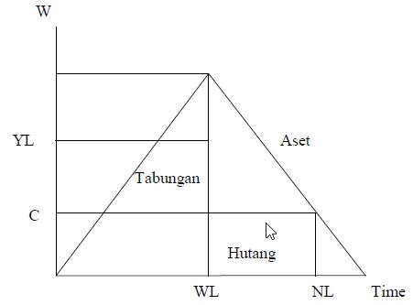

Source:
Modigliani, 1986
Information:
WR = Welfare
WL = Work life
YL = Annual labor income
NL = Number of years of life
C = Consumption
The picture above shows that consumption looks constant over time (WL years), so that an individual can save and collect assets. At the end of working period, a person begins to withdraw the assets and does not save for the rest of their life (NL-WL), so the asset will be zero at the end of their life.
- Institutional Theory and the Financial System
The financial system functions to channel funds from savers to borrowers to pay for the productive activities. There are 3 (three) ways in channeling funds from savers to borrowers, namely:
- Direct Finance, the owner of the funds (surplus units) directly lend the fund to the borrower (deficit unit) without the intervention of a financial intermediary, so there will be a submission of evidence of debt, such as bonds, stocks, or promissory note to the owner of the funds. The evidence is primary securities.
- Semi Direct Finance, the process to transfer the funds borrowed from surplus unit to deficit unit will be assisted by an individual or institution intermediary. There are two ways to do this process, it is through an investment bank or broker/dealer. If you use the services of an investment bank, then the transaction is known as the primary market. The Primary Market is a financial market that issues first-time securities and it is sold to the first buyer, and it is called IPO (Initial Public Offering). If the process is done by the broker / dealer services, the transaction is known as the secondary market (secondary market), which is a financial market that sells securities and has been issued by the exchange. Brokers are agents of investors who bring together buyers and sellers of securities, while dealers are those who link up the buyers and sellers of securities by buying and selling at the time of the transaction.
- Indirect Finance, the transfer process of loan from surplus units to deficit unit through a financial intermediary, such as banks, insurance companies, retirement funds, securities financing, and mutual funds.
Formal financial institutions, both banks and non-banks, have an important role in the financial system to make the financial structure foundation accessible to the public and economic actors (Cheng and Degryse, 2006).
- Financial inclusion
Financial inclusion is a trend after the crisis occurred in 2008. It is based on the impact of the crisis for the groups called in the bottom of the pyramid. This group is generally unbanked and actually recorded very high outside the developed countries. Financial inclusion according to World Bank (2008) cited by Supartoyo et al (2013) is a comprehensive activity that aims to eliminate all form of obstacles both in the form of price and non price in providing the access for the community to use or utilize formal financial services.
A financial inclusion exists because there is financial exclusion. According to the World Bank (2005), around 3 billion people in the world do not have access to formal financial services. Financial exceptions include savings, credit, banking transactions, and insurance (World Bank, 2005). Financial exclusion is the inability to access formal financial institutions due to various obstacles, such as conditions, prices, marketing, and obstacles from the perceptions of individuals and other entities.
Financial inclusion is one of the strategies to encourage economic growth through equal distribution of income, poverty alleviation and financial system stability. Low financial inclusion will cause high income inequality (Kempson et al., 2004). Thus, countries that have low levels of inequality tend to have relatively high financial inclusion (Buckland et al, 2005). The level of financial inclusion can increase in response to a country's prosperity and inequality reduction. The informal sector is also able to contribute a large share of employment in some underdeveloped countries that do not facilitate the process of financial inclusion (ILO, 2002). In developed countries, the formal financial sector serves the majority of the population, while in developing countries, especially low income groups have simple access to formal and informal financial institutions (Peachy and Roe, 2004). Thus, financial inclusion is not an option, but becomes a necessity and banking is the main driver that is able to implement it (Nengsih, 2015).
- Public Financial Services Education
Education concept is an investment (education as Investments) and has been growing rapidly. Some countries believe that the development of the education sector must be built before other sectors. The concept of investing in human capital (human capital investment) that can support economic growth has actually begun to be considered since the era of Adam Smith (1776) and classical economists before the 19th century which emphasized the importance of investing in human skills. A speech entitled “Investments in Human Capital” is the basic theory of modern human capital. The main message of the speech is simple, it shows that the process of acquiring knowledge and skills through education is not a form of consumption that will spend the budget, but an investment.
In developed countries, a paradigm which calls the education as a consumptive aspect has shifted. Education becomes Human Capital Investment and it is one of the main sectors. Therefore, the government's attention to the development of the education sector began to increase starting from budget for the education sector that was not lower than other sectors anymore, so that the success of education investment correlated with the progress of its macro development.
Education and socialization of Financial Literacy is currently still held by the Financial Services Authority (OJK), which has established regulations for Financial Service Providers (PUJK). However, the number of PUJK that submitted the Education Plan report was only 438 PUJK out of 2,333 PUJK in Indonesia or around 15.78%. It shows that the level of obedience to the requirements of education and consumer protection is still low. Educational activities that have been carried out still have misunderstanding between educational activities and marketing, so the purpose of Financial Literacy education is often not achieved (OJK, 2015).
The level of financial literacy of each person is different. Huston (2010) explains that some factors such as habits, cognitive, economy, family, peers, communities, and institutions can affect the financial habits (financial behavior) of a person. Meanwhile, Monticone (2010) explains that the financial literacy level of a person is influenced by demographic characteristics (gender, ethnicity, education and cognitive abilities), family background, wealth, and time preference. Capuano and Ramsay (2011) explain that personal factors (intelligence and cognitive abilities), social and economy can influence a person's financial literacy and financial behavior. So an individual can be said to be financial literate when someone has the knowledge and ability to apply that knowledge.
- Financial Technology (FinTech)
FinTech is defined as technological innovation in terms of financial services that can generate business models, applications, processes or products with material effects associated with the provision of financial services (FSB, 2017a). FinTech's activities in financial services can be classified into 5 (five) categories (FSB, 2017a), namely:
- Payment,
- Transfer,
- Clearing, and
- Settlement, this activity is closely related to mobile payments (either by banks or non-bank financial institutions), electronic wallets (digital wallets), digital currencies and the use of distributed ledger technology, DLT) for the payment infrastructure (Griffoli, 2017). These models aim to improve financial inclusion and ensure greater consumer access to payment services and ensure smooth functioning of the payment system. This model can also contribute to the management of a large number of transactions and transfers and large settlements between financial institutions.
- Deposits, loans and capital rising. The most common FinTech innovation in this field is crowd funding and P2P (peer-to-peer) online loan platform, digital currencies and DLT. This application is closely related to financial intermediation.
The evolution of FinTech was originated from credit card innovation in the 1960s, debit cards and the terminal that provides cash such as automatic teller machine / ATM in the 1970s (Arner et al , 2015; FSB, 2107b). Then it is followed by the existence of telephone banking in the 1980s and various financial products following the capital market deregulation and bonds in the 1990s. Next, internet banking appears which drives the existence of branchless banking and banking activities carried out remotely. These changes make the transaction in the bank office and face to face interaction between the customers and the bank officers are no longer necessary. In addition, there is high technology of mobile devices which make financial transactions easier.
The change has encouraged the beginning of direct financing and direct intermediation, which predicted to replace indirect, expensive and inefficient financial intermediation (FSB, 2017b). There are two main factors that bring the evolution in financial technology innovation (Bernanke, 2009; Awrey, 2013; De Haan, et al, 2015; FSB, 2017a; and 2107b), they are demand and supply side.
The factors that were originated from the demand side consist of: First, consumers’ preference change which influences consumers’ demand towards innovation. Easy internet access and internet network users’ ability to make a real time transaction has built high expectations especially about the comfort, speed, cheaper cost, and ease of using financial services. On the other hand, preference changes also occur because of the influence of demographic factors which affect the demand such as bigger acceptance from the group who originally grow with the digital technology (digital natives) and the millennial.
The second is technological evolution. Technology innovation in financial services has growth rapidly. The development is carrying out new ways and also taking advantages of different business models, for example business models that use big data technology, artificial technology (AI), machine learning, cloud computing and biometrics. In addition, different innovation is also applied to another new technology, it is DLT (He, et al., 2017 and Griffoli, 2017). Business models and new technology applications are possibly creating a lot of new actors in the financial service sectors. Famous magazine, the Economist (Issue 9 May 2015) states that technological advances in the field of financial services have the potential to democratize finance. The combination of a number of technologies along with devices access that are on the consumers’ hand, such as mobile phones and other mobile devices that connect to the Internet have added a new dimension to the digital world. Greater connectivity allows new forms of service provision.
- Research Framework and Hypothesis
Based on the theory described earlier, the research framework formed in this study is as follows.
H₁
H₃
Financial Inclusion (X)
Public Financial Services Education (Y)
Financial Technology (Z)
H₂

Figure 4. Research Framework
1. The Impact of Financial Inclusion on Public Financial Service Education
The main targets of inclusive financial programs in Indonesia are migrant workers and people who live in remote areas. This inclusive finance program starts from the category of unbanked community groups, this group consists of productive workers but they are still poor, quite poor and not poor (Banking Research and Regulation Department-Bank Indonesia, 2013). The lines used for financial inclusion in Indonesia are carried out through financial institutions which are banks, non bank institutions, and the government. Meanwhile, financial products / services offered are in the form of deposits, credit, insurance, pension funds, and so on. In addition, the government also offers public finance through subsidies, fiscal incentives, social welfare programs, cash transfers (BLT/direct assistance) for the poor, and so forth.
The inclusive financial strategy has six pillars, namely: 1. Financial Education (Financial Education); 2. Public Financial Facility (Loan Facility to the Community); Community Service Guarantee (Jamkesmas); 3. Mapping on Financial Information ; 4. Supporting Regulation /Policy, such as branchless banking (bank services without offices); 5. Intermediary /Distribution Facility (facilities for expanding financial services); and 6. Customer Protection (Banking Research and Regulation Department-Bank Indonesia, 2013). The low level of financial inclusion in Indonesia is due to the fact that it is still present barriers to accessing formal financial institutions. This obstacle is caused by lack of public knowledge (financial literacy) on the function of financial institutions and product mismatches offered by financial institutions as needed low income community. This is supported by a survey conducted by the FSA in 2013 which stated that the level of financial literacy of the Indonesian population was divided into four parts, namely well literate (21.84%), sufficient literate (75.69%), less literate (2.06%), and not literate (0.41%). Meanwhile, financial inclusion can also be obtained associated with individual characteristics. The poorer, the lower education, and the younger a person is, the lower financial inclusion will be possibly happened in Indonesia ( financially included ).
The results of research conducted by Wachira and Kihiu (2012) regarding the influence of financial literacy on access to financial services in Kenya in 2009, concluded that access to financial services was not only influenced by the level of financial literacy . Will however , be influenced by the level of income, the distance from the bank, age, marital status, gender, household size, and education level. Allen, Demirguc-Kunt, Klapper, and Martinez Peria (2012 ) also found that the possibility of having a bank account and saving at a bank was higher among those who were richer, lived in cities, were older, educated, worked, and married individuals . So based on the description above, the hypothesis formed is
H₁: Impact of Financial Inclusion affects the Public Financial Service Education
2. The Impact of Financial Inclusion on Financial Technology
The survey conducted by the OJK in 2016 on the level of financial literacy and inclusion showed that the financial literacy rate was lower than the level of financial inclusion. However, in this digital 4.0 era to reach Indonesia's financial inclusion index target of 75%, the Ministry of PPN (2017) said that the development of financial technology can support the growth of the financial inclusion index. However, no financial inclusion research has been carried out on technological developments. However, based on the Bank Indonesia Financial Stability Review (2017), Fintech is considered capable of reaching people who cannot be reached by banks.
The existence of Fintech aims to make it easier for people to access financial products, facilitate transactions and also increase financial inclusion. This goal can be achieved with opportunities based on the 2014 Global Index data contained in the annex of the National Strategy for Inclusive Finance (2016), only about 36% (thirty six percent) of the adult population in Indonesia have access to formal financial institutions . So, Fintech can target other Indonesian adults to get financial services. According to OJK (2017), the increasing use of Fintech is becoming one of the drivers for increasing national financial inclusion. Where, Indonesian people who have internet penetration according to the APJII survey (2016) have reached 51.8%, namely 132.7 million people out of 256.2 million inhabitants Indonesia. Thus, digital and internet-based financial services will be very easy to reach by people in various quarters and areas of residence. So based on the description above, the hypothesis formed is
H₂: Impact of Financial Inclusion affecting Financial Technology

- The Impact of Financial Inclusion on Public Financial Service Education through Financial Technology
Someone who has a low level of knowledge or education about finance will be easily lied to in using his money and vice versa (Lestari, 2015). However, the increase in financial knowledge will also be followed by the growth of the financial inclusion index. Based on Presidential Regulation No. 82 2016 on the National Strategy for Inclusive Finance establishes that the target of 75% of the adult population have access to financial services in 2019. The development of information technology and the Internet penetration rate which supported the rapid, then emerged a few digital financial services that facilitate the public to gain knowledge and education about finance and financial services , which is known as the financial technology.
The level of knowledge about finance is financial awareness and knowledge of financial products, financial institutions , and concepts regarding financial management skills (Xu and Zia 2012). According to the Authority Financial Services (2016) the knowledge, skills and confidence that will all p engaruhi attitudes and behaviors to improve the quality of decision-making and financial management , in order to achieve the welfare of so-called financial literacy . With this definition, it is expected that consumers of financial products and services as well as the wider community not only know and understand financial service institutions, as well as financial products and services, but also can change and improve people's behavior in financial management , so they can improve their welfare. Distribution of Fintech companies in Indonesia in 0218 can be seen in Figure 5 below.
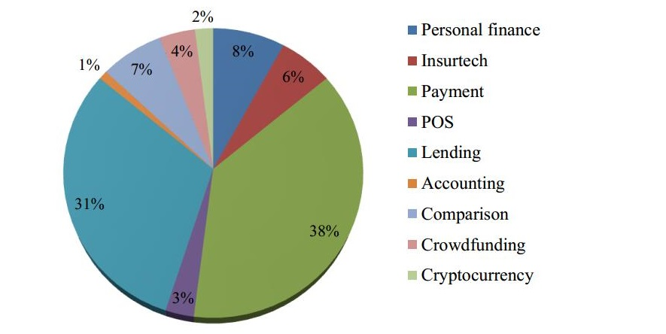
Figure 5 Distribution of Fintech companies in Indonesia in 2018
Source: Fintech News Singapore (2018)
Based on the survey of Fintech News Singapore, it can be seen that Indonesian community use more payment-based Fintech services up to 38% and it was followed by 31% of loan services. It shows that Fintech is able to support government in providing wider and more efficient payment and loan finance services in Indonesia. The total number of investment of Fintech in Indonesia in 2017 reached 2.29 trillion Indonesian Rupiahs according to Daily Social and Statistics on the Indonesia Fintech Report (2018). According to the Report of the World Economic Forum (2015) in an article about Indonesian Fintech, Indonesia will be one of the largest digital market in Southeast Asia in 2020. These predictions represent an opportunity for development of digital financial services in Indonesia, so it is necessary to fulfill the needs of the finance services for the community. In addition, the government also needs to act in response to that condition more aggressively to provide financial knowledge for unbanked people so that financial inclusion growth will improve in the future. Based on the description above, the hypothesis formed is;
H₃: Financial Inclusion affects the Public Financial Service Education through Financial Technology

C. RESEARCH METHOD
This type of research is quantitative research. Data collection methods used in this study are questionnaires and literature studies. The type of data in this study is secondary data. The Population of this study is residents who live in Sleman Regency Yogyakarta. The sampling method for this study is purposive sampling technique. The criteria for the sample in this study are: 1.Sleman residents who have lived for at least 10 years and have an Id card of Sleman Yogyakarta, 2. Sleman residents who do not have saving books and loans at the bank, 3. Sleman residents who have at least elementary school education and income, 4. Sleman residents who are at least 18 years old and have a job, dan 4. Sleman residents who do not have any knowledge about banking. So, based on the above criteria, the number of samples set in this study is 200 people. Likert Scale is used to determine the value of each answer.
Table 1. Measurement indicator of research variables
No. | Variable | Indicator | Number of questions / statements
1. | Financial Inclusion | - Financial Knowledge  - Financial Behavior  - Financial Attitude | 1,  2,  3,
2. | Public Financial Service Education | - Knowledge about financial planning.  - Knowledge on financial management.  - Knowledge about credit.  - Basic knowledge about investment.  - Knowledge about money and assets. | 4, 5,  6, 7,  8,  9, 10,  11, 12,
3. | Financial technology | - Risk and investment management  - Market provisioning,  - Cashless society. | 13,  14,  15,
Data analyses used in this study are the validity test, reliability test, descriptive statistical test, and SEM analysis test. The analytical tool used in this study is a data processing program, it is IBM Statistic Ver. 20.0 and Lisrel 8.0. The test model is formed as follows.
Figure 5. Research Analysis Model
Public Financial Services Education (Y)
P (X)(Z)

P (X)(Y)

Financial Inclusion (X)
P (X)(Z)(Y)

Financial Technology (Z)
Description:
Y = Public Financial Service Education
Z = Financial Technology
X = Independent variable Financial Inclusion
X Z = Financial Inclusion Variables through Financial Technology

D. RESULTS
The results of the data analysis have found several things, including the following.
Test Validity and Reliability
Table 3. Test Results for Financial Inclusion Validity
No. | Question | Loading> 0.4 (Standardized) | Loading> 1.96  (T-Value) | Decision
1. | IK01 | 0.59 | 5.35 | Valid
2. | IK02 | 0.45 | 4.72 | Valid
3. | IK03 | 0.58 | 5.31 | Valid

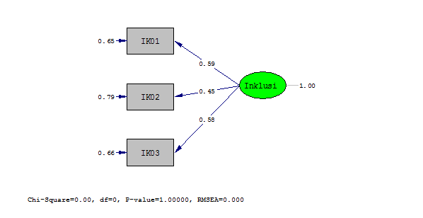
Source: Data processing, 2019.
The results of the validity test above indicate that the standardized value of the financial inclusion variable for IK01 is 0.59; IK02 is 0.45, and IK03 is 0.58. Furthermore, the value of T-Value is also obtained, for IK01 is 5.35, IK02 is 4.72, and IK03 is 5.31. So, this result concluded that all statements about financial inclusion used in this study are valid, because according to Sujarweni (2018) if at the SEM test the standardized value is > 0.40 then it is valid, but if the value is < 0.40 then it is invalid, or if T-Value is > 1.96 it is valid and if T-Value is < 1.96 then it is invalid.
Table 4. Test Results for Validity of Public Financial Service Education
No. | Question | Loading> 0.4 (Standardized) | Loading> 1.96  (T-Value) | Decision
1. | PF01 | 0.56 | 3.40 | Valid
2. | PF02 | 0.59 | 8.59 | Valid
3. | PF03 | 0.54 | 7.71 | Valid
4. | PF04 | 0.68 | 10.25 | Valid
5. | PF05 | 0.59 | 8.59 | Valid
6. | PF06 | 0.54 | 7.71 | Valid
7. | PF07 | 0.68 | 5,11 | Valid
8. | PF08 | 0.68 | 5,11 | Valid
9. | PF09 | 0.66 | 4.82 | Valid
10. | PF10 | 0.65 | 9.56 | Valid
11. | PF11 | 0.65 | 9.59 | Valid
12. | PF12 | 0.74 | 11.41 | Valid
Source: Data processing, 2019.
The results of the validity test above show that the standardized value of the Public Financial Service Education variable for all items is > 0.4. Furthermore, the T-Value value for all items is obtained > 1.96. So, it can be concluded that all statements about Public Financial Service Education used in this study are valid.

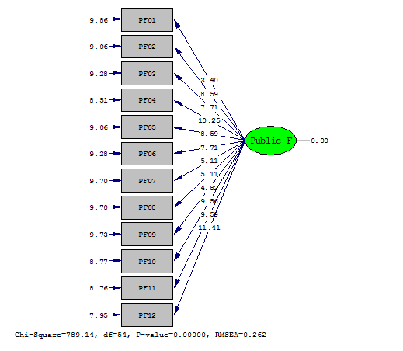
Table 5. Financial Technology Validity Test Results
No. | Question | Loading> 0.4 (Standardized) | Loading> 1.96  (T-Value) | Decision
1. | FT01 | 0.51 | 6.64 | Valid
2. | FT02 | 0.73 | 8.94 | Valid
3. | FT03 | 0.80 | 9.52 | Valid
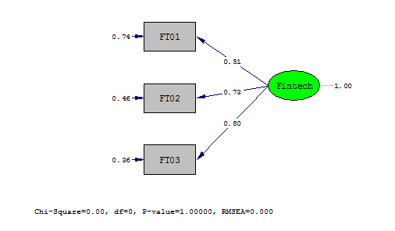
Source: Data processing, 2019.
The results of the above validity test indicate that the standardized value of the financial technology variable for FT01 is 0.51, FT02 is 0.73, and FT03 is 0.80. The result of T-Value is also obtained, for FT01 is 6.64, FT02 is 8.94, and FT03 is 9.52. So, this result shows that all statements about financial technology used in this study are valid.
Table 6. Research Variable Reliability Test Results
Case Processing Summary
 |  | N |  | %
Cases | Valid | 200 |  | 100.0
Cases | Excludedª | 0 |  | ,0
Cases | Total | 200 |  | 100.0
a. Listwise deletion is based on all variables in the procedure.
Reliability Statistics
Cronbach's Alpha |  |  | N of Items
,597 |  |  | 3
Source: Data processing, 2019.
Based on the results of the reliability test above it is known that the Cronbach's Alpha value is 0.597. This value will be compared with r table with N = 200 it can be found by using a significance of 5%. Based on data of r table, the obtained value is 0.138. This result concludes that Cronbach's Alpha value is > (more than) the value in r table or 0.597 > 0.195. So, it can be understood that all the statement items used in this study have been reliable or can be trusted as a data collection tool.

Characteristics of Respondents
The primary data collected by the researcher was analyzed to find out the characteristics of respondents from general questions. The questions are about gender, age, and education. Descriptive results of the respondents’ characteristics are presented in the number of male respondents is 70 people, it is less than the number of female respondents they are 130 people.
Table 7. Characteristics of respondents based on age
Age
 |  | Frequency
Valid | 19-25 | 182
Valid | 26-32 | 18
Valid | Total | 200
Source: Data processing, 2019.
Based on the table above it can be seen that the greater part of respondents in this study are in the age around 19-25 years old which are 182 people and there are 18 people are 26-32 years old.
Table 8. Characteristics of respondents based on education
Education
 |  | Frequency
Valid | Senior High School/Vocational High School | 102
Valid | Junior high school | 84
Valid | Elementary school | 14
Valid | Total | 200
Source: Data processing, 2019.
Based on the table, it can be seen that the biggest number of respondents in this study is the graduate of SMK (Vocational High School)/SMA (Senior High School) they are 102 people, and it is followed by Junior High School graduates it is 84 people and there are 14 graduates of Elementary School.
Descriptive Statistics Test
The descriptive analysis performed in this study conducted by categorizing the variables into five categories, according to Sugiyono (2012), they are;
Answer value 1.00 to 1.79 : Very Low
Answer value is 1.80 to 2.59 : Low
Answer value 2.60 to 3.39 : Enough
Answer value 3.40 to 4.19 : High
Answer value 4.20 to 5.00 : Very High
The further description will be shown in the table below:
Table 9. Descriptive Statistics Test Results - Financial Inclusion
Indicator | Strongly Agree (5) | Agree (4) | Neutral (3) | Disagree (2) | Strongly Disagree (1) | Respondents
IK01 | 8 | 54 | 68 | 38 | 32 | 200
IK 02 | 22 | 82 | 46 | 26 | 24 | 200
IK 03 | 20 | 66 | 52 | 42 | 20 | 200
TOTAL | 50 | 202 | 166 | 106 | 76
Average | 0.50 | 2.02 | 1.66 | 1.06 | 0.76
Source: Research data, 2019.
The above table presents that the average variable of financial inclusion shows the smallest value (minimum) it is 1 and the greatest value (Max) 5. The above results also indicate that respondents tend to be a bit disagreeing that financial inclusion affects the public financial service education. This is indicated by the average value that reaches 2.02 which is classified as low.
Table 10. Descriptive Statistics Test Results - Public Financial Service Education
Indicator | Strongly Agree (5) | Agree (4) | Neutral (3) | Disagree (2) | Strongly Disagree (1) | Respondents
PF 01 | 10 | 62 | 72 | 38 | 18 | 2 00
PF 02 | 8 | 66 | 62 | 28 | 36 | 2 00
PF 03 | 10 | 56 | 84 | 32 | 18 | 2 00
PF04 | 18 | 124 | 52 | 4 | 2 | 2 00
PF 0 5 | 14 | 88 | 84 | 10 | 4 | 2 00
PF06 | 30 | 122 | 42 | 6 | - | 2 00
PF07 | 6 | 96 | 76 | 20 | 2 | 2 00
PF 0 8 | 8 | 96 | 76 | 20 | - | 2 00
PF09 | 12 | 62 | 86 | 40 | - | 2 00
PF10 | 10 | 84 | 82 | 22 | 2 | 2 00
PF11 | 8 | 100 | 84 | 8 | - | 2 00
PF12 | 10 | 72 | 84 | 26 | 8 | 2 00
TOTAL | 144 | 1,028 | 884 | 254 | 90
Average | 1.44 | 10.28 | 8.84 | 2.54 | 0.90
Source: Research Data, 2019.
From the data presented in the table above, it can be understood that the average variable of public financial service education shows the smallest value (minimum) it is 1 and the greatest value (Max) 5. The above results also indicate that respondents tend to agree that the public financial service education is affected by the impact of financial inclusion. This is indicated by the average value that reaches 10.28, it is > 5.00 (very high).
Table 11. Descriptive Statistics Test Results - Financial Technology
Indicator | Strongly Agree (5) | Agree (4) | Neutral (3) | Disagree (2) | Strongly Disagree (1) | Respondents
FT 01 | 6 | 84 | 84 | 26 | - | 200
FT 02 | 10 | 84 | 80 | 26 | - | 200
FT 03 | 18 | 108 | 60 | 14 | - | 200
TOTAL | 34 | 276 | 224 | 66
Average | 0.34 | 2.76 | 2.24 | 0.66
Source: Research data, 2019.
The above table shows that the average variable of financial technology has the smallest value (minimum) it is 1 and the greatest value (Max) 5. The above results conclude that the respondents quite agree that financial inclusion affects public financial service education through financial technology. This is indicated by the average value which can reach 2.76 (sufficient).
SEM (Structural Equation Modeling) Analysis
Table 12. Test Results of SEM Analysis
No. | Variable | T- Value | Decision
1. | XY | 1.90 | Not significant
2. | XZ | 2.54 | Significant
3. | XZY | 3.65 | Significant
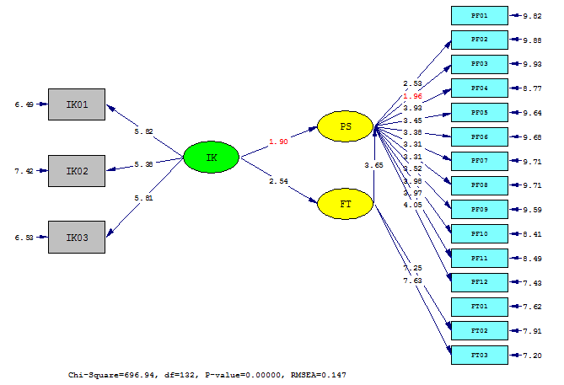
Source: Lisrel, 2019.
- Impact of financial inclusion on public financial services
The test results above show that financial inclusion has the value of T Value 1.90 or < 0.196 (Sujarweni, 2018). The results indicate that financial inclusion variables have been proven not to have a significant impact on public financial service education in Sleman Regency in 2018. This conclusion means that H₁ is rejected. It means that the impact of financial inclusion is not able to influence the public financial service education, so the higher the number of people with public financial service education does not mean the higher opportunity to decrease financial inclusion in Sleman. So, the role of government, private sector and academic circles would be very important in reducing the level of financial inclusion by more activating the access to get the public financial service education to the community in Sleman Regency continuously.
- Impact of financial inclusion on financial technology
The test results above show that financial inclusion variable has T Value 2.54 or > 0.196 (Sujarweni, 2018). The result indicates that financial inclusion variable has significant positive impact on financial technology in Sleman in 2018. It means that H₂ is accepted. The impact of financial inclusion can be undergone through financial technology. Financial technology is one form of technological modernization, so that it can be used as a way to facilitate the government and the private sector in overcoming financial inclusion in Sleman Regency.
Model Summary
Model | R | R Square | Adjusted R Square | Std. Error of the Estimate
1 | ,183ª | ,034 | ,029 | 1,778
a. Predictors: (Constant), IK_X
Source: IBM SPSS, 2019.
The results above found that the influence of financial inclusion toward the financial technology is 0.034 or 3.4 %. These results prove that financial inclusion is the smallest factor that drives the emergence of financial technology in Sleman Regency. Meanwhile, there are many other factors which further strengthen the existence of financial technology in Sleman. Thus, this fact provides a gap for other researchers to find the most powerful factors triggering the emergence of financial technology, especially in Sleman.
- The impact of financial inclusion on financial technology through financial technology
The test results above indicate that financial inclusion through financial technology as an intervening against public education financials service has the T Value at 3.65 or > 0.196 (Sujarweni, 2018). These results indicate that financial inclusion variables through financial technology proven have a positive significant impact on public financial service education in Sleman Regency in 2018. This conclusion means that H ₃ is accepted. It means that financial technology has proven to be able to integrate the relationship between financial inclusion and public financial services education.
Model Summary
Model | R | R Square | Adjusted R Square | Std. Error of the Estimate
1 | ,679ª | ,461 | ,458 | 3,850
a. Predictors: (Constant), XZ
Source: IBM SPSS, 2019.
Based on the coefficient of determination test results above, it can also be found that there is a great effect of the financial inclusion to the public financial service education through financial technology, it is 0.461 or 46.1 %. These results prove that the role of financial technology in intervening the impact of financial inclusion on financial technology in Sleman Regency in 2018 is quite large, and almost dominates. This result means that financial technology is very good at playing a role in reducing the level of financial inclusion and is considered as an effective form of public financial services education for community in Sleman Regency in 2018.

E. CONCLUSION, IMPLICATION AND LIMITATION
Based on the results of the tests and analyzes that have been carried out, some conclusions are found, and they are:
- The variable of financial inclusion has proven to have no significant impact on public financials services education for the people in Sleman Regency in 2018.
- The variable of financial inclusion has proven to have a positive significant impact on financial technology in Sleman Regency in 2018.
- Financial inclusion variable through financial technology has proven to have a positive significant impact on public financial service education in Sleman Regency in 2018.
So, it can be understood that public financial service education is not capable to fully reduce the level of financial inclusion in Sleman Regency. So the role of government, private sector and academia is essential to help in reducing the level of financial inclusion by providing more intensified access to public education financials service constantly to the public in Sleman. On the other hand, financial inclusion actually has an impact on the emergence of current financial technology. So, it becomes very helpful since it can assist people to obtain financial services and financial knowledge. In addition, the role of financial technology is also regarded as a form of public financials service education through technological modernization in the industrial revolution 4.0 today. Thus, the modernization of technology is an appropriate and easy step for the people to apply in several developed and developing countries. In accordance with Ozili's research (2018) entitled Impact of Digital Finance on Financial Inclusion and Stability, it can be found that in the current era of digital finance, Fintech has a positive effect on financial inclusion in several developing and developed countries.
The weakness of this study is in the part of filling out the questionnaire. It is because respondents have difficulty in understanding about research topics and lack of updates to information. This is quite difficult for researcher to provide simple explanations about financial inclusion. So, it is expected that if there is further research about the similar field, the appointed respondents can understand more about financial and financial inclusion simply.
F. REFERENCE
Adam Smith. 1776. “An Inquiry into the Nature of Causes of the Wealth of Nations” in Mark Skusen (2005); Sang Maestro Teori-teori Ekonomi Modern, Jakarta Prenada.
Allen, Franklin, Asli Demirguc-Kunt, Leora Klapper, and Maria Soledad Martinez Peria. 2012. "The Foundations of Financial Inclusion: Understanding Ownership and Use of Formal Accounts." World Bank Policy Research Working Paper.
Arner, D.W., Barberis, J., and Buckley, R.P.2015. The evolution of FinTech : A new post-crises paradigm?. University of Hong Kong.
Awrey, D. 2013. Toward a supply-side theory of financial innovation. Journal of Comparative Economics Vol. 41(2). pp. 401–419
Bank Indonesia. 2014. Booklet Keuangan Inklusif. Departemen Pengembangan Akses Keuangan dan UMKM.
Bank Indonesia. 2018. Laporan Publikasi [online] . Avaible at:http://www.bi.go.id
Beck T., Demirgüç-Kunt A., Levine R. 2000. A New Database on the Structure and Development of the Financial Sector. World Bank Economic Review 14 (3), 597-605.
Bernanke, B. S. 2009. Financial innovation and consumer protection. Speech at the Federal Reserve System’s Sixth Biennial Community Affairs Research Conference, Washington, D.C., 17 April 2009
Brigham dan Houston. 2010. Dasar-dasar Manajemen Keuangan Buku 1 (edisi II). Jakarta: Salemba Empat.
Buckland, J., Guenther, B., Boichev, G., Geddie, H. dan Mutch, M. 2005. There are no banks here‟: financial and insurance exclusion services in Winnipeg‟s North End. Winnipeg Inner-city Research Alliance
Capuano, Angelo and Ian Ramsay. 2011. What Causes Suboptimal Financial Behaviour? An Exploration Of Financial Literacy Social Influences And Behavioural Economics.
Cheng X, Degryse H. 2006. The Impact of Bank and Non-Bank Financial Institutions on Local Economic Growth in China
de Haan, J. Oosterloo, S. and Schoenmaker, D. 2015. Financial markets and institutions : A European perspective. 3rd edition, Cambridge : Cambridge University Press.
Financial Stability Board. FSB, 2017a. FinTech credit : Market structure, business models and financial stability implications. May 2017.
Financial Stability Board. FSB, 2017b. Financial stability implications from fintech. 27 June 2017.
Griffoli, T. M. 2017. Banking on change. Finance & Development (September), Vol. 54, No. 3. Washington DC, International Monetary Funds
He, D., et al. 2017. Fintech and financial services: Initial considerations. IMF Staff Discussion Notes No. 17/05 (June). Washington DC, International Monetary Funds.
Kempson E, A. Atkinson and O. Pilley. 2004. Policy level response to financial exclusion in developed economies: lessons for developing countries. Report of Personal Finance Research Centre, University of Bristol.
Merton, Robert C., and Zvi Bodie. 1995. Financial Infrastructure and Public Policy: A Functional Perspective. In The Global Financial System: A Functional Perspective.
Modigliani, F., 1986. “Life Cycle, Individual Thrift and The Wealth of Nations.” American Economic Review, Vol. 76, hal. 297-217.
Monticone, Chiara. 2010. Financial Literacy and Financial Advice Theory and Empirical Evidence.
Nengsih, Novia. 2015. Peran Perbankan Syariah dalam Mengimplementasikan Keuangan Inklusif di Indonesia. E-Journal Syarif Hidayatullah State Islamc University (UIN) Jakarta, Vol. 14(2): 221-240.
Ozili, Peterson Kitakogelu. 2018. Impact of Digital Finance on Financial Inclusion and Stability. University of Essex. MPRA Paper No. 84771, posted 24 February 2018 10:08 UTC. Online at https://mpra.ub.uni muenchen.de/84771/.
Peachey, Stephen and A. Roe. 2004. Access to Finance: A Study for the World Savings Banks Institute. Oxford:Oxford Policy Management, October.
Sugiyono. 2011. Metode Penelitian Kuantitatif, Kualitatif dan R&D. Bandung:Afabeta.
Sujarweni, V. Wiratna. 2018. Panduan Mudah Olah Data Struktural Equation Modeling (SEM) Dengan Lisrel. Pustaka Baru: Yogyakarta.
Supartoyo, Y. H., Tatuh, J., and Sendouw, R. H. E. 2013."The Economic Growth and The Regional Characteristics: The Case of Indonesia." Buletin Ekonomi Moneter Dan Perbankan, Vol July, 3–19.
Syamsuddin, Lukman. 2010. Manajemen Keuangan Perusahaan. Jakarta: Rajawali Pers.
Thiel, M. 2001. Finance and Growth: A Review of Theory and the Available Evidence, Directorate General for Economic and Financial Affairs, Economic Paper No. 158.
Wachira MI, Kihiu EN. 2012. Impact of financial literacy on access to financial services in Kenya. International Journal of Business and Social Sience. Vol 3 No.19.
Xu, Lisa., dan Bilal Zia. 2012. Financial Literacy around the World-An Overview of the Evidence with Practical Suggestions for the Way Forward. The World Bank:Finance and Private Sector Development.

