THE IMPACT OF REGULATION POLICY IN INDONESIA AGAINST WOMEN'S FAMILY HEAD

Ana Kuswanti¹, Amiruddin Saleh², Aida Vitayala S Hubeis²,
Herien Puspitawati², Muqsith Abdul Munadhil³

¹Communication Study Program of Agricultural and Rural Development of IPB University
²Faculty of Human Ecology, IPB University
³P.h.D Student in Mass Communication Faculty, Peoples' Friendship University of Russia (RUDN University)

Email : anakuswanti@upnvj.ac.id

Abstract. The female head of the family has a dual role, that is, a housewife and breadwinner to meet family needs. The study aims to analyze the effect of female head of household characteristics and group characteristics on participatory communication of groups and economic independence of women household heads. Respondents were Pekka groups in twelve villages in Batang City, Central Java, as many as 229 heads of households aged 22-74 years. The characteristics measured include 5 dimensions namely: age, education, marital status, number of dependents, and income. Data were analyzed descriptively and multiple linear regression testing was carried out. The results showed that there was a direct positive effect on the characteristics of female household heads in participatory communication and the economic independence of female household heads. and there is a direct negative effect on group characteristics on participatory communication and the economic independence of the female household head
Keywords:regulation effect, female head of a family, Pekka group, economic independence

Introduction

The national secretariat of female heads of household sees indications that one of the poorest groups of people who are slow to break down poverty is a family headed by women. Based on Marriage Law Number 1 of 1974, Article 31, Paragraph 3, which states that "The husband is the head of the family and the wife of the housewife." Both of these causes the existence of women as head of the household and head of the family not fully recognized, both in the applicable legal system and in the social life of the community. As a result, the existence of female heads of households tends to be "invisible," not actually counted, and does not appear in actual numbers in statistical data. This is a weakness that has the potential to cause the exclusion of women from various poverty reduction efforts undertaken both by the government and by non-governmental organizations (NGOs).
Astuti (2014) states that households that are headed by women are generally in a state of deficiency. There are obstacles to meeting the basic needs of the family. There is a limited ability to obtain income to meet the needs of family members. Especially if they are in poor condition, they will experience difficulties in meeting the needs of a more decent life. Therefore, the development of human resources, especially women in terms of arousing the power of thought, critical power, confidence, and being able to take decisions on the problems faced, it is important to do so that women can become independent both mentally and financially, in meeting the needs of life his family.
Women's development is an urgency, as an integral part of national development and development programs in alleviating poverty. Hubeis (2010) states that it is time for women to participate in the development, but society considers that by nature, women are still demanded that all work be carried out independently and alone by women. Fostering the potential and independence of the community is hopes will grow awareness to gain full power in determining the future (Suhaimi, 2016).
Women who have a dual role as housewives and at the same time become breadwinners make Pekka must be able to carry out their responsibilities in caring for, educating children and meeting all their family needs. In fact, women as family heads face obstacles in aspects of business, commerce, and social relations. A conscious effort must be made to improve conditions, build economic independence. Considering that conditions are still found in the community, Pekka with an economy below the poverty line, this is supported by the results of Wibawa and Wihartanti's research (2018) suggesting that the economic independence of women-headed households will soon be achieved, if there are various accesses to support business development, skills development, and have autonomy to make decisions with an awareness of equality and justice.
It is starting from the Pekka program, which organized its activities, where the role of women as head of the family in carrying out family functions, there was a lack of assertiveness in educating children, and the difficulty in allocating time to socialize in the community (Saputri, 2016). On the other hand, there are women as supporters of the husband's breadwinner, who have a contribution to help the family's economy in earning income, so having independence in the economy can even sustain family needs (Djazimah & Habudin, 2016). The role of women in household heads is capable of carrying out food security (Sasmita, 2011).
Batang City is one of the expansion areas of the central Pekka program; currently, it is still focused on empowering female heads of households. Based on World Bank data, extreme poverty was below 8.6 percent in 2018, the lowest percentage of people living in global poverty has dropped to 10 percent in 2015 (Andreas, 2018). The poverty rate in Batang Regency for 2017-2018 shows 10.80 percent, and the poverty rate for women is 6.48 percent (BPS Batang Regency, 2018). The decline in these conditions creates a gap in the standard of living of the people, so poverty action is needed.
Research becomes essential to see how participatory communication and processes as activities and coherence are among group members involved in the underdeveloped Pekka program in Batang, Central Java. An appropriate model of economic empowerment communication is needed in the Pekka program, which will make women an essential element in supporting development in Batang District. The empowerment communication model that is designed must pay attention to aspects inherent in the community, especially Pekka groups, as the target of program communication, which includes input, process, and output.
In addition, research is considered essential because the results can be used as a reference in understanding the differences in communication of economic empowerment for female heads of household and proper participatory group communication methods to help in realizing economic independence that has not been mentioned in previous studies. The results obtained illustrate the influence of group characteristics on participatory group communication and Pekka's economic independence. Further results showed that there was no significant influence between the characteristics of women-headed household groups in participatory communication and the economic independence of women-headed household groups.
Based on the explanation above, the study aims to: (1) describe the characteristics of female household heads in Batang City. (2) analyze the effect of Pekka characteristics and Pekka group characteristics, on participatory communication and economic independence of Pekka families.
Method

Research using quantitative research methods in one study to understand research, quantitative research is intended to be strengthened with qualitative analysis to provide a better understanding of research problems and questions, rather than just using one method alone (Creswell, 2010). Retrieval of quantitative data using survey methods. A survey, according to Singarimbun and Effendy (2002), is a study that takes a sample from one population and uses a questionnaire as a primary data collection tool. Survey research design uses research methods with hypothesis testing (researchers explain the relationship between variables) or is called explanatory research.
Research methods based on quantitative positivism paradigm are strengthened by qualitative methods so that they become post-positivism, used to examine populations of samples, sampling techniques are generally conducted randomly, research with research instruments, quantitative or statistical data analysis with the aim to test established research hypotheses (Sugiyono, 2013).
The research design is in accordance with the opinions of Singarimbun and Effendy (2002) explanatory research (explanatory research) is explanatory research that highlights the causal relationship between the research variables and tests the hypothesis that has been formulated previously. This kind of research in descriptive also contains descriptions, but the focus is on the relationship between variables. But in this study only looked at the relationship between variables, as well as testing the relationship of research hypotheses.
Quantitative data were obtained from primary data, which included: (1) Pekka characteristics; (2) characteristics of Pekka groups; (3) participatory communication; and (4) Economic independence. Primary data is obtained by filling out a questionnaire conducted by Pekka groups themselves. The research instrument was divided into two parts. First, questions related to Pekka group's characteristics related to age, education, marital status, number of dependents, and income. Secondly, questions about the characteristics of Pekka groups by looking at information access, the role of Pekka groups, the role of management, the role of cadres, the role of assistants. Third, questions about participatory communication by looking at the ability to provide ideas and ideas, dialogue, the intensity of the discussion, the direction of communication, how to solve problems, and the role of leadership. Fourth, questions about the independence of the Pekka economy by looking at the ability to meet the needs of life, the ability of productive businesses, the ability to overcome problems, and the ability to make decisions have been tested for validity and reliability. An instrument using a Likert scale starting from (1) Never, (2) Sometimes, (3) Often, (4) Always.
The reliability test results on each indicator showed the Cronbach alpha value as follows: information access indicators (34 questions; alpha Cronbach = 0.761), group role indicators (15 questions; alpha Cronbach = 0.765), indicators of the administrator's role (17 questions; alpha Cronbach = 0.745), cadre role indicator (17 questions; alpha Cronbach = 0.757), companion role indicator; alpha Cronbach = 0.752) and participative communication with the value of each indicator of ideas and ideas (6 questions; alpha Cronbach = 0.742), dialogical indicators (6 questions; alpha Cronbach = 0.726), indicators of discussion intensity; alpha Cronbach = 0.759), indicators of the direction of communication (6 questions; alpha Cronbach = 0.741), indicators of how to solve problems (6 questions; alpha Cronbach = 0.805), indicators of leadership roles (6 questions; alpha Cronbach = 0.7711) and variables of independence Pekka economy with the value of each indicator of the ability to meet the needs of life (6 questions; alpha Cronbach = 0.780), indicators of productive business ability (6 questions; alpha Cronbach = 0.790), indicators of problem solving (6 questions; alpha Cronbach = 0.756), indicators decision making ability (6 questions; alpha Cronbach = 0.791) it can be said that the instruments used are very reliable.
Data were analyzed using the SPSS version 22.0 program. And LISREL 8.8 The analysis used in the study are (1) descriptive analysis to explain the characteristics of Pekka (2) SEM analysis, to examine the influence of the independent variables on the dependent variable, namely: the effect of female head of household characteristics and group characteristics on participatory group communication and independence Pekka's economy; the influence of participatory communication of Pekka's economic empowerment groups; and the effect of group participatory communication and economic empowerment on Pekka's economic independence.

Results And Discussion
Women are the grassroots and key in development, where there are families headed by women in conditions of poverty. Therefore Pekka is a strategic program. Pekka is one of the manifestations of efforts to reduce poverty by women. Conditions in which families are headed by women.
Women are able to carry out roles and responsibilities as the main breadwinner, take care of the household, manage the continuity of family life, and as decision-makers in their families. In principle, the role of Pekka as a more dominant implementer is as the main respondent who has a core position in order to support the family.
Batang City is one of the expansion areas of Pekka. The condition of the trunk area there are many women become the backbone of the family. His role as the main breadwinner is a demand because of circumstances where there are conditions because the husband does not have a permanent job, the lack of a husband's sense of responsibility in carrying out his obligations as a breadwinner, so he relies more on his wife. Limited insight and lack of broad mindset to move forward, making them less able to take advantage of opportunities to find work. Do not have the courage to try new jobs so that they can continue working to meet the needs of their family life.
Batang City Pekka has a Pekka center as their place of activities. It has a coverage area consisting of 12 villages in two subdistricts and consists of 15 Pekka groups. Pekka activities are strongly encouraged by the participatory communication of members in each Pekka group. The purpose of Pekka's presence in Batang City is to assist government programs in alleviating poverty in unreached areas so that Pekka seeks to implement it through programs created by Pekka.
Pekka tries to dedicate its programs by forming Pekka groups through participatory communication groups. The goal is to have a group so that it is easier to control and be able to see its development because it is easy to identify the group members, which groups are considered active and not active so that the evaluation is easy to carry out.

Characteristics of Respondents Female head of household
The results of research on the identity of Pekka respondents consisted of age, education, marital status, number of family dependents, and income.
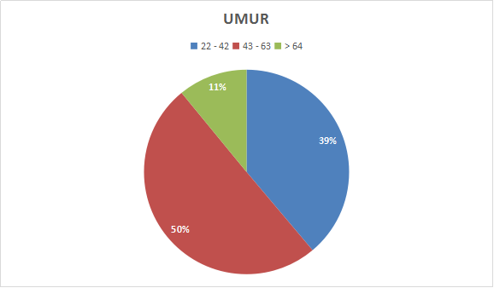
Figure 1. Percentage of Pekka characteristics based on age indicators

Based on the diagram above, the results of research on the characteristics of respondents based on age indicators note that the percentage of ages aged 22-42 years by 39 percent. According to the World Health Organization (WHO) in 2016 stated that the average life expectancy of women up to the age of 74 years. Age 43-63 years by 50 percent, while ages 64-74 years by 11 percent.

Figure 2. Percentage of Pekka characteristics based on education indicators

Based on the diagram above, the results show that the majority of Pekka educated in Elementary School (40%), and the second-highest percentage was not completing Elementary School. The number of Pekka that did not finish junior high school (6%), while the number of Pekka who graduated junior high school (17%). The number of Pekka that did not graduate from High School (1%), while Pekka who was able to study up to High School (5%). There is no Pekka with a diploma level of education (0%), while those who can attain education up to undergraduate level reach (1%).

Figure 3. Percentage of Pekka characteristics based on marital status

The results show that most Pekka members still have husbands, and they are permitted by their husbands to enter the Pekka group (65%). Pekka members with widowed status show figures (31%) and Pekka members with a single status (4%).

Figure 4. Percentage of Pekka characteristics based on number of family dependents

The results show that most Pekka members still have three family dependents (38%). The results show (29%) with four dependents. The results show (17%) with two dependents. Dependents of 5 people show results (7%), while for dependents, six people there (4%), and dependents of 7 people there (4%), and for dependents, eight people show results do not exist (0%).

Figure 5. Percentage of Pekka characteristics based on the amount of family income

The term income on characteristics is used on the grounds that most respondents' jobs have precarious work, so it is not based on work, but is based more on income. The results show that most Pekka members have an income of ≤ Rp. 500,000-900,000 (70%). Family income with an income of Rp. 1,000,000-2,000,000 (27%). The remaining Pekka with income of Rp. 2,000,000 only (3%).

SEM Analyst Results The Effect of Pekka Characteristics and Group Characteristics on Participatory Communication and Economic Independence21

Estimate (Loading Factor)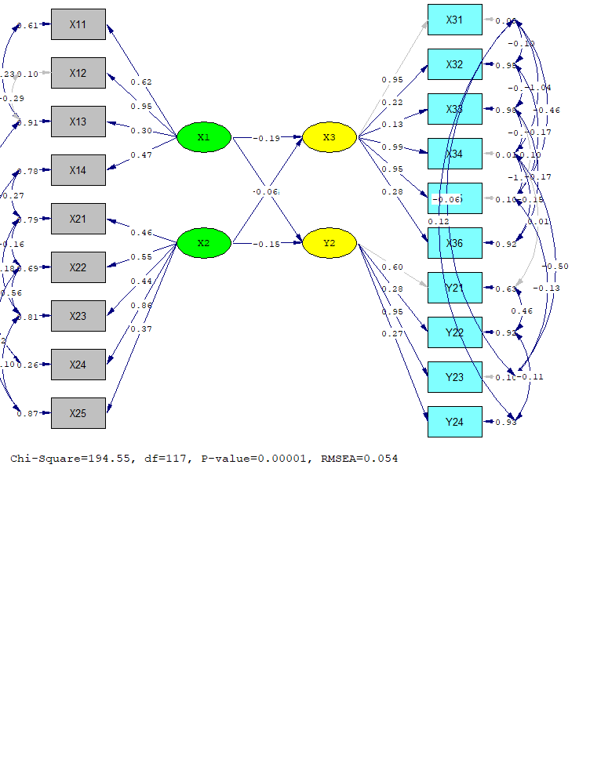
Coefisien β², df = 117, p ≥ 0.05 = 0,054
Pekka economic empowerment communication model, through participatory group communication, to realize Pekka's economic independence in Batang
Figure 6.
T-Test
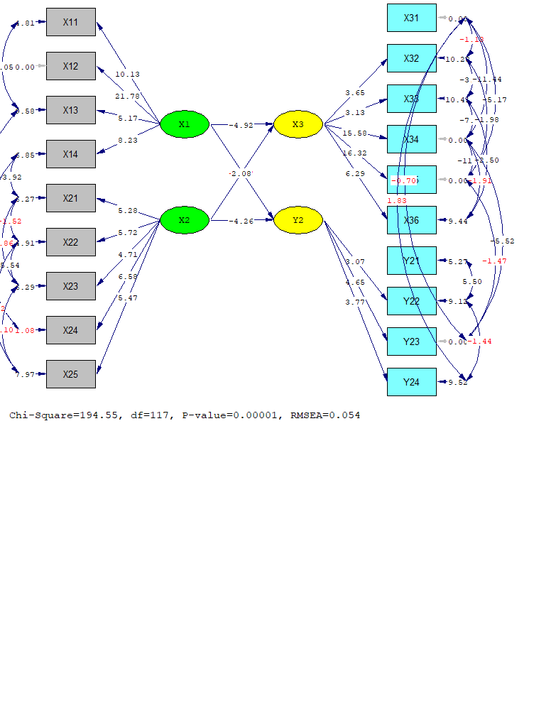 Coefisien β², df = 117, p ≥ 0.05 = 0,054
Pekka economic empowerment communication model, through participatory group communication to realize Pekka's economic independence in Batang
Figure 7.

Tabel 1 Testing the goodness of fit model 2019

Goodness-of-Fit | Cutt-off-Value | Result | Conclusion
X² - Chi-square | Expected to be small | 194.55 | Not goodness of fit
Significance | ≥ 0.05 | P = 0.0001
RMSEA | ≤ 0.08 | 0.054 | goodness of fit
GFI | Approaching 1 | 0.94 | goodness of fit
NFI | Approaching 1 | 1.00 | goodness of fit
CFI | Approaching 1 | 1.00 | goodness of fit

In Table 1 above, the results of processing for the goodness of fit test show that by using the Chi-square test the conclusion is p-value 0.0001 <0.05 so that Ho is rejected and Ha is accepted, which means the resulting model shows that the model is not good yet we can see the goodness of fit others because chi-square is influenced by data and models. In addition, SEM provides an alternative to using other goodness of fit indicators. RMSEA criteria produce a value of 0.054 0.08, which means that the resulting model is already goodness of fit.
The use of other goodness of fit criteria, namely GFI, NFI, and CFI, produces a value> 0.9, which means that the resulting model has the goodness of fit. Because the results of the conclusions of several indicators produce the conclusion of the model of the goodness of fit, the theoretical hypothesis testing can be done.

Hypothesis testing theory
Table 2 Results of Regression Estimation Model SEM 2019
Path | Estimate | S.E. | |t-hit| > 1.96 | Conclusion
Langsung
X1 -> X3 | -0.190 | 0.038 | 4.92 | Significant
X2 -> X3 | -0.038 | 0.039 | 0.97 | Significant
X1 -> Y2 | 0.062 | 0.030 | 2.08 | Significant
X2 -> Y2 | -0.150 | 0.035 | 4.26 | Significant

Hypothesis 1 states that the characteristics of Pekka (X1) have a direct negative effect on participatory group communication (X3). From the processing results obtained, an estimated coefficient of -0.190, which means that the higher the characteristics of Pekka (X1), the lower the group participatory communication (X3) directly and vice versa. These results indicate that the proposed theoretical hypothesis is proven with a statistic value of 4.92> t-table 1.96, which means that Ho is rejected so that it can be concluded that there is a positive influence of Pekka's characteristics (X1) on participatory communication groups (X3).
Hypothesis 2 states that group characteristics (X2) do not have a direct negative effect on participatory communication (X3). From the processing results obtained, an estimated coefficient of -0.038, which means that the higher the characteristics of the group (X2), the lower the participatory communication of the group (X3) directly and vice versa. These results indicate that the proposed theoretical hypothesis is proven with a statistic value of 0.97 <t-table 1.96, which means that Ho is accepted so that it can be concluded that there is no negative effect of group characteristics (X2) on participatory communication of groups (X3).
Hypothesis 3 states that the characteristics of Pekka (X1) have a direct positive effect on economic independence (Y2). From the processing results obtained, an estimated coefficient of 0.062, which means that the higher the characteristics of Pekka (X1), the higher the economic independence (Y2) directly and vice versa. These results indicate that the proposed theoretical hypothesis is proven with a statistical value of 2.08> t-table 1.96, which means that Ho is rejected so that it can be concluded that there is a positive influence of Pekka's characteristics (X1) on economic independence (Y2).
Hypothesis 4 states that group characteristics (X2) have a direct negative effect on economic independence (Y2). From the processing results obtained, an estimated coefficient of -0.150, which means that the higher the characteristics of the group (X2), the lower the economic independence (Y2) directly and vice versa. These results indicate that the proposed theoretical hypothesis is proven with a statistic value of 4.26> t-table 1.96, which means that Ho is rejected so that it can be concluded that there is a negative influence of group characteristics (X2) on economic independence (Y2).
This study using participatory communication theory showed significant results. Pekka's characteristics have an indirect negative influence on participatory communication and economic independence. Age is one of the social factors that influence human activities in working to meet the needs of daily life. Age is one of the characteristics of respondents that is very important to know. Age indicators have a direct negative effect on participatory communication and business independence. That is, the lower the age of the individual will affect participatory communication and economic independence. This is in line with Noviani's (2015) research, which revealed that the level of participation of members in the elderly tends to be in a low category. This shows that the age variation in the old category is not related to the level of one's participation in participatory communication. Likewise, vice versa, participatory individuals with young categories are expected to be able to maximize participatory communication to support economic independence.
Education is one of the main indicators of development to create quality human resources. Formal education in research is measured by the number of years of informal education. The opinion of Angeningsih (2008) formal education is a major prerequisite in economic development and human resources. Through education, large social benefits can be obtained for survival, such as obtaining employment, quality in insight, health, and the environment. Educated people will be more productive and be able to think to act in problem-solving and decision making.
When linked to research, education indicators have a significant direct negative effect on participatory communication and economic independence. Pekka members, on average, have low education, with the most percentage (40%) of Pekka members graduating from Elementary School. This means that Pekka's involvement in creating participatory communication and economic independence is influenced by the education of Pekka members.
In the field findings, it can be concluded that Pekka members who have low education tend to be less active in every meeting held, in contrast to Pekka members who have higher education tend to be more active in delivering ideas or ideas of this statement in line with the results of Kurniawati's research (2010) which states that education formal high can create community independence, and vice versa.
In line with this, based on the results of interviews in the field with community leaders as informants who came from the Writing Village said that:

“..The people here do not prioritize formal education. The mindset that education is not a priority that must be met. They only think that the main thing is to meet basic needs, food, clothing, and shelter. In addition to the lack of fees for formal education and livelihoods, the majority of whom are farmers, farm laborers, domestic workers, factory workers, and small traders. Making them does not require the public to get high formal education. This is because there are no fees. It is hoped that the existence of Pekka in this village will be able to change the mindset of the community so that they feel important with formal education so that they are better able to improve their standard of living when linked to research, education indicators have a significant direct negative effect on participatory communication and economic independence. Pekka members, on average, have low education, with the most percentage (40%) of Pekka members graduating from Elementary School. This means that Pekka's involvement in creating participatory communication and economic independence is influenced by the education of Pekka members. In the field findings, it can be concluded that Pekka members who have low education tend to be less active in every meeting held, in contrast to Pekka members who have higher education tend to be more active in delivering ideas or ideas of this statement in line with the results of Kurniawati's research (2010) which states that education formal high can create community independence, and vice versa. In line with this, based on the results of interviews in the field with community leaders as informants who came from the Writing Village said that:.”.
The explanation by one of the informants from the Writing Village above confirmed the data contained in the Writing Subdistrict in July 2019, where the majority of the inhabitants of the Writing Village were livelihoods as farmers, farm laborers, domestic workers, factory workers, and small traders who did not require the community received higher education and has the skills for his job
Based on the results of the FGD conducted in the field that in the Subdistrict of this community, the people prioritize prestige in having a nice house rather than receiving a higher education. It can also be seen directly by researchers, that the condition of houses in the Subdistricts of Write and Kandeman people have permanent, good and modern-looking houses. The walled house, magnificent, has a variety of tiles, more modern home design. But for the case of formal education with a higher level of education, they feel it is not a priority to be obtained in improving living standards. It is hoped that with the presence of Pekka, it will be able to arouse more advanced thinking power.
The indicator of the number of dependents has a direct negative effect on participatory communication and economic independence. This means that the lower the responsibility of Pekka groups will have an influence on creating participatory communication and economic independence. A condition where the burden of responsibilities of housewives who also hold responsibilities as head of the family has family responsibilities. Such conditions were strengthened by the results of interviews with community leaders at the FGD.

“Usually, PEKKA women have a higher responsibility in meeting the needs of their family life, compared to their husbands. Their husbands actually seem to be the wife who helps their husbands in making a living is the main thing, as well as meeting all the needs of the family they bear. Based on findings in the field that women (housewives who also work as breadwinners, finally their roles are shifted as the head of the family because all problems and decisions in problem-solving are carried out by the wife and husband as if they are free from their responsibilities....”

Finally, the income indicator has a significant direct negative effect on participatory communication and economic independence. As it is known, the income of Pekka members is in the low category with a percentage (70%) with an average salary of Rp 500,000 - 900,000 due to the low income of Pekka members who are less able to maximize business capital even though they often participate in training in Pekka programs as an effort to economic independence. However, group members have been able to maximize their daily basic needs by utilizing vacant land next to the house to plant vegetables or other natural resources such as cassava, bananas, and breadfruit which is then made into chips or other processed foods such as peyek, tempe chips , know to be entrusted to stalls in supporting their income.
Judging from the results of group characteristics has a direct negative influence on participatory communication and economic independence. This is different from Firmansyah (2012) saying, the facilitator or facilitator of the empowerment program really determines the level of community empowerment that is the target of the program. Without the presence of a companion, the community will find it difficult to carry out activities due to various limitations they have. The reality is that some Pekka groups are still unable to implement the training that has been conducted. This is in line with Listiana's research (2018), which states that the role of counterpart will influence IR (Home Industry) actors to participate in the implementation of programs implemented in order to improve their skills and business development.
In line with this statement, Ife (2014) states that the success of participatory communication in cultural renewal through a dialogic process depends very much on the role of the facilitator as the initiator and planner. This means that the facilitator is considered to have a considerable role in creating participatory communication and the economic independence of Pekka members. If it is related to research, assistance to Pekka Batang is quite good in delivering direct messages (linear) that contain elements of instruction (direction) about the activities to be carried out, but Pekka groups sometimes still want two-way (convergent) information where messages are delivered according to the potential, conditions, local specific needs of women-headed household groups and the delivery of information should consider the needs and wants of women-headed household groups. Therefore, the improvement must be carried out continuously by the facilitator to maximize the delivery of information and build the skills of Pekka groups, based on the findings which hampered the information provided by the facilitators due to the low level of activeness of group members in accessing mass and electronic media, group members Pekka relies more on direct communication in various activities and meetings, this is an obstacle in the delivery of information in Pekka groups.
In addition, the findings in the study also show that there is still a lack of trust among group members to the management and also cadres, based on the results of categorization and associated with SEM analysis, it can be concluded that group members trust trustees to overcome and provide solutions related to personal or group problems. This is thought to be the cause of group characteristics having a negative influence on participatory communication and economic independence. Therefore, the development of cadre roles and functions needs to be carried out optimally. In addition to the needs of the group, this will also help to create many active and competent Pekka members in overcoming various personal problems or problems in the group.

Conclusion

Based on the results of the research, it can be concluded that the age of Pekka members is in the range of 22-63 years with the highest level of education in elementary school (70%) who is married (65%), and has a maximum of 3 dependents (35%) and has revenue in the range (Rp.500-000-900,000). Based on the categorization, it can be concluded that the characteristics of the groups are in a low category, Pekka groups are still very dependent on the role of assistants both in training and economic independence due to the still low access to information and education of most Pekka groups. Participatory communication belongs to the high category with the highest dimension in the leadership role dimension. This means that the Pekka group already has a leadership spirit but is still constrained by access to ideas and ideas as well as dialogue and direction of communication, which is still one-way. Based on economic independence in the low category. Pekka members are still hampered in capital and skills that they feel are still lacking.
The results of the SEM analysis show that the characteristics of Pekka (X1) affect participatory communication (X3) and the characteristics of Pekka (X1) most influential on participatory communication (X3). A negative value of -0.190 which indicates that the higher the characteristics of Pekka (X1), the lower the participatory communication (X3) that occurs. The results from above also show that the characteristics of the group (X2) have the most influence on economic independence (Y2) compared to the characteristics of women household heads (X1). A negative value of -0.150 indicates that the higher the group characteristics (X2), the lower economic independence (Y2) occurs.

Suggestion
Based on the conclusions presented, the authors formulated suggestions to the facilitator to actively develop the role of groups, cadres, and administrators to create a harmony of information and skills in Pekka groups that leads to the creation of two-way communication, especially for members who have low education and are elderly. In addition, the facilitator should also develop training on a scale basis for all Pekka groups so that members have the desire to become more independent in the future.
REFERENCES

Andreas J. 2018. Laju pengentasan kemiskinan global masih lambat. (12 Okt 2018); Tirto.id. Rubrik Ekonomi. [diunduh 2019 Januari 30]. Tersedia pada: http://tirto.id/bank-duni``a-laju-pengentasan-kemiskinan-global-masih-lambat-c6wG.
Astuti, Fitri. 2014. Hubungan karakteristik sosial ekonomi terhadap alokasi pengeluaran wanita kepala rumah tangga di DIY (Analisis Susenas Tahun 2005 dan 2010). Fakultas Ekonomi. Universitas Gajah Mada.
Andi AM Supratomo, Iqbal S. 2015. Analisis Komunikasi Partisipatif Masyarakat Pada Pelaksanaan Musyawarah Perencanaan Pembangunan (Musrenbang) Desa Resapan Banjir Di Danau Tempe Kabupaten Wajo. Jurnal Komunikasi KAREBA. Vol. 4 (3):226 – 238
Angeningsih LR. 2008. Peran balai latihan kerja (BLK) dalam penangulanggan kemiskinan (Suatu kajian nilai sosial). Jurnal Ilmu Sosial Alternatif. Sekolah Tinggi Pembangunan Masyarakat Desa APMD. Vol 9(2) 96-112.
[BPS] Badan Pusat Statistik Kabupaten Batang. 2018. Kabupaten Batang dalam Angka “Batang Regency in Figures.” [diunduh 28 April 2019]. Tersedia pada: https://Batangkab.bps.go.id.
Creswell JW. 2010. Research Design: Pendekatan Kualitatif, Kuantitatif, dan Mixed. Yogjakarta: PT Pustaka Pelajar.
Djazimah S, Habudin I. 2016. Isteri sebagai pencari nafkah utama: studi terhadap perajin kapuk di Desa Imogiri, Bantul, Yogyakarta(ID). Jurnal Hukum Keluarga Islam. [diunduh 2018 November 3]. 9(1):47-65.Tersedia pada: http://ejournal.uin-suka.ac.id/syariah/Ahwal/article/view/1100/1037
Hubeis AVS. 2010. Pemberdayaan Perempuan dari Masa ke Masa. Bogor: IPB Press.
Ife, Jim, Frank T. 2014. Alternatif Pengembangan Masyarakat di Era Globalisasi”Comunity Development”. Yogyakarta: Pustaka Belajar
Noviani A. 2015. Hubungan Antara Tingkat Partisipasi Anggota dengan Kelancaran Program Tabur Puja di Posdaya Sejahtera, Kota Bogor. Jurnal Komunikasi Pembangunan, Vol. 1 (3)
Kurniawati D. 2010. Tingkat Partisipasi dan Kemandirian Masyarakat dalam Bidang Ekonomi Program Posdaya (kasus Posdaya Bina Sejahtera Kelurahan Pasir Mulya Kota Bogor). Jurnal Penyuluhan Vol 6, No 2.
Listiana I, Sumardjo, Sadono D, Prabowo T. 2018. Hubungan Kapasitas Penyuluh dengan Kepuasan Petani dalam Kegiatan Penyuluhan. Jurnal Penyuluhan 14 (2): 244-256.
Firmansyah, H. 2012. Tingkat Keberdayaan Masyarakat dalam Program Pemberdayaan Masyarakat di Kota Banjarmasin dan Kabupaten Tanah Laut.Jurnal Agribisnis Pedesaan. Universitas Lambung Mangkurat.
Msibi, F, Penzhorn, C. 2010. Participatory Communication for Local Government in South Africa : A Study of the Kungwini Local Municipality. Article Information Development26(3).South Africa: Sage Publications.
Sasmita S. 2011.Peran perempuan suku minangkabau yang menjadi kepala keluarga (pekka) bagi penciptaan ketahanan pangan rumah tang ga di kecamatan padang timur. Jurnal Ilmiah Ilmu-Ilmu Humaniora. [diunduh 2018 April 4]. DOI: https://doi.org/10.24036/jh.v10i1.48910. (1):82-92.Universitas Negeri Padang (ID):FISIP.
Singarimbun M. dan Effendy S. 2002. Metode Penelitian Survei. Jakarta:LP3ES.
Suhaimi A. 2016. Pengembangan dan Pemberdayaan Masyarakat. Yogyakarta:Deeepublish.
Sugiyono. 2013. Metode Penelitian Kuantitatif, Kualitatif dan R&D. Bandung: Alfabeta.CV.
Wibawa P R dan Wihartanti V L. 2018. Strategi perempuan kepala keluarga (pekka) dalam menciptakan kemandirian ekonomi keluarga di desa gesi kecamatan gesi kabupaten sragen. Jurnal Pendidikan Ekonomi UM Metro.6(2):57-62.

