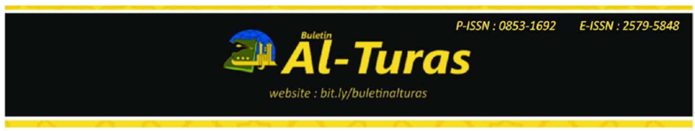
Language of Resistance: Linguistic Landscape in the Protest of Kanjuruan Tragedy, Indonesia

Muassomah Muassomah1 1*
Universitas Islam Negeri Maulana Malik Ibrahim
Malang, Indonesia
muassomah@bsa.uin-malang.ac.id

M. Faisol 2
Universitas Islam Negeri Maulana Malik Ibrahim
Malang, Indonesia
faisol@bsa.uin-malang.ac.id

Halimi Halimi 3
Universitas Islam Negeri Maulana Malik Ibrahim
Malang, Indonesia
halimizuhdy@uin-malang.ac.id

Baedt Giri Mukhoddam Billah 4
Universitas Islam Negeri Maulana Malik Ibrahim
Malang, Indonesia
220301210005@student.uin-malang.ac.id

Abstract

Purpose
Linguistics landscape (LL) is not only a means of showing the identity of a language but also a constructive effort to fight for justice for society. Landscape in this study is a form of protest against security forces for the loss of life of 135 Aremania fans after watching a soccer match between Arema and Persebaya at the Kanjuruan stadium. This research aims, apart from mapping all signs from aspects of language use patterns, also to conduct a critical analysis of the language used.

Method
This study uses quantitative and qualitative methods based on documentation in the form of billboards, boards, and banners installed in various parts of Malang, Indonesia. Content analysis and critical analysis are used to analyze this research.

Findings
The findings of this study show that the language used in the landscape has two forms, monolingual and bilingual. In addition, it indicates that four languages are used in the sign. Indonesian has a higher quantity than English, Javanese, and Arabic.

Conclusion
The language pattern used in the landscape tends to reflect sarcasm, cynicism, and rhetoric. This research suggests conducting a follow-up study that examines the same sign in the broader area, including Malang district and East Java region, to obtain varied data and various sign patterns. Thus the data information obtained is more comprehensive.

Keywords
Resistance; language; linguistic landscape; Kanjuruan tragedy.

Abstrak

Tujuan
Landscape linguistik (LL) bukan hanya sebagai sarana menunjukkan identitas sebuah bahasa tetapi juga menjadi upaya kontruktif memperjuangkan keadilan bagi masyarakat. Landscape dalam penelitian ini sebagai bentuk protes kepada aparatur keamanan atas hilangnya nyawa 135 suporter Aremania setelah menyaksikan pertandingan sepak bola antara Arema dan Persebaya di stadion Kanjuruan. Penelitian ini bertujuan selain memetakan seluruh sign dari aspek pola penggunaan bahasa, juga melakukan analisis kritis terhadap bahasa yang digunakan.

Metode
Penelitian ini menggunakan metode kuantitatif dan kualitatif yang berlandaskan pada dokumentasi yang berupa baliho, papan, dan benner yang telah dipasang di berbagai penjuru kota Malang, Indonesia. Analisis conten dan analisis kritis digunakan menganalisis dalam penenlitian ini.

Hasil/temuan
Temuan penelitian ini memperlihatkan bahwa bahasa yang digunakan dalam landscape memiliki dua bentuk, monolingual dan bilingual. Selain itu menunjukkan ada empat bahasa yang digunakan dalam sign. Bahasa Indonesia memiliki kuantitas lebih tinggi dibandingkan bahasa Inggris, Jawa, dan Arab.

Kesimpulan
Pola bahasa yang digunakan dalam landscape cenderung mencerminkan sarkasme, sinisme, dan retorikal. Penelitian ini menyarankan dilakukan studi lanjutan yang meniliti sign yang sama pada wilayah yang lebih luas mencakup kabupaten Malang, dan wilayah Jawa Timur untuk mendapatkan data yang variatif dan pola sign yang beragam. Dengan demikian informasi data yang didapatkan lebih komprehensif.

Kata kunci
Resistensi, bahasa, lanskap linguistik, tragedi Kanjuruan, Indonesia

INTRODUCTION
Landscape linguistics (LL) is not only a medium for conveying people's inspiration in the public sphere but also an act of social and political protest (Kasanga, 2014). LL in the Kanjuruan tragedy was used as a form of resistance from the community, especially the Aremania fans, for the use of tear gas, which the security forces misused. This misappropriation resulted in the deaths of 135 Aremania supporters and 575 injuries on October 1, 2022 (Mahfud MD, 2022) in the Arema vs Persebaya match at the Kanjuruan stadium, Malang, Indonesia. This number is the second highest in world football tragedies after the Estadio Nacional Disaster tragedy in Lima, Peru, in the Peru match against Argentina in 1964, where 328 people died, and 500 were injured (Edwin Shri Bimo, 2022). The symbols in LL are installed in various corners of the city, streets, public places, and even in front of the police station to ask for justice for fans, families who have been left behind, and the community. Thus, LL is a medium for voicing public dissatisfaction with government decisions and clarifying demands, and expressing feelings (Papen, 2012).
So far, research related to LL can be mapped into four trends. First, LL's study explores religious identity (Ardhian et al., 2021; Begum & Sinha, 2021; Inya, 2019). The use of Yoruba texts across items reveals religio-cultural and loyalist reasons. In contrast, Arabic confirms the language's inherent attachment to the Islamic religion and fosters a religion-based collective identity between sign writers and sign readers (Inya, 2019). Second, LL studies can reflect social change and urban development (Papen, 2012; Baranova & Fedorova, 2020; Sánchez-López, 2019). The once marginalized city has turned into a metropolis by showing a luxurious landscape on every street. Third, LL is used as a media protest against public dissatisfaction with the government and political system (Kasanga, 2014; Shiri, 2015; Dabbour, 2017; Kull, 2002; Lintz & Leibenath, 2020; Seloni & Sarfati, 2017). Each code is examined and given a symbolic meaning that reveals the mighty power of signs to provide cultural and political importance to protest (Kasanga, 2014). The language in protest demonstrations reveals a clear shift from monolingual LL, according to the rules of the official language, to multilingual, which refers to linguistic reporters (Shiri, 2015). Fourth, LL is a means of education (Burr, 2021; Sayer, 2009, 2020). LL is used as a medium for learning English by using public symbols to analyze the social meaning of English (Sayer, 2009).
This study aims to complement existing studies related to LL. Since the Kanjuruan tragedy, many signs have appeared in various parts of Malang City, Indonesia, with different shapes and patterns on the character. In line with that, this study aims, apart from mapping the languages used in the landscape from the type and number of languages used, it also conducts critical analysis. That is investigating the relationship between language and society to seek an understanding of the structure of language and how language functions.
This research is based on the argument that the widespread landscape spread across Malang, Indonesia, has become a sign of public anxiety, restlessness, and anger toward the security forces and the state apparatus. This landscape is a form of open symbolic resistance to the perpetrators of the Kanjuruan tragedy. Those who are supposed to provide protection and guarantee the safety of the public, especially football fans, have caused fatalities and injuries.

Language of Resistance
Resistance is defined as resistance, resistance carried out by a person or group of people openly or secretly to oppose or reject and to protest against the rules or actions of other people deemed not in accordance with the prevailing ideology and provisions (Scott, 2000). Meanwhile, humans can use language as a medium to express everything, including freeing themselves from the problems and pressures of life they experience (Habashi, 2008). Language can also encourage a person to express himself to attract the attention of others (Minocha, 2020). Correspondingly, cultural and language resistance can be used as a conceptual approach to which the limits of the impact of hegemonic monolithic language policies on specific groups (Dube, 2020). Forms of resistance can be contained in landscapes oriented toward population movement, distribution, and connectivity (Peterman et al., 2019). Thus many people use various symbols and languages to protest (Dabbour, 2017).
The language used as a medium for protest has specific characteristics, such as the choice of sarcasm and convincing words (Dabbour, 2017). Along with that (Christoph Steinhardt & Wu, 2016) states that the form of protest carried out by the community can be mapped into four prominent cases, namely: 1) expanding protest constituencies, 2) mobilization for public goods, 3) proactive strategies to prevent government projects; and 4) mutually reinforcing street mobilization and policy advocacy (Christoph Steinhardt & Wu, 2016). The use of specific languages also often arises from various motivations to protest government policies that reduce people's rights to live as a nation and state (Chamberlain & Snyman, 2017). Thus language in the landscape becomes a unit of analysis for signs of protest to find dominant patterns representing national identity (Dabbour, 2017).

Landscape Linguistics
Linguistics landscape (LL) represents the visibility and salience of language in public and commercial signs (Landry & Bourhis, 1997). Furthermore, they define LL as the language of general street signs, billboards, street names, place names, commercial shop signs, and available signs that form the linguistic landscape of a particular area, region, or urban agglomeration (Landry & Bourhis, 1997). In short, LL is defined as using written language in public spaces' (Landry & Bourhis, 1997). This is in line with (Monje, 2017), which states that LL can be in the form of moving posters, placards, banners, and other signs, including text on bodies, t-shirts, umbrellas, and stones. In line with that, LL is a linguistic study that links language with the spatial structure of place and time, semiotics with mobility, and images of social interaction in an area (Nash, 2016). Furthermore, LL can be a basis for knowing the strength of local and foreign languages in a place (Dal Negro, 2009). Thus LL has proven to be a helpful approach for investigating various dimensions of society in the use of written language in public spaces (Orman, 2008).
The LL study is a study that involves collaboration between applied linguists, sociolinguists, sociologists, psychologists, geographers, culturalists, and several other disciplines (Rafael et al., 2018). LL is also considered a means of developing globalization that conquers the world through world-spanning commercial networks and massive migration from underprivileged countries to privileged countries (Ben-Rafael, 2015). The collocations of "hidden agenda" and "implicit message" are commonly used to describe the influence of LL on language ideology and pedagogical decisions in specific environments (Przymus & Kohler, 2018). Syrjälä adds that LL is almost exclusively composed of signs in the language of a particular country's identity, as in Sweden, functionally, a variety of different signals can be found on local business centers, bulletin boards, information boards, and general directions (Syrjälä, 2022). LL studies can also analyze and interpret the relationship between language and space, including in the growing field of sociolinguistics (Hélot, C. et al., 2013). In all its diversity, LL can be seen as a linguistic mirror of the dynamics of global society. Thus, LL can be analyzed linguistically and culturally to explore language, culture, politics, and power.

Kanjuruan Tragedy
Tragedy is sad (Badan Pengembangan dan Pembinaan Bahasa, 2016). Tragedy is a word that has a negative connotation, which is a description of events that were not expected to occur but have occurred (Ikhwan, 2020). Furthermore, Ikhwan explained that the negativity of tragedy is always seen from the physical aspect, such as damage, destruction, death, injury, and deep disappointment (Ikhwan, 2020). Tragedy can also be interpreted as friction that arises from different dichotomies, namely art that emphasize the beauty of appearance, and art that prioritizes self-expression, between the world of dreams and the fundamental nature (Friedrich Nietzsche, 2015). The emergence of a tragedy cannot be avoided because tragedy is a dialogue process between two different camps (Liawati, 2019). Ebrahimi, M., & Taheri, A. (2017) state that tragedy is a struggle with fate that cannot be won. A tragedy never goes away because its events are always remembered and can develop into lessons that can be found over time.
The Kanjuruan tragedy was a chaotic incident on October 1, 2022, which occurred after the match between Arema FC and Persebaya with a score of 2-3 at the Kanjuruan stadium, Malang Regency, Indonesia (Mahfud MD, 2022). As a result of this defeat, several fans invaded the field area (Rahayu, 2022). Joint security officers from the police and the Indonesian National Army (TNI) tried to drive away the masses using tear gas (Eka Yudha Saputra, 2022). This tragedy has claimed the lives of hundreds of supporters, reaching 135 people, and 575 injured who were treated in hospitals (Komnas HAM, 2022). This tragedy was a deadly disaster and made Indonesia second in football riots with the most significant number of victims after the tragedy at the National Stadium in Lima, Peru, on May 24, 1964, which claimed 328 lives and 500 people were injured (Eduard Lukman, 2022).

METHOD
This study uses a qualitative descriptive research method based on a sign showing the protest of Malang City's people over the Kanjuruan tragedy. This Linguistic Landscape was chosen based on the proliferation of signs posted in various parts of Malang. Pictures were taken on signs posted in public places, on roads, bridges, city halls, squares, and stations, in front of police offices, educational institutions, and in front of shops. The unit of analysis in this study is each language they write in the sign. Starting from the variety of languages, the font size of the letters written, and the color of the writing on the sign.
This study uses documentation techniques in collecting data. Documents in the form of signs in various public places are photographed using the camera tool from HandPone, which has a rear camera resolution of 108 MP, a front camera resolution of 20 MP, and another main camera resolution of 8.2 MP. Data collection was carried out during October-December 2022. It has been three months since the Kanjuruan tragedy started, and the people of Malang are currently installing landscaping as a sign of protest. Another reason was that that month the city courts of Malang and East Java had issued criminal decisions against the perpetrators of the Kanjuruan tragedy. The landscape is installed as a form of open resistance to dissatisfaction and unfair punishment for the perpetrators, which resulted in the loss of more than one hundred lives and hundreds of injuries.
The collected data is then analyzed according to the stages of analysis initiated by Miles and Huberman (Miles & Huberman, 2016), namely data reduction, data display, data statement, and conclusion. The collected data were mapped and selected thematically (monolingual and bilingual signs). Then display data in the form of tables and figures. Data tables are needed to show the quantity and processing of each character. The image is a sample to show the language used in the sign. Data restatement is done through content analysis and critical analysis. Content analysis calculates the number and percentage of languages used in each character. Language is mapped on the type of language and language patterns used. To know which language is dominant and which is minimally used by the community. Critical analysis was conducted to determine the tendencies of the language patterns they wrote. Furthermore, a relevant conclusion can be drawn

FINDING AND DISCUSSION
After the data in photo documents is mapped thematically, the data is displayed as follows.

Table 1. Places placed landscape

No | Places | Monolingual | Bilingual
1 | Highway | 57 | 34
2 | Bridge | 13 | 8
3 | Police station | 11 | 6
4 | Town square | 7 | 1
5 | Town Hall | 24 | 21
6 | Station | 15 | 12
7 | Shop | 21 | 7
Total |  | 148 | 89

Table 2 shows the distribution of signs related to the Kanjuruan tragedy installed in Malang, Indonesia. The quantity of signs installed on the highway is more significant than in other places, with monolingual signs with 57 symbols and bilingual signs with 34 characters. Around the town square of Malang, there are signs with the minimum number of monolingual seven and bilingual 1. Meanwhile, in the offices of government officials, namely Malang city hall, there a large number, monolingual there are 24 signs, and bilingual there are 21 signs. In front of the police station, a place for people involved in securing the city, there are 11 monolingual signs and six bilingual signs. At the station for people to go in and out of Malang City and vice versa, there are 15 monolingual signs and seven bilingual signs.
Meanwhile, in front of the shop are 21 monolingual signs and seven bilingual signs. The signs hung on several bridges and reached 13 monolingual and eight bilingual signs. Furthermore, the place where the character of each form and domain is placed can be seen in Figure 1.

Figure 1. The place of the sign

Monolingual Sign
The data shows four languages used in the monolingual landscape: Indonesian, English, Javanese, and Arabic. Indonesian is the dominant language (68 signs) used by the people in voicing protests against the injustice of the state apparatus against the Kanjuruan tragedy. Each picture shows the demonstration differently, with harsh, sharp, and satirical words.

Image 1 | Image 2
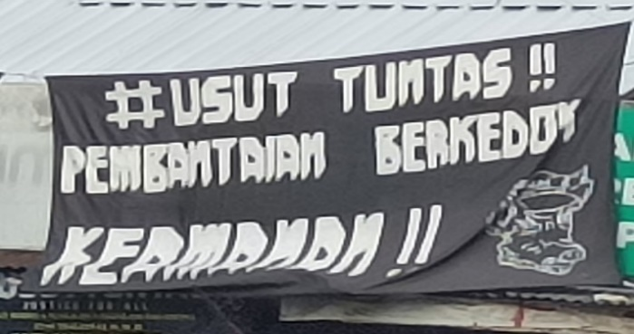 | 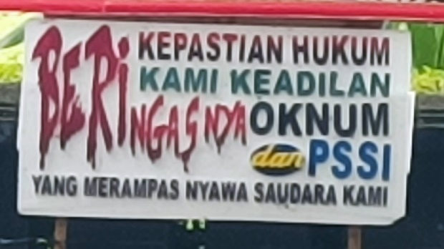
Figure 2. Monolingual sign in Indonesian

Figure 2 is a sample (two pictures) of monolingual signs in Indonesian. Image 1 reads, “Usut Tuntas: Pembantaian berkedok keamanan” (Investigate Completely: Massacre under the guise of security). Using the word massacre means to commit cruel killings with more than one victim. Where the police sprayed tear gas at Aremania football fans on the grounds of security while the stadium consisted of many groups (children, youth, adults, and seniors), they had been running headlong and jostled, to the point of stamping, asphyxiation, etc. This resulted in injuries and even death. Image 2 reads “Beri kami kepastian hukum. Beri kami keadilan. Beringasnya oknum dan PSSI (Persatuan Sepak Bola Seluruh Indonesia), yang merampas nyawa saudara kami” (Give us legal certainty. Give us justice. The ferocity of the individuals and the PSSI (All Indonesian Football Association), which took the lives of our brothers and sisters". The sentence in this sign seeks justice with legal certainty set for the perpetrators of the Kanjuruan tragedy and the people in charge of PSSI, East Java Regional Police, and Malang City Police in their failure to secure a football match between Arema and Persebaya.

Image 1 | Image 2
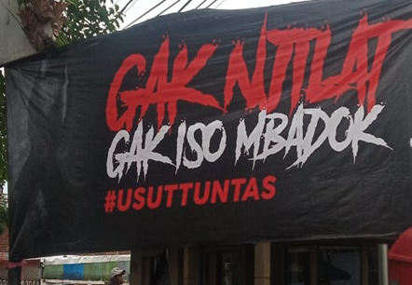 | 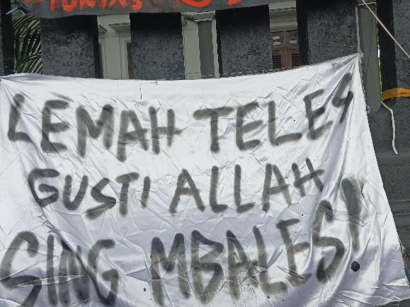
Figure 3. Monolingual sign in Javanese

This monolingual sign in Javanese uses the roughest level of language, as shown in image 1 (figure 3), which contains “Gak njilat, gak iso mbadok. #Usut Tuntas” (No lick, no iso mbadok. #Investigate Completely) can be interpreted as a person, in this case, government officials cannot seek a bite of rice except by fawning (i.e., doing things aimed at gaining their benefit by pleasing others, even if in a way that hurts and even harms many people). Image 2 further shows the community's surrender to the efforts made in various ways, so they write the following sentence "Lemah teles, Gusti Allah sing mbales," which means that every good and bad deed will always get a proper reward from God Almighty.

Image 1 | Image 2 | Image 3
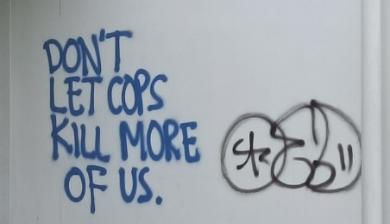 | 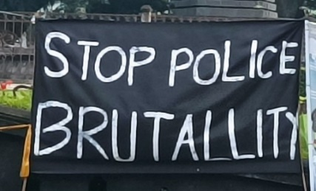 | 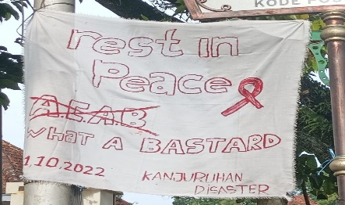
Figure 4. Monolingual sign in English

Figure 4 provides an example of three monolingual signs using English. Image 1 says it reads, "Don't let cops kill more of us," which means that the people ask the police as security guards for the nation and the nation not to commit more killings. They were appointed to maintain the country's stability, not complicate the situation and conditions. Image 2 reads the phrase "Stop police brutality" The public views that the actions committed by the police at the Kanjuruan stadium are a category of brutal behavior, namely acts that are cruel, impudent, impolite, rude, and barbaric. Image 3 reads, "Rest in peace, ACAB. What a bastard, Kanjuruan disaster. "The sign in Figure 3 has three dimensions. First, it provides support and prayer for Aremania football supporters who have passed away and are given a peaceful life in nature. The second is a word of ridicule and insult to the perpetrators of the murder. Third, there is a ribbon symbol that shows the meaning of mourning, expression of grief, and raising collective support for Kanjuran victims who have died and those who were injured after a mass tragedy

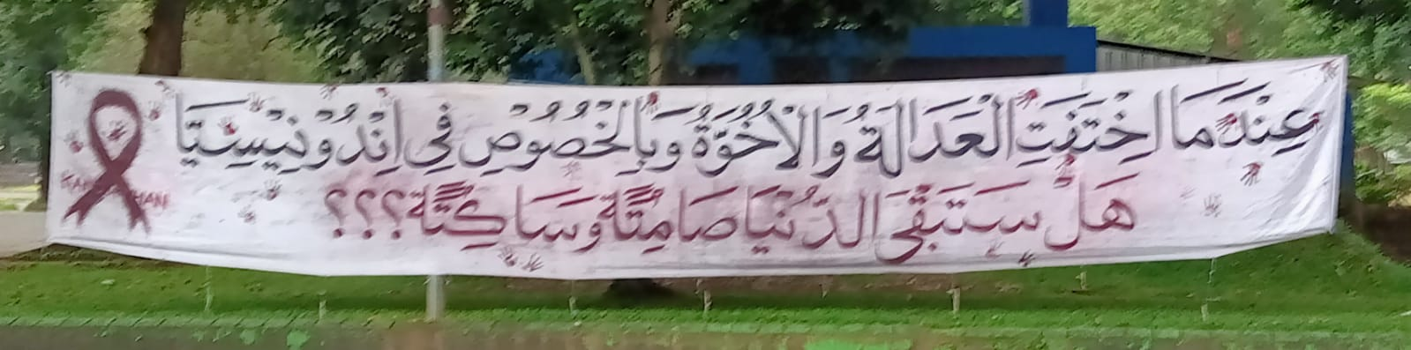
Figure 5. Monolingual sign in Arabic

Sign in Arabic illustrates dissatisfaction with the court's decision on the perpetrators of the Kanjuruan tragedy, which killed hundreds of people. Figure 5 reads, "'Indamaa ikhtafat al-'adalatu wa al-ukhuwwatu wa bil-specifically for Indonesia, hal satabqaa al-dunya shaamitah wa saakitah???” (“when justice is hidden and disguised, and brotherhood is divided, especially in Indonesia, will you remain silent and calm???”). The sentence in the sign warns the entire Indonesian nation to participate in thoroughly investigating the perpetrators. The Kanjuruan incident seems to have been covered up and kept secret by the masterminds and masterminds of the Kanjuruan tragedy.

Bilingual Sign
Research can show signs installed on the street and other places that use a combination of two languages: Indonesian-Javanese, Indonesian-English, and Indonesian-Arabic. All indications show Indonesian as the dominant language alongside other languages in each character. Every poster that uses bilinguals juxtaposes Indonesian, as shown in Figures 6, 7, and 8.
Image 1
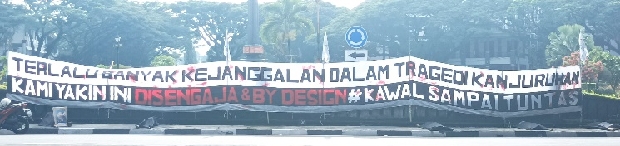
Image 2
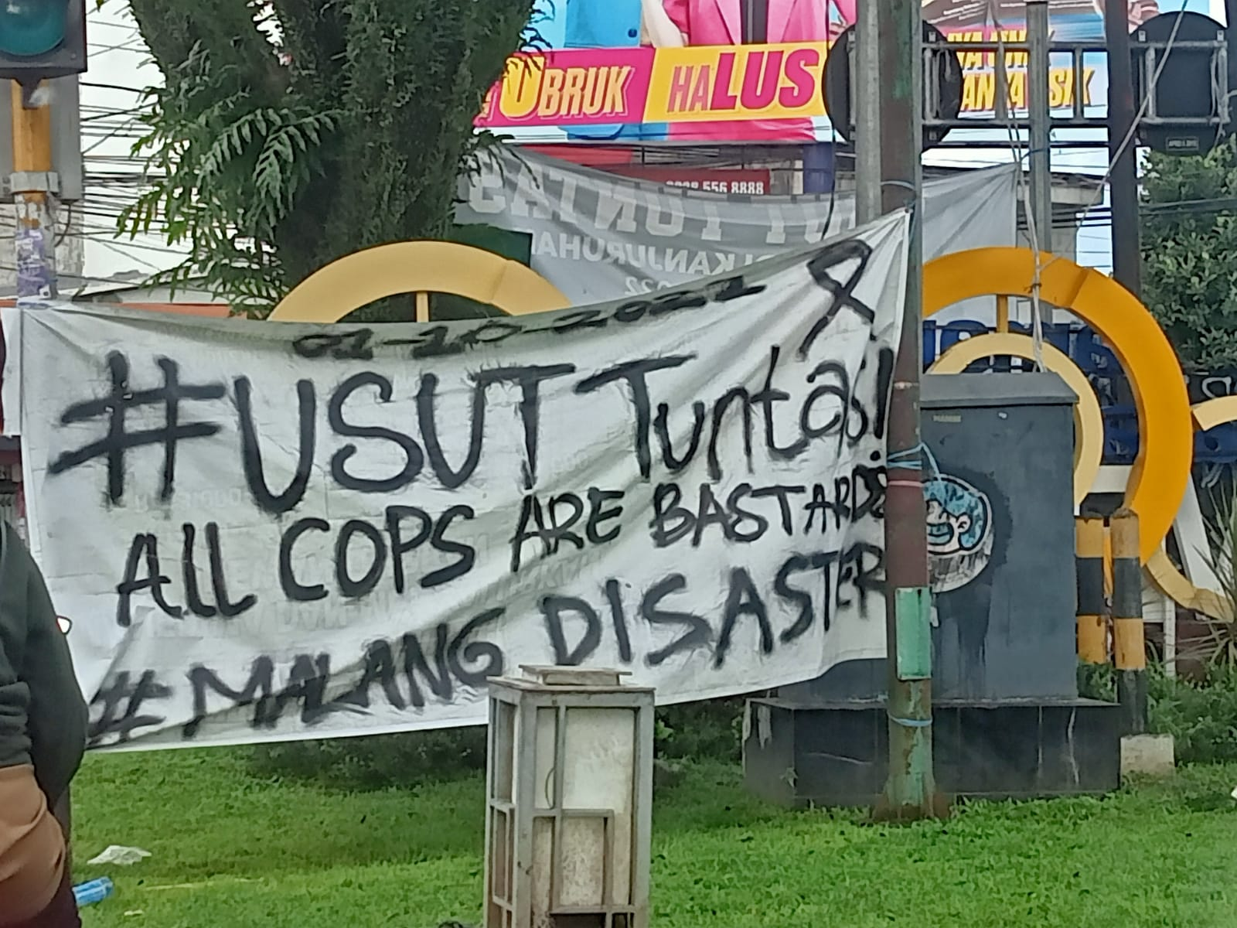
Figure 6. Bilingual sign in Indonesian-English

Figure 6 shows the sign using bilingual Indonesian and English. Image 1 reads “Terlalu banyak kejanggalan dalam tragedi Kanjuruan. Kami yakin disengata dan by design. Kawal sampai tuntas.” (There are too many irregularities in the Kanjuruan tragedy. We believe in sting and by design. Watch it to the end). Image 1 shows community resistance to the arrest of the perpetrators, and the punishments imposed on the perpetrators felt too light. They were only given a sentence following Article 395 of the Criminal Code "Anyone who because of his mistake (negligence) causes another person to die is threatened with imprisonment for five years or imprisonment for a maximum of one year. "The community considers This Kanjuruan tragedy as an act planned and deliberate by certain persons. Image 2 reads, “Usut Tuntas: All Cops are bastards. Malang disaster” (Investigate Completely: All Cops are bastards. Malang disaster). The sentence begins with the slogan of the Kanjuruan tragedy, "Investigate Completely," which is the vision of the people to find out the brain of this incident—followed by insulting sentences against police officers

Image 1 | Image 2
Figure 7. Bilingual sign in Indonesian-Javanese

Figure 7 shows bilingual signs in Indonesian and Javanese that the community uses. Image 1 “Duka kami ojo dipolitisi, Malang omahku, ojo dipecah belah karo nafsumu!!! #Usust Tuntas” (Don't politicize our grief, Malang is my home, don't be divided by your lust!!! #Investigate Completely). This sentence illustrates that the people of Malang, in particular, and the Indonesian people, in general, have been grieving due to the Kanjuruan tragedy. Where unhealthy political interests have ridden football matches. The security forces have torn apart the football union, not only Arema football but Indonesian football, which has received attention from FIFA and the world for Malang security. Image 2 “Tugasmu mengayomi/membunuh” (Your job is to protect/kill) reminds government officials that the state asks them to protect the community, not destroy, injure, and even kill.

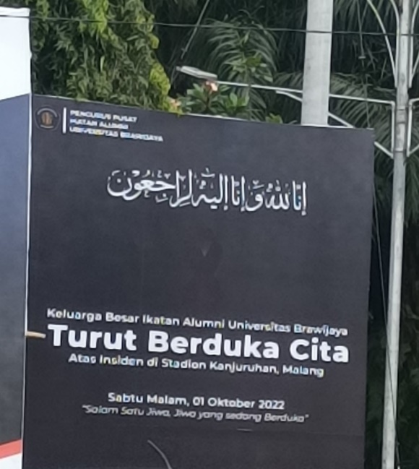
Figure 8. Bilingual sign in Indonesian-Arabic

Figure 8 shows the use of a sign in two languages, namely Indonesian-Arabic. The sign reads “Inna lillahi wa inna ilaihi raji'un, keluarga besar Ikatan Alumni Universitas Brawijaya Turut Berduka Cita atas inside di stadion Kanjuruan Malang, Sabtu Malam, 01 Oktober 2022, Salam satu jiwa, jiwa yang sedang berduka” (Inna lillahi wa inna ilaihi raji'un, the big family of the Alumni Association of Universitas Brawijaya Condolences for the incident at Kanjuruan Stadium Malang, Saturday Night, October 1, 2022, Greetings one soul, a grieving soul). The sentence in this sign is more about condolences for the victims of the Kanjuruan tragedy. In addition, there is a sentence with a larger font size, namely the sentence "Turut Berduka Cita," which emphasizes condolences to supporters who have died. The sign is closed with Arema's jargon “Salam Satu Jiwa” (Greetings one soul). This sentence shows full support for the Kanjuruan incident, and the community has united to defend and demand justice. The community as a whole, on behalf of Arema, has become brothers. If one is hurt, the others feel pain and help each other, and vice versa.
The findings in this study show that Indonesian is used predominantly by people in various places on the street, city hall, police station, etc., as shown in Table 1 and Table 2. Likewise, the use of Indonesian is horizontally side by side with other languages for signs using bilinguals. The symbol used does not highlight one language with another. All languages have the same font size and in no particular order of language usage. The font size is enlarged only on the word that is the focus, as shown in Figure 3, Figure 2, which shows rejection, and Figure 8, which expresses condolences to the victims. The sign has the same writing color. In addition, there are signs with the same font size but given a different writing color as a highlight of the form of rejection, as shown in Figure 5 in Figure 1. This is in line with Beckhaus, who stated that the writing model in signs could be used by using language aligned vertically and language is used horizontally (Backhaus, 2005).
Indonesian has the highest quantity of use in both monolingual and bilingual signs (table 1). This is in line with the identity of the Indonesian nation, where Indonesian is the official language of the Indonesian state, as well as the nation's unifying language, and is used as the language of formal communication, both written and spoken (Dalimunte, 2017; Kurniawan, 2017; Rumandang Bulan, 2019). Indonesia is a good capital for a nation built on ethnic and cultural diversity in fostering nationalism and strengthening national identity (Sanjaya, 2017). In contrast to findings (Monje, 2017), forms of community protest tend to use multilingualism and highlight the language of millennials. Thus, the linguistic landscape can describe how language is used from the dynamics of global society (Hélot, C. et al., 2013).
The massive signs posted in various public places are an act of symbolic/open resistance by using clear, direct, and to-the-point language (such as asking for an appropriate punishment for the perpetrators of the Kanjuruan tragedy, refusing the sentence imposed on the perpetrators who are considered too light, insulting the perpetrators, insulting government officials, etc.). The selected sentences use four figurative speech patterns: sarcasm, cynicism, rhetoric, and euphemism. Sarcasm sentences are the most frequently written sentence patterns in the linguistic landscape. As Found (Dabbour, 2017) states, the protest media has specific characteristics, such as the word choice that is sarcasm and belief. Where the sentences written by the community expressed their emotional feelings, they use harsh words and are negative in a direct and blatant manner. The sign installation movement in all corners of Malang, Indonesia, aims to get a response from city government officials, Indonesia, and even the world in general. In other words, language is used to attract the sympathy and attention of others (Minocha, 2020).
The choice of words, sentences, and symbols are also examined to determine the symbolic meaning that expresses the sign's strength to protest the Kanjuruan tragedy. The existing landscape is full of characters and discourses with cultural and political importance as a powerful tool to protest (Kasanga, 2014). These public demonstrations can be seen as LLs in which the discursive use of signs, banners, flags, and other protest signs builds an apparent socio-political space for a public conversation around demands for justice, firmness, and responsibility (Ku, 2020). This paper also shows the choice of language, social and grammatical indexicality, image, cultural capital contained, and the choreography of the assembly in the sign. In line with (Taylor-Leech, 2020), who see LL protest as a semiotic aggregate that can become a bridge for society.

CONCLUSION
This research reflects on three primary and dominant patterns in the LL Kanjuruan tragedy. First, the choice of language used in the Kanjuruan tragedy protest is more prevalent in sarcasm, cynicism, and rhetoric. These sentences were chosen to show people's emotions and anger toward the government. Second, the signs posted in public places highlight the Indonesian language used to express feelings, in addition to English, Javanese, and Arabic. This proves that the local language's (Indonesian) identity is still the community's leading choice even amid globalization and multi-media. Third, the form used in the sign indicates two forms, monolingual and bilingual. There were no signs using multilingual. In the bilingual sign, Indonesian still dominates, in which Indonesian accompanies and aligns horizontally with other languages.
This research has limitations in the areas used as field objects for taking pictures of signs related to community protests over the Kanjuruan tragedy on October 1, 2022. Namely, this research focuses on Malang, Indonesia, so the data collected is limited and less varied. It is also limited to the analysis of linguistic aspects, yet to look at cultural and political elements. In line with that, this research suggests conducting further studies that examine the same sign in the broader area including Malang district and East Java region to obtain varied data and various sign patterns. Thus the information obtained is more comprehensive and representative of multiple groups.

REFERENCES
Ardhian, D., Sumarlam, Purnanto, D., & Yustanto, H. (2021). Religious performance in Malang, Indonesia: Linguistic landscape on worship sign. Journal of Language and Linguistic Studies. 17(2), 983-1000. https://doi.org/10.52462/jlls.68
Backhaus, P. (2005). Signs of multilingualism in Tokyo — a diachronic look at the linguistic landscape. International Journal of the Sociology of Language. 103-121. https://doi.org/10.1515/ijsl.2005.2005.175-176.103
Badan Pengembangan dan Pembinaan Bahasa. (2016). KBBI Daring. Kementerian Pendidikan Dan Kebudayaan Indonesia.
Baranova, V., & Fedorova, K. (2020). Growing visibility: Migration and transformations in saint petersburg’s linguistic landscape. Laboratorium: Russian Review of Social Research. 12(1), 48-80. https://doi.org/10.25285/2078-1938-2020-12-1-48-80
Begum, N., & Sinha, S. (2021). The languages of the divine space: A case study from India. Dialectologia. 33-48. https://doi.org/10.1344/Dialectologia2021.27.2
Ben-Rafael, E., & Ben-Rafael, M. (2015). Linguistic landscapes in an era of multiple globalizations. Linguistic Landscape. An International Journal. 1(1-2), 19-37. https://doi.org/10.1075/ll.1.1-2.02ben
Burr, S. (2021). Linguistic Landscape Signs in E-Textbooks: Teaching Language as a Compass for Exploring Multimodal Texts, Multilingualism, and Digital Resources. Human, Technologies and Quality Of Education. 937-952. https://doi.org/10.22364/htqe.2021.74
Chamberlain, L., & Snyman, G. (2017). Lawyering protest - critique and creativity: Where to from here in the public interest legal sector? South African Crime Quarterly. 62, 7-20. https://doi.org/10.17159/2413-3108/2017/v0n62a3059
Christoph Steinhardt, H., & Wu, F. (2016). In the name of the public: Environmental protest and the changing landscape of popular contention in China. China Journal. 75(1), 61-82. https://doi.org/10.1086/684010
Dabbour, K. (2017). The Linguistic Landscape of Tahrir Square Protest Signs and Egyptian National Identity. Studies in Linguistics and Literature. 1(2), 142-161. https://doi.org/10.22158/sll.v1n2p142
Dal Negro, S. (2009). Local Policy Modeling the Linguistic Landscape. In Linguistic Landscape. Expanding the Scenery. 206-218. https://www.taylorfrancis.com/chapters/edit/10.4324/9780203930960-21/local-policy-modeling-linguistic-landscape-silvia-dal-negro
Dalimunte, A. A. (2017). Implementasi Kebijakan Bahasa dan Implikasinya dalam Penguatan Identitas, Integritas, dan Pluralitas Bangsa. Jurnal Humaniora Teknologi. 2(1). https://doi.org/10.34128/jht.v2i1.3
Dube, T. (2020). Language, Resistance and Multilingualism in Post-Colonial Zimbabwe: The Kalanga and their Struggle for Recognition. Journal of Southern African Studies. 46(6), 1183-1201. https://doi.org/10.1080/03057070.2020.1834238
Ebrahimi, M., & Taheri, A. (2017). The Tragedy in the Story of Rostam and Sohrab in Ferdowsi’s Shahnameh. Journal of History Culture and Art Research, 6(1), 96-105. http://kutaksam.karabuk.edu.tr/index.php/ilk/article/view/707
Eduard Lukman. (2022). Tragedi Kanjuruhan. Kompas.Id. https://www.kompas.id/baca/opini/2022/10/12/tragedi-kanjuruhan-2
Edwin Shri Bimo. (2022). Kini Indonesia Salah Satu Peringkat Teratas Korban Tewas Tragedi Sepak Bola Dunia, Ini Daftarnya. KOMPAS TV. https://www.kompas.tv/article/334089/kini-indonesia-salah-satu-peringkat-teratas-korban-tewas-tragedi-sepak-bola-dunia-ini-daftarnya
Eka Yudha Saputra. (2022). Kronologi Tragedi Kanjuruhan Malang yang Dipaparkan Kapolri. Tempo.Co. https://nasional.tempo.co/read/1642553/kronologi-tragedi-kanjuruhan-malang-yang-dipaparkan-kapolri
Friedrich Nietzsche. (2015). Lahirnya Tragedi. Yogyakarta: Narasi. https://opac.perpusnas.go.id/DetailOpac.aspx?id=945660
Habashi, J. (2008). Language of political socialization: Language of resistance. Children’s Geographies. 6(3), 269-280. https://doi.org/10.1080/14733280802183999
Ikhwan, I. (2020). Makna Tragedi dalam konteks kebudayaan (Suatu Tafsiran Bebas Terhadap Pandangan Friedrich Nietzsche). Jurnal Adabiya. 22(1), 120-104. https://doi.org/10.22373/adabiya.v22i1.7464
Inya, B. T. (2019). Linguistic landscape of religious signboards in ado ekiti, nigeria: Culture, identity and globalisation. Theory and Practice in Language Studies. 9(9), 1146-1159. https://doi.org/10.17507/tpls.0909.11
Kasanga, L. A. (2014). The linguistic landscape: Mobile signs, code choice, symbolic meaning and territoriality in the discourse of protest. International Journal of the Sociology of Language. (230), 19-44. https://doi.org/10.1515/ijsl-2014-0025
Komnas HAM. (2022). Tragedi Kanjuruhan: Komnas HAM temukan “pelanggaran pidana” - “Harus ada pertanggungjawaban hukum terhadap meninggalnya 135 orang.” Bbc.Com. https://www.bbc.com/indonesia/articles/c98w3yyd3pdo
Ku, E. K. (2020). Waiting for my red envelope: discourses of sameness in the linguistic landscape of a marriage equality demonstration in Taiwan. Critical Discourse Studies. 17(2), 156-174. https://doi.org/10.1080/17405904.2019.1656655
Kull, C. A. (2002). Madagascar aflame: Landscape burning as peasant protest, resistance, or a resource management tool? Political Geography. 21(7), 927-953. https://doi.org/10.1016/S0962-6298(02)00054-9
Kurniawan, K. (2017). Kebijakan nasional kebahasaan dan pelindungan bahasa daerah. Jurnal Handayani. 7(1), 1-12. https://doi.org/10.24114/jh.v7i1.6569
Landry, R., & Bourhis, R. Y. (1997). Linguistic landscape and ethnolinguistic vitality: An empirical study. Journal of Language and Social Psychology. 16(1), 23-49. https://doi.org/10.1177/0261927X970161002
Liawati, T. (2019). Nasionalisme dalam Drama Tragedi Kereta Api Maut Karya Achmad Toha (Nationalism in The Kereta Api Maut Tragedy Drama by Achmad Toha). Sirok Bastra. 7(1), 97-106. https://doi.org/10.37671/sb.v7i1.158
Hélot, C., Barni, M., Janssens, R., Bagna, C. (2013). Linguistic Landscapes, Multilingualism and Social Change. 16. https://doi.org/10.3726/978-3-653-02576-7
Lintz, G., & Leibenath, M. (2020). The politics of energy landscapes: The influence of local anti-wind initiatives on state policies in Saxony, Germany. Energy, Sustainability and Society. 10(1), 1-22. https://doi.org/10.1186/s13705-019-0230-3
Mahfud MD. (2022). Tragedi Kanjuruhan: “Lebih mengerikan daripada yang di medsos dan televisi”, TGIPF pastikan “kematian massal terutama disebabkan gas air mata.” Bbc.Com. https://www.bbc.com/indonesia/indonesia-63254091
Miles, M. B., & Huberman, A. M. (2016). Miles, M. B., & Huberman, A. M. (1994). Qualitative data analysis: An expanded sourcebook. In Nursing standard (Royal College of Nursing (Great Britain): 1987)
Minocha, D. A. (2020). Languages of Resistance: Women in the Print and Oral Cultures of Colonial Punjab. New Literaria. 1(2), 137-145. https://doi.org/10.48189/nl.2020.v01i2.006
Monje, J. (2017). Hindi bayani/not a hero: The linguistic landscape of protest in Manila. Social Inclusion. 5(4), 14-28. https://doi.org/10.17645/si.v5i4.1151
Nash, J. (2016). Is linguistic landscape necessary? Landscape Research. 41(3), 380-384. https://doi.org/10.1080/01426397.2016.1152356
Orman, J. (2008). Durk Gorter (ed): Linguistic Landscape: A New Approach to Multilingualism. Language Policy. https://doi.org/10.1007/s10993-007-9063-6
Papen, U. (2012). Commercial discourses, gentrification and citizens’ protest: The linguistic landscape of Prenzlauer Berg, Berlin. Journal of Sociolinguistics. 16(1), 56-80. https://doi.org/10.1111/j.1467-9841.2011.00518.x
Peterman, W. E., Winiarski, K. J., Moore, C. E., Carvalho, C. da S., Gilbert, A. L., & Spear, S. F. (2019). A comparison of popular approaches to optimize landscape resistance surfaces. Landscape Ecology. 34, 2197-2208. https://doi.org/10.1007/s10980-019-00870-3
Przymus, S. D., & Kohler, A. T. (2018). SIGNS: Uncovering the mechanisms by which messages in the linguistic landscape influence language/race ideologies and educational opportunities: Linguistics and education. Linguistics and Education. 44, 58-68. https://doi.org/10.1016/j.linged.2017.10.002
Rafael, E. B.-, Shohamy, E., Amara, M. H., & Hecht, N. T.-. (2018). Linguistic Landscape as Symbolic Construction of the Public Space: The Case of Israel. In Linguistic Landscape. 3(1), 7-30. https://doi.org/10.21832/9781853599170-002
Rahayu, S. (2022). Tragedi Kanjuruhan Renggut Ratusan Nyawa, Indonesia Disorot Dunia. Kompas.Com. https://bola.kompas.com/read/2022/10/02/13403128/tragedi-kanjuruhan-renggut-ratusan-nyawa-indonesia-disorot-dunia?page=all
Rumandang Bulan, D. (2019). Bahasa Indonesia Sebagai Identitas Nasional Bangsa Indonesia. Jurnal Jisipol. 3(2), 23-29. https://unibba.ac.id/ejournal/index.php/jisipol/article/view/115
Sánchez-López, L. (2019). Transforming the community's linguistic landscape in a mixed-learner service learning capstone course in a Spanish for specific purposes program. Revista Signos. 52(101). https://doi.org/10.4067/S0718-09342019000300996
Sanjaya, M. D. (2017). Bahasa Indonesia Dan Daerah Sebagai Perekat Jati Diri Dan Martabat Bangsa Di Era Globalisasi. Jurnal Bindo Sastra. https://doi.org/10.32502/jbs.v1i1.662
Sayer, P. (2009). Using the linguistic landscape as a pedagogical resource. ELT Journal. 1(1), 10-14. https://doi.org/10.1093/elt/ccp051
Sayer, P. (2020). Ethnographic language learning projects through the linguistic landscape. In Educational Linguistics. 327-347. https://doi.org/10.1007/978-3-030-55761-4_14
Scott, J. C. (2000). Senjatanya Orang-orang yang Kalah: Bentuk-bentuk perlawanan sehari-hari kaum tani. Yayasan Obor Indonesia. https://cir.nii.ac.jp/crid/1130282270313550208
Seloni, L., & Sarfati, Y. (2017). Linguistic landscape of Gezi Park protests in Turkey: A discourse analysis of graffiti. Journal of Language and Politics. 16(6), 782-808. https://doi.org/10.1075/jlp.15037.sel
Shiri, S. (2015). Co-Constructing Dissent in the Transient Linguistic Landscape: Multilingual Protest Signs of the Tunisian Revolution. In Conflict, Exclusion and Dissent in the Linguistic Landscape. 239-259. https://doi.org/10.1057/9781137426284_12
Syrjälä, V. (2022). Linguistic Landscapes in the Stockholm Archipelago—Producing and Reflecting a Sense of Place. Languages. 7(1), 37. https://doi.org/10.3390/languages7010037
Taylor-Leech, K. (2020). Timorese talking back. Linguistic Landscape. An International Journal. 6(1), 29-51. https://doi.org/10.1075/ll.00016.tay

