Idiomatic Phrases among Banten Sundanese Local Language Speakers

Dase Erwin Juansah
Universitas Sultan Ageng Tirtayasa
Serang, Indonesia
daseerwin77@untirta.ac.id

Akhmad Baihaqi*
Universitas Sultan Ageng Tirtayasa
Serang, Indonesia
akhmad.baihaqi@untirta.ac.id

Aisyah Hamidiyah
Universitas Sultan Ageng Tirtayasa
Serang, Indonesia
aisyah.hamidiyah@untirta.ac.id

*) Corresponding Author

AUTHOR‘S GUARANTEE FORM
CONCERNING WORK PRESENTED FOR PUBLICATION

AUTHORS: Dase Erwin Juansah, Akhmad Baihaqi, & Aisyah Hamidiyah guarantee(s) that the manuscript: Idiomatic Phrases among Banten Sundanese Local Language Speakers (hereinafter referred to as “Work”), presented for the Buletin Al-Turas (hereinafter referred to as “Publication”), is an original work and

- it was written by the Author(s) indicated in the Work;
- the material of the Work was not published in any other publications;
- the material of the Work is not and will not be presented for publication to any other publications;
- the Work does not contain statements, which do not correspond to reality, or material, which may infringe upon the intellectual property rights of another person or legal entity, and upon the conditions and requirements of sponsors or providers of financial support;
- all references used in the Work are indicated and, to the extent the Work incorporates text passages, figures, data or other material from the works of others, the undersigned has obtained any necessary permissions;
- do(es) not object to the spread of the Work by all means of distribution.

In the event the above Work is not accepted and is not published in the Publication or is withdrawn by the Author(s) before acceptance by the Publication, this guarantee form becomes null and void, and the submitted Work is not returned to the Author(s).

Hereby signing this form the Author(s) confirm(s) that the information presented above is correct and undertake(s) to abide by the guarantees and obligations given above:
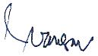

Dase Erwin Juansah ………………….. January 05, 2023

Akhmad Baihaqi ………………….. January 05, 2023
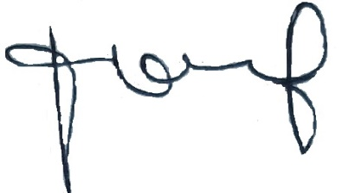

Aisyah Hamidiyah ………………….. January 05, 2023

