The Character of Muslim Aswaja An-Nahdliyah as Efforts to Strengthen Islamic Moderation in Islamic Boarding School

Faris Khoirul Anam*
UIN Maulana Malik Ibrahim
Malang, Indonesia
faris.fs@um.ac.id

Moh. Padil
UIN Maulana Malik Ibrahim
Malang, Indonesia
nganjukgondang@gmail.com

Mokhammad Yahya
UIN Maulana Malik Ibrahim
Malang, Indonesia
mokhammadyahya@pips-uin.malang.ac.id

*) Corresponding Author

AUTHOR‘S GUARANTEE FORM
CONCERNING WORK PRESENTED FOR PUBLICATION

AUTHORS: Faris Khoirul Anam, Moh. Padil, Mokhammad Yahya guarantes that the manuscript “The Character of Muslim Aswaja An-Nahdliyah as Effort to Strengthen Islamic Moderation in Islamic Boarding School” (hereinafter referred to as “Work”), presented for the Buletin Al-Turas (hereinafter referred to as “Publication”), is an original work and
- it was written by the Authors indicated in the Work;
- the material of the Work was not published in any other publications;
- the material of the Work is not and will not be presented for publication to any other publications;
- the Work does not contain statements, which do not correspond to reality, or material, which may infringe upon the intellectual property rights of another person or legal entity, and upon the conditions and requirements of sponsors or providers of financial support;
- all references used in the Work are indicated and, to the extent the Work incorporates text passages, figures, data or other material from the works of others, the undersigned has obtained any necessary permissions;
- does not object to the spread of the Work by all means of distribution.

In the event the above Work is not accepted and is not published in the Publication or is withdrawn by the Authors before acceptance by the Publication, this guarantee form becomes null and void, and the submitted Work is not returned to the Authors.

Hereby signing this form the Authors confirms that the information presented above is correct and undertakes to abide by the guarantees and obligations given above:
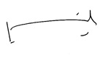

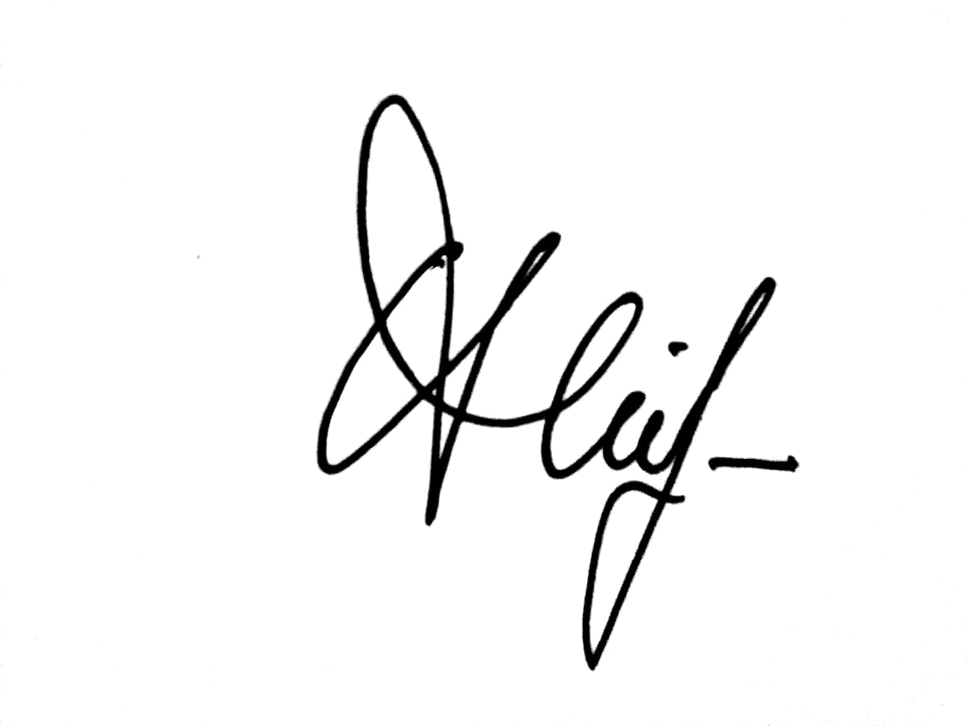
Faris Khoirul Anam ____________________________ 15th March 2021

Moh. Padil ____________________________ 15th March 2021
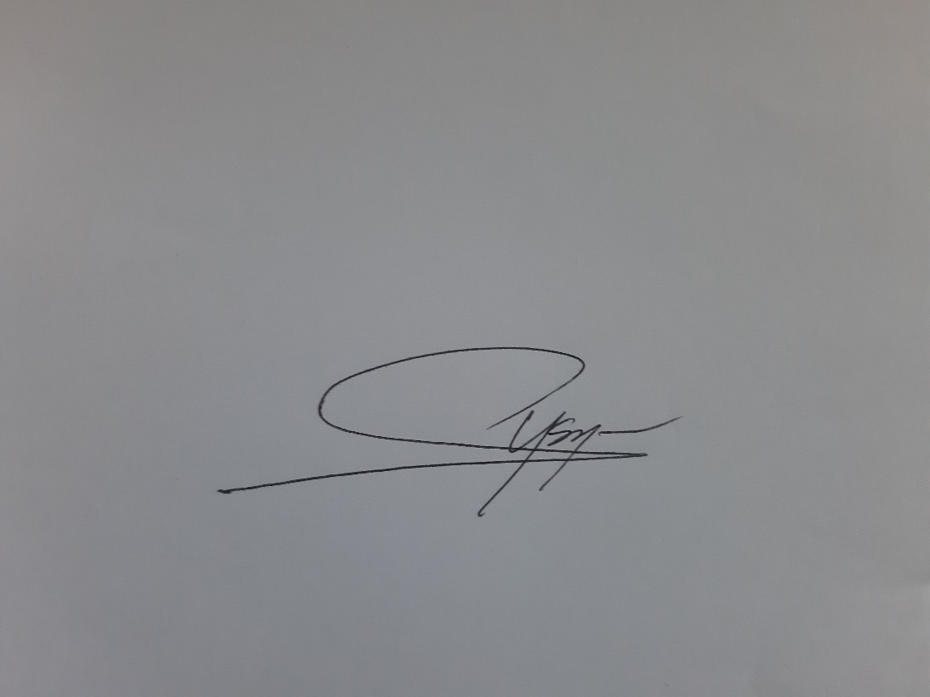

Mokhammad Yahya ____________________________ 15th March 2021

