2D JOINT INVERSION OF GRAVITY AND MAGNETIC DATA TO EVALUATE A GEOLOGICAL STRUCTURE IN TANIMBAR ISLAND

Submitted: ; Revised: ; Approved: ; Available Online:

Abstrak. Kebutuhan akan energi hidrokarbon yaitu minyak dan gas bumi mengharuskan untuk terus melakukan eksplorasi cadangan hidrokarbon terutama di wilayah Timur Indonesia. Kepulauan Tanimbar, Maluku dipilih untuk menjadi wilayah penelitian karena geologi bawah permukaannya yang kompleks dan berada pada jalur fold thrust belt hasil dari evolusi tektonik. Pada penelitian ini dilakukan pembaharuan menggunakan pemodelan joint inversion dengan mengkorelasikan parameter fisis dari dua data geofisika berbeda yaitu gravitasi dan geomagnetik. Tujuan dari penelitian ini yaitu untuk mengetahui pemetaan bawah permukaan daerah penelitian, mengetahui nilai densitas dan suseptibilitas batuan, serta mengetahui pola struktur yang ada di bawah permukaan. Hasil pemetaan bawah permukaan Kepulauan Tanimbar berdasarkan hasil pemodelan Joint Inversion telah ditemukan pola struktur geologi berupa fold thrust belt akibat zona subduksi Busur Banda. Pada section A-A’ terlihat adanya rangkaian fold thrust belt dengan 10 pola struktur yaitu 6 struktur berarah baratlaut-tenggara dan 4 struktur berarah timurlaut-baratdaya. Pada section B-B’ terlihat adanya 9 pola struktur berarah timurlaut-baratdaya. Anomali tinggi yang didapat nilai densitasnya berkisar 2.77 – 2.81 gr/cm³ dan suseptibilitas berkisar 0.00125 – 0.0013 SI diduga akibat basement high berupa batuan vulkanik, sedangkan anomali rendah didapat nilai densitasnya berkisar 2.45 – 2.49 gr/cm³ dan besar suseptibilitas berkisar 0.0008 – 0.00085 SI yang diduga karena lapisan sedimen yang tebal dari Formasi Batimafudi.

Kata Kunci: fold thrust belt, Geomagnetik, Gravitasi, Joint Inversion, Tanimbar

Abstract. The need for hydrocarbon energy, especially oil and gas, requires continuous exploration of hydrocarbon reserves, especially in eastern Indonesia. Tanimbar Islands, Maluku was chosen to be the research area because of its complex subsurface geology and is located on the fold thrust belt resulting from tectonic evolution. In this research, an innovation is carried out using joint inversion modeling by correlating physical parameters from two different geophysical data, which are gravity and geomagnetic. The purpose of this research is to determine the subsurface mapping of the research area, determine the density and susceptibility values of rocks, and determine the structural patterns that exist in the subsurface. The results of subsurface mapping of the Tanimbar Islands based on the results of Joint Inversion modelling have found a geological structure pattern in the form of a fold thrust belt due to the Banda Arc subduction zone. In section A-A', there is a sequence of fold thrust belt with 10 structural patterns, including 6 structures in the northwest-southeast direction and 4 structures in the northeast-southwest direction. In section B-B' there are 9 structural patterns in the northeast-southwest direction. High anomalies obtained density values ranging from 2.77 - 2.81 gr/cm³ and susceptibility ranging from 0.00125 - 0.0013 SI are thought to be caused by high basement in the form of volcanic rocks, while low anomalies obtained density values ranging from 2.45 - 2.49 gr/cm³ and susceptibility ranging from 0.0008 - 0.00085 SI are thought to be caused by thick sedimentary layers of the Batimafudi Formation.
Keywords: fold thrust belt, Geomagnetic, Gravity, Joint Inversion, Tanimbar

INTRODUCTION

The need for hydrocarbon energy, namely oil and natural gas, is not proportional to its production. As in 2012, oil consumption reached 1.6 million barrels per day while production was only around 900 thousand barrels [1]. Therefore, exploration is needed to find potential hydrocarbon or oil and gas reserves in Indonesian areas that have not been exploited, especially in the eastern part of Indonesia. Complex geology and being on the fold thrust belt (FTB) route as a result of tectonic evolution [2] makes the Tanimbar Islands, Maluku interesting to study and selected to be the research area. Structurally the Tanimbar Islands occupy part of the forearc of the banda arc (Figure 1) which is a collision zone between the Australian continental margin which causes deformation accompanied by diversion and fold and thrust processes along 23,000 km resulting from the mass of the Australian continental margin experiencing a roll back under the Banda trench. [3][4][5]. The characteristic of FTB in the study area is a thin-skinned anticline with a complex structure [6]. In some cases, the FTB contains accumulations of oil and gas in structural traps [7]
To see the oil and gas potential in the Tanimbar area, various efforts have been made, including the seismic reflection method. However, the results obtained in the study area are not clear enough to describe the complexity of geology [2]. Therefore, other geophysical data such as gravity and geomagnetic data are needed. An approach using the forward modeling method with gravity data has been carried out [8], so an update was made using joint inversion modeling using gravity and geomagnetic data. This joint inversion combines physical parameters from different geophysical data which aims to increase data resolution and reduce the ambiguity of inversion modeling separately [9]. In this study, applying joint inversion in research areas with complex geology and looking at its effectiveness.

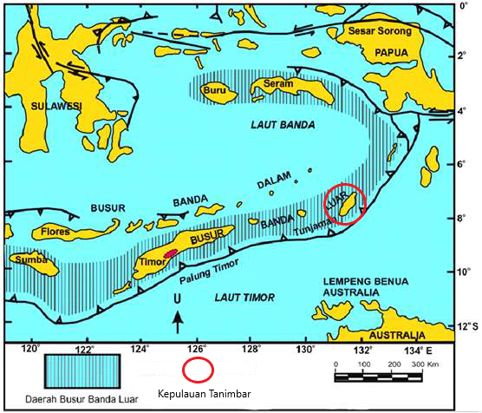
Figure. 1 Banda Arc Forearc Map (Haryanto et al, 2021)
Joint inversion was carried out by Luis A. Gallard who integrated P-wave, S-wave, DC resistivity and audiomagnetotellurics data, L. Gross (2019) and M. Tavakoli, et al (2020) which combined gravity and geomagnetic data. The three studies above show that joint inversion is a fairly effective method with structurally consistent images of several physical parameters and produces higher image resolution compared to separate inversions [10][11][12]. The research was conducted for a preliminary survey of oil and gas exploration which aims to determine the subsurface mapping, see the density and susceptibility of the subsurface, and determine the pattern of faults in the study area.

DATA AND METHOD

In this study, two secondary data from airborne surveys were used, namely gravity and geomagnetic data. The gravity method is based on measuring variations in the gravitational field caused by variations in rock density in the soil or subsurface [13]. The geomagnetic method is based on measuring variations in magnetic field intensity due to variations in the distribution of magnetized objects beneath the earth's surface [14]. The gravity data obtained has been acquired or the gravity data has been corrected to obtain a Complete Bouguer Anomaly (CBA) value. The geomagnetic data obtained has also been acquired and corrected to obtain a Total Magnetic Intensity (TMI) value. Then the data is processed into CBA and TMI contour maps (Figure 2).

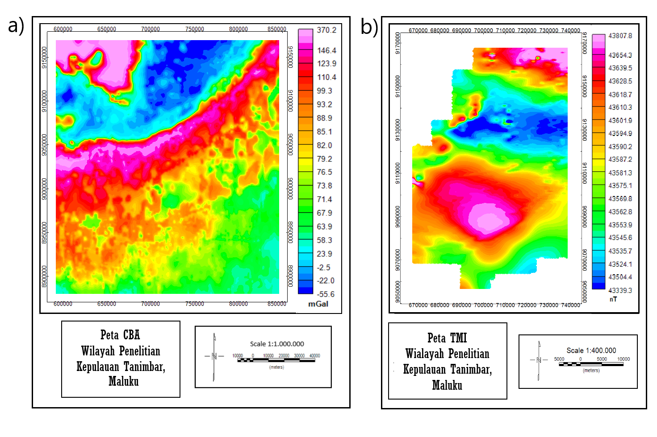
Figure. 2 (a) CBA Map (b) TMI Map

To facilitate interpretation, the TMI map is processed into a Reduce to pole (RTP) map, namely transforming the dipole anomaly into a monopole by changing the inclination angle of the study area, namely -30° to 90° and the declination angle, namely -5° to 0° so that it looks as if measurements were made at the north pole. CBA and RTP maps still consist of regional anomaly effects, residual (local) anomalies, and noise. Regional and residual anomalies interact with each other and cause overlapping anomalies, so these anomalies must be separated from each other [15]. Anomaly separation is carried out by analyzing the Radially Averaged Power Spectrum (RAPS) curve at Oasis Montaj using a Bandpass filter as shown in Figure 3. Bandpass filters are used to separate anomalies produced at different depths by adjusting the desired wave range [16].

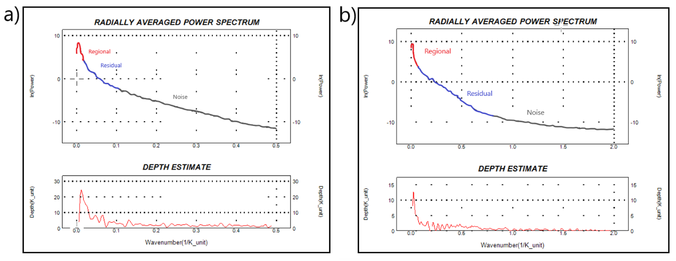
Figure. 3 (a) RAPS gravity (b) RAPS magnetic

The target of this research is a shallow anomaly (residual) with a depth of approximately 10 km, then the residual anomaly is selected for further processing for modeling. Residual gravity and magnetic anomalies obtained by slicing were carried out at GYM-SYS Oasis Montaj. Slicing is done 2 times as shown in Figure 4. The first digit is A-A' trending northeast - southwest. The second digit is B-B' trending northwest - southeast.

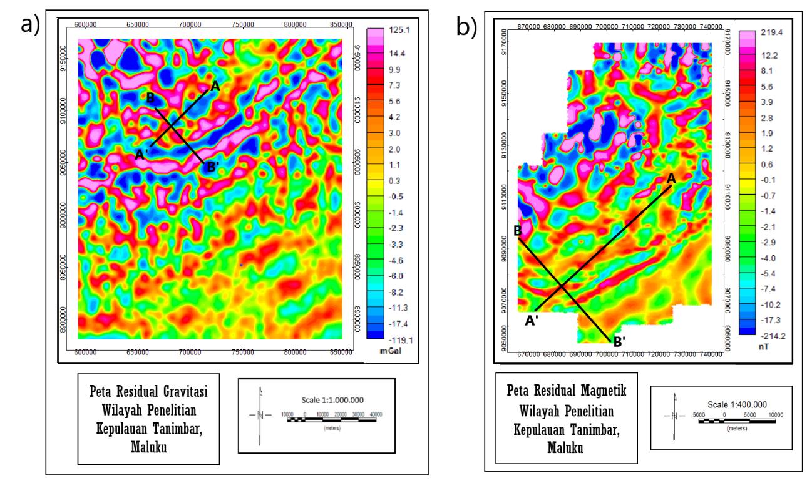
Figure. 4 (a) Gravity residual slicing (b) Magnetic residual slicing
Then the data obtained is modeled separately inversion in ZondGM2d software. After that, a joint inversion was performed by correlating the two physical parameters from the gravity and magnetic data using a cross-gradient in ZondGM2d. The inversion modeling process is carried out by matching the curve (curve fitting) between the mathematical model and the data from observations or measurements. The result of inversion modeling is a subsurface model to estimate rock physical parameters [17]. Inversion modeling was chosen one of them because of data limitations, namely the seismic cross section is blurry (poor quality) and there is no well or magnetotelluric data which makes it difficult to hypothesize subsurface models and if forward modeling is done, the subjectivity will be greater. Forward modeling has also been carried out in the research area, so it was updated with inversion modeling.

RESULTS AND DISCUSSIONS

The results of the gravity modeling are shown in the middle and the geomagnets at the bottom. The inversion modeling results show a heterogeneous subsurface pattern and the presence of low and high anomaly contrasts which might be caused by the fold thrust belt. Comparison of the results of single inversion and joint inversion is shown in Figure 5 (section A-A') and Figure 6 (section B-B'). It can be seen that there is a change in the model from the results of single inversion and joint inversion. Visible model changes are marked with red circles for gravity anomalies and also white circles for geomagnetic anomalies. There are several high anomalies that fade or become lower, and vice versa, namely low anomalies that fade to become higher. The error value generated by joint inversion is greater than that of single inversion, namely in section A-A' the gravity error is 6.41 and the geomagnetic error is 1.12. In section B-B' the gravity error is 3.33 and that of the geomagnet is 4.40. Model changes and increasing error values are caused by joint inversion to establish a flexible balance between data discrepancies from different methods and structural similarity. However, there are also insignificant model changes which are thought to be due to the good results from a single inversion, and the limitations of joint inversion modeling with the cross gradient method in fold thrust belt areas or in areas with complex geology.

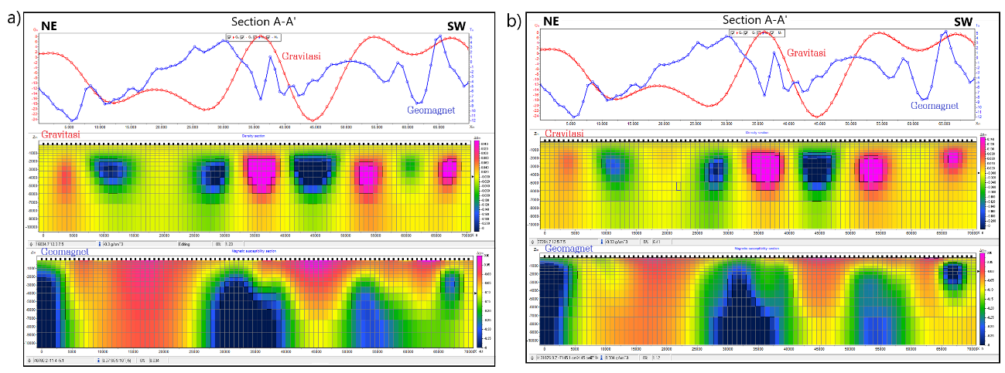
Figure. 5 Comparison of Sections A-A': (a) Single Inversi (b) Joint Inversi

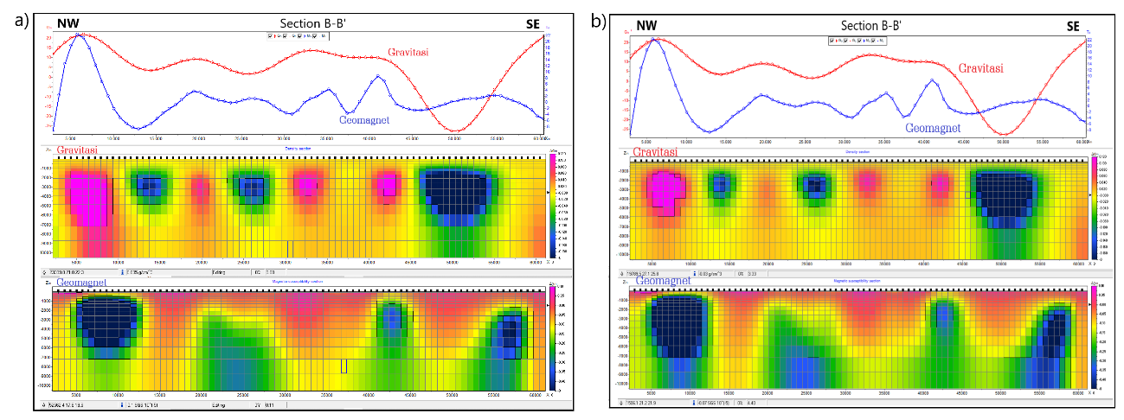
Figure. 6 Comparison of Section B-B': (a) Single Inversi (b) Joint Inversi

From the results of the joint inversion, an interpretation of the subsurface mapping in the study area was carried out. The results of the joint inversion show the value of the distribution of density and susceptibility values which can be seen from the contrast of the anomaly model obtained. In section A-A' and section B-B' (Figure 7) there is a high anomaly in the gravity and geomagnetic modeling which is marked with a red circle presumably due to the presence of a basement high with a high density of around 2.79 - 2.81 gr/cm3 (section A-A'). and 2.77 - 2.79 gr/cm3 (section B-B') and susceptibility with values ranging from 0.00125 – 0.0013 SI, which are suspected volcanic rocks from the Selu Formation of Permian age. This is the effect of subduction so that the basement is lifted up to the surface causing a high anomaly response. This usually allows the emergence of anticlinal structures as potential hydrocarbon structures. It is also seen that low anomalies in the gravity and geomagnetic modeling are marked with blue circles, presumably due to thick sedimentary rocks with density values ranging from 2.45 - 2.47 gr/cm3 (section A-A') and 2.47 - 2.49 gr/cm3 (section B-B'). and the susceptibility ranges from 0.0008 – 0.00085 SI which is thought to be caused by sedimentary rocks from the Batimafudi Formation consisting of shale and also sandy limestone crosses. In addition, there is also a high gravity anomaly but a low geomagnetic anomaly which is marked with a white circle. This is thought to be due to the subduction or collision of the Asian Continental plate (Banda Arc) with the Australian plate which causes high pressure and temperature so that the rocks experience demagnetization and the susceptibility value becomes low, while the density value becomes high due to the high temperature.

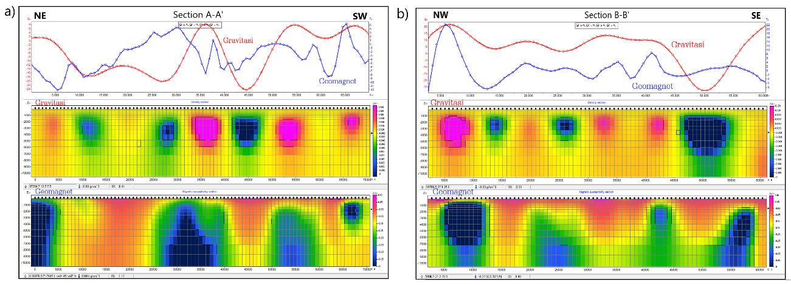
Figure. 7 Joint Inversion Modeling Results: (a) Section A-A’ (b) Section B-B’

The anomalous contrast resulting from the modeling of gravity and geomagnetic data indicated by the contrast of the blue (low) and pink (high) trend colors is thought to be due to the fracture of the fold thrust belt series due to the Banda Arc subduction zone. The model anomaly pattern generated by the gravity data is round in shape, which is suspected to be a fold of the fold thrust belt. This is in accordance with the concept or geological model from Charlton 2004, namely the existence of a fold thrust belt in the Tanimbar Islands. Referring to the geological model from Charlton 2004 [15], and seeing the trend of the anomalous pattern resulting from the joint inversion of gravity and geomagnetic data, a subsurface mapping was made in the study area shown in Figure 8. From the results of the model, a structural pattern can be seen indicating the presence of fold thrust. belt in the study area. In section A-A' (Figure 8 (a)) it can be seen that there is a series of folded thrust belts with 10 structural patterns located at the anomaly contrast boundaries. The structure consists of 6 structures trending northwest-southeast and 4 structures trending northeast-southwest. In section B-B' (Figure 8 (b)) it can be seen that there is a series of fold thrust belts with 9 structural patterns trending northeast-southwest. This pattern was proposed based on the geological model from Charlton 2004 (Figure 2.5) and the forward modeling results from Niluh 2021. Other structural patterns such as subsurface boundaries are not visible, and this is a limitation of inversion modeling.

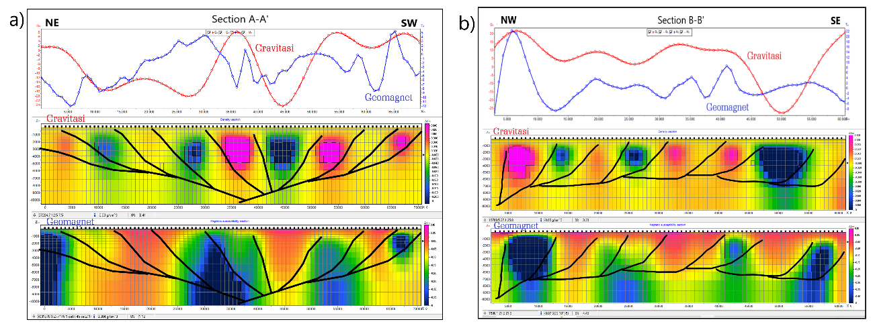
Figure. 7 Interpretation of Joint Inversion Modeling: (a) Section A-A’ (b) Section B-B’

CONCLUSIONS

The results of the subsurface mapping of the Tanimbar Islands based on the results of Joint Inversion modeling have found a geological structure pattern in the form of a fold thrust belt due to the Banda Arc subduction zone as seen from the contrast of gravity and geomagnetic anomalies with the direction or pattern of folds referring to the Charlton 2004 publication model. From the results of 2 cross sections Joint Inversion modeling obtained high anomalies with density values ranging from 2.77 - 2.81 gr/cm3 and susceptibility ranging from 0.00125 - 0.0013 SI which is suspected to be due to basement high in the form of volcanic rocks and low anomalies with density values ranging from 2.45 - 2.49 gr/cm3 and susceptibility ranging from 0.0008 - 0.00085 SI which is thought to be due to thick sedimentary rocks beneath the surface. In section A-A', there are 10 structural patterns, namely 6 structures trending northwest-southeast and 4 structures trending northeast-southwest. In section B-B', it can be seen that there are 9 structural patterns trending northeast-southwest.

REFERENCES

[1] H. A. Saputro, “Analisis Produksi Minyak Mentah Indonesia Dengan Pendekatan Error Correction Model,” Econ. Dev. Anal. J., vol. 3, no. 1, pp. 36–47, 2014, [Online]. Available: http://journal.unnes.ac.id/sju/index.php/edaj
[2] L. Lamba, I. Haryanto, D. S. Herutomo, N. Ilmi, and E. Sunardi, “Geologi Bawah Permukaan Dan Perhitungan Cadangan Hidrokarbon Dengan Metode Volumetrik Berdasarkan Interpretasi Data Seismik 2D Daerah Cekungan Tanimbar,” Padjadjaran Geosci. J., vol. 5, no. 4, pp. 394–404, 2021.
[3] Koesnama and A. K. Permana, “Sistem Minyak Dan Gas Di Cekungan Timor, Nusa Tenggara Timur Petroleum System In The Timor Basin, Nusa Tenggara Timur,” J.G.S.M, vol. 16, no. 1, pp. 23–32, 2015, [Online]. Available: https://jgsm.geologi.esdm.go.id/index.php/JGSM/article/view/48
[4] M. G. Audley-Charles, “Geometrical problems and implications of large scale over-thrusting in the Banda Arc-Australian margin collision zone,” Geol. Soc. London, Spec. Publ., vol. 9, no. 1, pp. 407–416, 1981.
[5] N. R. Amelia, Supriyanto, and H. Haryanto, “Identifikasi Stuktur Geologi Sebagai Potensi Area Jebakan Hidrokarbon Berdasarkan Integrasi Data Gaya Berat dan Data Seismik di Pulau Timor , Indonesia Timur,” Geosains Terap., vol. 4, no. 1, pp. 1–8, 2021.
[6] T. R. Charlton, T. R. Charlton, and S. Omer, “The petroleum potential of inversion anticlines in the Banda Arc,” vol. 5, no. 5, pp. 565–585, 2004, doi: 10.1306/12290303055.
[7] J. Poblet and R. J. Lisle, “Kinematic evolution and structural styles of fold-and-thrust belts,” Geol. Soc. Spec. Publ., vol. 349, pp. 1–24, 2011, doi: 10.1144/SP349.1.
[8] T. Niluh, “Integrasi Metode Gayaberat Dan Data Seismik Untuk Mengidentifikasi Struktur Perangkap,” 2021.
[9] R. Zhang, T. Li, C. Liu, X. Huang, K. Jensen, and M. Sommer, “3-D joint inversion of gravity and magnetic data using data-space and truncated Gauss–Newton methods,” IEEE Geosci. Remote Sens. Lett., vol. 19, pp. 1–5, 2021.
[10] L. A. Gallardo, “Cross-Gradients Joint Inversion of Disparate Geophysical Data for Improved Subsurface Characterisation : Multiple-Physics Field Examples,” Philosophy, pp. 1–7.
[11] L. Gross, “Weighted cross-gradient function for joint inversion with the application to regional 3-D gravity and magnetic anomalies,” Geophys. J. Int., vol. 217, no. 3, pp. 2035–2046, 2019, doi: 10.1093/gji/ggz134.
[12] M. Tavakoli, A. Nejati Kalateh, and M. Rezaie, “Two-Dimensional Cross-Gradient Joint Inversion of Gravity and Magnetic Data By a Sequential Strategy,” 82nd EAGE Conf. Exhib. 2021, vol. 2, no. November, pp. 1112–1116, 2021, doi: 10.3997/2214-4609.202010967.
[13] M. Syukri, Pengantar Geofisika. Syiah Kuala University Press, 2020.
[14] S. H. Muchtar, “Penerapan Metode Geomagnetik Untuk Identifikasi Sebaran Batubara Daerah Klatak Kecamatan Besuki Kabupaten Tulungagung,” Universitas Islam Negeri Maulana Malik Ibrahim, 2018.
[15] J. Purnomo, S. Koesuma, and M. Yunianto, “Pemisahan Anomali Regional-Residual pada Metode Gravitasi Menggunakan Metode Moving Average, Polynomial dan Inversion,” Indones. J. Appl. Phys., vol. 3, no. 01, p. 10, 2013, doi: 10.13057/ijap.v3i01.1208.
[16] J. D. Phillips, Geosoft eXecutables (GX’s) developed by the US Geological Survey, version 2.0, with notes on GX development from Fortran code. US Geological Survey, 2007.
[17] Supriyanto, Analisis Data Geofisika: Memahami Teori Inversi. 2007.

