Lithofacies Interpretation Of Sediment Rocks In The Cipamingkis River Outcrop, Jonggol Area, Bogor District, West Java

Submitted: ; Revised: ; Approved: ; Available Online:

Abstract. This research aims to study sedimentary structures and determine the depositional environment of the outcrop in the Cipamingkis River, Jonggol area, Bogor Regency, West Java. The method in this study includes literature studies, field surveys, data interpretation, and facies analysis. The result shows the outcrop in the Cimangkis River can be divided into four (4) sedimentation sequences unit: Claystone Unit (Sequence 1), Limestone/Calsirudit Unit (Sequence 2), Limestone/calcarenite-Calcilutite Unit (Sequence 3), Mudstone/ Calsilutite Unit (Sequence 4). Based on the depositional environment analysis, this outcrop displays characteristics of a shallow marine environment. The Interpretation of facies from outcrops can be used as a reservoir analog and can support subsurface interpretation in the Northwest Java Basin.

Keywords: fasies, cibulakan, cipamingkis river, carbonate.

INTRODUCTION

Regional Physiography
The outcrop is located along the Cipamingkis River in the Jonggol area of West Java. Its coordinates are approximately 6°31'57.64"S and 107°2'8.71"E. This outcrop is covered by the Jatiluhur Formation, which is equivalent to the Cibulakan Formation in the Northwest Java Basin. The Cibulakan Formation plays a significant role in hydrocarbon [1] exploration. The Jatiluhur Formation is composed of siliciclastic rocks intercalated with limestone, forming a slope-shelf system or continental shelf environment with ages ranging from Middle Miocene to early Late Miocene [2].
According to [3], this basin is situated between the Sunda Shelf in the North, the Pergulungan - Bogor Line in the South, the Karimun Jawa Lifting Area in the East, and the Seribu Island Shelf in the West. The North West Java Basin is influenced by a north-south trending block faulting system. This system divides the basin into graben or several sub-basins, namely Jatibarang, Pasir Putih, Ciputat, Rangkas Bitung, and several basement elevations, including Arjawinangun, Cilamaya, Pamanukan, Kandanghaur–Waled, Rengasdengklok, and Tangerang. Based on its stratigraphy, structural patterns, and its location within a subduction arc pattern over time, it becomes evident that the West Java Basin has undergone multiple sedimentation and tectonic phases from the Eocene to the present [3].
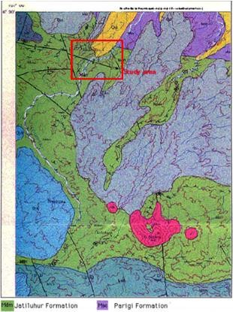
Figure 1 Geological map of the Cipamingkis area [4], the research study is covered by the Jatiluhur formation which is shown by a red box line.

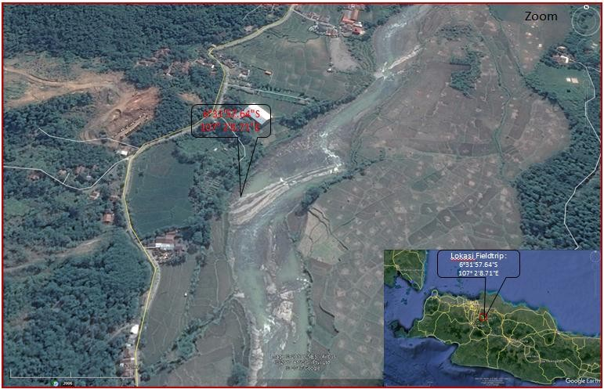
Figure 2 Location map of the outcrop in the Cipamingkis River [5]

Regional Stratigraphy
Cibulakan Formation
This formation consists of alternating shales, sandstones, and limestones. The limestone within this unit is primarily clastic limestone and locally developed reef limestone. This type of limestone is referred to as Mid Main Carbonate (MMC). The formation was deposited during the Early Miocene to Late Miocene period. It is further divided into three members:

a) Massive
This member is deposited unconformably above the Baturaja Formation. The lithology of this member consists of intercalations of claystone and sandstone with fine to medium grain sizes. Notably, significant hydrocarbon content, especially at the top, has been discovered within this extensive layer. Additionally, fossils of planktonic foraminifera, such as Globigerina trilobus, and benthic foraminifera, like Amphistegina, are present [6].

b) Main
The Main Members are deposited conformably above the Massive Members. Its lithology comprises claystone interspersed with fine to medium grain-sized sandstone (which possesses a glauconitic nature). In the initial stages of its formation, limestone and sandboxes developed. Within this section, the Main Member is further divided, referred to as the Mid Main Carbonate [7].

c) Pre Parigi
The Pre Parigi Members are conformably deposited above the Main Members. The lithology consists of alternating layers of limestone, dolomite, sandstone, and siltstone. This member was formed during the Middle Miocene to Late Miocene and was deposited in the Middle-Neritic to Inner Neritic environment [6], where shallow marine fauna and glauconitic sandstones are prevalent.
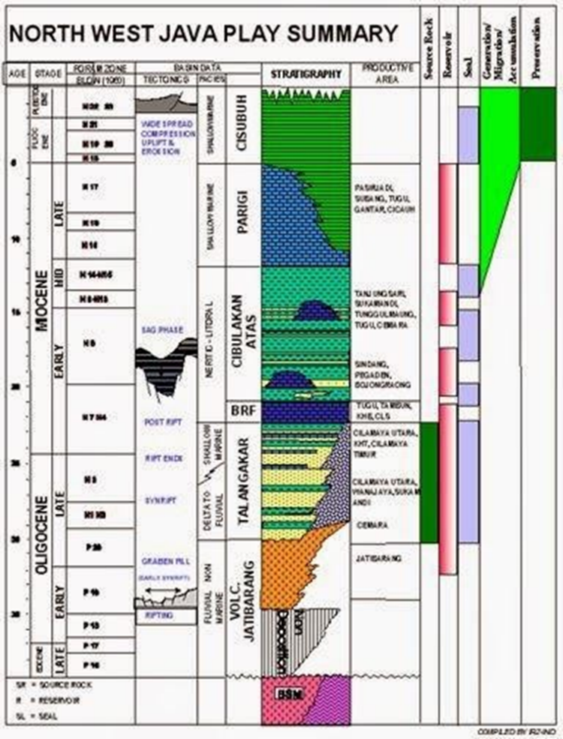

Figure 3 Stratigraphy of the North West Java Basin [8]

Gamma Ray log patterns
The determination of the depositional environment can be observed through the pattern of log curves, especially the gamma-ray log and spontaneous potential [9]. The interpretation of the depositional environment using the gamma-ray log pattern involves high uncertainties. Therefore, the interpretation of the depositional environment using the gamma-ray log needs to be corroborated with core data or outcrops as analogs.
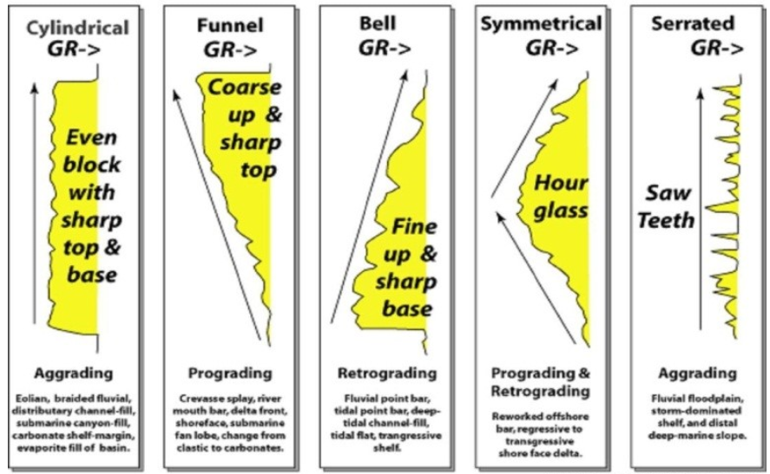
Figure 2.1 Response of gamma-ray log to variations in grain size and depositional environment
[9]
1. Cylindrical:
The cylindrical shape of the GR or SP logs may indicate the presence of thick and homogeneous sediment, bounded by channel-fills or channel-fills with sharp contacts. The cylindrical form represents homogeneity and ideal properties. It is associated with braided channel sediment deposits, estuarine or sub-marine channel fills, anastomosed channels, eolian dunes, and tidal sands.

2. Irregular:
This shape is a representation of reservoir rock presence. Irregular shapes are associated with alluvial plain sediments, floodplains, tidal sands, shelves, or back barriers. Generally, this pattern is identified as thin interbedded layers. Thin deposit elements may include crevasse splays, overbank deposits in lagoons, and turbidites.

3. Bell-Shaped:
The bell-shaped profile shows upward smoothing, possibly due to channel fills. Observations indicate that the grain size at each level tends to be the same, but the number shows a gradation towards fine-grained with more radioactive clays upwards. The bell shape is produced by point bar deposits, tidal deposits, transgressive shelf sands (shallow sea), sub-marine channels, and turbidite deposits.

4. Funnel-Shaped:
The profile in the form of a funnel or funnel shows upward roughness, which is the opposite of the bell shape. The funnel shape may result from progradation systems such as sub-marine fan lobes, regressive shallow marine bars, barrier islands or front reef carbonate prograding on top of mudstone, delta fronts or distributary mouth bars, crevasse splays, beach and barrier beach, strandplain, shoreface, prograding shelf sands, and submarine fan lobes.

5. Symmetrical:
The upward smoothing of the bell shape or bell shape is an indication of a regression event, while the upward roughening of the funnel shape represents a transgression event. Meanwhile, the constant cylindrical shape indicates a transition. The determination of the depositional environment is initially directed on a large scale and is further analyzed on a smaller scale using a combination of available data, such as cutting data and wireline log characters [9].

Classification of Carbonate Rocks
1. Grabau Classification (1904)
The Grabau classification is grounded in a straightforward characteristic of limestone or carbonate rock—the size of its constituent grains (Table 2.1) [10]. The concept behind this classification method aligns with general approaches used in categorizing clastic sedimentary rocks. The underlying idea of this method is associated with the potential deposition energy level of carbonate material [11]. The simplest categorization of limestone/carbonate rock is determined by the grain size of its components [10].

Table 2.1. Grabau Classification [10]

2. Folk Classification (1959)
This classification is founded on the concept of textural maturity in carbonate rocks, encompassing the type of rock composition (refer to Figure 2.2) [12]. The evolution of this classification stems from petrographic analysis of limestone, necessitating a more specific basis for determining depositional environments. Understanding the rock's fabric enables the interpretation of sediment deposition energy levels [13]. The Folk classification (1959) is rooted in the fabric and composition of carbonate rocks, categorizing them into three primary types: grains (allochems), matrix (micrite), and cement (sparite). Based on the allochem type—namely, intraclast, ooid, bioclast, and peloid—limestone is categorized into four groups. Furthermore, coherent, organically structured in-situ limestones are termed biolithites (as modified by [14]).

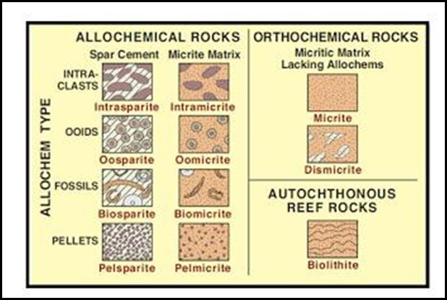
Figure 2.2. Folk Classification (1959) [12]

3. Dunham's classification
Dunham's classification is based on the fabric and composition of the carbonate rock. The three main divisions consist of limestone which has matrix-supported, grain-supported, and biological bound. The fourth category in addition is limestone that has undergone crystallization, namely crystalline carbonate [15].
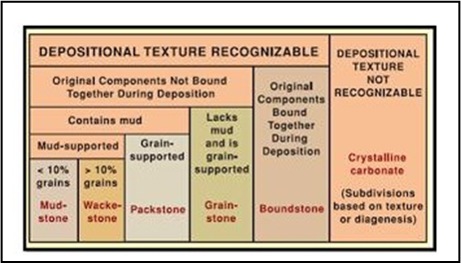
Figure 2.3 Dunham's classification of carbonate rocks [15]

4. Embry & Klovan Classification (1971)
This classification is founded upon the same characteristics as Dunham's classification, encompassing rock fabric, texture, the proportion of silt content in the rock, and the structural framework of the rock—both mechanical and biological in nature. This classification represents a refinement of Dunham's classification, which previously lacked specific categorization for boundstones [16]. Boundstone resulting from the organic framework of coral colonies is categorized into several types based on the composing organisms. By combining texture and composition, this classification offers insights into the conditions under which the rock was formed [13].

METHODS

This study can be divided into several research stages, as follows: Preparation Stage: This stage involves studying the literature related to the research area and obtaining permits for research locations. Description of Outcrops Stage: Field research is conducted through the following steps:
- General observations are made concerning sediment materials, sedimentation processes, and the environment around the study area.
- Rock samples are collected, and changes in rock facies are observed both vertically and laterally.
Rock Sedimentology Analysis Stage: In this stage, the data collected and recorded during field research are summarized in an article or report containing interpretations, discussions, and conclusions drawn from the data. Interpretation of Facies and Depositional Environment: The flow of these stages is illustrated in Figure 3.1.

Figure 3.1 Research workflow

RESULTS AND DISCUSSIONS

Description of the Outcrop Stratigraphic Columns
The stratigraphic column represents a stacking pattern that fining upwards due to sediment deposition processes that have occurred in the Cipamingkis River over geological timescales. The appearance of the Cipamingkis River outcrop aids in constructing a history of sediment deposition by revealing the condition of the sediment structure, which possesses distinct characteristics shown in Figures 4.1 and 4.2.
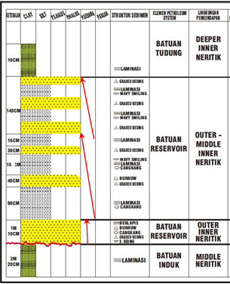
Figure 4.1 The Outcrop Stratigraphic Column (without scale)

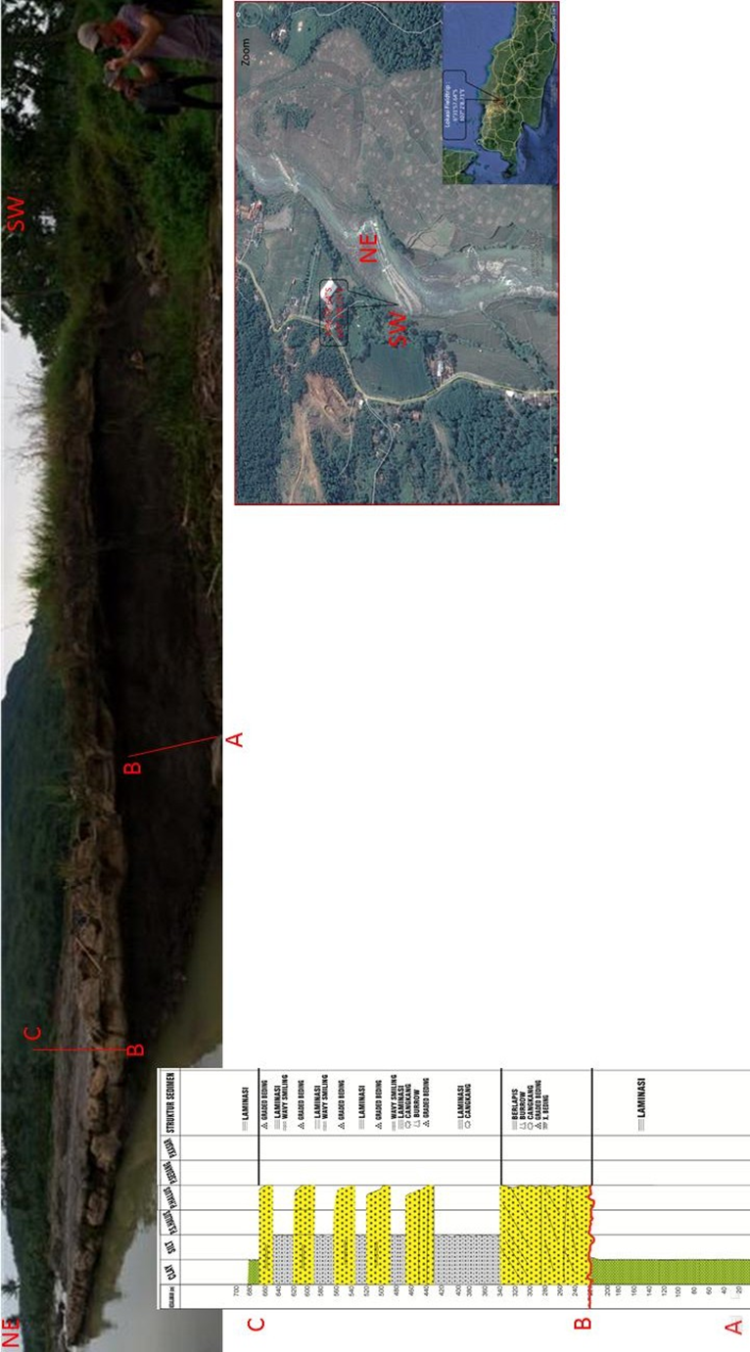
Figure 4.2 Outcrop Stratigraphic Column (same scale)

The stratigraphic column outcrop reveals that, based on the stacking pattern of sediment layers and the ratio of thickness of each lithofacies fining upward, it can be subdivided into four sequences of sediment deposition as follows:

A. Sequence 1 / Clay Stone Unit
Black color, clay grain size, texture : clay grain shape, good sorting, closed packing, mineral composition : slightly visible quartz very fine size, parallel-layered laminated sedimentary structure.

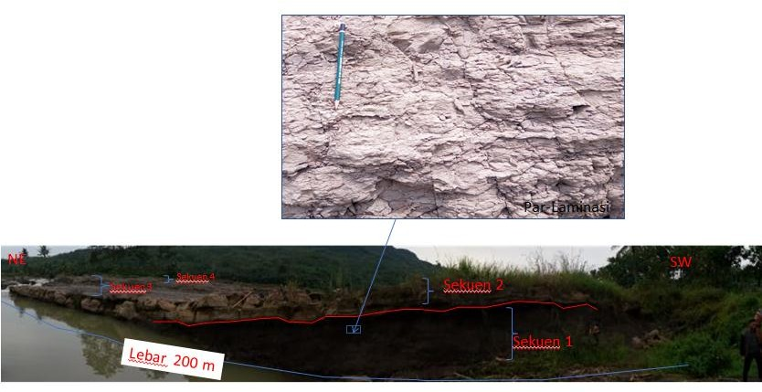
Figure 4.3 Sediment structure of parallel laminations in Sequence 1

B. Sequence 2 / Satuan Grainstone (Dunham, 1962) / Satuan Calsirudit
The carbonate rock is bright yellowish brown in color, grain size of fine sand-very fine sand, texture: angular-sub, rounded grain shape, moderately-good sorting, closed packing, mineral composition: slightly visible quartz, very fine size, coarse shell fragments very abundant, very abundant foraminifera grains, sedimentary structures in the form of cross-bedding, graded bedding, bedding, and burrowing, there is the appearance of erosional fields on the lower sequence boundaries, good porosity.

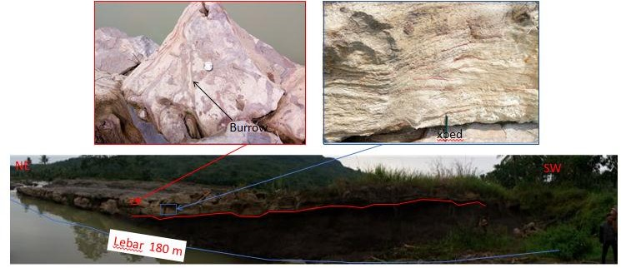
Figure 4.4 Crossbed, erosional and burrow sedimentary structures in Sequence 2

C. Sequence 3 / Calcarenite-Calsilutite Unit
Calcarenit : Bright blackish-gray color, grain size of fine sand-very fine sand, texture : rounded-sub.rounded grain shape, moderately-good sorting, sealed packing, mineral composition : slightly visible quartz very fine size, shell fragments very slightly coarse, very abundant foraminifera grains, graded bedding, burrowing, good porosity sediment structure
Calsilutite: Dark gray-black color, clay grain size, texture: clay grain shape, well sorted, sealed packing, mineral composition: very fine quartz, parallel lamination sedimentary structure, abundant shell fragments at the bottom and top Ripples and wavy smiles appear due to storms and waves.
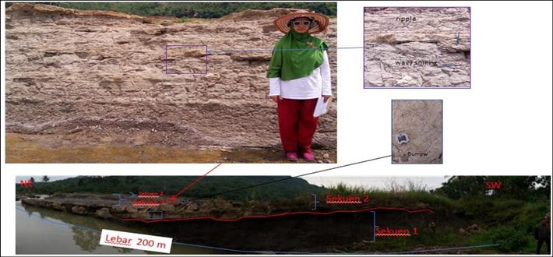
Figure 4.5 Sediment structure of parallel laminations in Sequence 3

D. Sequence 4 / Mudstone Unit (Dunham, 1962) / Calsilutite Unit
Texture: clay grain shape, good sorting, closed packing, mineral composition: slightly visible quartz, very fine size, parallel lamination sedimentary structure.

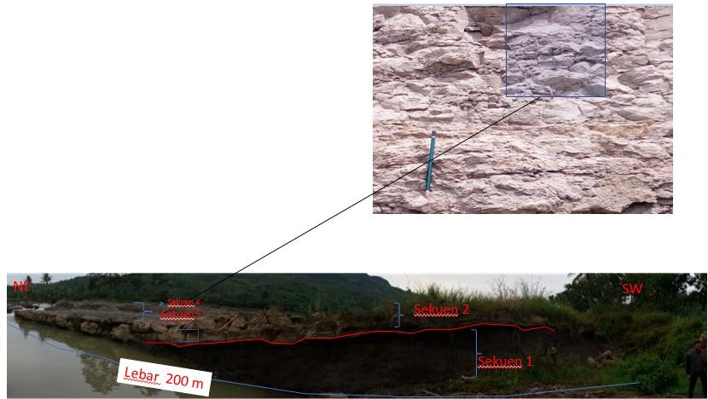
Figure 4.6 Sediment structure of parallel laminations in Sequence 4

Depositional Environment Analysis
Generally, carbonate rocks form in aquatic environments that meet criteria suitable for carbonate formation, such as warm ambient temperatures and the presence of carbonate-producing organisms. This sedimentation process results in carbonate facies exhibiting variations in depositional texture, mineralogy, chemical composition, and shape. These characteristics are associated with the distribution and pore size features within the rock. Carbonate rock facies are categorized into two types based on their forming materials: loose carbonate sedimentary materials and the products of organismal activities [17]. The presence of carbonate facies indicates a shallow marine depositional environment.

The identification of depositional environments and lithofacies in the stratigraphic column of STA 2 refers to the classification of depositional environments and lithofacies in shallow seas by [18]. The lithofacies units are named according to Dunham's Classification (1962). The stacking pattern in Sequence 1 exhibits a blocky pattern with a 1-meter thickness, identified as a Calsirudit Unit or Grainstone Unit (Dunham, 1962). The thickness ratio of each lithofacies aids in determining the environment.

An analysis of the depositional environment in the Cimangkis River outcrops, based on [18], places it in the Outer–Deeper Inner Neritic and Middle Neritic environments. This assessment is derived from observations of grain size, sediment structure characteristics, and a comparison of the thickness ratio of sand-shale lithofacies. According to [19], the study area's depositional environment is categorized as shallow marine.

Outcrop grain size patterns vs Subsurface Gamma ray log patterns of the upper Cibulakan Formation
According to [1], the Jatiluhur Formation is equivalent to the Cibulakan Formation. The deposition of the Jatiluhur Formation took place during the middle Miocene to early Late Miocene (N13 – N16) [20]. The description of the outcrop indicates an upward-fining pattern. Figure 4.7 illustrates an example of a gamma ray log pattern within the Cibulakan interval [21]. The gamma log pattern in the Cibulakan Formation interval exhibits an upward-fining pattern. This interval is dominated by sandstone lithology deposited in a shallow marine environment, specifically an inner littoral environment.

Figure 4.7 Gamma ray log pattern in Cibulakan Formation (modified from [21])

CONCLUSIONS

Based on the observed stratigraphic column, the outcrops in the Cimangkis River are divided into four sequences of sedimentation: Claystone Unit (Sequence 1), Grainstone/Calsirudit Unit (Sequence 2), Calcarenit-Calsilutite Unit (Sequence 3), and Mudstone/Calsilutite Unit (Sequence 4). The analysis of the depositional environment indicates that the outcrops in the Cimangkis River were deposited in a shallow marine environment, specifically interpreted as the Outer–Deeper Inner Neritic area.

ACKNOWLEDGMENTS
We thank to members of the Committee ‘Al-Fiziya: Journal of Materials Science, Geophysics, Instrumentation and Theoretical Physics’ for selecting this paper to be published.

REFERENCES
[1] Abdurrokhim. “Stratigrafi Sikuen Formasi Jatiluhur di Cekungan Bogor, Jawa Barat”. (Bulletin of Scientific Contribution, 2017). 15(2), 167–172.
[2] Abdurrokhim, & Ito, M. “The role of slump scars in slope channel initiation: A case study from the Miocene Jatiluhur Formation in the Bogor Trough,west java”. (Journal of Asian Earth Sciences, 2013). 73, 68–86.
[3] Martodjojo, S., “Parigi Limestone Field Trip, Karawang-Jatiluhur”, In House Field Trip ARII-ITB, 23PP. 1990
[4] Achdan, A. dan Sudana, D., Peta Geologi Lembar Karawang, Jawa, Direktorat Geologi,Departemen Pertambangan dan Energi, Republik Indonesia,Bandung. 1992
[5] www. Google earth. Diakses jam 20.00 WIB 12 oktober 2017
[6] Arpandi, D., Patmosukismo, S., “The Cibulakan Formation as One of the Most Prospective Stratigraphic Units in the Northwest Java Basinal Area”. (IPA Proceeding. Vol 4th Annual Convention. Jakarta, 1975)
[7] Budiyani et al., “Konsep Eksplorasi Untuk Formasi Parigi di Cekungan Jawa Barat Utara”. (Makalah IAGI. Vol 20th, Indonesia., .1991) hal 45-67.
[8] Pertamina BPPKA, “Petroleum Geology of Indonesian Basins: Principles, Methods and Application”. Pertamina BPPKA. Indonesia.1996
[9] Walker, R. G., & James, N. P. Fasies Model: Response to Sea Level Change. Geological Association of Canada. 1992.
[10] Grabau, A., On The Classification of Sedimentary Rocks, New Jersey:Princeton University. 1904.
[11] Nichols, G., Sedimentology and Stratigraphy 2nd Edition, San Antonio: Willey-Blackwell. 2009
[12] Folk, R.L. Practical petrographic classification of limestones. Bulletin of the American Association of Petroleum Geologists, 1959. 43(1): 1-38
[13] Tucker, M.T., dan Wright, V.P., Carbonate Sedimentology, Blackwell Science Ltd, Oxford. 1990.
[14] P. A. Scholle and D. S. Ulmer-Scholle, “A Color Guide to the Petrography of Carbonate Rocks: Grains, Textures, Porosity, Diagenesis,” AAPG Memoir, Vol. 77, 2003
[15] Dunham, R.J. Classification of Carbonate Rocks According to Depositional Texture. In: Ham, W.E., Ed., Classification of Carbonate Rocks, AAPG, Tulsa, 108-121. 1962
[16] Embry, A., dan Klovan, J., 1971, A Late Devonian Reef Tract on Northeastern Banks Island, Bulletin of Canadian Petroleum Geology vol.4, 730 – 781.
[17] Lucia, F. Jerry, Carbonate Reservoir Characterization “An Integrated Approach” 2nd edition, Springer-Verlag, Berlin. 2007.
[18] Tipsword, H. L, Setzer, F. M, and Smith, F. L. JR. “Interpretation of Depositional Environment in Gulf Coast Petroleum Exploration from Paleoecology and Related Stratigraphy.” Gulf Coast Assoc. Geol. Socs. Trans. 1966.
[19] W Imanda, et al., “Lithofacies analysis, ichnofacies analysis and depositional environment of Jatiluhur Formation in Cipamingkis area“ (IOP Conf. Series: Earth and Environmental Science 846, 2021) 012021 doi:10.1088/1755-1315/846/1/012021
[20] Mohamad Solihin, et al.,“Biozonasi Foraminifera Planktonik Di Lintasan Sungai Cipamingkis, Daerah Jonggol, Provinsi Jawa Barat,” Bulletin of Scientific Contribution, Volume 14, Nomor 1, April 2016 : 55 – 62.
[21] Firman Herdiansyah, et al., “Low Resistivity Zone Pada Reservoir Batupasir Formasi Cibulakan Atas, Cekungan Jawa Barat Utara Low Resistivity Zone In Sandstone Reservoir Upper Cibulakan Formation, North West Java Basin”, Bulletin of Scientific Contribution, Volume 14, Nomor 1, April 2016 : 97 – 116

